 CHEMICAL ENGINEERING TRANSACTIONS  VOL. xxx, 2026 | A publication of  
The Italian Association
of Chemical Engineering
Online at www.cetjournal.it

Guest Editors: Marco Bravi, Antonio Marzocchella, Giuseppe Caputo
Copyright © 2026, AIDIC Servizi S.r.l.
ISBN 979-12-81206-xx-x; ISSN 2283-9216

Enhancing Hydrogen Production Efficiency in Alkaline Water Electrolysis Through Biosurfactants, Ultrasound, and Their Synergistic Combination
Bruno A. Cabral Roque^{a,b,}*, Mohand Benachour^{a,b}, Leonie A. Sarubbo^{a,b,c}
ª Department of Chemical Engineering, Federal University of Pernambuco (UFPE), Av. dos Economistas, s/n, ZIP Code 50740-590, Recife, Brazil;
^{b} Advanced Institute of Technology and Innovation (IATI), Rua Potira, 31, ZIP Code 50751-310, Recife, Brazil;
^{c} School of Technology and Communication, Catholic University of Pernambuco (UNICAP), Rua do Príncipe, 526, ZIP Code 50050-900, Recife, Brazil
* bruno.roque@ufpe.br
Alkaline water electrolysis is a key technology for low-carbon hydrogen production; however, its efficiency is constrained by gas bubble accumulation and mass transfer limitations at the electrode–electrolyte interface. This study evaluates ultrasound application and biosurfactant addition as process intensification strategies to enhance hydrogen production under mild alkaline conditions. Experiments were performed in a hermetic tubular bench-scale electrolyzer operating with 1 M KOH, stainless-steel electrodes, and a saponin-based biosurfactant. Ultrasound was applied using an immersion transducer operating at 40 kHz under pulsed and continuous regimes. A 2³ factorial design with central points was employed to assess the effects of applied voltage, ultrasound condition, and biosurfactant concentration on the hydrogen volumetric flow rate. Statistical analysis based on ANOVA and response surface methodology identified applied voltage as the dominant factor, with significant quadratic effects defining optimal operating regions. Ultrasound exhibited a voltage-dependent synergistic effect by enhancing bubble detachment and mass transfer, whereas the biosurfactant showed a secondary interfacial effect within a narrow concentration range. These findings highlight ultrasound-assisted alkaline electrolysis as an effective route for performance enhancement without major modifications to electrolyzer architecture.
  - Introduction
The global energy landscape faces increasing challenges associated with resource depletion and environmental concerns. Fossil fuels, the primary contributors to carbon emissions, exacerbate global warming and climate change (Zahra et al., 2026). In this context, hydrogen has emerged as a strategic pathway for decarbonization, offering relevant advantages over fossil-based energy sources, including zero emissions at the point of use, high gravimetric energy density, and long-term storage capability. Moreover, its integration into green energy systems enables clean energy storage and enhances grid flexibility, consolidating hydrogen as a versatile energy carrier (Aditiya et al., 2026).
Among low-carbon hydrogen production routes, blue hydrogen and, in particular, green hydrogen stand out as the most promising alternatives. Green hydrogen is produced via water electrolysis powered by renewable energy sources such as solar, wind, and hydropower (Serik et al., 2026). Among the available electrolysis technologies, alkaline water electrolysis is distinguished by its technological maturity, high efficiency, and relatively lower cost compared to other electrolyzer technologies. This process is based on the decomposition of water into hydrogen and oxygen in the presence of an alkaline electrolyte (Dash et al., 2024).
Despite these advantages, the large-scale deployment of alkaline water electrolysis remains constrained by technical challenges related to process efficiency. Bubble dynamics plays a central role by directly affecting mass and charge transfer mechanisms at the electrode–electrolyte interface. In addition, electrolyte flow and concentration influence ionic transport and gas bubble behavior, while electrode spacing must be optimized to balance ohmic losses and operational stability. The selection of electrode materials and the implementation of surface engineering strategies are also critical to mitigating efficiency losses associated with material limitations and bubble adhesion, thereby improving overall electrolyzer performance (Eldeeb et al., 2026).
In this context, the present study aims to evaluate process intensification strategies applied to alkaline water electrolysis, focusing on the use of ultrasound and biosurfactant addition as approaches to enhance hydrogen production efficiency. Ultrasound is investigated as a means to modify bubble dynamics and reduce diffusive resistances, while biosurfactants are explored as interfacial modifiers capable of influencing gas–liquid interactions. The combined application of these strategies seeks to provide insights into the optimization of alkaline electrolyzer performance under moderate operating conditions.
  - Methodology
    - Configuration of the alkaline electrolysis experimental system and operating conditions
The experiments were carried out in a bench-scale tubular electrolyzer constructed from polyvinyl chloride (PVC), with a total length of 40 cm and an internal diameter of 2.8 cm, operating with 200 mL of a 1 M potassium hydroxide (KOH) electrolyte prepared with distilled water. When applicable, the electrolyte was supplemented with a plant-derived saponin biosurfactant extracted according to Bezerra et al. (2021). PVC was selected due to its chemical resistance under alkaline conditions, low cost, and ease of laboratory-scale fabrication. The system employed cylindrical stainless-steel electrodes (26.5 cm length, 4 mm diameter), with approximately 17 cm immersed in the electrolyte. Gas removal occurred through an upper outlet, and system tightness was verified prior to experimentation via pressurized air immersion tests. Electrochemical experiments were performed in triplicate using a regulated DC power supply (0–32 V, 0–5 A), with the applied voltage defined by the experimental design. Ultrasound irradiation was provided by an immersion transducer operating at 40 kHz and 300 W, with both the electrolyzer and transducer immersed in a water bath to ensure effective acoustic coupling. Ultrasound conditions included no irradiation, pulsed mode, and continuous mode. Figure 1 illustrates the complete experimental setup and its main components.

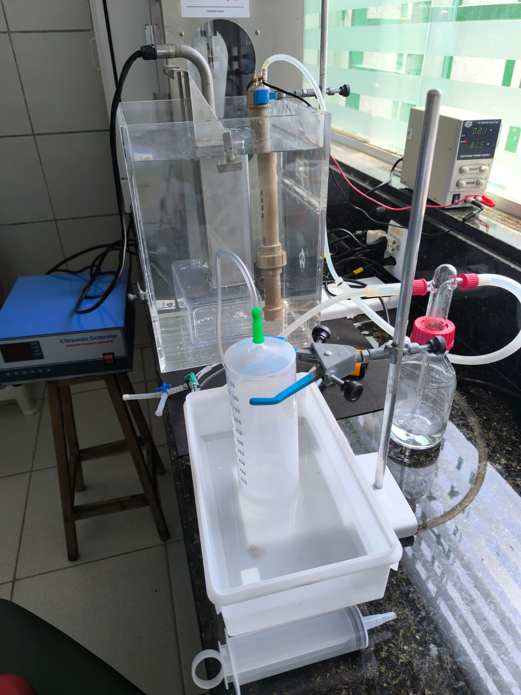
Figure 1: General view of the experimental setup used in the experimental runs.

    - Gas collection and quantification system
The volumetric quantification of gases produced during electrolysis was performed using the water displacement method, following Genç and Ayas (2025). The gas stream was routed from the electrolyzer through a gas washing bottle to remove electrolyte-derived aerosols and subsequently collected in a vertically positioned 500 mL graduated syringe submerged in water. Gas volume was measured as a function of time using a digital stopwatch, while temperature was periodically monitored with an infrared thermometer. As gas separation was not implemented, hydrogen and oxygen fractions were estimated based on the stoichiometry of water electrolysis, assuming a 2:1 H₂:O₂ molar ratio under near-ambient conditions. Accordingly, hydrogen volume was estimated as two-thirds of the total collected gas, and the hydrogen volumetric flow rate (mL·s⁻¹) was adopted as the response variable.
2.3. Experimental design
The statistical evaluation of the process considered three independent variables: ultrasound application, applied voltage, and biosurfactant concentration. The response variable analyzed was the volumetric hydrogen production rate (mL·s⁻¹). The experimental design was structured as a full factorial design of the 2³ type, augmented with six replicates at the central point, resulting in a total of 14 experimental runs. This design enabled the assessment of linear effects, factor interactions, and system curvature, thereby allowing the fitting of a second-order polynomial model.

2.3.1. Factor level matrix
The experimental domain was established based on preliminary assays and physicochemical limitations of the system, ensuring that all factor levels were technically feasible and operationally stable within the region of interest. A three-level coding scheme (−1, 0, +1) was employed to allow estimation of linear, interaction, and quadratic effects under a second-order response surface framework. The use of coded variables preserves model orthogonality, enhances numerical stability during regression analysis, and enables direct comparison of effect magnitudes irrespective of the original measurement scales. The coded and corresponding actual levels of the independent variables are summarized in Table 1.

Table 1: Matrix of levels of factorial design
Level | Ultrasound | Voltage (V) | Biosurfactant (%)
-1 | OFF | 2.0 | 0.02
0 | Pulsed | 2.5 | 0.06
+1 | Continuous | 3.0 | 0.10

2.3.2. Experimental design matrix
Table 2 presents the complete experimental matrix of the 2³ factorial design, comprising the eight factorial combinations corresponding to the extreme coded levels (−1 and +1) of the three independent variables, as well as six replicates at the central point (0, 0, 0). The factorial portion of the design enables the unbiased estimation of main effects and two-factor interactions, while the replicated central runs provide an independent estimate of pure experimental error and allow for the detection of curvature in the response surface.

Table 2: Experimental matrix of the 2³ factorial design with central points
Run | Ultrasound | Voltage (V) | Biosurfactant (%)
1 | −1 (OFF) | −1 (2.0 V) | −1 (0.02 %)
2 | +1 (Continuous) | −1 (2.0 V) | −1 (0.02 %)
3 | −1 (OFF) | +1 (3.0 V) | −1 (0.02 %)
4 | +1 (Continuous) | +1 (3.0 V) | −1 (0.02 %)
5 | −1 (OFF) | −1 (2.0 V) | +1 (0.10 %)
6 | +1 (Continuous) | −1 (2.0 V) | +1 (0.10 %)
7 | −1 (OFF) | +1 (3.0 V) | +1 (0.10 %)
8 | +1 (Continuous) | +1 (3.0 V) | +1 (0.10 %)
9 | 0 (Pulsed) | 0 (2.5 V) | 0 (0.06 %)
10 | 0 (Pulsed) | 0 (2.5 V) | 0 (0.06 %)
11 | 0 (Pulsed) | 0 (2.5 V) | 0 (0.06 %)
12 | 0 (Pulsed) | 0 (2.5 V) | 0 (0.06 %)
13 | 0 (Pulsed) | 0 (2.5 V) | 0 (0.06 %)
14 | 0 (Pulsed) | 0 (2.5 V) | 0 (0.06 %)

2.4. Statistical data analysis
The statistical analysis of the results was performed using the Python programming language, supported by scientific libraries for data analysis and statistical modeling. The effects of the independent variables and their interactions on the hydrogen volumetric flow rate were evaluated through analysis of variance (ANOVA), adopting a 95% confidence level (p < 0.05). A second-order polynomial model was fitted to the experimental data, enabling the identification of statistically significant terms and the construction of response surfaces. Model adequacy was assessed based on the F-statistic values, p-values, residual error, and the physical consistency of the estimated coefficients.

  - Results and Discussion
3.1. Statistical significance of operating variables and model adequacy
The influence of applied voltage, ultrasound application, and biosurfactant concentration on the hydrogen volumetric production rate was evaluated using a second-order response surface model derived from a full 2³ factorial design with central point replications. Analysis of variance (ANOVA) confirmed that the model is statistically significant at a 95% confidence level, with low residual variance and adequate predictive capability within the investigated domain. Applied voltage was identified as the dominant factor, exhibiting the highest standardized effect and F-value (F = 1104.9, p < 10⁻⁹), followed by biosurfactant concentration (F = 112.9, p < 10⁻⁵) and ultrasound application (F = 31.7, p < 10⁻⁴). Among the interaction terms, only the interaction between ultrasound and applied voltage was statistically significant (p < 0.01), whereas interactions involving biosurfactant concentration were not, indicating that its effect is predominantly independent. All quadratic terms were highly significant (p < 10⁻⁶), confirming the presence of curvature in the response surface and justifying the adoption of a second-order polynomial model. The dominant effect of applied voltage agrees with the findings of Luo et al. (2024), who state that cell voltage is the key parameter governing hydrogen production performance in alkaline water electrolysis. Similarly, Benghanem et al. (2024) reported a direct relationship between increasing electrical driving force and hydrogen generation rate. The statistical relevance of quadratic terms is consistent with the non-linear behavior described by Mütter et al. (2025), who demonstrated that second-order polynomial models are required to accurately represent electrochemical systems.
The relative importance of the main effects, interaction terms, and quadratic contributions is summarized in Figure 2, which clearly highlights the dominance of applied voltage and the relevance of the ultrasound–voltage interaction in governing hydrogen production.

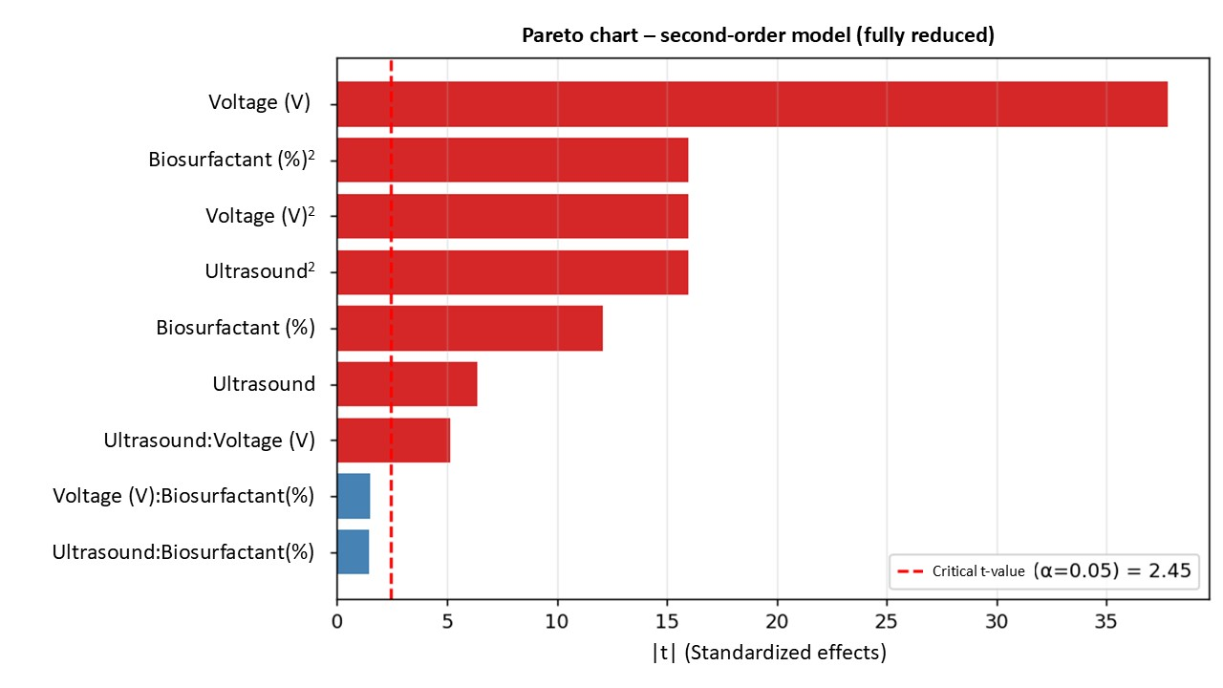
Figure 2: Pareto chart of standardized effects for hydrogen volumetric flow rate.

3.2. Empirical model and response surface formulation
Based on hierarchical reduction and statistical significance, the final second-order model describing the hydrogen volumetric flow rate ($Y$, mL·s⁻¹) is given by Eq. (1):
Y= ​0.8477 + 0.2089V − 0.0450V² − 0.0354U − 0.0450U² + 0.0668B − 0.0450B² + 0.0285(U×V)​ | (1)
where V is the applied voltage, U denotes the ultrasound condition (coded variable), and B represents the biosurfactant concentration. The negative quadratic terms indicate the presence of local optima, showing that excessive electrical, acoustic, or surfactant inputs result in diminishing performance. The close agreement between predicted and experimental responses confirms the adequacy of the fitted second-order model within the investigated domain, in line with the predictive performance reported by Mütter et al. (2025).
3.3. Combined effect of applied voltage and ultrasound on hydrogen production
Figure 3 illustrates the combined effect of applied voltage and ultrasound on the hydrogen volumetric flow rate, with the biosurfactant concentration fixed at its central level (0.06%). The response surface reveals a strong non-linear dependence of hydrogen production on applied voltage, consistent with its dominant statistical contribution, while also evidencing a clear modulation of this effect by ultrasound. At moderate voltages, ultrasound application enhances hydrogen production by promoting bubble detachment and interfacial renewal through acoustic cavitation and microstreaming, thereby reducing mass transfer resistance and effective diffusion layer thickness. This synergistic behavior is captured by the statistically significant ultrasound–voltage interaction term. At higher voltages, however, the benefits of ultrasound diminish, likely due to intensified gas evolution, bubble coalescence, and increased interfacial coverage, which limit further gains in electrochemical performance. The voltage-dependent enhancement promoted by ultrasound is in line with Teoh et al. (2025), who reported that sono-electrolysis increases hydrogen production by 10–20% at moderate operating conditions, while excessive electrical and acoustic intensities reduce energy efficiency. This supports the observed synergistic effect at intermediate voltages and its attenuation at higher electrical inputs.

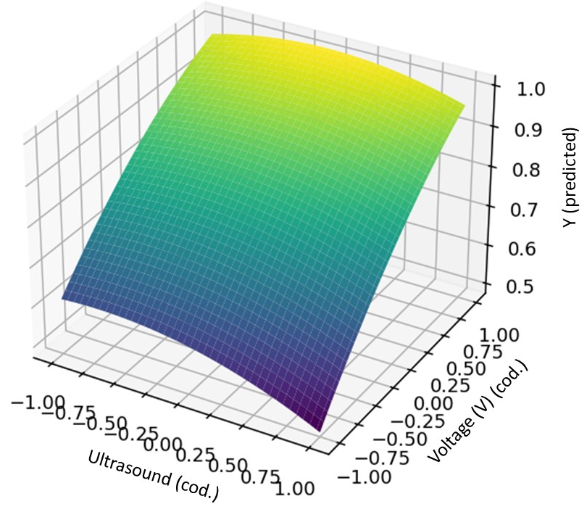
Figure 3: Response surface of hydrogen volumetric flow rate as a function of applied voltage and ultrasound condition, with biosurfactant concentration fixed at its central level.

3.4. Role of biosurfactant concentration and process intensification implications
Although biosurfactant concentration exhibited a statistically significant main effect, its influence was secondary compared to applied voltage and ultrasound. The positive linear and negative quadratic coefficients indicate that biosurfactants act within a narrow optimal concentration range, primarily by modifying gas–liquid interfacial properties. At low concentrations, surface tension reduction weakens bubble adhesion at the electrode surface, facilitating gas removal. At higher concentrations, excessive adsorption likely increases interfacial resistance and stabilizes gas bubbles, counteracting mass transfer enhancement. From a process intensification perspective, the results demonstrate that applied voltage defines the energetic regime of the system, ultrasound operates as a dynamic intensification strategy through its interaction with voltage, and biosurfactants function as interfacial modulators. The combined use of ultrasound and controlled biosurfactant addition enables enhanced hydrogen production under mild alkaline conditions, offering a viable pathway for electrolyzer optimization without substantial modifications to reactor architecture.
The existence of an optimal biosurfactant concentration range is consistent with Purnami et al. (2025), who demonstrated that surfactants enhance hydrogen evolution by modifying interfacial properties, whereas excessive concentrations increase interfacial resistance and stabilize gas bubbles. This behavior supports the interpretation of biosurfactants as secondary, interfacial intensification agents.
  - Conclusions
This study systematically evaluated the combined effects of applied voltage, ultrasound assistance, and biosurfactant addition on hydrogen production by alkaline water electrolysis under mild operating conditions. The results demonstrated that applied voltage is the primary factor governing hydrogen evolution, while ultrasound application significantly enhances system performance through its synergistic interaction with voltage, primarily by improving gas bubble detachment and mass transfer at the electrode–electrolyte interface.
Biosurfactant addition exhibited a statistically significant but secondary influence, acting mainly as an interfacial modifier within a narrow optimal concentration range. Although it did not show relevant interaction effects with the other variables, its contribution to bubble dynamics supports its role as a fine-tuning parameter rather than a dominant intensification mechanism.
The response surface analysis revealed pronounced non-linear behavior for all investigated variables, confirming the existence of optimal operating windows and highlighting the limitations of performance gains achieved through uncontrolled increases in electrical or acoustic input. These findings emphasize the importance of systematic optimization strategies when integrating physical and chemical intensification approaches into alkaline electrolysis systems.
Overall, the combined use of ultrasound and biosurfactants provides a viable pathway for intensifying alkaline water electrolysis, enabling enhanced hydrogen production without requiring major modifications to electrolyzer design. The mechanistic insights and quantitative relationships established in this work contribute to a deeper understanding of ultrasound-assisted electrochemical processes and offer practical guidance for the development of more efficient, low-carbon hydrogen production technologies.

Acknowledgments
This study has been financially supported by the Human Resources Training Program of the Brazilian National Agency for Petroleum, Natural Gas and Biofuels - PRH-ANP, under the management of the São Paulo Research Foundation (FAPESP), Brazil. Process N. 2025/03493-5. Especially to PRH30/UFPE.

References
Aditiya H.B., Mahlia T.M.I., Huang Z., 2026, Scaling green hydrogen: Production, storage, techno-economics and global perspectives, Renewable and Sustainable Energy Reviews, 226 (Part D), 116444.
Benghanem M., Almohamadi H., Haddad S., Mellit A., Chettibi N., 2024, The effect of voltage and electrode types on hydrogen production powered by photovoltaic system using alkaline and PEM electrolyzers, International Journal of Hydrogen Energy, 57, 625–636.
Bezerra K.G.O., Silva I.G.S., Almeida F.C.G., Rufino R.D., Sarubbo L.A., 2021, Plant-derived biosurfactants: Extraction, characteristics and properties for application in cosmetics, Biocatalysis and Agricultural Biotechnology, 34, 102036.
Dash S., Singh K.A., Jose S., Wilson D.V.H., Elangovan D., Surapraraju S.K., Natarajan S.K., 2024, Advances in green hydrogen production through alkaline water electrolysis: A comprehensive review, International Journal of Hydrogen Energy, 83, 614–629.
Eldeeb H.H., Abdelsalam A.M., Sakr I.M., El-Askary W.A., Farahat M.A., 2026, Experimental evaluation of a modular solar-powered alkaline electrolyzer for scalable hydrogen production, Fuel, 405 (Part D), 136802.
Genç Ş., Ayas N., 2025, Upgrading hydrogen production rate and energy efficiency of alkaline water electrolysis under effect of magnetic field, International Journal of Hydrogen Energy, 98, 820–832.
Luo S., Zhang T., Xu H., Zhang J., Zhao H., Yun J., Zhao H., 2024, Optimizing alkaline water electrolysis: A dual-model approach for enhanced hydrogen production efficiency, Energies, 17, 5512.
Mütter F., Boškoski P., Megel S., Hochenauer C., Subotić V., 2025, Design of experiment investigation and model-based process parameter optimisation of industrial-sized electrolyte supported solid oxide electrolysis stack for downstream Fischer–Tropsch synthesis, Energy Conversion and Management, 327, 119512.
Purnami P., Nugroho W.S., Sofi'i Y.K., Wardana I.N.G., 2024, The impact of sodium lauryl sulfate on hydrogen evolution reaction in water electrolysis, International Journal of Hydrogen Energy, 79, 1395–1405.
Serik A., Kuspanov Z., Daulbayev C., 2026, Cost-effective strategies and technologies for green hydrogen production, Renewable and Sustainable Energy Reviews, 226, 116242.
Teoh Y.H., Soon P.H., How H.G., Yaqoob H., Idroas M.Y., Jamil M.A., Mahmud S.U., Le T.D., Ali H.M., Shahzad M.W., 2025, Optimization of catalyst for electrolysis and sono-electrolysis process for hydrogen production, International Journal of Hydrogen Energy, 157, 150508.
Zahra R., Moshtaghi M., Ruuskanen V., Kosonen A., Ahola J., Chatzichristodoulou C., Jensen J.O., Kannan A.M., Kauranen P., 2026, Advances and challenges in intermediate temperature alkaline water electrolysis: A critical review, Renewable and Sustainable Energy Reviews, 228, 116569.

