 CHEMICAL ENGINEERING TRANSACTIONS  VOL. xxx, 2026 | A publication of  
The Italian Association
of Chemical Engineering
Online at www.cetjournal.it

Guest Editors: Marco Bravi, Antonio Marzocchella, Giuseppe Caputo
Copyright © 2026, AIDIC Servizi S.r.l.
ISBN 979-12-81206-xx-x; ISSN 2283-9216
A Continuous Tandem Catalytic Platform Linking Direct H₂O₂ Synthesis to Yeast Surface-Displayed Peroxygenases
Till Petersᵃ, *, Niklas Teetzᵇ, Burak C. Bildikᵃ, Pascal Hartmannᵃ, Manfred Krautᵃ, Dirk Holtmannᵇ, Roland Dittmeyerᵃ
^{ᵃ} Institute for Micro Process Engineering (IMVT), Karlsruhe Institute of Technology (KIT), Karlsruhe, Germany
^{ᵇ} Process Engineering in Life Sciences – Electro Biotechnology (EBT), Karlsruhe Institute of Technology (KIT), Karlsruhe, Germany
till.peters@kit.edu
Abstract
Continuous tandem catalysis enables the direct coupling of chemical hydrogen peroxide (H₂O₂) synthesis with oxidative biocatalysis while avoiding external peroxide addition. In this study, a continuous-flow tandem system combining palladium-catalyzed H₂O₂ direct synthesis with yeast surface–displayed unspecific peroxygenases (YSD-UPOs) is presented. Peroxygenases were immobilized via a recently published surface-display on Komagataella phaffii cells, which were solvent-inactivated, and freeze-dried to allow application in standard chemical labs. A palladium-based catalyst was prepared on titanium dioxide as a support and evaluated for H₂O₂ generation under conditions compatible with enzymatic reactions. Chemical and enzymatic steps were first studied separately to identify suitable operating windows for 2,2′-azino-bis(3-ethylbenzothiazoline-6-sulfonic acid) (ABTS) oxidation and hydroxylation of 1,2-(methylenedioxy)-4-nitrobenzene (NBD). The combined system was then operated in a continuous micro fixed-bed reactor proving the concept of continuous tandem catalysis reaching turnover numbers of 3596 for NBD and 6350 for ABTS oxidation.
  - Introduction
Unspecific peroxygenases (UPOs, EC 1.11.2.1) catalyze a broad range of synthetically valuable oxyfunctionalization reactions, including aliphatic and aromatic hydroxylations, epoxidations, and alcohol oxidations, often with high regio- and enantioselectivity (Hobisch et al., 2021). In addition, UPOs use hydrogen peroxide (H₂O₂) as a cofactor, which is an advantage over enzymes that need expensive and complex cosubstrates (e.g., nicotinamide cofactors such as NAD(P)H). Their application is, however, limited by inactivation at elevated H₂O₂ concentrations, requiring control of oxidant availability. Effective reaction systems must therefore balance sufficient H₂O₂ supply while avoiding local accumulation (Burek et al., 2019).
In situ generation of H₂O₂ represents an effective strategy to meet these requirements by enabling controlled and continuous delivery. The catalytic direct synthesis of H₂O₂ from its elements hydrogen and oxygen enables H₂O₂ formation in a single reaction step and avoids the multistep anthraquinone process, which is associated with high solvent consumption and centralized large-scale production (Samanta, 2008). In contrast, H₂O₂ direct synthesis allows in situ production of low H₂O₂ concentrations, which makes it potentially suitable for integration with enzymatic processes. The reaction network involves competing reactions such as water formation, peroxide decomposition, and hydrogenation, which limit selectivity especially under near-neutral pH conditions (Dittmeyer et al., 2015). This pH range is required for UPO stability and activity (Karich et al., 2016).
The coupling of H₂O₂ direct synthesis with peroxygenase catalysis has been demonstrated previously, enabling continuous low-level peroxide supply and efficient substrate hydroxylation. Catalyst composition and formulation were identified as key parameters for system performance in tandem systems where cyclohexane was hydroxylated to cyclohexanol (Freakley et al., 2019; Brehm et al., 2022). Most reported tandem systems have been investigated under batch one-pot conditions. Although batch systems allow for catalyst screening, they provide limited control over the oxidant compared to fed-batch or continuous systems. This can affect the robustness of the process and make enzyme immobilization necessary.
In this work, a continuous fixed-bed tandem system combining palladium-catalyzed H₂O₂ direct synthesis and YSD-UPOs is investigated. Enzyme immobilization was achieved by yeast surface-display as a one-step production and immobilization strategy (Teetz et al., 2024). UPOs were displayed on the surface of Komagataella phaffii cells, which were subsequently solvent-inactivated to allow handling outside biosafety level 1 laboratories. The resulting enzyme-functionalized cell material was freeze-dried to obtain a stable catalyst powder suitable for packed-bed operation and combined with a Pd/TiO₂ catalyst. Enzymatic activity and system compatibility were evaluated using ABTS as a one-electron oxidation probe and NBD to assess peroxygenase-catalyzed oxygen-transfer reactions.
  - Experimental Section
2.1 Yeast strain construction and cultivation
Komagataella phaffii strains displaying the evolved unspecific peroxygenase AaeUPO (PaDa I variant) originally derived from Agrocybe aegerita were constructed as described previously (Teetz et al., 2024). Surface-display was achieved by genetic fusion of PaDa I to cell wall anchor proteins followed by genomic integration into K. phaffii. Strains harboring the surface-display constructs were cultivated using a multi-phase fermentation strategy comprising precultivation, glycerol batch and fed-batch growth, and methanol-induced expression. Precultures were grown in shake tubes and baffled flasks at 30 °C. Bioreactor cultivations were performed at 30 °C and pH 5, with pH controlled by phosphoric acid and ammonia solution, the latter also serving as nitrogen source. Dissolved oxygen was maintained above 20 % saturation by adjustment of agitation and oxygen supply, while temperature was regulated by external cooling. After inoculation, cells were cultivated in a glycerol batch phase until carbon depletion, followed by biomass increase during glycerol fed-batch operation. Expression of UPO was induced by methanol feeding under methanol limited growth conditions to avoid accumulation. Fermentation was terminated after reaching stable enzyme activity. Cells were harvested by centrifugation, resuspended in potassium phosphate buffer, and stored at −8 °C prior to further processing.
2.2 Cell inactivation and freeze-drying
Cell inactivation was evaluated using different organic solvents to identify conditions that effectively prevent cell growth while preserving peroxygenase activity. The procedure is described in detail in (Teetz et al., 2025). Aliquots of yeast cell suspensions were centrifuged, resuspended in the respective solvent, and incubated for defined time intervals. The investigated solvents included potassium phosphate buffer (reference with living cells), isopropanol, ethanol, hexane, cyclohexane, decane, hexadecane, acetone, acetonitrile, methyl tert-butyl ether (MTBE). After incubation, cells were recovered by centrifugation, washed with potassium phosphate buffer, and resuspended for analysis. The effectiveness of cell inactivation was assessed by plating on YPD agar and monitoring colony formation. In parallel, residual enzymatic activity was determined using an ABTS oxidation assay to evaluate the impact of solvent treatment on peroxygenase activity. For application in continuous fixed-bed reactors, inactivated cells were freeze-dried to obtain a stable enzyme-containing cell powder.
2.3 Activity assessment of freeze-dried YSD-UPOs
For both assays, freeze-dried whole-cell catalysts were applied at a concentration of 200 mg L⁻¹ in a total assay volume of 3 mL. Enzyme activity was quantified using photometric ABTS and NBD assays. ABTS oxidation was monitored at 418 nm by following the formation of the ABTS radical cation in citrate–phosphate buffer (pH 4.4). UPO monooxygenase activity was assessed by O-dealkylation of NBD to 4-nitrocatechol, monitored at 425 nm in potassium phosphate buffer (pH 7) containing acetonitrile to ensure substrate solubility. All absorbance measurements were performed using a Cary 60 UV–Vis spectrophotometer (Agilent Technologies, Santa Clara, CA, USA). In both assays, reactions were initiated by addition of H₂O₂ and evaluated under initial-rate conditions. Volumetric reaction rates and mass-specific activities were calculated from the linear increase in absorbance using the Lambert–Beer law. Long-term storage stability was assessed over 160 d by periodic ABTS activity measurements of freeze-dried whole-cell catalysts stored at room temperature, 4 °C, −30 °C, and −80 °C.
2.4 Preparation and characterization of Pd/TiO₂ catalysts
Pd/TiO₂ catalysts with a nominal palladium loading of 1 wt % were prepared by incipient wetness impregnation. Titanium dioxide (P25, Evonik Industries, Essen, Germany) was used as support material. Palladium nitrate hydrate (Pd(NO₃)₂·2H₂O) (Sigma-Aldrich, St. Louis, MO, USA) was employed as metal precursor and dissolved in deionized water prior to impregnation. After impregnation, the material was dried at 80 °C, followed by calcination at 400 °C in air. The catalyst was subsequently reduced at 200 °C under a hydrogen/argon atmosphere and then stored in sealed glass vessels. The catalysts were characterized by N₂ physisorption, CO chemisorption, scanning electron microscopy (SEM) and inductively coupled plasma optical emission spectroscopy (ICP–OES).
2.5 Continuous reactor setup and experimental procedure
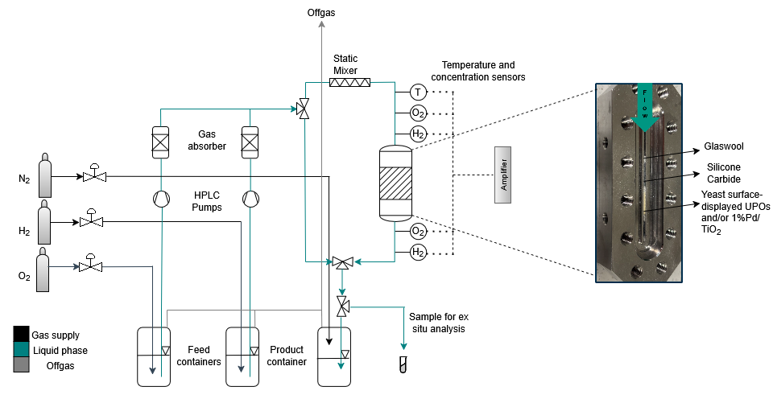
The experimental setup and packed fixed-bed reactor are shown schematically in Figure 1. Hydrogen, oxygen, and nitrogen were supplied from gas cylinders and dissolved separately in the liquid feed at ambient pressure to avoid formation of explosive gas mixtures. The combined flow contained less than equilibrium concentration to prevent bubble formation. Nitrogen was used for inertization during product collection. Gas saturation concentrations were estimated using Henry’s law, and flow rates were adjusted to obtain an equimolar H₂/O₂ ratio at the reactor inlet ( e.g., ~500 µM in water and ~620 µM in 5 % acetonitrile). The two gas-saturated liquid feeds were delivered independently to the reactor using HPLC pumps at a total flow rate of 5 mL min⁻¹. Prior to reaction, the catalyst bed was reduced for 30 min by pumping hydrogen-saturated liquid through the reactor. Upstream of the reactor, gas absorbers were installed to remove residual gas bubbles, followed by mixing in a static mixer before entering the fixed-bed reactor. Clarke-type microsensors for H₂, O₂, and temperature (Unisense, Aarhus, Denmark) were integrated into T-pieces (Swagelok Company, Solon, OH, USA) upstream and downstream of the reactor, enabling determination of gas conversion and selectivity during H₂O₂ synthesis. The reactor consisted of a stainless-steel microreactor containing a single channel (0.1 m × 0.058 m × 0.001 m) and was based on a design originally developed for operando X-ray absorption spectroscopy (Deschner et al., 2021). The channel was packed against the flow direction with glass wool and silicon carbide as inert retaining materials, followed by the catalytic bed. Catalyst and cell material were retained using stainless-steel frit screws equipped with sintered metal filters.

Figure 1: PFD of the continuous fixed-bed reactor system and a picture of the fixed-bed reactor with YSD-UPO (detailed description in the main text).
For direct H₂O₂ synthesis, 16 mg of Pd/TiO₂ catalyst were used. Due to low peroxide yields under enzyme-compatible conditions, the catalyst loading was increased for tandem catalysis experiments. In the tandem configuration, the reactor was packed with an upstream Pd/TiO₂ section for H₂O₂ generation, followed by a mixed bed containing 20 mg Pd/TiO₂ catalyst and 40 mg freeze-dried YSD-UPO material. Liquid samples were withdrawn downstream of the reactor for ex situ analysis or collected in a nitrogen-inertized product vessel. For tandem experiments, samples were centrifuged at maximum speed prior to analysis to remove washed-out cells or catalyst particles. H₂O₂ concentrations were quantified using a potassium iodide assay based on triiodide formation at 350 nm (Xiao et al., 2019). ABTS oxidation was monitored at 418 nm, and formation of 4-nitrocatechol was quantified at 425 nm. Concentrations were calculated using the Lambert–Beer law.
  - Results and Discussion
3.1 Preparation and characterization of YSD-UPOs
At the end of fermentation, a biomass concentration of 51 g L⁻¹ was obtained, corresponding to a volumetric ABTS activity of 31.1 U mL⁻¹ and a total activity of approximately 1.0 × 10⁵ U distributed in approximately 3.3 L of fermentation broth. Among the tested solvents for cell inactivation, alcohols provided the best compromise between effective inactivation and enzyme activity retention or even enhancement. No colony formation was observed after treatment with isopropanol or ethanol (data not shown), while enzymatic activity was preserved or increased (Figure 2 (a)). Complete inactivation was achieved using isopropanol after 4 h at a solvent-to-suspension ratio of ≥1:1, and these conditions were selected for subsequent experiments as treatment led to enhanced activity compared to the control.
The freeze-dried YSD-UPOs exhibited high storage stability over 160 d at 4 °C, −30 °C, and −80 °C, whereas storage at room temperature led to pronounced activity loss (Figure 2 (b)). The resulting material showed a mass-specific activity of 0.36 U mg⁻¹ dry biomass, corresponding to an enzyme loading of 1.05 × 10⁻³ mg UPO per mg dry cell mass. The influence of pH and acetonitrile content on the NBD conversion rate is shown in Figure 2 (c). For all tested acetonitrile concentrations (5–15 vol %), increasing reaction rates were observed with increasing pH, with maximum activity at pH 7. In contrast, variations in acetonitrile content within the investigated range had only a minor effect on enzymatic activity, indicating that substrate solubilization can be achieved without strongly compromising peroxygenase performance.
SEM images of freeze-dried, solvent-inactivated K. phaffii (Figure 2 (d)) show agglomerated cells with visible outlines, collapsed morphology due to dehydration, and a cell size of ~1 µm.
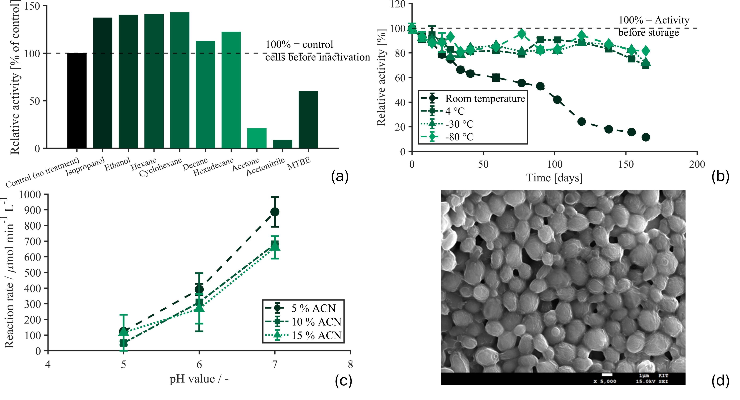Figure 2: Characterization of yeast surface-displayed UPOs. (a): ABTS activity of resuspended YSD-UPO cells after solvent treatment; (b): Long-term ABTS activity of freeze-dried, solvent-inactivated YSD-UPOs under different storage conditions; (c): NBD activity under varying pH and acetonitrile conditions; (d): SEM image of freeze-dried, solvent-inactivated YSD-UPOs (5,000×).
3.2 H₂O₂ direct synthesis under enzymatic flow conditions
Several Pd/TiO₂ catalysts were evaluated for H₂O₂ direct synthesis. Based on reproducible performance and well-defined physicochemical properties, a 1 wt % Pd/TiO₂ catalyst was selected for detailed investigation and subsequent tandem catalysis experiments. The catalyst showed a BET surface area of 55 m² g⁻¹, a Pd dispersion of 41.8 %, and a Pd loading of 0.99 wt % (ICP–OES). Stable micromolar H₂O₂ formation with reaction rates around 10⁻⁴ mol kg⁻¹ s⁻¹ was achieved. As shown in Figure 3, H₂O₂ direct synthesis under enzymatically compatible conditions resulted in markedly lower yields and selectivities compared to chemically optimized reference conditions using NaBr and H₂SO₄. In citrate–phosphate buffer, which reflects the requirements for UPO catalysis, peroxide formation remained limited. Within the investigated pH values, no pronounced effect on H₂O₂-yield was observed. In contrast, increasing acetonitrile content led to a strong decrease in peroxide yield, with the highest value (12.9 %, 63.7 µM) obtained in pure aqueous buffer at pH 6. Interestingly, the addition of acetonitrile enhances the catalyst's selectivity. This suggests that acetonitrile blocks active centers for both H₂O₂ synthesis and water formation and hydrogenation. The results confirm that direct synthesis in the tandem system is operated under non-ideal chemical but enzyme-compatible conditions. Therefore, a compromise was identified that met both requirements, with a particular focus on the enzyme prerequisites.
Due to the overall low peroxide yields under these conditions, the palladium catalyst loading was increased from 16 mg to 30 mg for subsequent tandem catalysis experiments to ensure sufficient H₂O₂ availability.
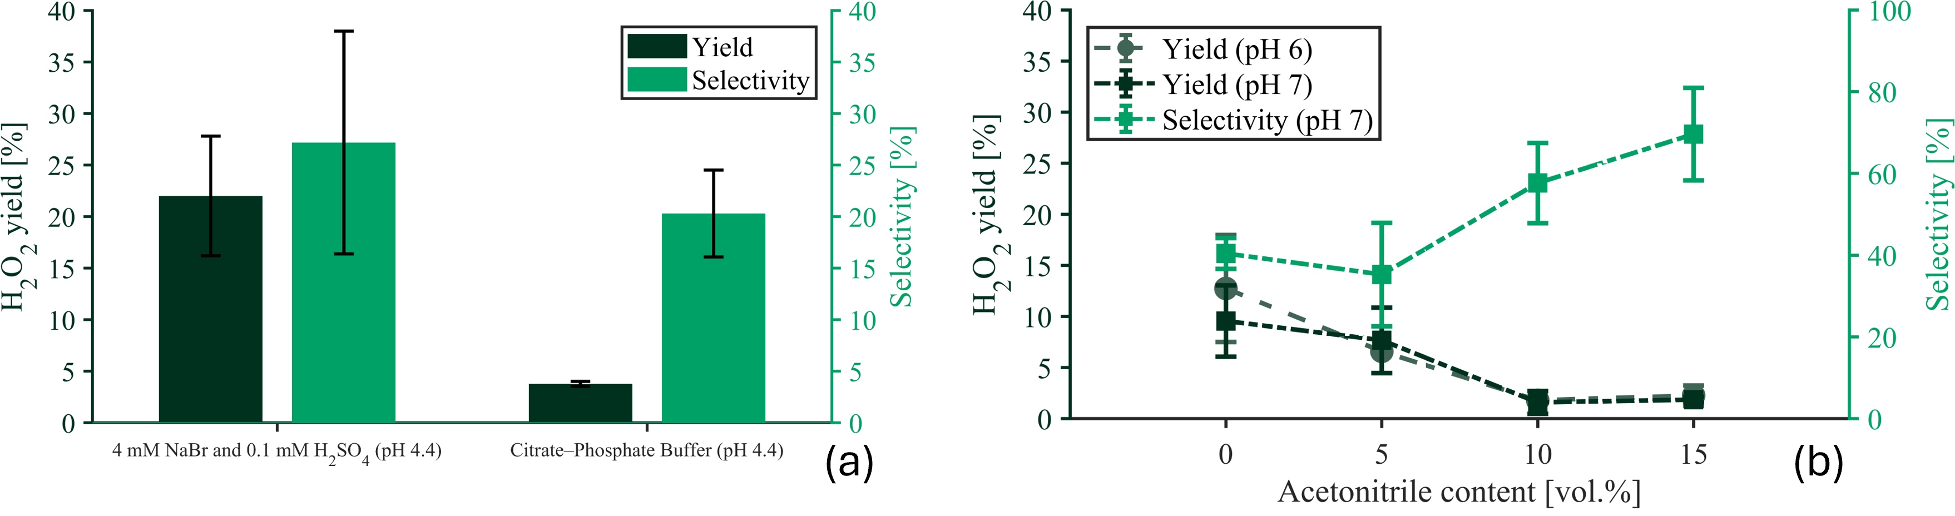Figure 3: Yield and selectivity obtained in: (a) Acidic reference electrolyte and citrate–phosphate buffer corresponding to ABTS assay conditions (pH 4.4). (b) Potassium phosphate buffer with varying acetonitrile content and pH corresponding to NBD assay conditions.
3.3 Tandem catalysis under flow conditions
Preliminary experiments identified a total liquid flow rate of 5 mL min⁻¹ as suitable. In addition, mixing of Pd/TiO₂ catalyst and freeze-dried YSD-UPO material within the reaction channel resulted in higher yield compared to configurations using spatially separated catalyst and enzyme beds (data not shown). The freeze-dried cells used in the tandem experiments exhibited specific activities of 0.18 µmol min⁻¹ mg⁻¹ (ABTS) and 0.03 µmol min⁻¹ mg⁻¹ (NBD), as determined in cuvette-based activity assays. The resulting product concentrations obtained for ABTS oxidation and NBD conversion are shown in Figure 4 (a) and (b), respectively.
For ABTS oxidation (Figure 4 (a)), product concentrations of up to 25 µM were initially achieved. However, a pronounced decrease in product concentration was observed over time for both direct H₂O₂ dosing and in situ H₂O₂ generation. The tandem system exhibited a slower rate of activity decrease than direct peroxide addition. This demonstrates the attenuating impact of an in situ H₂O₂ supply on enzyme deactivation. Furthermore, the activity loss is partly attributed to biocatalyst washout, as enzymatic activity was detected in the liquid samples. Bradford assay performed after centrifugation revealed only minor protein concentration in the first sample after 15 min. After that, no significant protein concentration was measured, indicating low enzyme detachment. NBD conversion (Figure 4 (b)) resulted in substantially lower product concentrations that remained nearly constant over the investigated time span. In this case, tandem catalysis did not outperform direct H₂O₂ dosing, suggesting that in situ H₂O₂ formation was less effective for sustaining NBD hydroxylation under the applied conditions.
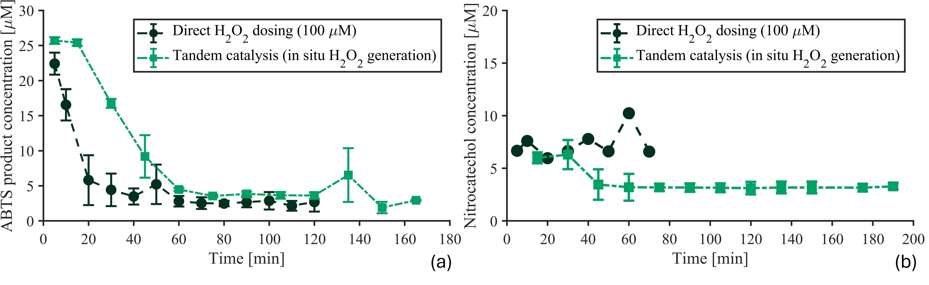Figure 4: Product formation during continuous tandem catalysis comparing direct H₂O₂ dosing and in situ H₂O₂ generation for (a) ABTS oxidation and (b) NBD hydroxylation.

During ABTS tandem experiments, an average hydrogen consumption of approximately 200 µM was observed, corresponding to a conversion of 40.8 % relative to the dissolved inlet concentration (~490 µM). Although only micromolar H₂O₂ concentrations were formed due to the limited selectivity of the Pd catalyst, the enzymatic reaction does not appear to be primarily limited by H₂O₂ availability. Instead, the declining product concentrations observed over time indicate progressive enzyme deactivation. NBD tandem experiments conducted in the presence of acetonitrile showed a markedly lower hydrogen consumption of approximately 50 µM, corresponding to a conversion of 8.1 % relative to the dissolved inlet concentration (~619 µM). The reduced hydrogen conversion suggests impaired H₂O₂ formation. Catalytic performance parameters are summarized in Table 1. ABTS oxidation showed higher turnover numbers (TON), turnover frequencies (TOF), and space–time yields (STY) than NBD conversion, reflecting the reduced efficiency of H₂O₂ synthesis in the presence of acetonitrile. In addition to solvent effects, the lower NBD performance is attributed to mechanistic differences, as ABTS oxidation proceeds via rapid one-electron transfer, whereas NBD conversion requires a kinetically more demanding oxygen-transfer reaction.
Substrate | ABTS | NBD
TON | 6350 | 3596
TOF | 0.64 | 0.36
STY | 461 | 242
Table 1: Performance metrics of tandem catalysis: TON [-]; TOF [s⁻¹] and STY [µmol L⁻¹ h⁻¹]

  - Conclusion and Outlook
A continuous fixed-bed tandem system combining palladium-catalyzed H₂O₂ direct synthesis with YSD-UPOs was demonstrated. Stable enzyme immobilization enabled packed-bed operation after solvent inactivation and freeze-drying. Micromolar H₂O₂ concentrations were generated in situ under enzyme-compatible conditions without external oxidant addition, demonstrating for the first time the technical feasibility of continuous chemo-enzymatic tandem catalysis. The developed continuous fixed-bed tandem system can be used with a wide range of H₂O₂ dependent enzymes. Deactivation and cell loss from the system will be addressed in further experiments. Future work should address kinetic analysis of both catalytic steps and evaluation of synthetically relevant substrates to assess the scalability and process potential of the tandem concept.
References
Brehm J., Lewis R.J., Richards T., Qin T., Morgan D.J., Davies T.E., Chen L., Liu X., Hutchings G.J., 2022, Enhancing the chemo-enzymatic one-pot oxidation of cyclohexane via in situ H₂O₂ production over supported Pd-based catalysts, ACS Catalysis, 12, 11776–11789.
Burek B.O., de Boer S.R., Tieves F., Zhang W., van Schie M., Bormann S., Alcalde M., Holtmann D., Hollmann F., Bahnemann D.W., Bloh J.Z., 2019, Photoenzymatic hydroxylation of ethylbenzene catalyzed by unspecific peroxygenase: Origin of enzyme inactivation and the impact of light intensity and temperature, ChemCatChem, 11, 3093–3100.
Deschner B.J., Doronkin D.E., Sheppard T.L., Rabsch G., Grunwaldt J.D., Dittmeyer R., 2021, Continuous-flow reactor setup for operando x-ray absorption spectroscopy of high pressure heterogeneous liquid-solid catalytic processes, Review of Scientific Instruments, 92.
Dittmeyer R., Grunwaldt J.D., Pashkova A., 2015, A review of catalyst performance and novel reaction engineering concepts in direct synthesis of hydrogen peroxide, Catalysis Today, 248, 149–159.
Freakley S.J., Kochius S., van Marwijk J., Fenner C., Lewis R.J., Baldenius K., Marais S.S., Opperman D.J., Harrison S.T.L., Alcalde M., Smit M.S., Hutchings G.J., 2019, A chemo-enzymatic oxidation cascade to activate C–H bonds with in situ generated H₂O₂, Nature Communications, 10.
Hobisch M., Holtmann D., Gomez De Santos P., Alcalde M., Hollmann F., Kara S., 2021, Recent developments in the use of peroxygenases – exploring their high potential in selective oxyfunctionalisations, Biotechnology Advances, 51, 107615.
Karich A., Scheibner K., Ullrich R., Hofrichter M., 2016, Exploring the catalase activity of unspecific peroxygenases and the mechanism of peroxide-dependent heme destruction, Journal of Molecular Catalysis B: Enzymatic, 134, 238–246.
Samanta C., 2008, Direct synthesis of hydrogen peroxide from hydrogen and oxygen: An overview of recent developments in the process, Applied Catalysis A: General, 350, 133–149.
Teetz N., Lang S., Liese A., Holtmann D., 2024, Yeast surface display enables one-step production and immobilization of unspecific peroxygenases, ChemCatChem, 16, e202400908.
Teetz N., Zuhse L., Holtmann D., 2025, Optimizing yeast surface-displayed unspecific peroxygenase production for sustainable biocatalysis, Bioengineering, 12, 822.
Xiao J., Wang M., Pang Z., Dai L., Lu J., Zou J., 2019, Simultaneous spectrophotometric determination of peracetic acid and the coexistent hydrogen peroxide using potassium iodide as the indicator, Analytical Methods, 11, 1930–1938.

