 CHEMICAL ENGINEERING TRANSACTIONS  VOL. xxx, 2026 | A publication of  
The Italian Association
of Chemical Engineering
Online at www.cetjournal.it

Guest Editors: Marco Bravi, Antonio Marzocchella, Giuseppe Caputo
Copyright © 2026, AIDIC Servizi S.r.l.
ISBN 979-12-81206-xx-x; ISSN 2283-9216

Experimental Determination and Modelling of Cyrene Vapor Pressure
Omnia W. F. M. Farag^{a,}*, Valentina Schiattarellaª, Giorgia De Guidoª, Stefania Moioliª
ªGASP - Group on Advanced Separation Processes & GAS Processing, Dipartimento di Chimica, Materiali e Ingegneria Chimica “Giulio Natta”, Politecnico di Milano, Piazza Leonardo da Vinci 32, 20133 Milano, Italy
omniawalid.farag@polimi.it
Cyrene (dihydrolevoglucosenone) is a bio-based, dipolar aprotic solvent derived from cellulose and is considered as a sustainable alternative to conventional petrochemical solvents such as N-methyl-2-pyrrolidone (NMP) and N,N-dimethylformamide (DMF), due to their toxicity and environmental hazards. Because of the low vapor pressure and wide liquid stability range, Cyrene is considered an attractive green solvent. However, thermodynamic and phase equilibrium data are still limited and needed for simulating processes with this component. This study focuses on the thermodynamic behaviour of pure Cyrene, intending to determine its boiling temperature at different pressures through vapor pressure measurements. The experiments were performed using the Fischer® Labodest® VLLE 602 unit located at the Process Thermodynamics laboratory (PT lab) of Politecnico di Milano. Vapor pressure measurements covered a pressure range from 30 to 90 kPa, corresponding to equilibrium temperatures between approximately 450 and 495 K, using Cyrene with a purity of 99.8 wt.%. The experimentally obtained vapor pressure vs. temperature relationship is compared with the available literature data reported in a few other sources, and shows good agreement, confirming both the reliability of the Fischer® Labodest® VLLE 602 unit and the robustness of the adopted experimental procedure. A vapor pressure correlation is also proposed. The collected experimental data and the proposed correlation will be employed in future works for the modeling and simulation of separation processes involving Cyrene.
  - Introduction
The shift toward more sustainable chemical processes has intensified research into bio-based solvents as alternatives to conventional petrochemical compounds. Notably, widely used dipolar aprotic solvents such as N-methyl-2-pyrrolidone (NMP) (Schiattarella et al., 2025) and N,N-dimethylformamide (DMF) have faced increasing regulatory restrictions within the European Union. Both are included on the REACH (Registration, Evaluation, Authorization and Restriction of Chemicals) list as substances of very high concern (SVHC) due to their toxicity and adverse environmental impact (Medgyesi and Mika, 2024). These regulatory constraints have accelerated the development and assessment of safer, renewable solvents that can deliver comparable physicochemical performance in industrial applications (De Guido et al., 2026).
Cyrene (dihydrolevoglucosenone) is a promising biomass-derived dipolar aprotic solvent produced by hydrogenation of levoglucosenone, which itself is obtained through pyrolysis of cellulose-based renewable feedstock (Baird et al., 2019). Due to its molecular structure, Cyrene demonstrates high polarity and lacks hydrogen-bond donating functional groups, resulting in solvating properties similar to those of conventional aprotic solvents such as NMP, DMF, and DMSO (Camp et al., 2020; Jeřábek et al., 2023). In addition, Cyrene does not contain nitrogen and sulfur heteroatoms, which are commonly associated with the formation of NO_{x} and SO_{x} emissions during incineration. Consequently, Cyrene exhibits a reduced end-of-life environmental impact compared to many conventional organic solvents (Sherwood et al., 2014).
Medgyesi and Mika (2024) reported that it is readily biodegradable. Additionally, Stini et al. (2022) reported that Cyrene exhibits high miscibility with water, which facilitates the removal of the solvent from reaction mixtures through liquid–liquid extraction and is subsequently recovered by water distillation, enabling its reuse in large-scale industrial processes. Cyrene also shows complete solubility in different organic solvents such as acetone (Duval and Avérous, 2022). Furthermore, Cyrene possesses a high boiling point, low vapor pressure, and exhibits good thermal stability as a liquid over a wide temperature range, making it suitable for high-temperature applications and separation processes (Andreeva et al., 2021).
Despite the growing interest in Cyrene and its proposed use in synthesis, extraction, and solvent-based separations, large-scale manufacture, the comprehensive thermodynamic properties, such as density, vapor pressure, heat capacity, and phase equilibrium data, remain limited. These properties are essential for the modelling, design, and scale-up of separation units. Only a few experimental studies have reported thermochemical properties and vapor pressure data (Table 1) for Cyrene using different experimental techniques, including static and transpiration methods. Baird et al. (2019) determined vapor pressure data at relatively low temperatures using the gas saturation method. Andreeva et al. (2021) employed a transpiration method, while Jeřábek et al. (2023) utilized two static apparatuses referred to as STAT6 and STAT8, respectively. Moreover, independent experimental validation using alternative equilibrium apparatuses is important to assess data consistency and experimental reliability.
Table 1: Literature sources of experimental vapor pressure data for Cyrene
Source | Purity [wt.%] | Temperature range [K] | Number of points
Baird et al. (2019) | 99.8% | 298.26 – 403.16 | 15
Andreeva et al. (2021) | 99.31% | 279 – 335 | 10
Jeřábek et al. (2023)  (STAT6) | 99.6% | 253.26 – 308.12 | 36
Jeřábek et al. (2023)  (STAT8) | 99.6% | 284.72 – 363.19 | 51
Medgyesi and Mika (2024) | 99.9% | 373.05 – 494.7 | 16

In this context, the present work aims to experimentally investigate the thermodynamic behavior of pure Cyrene by determining its boiling temperature at different pressures using the Fischer® Labodest® VLLE 602 apparatus located at the Process Thermodynamics laboratory (PT lab) of Politecnico di Milano, that was previously employed for collecting experimental data of non-ideal systems with azeotropes (Barbieri et al., 2024a; Moioli et al., 2021) and for studying a new solvent for CO₂ removal (Barbieri et al., 2024b; Schiattarella et al., 2024). The related uncertainties have been also calculated and are reported in the following. The experimental vapor pressure–temperature data are compared with the available literature sources (Andreeva et al., 2021; Baird et al., 2019; Jeřábek et al., 2023; Medgyesi and Mika, 2024) to evaluate consistency and validate the adopted experimental methodology, with the aim of providing a reliable basis for future thermodynamic modelling and process simulation, supporting the implementation of Cyrene in sustainable solvent-based technologies.
  - Materials and Experimental Setup
    - Materials
Cyrene with a stated purity of 99.8 wt.% was used in all the experiments. The solvent was supplied by Sigma Aldrich (Darmstadt, Germany) and used as received without further purification. Before each experimental run, Cyrene was stored and prepared under a nitrogen atmosphere at the PT lab of Politecnico di Milano to prevent possible degradation. The solvent was subsequently stored in airtight containers until use. Table 2 illustrates the properties of the chemicals used in this work, taken from the supplier’s Safety Data Sheet, including the molecular weight (MW), and the normal boiling point (T_{NBP}).
Table 2: Properties of the chemicals used in this study
Name | CAS number | Supplier | Purity [wt.%] | MW [g/mol] | T_{NBP} [K]
Dihydrolevoglucosenone | 53716-82-8 | Sigma Aldrich | 99.8% | 128.128 | 500.15
Nitrogen | 7727-37-9 | Sapio | 100% | 28.014 | 77.15

    - Experimental Apparatus
Vapor pressure measurements were carried out using the Fischer® Labodest® VLLE 602 unit, shown in Figure 1, located at the PT lab. This apparatus is an equilibrium system designed for the determination of vapor–liquid–liquid equilibrium (VLLE) and vapor–liquid equilibrium (VLE) data over a wide range of temperatures, from ambient temperature to 523 K and pressures from vacuum to 400 kPa.
The apparatus is composed of a 250 mL graduated feed vessel for loading the liquid Cyrene, a heater, a condenser, a flash chamber where the real equilibrium between vapor and liquid is established, two receivers for the collection of separated condensed vapor and liquid phases, and a discharge valve. This unit is connected to a vacuum pump, allowing the operating pressure required for the experiments to be maintained.
    - Experimental Procedure
In each experimental run, 110 mL of pure Cyrene was introduced into the feed vessel of the Fischer® Labodest® VLLE 602 unit. The system pressure was adjusted to the target value, ranging from 30 to 90 kPa, using the vacuum line connected to the apparatus. Following pressure adjustment, the heating of the solvent commenced.
The heating rate was regulated by incrementally adjusting the heater power, resulting in a gradual increase in temperature. Heater power was increased by 1% at fixed 30-minute intervals to ensure a controlled and quasi-equilibrium approach to boiling. As boiling onset neared and the first vapor bubbles appeared in the liquid phase, the interval between power adjustments was progressively shortened to maintain stable operating conditions.
Once vapor bubble formation became frequent and stable, the high-temperature heating system surrounding the equilibrium section was activated to reduce heat losses and promote vapor generation. Stable vapor–liquid equilibrium conditions were assumed when a condensation rate of approximately 60 droplets per minute was maintained, and the temperature was stable for a minimum duration of 10 minutes.
Under these steady-state conditions, the average vapor temperature recorded during this period was taken as the equilibrium temperature (TVLE) corresponding to the imposed system pressure. For each pressure level, measurements were repeated at least three times to verify reproducibility. The resulting dataset represents the vapor pressure of pure Cyrene as a function of temperature.

Figure 1: The Fischer® Labodest® VLLE 602 unit operating at the PT lab of Politecnico di Milano
  - Vapor Pressure Correlation Methodology
The availability of reliable vapor pressure data over an extended temperature range is essential for some thermodynamic models and, therefore, for the design and optimization of separation processes.
A correlation was established using vapor pressure measurements of pure Cyrene collected over the investigated temperature range at the PT lab and the ones from the literature (Medgyesi and Mika, 2024). This combined dataset was considered due to the excellent agreement observed between the present measurements and the literature values reported in that study, as detailed in Section 4.1. This correlation was developed based on the Clausius–Clapeyron equation (Prausnitz et al., 1998; Reid et al., 1987).
For regression analysis, the experimental logarithmic vapor pressure data were correlated as a function of 1/T using both a linear model (c = 0) and a second-order polynomial model, as shown in Eq (1).

$$lnP_{ev}=a+ \frac{b}{T}+\frac{c}{T^{2}}$$ | (1)
  - Results and Discussion
    - Experimental Data
Figure 2 presents the vapor pressure of pure Cyrene as a function of temperature, as determined in this study, alongside experimental data reported in the literature (Andreeva et al., 2021; Baird et al., 2019; Jeřábek et al., 2023; Medgyesi and Mika, 2024). Measurements were conducted over a pressure range of 30 to 90 kPa, corresponding to a TVLE between approximately 450 and 495 K. The uncertainties have been determined on the basis of the method by Taylor and Kuyatt (Taylor and Kuyatt, 1994). The estimated temperature uncertainty u(T) for the measurements of the vapor pressure of Cyrene is equal to 0.52 K.
The experimental data collected in this study display a smooth and monotonic increase in vapor pressure with temperature, consistent with the behavior of a pure component. The measured vapor pressure values align closely with the high-temperature trends reported by Medgyesi and Mika (2024), thereby confirming the consistency of the measurements at reduced pressures and elevated temperatures.
At lower temperatures, the literature data reported by the other authors extend the vapor pressure curve toward the low-pressure region, providing a comprehensive description of the vapor-liquid equilibrium behavior of Cyrene over a wide temperature range. The deviations observed between different sources can be attributed to differences in experimental apparatus, measurement methodology, uncertainty associated with temperature and pressure control, and composition of pure Cyrene, that differs for the sources, as illustrated in Table 1.
During the experimental campaign, a visible change in the colour of the liquid Cyrene was observed after experiments conducted at higher pressures and temperatures. Specifically, the Cyrene discharged from tests performed at higher pressure levels, ranging from 60 to 90 kPa, appeared noticeably darker compared to samples collected after lower-pressure experiments, as shown in Figure 3. This colour change cannot be identified without chemical analysis, but it may be associated with the formation of trace degradation products or polymerization phenomena at elevated temperatures. Cyrene is generally described as a clear, colourless to pale yellow viscous liquid under standard conditions, as reported in the literature (Kong and Dolzhenko, 2022; Medgyesi and Mika, 2024). To the authors’ knowledge, this paper is the first one reporting these characteristics of pure Cyrene. No experimental studies reporting colour changes of Cyrene under operating conditions have been identified in the literature, though Hughes et al. (Hughes et al., 2018) mentions potential degradation at temperatures greater than 413.15 K. It is worth noting that the observed colour change did not affect the reproducibility of the vapor pressure measurements or the consistency of the equilibrium data.
Figure 2: Experimental data of the vapor pressure of Cyrene collected at the PT lab of Politecnico di Milano and reported in the literature (literature sources are indicated in the figure caption)
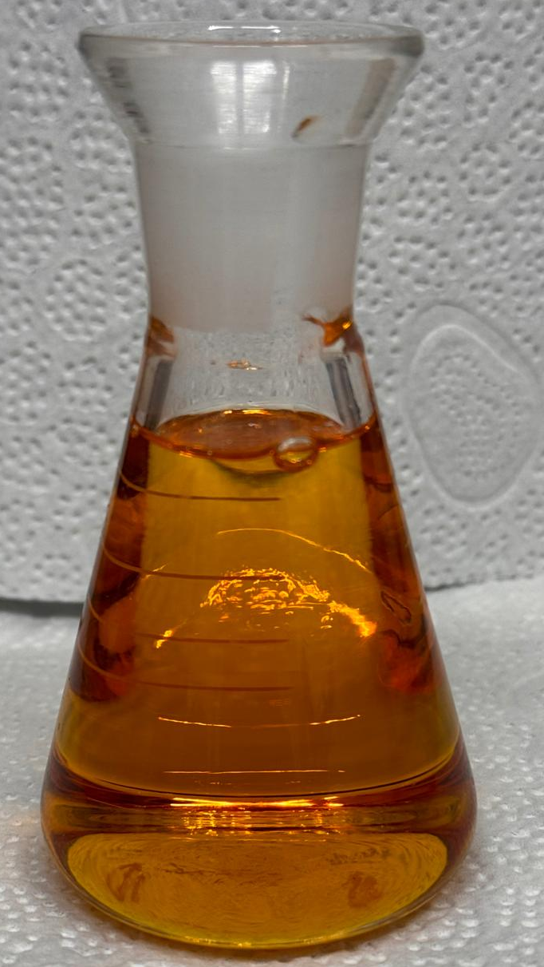  (a) | 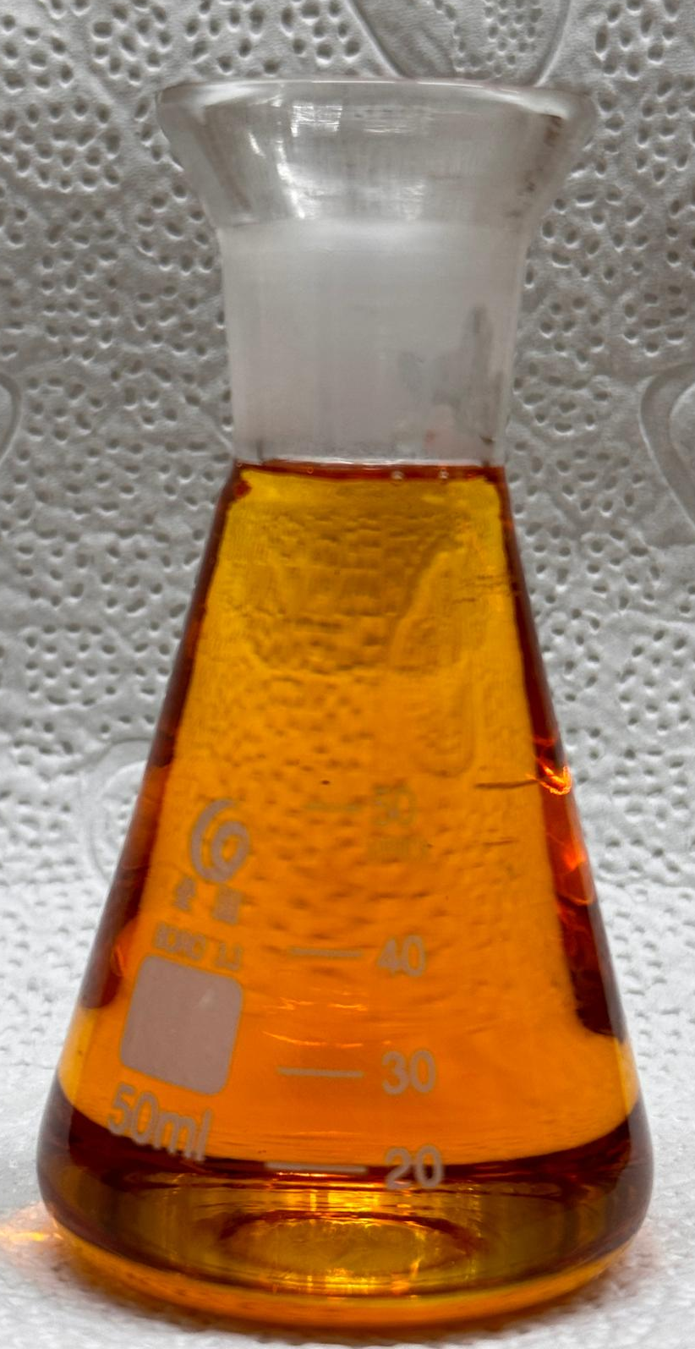  (b) | 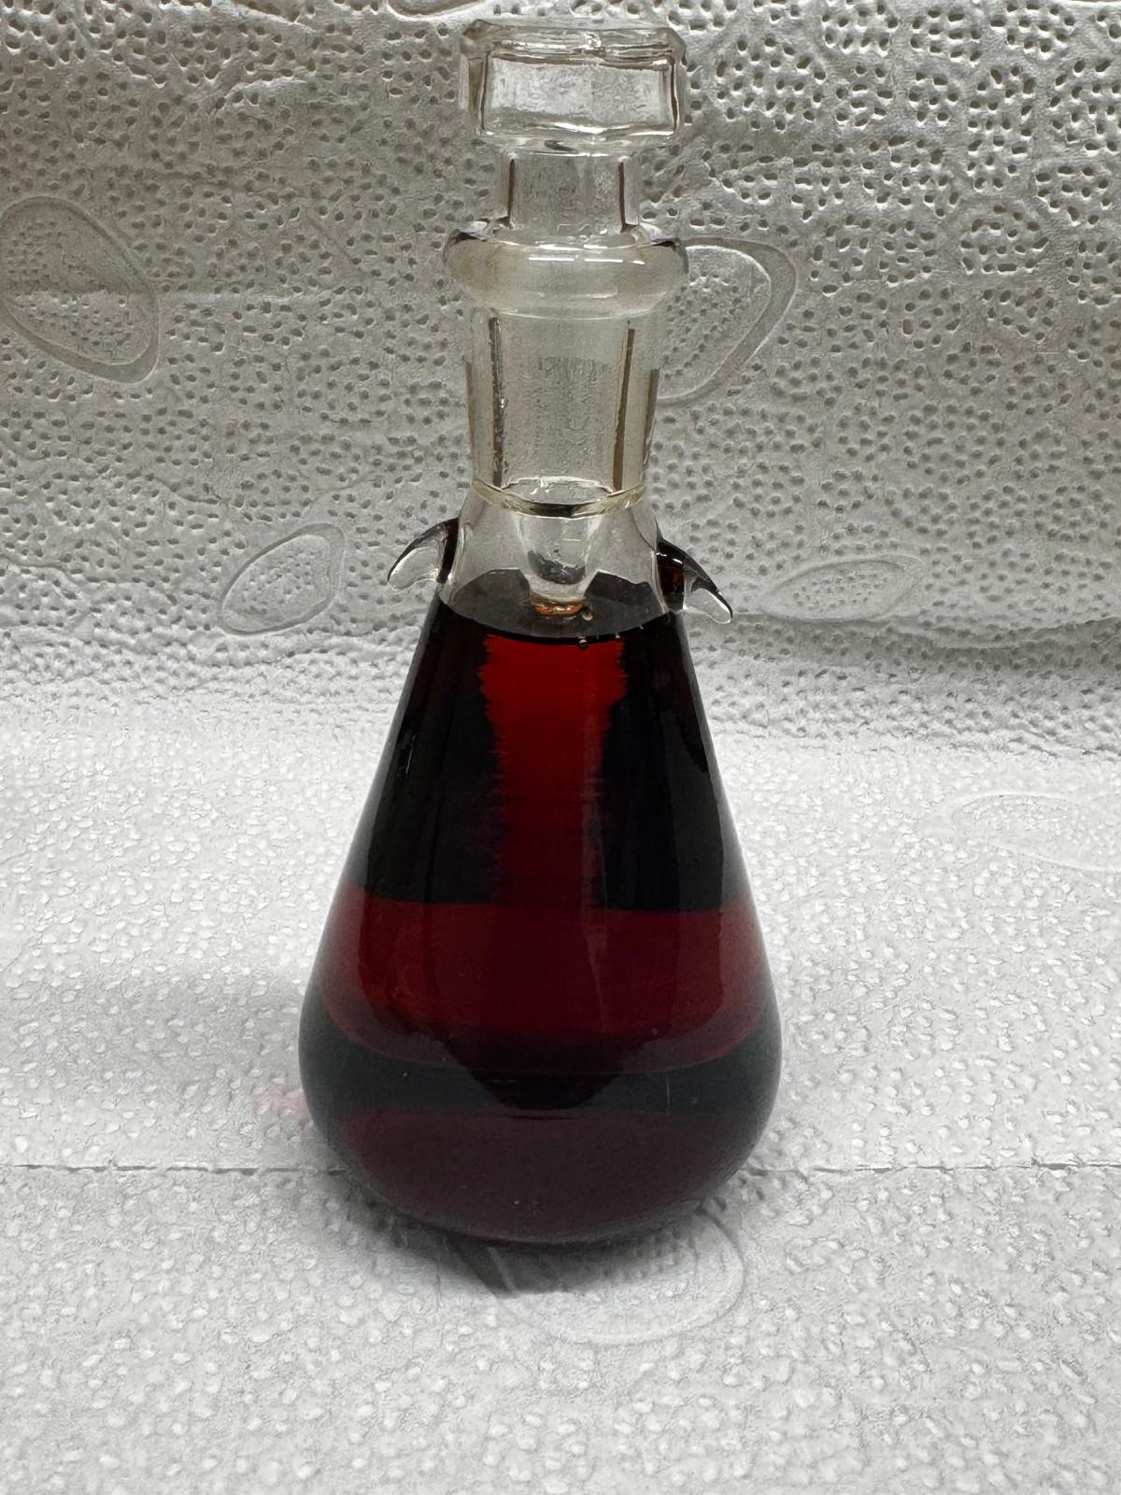  (c) | 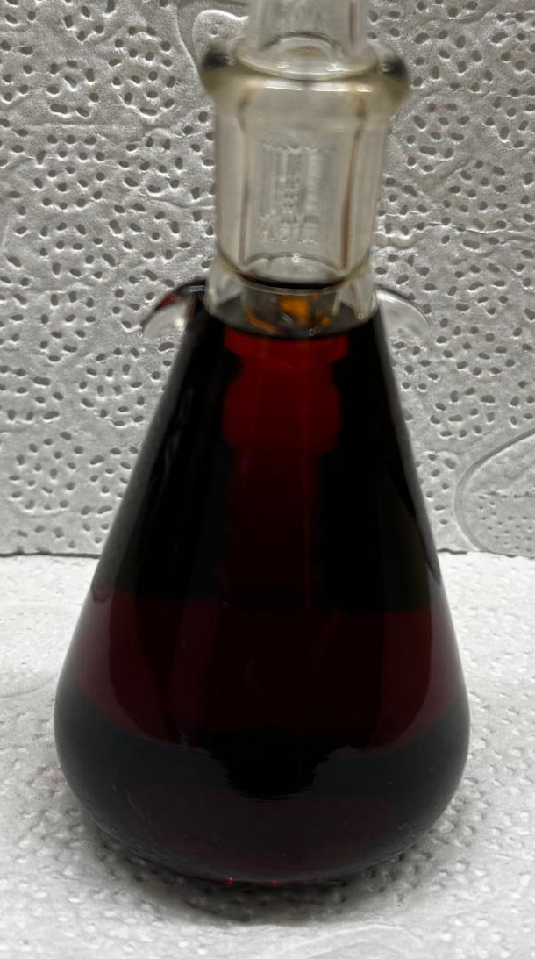  (d)
Figure 3: Discharged Cyrene at: (a) P = 40, (b) P = 50, (c) P = 70, and (d) P = 80 kPa
    - Vapor Pressure Correlation
Figure 4 illustrates the vapor pressure correlations derived from the experimental data, which are reported in the figure caption. Figure 4a demonstrates that both linear (grey dotted line) and second-order (green dotted line) polynomial regressions provide an excellent representation of the data collected at the PT lab within the investigated temperature range, with the polynomial model providing slightly greater accuracy. Figure 4b presents the regression results using a combined dataset comprising PT lab measurements and literature data reported by Medgyesi and Mika (2024).

(a) | (b)
Figure 4: Vapor pressure correlations, considering both linear (grey dotted line) and polynomial (green dotted line) models, based on experimental data (a) collected at PT lab and (b) collected at PT lab and taken from the literature (Medgyesi and Mika (2024))
  - Conclusions
This study provides novel experimental insights into the vapor-liquid equilibrium behaviour of Cyrene, a bio-based, dipolar aprotic solvent with increasing industrial interest, for which only a few data are available in the literature. The agreement between the measurements performed at PT lab of Politecnico di Milano and the previously published data demonstrates the reliability of the experimental methodology based on the Fischer® Labodest® VLLE 602 apparatus for the equilibrium studies and addresses existing data gaps that currently hinder the implementation of Cyrene in process design and simulation.
Qualitative changes in the appearance of the solvent were observed after experiments conducted under more severe operating conditions, although these observations did not affect the quality or reproducibility of the equilibrium data.
The vapor pressure experimental data are correlated to determine its temperature dependence to be employed for simulations. Overall, the findings of this study support the suitability of Cyrene for use in processes as CO₂ removal because of its low vapor pressure and provide an experimental basis for future investigations. Further work will focus on evaluating additional physicochemical properties, such as density and viscosity.
Acknowledgments
This work has been carried out in the context of the PRIN 2022 project “GREEN-based water-lean SOLvent for CO₂ capture” (GREENSOL), funded by the European Union – NextGenerationEU, CUP D53D23003100001 – and we acknowledge financial support under the National Recovery and Resilience Plan (NRRP), Mission 4, Component C2, Call for tender No. 104 published on 2.2.2022 by the Italian Ministry of University and Research (MUR).
References
Andreeva, I.V., Pimerzin, A.A., Turovtsev, V.V., Qian, S., Bara, J.E., Verevkin, S.P., 2021. Commodity Chemicals and Fuels from Biomass: Thermodynamic Properties of Levoglucosan Derivatives. Industrial & Engineering Chemistry Research 60, 17183–17194.
Baird, Z.S., Uusi-Kyyny, P., Pokki, J.-P., Pedegert, E., Alopaeus, V., 2019. Vapor Pressures, Densities, and PC-SAFT Parameters for 11 Bio-compounds. International Journal of Thermophysics 40, 102.
Barbieri, C., De Guido, G., Moioli, S., 2024a. Vapor-liquid equilibrium data for the binary system isopropanol+water at 60 kPa and 80 kPa. The Journal of Chemical Thermodynamics 198, 107342.
Barbieri, C., Schiattarella, V., Moioli, S., Pellegrini, L.A., Filippini, G., De Angelis, A.R., Fiori, G., 2024b. Measurement and Correlation of Vapor–Liquid Equilibrium of Mixtures of 1,2-Propanediol or 1,4-Butanediol + 1,8-Diazabicyclo(5.4.0)undec-7-ene at 30 kPa. Clean Technologies 7, 3.
Camp, J.E., Nyamini, S.B., Scott, F.J., 2020. CyreneTM is a green alternative to DMSO as a solvent for antibacterial drug discovery against ESKAPE pathogens. RSC Medicinal Chemistry 11, 111–117.
De Guido, G., Schiattarella, V., Moliner, C., Moioli, S., 2026. Novel bio-based solvents for CO₂ removal through physical absorption. Renewable and Sustainable Energy Reviews 226, 116285.
Duval, A., Avérous, L., 2022. Dihydrolevoglucosenone (CyreneTM) as a versatile biobased solvent for lignin fractionation, processing, and chemistry. Green Chemistry 24, 338–349.
Hughes, L., McElroy, C.R., Whitwood, A.C., Hunt, A.J., 2018. Development of pharmaceutically relevant bio-based intermediates though aldol condensation and Claisen–Schmidt reactions of dihydrolevoglucosenone (Cyrene®). Green Chemistry 20, 4423–4427.
Jeřábek, V., Štejfa, V., Klajmon, M., Řehák, K., 2023. Thermodynamic Properties and Phase Equilibria of Dihydrolevoglucosenone and Its Mixtures with Hydrocarbons. Journal of Chemical & Engineering Data 68, 3361–3376.
Kong, D., Dolzhenko, A.V., 2022. Cyrene: A bio-based sustainable solvent for organic synthesis. Sustainable Chemistry and Pharmacy 25, 100591.
Medgyesi, Z., Mika, L.T., 2024. Characterization and Application of Cyrene as a Biomass‐Based Solvent for Homogeneous Heck‐Coupling Reaction. ChemPlusChem 89, e202400379.
Moioli, S., De Guido, G., Gilardi, M., Pellegrini, L.A., Bonalumi, D., Lozza, G.G., 2021. Isobaric Vapor–Liquid Equilibrium Data for the Isopropanol–Water System. Journal of Chemical & Engineering Data 66, 4148–4158.
Prausnitz, J.M., Lichtenthaler, R.N., Azevedo, E.G. de, 1998. Molecular Thermodynamics of Fluid-Phase Equilibria, 3rd ed. Pearson Education.
Reid, R.C., Prausnitz, J.M., Poling, B.E., 1987. The Properties of Gases and Liquids, 4th ed., Chemical Engineering Series. McGraw-Hill.
Schiattarella, V., Barbieri, C., Moioli, S., Pellegrini, L.A., Filippini, G., De Angelis, A.R., Fiori, G., 2024. Study of Mixtures of 1,3-Propanediol+DBU and DBU+Sulfolane for a New Sustainable Solvent for CO₂ Removal. Sustainability 16, 11143.
Schiattarella, V., Moioli, S., Moliner, C., De Guido, G., 2025. Comparison Between Cyrene and Nmp as Solvents for CO₂ Removal. Chemical Engineering Transactions 117, 421–426.
Sherwood, J., Constantinou, A., Moity, L., McElroy, C.R., Farmer, T.J., Duncan, T., Raverty, W., Hunt, A.J., Clark, J.H., 2014. Dihydrolevoglucosenone (Cyrene) as a bio-based alternative for dipolar aprotic solvents. Chemical Communications 50, 9650–9652.
Stini, N.A., Gkizis, P.L., Kokotos, C.G., 2022. Cyrene: a bio-based novel and sustainable solvent for organic synthesis. Green Chemistry 24, 6435–6449.
Taylor, B.N., Kuyatt, C.E., 1994. Guidelines for Evaluating and Expressing the Uncertainty of NIST Measurement Results.

