 CHEMICAL ENGINEERING TRANSACTIONS  VOL. , 2025 | A publication of  
The Italian Association
of Chemical Engineering
Online at www.cetjournal.it

Guest Editors:
Copyright © 2025, AIDIC Servizi S.r.l.
ISBN 979-12-81206-XX-X; ISSN 2283-9216

Metal-organic Framework-induced Enhanced Oxygen Reduction Reaction for Industrial Effluent Treatment in Microbial Desalination Cell
Srishti Mishraª, Lakshmi Pathi Thulluru^{b}, Gourav Dhar Bhowmick^{c}, Brajesh K. Dubeyª, Shamik Chowdhury^{b}, Makarand M. Ghangrekar*^{,d}
ªSchool of Water Resources, Indian Institute of Technology Kharagpur, Kharagpur, West Bengal, 721302, India
^{b}School of Environmental Science and Engineering, Indian Institute of Technology Kharagpur, Kharagpur, West Bengal, 721302, India
^{c}Food and Agriculture Engineering Department, Indian Institute of Technology Kharagpur, Kharagpur, West Bengal, 721302, India
^{d}National Institute of Technology, Puducherry, Karaikal, 609609, India
ghangrekar@civil.iitkgp.ac.in
The treatment of high chemical oxygen demand (COD) industrial effluents remains a critical environmental challenge, particularly when coupled with salinity management. In this research, a microbial desalination cell (MDC) is proposed as a sustainable alternative or pre-conditioning treatment to conventional reverse osmosis (RO) for simultaneous organic load reduction and desalination. The MDC system integrates anodic biodegradation of organic matter with a bio-electrochemical desalination mechanism, thereby eliminating the high energy demand associated with RO. A lab-scale five-chambered MDC was implemented for treating effluent (synthetic wastewater) with a COD of 7.98 ± 0.05 g/L and total dissolved solids (TDS) of 24.05 ± 0.11 g/L, and a NaCl solution of salinity 15 g/L. A metal-organic framework (MOF) based catalyst (ZIF8 – ZIF67) was synthesised and coated over the cathode to enhance the charge transfer mechanism and consequently the ORR of the MDC. The electrochemical properties of the catalyst were recorded through electrochemical characterisation, topography, and elemental composition through scanning electron microscopy (SEM) and energy dispersive X-ray (EDX) analysis, and the material’s crystal structure through X-ray diffraction (XRD) analysis. The applied cathode catalyst resulted in 78.8 ± 2.5 % of COD removal, 81.8 ± 3.2 % of TDS removal, and 86.4 ± 1.7 % of desalination efficiency. Simultaneously, the maximum operating voltage recorded was 303 ± 8.9 mV across a 100 Ω external resistor of the MDC. The maximum power density and coulombic efficiency noted during the investigation were 608.3 mW/m² and 11.29 %, respectively. This method showed a promising way to achieve energy-efficient, carbon-neutral, and cost-effective wastewater treatment.
  - Introduction
Industrial effluents containing high chemical oxygen demand (COD) with elevated salinity, mainly from textile dyeing, tannery, and food-processing industries, pose a great challenge within environmental engineering due to the limitations of conventional treatment technologies. The conventional physical and chemical methods, like the activated sludge process, advanced oxidation method, and reverse osmosis (RO), require high energy inputs, higher operational costs compared to bioelectrochemical and anaerobic treatment systems, and also require complex tertiary treatment for satisfactory removal of organics and salt. Conventional activated sludge processes are energy-intensive because of continuous aeration, accounting for approximately 50–70% of the total energy consumption of wastewater treatment plants (Rosso et al., 2008). Further, advanced oxidation processes and RO demand high electrical energy, chemical inputs, and complex post-treatment steps, resulting in elevated operational costs (Oturan and Aaron, 2014). Additionally, the issue of membrane fouling limits the economic viability of RO as a stand-alone solution for high-strength industrial effluents (Al-Mamun et al., 2018). These challenges have driven research towards integrated and energy-efficient alternative technologies for simultaneous organic matter degradation, desalination, and energy recovery.
Microbial desalination cells (MDCs), a type of bioelectrochemical system (BES), represent a promising approach that integrates wastewater treatment and saltwater desalination in a single process configuration through its self-power generation capability. In MDCs, exo-electrogenic microbes oxidise the organic matter in the anodic chamber, generating electrons that travel through an external circuit to the cathode, creating a potential difference, which drives cation and anion migration through ion-exchange membranes, resulting in desalination (Imoro, Mensah and Buamah, 2021). The potential generated across the circuit due to electron flow exempts the energy requirement typically associated with external power input in conventional desalination methods. Hence, MDC provides a sustainable substitute to treat high-strength COD wastewater, while concurrently reducing salinity and harvesting electrical energy (Chen et al., 2012). A significant investigation demonstrated the implementation of MDC for substantial COD and TDS reduction in the effluents of textile and tannery, highlighting the trifecta capability of the technology for real-world wastewater matrices (Sikder et al., 2024). Additionally, comparative experimentation has illustrated the role of cathode type and operational strategies on COD removal pattern, output power generation, and salinity removal in the scenarios of saline wastewater treatment (Jia et al., 2025). Thus, such findings demonstrate the critical influence of electron transfer pathways and electrochemical interfaces in the performance of MDC.
Despite the great potential, a persistent bottleneck in MDC functioning and performance is the sluggish oxygen reduction reaction (ORR) at the cathode. The ORR is a multi-electron process that involves the reduction of dissolved oxygen to water (ideally via a four-electron pathway). However, on bare carbon or unmodified electrodes, the ORR is characterised by high overpotentials and lower catalytic activity. This slower reaction at the cathode not only limits the overall power output but also declines the voltage generation responsible for driving ion migration (Juma Al Balushi et al., 2022). Initially, precious metal catalysts, such as platinum, were implemented to enhance the ORR due to their high catalytic activity. However, the high cost associated, susceptibility to toxic nature, and lower long-term stability presented them as impractical for large-scale applications in wastewater treatment. Thus, promoting extensive research on non-precious metal catalysts, carbon-based, and nanostructured composites, focusing on the durability and scalability of the material and MDC for extensive applications (Tylus et al., 2014).
One of the promising categories of ORR catalysts is metal-organic framework (MOF) and its derivatives. The MOFs are crystalline porous materials composed of metal ions coordinated with organic linkers. They are a highly versatile class of functional materials due to their exceptional porosity, tuneable composition, and customizable active sites, making them attractive electrocatalyst materials. Moreover, they can be engineered to maximize the exposure of active sites, electron transport, and mass transfer (Lu et al., 2020). Further, MOF can serve as precursors for MOF-derived catalysts, where controlling the thermal and chemical treatment can yield heteroatom-doped porous carbon and metal-nitrogen-carbon (M-N-C) active sites, which can promote improved ORR surpassing the conventional catalysts for MDC applications (Dhanabalan et al., 2023).
Recent studies have reported significant advances in MOF and MOF-derived catalysts for ORR in bioelectrochemical systems. A Cu-MOF@Fe-MOF composite has demonstrated enhanced ORR capability with improved stability and increased power density by 2.74 times than that of Fe-MOF-MFC from 84.1 mW/m² to 231.2 mW/m² when integrated into a microbial system. The synergistic architecture increased the accessible active sites and facilitated efficient electron transfer, outperforming single-component MOF catalysts (Lan et al., 2025). Additionally, MOF templates such as ZIF-67 have been carbonized to produce nitrogen-doped carbon catalysts with high ORR activity, offering performance that can rival commercial Pt/C catalysts in some metrics (Al Murisi et al., 2023). The integration of MOF-derived ORR catalysts into MDC cathodes accelerates oxygen reduction kinetics, enhancing the charge transfer process, thereby improving the electrical performance, ion migration, and contaminant removal efficiencies in the MDC (Dhanabalan et al., 2023).
Given these insights, the present study investigates the synthesis and application of a ZIF–8–ZIF–67 MOF-based cathode catalyst in a lab-scale five-chambered MDC for treating high-COD, high-salinity industrial effluent. By systematically characterizing the physicochemical properties of the catalyst and evaluating its impact on key MDC’s performance metrics, including COD removal, TDS reduction, desalination efficiency, voltage generation, power density, and coulombic efficiency, this work aims to demonstrate the feasibility of MOF-induced ORR enhancement in the performance of MDC. This also proposes the application of MDC as a sustainable pre-conditioning unit to energy-intensive desalination technologies, such as RO, for lowering the external energy requirement in the treatment system, as represented in Fig. 1.

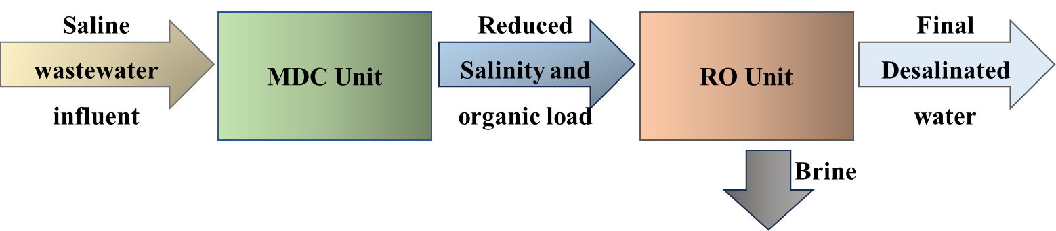
Figure 1: Microbial desalination as a pre-treatment unit to reverse osmosis for industrial wastewater treatment
  - Materials and Methods
The MOF catalyst was synthesised and coated on the cathode of a lab-scale five-chambered MDC of 400 mL total volume. The setup was operated at a fed batch mode with a feed cycle time of 72 h after an acclimatization period of 15-20 days, and achieving a stable operating voltage.
    - Catalyst preparation and reactor setup
The synthesis of ZIF-8 comprised 6.6 g of 2-methylimidazole (Hmim) and 3.0 g of zinc nitrate hexahydrate. Both precursors were mixed separately in 25 mL of methanol each and mixed for 10 min. This was followed by mixing the two solutions and stirring them for 4 h (Tezerjani et al, 2021). On the other hand, ZIF-67 was synthesised using 11.0 g of Hmim and 0.9 g of cobalt nitrate hexahydrate. A similar process was followed, where Hmim and cobalt nitrate were dissolved in 40 mL and 6 mL of methanol, respectively, for 10 min. Further, both were mixed and stirred for 4 h at 700 rpm (Gupta & Murthy, 2022) followed by mixing the white ZIF-8 solution with the violet ZIF-67 solution, which was then stirred for an additional 3 h. The precipitate was washed three times with methanol and then centrifuged. The precipitated pellet was dried overnight at 120 °C and ground into a fine powder using a mortar and pestle. The catalyst was then coated using the drop-cast method onto a 4 cm × 4 cm graphite felt cathode, using polydimethylsiloxane as a binder. The MDC reactor was constructed from acrylic sheets and comprised a 150 mL cathodic chamber, a 150 mL anodic chamber, a 50 mL desalination chamber, and two 25 mL chambers. These additional chambers were separated by anion and cation exchange membranes (Ralex (AEM and CEM)), arranged alternately between the anodic and cathodic chambers.
    - Anolyte and catholyte
The anaerobic sludge was collected from the secondary treatment unit of a sewage treatment plant with a capacity of 1350 m³/day located at IIT Kharagpur and was used as inoculum. It was treated using heat shock at 90 °C for 30 min for suppressing the methanogens and promoting the exoelectrogens, and was supplied as 10 % volume of the anodic chamber (Raychaudhuri and Behera, 2020). Synthetic feed of COD around 8000 mg/L (mimicking wastewater typical of food processing and fermentation-based industries) was prepared in the lab with a sucrose base and used as anolyte (Ghangrekar and Shinde, 2007). Tap water was supplied in the cathodic chamber, and aeration was provided using the SOBO air pump, India. This was done to ensure the availability of dissolved oxygen at the cathode through diffusion for the reduction reaction. A 15 g/L salt concentration (NaCl) was prepared with deionized water and used as an initial input into the desalination chamber. The MDC was kept for the acclimatization period of 3-4 weeks, and feed was changed periodically at an interval of every 72 h (Tran et al., 2022). A stable voltage performance was allowed to be achieved before carrying out the individual experiments. The voltages (both operating voltage (OV) and open circuit voltage (OCV)) were recorded with a digital multimeter (Agilent Technologies, Malaysia). Finally, a polarization experiment was performed for recording the power generation with the changing applied resistance values using a Decade, India resistance box, ranging from 11,000 Ω to 10 Ω.
    - Analytics
Polarization was performed, noting the current (I) in the circuit by I = V/R; the power (P) output of the cell was calculated as P = I × V. The polarization curve was generated during the stabilized phase of the MDC operation using a variable resistance ranging from 1100 Ω to 10 Ω, and the corresponding voltage drop at every 30 min was recorded using a multimeter. Power density (PD, mW/m²) and current density (CD, mA/m²) were expressed based on the electrode projected surface area (16 cm²). The COD, TDS, and salt removal efficiencies were estimated based on the percentage reduction from the initial and final values after a 72 h feed cycle time (as this duration corresponds to system stabilization and steady-state performance of batch operation of MDC) (Tran et al., 2022).

  - Results and discussion
    - Catalyst characterisation
The CV of the synthesised MOF Zif-8-ZiF67 cathode catalyst (Fig. 2a) showed well-defined anodic and cathodic peaks, attributing to the electrochemical activity and reversible redox behaviour. At different scan rates, it displayed an increased current response with increasing scan rate, confirming an effective charge transport and electroactive surface accessibility of the catalyst. The onset potential for ORR was observed at approximately −0.15 to −0.20 V (vs Ag/AgCl), and the peak cathodic current density increased progressively with scan rate, reaching values in the range of 3.5–5.2 mA/cm², suggesting improved electron transfer and abundant electrochemically active sites. Further, the quasi-rectangular shape of the CV curves, along with minimal peak separation, indicated a combination of double-layer capacitance and pseudocapacitive behaviour, attributed to metal–nitrogen coordination sites (Co–N/Zn–N) and high porosity (Li et al., 2018). This behaviour is characteristic of MOF-based and MOF-derived catalysts, where the presence of metal–nitrogen coordination sites and porous carbon frameworks facilitates fast electron transfer and electrolyte penetration. The linear relationship between peak current and the square root of scan rate confirms a diffusion-controlled ORR process, favourable for sustained cathodic performance in MDC operation.
The Nyquist plot (Fig. 2b) displayed a small semicircle in the high-frequency region, followed by a linear Warburg tail at low frequencies. The solution resistance (R_{s}), obtained from the high-frequency intercept, was about 11 Ω, indicating good electrolyte conductivity. The charge transfer resistance (R_{ct}) for the MOF-coated cathode is notably low, estimated at 49 Ω, which is significantly smaller than that of unmodified carbon cathodes (>120 Ω). This low R_{ct} confirmed fast ORR kinetics and efficient charge transfer, enabled by conductive pathways and exposed metal active sites. The low-frequency linear region reflected efficient oxygen diffusion, supported by the porous ZIF framework. Overall, the reduced impedance confirmed strong electrode–electrolyte interaction and catalytic robustness.
The XRD pattern of the synthesized cathode catalyst exhibited distinct, sharp diffraction peaks at characteristic 2θ values that aligned well with the crystalline frameworks of zeolitic imidazolate, particularly ZIF-8 and ZIF-67. In ZIF-8, reported intense reflections at approximately 7.3°, 10.4°, 12.7°, and 18.0° indicating a sodalite-type topology derived from Zn(II) and 2-methylimidazole ligands. Similarly, ZIF-67 exhibits analogous peak positions due to isostructural Co(II) coordination (Yao et al., 2013). The similarity of peak positions confirmed successful formation of a bimetallic ZIF-8/ZIF-67 hybrid framework, retaining long-range order and phase purity. Additional broad humps in the ∼20–30° range can be due to partial carbonization or amorphous carbon presence, often favourable for electrocatalysis by enhancing electrical conductivity and exposing active sites. The well-defined crystalline structure, combined with conductive features, can support efficient ORR, due to its high surface area, exposed metal-nitrogen coordination sites, and improved charge transport.
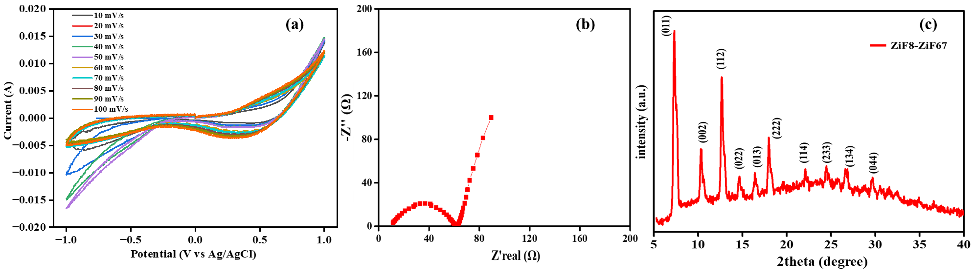
Figure 2: (a) Cyclic voltammetry, (b) Nyquist plot, and (c) X-ray diffraction results of the MOF cathode catalyst
The SEM micrographs (Fig. 3(a–c) revealed a highly crystalline morphology of the synthesised MOF. At low magnification (Fig. 3a), the catalyst exhibited spherical agglomerates (~10–20 µm) composed of densely packed microcrystals, indicating uniform nucleation during synthesis. Higher magnification images (Fig. 3b and c) clearly showed well-defined polyhedral crystals with sharp edges and faceted surfaces, characteristic of zeolitic imidazolate frameworks such as ZIF-8 and ZIF-67. The primary crystal size was observed in the range of 50–200 nm, which is consistent with reported ZIF-8/ZIF-67 nanocrystals, and it is advantageous for ORR due to increased electrochemically active surface area and shortened electron transport pathways (Yao et al., 2013). The observed crystallinity and faceted morphology correlate strongly with the sharp and intense XRD reflections previously identified at 2θ ≈ 7.3°, 10.4°, 12.7°, 16.4°, and 18.0°, confirming the formation of a highly ordered sodalite-type framework. Additionally, the EDX analysis (Fig. 3d) confirmed the elemental composition of the MOF. The homogeneous elemental distribution further indicated uniform metal incorporation, reducing charge-transfer resistance and enhancing cathodic performance (Yao et al., 2013).
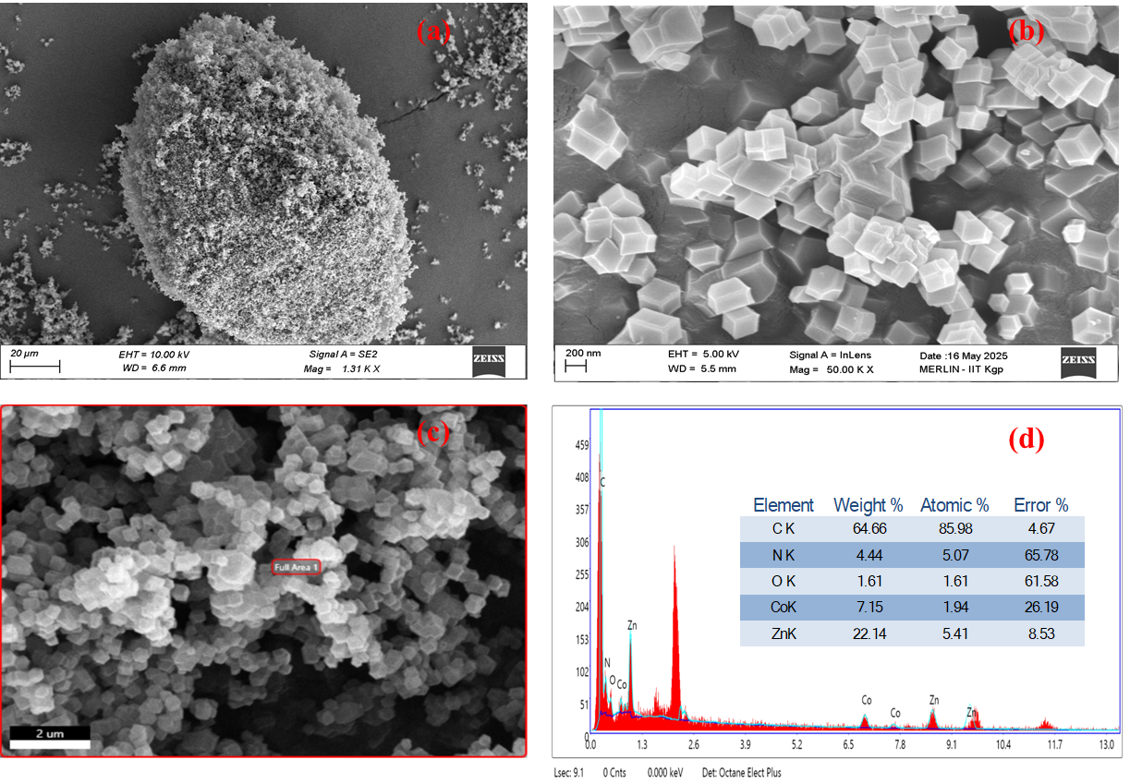
Figure 3: Scanning electron microscopy images at (a) 20 µm, (b) 200 µm, (c) 2 µm, and (d) EDX results
    - Performance of MDC
The MDC with applied cathode catalyst achieved a maximum COD removal of 78.8 ± 2.5 %, a TDS removal of 81.8 ± 3.2 %, and a desalination efficiency of 86.4 ± 1.7 %. Whereas, for control MDC, the observed values were 48.2 ± 3.1 %, 50.0 ± 1.6 %, and 46.6 ± 2.9 % for COD, TDS, and salt removal, respectively. Since TDS includes both ionic species and dissolved organic matter, and its removal reflects the combined effects of ion migration across membranes and partial organic matter degradation, its removal percentage is usually higher than that of COD. The maximum operating voltage for MDC having the catalyst-coated cathode was 303 ± 8.9 mV across a 100 Ω external resistor (Fig. 4a) compared to 58 ± 7.2 mV of the control MDC. Additionally, the power density recorded was 456.7 ± 18 mW/m², while the coulombic efficiency was 10.45 ± 2.13 %. The influent wastewater was having COD of 7.98 ± 0.05 g/L, TDS of 24.05 ± 0.11 g/L, and a salinity of 15 g/L. Additionally, a 30-day operation of 10 cycles did not show any significant reduction in performance. Thus, the synthesised MOF catalyst improved the treatment of industrial effluent using MDC compared to the control MDC.
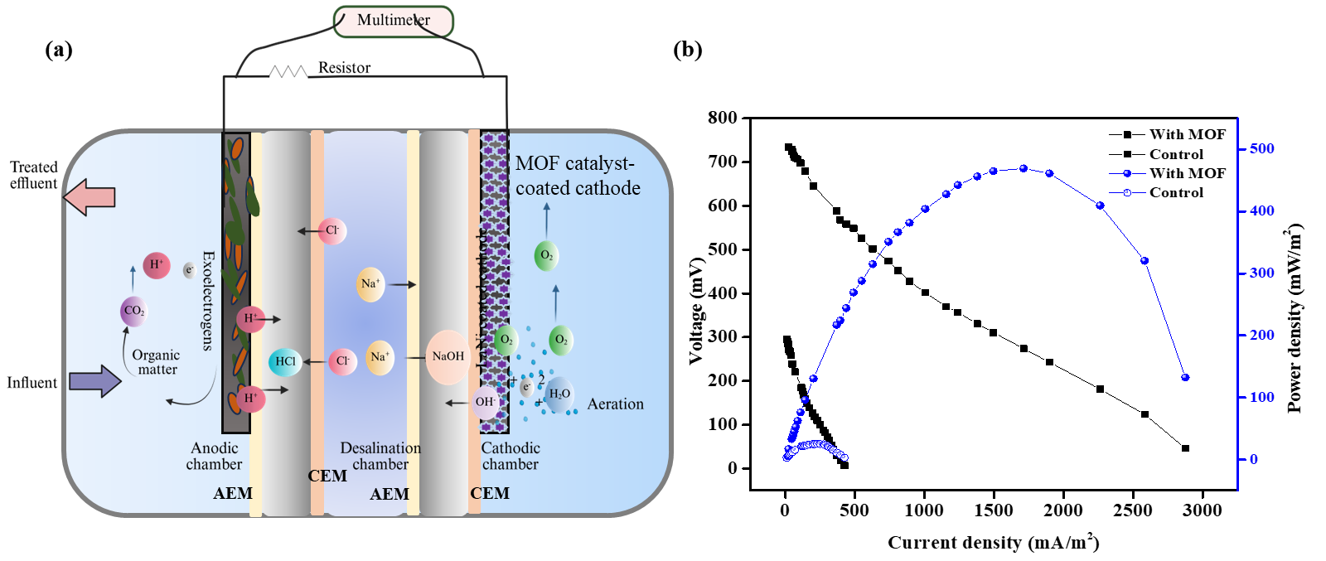
Figure 4: (a) schematic representation of MDC and (b) polarization curve
  - Conclusion and future prospects
The MDC system exhibited self-sustaining operation, as the energy derived from microbial metabolism was internally utilized to control ion transport and cathodic reactions. Thus, the MDC not only treated high-strength wastewater but also produced a low-salinity treated effluent, achieving simultaneous COD reduction, desalination, and energy recovery. This approach demonstrated a promising pathway towards energy-efficient, carbon-neutral, and cost-effective wastewater treatment, positioning MDCs as a viable pretreatment to RO. Further, integrating MOF-based ORR catalysts into MDC offers a promising strategy to overcome the present limitations of traditional cathode materials, enabling more efficient and sustainable industrial effluent treatment combined with desalination and energy recovery. Through structural engineering and functional design, MOF catalysts can significantly impact the performance and scalability of MDC technologies, thus addressing critical challenges in water–energy nexus applications. Additionally, due to the design of MDC as a five-chambered, the removed ions get accumulated in the concentrate chambers, which can be tested for the acidity and basicity of the obtained electrolyte and can be recovered as resources for additional application purposes or revenue generation.
Acknowledgments
This work was supported financially by Praj Industries Limited, India, in collaboration with the Indian Institute of Technology, Kharagpur, India (Project code - IIT/SRIC/CE/OIA/2023-2024/253).
References
Akhundzadeh Tezerjani A., Halladj R., Askari S., 2021, Different view of solvent effect on the synthesis methods of zeolitic imidazolate framework-8 to tuning the crystal structure and properties, RSC Advances, 11(32), 19914–19923.
Al-Mamun A., Baawain M.S., Rahman S.M., Islam S.M.N., 2018, A review of microbial desalination cell technology: Configurations, optimization and applications, Journal of Cleaner Production, 183, 458–480.
Al Murisi M., Al-Mamun A., Baawain M.S., Choudhury M.R., 2023, In situ growth of zeolite imidazole frameworks (ZIF-67) on carbon cloth for the application of oxygen reduction reactions and microbial fuel cells, ACS Omega, 8(47), 44514–44522.
Chen X., Xia X., Liang P., Cao X., Sun H., Huang X., 2012, Sustainable water desalination and electricity generation in a separator coupled stacked microbial desalination cell with buffer-free electrolyte circulation, Bioresource Technology, 119, 88–93.
Dhanabalan K., Arulmani S., Suresh M., Raghavan V., 2023, Metal–organic framework (MOF)-derived catalyst for oxygen reduction reaction (ORR) applications in fuel cell systems: A review of current advancements and perspectives, Energies, 16, 4950.
Ghangrekar M.M., Shinde V.B., 2007, Performance of membrane-less microbial fuel cell treating wastewater and effect of electrode distance and area on electricity production, Bioresource Technology, 98(15), 2879–2885.
Gupta N., Murthy Z.V.P., 2022, Synthesis and application of ZIF-67 on the performance of polysulfone blend membranes, Materials Today Chemistry, 23, 100685.
Imoro A.Z., Mensah M., Buamah R., 2021, Developments in the microbial desalination cell technology: A review, Water–Energy Nexus, 4, 76–87.
Jia H., Zhang Y., Li J., Wang X., 2025, Performance of microbial desalination cells with different cathode types in treating saline wastewater, Scientific Reports, 15(1), 16178.
Juma Al Balushi N., Al-Mamun A., Baawain M.S., Choudhury M.R., 2022, A comprehensive study on air-cathode limitations and its mitigation strategies in microbial desalination cell – A review, Energies, 15(20), 7459.
Lan F., Zhang J., Liu Y., Chen Y., 2025, Enhancing oxygen reduction reaction in microbial fuel cell by Cu-metal organic framework@Fe-metal organic framework (Cu-MOF@Fe-MOF) as cathode catalyst, Journal of Environmental Chemical Engineering, 13(2), 115448.
Li L., Sun Y., Xu J., Shao M., 2018, ZIF-67 derived P/Ni/Co/NC nanoparticles as highly efficient electrocatalyst for oxygen reduction reaction (ORR), Journal of Solid State Chemistry, 264, 1–5.
Lu X.F., Yu L., Lou X.W., 2020, Metal-organic frameworks based electrocatalysts for the oxygen reduction reaction, Angewandte Chemie International Edition, 59(12), 4634–4650.
Oturan M.A., Aaron J.J., 2014, Advanced oxidation processes in water/wastewater treatment: Principles and applications, Critical Reviews in Environmental Science and Technology, 44, 2577–2641.
Raychaudhuri A., Behera M., 2020, Comparative evaluation of methanogenesis suppression methods in microbial fuel cell during rice mill wastewater treatment, Environmental Technology & Innovation, 17, 100509.
Rosso A., Larson L.E., Stenstrom M.K., 2008, Aeration of large-scale municipal wastewater treatment plants: State of the art, Water Science and Technology, 57(7), 973–978.
Sikder S., Hossain M.F., Islam M.S., Rahman M.M., 2024, Efficiency of microbial desalination cells in treating wastewater, desalinating saltwater, and generating bioelectricity in Bangladesh, RSC Advances, 14(52), 38547–38559.
Tylus U., Jia Q., Strickland K., Ramaswamy N., Serov A., Atanassov P., Mukerjee S., 2014, Elucidating oxygen reduction active sites in pyrolyzed metal–nitrogen coordinated non-precious-metal electrocatalyst systems, Journal of Physical Chemistry C, 118(17), 8999–9008.
Tran V.H., Kim E., Jung S.P., 2022, Anode biofilm maturation time, stable cell performance time, and time-course electrochemistry in a single-chamber microbial fuel cell with a brush-anode, Journal of Industrial and Engineering Chemistry, 106, 269–278.
Yao J., He M., Wang Y., 2013, High-yield synthesis of zeolitic imidazolate frameworks from stoichiometric metal and ligand precursor aqueous solutions at room temperature, CrystEngComm, 15(18), 3601.

