 CHEMICAL ENGINEERING TRANSACTIONS  VOL. xxx, 2026 | A publication of  
The Italian Association
of Chemical Engineering
Online at www.cetjournal.it

Guest Editors: Marco Bravi, Antonio Marzocchella, Giuseppe Caputo
Copyright © 2026, AIDIC Servizi S.r.l.
ISBN 979-12-81206-xx-x; ISSN 2283-9216

Wine lees valorisation via pilot-scale production of phototrophic purple bacteria for aquaculture applications
A.C. Parmarª, S. Danieliª, F. Battista^{b}, J. Dosta^{c}, P. Pavanª, F. Valentinoª
ª Department of Environmental Science, Informatics and Statistics, Ca’ Foscari University of Venice, Via Torino 155, 30172 Venezia Mestre, Italy
^{b} Department of Biotechnology, University of Verona, Strada Le Grazie 15, 37134 Verona, Italy
^{c} Department of Chemical Engineering and Analytical Chemistry, University of Barcelona, C/Marti i Franquès 1, Barcelona, Spain
francesco.valentino@unive.it

Phototrophic purple bacteria (PPB) are a ubiquitous group of anoxygenic phototrophs, that can use organic/inorganic electron donors for anaerobic growth under heterotrophic and autotrophic conditions. PPB can collect light via bacteriochlorophylls (BChls) and carotenoids (Crts), also in non-sterile environments, and can contain approximately 60% of crude protein. These factors make PPB an ideal microorganisms’ group for assimilation of nutrients from waste/wastewater, yielding a product with potential interest as aquaculture feed or fish-feed additive. In this work, wine lees (WL) was exploited as renewable carbon source for PPB production in three tubular pilot-scale photobioreactors (PBRs; 50 L each) under different operating conditions, which were set to investigate the impact of the light availability (24h/day and 12h/day) and hydraulic retention time (HRT; 3 – 6 days). The organic loading rate was set at 1.0 g COD/(L d) (as soluble COD); wine lees was previously fermented to produce a volatile fatty acids (VFA) rich stream mainly composed by acetic, butyric and propionic acid (65%, 29% and 8% respectively). Each PBR was maintained in a dark thermostatic (25°C) container, illuminated by 4 LED lamps (122W in total) in far-red and infrared spectrum.
The continuous light availability supported the growth of PPB and the synthesis of pigments better than intermittent light, with a growth yield of 0.43 COD_{PPB}/COD_{SOL} (20% higher than PBR with 12 h light/day). However, intermittent light promoted the storage of intracellular polyhydroxyalkanoates (PHA; up to 6% of cells’ dry weight), presumably as response to the stress caused by discontinuous illumination. On the contrary, PHA was not detected in the PPB grown under continuous light. Regarding the effect of HRT, when it was set at 6 days a 100% VFA removal was observed, which decreased to 75% when the HRT was reduced to 3 days. This suggested the necessity to investigate intermediate HRT values.
In terms of nutritional value, the crude protein content of the three biomasses (separately collected from the three PBRs) was in the range 44-56 wt%. The highest value was obtained in the PBR operated under continuous light and 3 days as HRT. Other analyses are ongoing and addressed to measure carbohydrates, lipids and aminoacidic profile highlighting the potential of PPB biomass as a high protein, pigment rich ingredient for aquafeeds
  - Introduction
Winemaking generates several by-products, including wine lees, grape pomace, and winery wastewater, which, if not properly managed, can cause significant environmental impacts due to their high organic load, phenolic content, and mineral salts. However, wine lees (WL) also represent a promising substrate for bio-based processes: they contain residual yeasts and bacteria, sugars, organic acids, nitrogen compounds, and micronutrients, making them suitable for microbial valorisation within circular bio-refinery schemes. Recent studies have emphasized the potential of transforming wine lees from waste into valuable feedstocks for microbial cultivation and the extraction of bioactive compounds (Chetrariu et al., 2025).
Purple phototrophic bacteria (PPB) and particularly purple non-sulphur bacteria (PNSB) are metabolically versatile microorganisms capable of anoxygenic photosynthesis using bacteriochlorophylls and carotenoids, which confer their characteristic reddish-purple pigmentation. PNSB can grow photoautotrophically, photoheterotrophically, or chemoheterotrophically, and they efficiently utilize a wide range of organic substrates while adapting to fluctuating oxygen and light conditions. This metabolic flexibility enables their application in sustainable biotechnological processes such as wastewater treatment, biohydrogen production, biopolymer synthesis, and microbial protein generation (Bayon-Vicente et al., 2025). Among these applications, the use of PPB as a source of microbial protein (single-cell protein, SCP) for aquaculture feed has recently gained attention. PPB biomass typically contains 50–70% protein (dry weight), along with bacteriochlorophylls, carotenoids, vitamins, and essential amino acids that can enhance the nutritional value of aquafeeds while reducing the reliance on fishmeal. Moreover, PPB cultivation can be performed on agro-industrial residues such as wine lees, thereby coupling nutrient recovery with high-value biomass production (Capson-Tojo et a. 2020).
Using WL as a substrate for PNSB cultivation presents both opportunities and challenges. The high nutrient content supports microbial growth, but phenolic compounds and seasonal variability may require pretreatment (e.g., dilution, pH adjustment, filtration, or co-substrate addition) to enhance biodegradability. Acidogenic fermentation under pH-control strategy is a feasible method to convert most of organic material (soluble and/or suspended) into volatile fatty acids (VFA), which can be easily metabolized by PPB under chemo heterotrophic growth conditions (Almeida et al., 2021).
Recent pilot-scale studies have demonstrated the technical feasibility of continuous PPB cultivation systems, where biomass productivity and protein yields can be significantly improved compared to batch setups (Almeida et al., 2024). These systems, operated under controlled light and hydraulic retention conditions, have reached medium technology readiness levels (TRL 5–6), showing stable performance over extended periods and validating the scalability of PPB-based valorisation processes. Continuous and/or semicontinuous feeding PBRs are particularly attractive since steady organic loads can support sustainable microbial protein production with a stable biomass characteristics such as pigments’ content and polyhydroxyalkanoates, apart from PPB concentration and productivity. In this context, valorising wine lees through continuous cultivation of PPB represents a promising approach to integrate winery industry by-products conversion with aquafeed production. This proposed bioprocess is based on (a) the bioconversion of a high-COD content winery by-product into a low-COD effluent at reduced nutrients’ content, and (b) the production of high-protein microbial biomass for the formulation of aquaculture feeds. Therefore, the main objective of this work is to evaluate the potential of WL as a substrate for the growth and enrichment of PPB in a pilot-scale photobioreactor aimed at microbial protein production for aquaculture. The study focuses on characterizing the enriched PPB communities, mainly assessing growth yield, protein content, pigments and PHA concentration as added-value components under steady-state photoheterotrophic conditions.
  - Materials and Methods
The inoculum was obtained by collecting a mixed water and sediment sample from the Sile river (Treviso, northeast Italy). This mixture, after the addition of a fermented carbon source derived from parallel research activity, was maintained under anaerobic conditions in a 2 L lab scale photobioreactor and exposed to continuous IR illumination to select and enrich the culture in PPB. In one week, the biomass turned to the characteristic purple colour (Figure 1).
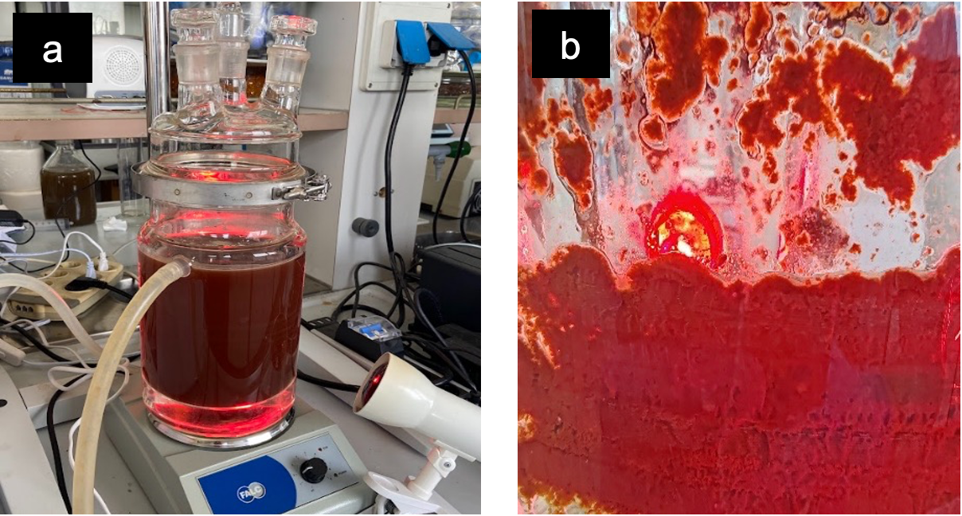
Figure 1. Mixed liquor after PPB enrichment (a); PPB biofilm attached to the photobioreactor wall (b).
    - WL characteristics and PPB cultivation in PBRs
WL was collected from a local company and stored in the fridge (4°C) to prevent its COD degradation. Given the high soluble COD level (close to 60 g/L), mainly represented by ethanol (more than 30%), an acidogenic dark fermentation step was performed to produce VFA as precursors for PPB cultivation. The dark fermentation was conducted in 5 L mesophilic semi-continuous stirred tank reactor (CSTR), mechanically stirred and under temperature control (37 °C) using a thermostatic jacket. The hydraulic retention time (HRT) was set at 4 days and the pH (6.0 – 6.5) was externally controlled with a peristaltic pump (NaOH 3M dosage) connected to a software designed by Idea Bioprocess Technology Srl. The applied OLR was in the range 8.0 – 10.5 g VS/(L d), according to the VS content of the WL. Daily, the fermented VFA-rich stream was centrifuged (Heraeus Megafuge 40, Swinging Bucket Rotor with maximum radius 195 mm and minimum radius 83 mm; Thermo Fisher Scientific, Waltham, MA, United States) for 15 min at 4700 rpm, to remove the solid fraction, and then collected and stored at 4°C before its use. The following Table 1 summarizes the physical-chemical features of the WL (immediately after collection and after fermentation process).

Table 1: Main parameters of wine lees (WL) before and after acidogenic fermentation step
Parameters | Unit | WL | fermented WL*
Total Solids (TS) | g/L | 2.1 ± 0.2 | -
Volatile Solids (VS) | g/L | 1.6 ± 0.3 | -
COD_{SOL} | g/L | 58.7 ± 0.9 | 61 ± 1
COD_{VFA} | g/L | 8.3 ± 0.2 | 36.7 ± 0.5
Acetic acid | g COD/L | 8.3 ± 0.2 | 23.6 ± 0.4
Propionic acid | g COD/L | - | 3.2 ± 0.7
Butyric acid | g COD/L | - | 10.7 ± 0.3
Ethanol | g COD/L | 19.6 ± 0.4 | 2.2 ± 0.1
pH | - | 6.4 ± 0.3 | 6.0 ± 0.2
Ammonia | g N-NH₄⁺/L | 0.21 ± 0.06 | 0.44 ± 0.02
Phosphate | g P-PO₄³⁻/L | 0.35 ± 0.02 | 0.39 ± 0.01
*after centrifugation of fermented WL

Pilot scale PBRs operations were conducted in parallel to avoid any differences in the adaptation and composition of the inoculum, which was produced in a lab-scale PBR and maintained for one week in the pilot reactors with a culture media described elsewhere (Yu et al., 2021) at the working volume of 40 L. The plexiglass tubular PBRs (height 1.1 m; diameter 250 mm) were maintained under mixing with recirculation pumps 24 h a day; the feeding and discharging were made manually once a day (cycle length 24 h). In all the three PBRs, the OLR was set at the medium-low value of 1.0 g COD_{SOL}/(L d), to prevent the risk of high concentration of residual organics in the media and, in turn, the proliferation of competitive bacterial or algal populations. The PBRs were placed in a dark thermostatic container (25 °C); each of them was illuminated by 4 LED lamps in far-red and infrared spectrum. In total, three conditions have been investigated: PBR-1 was maintained at an HRT of 3 days, with continuous light availability (24 h/d) at 140 W/m²; PBR-2 was maintained at an HRT of 6 days, with continuous light availability (24 h/d) at 140 W/m²; PBR-3 was maintained at an HRT of 6 days, with intermittent light availability (12 h/d) at 140 W/m² for half of the operating cycle. For PBR-3, the feedstock was fed at the beginning of the light-driven period.
    - Analytical Methods
Except for VFA, the features depicted in Table 1 for both feedstock were quantified according to Standard Methods (APHA/AWWA/WEF, 2012). The reactors’ effluent was monitored two times per week approximately for COD, pH and VFA. The quantification of ethanol (in unfermented WL only) and VFA was conducted using AGILENT 6890N gas chromatograph equipped with a flame ionization detector (at 200°C), a fused silica capillary column, DB-WAX (15 m x 0.53 mm × 0.5 μm film thickness); hydrogen was the gas carrier. The chromatographic runs were conducted by increasing the temperature from 40 to 200°C, at a rate of 10°C/min. The samples were analysed after centrifugation (Heraeus Megafuge 40; Thermo Fisher Scientific, Waltham, MA, United States; 10 min, 4600 rpm) and filtration (0.2 μm filter porosity).
PHA analyses were performed starting by 10.0 mL of mixed liquor, which was treated with 1.0 mL of NaClO solution (2-5 % active Cl₂) and subsequently analysed according to the method depicted in Tuci et al. (2025), via GC and after intracellular PHA extraction and conversion into 3-hydroxyacyl methyl esters: 3-hydroxybutyric (3HB) and 3-hydroxyvaleric (3HV) monomers.
Bacteriochlorophylls’ content (BChls) was determined using organic solvent extraction and spectrophotometric analysis. The PPB biomass was washed twice with distilled water before extraction with a mixture of acetone and methanol (7:2, v/v), followed by centrifugation (Heraeus Megafuge 40; Thermo Fisher Scientific, Waltham, MA, United States) for 10 min at 4600 rpm to remove cellular debris. The supernatant was then analysed spectrophotometrically at 770 nm. To prevent photo-oxidation, all extractions and measurements were performed in a dark environment. A similar procedure was followed for carotenoids (Crts) quantification, except for the wavelength used, which was equal to 480 nm. For both BChls and Crts concentrations, the following formulas was used:
 | (1)
  C_{BChls} = [A₇₇₀ / (Ɛ*d)] and C_{Crts} = [A₄₈₀ / (Ɛ*d)]
where “C” is the concentration, A₇₇₀ and A₄₈₀ are the absorbances at 770 nm and 480 nm respectively, “Ɛ” is the molar extinction coefficient, and “d” is the path length (1 cm).
  - Results and discussion
    - Effect of the HRT and light availability on the PPB growth response
Under steady-state conditions, biomass productivity (g PPB L⁻¹ d⁻¹) and observed yield (Y_{OBS}; COD_{PPB}
COD_{SOL}⁻¹) were markedly affected by the adopted HRT and light intensity/availability (Figure 2). The highest biomass productivity was observed in PBR-2, operated at an HRT of 6 days under continuous illumination, reaching 0.34 g PPB L⁻¹ d⁻¹, compared to 0.23 g PPB L⁻¹ d⁻¹ in PBR-1, which was operated at a shorter HRT (3 days) under the same lighting regime. This increase suggested that extending HRT had a positive effect on biomass production, despite the 100% of VFA depletion, which was observed only at an HRT of 6 days. This could be interpreted as carbon-limiting growth condition (not observed at an HRT of 3 days, where VFA were depleted only at 75%), but probably higher HRT (6 days) was necessary to support microbial growth under photoheterotrophic conditions.
When light availability was reduced at 12 h/day by maintaining constant HRT, biomass productivity decreased to 0.27 g PPB L⁻¹ d⁻¹ in PBR-3, indicating that continuous illumination favoured higher biomass production compared to a 12 h/12 h light/dark approach. This observation is consistent with earlier studies showing that prolonged light exposure enhanced photosynthetic activity and biomass formation in PPB-based systems, while light–dark cycles may limit overall photon utilization efficiency (Fradinho et al., 2019).
A similar trend was observed for the observed yield. The maximum yield (0.57 g COD_{PPB} g COD_{SOL}⁻¹) was obtained in PBR-2, whereas lower values (0.48 g COD_{PPB} g COD_{SOL}⁻¹) were quantified in PBR-1 and PBR-3. The increase in Y_{OBS} from PBR-1 to PBR-2 further confirmed the beneficial effect of a longer HRT under continuous light and, even though carbon limiting conditions were observed, this did not prevent higher productivity, suggesting efficient substrate use under longer residence. Conversely, the reduction in light availability in PBR-3 resulted in a yield comparable to that of the short-HRT system, despite the longer residence time, indicating that light limitation limited the substrate-to-biomass conversion efficiency. It must be highlighted that those Y_{OBS} values are generally lower, and in some cases comparable, with values observed in pure and mixed PPB cultures reported in a recent review (Capson-Tojo et al., 2020). This difference could be due to the feeding strategy adopted in this study, which was based on the feast-famine approach to trigger PHA storage (Valentino et al., 2013).
Overall, these results demonstrate that, under constant OLR, HRT and illumination regime affected both PPB productivity and yield, with optimal performance achieved at longer HRT coupled with continuous light supply.
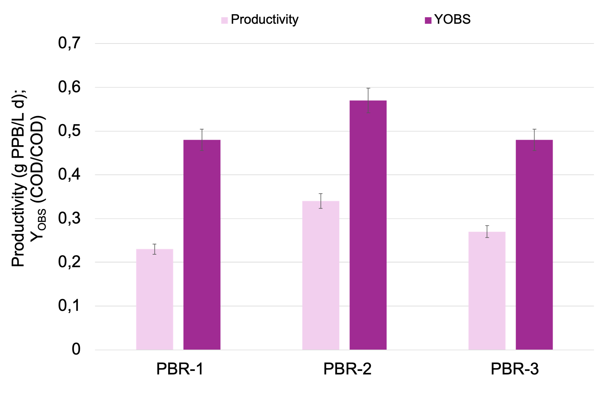
Figure 2: Average values of PPB productivity (g PPB L⁻¹ d⁻¹) and observed yield (COD_{PPB} COD_{SOL}⁻¹) in the three photobioreactors at the steady state.

Pigments’ synthesis was also affected by both HRT and light availability (Figure 3). Total Crts content increased from 2.5 mg_{Crts} g_{dry} _{PPB}⁻¹ in PBR-1 to 4.5 mg_{Crts} g_{dry} _{PPB}⁻¹ in PBR-2, indicating that the extension of HRT from 3 to 6 days under continuous illumination favored the accumulation of photoprotective pigments. A decrease in Crts content to 3.5 mg_{Crts} g_{dry} _{PPB}⁻¹ was observed in PBR-3, where the same HRT was maintained but light availability was reduced to 12 h per day, suggesting that continuous illumination or higher irradiance favored higher Crts synthesis, compared to light–dark cycles, as photoprotective pigments. In contrast, total BChls content showed a different trend. While BChls concentration increased from 1.9 mg_{BChls} g_{dry} _{PPB}⁻¹ in PBR-1 to 3.2 mg_{BChls} g_{dry} _{PPB}⁻¹ in PBR-2, the highest value (4.1 mg_{BChls} g_{dry} _{PPB}⁻¹) was measured in PBR-3. This remarkable increase under reduced light availability is consistent with photo-acclimation mechanisms, whereby purple bacteria enhance light-harvesting pigment synthesis to compensate lower photon flux and shorter illumination periods.
As a consequence of these opposite trends, total pigment content (Crts and BChls) progressively increased from 4.4 mg g_{dry} _{PPB}⁻¹ in PBR-1 to 7.7 mg g_{dry} _{PPB}⁻¹ in PBR-2, and 7.6 mg g_{dry} _{PPB}⁻¹ in PBR-3. These results suggested that while longer HRT under continuous light promotes overall pigments’ accumulation, reduced light availability further stimulates the synthesis of photosynthetic pigments, particularly BChls, to optimize light capture efficiency.
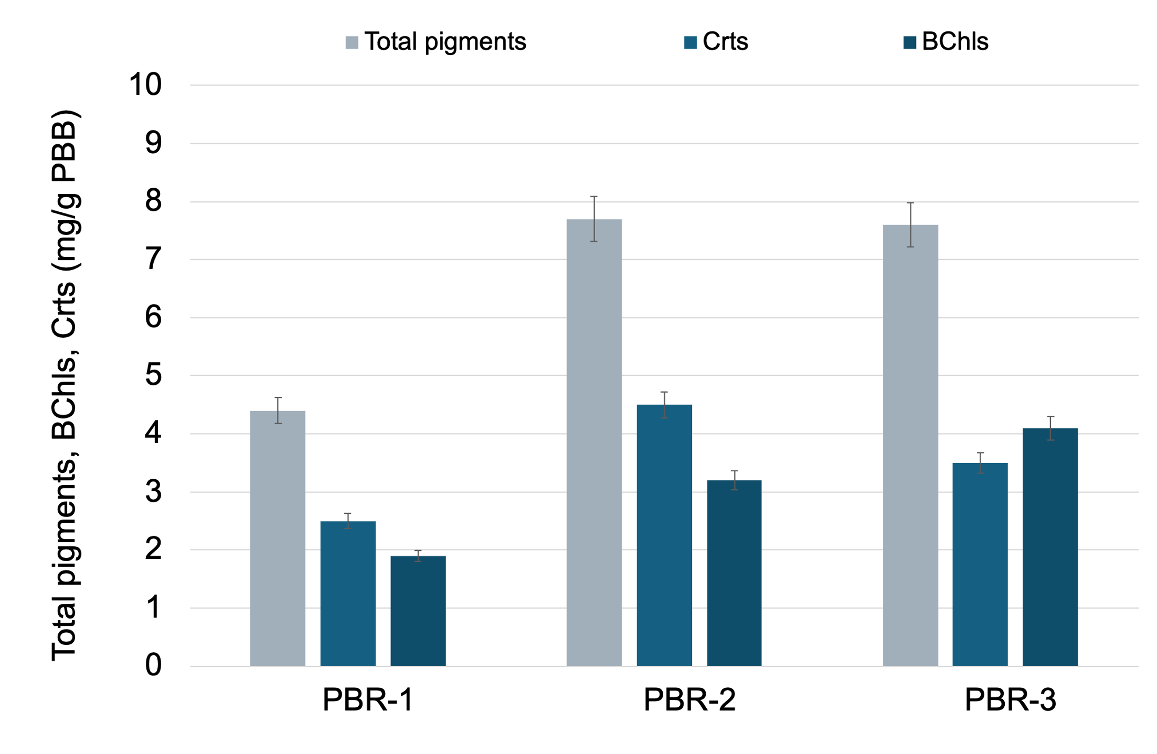
Figure 3: Average values of total pigments, carotenoids (Crts) and bacteriochlorophylls (BChls) at the steady state in the PPB biomasses selected in the photobioreactors.
    - PHA synthesis and protein content of PPB biomass in PBRs
Intracellular PHA content varied notably among the three operating conditions under steady state. All the biomasses were selected under the feast-famine strategy to stimulate PHA synthesis (Valentino et al., 2013). Despite residual VFA in the effluent and, in turn, the failure to achieve a true feast–famine-regime, PBR-1 exhibited a PHA accumulation of 4.0% (g_{PHA} g_{PPB}⁻¹), whereas PBR-2, operated at longer HRT, showed a markedly lower content of 1.8% g_{PHA} g_{PPB}⁻¹, likely due to reduced selective pressure for PHA-accumulating bacteria. Interestingly, PBR-3 showed the highest PHA content (5.2% g_{PHA} g_{PPB}⁻¹), suggesting that the combination of low to intermediate HRT and light limitation may have boosted carbon storage into PHA under nutrient-limited conditions.
The preliminary analysis of biomass composition revealed that the protein content was 56.7% in PBR-1, 55.2% in PBR-2, and substantially lower (44.8%) in PBR-3. (Table 2). Although the lower protein content in PBR-3 coincided with the highest intracellular PHA observed, the reduced protein accumulation cannot be attributed solely to the increase in PHA storage, indicating that other metabolic or physiological factors, possibly linked to light limitation or carbon allocation, played a role.
Table 2: Proximate composition of PPB biomass grown in the three photobioreactors at steady state
Proximate composition (%) | PBR-1 | PBR-2 | PBR-3
Moisture | 5.9 ± 0.4 | 5.4 ± 0.6 | 6.5 ± 0.1
Proteins | 56.7 ± 0.2 | 55.2 ± 0.9 | 44.8 ± 0.8
Lipids | 11.5 ± 0.7 | 10.8 ± 0.1 | 15.1 ± 0.8
Carbohydrates | 15.0 ± 0.1 | 15.2 ± 0.2 | 17.9 ± 0.2
PHA | 4.0 ± 0.1 | 1.8 ± 0.9 | 5.2 ± 0.3
Ashes | 5.4 ± 0.8 | 5.7 ± 0.2 | 5.6 ± 0.3
The proximate composition of the three PPB biomasses indicated their potential as a functional ingredient in aquafeed. All of them had high protein content, particularly PBR-1 and PBR-2, which are within the range suitable for fish diets. PBR-3 had a lower protein content, but this is partially compensated by higher lipid (15.1%) and carbohydrate (17.9%) fractions, which can provide additional energy in the feed. The presence of PHA (especially in PBR-1 and PBR-3) can be an additional value for aquafeeds since it may influence feed digestibility and gut health. Ash content is moderate (5.4-5.7%), suggesting a balanced mineral contribution without excessive inorganic load. As previously discussed, other than PHA, the biomasses contained pigments, which could act as antioxidant and immunostimulant factors for fish. Overall, PBR-1 and PBR-2 biomasses appeared most suitable as high-protein feed ingredients, while PBR-3 biomass, despite lower protein, could offer a richer energy fraction and bioactive compounds, making it potentially useful in combination with other protein-rich sources to formulate balanced aquafeeds (Tuci et al., 2025). Other analyses, such as amino acid profiles and the calculation of the essential amino acid index (EAAI), are ongoing and will be used to further evaluate the potential use of PPB biomass for specific fish’s species.
    - Conclusions
Within the context of PPB production from winery by-products as renewable nutrients’ source, this work demonstrates that both HRT and light availability significantly affect the PPB biomass productivity and yield. Longer HRT (6 days) combined with continuous illumination promoted higher biomass production (0.34 g PPB L⁻¹ d⁻¹ and overall pigment accumulation (7.7 mg g_{dry} _{PPB}⁻¹), whereas reduced light availability stimulated BChls’ synthesis (4.1 mg_{BChls} g_{dry} _{PPB}⁻¹) as an adaptive response to lower energy source. PHA was also stored according to the feast-famine strategy, with higher accumulation observed under low HRT and intermittent light (4.0-5.2% g_{PHA} g_{PPB}⁻¹). Along with bioactive pigments and PHA, PPB biomass composition revealed high protein content in specific operating conditions (mainly higher HRT and continuous light). Proteins level, pigments and PHA content can be tuned by operating conditions, which is important from a formulation perspective in aquafeeds. Further analyses, including amino acids and EAAI evaluation will provide deeper insights into PPB suitability for specific fish species.

Acknowledgments
This work was supported by the DoE 2023-2027 (MUR, AIS.DIP.ECCELLENZA2023_27.FF project).
References
Almeida J.R., Serrano E., Fernandez M., Fradinho J.C., Oehmen A., Reis M.A.M., 2021, Polyhydroxyalkanoates production from fermented domestic wastewater using phototrophic mixed cultures, Water Research 197, 117101. https://doi.org/10.1016/j.watres.2021.117101.
Almeida J.R., Serrano León E., Rogalla F., Fradinho J.C., Oehmen A., Reis M.A.M., 2024, Polyhydroxyalkanoates production in purple phototrophic bacteria ponds: A breakthrough in outdoor pilot-scale operation, Science of The Total Environment 912, 168899. https://doi.org/10.1016/j.scitotenv.2023.168899.
APHA/AWWA/WEF, Stand. Methods Exam. Water Wastewater (2012).
Bayon-Vicente G., Toubeau L, Gilson M, Gégo G, Landgey N, Krings S, Leroy B., 2025, Metabolic pathways to sustainability: review of purple non-sulfur bacteria potential in agri-food waste valorization. Frontiers in Bioengineering and Biotechnology, 13, https://doi.org/10.3389/fbioe.2025.1529032.
Capson-Tojo G., Batstone D.J., Grassino M., Vlaeminck S.E., Puyol D., Verstraete W., Kleerebezem R., et al., 2020, Purple Phototrophic Bacteria for Resource Recovery: Challenges and Opportunities, Biotechnology Advances, 43, 107567. https://doi.org/10.1016/j.biotechadv.2020.107567.
Chetrariu A., Dabija A., Caisin L., Agapii V., Avrămia I., 2025, Sustainable Valorization of Wine Lees: From Waste to Value-Added Products. Applied Science, 15, 3648, https://doi.org/10.3390/app15073648.
Fradinho J.C., Oehmen A., Reis M.A.M., 2019, Improving polyhydroxyalkanoates production in phototrophic mixed cultures by optimizing accumulator reactor operating conditions, International Journal of Biological Macromolecules 126, 1085-1092. https://doi.org/10.1016/j.ijbiomac.2018.12.270.
Tuci G.A., Gottardo M., Parmar A.C., Cardinaletti G., Pascon G., Pavan P., Valentino F., 2025, Single-cell proteins polyhydroxyalkanoates-rich microbial biomass from municipal and winery waste as potential additive for aquafeeds, New Biotechnology 89, 29-39. https://doi.org/10.1016/j.nbt.2025.06.003.
Valentino F., Brusca A.A., Beccari M., Nuzzo A., Zanaroli G., Majone M., 2013, Start up of biological sequencing batch reactor (SBR) and short-term biomass acclimation for polyhydroxyalkanoates production, Journal of Chemical Technology & Biotechnology 88, 261-270. https://dx.doi.org/10.1002/jctb.3824.
Yu S., Peng L., Xu Y., Song S., Xie G.J., Liu Y., Ni B.J., 2021, Optimizing light sources for selective growth of purple bacteria and efficient formation of value-added products, Journal of Cleaner Production 280, 124493. https://doi.org/10.1016/j.jclepro.2020.124493.

