 CHEMICAL ENGINEERING TRANSACTIONS  VOL. xxx, 2026 | A publication of  
The Italian Association
of Chemical Engineering
Online at www.cetjournal.it

Guest Editors: Marco Bravi, Antonio Marzocchella, Giuseppe Caputo
Copyright © 2026, AIDIC Servizi S.r.l.
ISBN 979-12-81206-xx-x; ISSN 2283-9216

Bio-Based k-Carrageenan/Degalactosylated Xyloglucan Hydrogels Bioink for Scaffolds 3D Printing
Emanuela Muscolino^{a,b,*}, Anna Barbara Di Stefano^{c}, Francesca Toia^{c}, Clelia Dispenzaª
ª Dipartimento di Ingegneria, Università degli Studi di Palermo, Viale delle Scienze 6, 90128 Palermo, Italy;
^{b} Istituto di BioFisica, Consiglio Nazionale delle Ricerche, Via U. La Malfa 153, 90146 Palermo, Italy.
^{c} BIOPLAST - Laboratory of BIOlogy and Regenerative Medicine-PLASTic Surgery, Dipartimento di Discipline Chirurgiche, Oncologiche e Stomatologiche, Università degli Studi di Palermo, via del Vespro 129, 90127, Palermo, Italy;
*emanuela.muscolino@unipa.it
The transition toward sustainable, bio-based materials is a key objective in industrial biotechnology, driving the replacement of fossil-derived polymers with renewable alternatives in advanced manufacturing and biomedical applications. In this context, polysaccharide hydrogels are particularly attractive due to their biodegradability, low environmental impact, and ability to form functional networks under mild conditions. Hybrid hydrogels based on plant-derived κ-carrageenan (k-C) and degalactosylated xyloglucan (Deg-XG) represent a fully bio-based and scalable platform for cell-compatible 3D printing.
κ-Carrageenan is a red-algae–derived sulfated polygalactan whose thermoresponsive gelation and glycosaminoglycan-like structure make it a promising biomaterial for soft-tissue scaffolding. However, its intrinsic brittleness and limited porosity restrict its applicability in extrusion-based fabrication. Degalactosylated xyloglucan, obtained via enzymatic removal of galactose residues from tamarind-seed xyloglucan, forms soft, adhesive, and biocompatible hydrogels. When blended with k-C, Deg-XG enhances swelling behavior, microporosity, and elasticity, yielding hybrid networks with improved structural stability while preserving a fully renewable origin.
In this study, aqueous k-C/Deg-XG hydrogels were investigated as sustainable bioinks for extrusion-based 3D printing. Rheological analyses were performed to evaluate gel behavior during processing, and printing parameters were optimized to achieve higher print fidelity. Preliminary tests with adipose-derived stem cell spheroids confirmed cytocompatibility, highlighting the potential of k-C/Deg-XG hydrogels for renewable, plant-based bioinks in tissue engineering.
  - Introduction
The development of sustainable, bio-based materials for advanced manufacturing and biomedical applications is a key objective of industrial biotechnology, driven by the need to reduce reliance on fossil-derived polymers while maintaining high performance and safety standards. In regenerative medicine and tissue engineering, this challenge is particularly evident, as biomaterials must simultaneously meet strict requirements in terms of biocompatibility, biodegradability, mechanical integrity, and processability. In this context, polysaccharide-based hydrogels have emerged as highly attractive candidates, as they are derived from renewable resources, can be processed under mild conditions, and closely resemble the hydrated, viscoelastic nature of native extracellular matrices (ECM) (Chimene et al., 2016).
Three-dimensional (3D) scaffolds play a fundamental role in tissue engineering, providing structural support for cell infiltration, proliferation, and ECM resemblance while guiding tissue regeneration in complex anatomical environments (Chia and Wu, 2015). Effective scaffolds must be carefully designed across multiple length scales: the macroarchitecture should match the overall shape of the target tissue or organ, the microarchitecture should ensure appropriate porosity and pore interconnectivity for nutrient and oxygen transport, and the nanoarchitecture should promote favorable cell–material interactions that regulate adhesion, migration, and differentiation (Chia and Wu, 2015). Achieving simultaneous control over these hierarchical features remains a major technological challenge with conventional scaffold fabrication techniques, such as freeze-drying, solvent casting, or electrospinning, which offer limited control over macroscopic geometry.
3D bioprinting has therefore gained increasing attention as a powerful strategy to fabricate scaffolds with precisely defined architectures directly from computer-aided design (CAD) models, enabling patient-specific and reproducible constructs (Gungor-Ozkerim et al., 2018). Among the available bioprinting techniques, extrusion-based printing is the most widely adopted due to its simplicity, versatility, and compatibility with a broad range of biomaterials and cell-laden formulations (Chimene et al., 2016). However, the success of this approach critically depends on the properties of the bioink. An ideal bioink must exhibit suitable rheological behavior for extrusion, rapid shape stabilization after deposition, sufficient mechanical stability to maintain the printed structure, and high biocompatibility to preserve cell viability and function (Gungor-Ozkerim et al., 2018).
Hydrogels are used as bioinks because of their high water content, tunable mechanical properties, and ability to encapsulate living cells while supporting matrix remodeling and cell–cell interactions (Chimene et al., 2016). Nevertheless, many naturally derived hydrogels suffer from limited mechanical strength or poor print fidelity, restricting their applicability in extrusion-based fabrication. Hybrid hydrogel systems, obtained by blending complementary polymers, offer an effective strategy to overcome these limitations by decoupling and tailoring mechanical, structural, and biological properties (Visscher et al., 2019).
Within this context, κ-carrageenan (k-C) and partially degalactosylated xyloglucan (Deg-XG) represent a promising, fully plant-derived combination for sustainable bioink development (Muscolino et al., 2024). κ-Carrageenan is a sulfated polygalactan extracted from red seaweeds that undergoes thermoreversible gelation through a coil-to-double-helix transition, followed by helix aggregation, particularly in the presence of potassium ions (Mangione et al., 2005). Its strong anionic character and structural similarity to glycosaminoglycans make k-C attractive for biomedical applications; however, κ-carrageenan gels are typically brittle, the sol state is not viscous enough to maintain filament shape upon extrusion and exhibit limited intrinsic porosity, which can hinder extrusion printing and cell infiltration (Necas and Bartosikova, 2013).
Degalactosylated xyloglucan, obtained by enzymatic removal of galactose residues from tamarind seed xyloglucan, forms soft, thermoreversible hydrogels driven by hydrophobic interactions among the glucan backbone (Di Stefano et al., 2025). Deg-XG is biodegradable, biocompatible, and FDA-approved as a food additive, and has already been explored for drug delivery and soft tissue engineering applications (Picone et al., 2024). Importantly, Deg-XG hydrogels exhibit high swelling capacity, adhesive behavior, and inherent cytocompatibility, making them attractive as a complementary component to reinforce and plasticize stiffer polysaccharide networks.
Blending k-C and Deg-XG enables the formation of hybrid hydrogels in which the cross-linking density, mechanical response, and morphology can be finely tuned by composition and ionic conditions (Muscolino and Dispenza, 2025). Such systems hold significant potential as sustainable bioinks for extrusion-based 3D printing, combining renewable origin, processability, and biological performance. In this study, aqueous k-C/Deg-XG hydrogels were investigated as candidate bioinks, focusing on their rheological behavior, printability, and preliminary compatibility with human adipose-derived stem cell spheroids, with the ultimate goal of advancing fully bio-based materials for regenerative medicine applications.
  - Experimental Section
    - Materials
Tamarind seeds xyloglucan was purchased from Megazyme International (Ireland). Sugar composition of the tamarind seed xyloglucan is xylose 34 %w; glucose 45 %w; galactose 17 %w; arabinose and other sugars 4 %w, as provided by Megazyme International. b-Galactosidase from Aspergillus oryzae (11.8 U/mg) was purchased from Sigma Chemicals (USA). Tamarind seeds xyloglucan was partially degalactosylated according to an established protocol, to obtain a degalactosylated degree of ca. 45% (Brun-Graeppi et al., 2010; Shirakawa et al., 1998). k-C was provided from Gelcarin ME 8625 FMC Biopolymer. Sodium azide (NaN₃) and Potassium Chloride (KCl) were purchased from Sigma-Aldrich. All chemicals were used as received with no more purification. Distilled water was used in hydrogel preparation.
    - Hydrogels Preparation
A Deg-XG solution at 3 %w, 2 %w and 1 %w were prepared by adding Deg-XG powder to 0.22 μm pre-filtered water, and stirred for about 2 hours at 5 °C until a homogenous dispersion was obtained. These solutions will be identified as Deg-XG (3), Deg-XG (2) and Deg-XG(1) respectively.
k-C solution (4 %w) also containing NaN₃ (0.04 %w) and KCl (0.8 %w) was prepared by continuous stirring at 80 °C for the time needed to obtain a clear, homogenous solution. Then, equal volumes of the k-C aqueous polymers solution and the Deg-XG(2) were mixed and stirred at ca. 120 °C for five further hours in an oil bath. Stirring was interrupted when the mixture resulted homogenous and the mixture was slowly cooled down to room temperature by keeping it immersed in the oil bath with no heating provided. This solution will be identified as k-C(2)/Deg-XG(1). k-C solution (3 %w and 2 %w) also containing NaN₃ (0.02 %w) and KCl (0.4 %w) were prepared by continuous stirring at 80 °C for the time needed to obtain a clear, homogenous solution. These solutions will be identified as k-C(3) and k-C(2), respectively.
    - Rheological analysis
The viscoelastic behaviour of the hydrogels was studied with a stress-controlled Rheometer AR G2, TA Instruments, equipped with a 60 mm aluminum and a 40 mm PIK crosshatched plate geometry.
Temperature ramps
To assess the gelation temperature, the temperature of the rheometer was varied from 90 °C to 30 °C at 1 °C/min, with frequency and strain of 1 Hz and 0.0008, respectively. The gel temperature was determined by the point of intersection of the build-up modulus (G′) and loss modulus (G′′) curves.
Strain and frequency sweeps
As a preliminary step in the analysis, strain sweep measurements were carried out to identify measurement conditions where there is independence of instrumental responses of oscillation amplitude, i.e., the limit of linear viscoelastic regime (LVR). Measurements were performed in “strain sweep” mode (in the 0.00001 –1 range) at fixed frequency of 1 Hz, and in “frequency sweep” mode (in the 0.1 to 10 Hz range) at a fixed strain, selected for each formulation so that the material was tested within its linear viscoelastic region (LVR). The temperature was kept constant at 37 °C.
    - Morphological analysis
Hydrogels microstructure was investigated using a Field Emission Scanning Electron Microscope (SEM) Phenom ProX desktop at an accelerating voltage of 10kV. The hydrogels were frozen in liquid nitrogen, freeze-dried, mounted on aluminum stubs and gold coated by JFC-1300 gold coater (JEOL) for 120 s at 30 mA before scanning.
    - Spheroids of Adipose Stem Cells (SASCs)
Adipose tissue was collected from healthy individuals, following approval of an informed consensus. Lipoaspirate samples were harvested from different body areas such as abdomen, breast, flanks, trochanteric region. After mechanic (shake 30 minutes at 37°C) and enzymatic (collagenase 150 mg/ml, Gibco, Carlsbad, CA) digestion, the samples were centrifuged at 1200 rpm for 5 minutes and the stromal vascular fraction (SVF) was resuspended in specific medium. For 3D cultures, the SASCs were plated in stem cell medium (SCM) composed principally by DMEM/F12 salts with added basic fibroblast growth factor (bFGF, 10 ng/ml; Sigma, St. Louis, MO) and epidermal growth factor (EGF, 20 ng/ml, Sigma). SASCs were grown as fluctuating spheroids in an ultra-low attachment culture flask (Corning, NY).
    - 3D Printing
The 3D printability tests were performed with a Dr ROKIT Invivo printer. The PVA/k-C and k-C/Deg-XG solutions were loaded in the printing syringe mounting a G22 metal needle at 70 °C, let equilibrate at the printing temperature of 45 °C or 65 °C for 10 minute and printed into a geometry of a 3 x 3 squares grid of LxHxP 20x5x20 mm. The prints were performed on several sample solutions and the following printing parameters were systematically varied: print speed, travel speed and bottom layer speed.
  - Results and Discussion
In the prospect of developing fast gelling bio-inks for 3D printing of scaffolds to reconstruct human body tissue through adipose derived stem cell differentiation, the formulations must fulfil several requirements, related to both their processing conditions and their application. Two polysaccharides have been selected for their ability to undergo reversible temperature-induced gelation, schematized in Figure 1a. k-C gels form when cations, preferably K⁺, screen the negative charges of the sulfate groups along the polysaccharide backbone, promoting coil-to-double-helix transitions upon cooling below 60–70 °C. However, in the sol state, k-C solutions exhibit insufficient viscosity to preserve filament integrity during extrusion-based processing and k-C hydrogels are intrinsically brittle (Necas and Bartosikova, 2013). Deg-XG becomes temperature-responsive when the degree of degalactosylation exceeds ~35% and undergoes gelation upon in the temperature interval of 25-100 °C, depending on the extent of degalactosylation. Deg-XG hydrogels are soft, adhesive, and biocompatible. When blended with k-C, Deg-XG increases the viscosity and adhesiveness of the extruded material, thereby improving printability.
The rheological properties of the hydrogel blends were analysed using the corresponding single-component hydrogels as references. The frequency sweep test (Figure 1b) highlights clear differences in the viscoelastic behavior of k-C, Deg-XG, and their blend.
Pure k-C hydrogels exhibit a solid-like response over the entire frequency range, with the storage modulus (G′) consistently higher than the loss modulus (G″) and both moduli essentially invariant with frequency. This behavior is characteristic of strong, well-developed gel networks, reflecting the formation of stable double-helix crosslinks typical of κ-C. Deg-XG hydrogels show a markedly weaker mechanical response. At concentrations 3 %w, G′ exceeds G″ and displays a weak frequency dependence, indicating the formation of a gel-like network. However, the absolute values of G′ are at least two orders of magnitude lower than those of k-C at comparable concentrations, confirming that Deg-XG forms much softer and more weakly crosslinked hydrogels. At lower concentration (1 %w), Deg-XG behaves predominantly as a viscoelastic liquid, with low moduli and a stronger frequency dependence.
The k-C(2)/Deg-XG(1) hydrogel blend shows G′ higher than G″ across the frequency range, with moduli values close to those of pure k-C(2). This indicates that the carrageenan network dominates the mechanical response of the blend, while Deg-XG acts as a secondary component that does not disrupt gel integrity. Overall, the blend retains the strong gel character of k-C while potentially benefiting from the softer, more compliant nature of Deg-XG. The role of Deg-XG is of a functional modifier rather than a structural driver. Practically, this can help cell compatibility and printability.
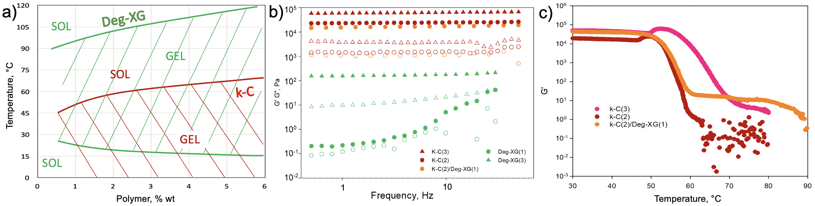Figure 1: a) Sol-Gel Transition scheme of Deg-XG and k-C. Rheological analysis of k-C(2), k-C(3), k-C(2)/Deg-XG(1), Deg-XG(1) and Deg-XG(3): b) storage modulus, G′ (full dot), and loss modulus, G′′ (hollow dot), as a function of frequency; c) storage modulus (G′) from temperature-ramp of hydrogels containing k-C, decreasing the temperature at a rate of 1°C/min from 90 to 30°C.
From the temperature ramp (Figure 1c), the k-C(2)/Deg-XG(1) blend exhibits two distinct thermal transitions. Going from 90 °C to 30 °C, the first transition, observed at temperatures above 90 °C, is attributed to the Deg-XG component, consistent with its known high-temperature gelation behavior. The second transition, occurring at temperatures comparable to that of k-C(2), indicates that the carrageenan network forms and melts independently within the hybrid system. Importantly, the sol–gel transition temperature associated with k-C in the blend remains very close to that of pure k-C(2) while it stays lower than k-C(3), the solution with the same total polymer content of k-C(2)/Deg-XG(1). The results demonstrate that the presence of Deg-XG does not significantly interfere with κ-carrageenan gelation, which remains comparable to that of the pure κ-C system at the same polymer concentration. This is probably due to a lack of physical interaction between the two polysaccharides chains, as it could be expected since k-C forms networks through ionic interactions while Deg-XG through hydrophobic ones. From a 3D printing perspective, this behavior is highly favorable. The retention of k-C gelation characteristics in the blend ensures predictable thermal control during printing, allowing extrusion in the sol state followed by rapid gelation upon cooling to stabilize the printed filament. Meanwhile, the fact that Deg-XG is not in a sol state, while remaining injectble, at the printing temperature of 65 °C gives more structure to the filament avoiding the loss of definition in the printed filament, typical of pure k-C.
SEM micrographs reveal distinct microstructural features for k-C, Deg-XG, and their blend, which are directly relevant to their performance as scaffolds. Figure 2 shows the comparison between the polymer blend and the two individual components at an equal total polymer concentration. k-C displays a compact morphology characterized by corrugated lamellar domains. While this dense architecture supports the high mechanical strength of k-C hydrogels, it also suggests limited intrinsic porosity, which may restrict cell infiltration and mass transport when used alone.
Deg-XG(3) exhibits a highly heterogeneous network, composed of large cavities interspersed with smaller pores. This open morphology is consistent with the softer, weaker mechanical response observed rheologically and is favorable for water uptake, nutrient diffusion, and cell accommodation, but lacks sufficient structural integrity for stand-alone extrusion printing.
Notably, the k-C(2)/Deg-XG(1) blend combines features of both components. The presence of Deg-XG disrupts unevenly the dense lamellar packing of k-C, promoting pore interconnectivity without collapsing the gel network. This balanced microarchitecture is particularly advantageous for the application as it provide more permeable pathways for nutrient transport and cell–matrix interactions.

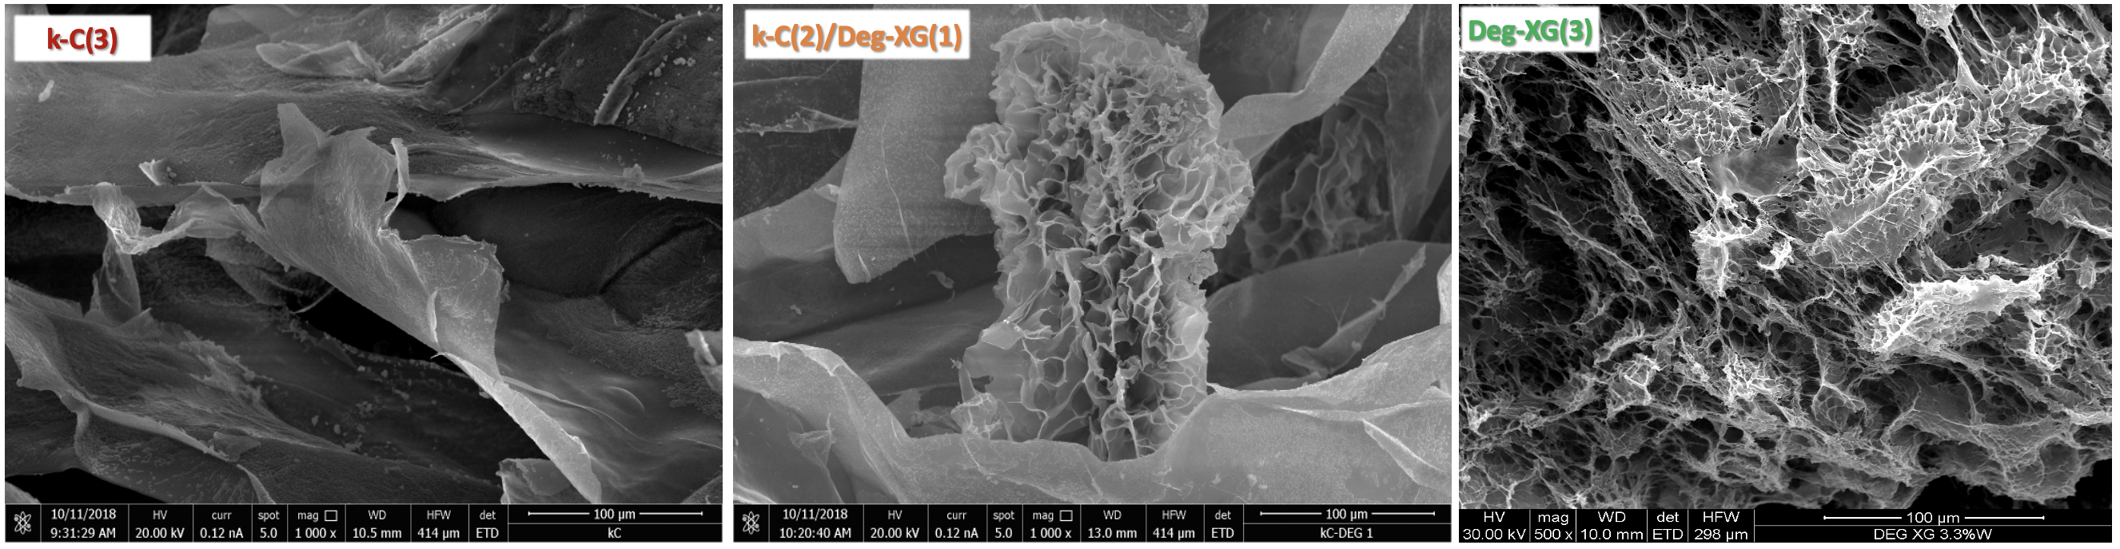
Figure 2: SEM micrographs of freeze-dried polysaccharide hydrogels at equal total polymer concentration: k-C(3), Deg-XG(3), and k-C(2)/Deg-XG(1).
Biological compatibility was assed preliminary though optical microscopy images that show the morphology of adipose-derived stem cell spheroids (S-ASCs) incubated with the individual component of the blend, Deg-XG(1) and k-C(2) hydrogels, over 1, 7, and 21 days (Figure 3a). In all conditions, S-ASCs retain their spheroidal organization and characteristic morphology, with no evident signs of cell damage, disaggregation, or abnormal spreading over time. This behavior indicates that both polysaccharide matrices provide a cytocompatible environment capable of supporting cell viability during prolonged incubation. In Deg-XG(1), spheroids appear well distributed within the hydrogel, consistent with the softer and more hydrated network, which likely facilitates nutrient diffusion and mass transport. In k-C(2), spheroids remain intact and localized, reflecting the denser gel structure while still preserving cell morphology. Importantly, no morphological differences suggesting cytotoxic effects or stress responses are observed up to 21 days in either system. These results demonstrate that both k-C and Deg-XG hydrogels are biologically suitable and compatible with stem cell spheroids, satisfying a key requirement for bio-ink materials for scaffolds. Further quantitative viability and differentiation studies are beyond the scope of the present work.
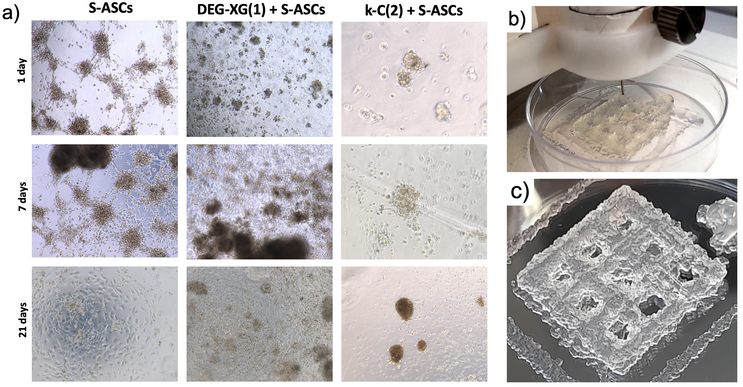
Figure 3: a) Optical microscopy S-ASCs incubated with the individual component of the blend, Deg-XG(1) and k-C(2) hydrogels, over 1, 7, and 21 days. b) and c) 3D printed k-C(2)/Deg-XG(1).
Preliminary 3D printing tests have been carried out on the k-C(2)/Deg-XG(1). Printing paramenter such as Fill Density, Printing Temperature, Retraction, Print Speed and Input Flow were varied in several attempt to obtain a 3D printed strcuture. The first attempts performed at temperatures below 50 °C, failed even changing the other parameters. When the printing temperature was set to 65 °C the prints improved till reaching the results shown in Figure 3 b-c, after further adjustments. Although the print results a bit rough in definition, the hydrogel resulted printable. The printing flow resulted homogeneous and continuous, the thickness of the printed strand resulted of ~3 mm, and this encourage the research to further continue to explore and find the best possible parameters to print the hydrogel.
When considered together with the favorable rheological and microstructural properties of the k-C/Deg-XG blend, these findings support its use as a cell-friendly bio-ink for extrusion-based 3D bioprinting of soft tissue constructs, although further quantitative viability and differentiation analyses are necessary.
Conclusions
In this work, fully bio-based hydrogels composed of κ-carrageenan and degalactosylated xyloglucan were investigated as sustainable bioinks for 3D printing in tissue engineering applications. The combination of these two plant-derived polysaccharides enables the formation of thermoresponsive, cytocompatible hydrogels that address key limitations of κ-carrageenan when used alone, while preserving a renewable and scalable material platform.
Rheological analyses demonstrated that the mechanical response of the k-C/Deg-XG hydrogels is primarily governed by the k-C network, and the presence of Deg-XG acts as a functional modifier, improving filament stability and print fidelity compared to pure k-C formulations.
Morphological investigations revealed that blending Deg-XG with k-C results in a more open and interconnected microstructure advantageous for tissue engineering, as it enhances potential mass transport and cell–matrix interactions.
Preliminary biological evaluations confirmed that S-ASCs retained their morphology over extended culture times, indicating the absence of cytotoxic effects and the ability of the hydrogels to support cell viability.
Finally, 3D printing trials demonstrated that the k-C(2)/Deg-XG(1) formulation is printable under optimized thermal conditions, producing continuous and homogeneous filaments. Although further refinement of printing parameters is needed to improve resolution and surface definition, these results confirm the practical processability of the hydrogel blend as a bioink.
These findings support their further development for sustainable bioprinting of soft tissue scaffolds, with future studies focusing on quantitative cell viability, differentiation, and long-term tissue maturation within printed constructs.
Fundings
European Union – NextGenerationEU through the Italian Ministry of University and Research under the PNRR – M4C2-I1.3 Project PE_00000019 “HEAL ITALIA” CUP B73C22001250006.
References
Brun-Graeppi, A.K.A.S., Richard, C., Bessodes, M., Scherman, D., Narita, T., Ducouret, G., Merten, O.-W., 2010. Study on the sol–gel transition of xyloglucan hydrogels. Carbohydrate Polymers 80, 555–562.
Chia, H.N., Wu, B.M., 2015. Recent advances in 3D printing of biomaterials. J Biol Eng 9, 4.
Chimene, D., Lennox, K.K., Kaunas, R.R., Gaharwar, A.K., 2016. Advanced Bioinks for 3D Printing: A Materials Science Perspective. Ann Biomed Eng 44, 2090–2102.
Di Stefano, A.B., Muscolino, E., Trapani, M., Moschella, F., Corradino, B., Toia, F., Cordova, A., Dispenza, C., 2025. Partially degalactosylated xyloglucan hydrogel artificial niches enhance human spheroids derived from adipose stem cells stemness and differentiation potential. Carbohydrate Polymer Technologies and Applications 9, 100652.
Gungor-Ozkerim, P.S., Inci, I., Zhang, Y.S., Khademhosseini, A., Dokmeci, M.R., 2018. Bioinks for 3D bioprinting: an overview. Biomater. Sci. 6, 915–946.
Mangione, M.R., Giacomazza, D., Bulone, D., Martorana, V., Cavallaro, G., San Biagio, P.L., 2005. K+ and Na+ effects on the gelation properties of κ-Carrageenan. Biophysical Chemistry 113, 129–135.
Muscolino, E., Di Stefano, A.B., Toia, F., Giacomazza, D., Moschella, F., Cordova, A., Dispenza, C., 2024. Xyloglucan, alginate and k-carrageenan hydrogels on spheroids of adipose stem cells survival; preparation, mechanical characterization, morphological analysis and injectability. Carbohydrate Polymer Technologies and Applications 8, 100566.
Muscolino, E., Dispenza, C., 2025. Bio-based hydrogel patches made of κ-carrageenan enriched with degalactosylated xyloglucan for wound dressing applications. Biomolecular Concepts 16, 20250056.
Necas, J., Bartosikova, L., 2013. Carrageenan: a review. Veterinarni Medicina 58, 187–205.
Picone, P., Muscolino, E., Girgenti, A., Testa, M., Giacomazza, D., Dispenza, C., Nuzzo, D., 2024. Mitochondria embedded in degalactosylated xyloglucan hydrogels to improve mitochondrial transplantation. Carbohydrate Polymer Technologies and Applications 8, 100543.
Shirakawa, M., Yamatoya, K., Nishinari, K., 1998. Tailoring of xyloglucan properties using an enzyme. Food Hydrocolloids 12, 25–28.
Visscher, D.O., Gleadall, A., Buskermolen, J.K., Burla, F., Segal, J., Koenderink, G.H., Helder, M.N., van Zuijlen, P.P.M., 2019. Design and fabrication of a hybrid alginate hydrogel/poly(ε‐caprolactone) mold for auricular cartilage reconstruction. J. Biomed. Mater. Res. 107, 1711–1721.

