 CHEMICAL ENGINEERING TRANSACTIONS  VOL. xxx, 2026 | A publication of  
The Italian Association
of Chemical Engineering
Online at www.cetjournal.it

Guest Editors: Marco Bravi, Antonio Marzocchella, Giuseppe Caputo
Copyright © 2026, AIDIC Servizi S.r.l.
ISBN 979-12-81206-xx-x; ISSN 2283-9216

Electron-beam irradiation-sculptured nanogels as drug delivery systems for prostate cancer treatment
Francesca Foto^{1,2}, Federica Seidita ^{1,3}, Nouria Bouchikhi ⁴, Viviana Benfante⁵, Pierpaolo Alongi ^{5,6}, Albert Comelli ², Clelia Dispenza¹
1 Dipartimento di Ingegneria, Università̀ degli Studi di Palermo, Viale delle Scienze 6, 90128, Palermo, Italia
2 Ri.MED Foundation, Via Bandiera 11, 90133 Palermo, Italy
3 Institute for Bioengineering of Catalonia (IBEC), Carrer de Baldiri Reixac, 10, 12, Les Corts, 08028 Barcelona, Spagna
4 Centre de Recherche Scientifique et Technique en Analyses Physico-chimiques, BP 384, Zone Industrielle Bou-ismail, RP 42004 Tipaza, Algeria
5 Advanced Diagnostic Imaging-INNOVA Project, Department of Radiological Sciences, A.R.N.A.S. Civico Di Cristina e Benfratelli Hospitals, P.zza N. Leotta 4, 90127 Palermo, Italy
6 Department of Biomedicine, Neuroscience and Advanced Diagnostics (BiND), University of Palermo, Palermo, 90127, Italy
francesca.foto@unipa.it

Poly(N-vinylpyrrolidone) (PVP) nanogels were synthesized via electron-beam irradiation and subsequently functionalized as targeted nanochemotherapeutic systems for prostate cancer. In particular, in this work, PVP-co-acrylic acid nanogels (05AA50) were obtained by radiation-induced crosslinking of PVP and simultaneous grafting of acrylic acid (AA) at 40kGy of irradiation dose using an industrial linear accelerator. These nanogels were subsequently functionalised with a Glu-urea-Glu tripeptide binding to the prostate-Specific Membrane Antigen (PSMA), that can provide the nanogels with active targeting features, and in parallel loaded with a model chemotherapeutic drug, doxorubicin (DOXO). The successful conjugation of the PSMA targeting ligand and doxorubicin (DOXO) to the nanogels was confirmed by UV–Vis fluorescence spectroscopy. Structural effects on the nanogel induced by DOXO incorporation were investigated by attenuated total reflectance Fourier-transform infrared spectroscopy (ATR-FTIR). Multi-angle dynamic light scattering (DLS) and ζ-potential measurements were conducted before DOXO loading to verify the preservation of the nanometric size distribution and the negative surface charge density of the nanogels. Taken together, these results indicate that 05AA50 represents a promising nanoplatform for the development of target-specific nano-chemotherapeutics for prostate cancer.
  - Introduction
Prostate cancer is among the most prevalent malignancies in the male population and represents one of the leading causes of cancer-related morbidity and mortality worldwide (Sung et al., 2021). Advances in diagnostic technologies and increased life expectancy have contributed to a continuous rise in incidence, making this disease a major clinical and socio-economic challenge (Gandaglia et al., 2021). Although conventional therapeutic approaches such as surgery, radiotherapy and androgen deprivation therapy are well established and effective in early-stage disease, advanced and metastatic forms remain associated with poor prognosis and require prolonged systemic treatments, which frequently lead to unsatisfactory outcomes (Teo et al., 2019).
Systemic chemotherapy continues to be a cornerstone in the management of hormone-refractory cases; however, its clinical efficacy is significantly hindered by well-known limitations, including insufficient selectivity toward cancer cells, the development of multidrug resistance and the occurrence of severe adverse effects (Schirrmacher, 2019). DOXO is a broad-spectrum chemotherapeutic agent widely employed in the treatment of solid tumours and haematological malignancies, but its therapeutic potential is restricted by cumulative cardiotoxicity and non-specific biodistribution, resulting in systemic toxicity and preventing dose escalation (Rivankar, 2023).
In recent years, increasing attention has been devoted to nanotechnology-based drug delivery systems capable of improving the therapeutic index of anticancer agents by enhancing their accumulation within the tumour microenvironment (Peer et al., 2007). Among these, polymeric nanogels—three-dimensional hydrophilic networks with characteristic diameters between 20 nm and 200 nm—represent a promising class of nanocarriers due to their biocompatibility, colloidal stability and ability to encapsulate or conjugate bioactive molecules for controlled release (Kabanov and Vinogradov, 2009). E-beam irradiation is a simple and effective methodology to generate nanogels from aqueous solutions of suitable polymers. Poly (N-vinyl pyrrolidone) is particularly suitable as starting material, due to its water solubility, coiled conformation in semi-diluted aqueous solutions, biocompatibility and well-established pharmaceutical use. When exposed to electron beam irradiation in aqueous media, PVP coils undergo intermolecular crosslinking without the need for chemical initiators or surfactants, and - provided that the doses are within the sterilisation dose range - the process simultaneously sterilises the final dispersions (Grimaldi N. et al. 2014)
In the present work, a PVP-based nanogel system functionalized with acrylic acid was produced via pulsed electron-beam irradiation. Irradiation conditions were optimized to yield nanogels with a controlled size distribution and negative surface charge, thereby minimizing opsonization and premature clearance from circulation while promoting enhanced tumor penetration and retention within the tumor microenvironment. The resulting nanogels present both carboxyl and primary amine functionalities enabling drug conjugation and functionalization with prostate cell–membrane receptor ligands. (Ditta et al. 2019) These nanogels have been decorated with therapeutic proteins, antibodies and oligonucleotides (Dispenza et al. 2017, Picone P. et al. 2016).
Among the various formulations obtainable by varying the polymer and monomer concentrations in water, the irradiation conditions (i.e. electron-beam pulse current and frequency, and total absorbed dose), and the gaseous atmosphere during irradiation, the system designated 05AA50 was selected for this study. It was simply prepared from a 0.5% w/w aqueous PVP solution with a small addition of AA (PVP repeating unit–to–AA molar ratio of 50:1). The solution was deaerated and saturated with N₂O prior to irradiation and subsequently exposed to a total absorbed dose of 40 kGy in a single pass under the electron beam. The irradiation dose grants system sterility. The resulting base nanogels were then subjected to two chemical modifications: functionalization with a targeting ligand and covalent conjugation of DOXO. For the first modification, a primary amino group modified tripeptide that targets PSMA, a receptor overexpressed in advanced prostate cancer (Ghosh and Heston, 2004; Ngen EJ et al., 2021), was used. The second modification was performed to bind DOXO. The covalent attachment of a few DOXO molecules can offer a template for further stacking. DOXO contains rigid, planar, fused aromatic rings that can engage in π−π stacking interactions. At mildly acidic to neutral pH (6.5-7.4) the partial protonation of DOXO’s amine preserves aromatic stacking while allowing additional hydrogen bonding with carbonyl groups of PVP, which stabilises the loaded state. At the tumour site—and more markedly within endosomal compartments—the acidic microenvironment shifts doxorubicin’s protonation equilibrium toward its cationic form, weakening π–π interactions and promoting pH-triggered drug release. (Liu et al. 2009) The successful attachment of the PSMA ligand and DOXO loading were confirmed by UV-Vis fluorescence spectroscopy. Both modifications required the preliminary activation of the carboxyl groups via EDC/suflo-NHS chemistry of the 05AA50 nanogel, but while of the low molecular weight, hydrophilic PSMA ligand is not expected to affect the colloidal stability of the nanogel, much more delicate is the process of DOXO loading because a too high DOXO loading can cause nanogels flocculation and precipitation. Multi-angle dynamic light scattering (DLS) and ζ-potential analyses were performed before and after the conjugation, to verify that the nanometric particle size and negative surface charge density of the nanogels were both preserved. Infrared spectroscopy was employed to probe the nanogel network after DOXO conjugation.
  - Materials and methods
    - Materials
Poly(N-vinylpyrrolidone) (PVP K60, 45 % w/w aqueous solution, Mw ≈ 160 kDa), acrylic acid (AA), doxorubicin hydrochloride (DOXO·HCl),1-ethyl-3-(3-dimethylaminopropyl)carbodiimide hydrochloride (EDC) and N-hydroxysulfosuccinimide (Sulfo-NHS) were all purchased from Sigma-Aldrich (Merck, Darmstadt, Germany) and used without further purification. The Vipivotide tetraxetan ligand-linker conjugate (here named PSMA) was purchased from MedChemExpress (Monmouth Junction, NJ, USA). All reactions were carried out dissolving 2-(N-morpholino)ethanesulfonic acid (MES) in Milli-Q water (0.1 M, pH 5.5). Dialysis procedures were performed using regenerated cellulose membranes (Cellulose membrane tubing – Sigma-Aldrich, St. Louis, MO, USA) with a molecular weight cut-off of 14 kDa, activated by double boiling prior to use. Sterile filtration of solutions, when required, was carried out using 0.22 μm cellulose acetate syringe filters.
2.2 Methods
2.2.1Synthesis of PVP/AA nanogels
Aqueous solutions of PVP (0.5 % w/w) and acrylic acid (AA) were prepared by setting a molar ratio of 1:50 between the PVP repeating units and acrylic acid, corresponding to the presence of one acrylic acid molecule every 50 repeating units of the polymer. The solutions were subsequently saturated with nitrous oxide (N₂O) and irradiated with a pulsed electron beam to a total absorbed dose of 40 kGy using a linear accelerator (LINAC, INCT, Warsaw). Selected nanogels were then purified by dialysis for 24 h using a 14 kDa molecular weight cut-off membrane against Milli-Q water.
2.2.2 Conjugation of PSMA ligand
Nanogels were dispersed in MES buffer (pH 5.5) and carboxyl groups were activated by the sequential addition of EDC and Sulfo-NHS (1:2 molar ratio), followed by 30 min of stirring at room temperature. Subsequently, the PSMA-targeting ligand was added to the dispersion to reach a final concentration of 0.0079 mM. The reaction was allowed to proceed for 4 h under continuous stirring at room temperature. The functionalized product (05AA50-PSMA) was purified via a 5-day dialysis (14 kDa MWCO) against Milli-Q water to remove any unreacted ligand and by-products.
2.2.3 Conjugation of DOXO
Nanogels were dispersed in MES buffer (pH 5.5) and their carboxyl groups were activated by sequential addition of EDC and Sulfo-NHS (1:2 molar ratio), followed by 30 min stirring at room temperature. Specifically, an aliquot of 0.228 mL of DOXO aqueous solution was added to 5.015 mL of activated nanogel dispersion to reach a final drug concentration of 0.15 mM.. After 4 h reaction, the conjugate (05AA50-DOXO) was purified via 5 day dialysis to remove unbound drug and by-products.
2.2.4 UV-Vis fluorescence spectroscopy
Fluorescence spectroscopy measurements were performed using a JASCO FP-8350 spectrofluorometer. Analyses were carried out at room temperature in MES buffer on dispersions of bare nanogels, PSMA ligand, PSMA-functionalized nanogels, doxorubicin (DOXO), and DOXO-conjugated nanogels. Emission spectra were recorded using an excitation wavelength of 270 nm for all samples. Fluorescence emission was collected in the 300–700 nm range. Additionally, bare nanogels, DOXO, and DOXO-conjugated nanogels were also analyzed using an excitation of 480 nm and fluorescence emission was collected in the 500-700 nm wavelength range.
2.2.5 ATR-FTIR analysis
FTIR spectra were recorded on pristine nanogels and nanogels conjugated with doxorubicin. All samples were freeze-dried prior to analysis. Measurements were performed using an ATR-FTIR spectrometer Nicolet iS50 Analytical Flex FTIR spectrometer (Thermo Fisher Scientific, Waltham, MA, USA) placing the lyophilised powders directly onto the ATR crystal after background acquisition.
2.2.6 Multi-angle dynamic light scattering and ζ-potential measurements
The average hydrodynamic diameter (Z-average), size distribution, and ζ-potential of the nanogels were determined by Multi-Angle Dynamic Light Scattering (MADLS) and electrophoretic light scattering (ELS) using a Zetasizer Ultra (Malvern Panalytical, UK), equipped with MADLS technology and a He–Ne laser operating at 633 nm. Prior to measurements, samples were filtered through 0.22 µm filters, and diluted with Milli-Q water to a final concentration of 0.5 mg/mL at room temperature. Particle size measurements in MADLS mode were performed by loading the samples into 12 mm square polystyrene cuvettes (DTS0012, Malvern Panalytical), recording light scattering at multiple angles (173°, 90° and 17°). Bare nanogels were dialyzed for one day against water prior to analysis.
  - Results and discussion
Figure 1a shows the fluorescence spectra of the base nanogel 05AA50, the PSMA ligand, and the PSMA-functionalized nanogel (05AA50-PSMA) in MES buffer after excitation at λ = 270 nm. Figure 1b shows the fluorescence spectra of 05AA50, DOXO and the 05AA50–DOXO conjugate after excitation at λ = 270 nm, while Figure 1c reports the fluorescence spectra of DOXO, bare nanogels and nanogel–DOXO conjugates after excitation at λ = 480 nm, corresponding to the π–π* electronic transitions of the anthracycline chromophore. All fluorescence spectra of the nanogel conjugates clearly exhibit the characteristic features of the covalently attached species, either the PSMA ligand or the drug.
When excited at λ = 270 nm, the pristine nanogel dispersion diluted in MES buffer shows negligible fluorescence emission, whereas the PSMA ligand displays a distinct emission peak with a maximum at 330 nm. Interestingly, the 05AA50-PSMA system exhibits three emission bands: one corresponding to the PSMA emission, slightly red-shifted to 336 nm, and two broader, partially overlapping bands at higher wavelengths, which can be attributed to fluorescence contributions from the 05AA50 nanogel after conjugation with PSMA. It is worth noting that linear PVP is essentially non-fluorescent, as excited states mainly relax through non-radiative pathways (internal conversion and vibrational relaxation) in the absence of rigid or conjugated emissive structures. Upon irradiation, backbone double bonds formed via radical disproportionation reactions and the presence of crosslinks reduce vibrational freedom, suppressing non-radiative decay of carbonyl n → π* transitions.
The fluorescence spectra of 05AA50–DOXO conjugates were also collected after excitation at 270 nm. Although this wavelength does not correspond to the absorption maximum of doxorubicin, it still produces a broad emission band centered at approximately 560 nm, with a tail at 580–600 nm, characteristic of free DOXO (see Figure 1b). The observed blue shift of the emission maximum can be attributed to conjugation and/or π–π stacking interactions. Notably, the nanogel emission band at approximately 410 nm is strongly enhanced after conjugation with DOXO. This enhancement may be attributed to conformational rigidification of nanogel chromophores induced by the bulky aromatic drug, which suppresses non-radiative relaxation pathways, and/or to non-radiative energy transfer from the drug to the polymeric network. The fluorescence spectra collected after excitation at 480 nm (Figure 1c) further confirm the attribution of the higher-wavelength emission band to DOXO and its successful conjugation to the nanogel.

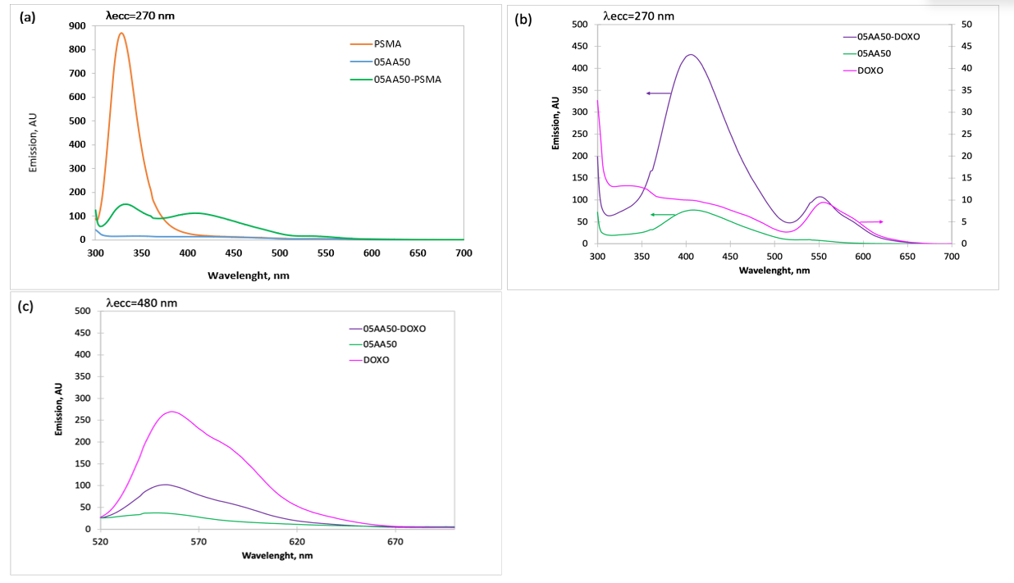
Figure 1. UV-vis fluorescence spectra of PSMA_ligand, bare nanogel and nanogel-PSMA_ligand conjugate (05AA50-PSMA) (a); DOXO, bare nanogel and nanogel-DOXO conjugate (b). Excitation wavelength is 270 nm. In the inset, magnification of a portion of the emission spectrum of the bare nanogel.
Figure 2 shows the ATR-FTIR spectra of the 05AA50 and 05AA50-DOXO conjugates. The FTIR spectra of the nanogel–DOXO conjugate closely resemble the one of the pristine nanogel. Minor differences are present in the carbonyl envelope band, probably due to interactions with DOXO and/or changes in H-bonding. The apparent invariance of the FTIR spectra, despite pronounced fluorescence changes, reflects the fundamentally different sensitivities of vibrational and excited-state spectroscopies. Due to the low relative drug content and the extensive overlap of DOXO vibrational modes with those of the polymer matrix, FTIR spectra do not reveal the presence of DOXO. In contrast, fluorescence spectroscopy, that is highly sensitive to local electronic environments and excited-state interactions, reflect significant changes occurring to both the nanogel and the drug chromophores. The combined spectroscopic evidence thus indicates successful DOXO conjugation, while preserving the chemical integrity of the nanogel backbone.
Figure 2. ATR-FTIR spectra of bare nanogel (05AA50) and its DOXO conjugated variant (05AA50-DOXO). In the inset, magnification of the 1800-1500 cm⁻¹ spectral range. Spectra are normalised with respect to the absorbance at 1661 cm-1, relative to the carbonyl groups
Dynamic light scattering (DLS) measurements performed in multi-angle mode revealed that the bare 05AA50 nanogels exhibit a bimodal size distribution (Table 1), with population maxima centered at approximately 25 nm and 148 nm. Owing to the strong size dependence of light scattering, the larger particle population accounts for roughly 90% of the total scattered intensity. Functionalization with the PSMA ligand does not induce any significant changes in the particle size distribution (data not shown), whereas conjugation with DOXO results in an average size increase of approximately 30%. Nevertheless, the nanogel system remains colloidally stable and well within the targeted particle size range.
Figure 3 shows the particle size distributions of the nanogel and nanogel-DOXO conjugate by intensity (Figure 3a) and by number (Figure 3b). The comparison between the two panels shows how the most significant population of nanoparticles by number in 05AA50 is the one with the smallest hydrodynamic diameter, that has a narrow size distribution, that becomes even narrower after conjugation with DOXO, probably due to reduced hydrophilicity. ζ-potential measurements confirm that the bare nanogels possess a negative surface charge and that DOXO conjugation does not compromise this favorable property.
Table 1. Hydrodynamic diameters and ζ-potential values of nanogels and their conjugates with DOXO
Sample Name |  | Dh (nm), Peak 1 |  | Area (%), Peak 1 |  |  | Dh (nm), Peak 2 |  |  | Area (%), Peak 2 |  | ζ-potential (mV)
05AA50 | 113,3 |  | 89,2 |  |  | 25,2 |  | 10,8 |  |  | -22,8 ± 1,3
05AA50-DOXO | 147,8 |  | 87,3 |  | 32,8 |  |  |  | 12,7 |  |  | -29,5 ± 2,5

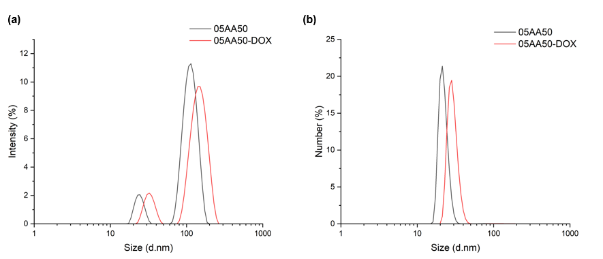
Figure 3. Particle size distributions of bare nanogels (05AA50) and DOXO-conjugated nanogels (05AA50-DOXO) by MADLS: (a) intensity and (b) number.
4. Conclusions
Nanogels based on PVP and functionalized with acrylic acid can be decorated with a PSMA ligand to target specifically prostate cancer cells and be loaded with doxorubicin. Both conjugations, with DOXO and the PSMA ligand, have been carried out by activating the carboxyl groups of the nanogel using EDC/sulfo-NHS ester chemistry and promoting amide bond formation. While modification with the PSMA linker has a limited impact on the colloidal properties of the nanogels—owing to its hydrophilicity and structural similarity to PVP—doxorubicin behaves differently. When loaded at pH 5.5, where it is predominantly protonated, doxorubicin can interact attractively with the negatively charged nanogels. Local deprotonation at the nanogel interface may occur, increasing its reactivity while also enhancing its hydrophobic character. As a result, doxorubicin can be both partially covalently linked and partially adsorbed, the latter being stabilized by hydrophobic interactions and π–π stacking between free molecules and those chemically bound to the nanogel. This strong interaction with the nanogel is supported by fluorescence spectra of the nanogels collected before and after conjugation upon excitation at 270 nm. The presence of DOXO clearly enhances the emissive behavior of the nanogel fluorophores, which in turn efficiently excite DOXO emission. The two components therefore act as a donor–acceptor Förster resonance energy transfer (FRET) pair. This effect, demonstrated here for the first time, will be used to investigate DOXO release behavior in simulated biological media.
ATR-FTIR and MADLS analyses of nanogel-DOXO conjugates indicate that the covalent modification of the nanogel preserves the structural integrity of the network and its colloidal properties. Both particle size distribution and the surface charge density are not detrimentally affected by the loaded DOXO. Based on these results, the nanodevice will be further engineered by coupling the two modifications on the same nano-construct and testing it in prostate cancer models in vitro and in vivo.
References
Ditta L.A. et al. 2019, The role of molecular oxygen in the formation of radiation engineered multifunctional nanogels, European Polymer Journal, 169, 108781.
Dispenza C., Sabatino M.A., Grimaldi N., Picone P., Di Carlo M., Ghersi G., 2017, Radiation-engineered PVP-based nanogels for the targeted delivery of oligonucleotides and proteins, RSC Advances, 7(74), 46682-46691.
Gandaglia G., et al., 2021, The epidemiology of prostate cancer, European Urology Oncology, 4, 877–892.
Grimaldi N., Sabatino M.A., Przybytniak G., Kaluska I., Bondì M.L., Bulone D., Alessi S., Spadaro G., Dispenza C., 2014, High-energy radiation processing, a smart approach to obtain PVP-graft-AA nanogels, Radiation Physics and Chemistry, 94, 76-79.
Ghosh A., Heston W.D., 2004, Tumour target prostate-specific membrane antigen (PSMA), Journal of Cellular Biochemistry, 91, 528–539.
Kabanov A.V., Vinogradov S.V., 2009, Nanogels as pharmaceutical carriers, Angewandte Chemie International Edition, 48, 5418–5429.
Liu J., Pang Y., Huang W., Zhu Z., Zhu X., Zhou Y., Yan D., 2009, Redox-responsive polyplexes for gene delivery based on poly(amidoamine) with cystamine in the main chain, Biomaterials, 30, 156-165.
Ngen EJ, Chen Y, Azad BB, Boinapally S, Jacob D, Lisok A, Shen C, Hossain MS, Jin J, Bhujwalla ZM, Pomper MG, Banerjee SR. Prostate-specific membrane antigen (PSMA)-targeted photodynamic therapy enhances the delivery of PSMA-targeted magnetic nanoparticles to PSMA-expressing prostate tumors. Nanotheranostics. 2021 Jan 19;5(2):182-196. doi: 10.7150/ntno.52361. PMID: 33564617; PMCID: PMC7868004.
Peer D., Karp J.M., Hong S., Farokhzad O.C., Margalit R., Langer R., 2007, Nanocarriers as an emerging platform for cancer therapy, Nature Nanotechnology, 2, 751–760.
Picone P., Ditta L.A., Sabatino M.A., Militello V., San Biagio P.L., Di Giacinto M.L., Cristaldi L., Nuzzo D., Dispenza C., Giacomazza D., Di Carlo M., 2016, Ionizing radiation-engineered nanogels as insulin nanocarriers for the treatment of Alzheimer's disease, Biomaterials, 80, 179-194.
Rivankar S., 2023, An overview of doxorubicin-induced cardiotoxicity, Journal of Cancer Research and Therapeutics, 19, 1-6.
Saito G., Swanson J.A., Lee K.D., 2003, Drug delivery strategy utilising conjugation via antigen-specific disulfides, Advanced Drug Delivery Reviews, 55, 199–215.
Schirrmacher V., 2019, From chemotherapy to biological therapy: A review of novel concepts to reduce side effects and overcome resistance, International Journal of Oncology, 54, 407–419.
Sung H., et al., 2021, Global cancer statistics 2020: GLOBOCAN estimates of incidence and mortality worldwide, CA: A Cancer Journal for Clinicians, 71, 209–249.
Teo M.Y., Rathkopf D.E., Kantoff P., 2019, Biology and management of advanced prostate cancer, Annual Review of Medicine, 70, 479–499.

