 CHEMICAL ENGINEERING TRANSACTIONS  VOL. xxx, 2026 | A publication of  
The Italian Association
of Chemical Engineering
Online at www.cetjournal.it

Guest Editors: Marco Bravi, Antonio Marzocchella, Giuseppe Caputo
Copyright © 2026, AIDIC Servizi S.r.l.
ISBN 979-12-81206-xx-x; ISSN 2283-9216

In-line determination of Cupriavidus necator growth phases for optimization of PHB production processes
Lars Häcker, Dmytro S. Golovko, Sara Sory, Karsten Rebner and Daniela Almeida Streitwieser*
Process Analysis & Technology, Reutlingen University of Applied Sciences, 72762 Reutlingen, Germany
* d.almeida_streitwieser@reutlingen-university.de
Climate change and the urgent need for decarbonization of the heavy industry demand innovative solutions that transform waste into value. One promising approach is the biological utilization of CO₂-rich exhaust gases to produce sustainable materials.
The goal of this study was to develop a process strategy for maximizing polyhydroxybutyrate (PHB) production by Cupriavidus necator through optimized nutrient management and real-time in-line process analytics. For this, C. necator was grown in a lab-bioreactor with probes for dissolved oxygen, redox potential, and pH value. The kinetics and metabolic phases were measured using reference analytics such as OD₆₀₀, HPLC-RID and GC. To validate these observations and accurately identify the end of the growth phase, we employed an in-line flow-through cuvette VIS spectroscopy.
We were able to correlate several chemical process parameters to the spectral results of the process analysis technology (PAT). This process analytical approach enables precise control of cultivation conditions, paving the way for efficient PHB production from industrial gas streams.
  - Introduction
Driven by economic and environmental pressures, biotechnology process research has increasingly shifted toward the microbial conversion of low-value and waste-derived substrates into complex, high-value products. In this context, the increasing number of publications in recent years reflects a growing scientific interest in gas fermentation as a key technology for sustainable biomanufacturing. (Pacheco et al., 2023) As an example, Cupriavidus necator has emerged as a model organism for the production of polyhydroxy butyrate (PHB), a biodegradable biopolymer with significant potential to replace fossil-based plastics. (Dürre and Eikmanns, 2015) Owing to its remarkable metabolic versatility, C. necator can utilize a broad range of diverse feedstocks, including food waste, agricultural residues and CO₂ rich gas streams, making it particularly attractive for circular bioeconomy applications and carbon utilization concepts (Morlino et al., 2023). However, efficient PHB production critically depends on the precise control of growth and accumulation phases, highlighting the need for robust, real-time analytical tools to monitor microbial physiology during cultivation.
Therefore, C. necator requires an optimized feeding strategy to achieve optimal growth and product yield. In-process analytics play a critical role in addressing these challenges by enabling real-time or near–real-time insight into key physiological and metabolic states of the culture. Conventional off-line analytical methods, such as gravimetric biomass determination or chromatographic quantification of substrates and products, are labour-intensive, time-delayed, and insufficient for capturing rapid process dynamics. As a result, there is increasing interest in implementing advanced in-process analytical technologies to improve process understanding, robustness, and scalability for C. necator fermentations.
Previous research results at Reutlingen PAT Institute for spectroscopic in-line analysis of bioprocesses were published for human cells (Boldrini et al., 2014; Graf et al., 2022). For bacterial processes, a concept of spectroscopic in-process analysis and the correlation of the parameters for an Escherichia coli fermentation has been published recently (Metcalfe et al., 2020).
This study describes the development and application of in-process analytical methods for monitoring C. necator fermentation. By integrating spectroscopic analytics to conventional process measurements, we aim to enhance real-time visibility into fermentation performance and demonstrate how in-process analytics can support improved process control, accelerated development, and more consistent production outcomes. The findings contribute to the broader adoption of PAT frameworks for microbial bioprocesses involving C. necator, for example, through coordinated changes in nutrient or gas supply. The project concept is presented in Figure 1.
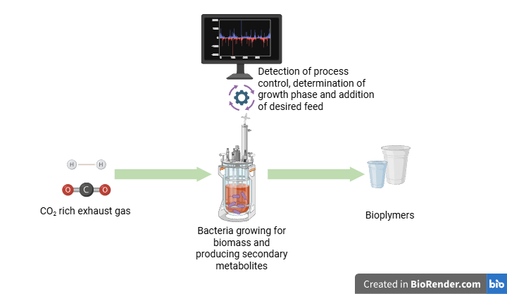
Figure 1 Concept of the CO₂ utilization with in-line real-time process analysis.

  - Materials and methods
    - Bioreactor setup and experimental design
C. necator H 16 (DSM 428) was derived from DSMZ. The medium was prepared according to DSMZ Medium 1 (NB-Medium). Meat extract and peptone were supplied by Carl Roth (Karlsruhe, Germany). The pre-culture was done in 250 mL shaking flasks at 30 °C, 85 rpm.
For the bioprocess, a 2 L double wall Habitat bioreactor (IKA, Freiburg, Germany) is used, equipped with probes for pH (EasyFerm Bio HB K8 225), dissolved oxygen (OxyFerm) and redox (EasyFerm Plus ORP Arc 225) (all Hamilton, Switzerland).
The simplified Setup for the described experiments is shown in Figure 2. The original bioreactor components are shown in the left side, the spectrometric PAT consists out of a lamp, spectrometer and computer for data acquisition. Synthetic air and CO₂ are premixed before they are bubbled into the liquid medium by a sparger. A constant pump flow allows the real-time measurement of the optical density in the flowthrough cuvette. The temperature control as well as the pH-adjusting and antifoam solutions are not shown for clarity.
The settings for the cultivations were 30°C with fixed stirrer speed (250 rpm) and gas supply (0.25 vvm, 80 % synthetic air (Westfalen, Münster, Germany), 20 % CO₂ (Westfalen, Münster, Germany) in NB-Medium. The pH was set to 7.0 ± 0.2 with 50 mL 1 M NaOH (Fisher Chemicals, UK), forming a Carbonate/Bicarbonate buffer system before inoculation. The DO probe was calibrated to 100 % with a flow of 0.25 vvm of synthetic air before the CO₂ was added.
    - In-line Process analytics
The optical measurements were performed using a 5 mm thick quartz cuvette from Hellma GmbH (Germany). The cell suspension was peristaltically pumped (Ismatec MS, Ismatec Laboratoriumstechnik GmbH) through the cuvette with 100 mL per minute during the complete growth process. Optical density was measured with a VIS spectrometer (UV-VIS TIDAS, 400-612 nm) from J&M Analytik AG (Germany) in transmission mode. A deuterium/halogen light source (DH-2000-BAL) was used from Ocean Optics Germany GmbH. The spectra were acquired at 1 min sampling interval with 65 ms integration time and 10 accumulations.

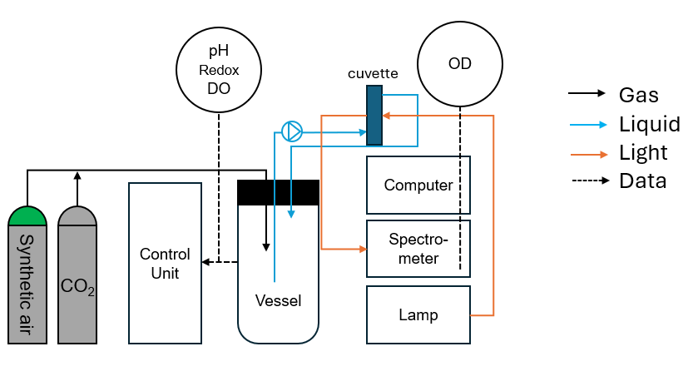
Figure 2 Experimental setup of the bioreactor. Synthetic air and CO₂ are premixed before they are inserted into the vessel by a sparger. A constant pump flow allows the real-time measurement of the optical density in the flowthrough cuvette.

    - Growth determination
For external Growth control, we used a ThermoScientific Evolution Array spectrophotometer with 1 cm single use cuvettes. Living cells were counted on agar plates incubated for at least 36 h. Cell dry mass experiments were done by taking 8 mL of sample, centrifuging at 4500 rpm for 10 minutes, followed by two washing and resuspending steps with PBS buffer. The pellets were dried at 105 °C for 24 h.
    - Characterization methods
For HPLC analytics, an Agilent 1100 series system equipped with a Hi-Plex H, 300 x 7.7 mm (8 % cross linkage, 8 µm particle size) column was used. According to the supplier application note, 0.005 M sulfuric acid was used as eluent with 0.7 mL/min flow rate. The column temperature was set to 60 °C, the RID was heated to 55 °C.
Glucose and Fructose standards were injected as possible heterotrophic carbon sources for substrate consumption analysis. For metabolite analysis, standard solutions containing ethanol, acetic acid, propionic acid, butyric acid and formic acid were injected in concentrations between 0.05 and 2 vol%.
For GC analytics, a gas chromatograph with flame ionization detector (GC/FID) of the type Shimadzu GC 2010 Plus was used, equipped with a capillary column DB FATWAX UI (30 m × 0.25 mm × 0.25 μm). Peak integration and evaluation were carried out using the LabSolutions software (Shimadzu). All measurements were applied with splitless injection on the head space using solid phase membrane extraction method (HS-SPME).
For gas chromatography, helium 5.0 was used as the carrier gas and nitrogen 5.0 as the makeup gas. The FID was operated with hydrogen produced in-house and synthetic air (20.5 vol.% oxygen, balance nitrogen). All gases were supplied by Westfalen (Münster, Germany).
  - Results and discussion
The diagrams in Figure 3 show that the recorded parameters can be used to detect the end of growth for C. necator fermentation. Taking the established method for growth determination, the OD₆₀₀, we see exponential growth between 6 and 21 hours of process time. Before that growth phase, we can consider a lag phase due to the adaption of the bacteria to the conditions in the bioreactor. After 21 hours, the optical density stays constant, indicating a steady bacterial concentration. This growth curve can be described as sigmoidal curve, typical for such growth experiments.
The fermentation in NB-Media with additional CO₂ can be considered a mixotrophic fermentation process. The combination at CO₂ and fatty acids was described by (Jawed et al., 2022). Fatty acids are also important intracellular intermedia for cell growth and PHB formation (Holmes et al., 2025).
The pH value stabilized to 6.8 before inoculation, also increases slightly, but consistent alongside the Optical density. Jin and Kirk (Jin and Kirk, 2018) described the influence of the pH value towards the metabolism of the bacteria. Depending on the pH, redox reactions occur to adapt the intracellular metabolism to the outer conditions. Watching the change of the pH value, or consumption of pH correcting solvents, we can get a clue on the main running reactions and metabolism inside the cell. For increasing pH value, as in this case, the dominant metabolism can be assumed consuming acids and production of reduced metabolites.
Looking at the dissolved oxygen (Figure 3c) saturation in the bioreactor, we can see a strong decrease during the first six hours of fermentation. The saturation was consistent at zero during the following 15 hours before increasing and stabilizing at 50 % between process hour 21 and 23.
The redox potential (Figure 3d) can be described similar to the dissolved oxygen graph This indicates a strong positive correlation between oxygen saturation and redox potential. During the growth phase, the decreasing oxygen saturation is accompanied by a continuous decline in redox potential, reflecting increasingly reducing conditions. Once oxygen levels are restored after the end of growth, the redox potential increases accordingly and stabilizes together with oxygen saturation, indicating a return to more oxidizing and stable conditions.
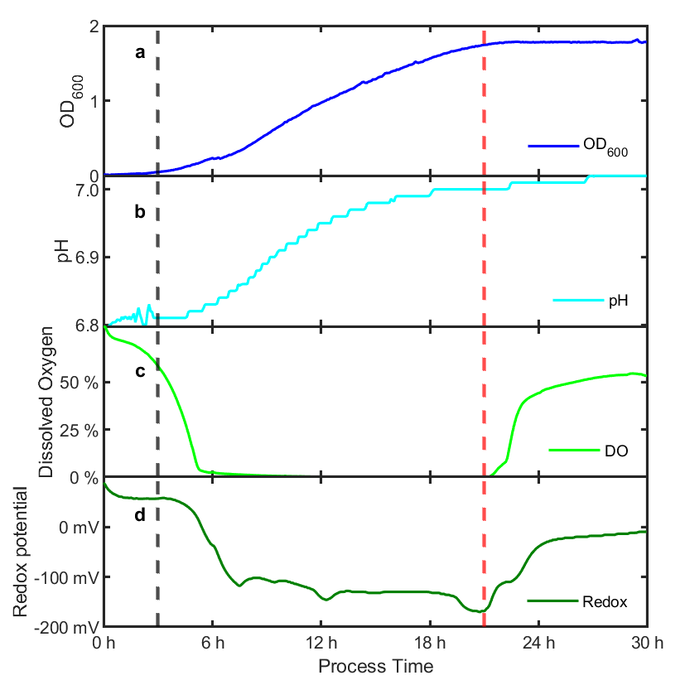
Figure 3 Stacked plots of the recorded parameters. (a) OD₆₀₀ in-line, (b) pH value, (c) dissolved oxygen saturation, (d) redox potential. The black vertical line marks the start of the exponential growth phase, the red line the end of the exponential phase and the begin of the following static process time.

The graphs described above can all be combined to one growth description: We can see a lag phase of the bacteria adapting to the bioreactor with slight growth and minor chemical activity. The following phase can be considered as exponential growth phase, in which we assume due to 0 % oxygen saturation reductive, anaerobic conditions. In the constant phase, we still see oxygen consumption, but neither growth nor major pH changes can be observed.
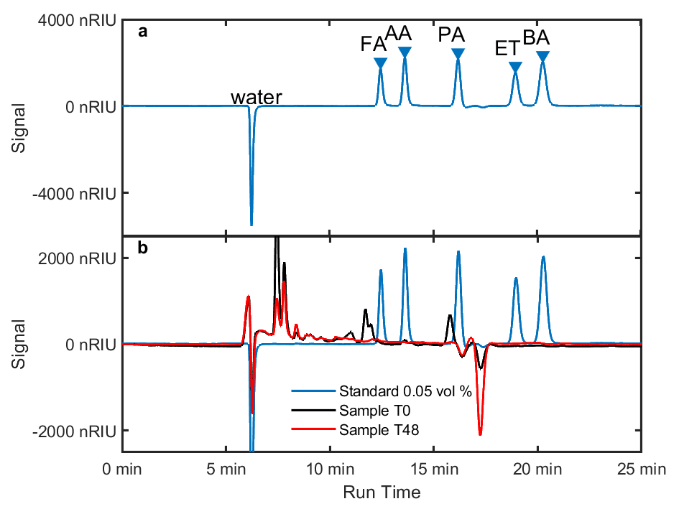
Figure 4 HPLC Chromatograms: (a) HPLC run of the 0.05 vol% standard for a mixture of Ethanol and organic acids in water. The analytes are described as follows (FA: Formic Acid, AA: Acetic Acid, PA: Propionic Acid, ET: Ethanol, BA: Butyric Acid. (b) Comparison of the standard with samples from the start (T0) and the end of the fermentation (T48).

The HPLC chromatograms depicted in Figure 4 show the difficulties in detecting metabolites in complex media. The standard in section (a) shows that the refraction of the solvent water is already higher than of the analytes. In subplots (b) and (c) This standard is compared to samples taken at the start and end of fermentation. Samples taken during the fermentation are not shown, as no clear differences were observed compared to T0 and T48. We know that organic acids are part of the C. necator metabolism (Sohn et al., 2021), but we conclude that these metabolites could not be detected in the external liquid phase under the present conditions. The same was observed by analysing the liquid media phase by HS-SPME GC method. Again, none of the compounds of interest were found in the liquid media phase.
For future experiment setup, we will focus on the following measures:
- Replacing complex media by defined media recipes, to reduce the unknown components in the fermentation process. This will force the bacterium to grow using the intended and defined carbon source. In addition, analysing, understanding and calculating the process will be easier.
- Expanding analysis of the liquid phase by total organic carbon (TOC) determination.
- Establishing a way to measure intracellular components for better understanding of the growth phase. E.g. for PHB forming analysis, we will use established GC-FID methods (Kamasaka et al., 2025).
- Analysing the elementary composition using Elemental Analysis, especially the Nitrogen and Phosphor content of the cell mass to track PHB formation inducing nutrient limitation.
- To expand PAT, we will include Raman and NIR spectroscopy detection of the liquid phase as well as a dual Raman/Mass spectrometric analysis of the exhaust gas stream. We expect to get information about the chemical composition of the liquid phase as well as the gaseous phase.

  - Conclusions
We showed that the end of growth can be determined by several parameters also in complex media. We successfully established HPLC determination of metabolites, though, in the moment, we can only demonstrate they are below the detection limit in the liquid media.
The overall goal of the project is to develop an intelligent system to detect the viability and productivity of C. necator, able to control and correct the process parameters. Seeing these results, we are confident to achieve this goal by implementing further probes. Being an institute with strong knowledge in PAT, we are confident to develop an additional multivariate data analysis and soft-sensor modelling. These tools allow the in-line, non-invasive real-time process analysis and control.
Nomenclature

AA = Acetic Acid
BA = Butyric Acid
CO₂ = Carbon dioxide
ET = Ethanol
FA = Formic Acid
FID = Flame ionization Detection
GC = Gas Chromatography
H₂ = Hydrogen
HPLC = High Performance Liquid Chromatography
NaOH = Sodium hydroxide
NB = Nutrient broth
OD = Optical Density
PA = Propionic Acid
PAT = Process Analysis Technology
PHB = Polyhydroxy butyrate
TOC = Total Organic Carbon

Acknowledgments
The project “SynGas” was funded by BMBF, funding indicator 13FH580KX2.
References
Boldrini B., Drieschner T., Lorenz A., Rebner K., 2014, Multimodal Spectroscopic Investigation for Inline Determination of Cell Viability: MultiSpec@Cell, 10. Kolloquium Prozessanalytik, Gerlingen.
Dürre P., Eikmanns B.J., 2015, C1-carbon sources for chemical and fuel production by microbial gas fermentation, Current Opinion in Biotechnology, 35, 63–72.
Graf A., Lemke J., Schulze M., Soeldner R., Rebner K., Hoehse M., Matuszczyk J., 2022, A Novel Approach for Non-Invasive Continuous In-Line Control of Perfusion Cell Cultivations by Raman Spectroscopy, Frontiers in Bioengineering and Biotechnology, Volume 10 - 2022.
Holmes E.C., Breunig S.L., Johnson C.W., Beckham G.T., Bleem A.C., 2025, Insights into genetic determinants of volatile fatty acid catabolism in Cupriavidus necator H16, Applied and environmental microbiology, 91, e00515-25.
Jawed K., Irorere V.U., Bommareddy R.R., Minton N.P., Kovács K., 2022, Establishing Mixotrophic Growth of Cupriavidus necator H16 on CO2 and Volatile Fatty Acids, Fermentation, 8, 125.
Jin Q., Kirk M.F., 2018, pH as a Primary Control in Environmental Microbiology: 1. Thermodynamic Perspective, Frontiers in Environmental Science, Volume 6 - 2018.
Kamasaka K., Abekawa N., Takeda K., Noi K., Matsuda M., Matsumoto K., Yumoto N., Kondo A., Hasunuma T., 2025, Monitoring proliferation and material production of Cupriavidus necator H16 using cell count and volume measurement, Scientific Reports, 15, 30416.
Metcalfe G.D., Smith T.W., Hippler M., 2020, On-line analysis and in situ pH monitoring of mixed acid fermentation by Escherichia coli using combined FTIR and Raman techniques, Analytical and Bioanalytical Chemistry, 412, 7307–7319.
Morlino M.S., Serna García R., Savio F., Zampieri G., Morosinotto T., Treu L., Campanaro S., 2023, Cupriavidus necator as a platform for polyhydroxyalkanoate production: An overview of strains, metabolism, and modeling approaches, Biotechnology Advances, 69, 108264.
Pacheco M., Moura P., Silva C., 2023, A Systematic Review of Syngas Bioconversion to Value-Added Products from 2012 to 2022, Energies, 16, 3241.
Sohn Y.J., Son J., Jo S.Y., Park S.Y., Yoo J. in, Baritugo K.-A., Na J.G., Choi J., Kim H.T., Joo J.C., Park S.J., 2021, Chemoautotroph Cupriavidus necator as a potential game-changer for global warming and plastic waste problem: A review, Bioresource Technology, 340, 125693.

