 CHEMICAL ENGINEERING TRANSACTIONS  VOL. xxx, 2026 | A publication of  
The Italian Association
of Chemical Engineering
Online at www.cetjournal.it

Guest Editors: Marco Bravi, Antonio Marzocchella, Giuseppe Caputo
Copyright © 2026, AIDIC Servizi S.r.l.
ISBN 979-12-81206-xx-x; ISSN 2283-9216

Avocado-Based Biodiesel as a Tool for Sustainable Energy and Gender Equity in Science
Jade O. Bomfimª, Nicole R. dos Santosª, Pachiele de S. Cabralª, Alison B. Vitor^{b}, Larissa R. Martins^{b}, Ana B. de A. Rodrigues^{c}, Gabrielly de M. Bezerra^{b}, Carine T. Alves^{b*}

ªCentro Territorial of Professional Education of Araci, Ruy Barbosa Av. BR - 116, no number,48760-000 Araci, Bahia, Brazil
^{b}Federal University of Recôncavo of Bahia, Center for Science and Technology in Energy and Sustainability (CETENS), 697 Centenário Av., SIM, 44085-132, Feira de Santana, Bahia, Brazil
^{c}State University of Feira de Santana, Transnordestina Av., Novo Horizonte, no number, 44036-900, Feira de Santana, Bahia, Brazil

*Corresponding Author: carine.alves@ufrb.edu.br

The pursuit of sustainable energy alternatives has driven the development of technologies that utilise agro-industrial residues as renewable energy sources. Among these, avocado-derived biodiesel emerges as a promising substitute for conventional diesel, owing to its high fatty acid content, particularly oleic acid, and its potential for reduced greenhouse gas emissions. This study aimed to evaluate and characterise the oil extracted from avocado pulp for biodiesel production. A total of 1.5 kg of fresh avocado pulp was heated at 230 °C with continuous stirring until a pasty consistency was achieved. The material was then oven-dried at 200 °C for one hour, cooled to room temperature, and ground into a homogeneous mass. Initial oil extraction was performed using artisanal filtration with a cloth coffee filter, followed by manual pressing to separate the crude oil from the solid fraction. The oil was subsequently decanted and filtered to remove residual impurities, yielding approximately 100 mL of crude oil, corresponding to an average extraction efficiency of 6.7% (w/w) relative to the initial mass. The results demonstrate that avocado pulp is a viable feedstock for biodiesel production. It is essential to emphasise that this study focuses on the extraction and physicochemical, spectroscopic, and thermal characterisation of avocado oil as a potential biodiesel feedstock; the production of biodiesel and evaluation of fuel performance were not within the scope of this work. This approach provides preliminary technical data for future conversion studies, thereby contributing to the advancement of sustainable energy solutions. This research is part of the project Biocombustíveis para um Futuro Sustentável: Inspirando Meninas e Mulheres na Ciência (BIOFEMME), which promotes the engagement of women and girls in scientific research and technological innovation.

  - Introduction

The growing demand for sustainable energy sources has driven the development of biofuels capable of reducing dependence on fossil fuels and mitigating the environmental impacts associated with greenhouse gas emissions. In this context, biodiesel stands out as a renewable, biodegradable, and less polluting alternative, produced mainly through the transesterification of vegetable oils rich in triglycerides, which present high technical and energetic viability for this purpose (Demirbas, 2009; Knothe et al., 2010). Vegetable oils have been widely investigated as feedstocks for biodiesel production due to their favourable lipid composition, especially their high content of unsaturated fatty acids, which positively influence properties such as viscosity, oxidative stability, and performance in diesel engines (Atabani et al., 2012). However, the use of refined edible oils raises concerns related to food security and production costs, leading the scientific community to explore crude oils, agro-industrial residues, and alternative biomasses as more sustainable and economically viable lipid sources (Gui et al., 2008). Avocado pulp oil emerges as a promising alternative raw material for biodiesel production, since it does not directly compete with edible oil supply chains and contributes to the valorisation of waste (Rodríguez-Martínez et al., 2022). Avocado (Persea americana Mill.) is a tropical and subtropical fruit widely cultivated in Latin America, Africa, and Asia, with global production showing significant growth in recent decades, reaching over 10.5 million tons in 2023 (FAOSTAT, 2024). The fruit is widely consumed fresh or processed into products such as pulp, oil, cosmetics, and functional food ingredients. However, the expansion of the production chain and large-scale processing result in the generation of significant volumes of agro-industrial waste, especially overripe fruit and discarded pulp, which are often underutilized or managed inadequately, causing economic losses and potential environmental impacts (Oke et al, 2025). Recent studies have further demonstrated the versatility of avocado biomass in integrated biorefinery structures, enabling the production of edible oil, bio-oil, biochar, and biogas from different fractions of the fruit, thus expanding its industrial, energy, and sustainability-oriented applications (Malagn-Romero et al, 2026). In parallel, international studies demonstrate that crude vegetable oils can be used for biodiesel production provided that their physicochemical, thermal, and structural properties are properly characterized, since parameters such as free fatty acid content, thermal stability, and degradation behaviour directly affect the efficiency of the transesterification process and the quality of the resulting biofuel (Ramos et al., 2017). Therefore, analytical techniques such as Fourier transform infrared spectroscopy (FTIR) and thermogravimetric analysis (TG/DTG) are fundamental tools for assessing the energetic potential of vegetable oils intended for biofuel applications (Knothe, 2006). Beyond technical and scientific advances, biofuel research has increasingly incorporated discussions related to social inclusion and gender equity in science. Recent bibliometric analyses indicate that, although scientific output in the biofuels field has grown significantly in recent years, female participation remains uneven in terms of authorship and scientific leadership, highlighting the need for initiatives that promote the inclusion of girls and women in energy and technological sciences (Vitor et al., 2025). In this context, the present study is part of the project Biofuels for a Sustainable Future: Inspiring Girls and Women in Science (BIOFEMME), which integrates applied research, science education, and social inclusion, contributing to sustainable development and the democratization of scientific knowledge. Therefore, this study aims to evaluate and characterize oil extracted from avocado pulp residues as a potential feedstock for biodiesel production, emphasizing sustainable resource utilization and educational engagement. The scope of the investigation is limited to oil extraction and its physicochemical, spectroscopic, and thermal characterization, without addressing biodiesel synthesis or fuel property evaluation. By combining experimental investigation with a gender-inclusive scientific approach, this work contributes to both the advancement of renewable biofuels and the promotion of equity in science and technology.

  - Materials and methods

Avocado oil (figure 1) was obtained using a homemade protocol developed by students at the Territorial Center for Professional Education of Araci, Bahia, Brazil. The avocado pulp was transferred to a blender and homogenized until a pasty consistency like a smooth cream was achieved. The resulting mass was then placed in a stainless-steel pan and heated over moderate heat for a few minutes until boiling began. During heating, a gradual change in colour to darker tones and water evaporation were observed, until the mass began to detach from the bottom and sides of the pan, indicating that it had reached the appropriate point for oil extraction. After cooking, the sample was carefully transferred to a clean tray and dried in an oven at 200 °C for approximately 70 minutes, until reaching a near-complete dryness while still warm, which facilitated subsequent handling. A simple filtration step was then performed using a cloth coffee filter, allowing preliminary separation of coarse residues by gentle manual compression. The filtered material was placed in an appropriate container and stored at room temperature, which favours natural oil decantation, preserves physicochemical properties, and prevents the formation of undesirable emulsions.

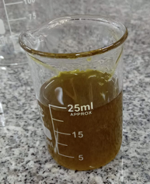
Figure 1: Avocado oil extracted

The oily fraction, concentrated on the surface of the container due to its lower density, was collected using a 20 mL syringe and divided into twelve 15 mL Falcon tubes, each containing approximately 10 mL of sample, ensuring uniformity for subsequent analyses. The samples were then sent to the Municipal Laboratory of Araci, where they underwent centrifugation for 20 minutes, allowing impurities to settle at the bottom and further refining the oil fraction. This step was essential to simplify the analyses and enable accurate characterization of the oil’s physicochemical properties. The analyses performed included moisture content, density, relative viscosity, and acidity, all conducted in triplicate using simple and accessible methods to ensure reproducibility and reliability of the results. The samples were subsequently sent to the Federal University of Bahia (UFBA) for instrumental analysis of lipid composition and spectroscopic characterization. Triglyceride (TG) composition was evaluated according to the methodology described by Lago et al. (1989), enabling identification of the main triglyceride species present in the oil. Fourier Transform Infrared (FTIR) spectroscopy was employed to obtain characteristic spectra of the oils, allowing analysis of functional groups and bands related to triglycerides, following the methodology reported by Mueller et al. (2013). Although the oil extraction protocol adopted in this study differs from conventional solvent-based or mechanical extraction techniques commonly reported for biodiesel feedstocks, it is consistent with simplified extraction approaches assisted by heating that have been previously described for oleaginous pulps, such as avocado (Flores et al., 2019). From a methodological perspective, the rigor of the study was ensured through the use of standardized physicochemical analyses performed in triplicate, as well as spectroscopic (FTIR) and thermogravimetric (TG/DTG) techniques widely employed in biodiesel research to evaluate feedstock suitability. The selected parameters—moisture content, density, relative viscosity, acidity, functional groups, and thermal stability—are routinely assessed in studies involving vegetable oils before transesterification and are directly related to processing efficiency and fuel quality. Therefore, despite the simplicity of the extraction step, the analytical methodology adopted allows reliable comparison with data reported for oils obtained using standard extraction protocols, providing a consistent technical basis for evaluating avocado oil as a potential biodiesel feedstock. The oil extraction procedure was conducted within the context of junior scientific initiation activities developed by students from the Territorial Center for Professional Education of Araci-BA. Approximately 1.5 kg of avocado pulp was processed, resulting in an average oil yield of about 100 mL, corresponding to approximately 6.7%. The pH of both the avocado pulp and the extracted oil was measured using standard laboratory procedures to assess raw material quality before physicochemical characterization. The schematic method used to extract and characterise the avocado oil is shown in figure 2.

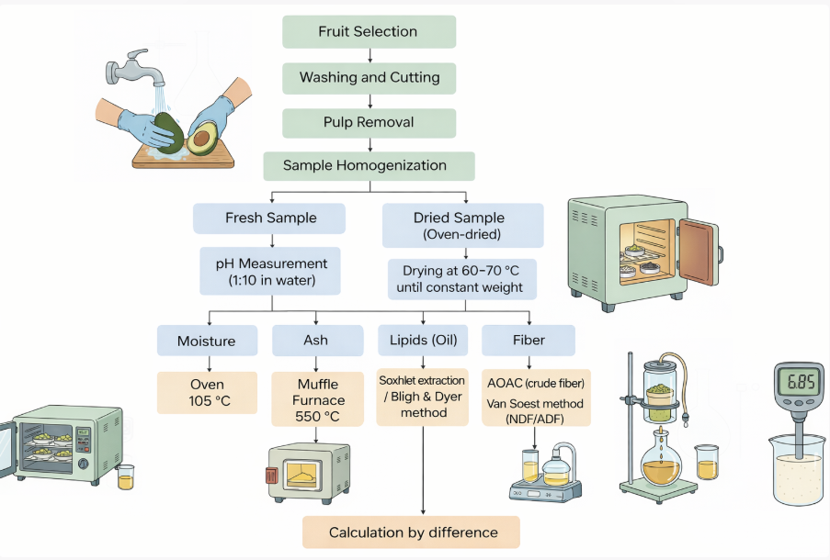
Figure 2: Schetmatic used to characterise the extracted avocado oil.
  - Results and discussions
The physicochemical characterization of the extracted avocado oil provides important insights into its suitability as a biodiesel feedstock. The pH values close to neutrality (pH ≈ 7) indicate good raw material quality and the absence of significant chemical degradation, which is favourable for oil extraction and subsequent processing. The extraction yield obtained is comparable to values reported in the literature for avocado oil extracted under simplified or small-scale conditions (Ferrari, 2015), demonstrating the feasibility of the adopted approach. The physicochemical characterization of virgin avocado oil, presented in Table 1, demonstrates parameters consistent with high-quality vegetable oils and indicates its potential application as a feedstock for biodiesel production. The moisture content obtained was 0.67 ± 0.15%, which falls within the acceptable range for vegetable oils, indicating a low water content. Such low moisture levels are important to prevent undesirable reactions, such as triglyceride hydrolysis and increased acidity, which may compromise transesterification efficiency (Flores et al., 2019). The average density of the oil was 0.87 ± 0.04 g/mL, a value that confirms the predominance of triglycerides in its composition and reinforces its suitability as an energy input. Ferrari (2015), when characterizing avocado oil extracted by centrifugation, reported that density is only slightly influenced by the extraction method when no significant thermal degradation occurs. The relative viscosity obtained, 6.23 ± 2.80, reflects the characteristic lipid composition of avocado oil, which is rich in oleic acid. However, elevated viscosity values may negatively affect fuel atomization in engines, emphasizing the need to convert the oil into biodiesel in order to improve its rheological properties (Olosunde & Edet, 2022). The oil's acidity was 0.40 ± 0.02%, expressed as oleic acid, indicating a low content of free fatty acids. Reduced acidity values ​​are commonly associated with good raw material quality and are desirable for biodiesel applications, as they contribute to minimizing secondary reactions during processing, such as saponification, as discussed by Flores et al. (2019). According to these authors, vegetable oils with low free fatty acid content are more suitable for alkali-catalysed transesterification processes. Although the crude oil does not meet the ASTM/EN specifications for direct use as fuel, its physicochemical profile is compatible with the values ​​reported in the literature for raw materials intended for biodiesel production, characterized according to these standards. Thus, considering the requirements generally adopted for biodiesel, the results obtained suggest that the extracted avocado oil presents properties favourable to its conversion into biodiesel, with the expected improvements after the transesterification step for systems based on vegetable oils.

Table 1: Physicochemical Characterization of Virgin Avocado Oil
Moisture | Density | Relative viscosity | Acidity (% oleic acid)
0.67% ± 0.15 | 0.87 g/ml ± 0.04 | 6.23 ± 2.80 | 0.40 % ± 0.02

The oil yield and physicochemical properties obtained in this study are consistent with values ​​reported in the literature for avocado oil extracted using different methodologies. Studies report that extraction techniques ranging from artisanal or heat-assisted approaches to more structured laboratory-scale methods can produce oils with comparable physicochemical characteristics (Ferrari, 2015; Flores et al., 2019), although the yield and quality of extraction are influenced by factors such as raw material conditions, moisture content, and processing temperature. Ferrari (2015), employing a mechanical extraction process with heat-assisted kneading, reported free fatty acid contents ranging from 0.52 to 0.62% (as oleic acid) and moisture values ​​between 0.09 and 0.16% for mechanically extracted avocado oil. Although there are differences in the extraction method and processing conditions, the physicochemical characteristics obtained are within the range commonly reported for crude avocado oils before transesterification. This comparison indicates that the simplified extraction protocol adopted is capable of producing oil with properties comparable to those reported for more structured extraction approaches, corroborating its viability for preliminary evaluation as a raw material for biodiesel. The FTIR spectrum of avocado oil presented in figure 3 shows characteristic absorption bands typical of vegetable oils predominantly composed of triglycerides. A broad band observed around 3400 cm⁻¹ is associated with O–H stretching, indicating the presence of trace moisture or naturally occurring phenolic compounds. The intense bands located at approximately 2920 and 2850 cm⁻¹ are attributed to the asymmetric and symmetric C–H stretching vibrations of methylene and methyl groups, which are characteristic of long-chain fatty acids in vegetable oils. These spectral features confirm the lipid nature of avocado oil and its structural similarity to other high-quality edible oils (Mueller et al., 2013; Flores et al., 2019).
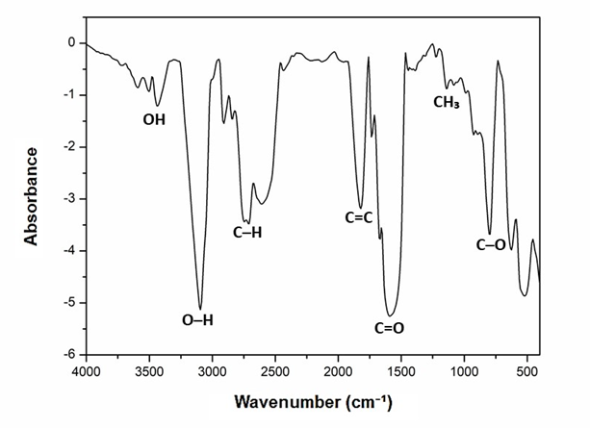
The strong absorption band observed near 1740 cm⁻¹ is assigned to the C=O stretching of ester functional groups, indicating the structural integrity of triglycerides in the analysed oil. The band detected around 1650 cm⁻¹ corresponds to C=C stretching, reflecting the unsaturated character of avocado oil, mainly associated with its high oleic acid content. Additional absorption bands in the region between 1200 and 1000 cm⁻¹ are attributed to C–O stretching vibrations, which are typical of ester bonds in lipid compounds. The combination of these absorption features confirms the characteristic chemical composition of vegetable oils and supports the suitability of avocado oil as a feedstock for industrial and energy applications, including biodiesel production (Gunstone, 2011; Boskou, 2015).
Figure 3: FTIR spectrum of avocado oil recorded in the 4000–500 cm⁻¹ region. Key functional groups are indicated at their characteristic absorption bands.

The thermogravimetric (TG) curve of avocado oil presented in figure 4 demonstrates high thermal stability up to approximately 300 °C, with no significant mass losses, indicating a low moisture content and the absence of low-molecular-weight volatile compounds. This behaviour is typical of crude vegetable oils predominantly composed of triglycerides and reflects a feedstock with good physicochemical integrity. The observed stability is consistent with studies on vegetable oils used as biodiesel feedstocks, in which the absence of initial mass losses is associated with efficient extraction processes and low oxidative degradation of the crude oil (Li et al., 2015; Yang et al., 2018).
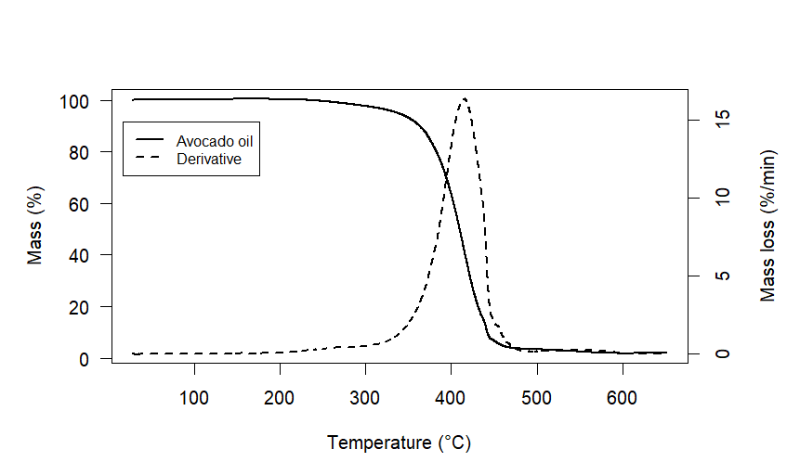

Figure4: TG curve of avocado oil under nitrogen atmosphere. The solid line shows the remaining mass (Mass %), and the dashed line shows the derivative of mass loss (Mass loss %/min), highlighting decomposition events.
The main stage of thermal degradation occurs between approximately 350 °C and 480 °C, characterized by a sharp decrease in mass associated with the thermal decomposition of triglycerides. The derivative thermogravimetric (DTG) curve shows a maximum mass loss peak around 410–430 °C, indicating the temperature of the highest degradation rate of the oil. This stage is related to the cleavage of ester bonds and the decomposition of saturated and unsaturated fatty acid chains. Similar thermal profiles have been reported for crude vegetable oils such as palm oil, soybean oil, and avocado oil, confirming that this behaviour is characteristic of oils rich in oleic acid and other unsaturated fatty acids, with direct application in the evaluation of feedstocks for thermal and energy processes (Santos et al., 2014). The temperatures used during the artisanal extraction protocol can influence the stability and quality of the oil; they deserve consideration. Excessive temperatures or prolonged exposure can lead to lipid degradation, oxidation, or hydrolysis. As reported by Ferrari (2015) and Flores et al. (2019), heat-assisted avocado oil extraction requires a balance between process viability and the preservation of physicochemical properties. In this study, heating was used to promote water evaporation and facilitate the release of oil from the avocado pulp. In this context, the physicochemical parameters and the FTIR and TG/DTG profiles obtained suggest that the applied temperatures did not result in significant oil degradation, corroborating the suitability of the adopted protocol for preliminary evaluation of the raw material.

4. Conclusion

The results obtained in this study demonstrate that the avocado oil extracted through an artisanal protocol exhibited physicochemical properties consistent with good-quality vegetable oils, highlighting its potential as a feedstock for biodiesel production. Within the scope of this work, the analyses were limited to oil extraction and characterization, providing preliminary technical information to support future biodiesel synthesis and fuel performance studies. The low moisture and acidity levels, combined with density and relative viscosity values typical of triglyceride-rich oils, indicate favourable conditions for energy conversion processes. FTIR spectroscopic analyses confirmed the presence of functional groups characteristic of triglycerides, while thermogravimetric analysis (TG/DTG) revealed high thermal stability and a degradation profile consistent with crude vegetable oils, reinforcing the feasibility of avocado oil for bioenergy applications. Beyond the technical and scientific outcomes, the social and educational relevance of this work is noteworthy, as the oil extraction and initial characterization steps were carried out by junior scientific initiation students from the Centro Territorial de Educação Profissional de Araci (CETEP Araci), Bahia, Brazil, demonstrating the potential of the school environment as a space for scientific knowledge production. The active participation of girls in this process contributes to strengthening science education, promoting scientific outreach, and encouraging female inclusion in science, technology, and energy-related fields. Initiatives such as this highlight the importance of integrating public schools, universities, and applied research to foster sustainable development, social inclusion, and the training of future scientists committed to social transformation through science.
Acknowledgments
The authors express their gratitude to the Conselho Nacional de Desenvolvimento Científico e Tecnológico, CNPq (Grant nº 440133/2024-6) and Universidade Federal do Recôncavo da Bahia, UFRB, for providing all the necessary support for completing the work.

References

Aras, J., Rohman, A., 2025, Global research trends on avocado oil and its fatty acid composition: A bibliometric review. Food Research International, 182, 113987.
Atabani, A. E., Silitonga, A. S., Badruddin, I. A., Mahlia, T. M. I., Masjuki, H. H., & Mekhilef, S., 2012, A comprehensive review on biodiesel as an alternative energy resource and its characteristics. Renewable and Sustainable Energy Reviews, 16(4), 2070–2093.
Boskou, D., 2015, Olive and avocado oils: Composition and health benefits. European Journal of Lipid Science and Technology, 117, 1–8.
Demirbas, A., 2009, Progress and recent trends in biodiesel fuels. Energy Conversion and Management, 50(1), 14–34.
FAOSTAT,2024, Production – Crops and livestock products. Food and Agriculture Organization of the United Nations.
Ferrari, R. A., 2015, Characterization of avocado oil extracted by centrifugation and its by-products, Brazilian Journal of Food Technology, 18(1), 1–9. (in Portuguese)
Flores, M., Saravia, C., Vergara, C. E., Avila, F., Valdés, H., & Ortiz-Viedma, J., 2019, Avocado oil: Characteristics, properties and applications. Molecules, 24(11), 2172.
Gui, M. M., Lee, K. T., & Bhatia, S., 2008, Feasibility of edible oil vs. non-edible oil vs. waste edible oil as biodiesel feedstock. Energy, 33(11), 1646–1653.
Gunstone, F. D., 2011, Vegetable oils in food technology: Composition, properties and uses. Wiley-Blackwell, Hoboken, NJ, USA.
Knothe, G., 2006, Analyzing biodiesel: Standards and other methods. Journal of the American Oil Chemists’ Society, 83(10), 823–833.
Knothe, G., Van Gerpen, J., & Krahl, J., 2010, The Biodiesel Handbook. AOCS Press, Urbana, IL, USA.
Lago, R. C. A.; Siqueira, F. A. R.; Hartman, L.,1989, Determination of triacylglycerol composition of vegetable oils by HPLC based on random 1,2,3 distribution. Pesquisa Agropecuária Brasileira, v. 24, n. 12, p. 1451–1455. (in Portuguese).
Li, H., Niu, S., Lu, C., & Wang, Y., 2015, Comprehensive investigation of the thermal degradation characteristics of biodiesel and its feedstock oil through TGA–FTIR. Energy & Fuels, 29, 5145–5153.
Malagón-Romero, D. H., Velasco-Peña, M. A., Arrubla-Vélez, J. P., Clavijo-Barreto, L. F., Barrera-Mendoza, I. N., Jiménez-Montero, E. D., 2026, Valorization of Colombian native avocado (Persea americana cv. papelillo): biochar, bio-oil, biogas, and edible oil production. Cleaner Waste Systems, 13, 100145.
Mueller, D.; Ferrão, M. F.; Marder, L.; da costa, A. B.; R; Schneider, R. de C. de S., 2013, Fourier Transform Infrared Spectroscopy (FTIR) and Multivariate Analysis for Identification of Different Vegetable Oils Used in Biodiesel Production. Sensors, v. 13, n. 4, p. 4258–4271, 2013
Mueller, M., Schmid, M., & Sieber, R., 2013, Infrared spectroscopy for the detection of adulteration in edible oils. Food Control, 33, 292–297.
Oke, M. A.; Adebayo, E. A.; Ajisope, N. A.; Olowe, B. M.; Fasuan, O. S., 2025, Avocado (Persea americana) peel: a promising source of bioactive compounds. Frontieres. Nutrition. 12:1642969.
Olosunde, W. A., & Edet, E. U., 2022, Effects of moisture content on the quality characterization of avocado seed oil for potential biodiesel production. Adeleke University Journal of Engineering and Technology, 6(1), 1–10.
Ramos, L. P., Silva, F. R., Mangrich, A. S., & Cordeiro, C. S., 2017, Biodiesel production technologies. Bioenergy Research, 10, 1–22.
Rodríguez-Martínez, B., Romaní, A., Eibes, G., Garrote, G., Gullón, B., del Río, P. G., 2022, Potential and prospects for utilization of avocado by-products in integrated biorefineries. Bioresource Technology, 364, 128034.
Santos, J. C. O., A. G. dos Santos, de Souza A. G., Prasad S., dos Santos A. V., 2014, Thermal Stability and Kinetic Study on Thermal Decomposition of Commercial Edible Oils by Thermogravimetry. Journal of Food Science, 67, 1393–1398.
Vitor, A. B., Bezerra, G. M., Silva, M. S., Rodrigues, A. B. A., Silva, A. C. F. S., Hocevar, L. S., Jesus, T. B., & Alves, C. T., 2025. Female Participation in Biofuel Research: A Global Bibliometric Analysis (2019–2024), RGSA – Revista de Gestão Social e Ambiental, Miami, v.19.n.8, p.1-22, e013156.
Yang, H., Yan, R., Chen, H., Lee, D. H., & Zheng, C., 2018, Thermal decomposition behavior of vegetable oils studied by TG–DTG analysis. Energy Conversion and Management, 171, 1182–1189.

