 CHEMICAL ENGINEERING TRANSACTIONS  VOL. xxx, 2026 | A publication of  
The Italian Association
of Chemical Engineering
Online at www.cetjournal.it

Guest Editors: Marco Bravi, Antonio Marzocchella, Giuseppe Caputo
Copyright © 2026, AIDIC Servizi S.r.l.
ISBN 979-12-81206-xx-x; ISSN 2283-9216

Valorization of agricultural industry residues for microalgae production
Serena Limaª, Arima Marcheseª, Alessandro Cosenzaª, Valeria Villanova^{b}, Giuseppe Caputoª, Francesca Scargialiª
ª Department of Engineering, University of Palermo, Viale delle Scienze ed. 6, 90128, Palermo, Italy;
^{b} Department of Biological, Chemical and Pharmaceutical Sciences and Technologies (STEBICEF), University of Palermo, Viale delle Scienze ed. 6, 90128, Palermo, Italy.
serena.lima@unipa.t

Abstract
Agricultural vegetable waste represents an underutilized feedstock for microalgal cultivation and high-value metabolite production. This study evaluated carrot residues as substrates for waste-derived growth media suitable for Chlorella sp. microalgae, using four pretreatment strategies: hydrothermal (120 °C, 3 h), enzymatic (45 °C, 3 h), and chemical (HCl, H₃PO₄). Hydrothermal pretreatment maximized dissolved organic carbon recovery (3.3-5.7 g/L) suitable for heterotrophic/mixotrophic growth but generated nutrient-poor media (NO₃⁻ 10-20 ppm; PO₄³⁻ 30-50 ppm). Enzymatic pretreatment preferentially mobilized macronutrients at 5-38-fold higher concentrations, enabling zero-supplementation, nutrient-complete media. Chlorella cultivation confirmed enzymatic pretreatment as the most reliable and universally applicable strategy (final biomass 0.60-0.88 g/L). Overall, these results establish a sustainable strategy for agricultural waste valorization through microalgal cultivation, directly applicable to food processing small-to-medium enterprises.
  - Introduction
Chlorella, a genus of microalgae with unicellular green freshwater microalga with exceptional metabolic flexibility, has emerged as a preeminent biotechnological platform thanks to its capacity to simultaneously synthesize multiple high-value product including proteins (up to 51% of dry weight), lipids (20-70% of dry weight depending on cultivation mode), polysaccharides, carotenoids, chlorophyll, and bioactive secondary metabolites [1,2]. Moreover, these microorganisms show a strong ability to thrive across phototrophic, mixotrophic, and heterotrophic cultivation regimes while simultaneously remediating diverse wastewater streams and the functional capacity of sequestering CO₂ at rates of 1.5-2.0 kg CO₂ per kg dry biomass [3]. All these characteristics place Chlorella sp. at the nexus of integrated biorefinery systems designed to convert renewable carbon and waste-derived nitrogen and phosphorus into economically viable biomaterials, nutraceuticals, biofuels, and food ingredients [4]. Its use as a multifunctional biorefinery is increasing in industry applications, leading to circular nutrient cycling, waste valorization, and climate change mitigation. Mixotrophic cultivation, wherein Chlorella sp. simultaneously exploits photosynthetic and heterotrophic metabolic pathways, has emerged as a transformative strategy for intensifying both biomass productivity and targeted metabolite synthesis while reducing per-unit cultivation costs. Under optimally balanced mixotrophic conditions, C. vulgaris achieves exceptional cellular densities (3.52×10⁷ cells mL⁻¹), specific growth rates (0.75 d⁻¹), and biomass concentrations (3.48 g L⁻¹) that substantially exceed photoautotrophic cultivation, with simultaneous optimization of product composition [5,6]. Lipid accumulation reaches maximum productivities of about 2.2 g L⁻¹ d⁻¹ under optimal C:N stoichiometry, while carbohydrate content can be selectively enhanced to approximately 45% of dry weight through nutrient starvation strategies [7].
Agricultural and food processing activities generate massive quantities of surplus biomass and processing residues representing one of the most pressing sustainability challenges in the modern agri-food sector. Globally, approximately one-third of food production is discarded as waste throughout the supply chain, accumulating in landfills, incinerators, and agricultural fields, each pathway generating substantial environmental burdens including greenhouse gas emissions, soil contamination, and depletion of aqueous resources [8]. This economic and environmental waste is particularly abundant in developed economies and Mediterranean regions, where intensive fruit and vegetable production generates seasonal surpluses of unmarketable products alongside continuous processing waste streams from dairy, brewing, and food manufacturing. Paradoxically, these agri-food residues represent highly valuable reservoirs of biomolecules, containing substantial carbohydrate polymers (35-75% dry weight), proteins (5-35%), lipids (2-20%), and diverse bioactive secondary metabolites. The circular bioeconomy paradigm offers a transformative alternative: rather than viewing agri-food residues as waste requiring costly disposal, they constitute renewable feedstocks for producing high-value biomass, biofuels, platform chemicals, and nutraceuticals through strategic bioconversion processes. The fundamental bottleneck in realizing circular bioeconomy value from agri-food residues lies in the inherent biochemical recalcitrance of polymeric carbohydrates: carbohydrate polymers (cellulose, hemicellulose, starch, pectins) must be physically size-reduced and chemically hydrolyzed into fermentable monosaccharides before biological uptake by microorganisms becomes possible. Emerging pretreatment technologies can systematically unlock this locked energy and nutrient potential. Hydrothermal pretreatment-applying controlled temperatures, pressures, and residence times without added chemicals-effectively disrupts biomass structure, enhances surface porosity, and facilitates subsequent enzymatic accessibility while minimizing formation of inhibitory compounds. Hydrothermal processing of food waste increases total bioproduct yields by 59.75% and accessible sugar content by 55%, generating liquid fractions enriched in glucose and xylose suitable for direct microbial fermentation [9]. Complementary enzymatic hydrolysis using commercial cellulase/hemicellulase enzyme cocktails (e.g., Viscozyme L) containing broad-spectrum carbohydrases (cellulase, β-glucanase, hemicellulase, xylanase, arabinase, pectinase) further maximizes monosaccharide recovery, achieving glucose yields of 50 g L⁻¹ in optimized hydrolysates [10–12]. Integration of mild hydrothermal pretreatment with enzymatic saccharification offers particular advantages: autoclaving at 120°C simultaneously reduces microbial contamination burden while preparing lignocellulosic substrates for enzymatic attack, reducing enzymatic hydrolysis inhibition while maintaining sugar yields. The resulting hydrolysate, rich in fermentable carbohydrates, amino acids, nitrogen, and phosphate, constitutes a nutrient-dense growth medium suitable for demanding heterotrophic or mixotrophic bioprocesses [13–15].​ In the present work, agri-food residues sourced from an Italian vegetable processing facility (Agrinsieme) were valorized as nutrient-dense feedstocks for microalgal biorefinery development. Hydrothermal pretreatment and enzymatic hydrolysis were applied to enhance liberation of fermentable monosaccharides and residual nutrients.
  - Materials and methods
Vegetable processing residues were obtained as fresh processing waste from O.P Agrinsieme (Latina, Italy). All materials were subjected to size reduction using an industrial-scale blender to achieve a uniform particle size of approximately 500 µm. The resulting homogenized samples were transferred to airtight, food-grade polyethylene storage bags and frozen at -20°C to minimize physicochemical and microbiological degradation until experimental use. Prior to pretreatment procedures, frozen samples were equilibrated to ambient temperature through passive thawing.
Pretreatments
The initial experimental phase focused on systematically optimizing hydrothermal pretreatment and enzymatic hydrolysis protocols to maximize the liberation and bioavailability of fermentable carbohydrates and essential nutrients from vegetable processing residues. Hydrothermal pretreatment conditions were varied across a matrix of temperatures (80-140°C) and residence times (60-90 min) to identify the optimal balance between hemicellulose solubilization, lignin disruption, and minimization of inhibitory by-product formation. Enzymatic saccharification was subsequently applied using broad-spectrum carbohydrase mixtures, with optimization conducted across pH (4.5-5.5), temperature (40-50°C), and enzyme dosage parameters. This two-stage pretreatment strategy was designed to systematically decouple the complex interactions between physical disruption, chemical modification, and enzymatic accessibility.Table 1 resumes the treatment carried out for the experimental campaign.

Table 1. Treatments carried out during the experimental campaign.
Treatment | Time (h) | Temperature (°C)
Non-catalyzed hydrothermal treatment | 1, 2, 3 | 100, 120
HCl-catalyzed hydrothermal treatment | 1, 2, 3 | 100, 120
H₃PO₄-catalyzed hydrothermal treatment | 1, 2, 3 | 100, 120
Enzymatic hydrolysis (Viscozyme) | 3, 6 | 45

For the hydrothermal treatment, the homogenized vegetable waste (800 mg dry mass) was combined with 20 mL of deionized water in airtight borosilicate glass vessels sealed with PTFE-lined caps. The sealed reaction systems were immersed in a thermostatic oil bath maintained at the target temperature (80, 100, 120, or 140°C) for specified residence times (60, 75, or 90 min). Following the heat treatment, reaction vessels were rapidly cooled to room temperature using an ice bath to quench ongoing reactions. For the enzymatic treatment, ground vegetable biomass (800 mg) was suspended in 20 mL of deionized water, with pH adjusted to 4.5 ± 0.1 using hydrochloric acid (0.1 M). Viscozyme L enzyme cocktail (50 µL) was added to initiate enzymatic saccharification. The reaction mixture was maintained at 45°C in a temperature-controlled water bath for the specified duration (0, 6, 12, 24, or 48 h). Enzyme deactivation was achieved by heating the reaction mixture to 80°C for 10 minutes, followed by rapid cooling to room temperature. In both cases of treatments, the resulting suspension was filtered through a 0.45 µm polypropylene sterile membrane filter; the aqueous filtrate was retained for subsequent chemical analysis and then stored at -20°C.
Organic carbon content of the hydrolysates was quantified using a total organic carbon (TOC) analyzer (Enviro TOC, Elementar) following manufacturer protocols. Ionic composition, including major anions (chloride, sulfate, nitrate) and cations (sodium, potassium, calcium, magnesium, ammonium), was determined via ion chromatography (Metrohm IC system) with suppressed conductivity detection. Samples were filtered through 0.2 µm nylon membranes prior to ion chromatographic analysis to remove particulates.

Cultivation of Chlorella sp. and bio-compound analysis
Optimized pretreatment conditions identified in the preliminary phase were scaled to culture media preparation volumes suitable for microalgal cultivation. Vegetable processing residues (16 g dry mass) were suspended in 400 mL of ultrapure water (resistivity ≥18 MΩ·cm), and the resulting suspension underwent the previously optimized hydrothermal pretreatment and enzymatic hydrolysis protocols. Following enzymatic treatment, the reaction mixture was sterilized through membrane filtration (0.45 µm, sterile polypropylene filters) to simultaneously remove particulates and eliminate vegetative microorganisms that could compromise axenic Chlorella vulgaris cultures. The resulting sterile liquid fraction, enriched in fermentable monosaccharides (glucose, xylose), soluble proteins, and essential inorganic nutrients (nitrogen, phosphorus, potassium, calcium, magnesium), was directly utilized as the growth medium for heterotrophic and mixotrophic Chlorella vulgaris cultivation without further supplementation. Chlorella sp. cultures were conducted in triplicate using 250 mL Erlenmeyer flasks. Inoculum was prepared from established stock cultures by harvesting cells through centrifugation (4,500 rpm, 15 min, 4°C) to obtain a cellular pellet. The pellet was washed twice with sterile isotonic saline solution (0.9% w/v NaCl, 10 mL per wash) to remove residual culture medium. The final washed pellet was resuspended in 100 mL of the waste-derived growth medium or synthetic control medium to achieve an initial optical density at 750 nm (OD₇₅₀) of 0.15 ± 0.01, corresponding to an estimated initial cell concentration of approximately 1 × 10⁷ cells/mL. Cultures were maintained under controlled conditions (temperature of 25°C and 200 µE m⁻² s⁻¹) and sampled for determination of biomass concentration
  - Results
All the tested pretreatments effectively liberated dissolved organic carbon (measured by TOC) from the tested vegetable waste matrices into the aqueous phase. Characterization of growth media, showed in Figure 1, generated through agricultural waste pretreatment, revealed that hydrothermal treatment (120°C, 3h) achieving superior dissolved organic carbon recovery (4,700-5,700 ppm), while enzymatic hydrolysis at 45°C demonstrated preferential macronutrient liberation, achieving 5-10 fold higher concentrations of nitrogen and phosphorus species essential for microalgal growth (Figure 2). It is worth noting that, due to the addiction of chlorides and phosphates, the characterization of ions in the catalyzed hydrothermal treatment trials was impossible.
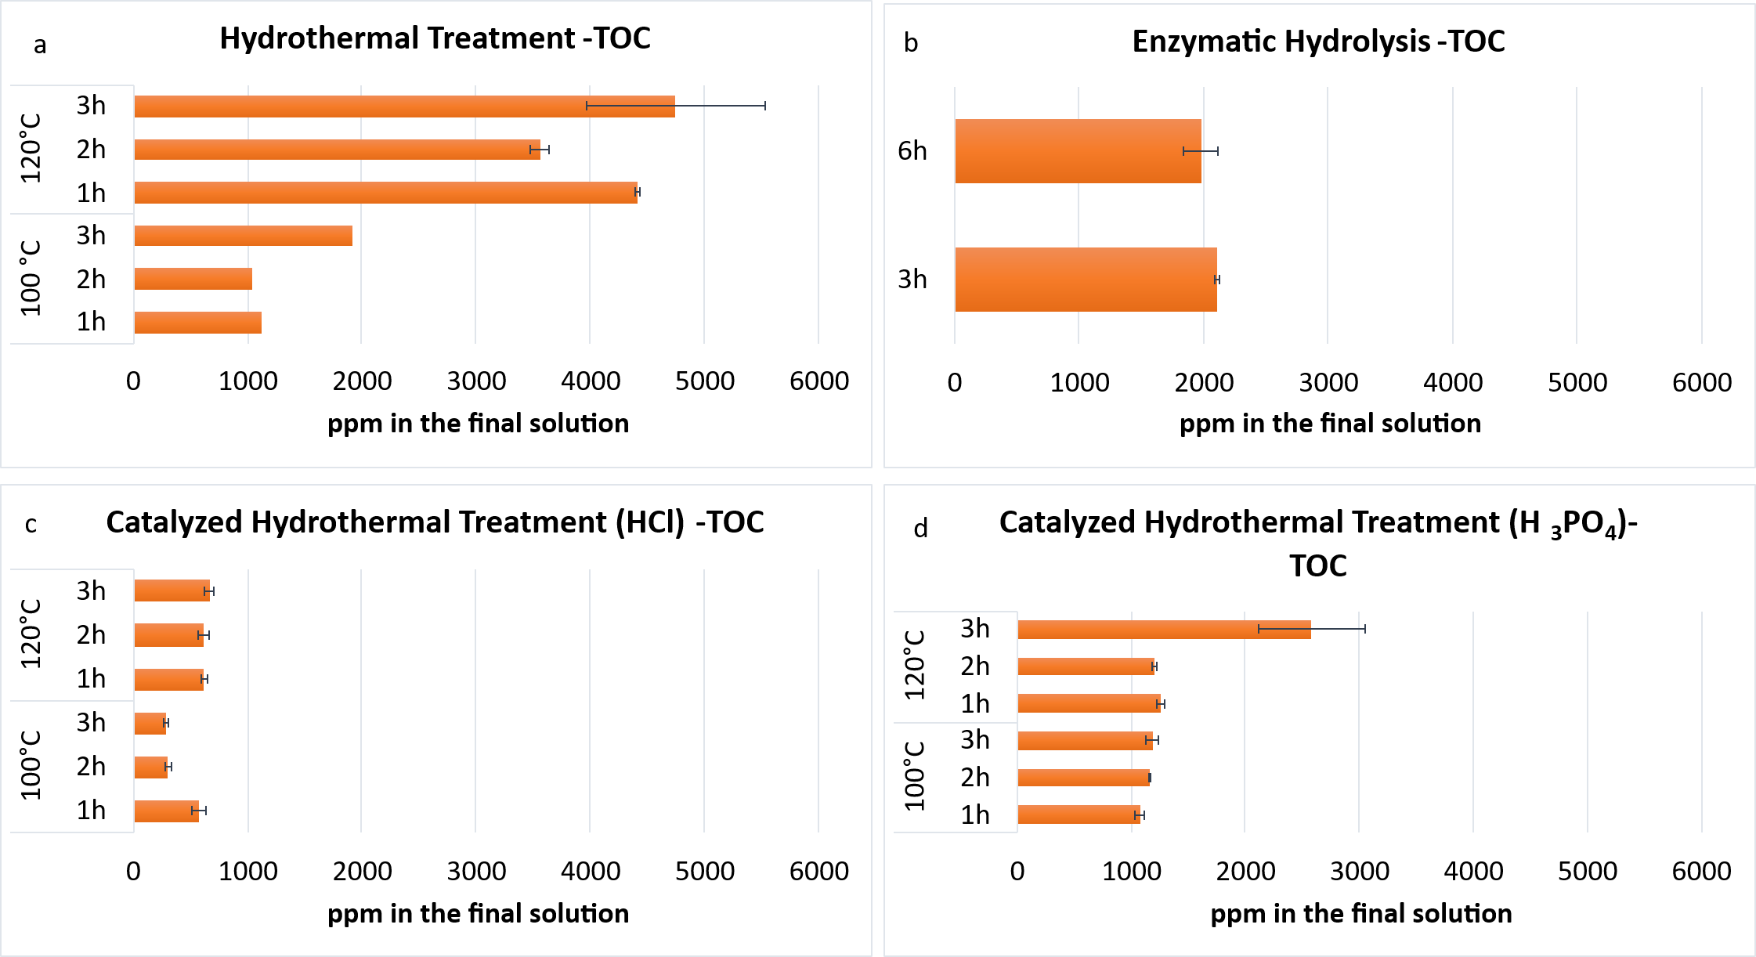
Figure 1. Characterization of the growth media TOC obtained after the treatments of the agricultural waste a) Hydrothermal treatment; b) Enzymatic Hydrolysis; c) Catalyzed Hydrothermal Treatment (HCl); d) Catalyzed Hydrothermal Treatment (H₃PO₄).

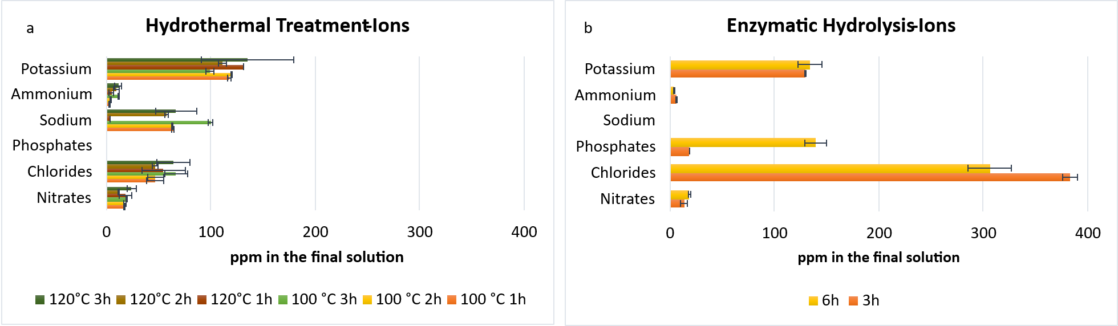
Figure 2: Characterization of the growth media nutrient concentration obtained after the treatments of the agricultural waste a) Hydrothermal treatment; b) Enzymatic Hydrolysis.
Considering the described results, the microalga was inoculated in the best obtained growth medium for each alternative pretreatment method. The cultivation on carrot waste-derived media (Figure 3) revealed that enzymatic pretreatment (45°C, 3h) outperformed hydrothermal pretreatment (120°C, 3h) achieving higher biomass concentrations (0.60-0.88 g/L vs. 0.70-0.85 g/L) and superior growth kinetics characterized by shorter lag phases (10-15 h vs. 15-30 h) and sustained exponential growth without nutrient-limitation signatures. Overall, these findings demonstrate a sustainable approach to valorizing agricultural waste via microalgal cultivation, with direct applicability to small- and medium-sized enterprises in the food processing sector.
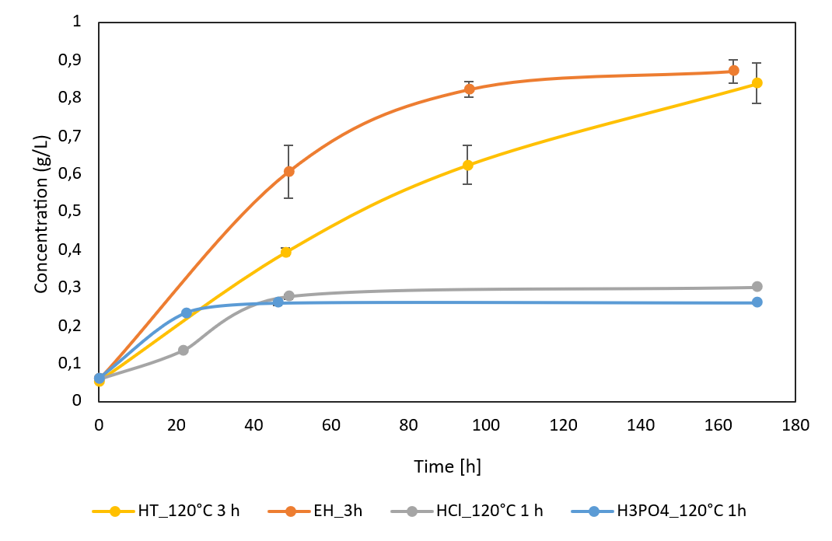
Figure 3. Microalgal growth curves in media derived from carrot wastes treated with different methods.
The superior performance of enzymatic pretreatment despite delivering only 40–45% of the carbon available in hydrothermal media (e.g., carrot: 2,100 ppm enzymatic vs. 4,700 ppm hydrothermal) demonstrates that macronutrient availability (nitrogen, phosphorus) is more growth-limiting than carbon concentration for Chlorella cultivation on waste-derived media. Hydrothermal pretreatment generated media showing nutrient-limitation growth, including extended lag phases (20-30 h vs. 10-15 h enzymatic) and growth plateaus preceding maximum biomass. These growth patterns indicate that nutrient depletion becomes limiting after 50-100 hours of cultivation, restricting sustainable biomass accumulation despite abundant fermentable carbon availability.
  - Conclusions
The present work demonstrates that agricultural wastes obtained from carrots are viable feedstocks for microalgal cultivation media. Hydrothermal pretreatment of the waste at 120 °C generates media with the highest dissolved organic carbon. However, the growth results higher in the medium obtained from Enzymatic Treatment, probably because of the higher concentration in inorganic nutrients obtained. Therefore, Hydrothermal Treatment is a powerful option for maximizing carbon availability, while Enzymatic Treatment promotes the release of inorganic nutrients.
Acknowledgments
The authors acknowledge the third-party research project ROW2Bios (CON-0671), funded by O.P. Agrinsieme (Latina, Italy). We gratefully thank Massimiliano Landini for personally delivering the vegetable samples to our University, and Cristiano Sternini for his support with the administrative procedures involving Lazio Region.
References
[1] Gurreri L., Calanni Rindina M., Luciano A., Lima S., Scargiali F., Fino D., Mancini G., 2023, Environmental Sustainability of Microalgae-Based Production Systems: Roadmap and Challenges towards the Industrial Implementation, Sustainable Chemistry and Pharmacy, Sustainable Chemistry and Pharmacy, 35, 101191.
[2] He S., Barati B., Hu X., Wang S., 2023, Carbon migration of microalgae from cultivation towards biofuel production by hydrothermal technology: A review, Fuel Processing Technology, 240, 107563.
[3] Sobczuk T.M., García F., Rubio F.C., 2000, Carbon Dioxide Uptake Efficiency by Outdoor Microalgal Cultures in Tubular Airlift Photobioreactors, Biotechnology and Bioengineering, 67, 465–472.
[4] Cosenza A., Lima S., Gurreri L., Mancini G., Scargiali F., 2024, Microalgae in the Mediterranean area: A geographical survey outlining the diversity and technological potential, Algal Research, 82, 103669.
[5] Yan X., Shan S., Li X., Xu Q., Yan X., Ruan R., Cheng P., 2024, Carbon and energy metabolism for the mixotrophic culture of Chlorella vulgaris using sodium acetate as a carbon source, Frontiers in Microbiology, 15, 1436264.
[6] Marchese A., Lima S., Cosenza A., Giambalvo F., Scargiali F., 2025, Effects of Light Quality Adjustment in Microalgal Cultivation: Flashing Light and Wavelength Shifts in Photobioreactor Design, Processes, 13, 1159.
[7] Grubišić M., Peremin I., Djedović E., 2024, Cultivation of a Novel Strain of Chlorella vulgaris S2 under Phototrophic, Mixotrophic, and Heterotrophic Conditions, and Effects on Biomass Growth and Composition, Fermentation, 10, 270.
[8] Berenguer C.V., Andrade C., Pereira J.A.M., Perestrelo R., Câmara J.S., 2022, Current Challenges in the Sustainable Valorisation of Agri-Food Wastes: A Review, Processes, 11, 20.
[9] Oladzad S., Fallah N., Mahboubi A., Afsham N., Taherzadeh M.J., Toghyani J., 2024, Comparison of acid and hydrothermal pretreatments of date waste for value creation, Scientific Reports, 14, 68879.
[10] Agrawal R., Semwal S., Kumar R., Mathur A., Gupta R.P., Tuli D.K., Satlewal A., 2018, Synergistic enzyme cocktail to enhance hydrolysis of steam exploded wheat straw at pilot scale, Frontiers in Energy Research, 6, 122.
[11] Cabas Candama M.A., Duque Martinez S., Cadena Chamorro E.M., 2020, Optimization of Enzymatic Pretreatments to Obtain Fermentable Sugars from Fruit and Vegetable Waste, Waste and Biomass Valorization, 11, 5991–6002.
[12] Gama R., Van Dyk J.S., Pletschke B.I., 2015, Optimisation of enzymatic hydrolysis of apple pomace for production of biofuel and biorefinery chemicals using commercial enzymes, 3 Biotech, 5, 1075–1087.
[13] Papathoti N.K., Laemchiab K., Megavath V.S., Keshav P.K., Numparditsub P., Le Thanh T., Buensanteai N., 2025, Augmented ethanol production from alkali-assisted hydrothermal pretreated cassava peel waste, Energy Sources, Part A: Recovery, Utilization and Environmental Effects, 47, 8243–8253.
[14] Marques F., Pereira F., Machado L., Martins J.T., Pereira R.N., Costa M.M., Genisheva Z., Pereira H., Vicente A.A., Teixeira J.A., Geada P., 2024, Comparison of Different Pretreatment Processes Envisaging the Potential Use of Food Waste as Microalgae Substrate, Foods, 13, 1018.
[15] Obeng A.K., Premjet D., Premjet S., 2019, Combining Autoclaving With Mild Alkaline Solution As a Pretreatment Technique To Enhance Glucose Recovery From the Invasive Weed Chloris Barbata, Biomolecules, 9, 120.

