 CHEMICAL ENGINEERING TRANSACTIONS  VOL. xxx, 2026 | A publication of  
The Italian Association
of Chemical Engineering
Online at www.cetjournal.it

Guest Editors: Marco Bravi, Antonio Marzocchella, Giuseppe Caputo
Copyright © 2026, AIDIC Servizi S.r.l.
ISBN 979-12-81206-xx-x; ISSN 2283-9216

POTENTIAL VALORIZATION OF COCOA WASTE IN BAHIA: TECHNOLOGICAL ROUTES, BIOMASS CHARACTERIZATION AND SUSTAINABILITY
Yan V. S. Rodriguesaª*, Ana L. B. de Souzaª, Fernando L. P. Pessoaª
ªUniversity SENAI CIMATEC, 1845 Orlando Gomes Av., Piatã, 41650-010, Salvador, Bahia, Brazil
yanvaldez@gmail.com
Brazil is one of the leading cocoa-producing countries worldwide, with the state of Bahia accounting for approximately 60 % of national production. Cocoa processing generates substantial amounts of residues, particularly pod husks and mucilage, which together represent a large fraction of the fruit mass and are rich in lignocellulosic components such as cellulose, hemicellulose, lignin, pectin’s and minerals. Despite this potential, these residues remain underutilized in many producing regions. This study presents an exploratory literature review aimed at analysing technological routes for cocoa residue valorisation, with emphasis on biomass characteristics, technological readiness and sustainability aspects. A total of 56 studies were initially screened, from which 12 were selected for detailed analysis to support a more focused and structured discussion. The results show that cocoa residues can be converted through biochemical, thermochemical and extraction-based pathways, with performance strongly dependent on residue composition. Bioenergy routes such as anaerobic digestion and fermentation exhibit higher technological maturity, whereas processes such as pyrolysis and gasification remain at pilot or demonstration stages. Extraction-based approaches offer higher added value but are still limited in scale. Overall, the analysis indicates that current research is predominantly focused on isolated processes, with limited integration between conversion routes. In this context, integrated biorefinery approaches emerge as a more consistent strategy for improving resource efficiency and supporting the development of circular bioeconomy solutions in cocoa-producing regions such as Bahia.
  - Introduction
The transition toward low-carbon systems has intensified the search for sustainable alternatives to fossil-based production, particularly within the context of agro-industrial systems. In this scenario, agricultural residues have gained relevance not merely as waste streams, but as resources capable of supporting the production of fuels, chemicals and biomaterials under circular economy principles (Klemeš et al., 2013; Kumar et al., 2023). Among these residues, lignocellulosic biomass from tropical crops stands out due to its abundance and compositional versatility, which enables its use across multiple conversion pathways. Cocoa (Theobroma cacao L.) is a prominent example of such crops, with production concentrated in regions such as West Africa, Southeast Asia and Latin America. In Brazil, cocoa production remains significant, with the state of Bahia accounting for approximately 60 % of national output. However, cocoa processing is inherently associated with the generation of large volumes of residues, including pod husks, shells and mucilage, which together represent a substantial fraction of the fruit mass. Estimates indicate that up to ten tons of wet residues can be generated per ton of dry cocoa beans (Silva et al., 2021; Okoro and Adeleke, 2022). These materials are predominantly lignocellulosic, containing cellulose, hemicellulose and lignin, as well as pectin, minerals and bioactive compounds such as polyphenols. This composition suggests that cocoa residues should not be regarded solely as by-products, but as feedstocks with potential for different valorization strategies (Valladares-Diestra et al., 2022; Kumar et al., 2023). Despite this potential, in producing regions such as Bahia, these residues are still largely underutilized, often left to decompose in the field or managed with limited recovery, which contributes to greenhouse gas emissions, nutrient losses and local sanitary issues.
Recent studies have explored different technological pathways for converting cocoa residues into value-added products, demonstrating their potential to produce biofuels such as bioethanol, biogas and bio-oil, as well as chemicals including organic acids, xylitol and antioxidant compounds (Okoro and Adeleke, 2022; Santos et al., 2025). Thermochemical processes, particularly pyrolysis and gasification, have been investigated for the generation of biochar and syngas, while biochemical routes based on fermentation and anaerobic digestion have shown promising results at laboratory and pilot scales. However, these approaches differ significantly in terms of technological maturity, economic feasibility and environmental performance, which poses challenges for their large-scale implementation. In this context, the biorefinery concept has been increasingly discussed to integrate multiple conversion routes and product streams within a single system, aiming to enhance resource efficiency and overall process viability (Klemeš et al., 2013). For cocoa residues, such configurations may involve sequential steps, including mechanical pretreatment, extraction of pectin and bioactive compounds, followed by the conversion of residual biomass through biochemical or thermochemical processes. Evidence from the literature suggests that these integrated strategies tend to outperform single-product systems, particularly when evaluated using life-cycle assessment approaches, highlighting their relevance from a sustainability perspective (Silva et al., 2021; Kumar et al., 2023).
Despite the growing number of studies addressing the valorization of cocoa residues, the available literature remains dispersed across different research areas, frequently focusing on isolated processes, specific products or laboratory-scale investigations. As a result, integrated assessments that combine biomass characterization, technological pathways, levels of technological readiness and sustainability aspects are still limited, particularly when regional specificities are considered. This gap is especially relevant in contexts such as Bahia, where cocoa production is concentrated and residue generation is substantial, yet systematic approaches to their utilization are still incipient. In addition, there is a lack of consolidated analyses capable of supporting process integration, scale-up strategies and techno-economic evaluations. Considering these limitations, this study aims to contribute to a more structured understanding of cocoa residue valorization in Bahia by conducting an exploratory literature review. The work focuses on mapping the main technological routes, synthesizing key characteristics of the biomass and discussing the associated sustainability implications. By bringing together evidence from 12 selected studies, this article seeks not only to organize existing knowledge, but also to identify critical gaps and opportunities for advancing integrated biorefinery systems and circular bioeconomy strategies in cocoa-producing regions.
  - Methodology
This study was developed as an exploratory literature review focused on identifying and organizing the main technological routes for the valorization of cocoa processing residues, with particular attention to biomass characteristics, technological maturity and sustainability aspects. In addition to synthesizing the current state of knowledge, the study is intended to provide a structured foundation for the development of more detailed future investigations. Rather than strictly following a rigid systematic protocol, the methodological approach was designed to allow a comprehensive and consistent analysis of the available literature, while maintaining alignment with commonly adopted practices in studies on biomass valorization and biorefineries.
    - Scope definition and research strategy
The scope of this review was defined to include scientific studies addressing cocoa (Theobroma cacao L.) residues generated throughout the agro-industrial chain, particularly pod husks, shells, mucilage and related by-products. Priority was given to studies reporting information on physicochemical characterization, conversion processes, process performance, sustainability aspects and technological maturity associated with cocoa waste valorization. Instead of adopting a highly restrictive systematic protocol, an exploratory approach was intentionally chosen to incorporate different types of contributions, including experimental studies, process evaluations, conceptual biorefinery designs and sustainability assessments. This broader perspective was considered necessary to better reflect the multidisciplinary nature of cocoa residue utilization and to avoid overlooking relevant technological insights that may not fit within narrowly defined methodological frameworks.
    - Literature search and data sources
The literature search was carried out using four widely recognized scientific databases: Web of Science, ScienceDirect, Scopus and Lens, selected for their broad coverage of peer-reviewed publications in areas such as chemical engineering, biomass conversion, renewable energy and sustainability. Search strategies were developed based on combinations of keywords and related terms associated with cocoa residues and biorefinery concepts, including expressions such as cocoa residues, biorefinery, process intensification, modeling, simulation, life cycle assessment, LCA and green economy. Boolean operators were applied to balance search sensitivity and thematic relevance. No restrictions were initially imposed on publication year to capture both early and recent contributions. This initial approach resulted in many records, ranging from hundreds to several thousand, which reflects the wide scope of research on agricultural residue valorization. All records were exported and compiled into a single database for analysis. The search strategy was then progressively refined through the combination of keywords and thematic filters, reducing the dataset to a more manageable number of studies, typically below one hundred, and enabling a more focused screening process.
    - Screening, inclusion and exclusion criteria
After consolidating the retrieved records, duplicate entries were identified and removed. The remaining studies were initially screened based on titles and abstracts to verify their alignment with the defined scope, followed by full-text analysis of the most relevant articles. The selection process was guided by clearly defined inclusion and exclusion criteria to ensure consistency. Studies were included when they consisted of peer-reviewed publications written in English, explicitly addressed cocoa-derived residues and provided data or analyses related to biomass characterization, conversion technologies, technological maturity or sustainability aspects. Conversely, studies were excluded when they did not focus on cocoa residues, lacked sufficient methodological or technical detail, or consisted of non-peer-reviewed material, such as editorials or purely speculative discussions without a technical basis. After applying these criteria, a total of 56 articles were selected for detailed analysis. From this set, a subset of 12 studies was further identified as particularly relevant for the development of this introductory work, based on their scope, level of detail and contribution to the understanding of cocoa residue valorization. These selected studies served as the primary basis for deeper discussion and synthesis throughout the article.
    - Data extraction and categorization
Data extraction was carried out using structured spreadsheets to maintain consistency across the analyzed studies. For each article, information was compiled on the type of cocoa residue, physicochemical composition, pretreatment strategies, conversion pathways, main products, process performance indicators, technological maturity and reported sustainability outcomes, whenever such data were available. To support a more systematic interpretation, the collected data were organized into three main analytical dimensions: biomass characterization, focusing on compositional and physical properties; technological routes, encompassing biochemical, thermochemical and physicochemical processes; and sustainability and technological readiness, which included environmental indicators, integration potential and reported stages of development. This organization allowed for a more consistent comparison between studies and contributed to identifying prevailing research directions, as well as areas that remain insufficiently explored.
    - Assessment of technological readiness and sustainability aspects
To better interpret the maturity of the identified conversion routes, a qualitative assessment of technological readiness was performed based on the reported development scale of each process, including laboratory studies, pilot demonstrations and indications of industrial applicability. The technologies were grouped into broad categories ranging from early-stage research to near-commercial applications, following classifications commonly adopted in biomass and biorefinery research (Silva et al., 2021; Santos et al., 2025). Sustainability aspects were also examined qualitatively by compiling and comparing information reported in the literature, particularly results from life-cycle assessment studies, energy efficiency indicators and environmental performance metrics. Instead of conducting a new LCA, the analysis focused on identifying consistent patterns and contrasts across studies, especially with respect to greenhouse gas emissions, resource use efficiency and waste reduction potential. This approach was considered more appropriate for the exploratory nature of the present work.
    - Limitations of the methodology
The present methodology is inherently dependent on data reported in the literature, which may differ in terms of quality, system boundaries and underlying assumptions. For this reason, quantitative comparisons between studies were approached with caution. In addition, the lack of standardized reporting for cocoa residue properties and conversion performance limited the possibility of direct harmonization across different sources. Despite these constraints, the adopted approach remains suitable for the objectives of this work, as it enables a consistent qualitative mapping of technological pathways and supports the identification of relevant research gaps in the context of cocoa residue valorization in Bahia.
  - Results
The results are organized according to the analytical dimensions defined in the methodology, namely biomass characterization, technological conversion routes, technological readiness and sustainability aspects. The analysis of the 12 selected studies makes it possible to outline the current state of research on cocoa residue valorisation, revealing recurring approaches, areas of convergence between technologies and, importantly, aspects that remain insufficiently explored.
    - Distribution of studies and research focus

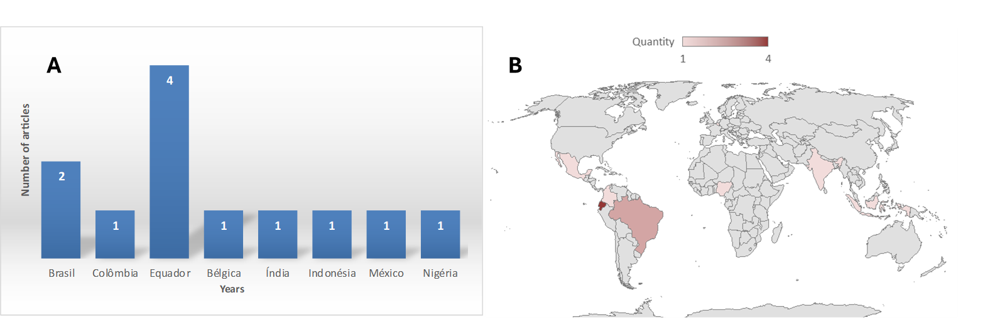

Figure 1A. Temporal distribution of the selected studies on cocoa residue valorization, showing the number of articles published per year among the 12 studies selected from the broader set of 56 articles. Figure 1B. Geographic distribution of the selected studies on cocoa residue valorization, highlighting the countries where the 12 studies were conducted and indicating the concentration of research in major cocoa producing regions.

The analysis of the 12 principal studies, selected from the broader set of 56 articles, indicates that research on cocoa residue valorization is strongly concentrated in major producing regions such as Brazil, Colombia, Ghana, Nigeria, Malaysia and Indonesia, as illustrated in Figure 1B. This spatial distribution reflects the direct relationship between biomass availability and the development of scientific research, since regions with higher production volumes also face greater environmental challenges associated with residue accumulation. In West Africa, studies tend to emphasize issues related to inadequate disposal of cocoa residues, whereas in Latin America and Southeast Asia research is often supported by more structured agro industrial systems, enabling more consistent experimental investigations. From a temporal perspective, Figure 1A shows that publications are relatively recent and unevenly distributed over time, with a peak observed in 2021 and fewer contributions in other years. This behavior suggests that the field is still emerging and has not yet reached a stage of continuous and stable growth. In terms of research focus, most studies are oriented toward conversion pathways, particularly anaerobic digestion, fermentation, pyrolysis and gasification, due to their technological maturity and compatibility with the physicochemical characteristics of cocoa residues. At the same time, there is significant interest in the extraction of high value compounds such as polyphenols and alkaloids, especially from cocoa bean shells and cocoa pod husks. Despite these advances, both Figure 1A and Figure 1B, together with the literature analysis, highlight an important gap, as most studies still address processes in isolation. Integrated biorefinery approaches and comprehensive life cycle assessments remain limited. In addition, key factors such as regional biomass availability, logistics and scale up feasibility are often overlooked.

    - Cocoa waste characterization results

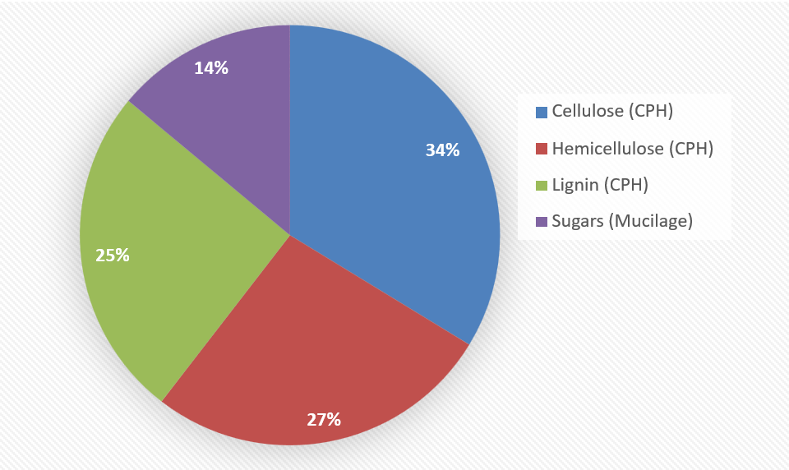

Figure 2. Percentage distribution of the main components of cocoa processing residues based on average values reported in the literature. The lignocellulosic fraction of CPH is represented by cellulose, hemicellulose, and lignin, while sugars correspond to cocoa mucilage. The data were estimated from compositional ranges described by Mendoza Meneses et al. 2021 and Rodríguez Salazar et al. 2020.

The Figure 2 illustrates the percentage distribution of the main components of cocoa processing residues, based on average values from ranges reported in the literature. Cellulose, derived from CPH, represents the largest fraction, at approximately 34 percent, followed by hemicellulose at about 27 percent and lignin at around 25 percent. Sugars from cocoa mucilage correspond to the smallest fraction, at approximately 14 percent. These values are directly derived from the compositional ranges reported by Mendoza Meneses et al. 2021, who describe CPH as a predominantly lignocellulosic material containing 23 to 35 percent cellulose, 8 to 38 percent hemicellulose, and 11 to 33 percent lignin. The predominance of these structural fractions explains the recalcitrant nature of the material, which is consistent with the limitations of biological conversion discussed by Djali et al. 2017, who highlight operational constraints and long processing times associated with ligninolytic fungal pretreatment. In the case of mucilage, the sugar content used in the graph is based on the ranges reported by Rodríguez Salazar et al. 2020 and Mendoza Meneses et al. 2021, indicating values between 10 and 14 percent, mainly composed of glucose, fructose, and sucrose. This composition supports its higher potential for fermentation processes with minimal pretreatment requirements. Although CBS is not directly represented in the graph, its characterization discussed by Okiyama et al. 2017 and Samaniego et al. 2020 complements the interpretation, highlighting the presence of bioactive compounds such as theobromine and caffeine, as well as minerals that may affect thermochemical processes, as also noted by Mendoza Meneses et al. 2021.
    - Conversion pathways and technological performance
Conversion pathways for cocoa residues can be grouped into biochemical, thermochemical and extraction routes, with performance strongly dependent on composition and moisture (Mendoza Meneses et al., 2021). Biochemical processes are more suitable for cocoa mucilage due to its high sugar content, with studies demonstrating bioethanol yields comparable to conventional substrates (Rodríguez Salazar et al., 2020). In contrast, their application to solid residues such as CPH and CBS is limited by lignocellulosic recalcitrance, even with pretreatment (Djali et al., 2017). Anaerobic digestion is one of the most established options for solid residues, showing stable methane production, although process stability depends on substrate characteristics (Acosta et al., 2018). Thermochemical routes such as combustion, pyrolysis and gasification are widely applied to CPH and CBS due to their energy content and flexibility, despite challenges related to ash and mineral content (Mendoza Meneses et al., 2021). Extraction of bioactive compounds from CBS offers higher added value but is typically limited to smaller scale applications (Okiyama et al., 2017; Samaniego et al., 2020).

    - Technological readiness and sustainability-related performance of cocoa residue conversion pathways
The technological readiness of cocoa residue valorization pathways varies significantly depending on the conversion route and target products. Bioenergy options, especially anaerobic digestion and direct combustion, are the most mature, typically at TRL 7 to 9, with proven operation in decentralized systems, including combined heat and power generation. However, their sustainability depends on local factors such as feedstock variability, logistics and digestate management (Acosta et al., 2018; Muñoz López and González Delgado, 2021). Thermochemical processes such as pyrolysis and gasification present intermediate maturity, generally at pilot or demonstration scale, offering flexibility in feedstock use but facing challenges related to emissions and ash, particularly for mineral rich residues like cocoa bean shell (Mendoza Meneses et al., 2021). Biochemical routes for liquid biofuels, such as ethanol from cocoa mucilage, show moderate maturity, TRL 4 to 6, but are limited by seasonal availability and process demands (Rodríguez Salazar et al., 2020). Extraction of bioactive compounds remains at lower TRL levels, 3 to 5, with sustainability strongly influenced by solvent use and separation requirements (Okiyama et al., 2017; Samaniego et al., 2020). Overall, no single pathway combines high maturity, environmental performance and economic viability. This reinforces the relevance of integrated biorefinery approaches, although studies addressing system integration and scale up are still limited.
  - Conclusions
Cocoa residues generated in Bahia represent a significant yet underutilized biomass resource. Although the literature demonstrates their potential for conversion through biochemical, thermochemical and physicochemical routes, most studies remain focused on isolated processes, with limited consideration of integration and large-scale application. Advancing their valorisation requires greater emphasis on integrated approaches, including process integration, cost reduction and life cycle and socio-economic assessments. In this context, biorefinery strategies offer a more effective pathway, improving resource efficiency while contributing to waste reduction and enhancing the sustainability and competitiveness of the cocoa sector in regions such as Bahia.
Nomenclature
CBS – Cocoa Bean Shell
CPH – Cocoa Pod Husk
LCA – Life Cycle Assessment
TRL – Technology Readiness Level
°C – degree Celsius
wt% – weight percentage
Acknowledgments
The authors acknowledge the institutional and academic support of the PRH27 Human Resources Program, SENAI CIMATEC, particularly its Oil and Gas Area, as well as the support for human resources training and scientific and technological development provided by the Brazilian National Agency of Petroleum, Natural Gas and Biofuels (ANP). The authors also recognize Call for Proposals No. 010/2023 (FAPESB–FAPESP) as a mechanism to foster scientific cooperation and strengthen research activities, within the scope of which this work is framed.
References
Acosta, N., de Vrieze, J., Sandoval, V., Sinche, D., Wierinck, I., Rabaey, K., 2018, Cocoa residues as viable biomass for renewable energy production through anaerobic digestion, Bioresource Technology, 265, 568–572.
Djali, M., Sabariman, S., Sugiarto, S., 2017, Degradation of lignocelluloses cocoa shell (Theobroma cacao L.) by various types of mould treatments, Journal of Biological Sciences, 17, 124–130.
Mendoza-Meneses, C.J., Feregrino-Pérez, A.A., Gutiérrez-Antonio, C., 2021, Potential use of industrial cocoa waste in biofuel production, Journal of Chemistry, 2021, 1–15.
Muñoz-López, C.A., González-Delgado, Á.D., 2021, Life cycle assessment of Colombian cocoa pod husk transformation into value-added products, Journal of Cleaner Production, 278, 123957.
Okiyama, D.C.G., Navarro, S.L.B., Rodrigues, C.E.C., 2017, Cocoa shell and its compounds: Applications in the food industry, Trends in Food Science & Technology, 63, 103–112.
Ponce, S., Mena-Campoverde, C., Proaño, J.S., Álvarez-Barreto, J.F., Aguirre, F., Torres-Quintana, D., Sanchez-Prieto, J.S., Almeida-Streitwieser, D., 2022, Proposal of a regulatory framework for bioenergy implementation in a unified agricultural code for Ecuador, Biofuels, Bioproducts and Biorefining, 16, 1192–1206.
Rodríguez-Salazar, J.A., Zambrano-Aguayo, M.D., Hidalgo-González, L.A., Vera-Salazar, J.A., 2020, Kinetic modeling of batch bioethanol production from CCN-51 cocoa mucilage, Journal of Environmental Chemical Engineering, 8, 103650.
Rivera-Carchi, D.W., Villa-Lema, Y.E., Beltran-Borbor, K.K., Villa-Valdivieso, D.A., Manzano-Santana, P., Tinoco-Caicedo, D.L., 2025, Nutritional, Functional and Physical Impact of Fortification of Corn Extrudates with Cocoa Pod Husks and Brewer's Spent Grains: Effect of Extrusion Processing, Chemical Engineering Transactions, 118, 133–138.
Samaniego, I., Espín, S., Quiroz, J., Rosales, C., Carrillo, W., Mena, P., García-Viguera, C., 2020, Profile of bioactive components of cocoa (Theobroma cacao L.) by-products from Ecuador and evaluation of their antioxidant activity, Nutrients, 12, 1123.
Silva, A.F., Santos, J.C., Lima, J.S., 2021, Valorization of cocoa residues for bioenergy and bioproducts: A review, Renewable and Sustainable Energy Reviews, 144, 110960.
Okoro, O.V., Adeleke, J.T., 2022, Cocoa waste valorization for sustainable energy production in West Africa, Cleaner Engineering and Technology, 6, 100384.
Kumar, M., Ghosh, P., Shah, G., 2023, Agricultural residues for sustainable bioenergy production: Feedstock characterization and conversion pathways, Energy Conversion and Management, 276, 116513.

