 CHEMICAL ENGINEERING TRANSACTIONS  VOL. xxx, 2026 | A publication of  
The Italian Association
of Chemical Engineering
Online at www.cetjournal.it

Guest Editors: Marco Bravi, Antonio Marzocchella, Giuseppe Caputo
Copyright © 2026, AIDIC Servizi S.r.l.
ISBN 979-12-81206-xx-x; ISSN 2283-9216

Quantification of Mercury in Freshwater Sediments from an Agricultural Region in Northern Colombia Using Caenorhabditis elegans as a Toxicological Model
Belkis Palacio Villalba *, Leonor Cervantes Ceballos, Daniela Alcala Montoya,
Maria Cecilia Garcia Espiñeira
Faculty of Medicine; Biomedical, Toxicological and Environmental Sciences Research Group (BIOTOXAM), University of Cartagena, Campus de Zaragocilla, Calle 29 # 50-50, Cartagena de Indias, 130014, Colombia

belkis.palacio@unicartagena.edu.co
Mercury (Hg) contamination in freshwater sediments represents a major environmental concern due to its persistence, bioaccumulation potential, and high toxicity. In agricultural regions, intensive land use and hydrological modifications may enhance mercury mobilization and accumulation in aquatic systems. This study quantified total mercury concentrations in surface sediments from the Marialabaja swamp, an agriculturally impacted freshwater ecosystem in northern Colombia, and evaluated their toxicological effects using Caenorhabditis elegans as an in vivo model. Total mercury was detected in all sediment samples, with concentrations ranging from 0.116 to 0.174 mg/kg. Measured values were compared with internationally recognized sediment quality guidelines, including the Threshold Effect Level (TEL = 0.13 mg/kg) and Probable Effect Level (PEL = 0.70 mg/kg) from CCME, as well as the Effects Range Low (ERL = 0.15 mg/kg) and Effects Range Median (ERM = 0.71 mg/kg) from NOAA. Sediment mercury concentrations at several sites exceeded TEL/ERL thresholds, indicating potential ecological risk. Exposure to aqueous sediment extracts induced concentration-dependent lethality and locomotor impairment in C. elegans. Transgenic reporter assays revealed activation of oxidative stress (sod-1, sod-3) and neurobehavioral pathways (nlg-1). These findings demonstrate that sediment-associated mercury poses ecotoxicological risk and confirm the value of C. elegans as a sensitive and integrative model for environmental monitoring, highlighting the importance of combining chemical and biological tools for environmental risk assessment in agricultural freshwater systems.

Keywords
Mercury; freshwater sediments; Caenorhabditis elegans; oxidative stress; neurotoxicity

1. Introduction

Mercury (Hg) is a global environmental contaminant characterized by high persistence, bioaccumulation potential, and severe toxicity to living organisms. In aquatic ecosystems, mercury occurs in both inorganic and organic forms, with methylmercury being the most toxic species due to its high bioavailability and capacity to biomagnify along food webs, ultimately affecting human populations (Clarkson, 1997; Clarkson et al., 2003). Freshwater sediments play a central role in the environmental cycling of mercury, acting as sinks and potential secondary sources through remobilization and microbial methylation processes (Fujimura and Usuki, 2022). In agricultural regions, irrigation systems, land-use changes, and hydrological connectivity may intensify mercury transport and accumulation in wetlands and floodplain environments (Harada, 1995; Bjørklund et al., 2017).

Mercury-induced toxicity has been consistently associated with oxidative stress, disruption of antioxidant defense systems, and neurotoxicity, particularly affecting the central nervous system. Methylmercury exhibits a strong affinity for thiol and selenol groups, leading to enzyme inhibition, redox imbalance, and neuronal dysfunction (Kaur et al., 2006; Franco et al., 2009). Experimental and epidemiological studies have linked mercury exposure to neurodevelopmental impairment and neurodegenerative processes (Grandjean et al., 1997).

Caenorhabditis elegans has emerged as a robust model organism in environmental toxicology due to its short life cycle, genetic tractability, transparency, and conservation of molecular pathways involved in oxidative stress and neuronal signaling (Leung et al., 2008; Kaletta and Hengartner, 2006). The availability of transgenic reporter strains enables the evaluation of organism-level and molecular endpoints, providing mechanistic insight into contaminant-induced toxicity (Benítez and Olívero-Verbel, 2016). The objective of this study was to quantify total mercury concentrations in surface sediments from the Marialabaja swamp and to assess their toxicological effects using lethality, locomotion, oxidative stress, and neurobehavioral endpoints in C. elegans. However, limited information is available on the biological effects of sediment-associated mercury in tropical agricultural freshwater ecosystems.
2. Materials and Methods
2.1 Study area and sediment sampling
The Marialabaja swamp is located in northern Colombia within the Montes de María region, an area characterized by intensive agricultural activity and extensive irrigation infrastructure connected to the Canal del Dique system (Quiroga Manrique and Vallejo Bernal, 2019; Daniels Puello, 2016). Surface sediment samples were collected from four representative sites distributed across the swamp. The geographic location of the study area and the sediment sampling sites is shown in Figure 1.
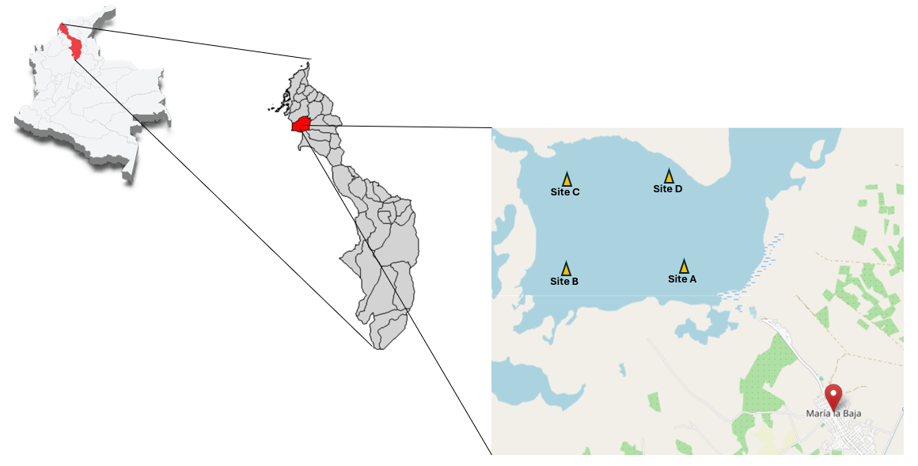
Figure 1: Geographical location of the Marialabaja swamp in the department of Bolívar, northern Colombia, and the sediment sampling sites (A–D).
2.2 Sample preparation and total mercury analysis
Sediment samples were freeze-dried, homogenized, and sieved (<63 µm). Total mercury concentrations were determined using a direct mercury analyzer based on thermal decomposition, amalgamation, and atomic absorption spectrometry, following US EPA SW-846 Method 7473 (Olivero et al., 2014). Quality control procedures included certified reference materials, calibration curves, blanks, and duplicate analyses.
2.3 Preparation of aqueous sediment extracts
Aqueous sediment extracts were prepared to estimate the bioavailable dissolved fraction of mercury rather than total sediment-bound concentrations (Eggleton and Thomas, 2004; Tejeda-Benítez et al., 2018). Freeze-dried sediment samples were homogenized and mixed with ultrapure water at a ratio of 1:4 (w/v). The suspensions were agitated for 24 h at room temperature, centrifuged at 4,000 rpm for 15 min, and the supernatant was filtered through a 0.45 μm membrane filter. Mercury concentrations in the extracts were quantified and expressed in parts per million (ppm), representing dissolved mercury available for biological uptake in bioassays.
2.4 Caenorhabditis elegans culture and exposure
Wild-type Bristol N2 and transgenic GFP reporter strains (sod-1::GFP, sod-3::GFP, and nlg-1) were obtained from the Caenorhabditis Genetics Center. Nematodes were maintained under standard laboratory conditions and synchronized prior to exposure (Corsi et al., 2015; Leung et al., 2008).
2.5 Toxicity and reporter assays
Lethality and locomotion assays were performed after 24 h exposure to aqueous sediment extracts at different concentrations. Oxidative stress and neurobehavioral responses were evaluated using GFP reporter strains, with fluorescence intensity measured using a microplate reader (Staab et al., 2014; Anbalagan et al., 2013). Each treatment included three independent biological replicates.
2.6 Statistical analysis
Results are expressed as mean ± SEM of three independent biological replicates. Statistical analyses were conducted using one-way ANOVA followed by Tukey’s post hoc test. Statistical analyses were performed using GraphPad Prism. Differences were considered significant at p < 0.05.
3. Results and Discussion
3.1 Total mercury concentrations in sediments
Total mercury was detected in all surface sediment samples collected from the Marialabaja swamp, indicating widespread contamination within the aquatic system. Concentrations ranged from 0.116 to 0.174 mg/kg, with the highest mean values observed at sites B and D, while the lowest concentrations were recorded at site C (Table 1).
Measured mercury concentrations were compared with internationally recognized sediment quality guidelines, including the Threshold Effect Level (TEL = 0.13 mg/kg) and Probable Effect Level (PEL = 0.70 mg/kg) established by the Canadian Council of Ministers of the Environment (CCME), as well as the Effects Range Low (ERL = 0.15 mg/kg) and Effects Range Median (ERM = 0.71 mg/kg) defined by NOAA (MacDonald et al., 2000; Long et al., 1995; CCME, 2001).
Sediment mercury concentrations at sites A, B, and D exceeded TEL and ERL thresholds, indicating a potential risk of adverse biological effects, although all values remained below PEL and ERM levels associated with a high probability of ecological toxicity. These results suggest localized ecological concern linked to agricultural activity, irrigation practices, and sediment transport processes in the Marialabaja irrigation district.
Table 1: Total mercury concentrations (Hg-T) in surface sediments from the Marialabaja swamp.
Site | Hg-T (mg/kg) Mean ± Error | SD | CV (%)
A | 0.149 ± 0.005 | 0.007 | 4.84
B | 0.157 ± 0.001 | 0.002 | 1.04
C | 0.117 ± 0.001 | 0.001 | 0.18
D | 0.173 ± 0.001 | 0.001 | 0.53
3.2 Relationship between sediment Hg (mg/kg) and extract exposure (ppm)
Total mercury in sediments represents the environmental burden, whereas ppm concentrations in bioassays reflect the bioavailable dissolved fraction (Luoma and Rainbow, 2008). Only a fraction of sediment-bound mercury becomes solubilized and biologically accessible (Eggleton and Thomas, 2004). Thus, ppm values should not be interpreted as direct conversions from sediment mg/kg, but rather as estimates of environmentally relevant exposure that better represent uptake potential in aquatic organisms (Chapman et al., 2003).
3.3 Effects on lethality and locomotion
Exposure of C. elegans to aqueous sediment extracts resulted in concentration-dependent biological effects. Lethality assays showed no significant differences compared with the control at 10 and 100 ppm; however, exposure to 1,000 ppm induced a significant increase in mortality (Figure 2a), indicating that sediment-associated mercury remains biologically available and capable of inducing acute toxicity at higher concentrations. In contrast, locomotion was significantly impaired at all tested concentrations (Figure 2b), demonstrating that sublethal endpoints are more sensitive indicators of mercury toxicity. Locomotor activity in C. elegans is closely linked to neuronal and neuromuscular function, and reductions in body bends reflect early neurotoxic effects. The observation that locomotion was affected even at non-lethal concentrations suggests disruption of neuronal signaling prior to overt toxicity.
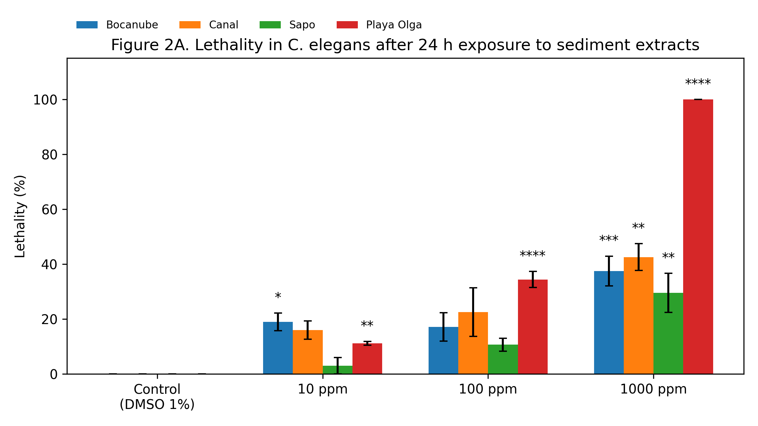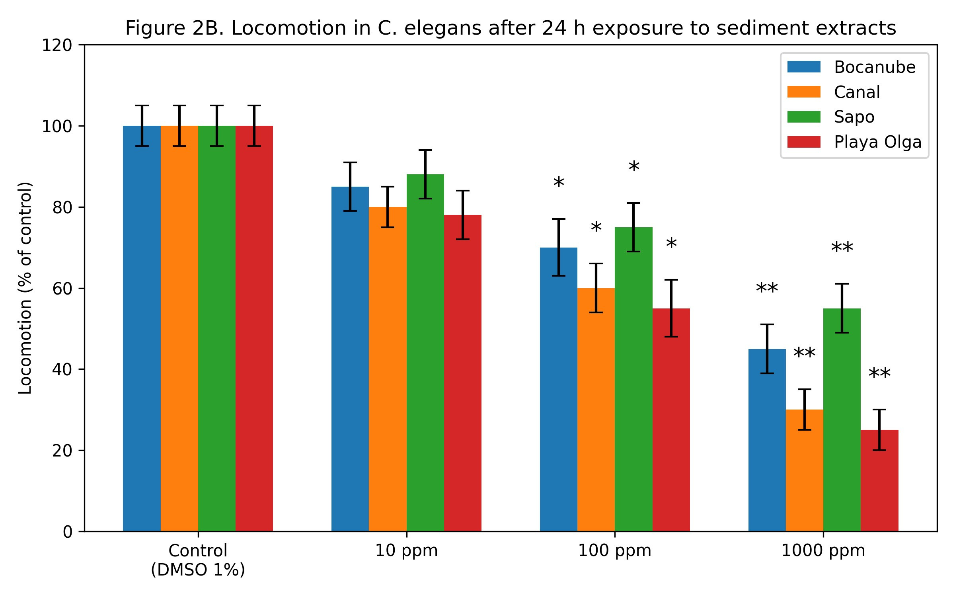
Figure 2: Effects of aqueous sediment extracts on C. elegans. (2a) Lethality after 24 h exposure. (2b) Locomotion expressed as body bends per unit time. Values represent mean ± SEM. * indicates significant differences compared to the control (p < 0.05).
3.4 Oxidative stress response in C. elegans
At the molecular level, oxidative stress reporter assays revealed significant induction of GFP expression driven by the sod-1 and sod-3 promoters following exposure to aqueous sediment extracts (Figure 3). Superoxide dismutases play a central role in the detoxification of reactive oxygen species, and their upregulation reflects an adaptive cellular response to increased oxidative burden. These results support the hypothesis that oxidative stress is a key mechanism underlying mercury-induced toxicity, even at environmentally relevant concentrations. Sustained activation of antioxidant defense pathways may lead to cellular exhaustion under chronic exposure scenarios, potentially contributing to long-term toxic effects in exposed organisms.
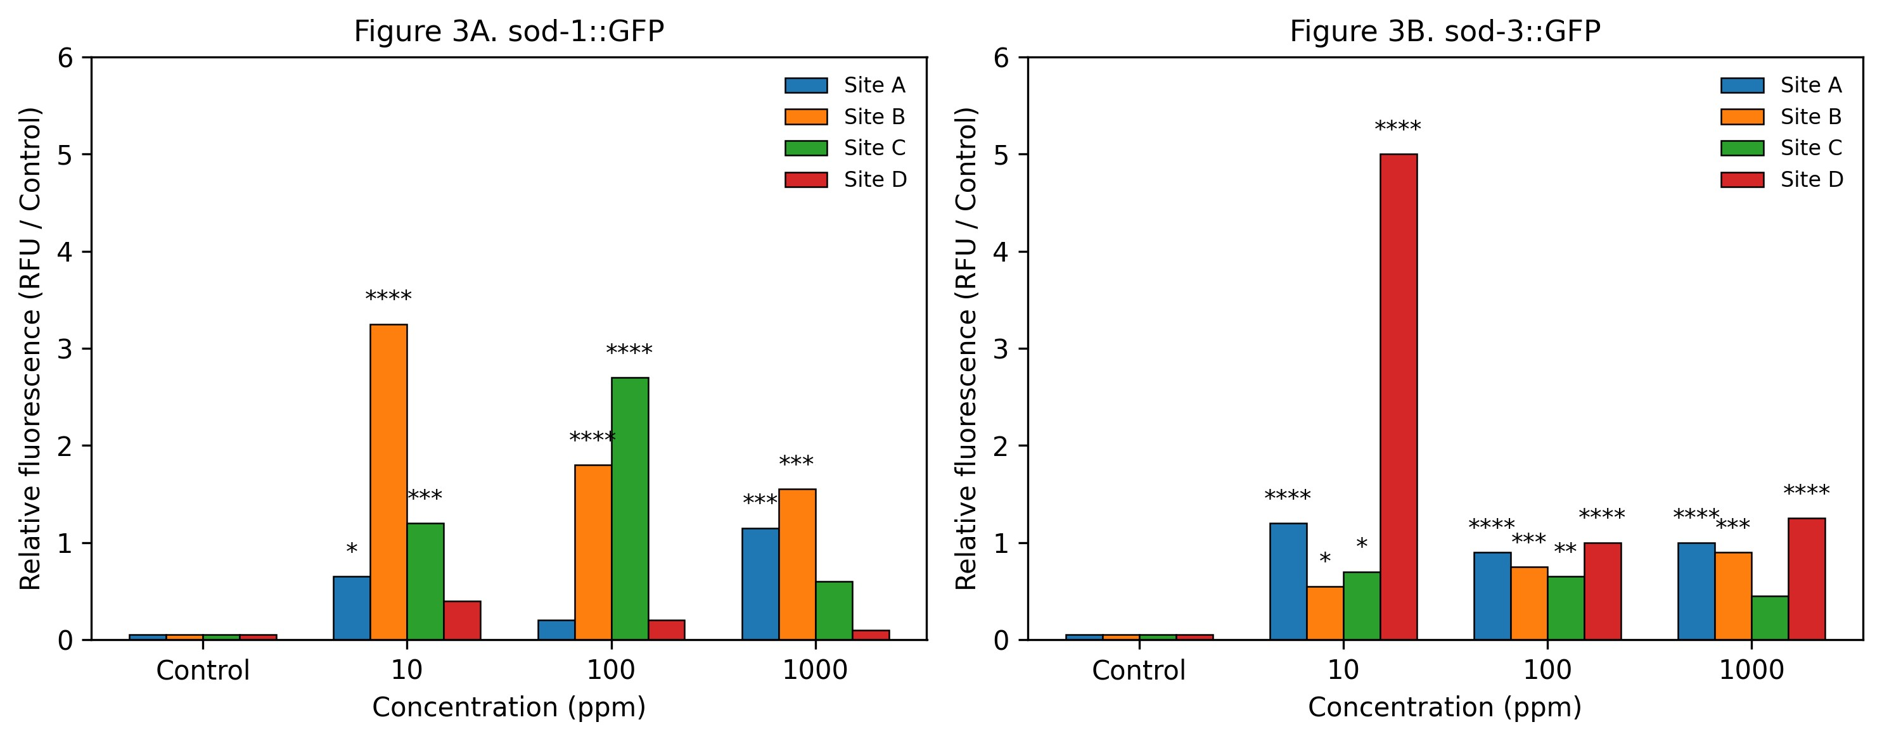
Figure 3: Oxidative stress response evaluated by relative GFP fluorescence in transgenic C. elegans exposed to aqueous sediment extracts. Fluorescence values were normalized to the control. Bars represent mean ± SEM. * indicates significant differences compared with the control (p < 0.05; one-way ANOVA followed by Tukey’s post hoc test).
3.5 Neurobehavioral alterations associated with mercury exposure
Neurobehavioral alterations were further evidenced by changes in nlg-1 expression in exposed nematodes. Neuroligins are essential for synaptic organization and neuronal communication, and their dysregulation has been associated with impaired synaptic function and altered behavior. The modulation of nlg-1 expression observed in this study suggests that mercury exposure interferes with synaptic integrity and neural connectivity, providing a mechanistic explanation for the locomotor deficits detected in C. elegans. The integration of behavioral and molecular endpoints strengthens the interpretation of mercury-induced neurotoxicity and highlights the usefulness of C. elegans as a model for linking sublethal behavioral effects with underlying cellular mechanisms.
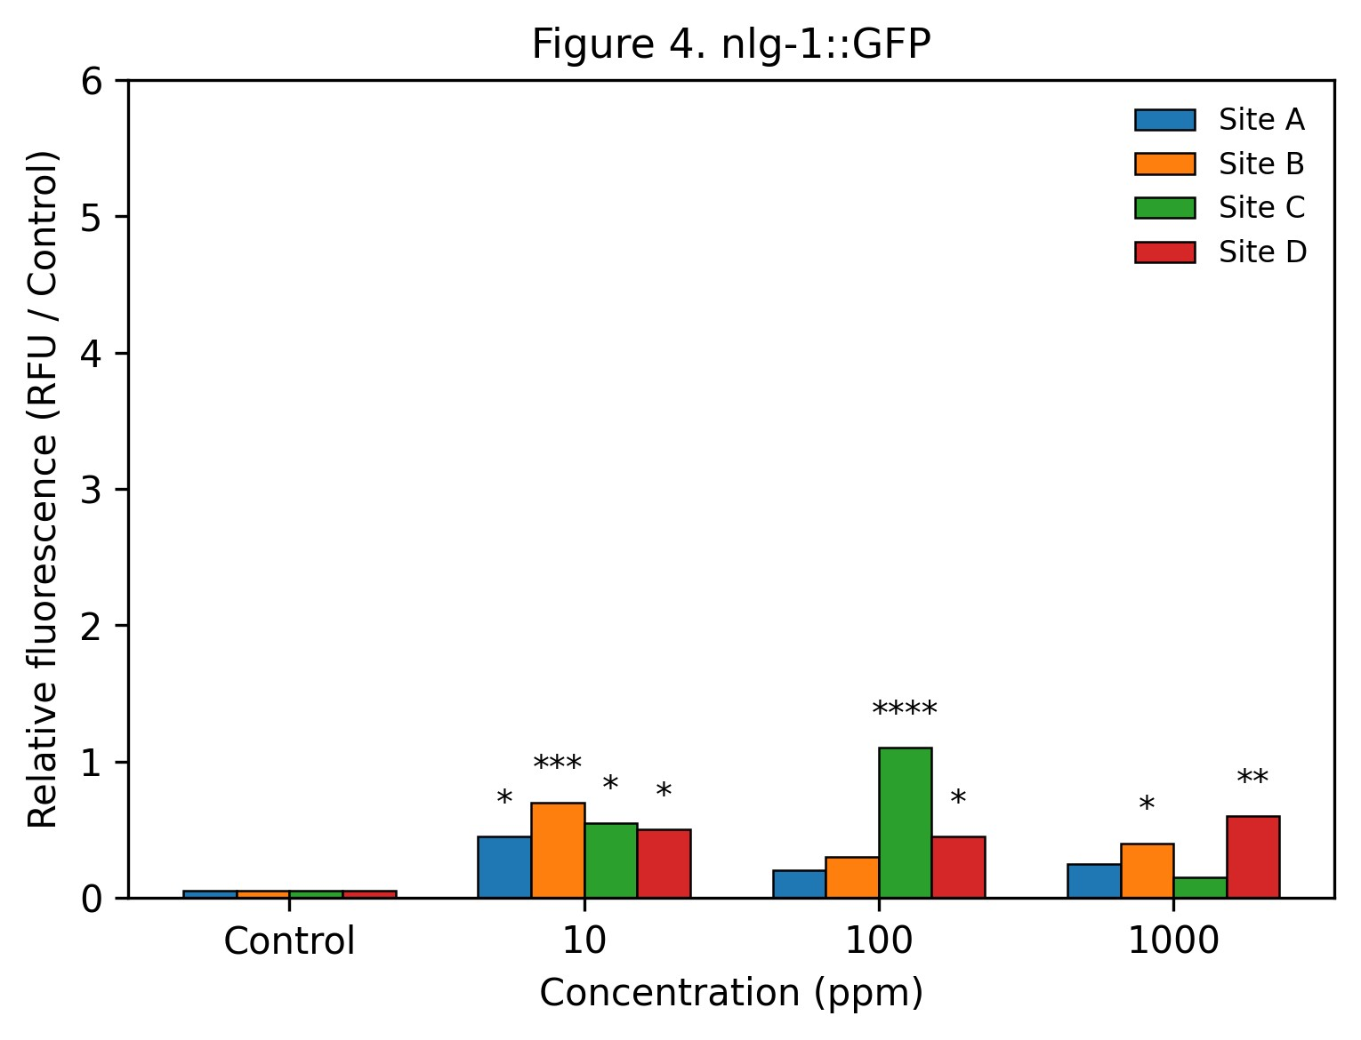
Figure 4: Neurobehavioral response assessed by relative GFP fluorescence driven by the nlg-1 promoter in transgenic C. elegans after exposure to aqueous sediment extracts for 24 h. Values represent mean ± SEM. * p < 0.05, ** p < 0.01 compared with the control (one-way ANOVA followed by Tukey’s post hoc test).
4. Conclusions
This study demonstrates that surface sediments from the Marialabaja swamp contain biologically active mercury capable of inducing lethal and sublethal toxic effects in Caenorhabditis elegans. Mercury exposure impaired locomotion and activated oxidative stress and neurobehavioral pathways, underscoring the ecological relevance of sediment-associated contamination in agricultural freshwater systems. The results emphasize the importance of integrating chemical analysis with biological assays for environmental risk assessment and support the use of C. elegans as a sensitive and mechanistically informative model for sediment toxicity evaluation.
Conflict of interest
The authors declare no conflict of interest.
Acknowledgments
Vice-Rectory for Research at the University of Cartagena-Colombia, support Research Group BIOTOXAM Grant N° 003A-2022, Resolution No. 01388 august 31, 2021. National Program for Doctoral Formation Minciencias Grant 727- 2015.
References
Anbalagan, C., Lafayette, I., Antoniou-Kourounioti, M., Haque, M., King, J., Johnsen, B., Baillie, D., Gutierrez, C., Martin, R., 2013, Transgenic nematodes as biosensors for metal stress in soil pore water samples, Environmental Toxicology and Chemistry, 32, 2601–2610.
Benítez, L., Olívero-Verbel, J., 2016, Caenorhabditis elegans, a biological model for research in toxicology, Reviews of Environmental Contamination and Toxicology, 237, 1–35.
Bjørklund, G., Dadar, M., Mutter, J., Aaseth, J., 2017, The toxicology of mercury: current research and emerging trends, Environmental Research, 159, 545–554.
Canadian Council of Ministers of the Environment (CCME), 2001, Canadian sediment quality guidelines for the protection of aquatic life: Mercury, Canadian Environmental Quality Guidelines, Winnipeg.
Chapman, P.M., Wang, F., Janssen, C., Goulet, R., Kamunde, C., 2003, Conducting ecological risk assessments of inorganic metals and metalloids: current status, Human and Ecological Risk Assessment, 9, 641–697.
Clarkson, T.W., 1997, The toxicology of mercury, Critical Reviews in Clinical Laboratory Sciences, 34, 369–403.
Clarkson, T.W., Magós, L., Myers, G.J., 2003, The toxicology of mercury—current exposures and clinical manifestations, New England Journal of Medicine, 349, 1731–1737.
Corsi, A.K., Wightman, B., Chalfie, M., 2015, A transparent window into biology: a primer on Caenorhabditis elegans, Genetics, 200, 387–407.
Daniels Puello, A.J., 2016, La transformación de la estructura productiva de los Montes de María: de despensa agrícola a distrito minero-energético, Memorias. Revista Digital de Historia y Arqueología desde el Caribe, 29, 52–83.
Eggleton, J., Thomas, K.V., 2004, A review of factors affecting the release and bioavailability of contaminants during sediment disturbance events, Environment International, 30, 973–980.
Franco, J.L., Posser, T., Dunkley, P.R., Dickson, P.W., Mattos, J.J., Martins, R., Bainy, A.C.D., Dafre, A.L., Farina, M., 2009, Methylmercury neurotoxicity is associated with inhibition of the antioxidant enzyme glutathione peroxidase, Free Radical Biology and Medicine, 47, 449–457.
Fujimura, M., Usuki, F., 2022, Cellular conditions responsible for methylmercury-mediated neurotoxicity, International Journal of Molecular Sciences, 23, 7218.
Grandjean, P., Weihe, P., White, R.F., Debes, F., Araki, S., Yokoyama, K., Murata, K., Sørensen, N., Dahl, R., Jørgensen, P.J., 1997, Cognitive deficit in 7-year-old children with prenatal exposure to methylmercury, Neurotoxicology and Teratology, 19, 417–428.
Harada, M., 1995, Minamata disease: methylmercury poisoning in Japan caused by environmental pollution, Critical Reviews in Toxicology, 25, 1–24.
Kaletta, T., Hengartner, M.O., 2006, Finding function in novel targets: C. elegans as a model organism, Nature Reviews Drug Discovery, 5, 387–399.
Kaur, P., Aschner, M., Syversen, T., 2006, Glutathione modulation influences methylmercury-induced neurotoxicity in primary cell cultures of neurons and astrocytes, NeuroToxicology, 27, 492–500.
Leung, M.C.K., Williams, P.L., Benedetto, A., Au, C., Helmcke, K.J., Aschner, M., Meyer, J.N., 2008, Caenorhabditis elegans: an emerging model in biomedical and environmental toxicology, Toxicological Sciences, 106, 5–28.
Long, E.R., MacDonald, D.D., Smith, S.L., Calder, F.D., 1995, Incidence of adverse biological effects within ranges of chemical concentrations in marine and estuarine sediments, Environmental Management, 19, 81–97.
Luoma, S.N., Rainbow, P.S., 2008, Metal contamination in aquatic environments: science and lateral management, Cambridge University Press, Cambridge.
MacDonald, D.D., Ingersoll, C.G., Berger, T.A., 2000, Development and evaluation of consensus-based sediment quality guidelines for freshwater ecosystems, Archives of Environmental Contamination and Toxicology, 39, 20–31.
Olivero-Verbel, J., Caballero-Gallardo, K., Marrugo-Negrete, J., 2014, Relationship between physicochemical parameters and heavy metal concentrations in sediments of a tropical estuary, Environmental Science and Pollution Research, 21, 6336–6348.
Quiroga Manrique, C., Vallejo Bernal, D., 2019, Territorios de agua: infraestructura agrícola, reforma agraria y palma de aceite en el municipio de Marialabaja (Bolívar), Revista Colombiana de Antropología, 55, 59–89.
Staab, T.A., Egrafov, O., Knowles, J.A., Sieburth, D., 2014, Regulation of synaptic nlg-1 abundance by the SKN-1/Nrf stress response pathway protects against oxidative stress, PLOS Genetics, 10, e1004100.
Tejeda-Benítez, L., Flegal, R., Olivero-Verbel, J., 2018, Toxicity of sediment extracts assessed using Caenorhabditis elegans, Ecotoxicology and Environmental Safety, 156, 216–222.

