 CHEMICAL ENGINEERING TRANSACTIONS  VOL. xxx, 2026 | A publication of  
The Italian Association
of Chemical Engineering
Online at www.cetjournal.it

Guest Editors: Marco Bravi, Antonio Marzocchella, Giuseppe Caputo
Copyright © 2026, AIDIC Servizi S.r.l.
ISBN 979-12-81206-xx-x; ISSN 2283-9216

THE POTENTIAL OF BRAZILIAN AGRICULTURAL RESIDUES FOR BIOREFINERIES: A NETWORK-BASED TREND ANALYSIS
Yuri Uriel Cerqueira Gil Braz Moreira^{a,*}, Tito Francisco Ianda^{b}, Fernando Luiz Pellegrini Pessoaª
ªUniversity SENAI CIMATEC, 1845 Orlando Gomes Av., Piatã, 41650-010, Salvador, Bahia, Brazil
^{b}Federal University of Bahia, n/nº Ondina, Av. Milton Santos, 40170-110, Salvador, Bahia, Brazil
*yuri-braz@hotmail.com
Brazil produces significant amounts of agricultural residues with potential for valorization in biorefineries. However, the scientific literature on this topic remains scattered across various conversion methods. This study aimed to map research trends in the valorization of these residues from 2020 to 2025 through a bibliometric analysis. Records from the Web of Science and Scopus databases were combined, deduplicated, and screened for relevance, resulting in a corpus of 777 documents analyzed with Bibliometrix software. Keyword co-occurrence network analysis revealed three main technological clusters: Biochemical (fermentation, biogas, and ethanol; 40.7 %), Thermochemical (biochar and activated carbon; 32.6 %), and Bioactive Extraction (phenolic compounds and antioxidants; 26.0 %). Sugarcane bagasse was the most common substrate, appearing in 25.5 % of publications, largely due to its widespread availability at processing sites. The primary finding was the increasing convergence of the three routes toward similar proportions by 2025 (around 33 % each), supported by 18.4 % of articles that combined multiple clusters in a single study. This convergence signals a shift from the single-product conversion model toward integrated biorefinery systems, where lignocellulosic, carbonaceous, and phenolic fractions of by-products are valorized sequentially in a cascade.

  - Introduction
Brazil’s consolidation as a global agricultural leader, with a production value of BRL 783.2 billion in 2024, creates a direct relationship between the productivity of primary supply chains and the continuous availability of residual biomass (Loschi and Pirrho, 2025). The country’s major crops, including sugarcane, maize, soybean, and planted forests, each generate more than 100 million tons of biomass per year, while coffee and açaí range between 500 thousand and 5 million tons annually (BRASIL, 2025). Despite this substantial scale, the diagnosis of Brazilian biorefining reveals that most supply chains still operate as pre-biorefineries: they extract a single main product and discard by-products and co-products in considerable quantities, with integral biomass utilization being the exception rather than the rule (BRASIL, 2025). Comprehensive estimates indicate that the country generates approximately 37 million tons of organic residues per year, of which only 1 % is effectively valorized (EMBRAPA, 2022).
Overcoming this scenario of underutilization requires a transition from linear disposal models to integrated biorefineries capable of converting lignocellulosic streams into biofuels, bioproducts, and high-added-value materials (EMBRAPA, 2022; Grillo and Santos, 2023). Brazil’s sugarcane energy sector demonstrates this potential, producing more than 600 million tons of cane per year, generating approximately 280 kg of wet bagasse per processed ton of sugarcane, and occupying only 1.1 % of national territory (Karp et al., 2021). This volume positions the country as the world’s second-largest ethanol producer, accounting for 30 % of global production in 2019 and enabling reductions of up to 80 % in greenhouse gas emissions compared with petrol (Karp et al., 2021). At the same time, sugarcane presents the highest relative utilization of residues among Brazilian crops, although still with limited diversification and low generation of high-added-value products (BRASIL, 2025). Beyond the sugarcane sector, the citrus and coffee industries contribute approximately 7 million tons of dense organic matter suitable for bioactive compound extraction (Schneider and Peresan, 2012), while Brazil and Colombia together account for 97 % of the residues derived from sugarcane processing in South America (Sampaolesi et al., 2023).
The valorization of these resources is encompassed by the National Bioeconomy Strategy, which prioritizes integral biomass use and product diversification as drivers of regional economic integration (BRASIL, 2025). Despite the documented potential, the integration of multiple conversion routes in a single industrial plant remains incipient: the literature concentrates on isolated routes, and few industrial units operate under the concept of an integrated biorefinery. The present study aims to characterize this landscape through bibliometric mapping, to identify trends, thematic concentrations, and signals of convergence among conversion routes in the valorization of Brazilian residues.
  - Materials and Methods
To ensure robust and reliable data, the Web of Science (WoS) and Scopus databases were adopted as reference sources. In WoS, searches were carried out using the Topic field; in Scopus, using the Title-Abstract-Keywords field, to capture comparable textual metadata across platforms. The analysis covered the period from 01/01/2020 to 26/12/2025, including records already accepted and available as early access versions.
In the initial stage, keywords were organized into three main thematic categories, as summarized in Table 1: Residue type, Processes and applications, and Brazil scope. The search strategy was intentionally designed to encompass terms associated with both agricultural residues and agroindustrial by-products, since the literature frequently uses overlapping terminology depending on crop origin, processing stage, and regional or sectoral context. The search strategy was implemented through progressive Boolean combinations.

Table 1: Thematic groups and keyword variants used in bibliometric research.
Group | Thematic | Keyword variants
01 | Residue Type | ("agroindustrial residu*" OR "agro industrial residu*" OR "byproduct*" OR "by-product*" OR "coproduct*" OR "co-product*" OR "husk*" OR "hull*" OR "shell*" OR "peel*" OR "bran" OR "pulp" OR "pomace" OR "parchment" OR "spent coffee ground*" OR "coffee husk*" OR "coffee pulp*" OR "coffee parchment*" OR "press cake" OR "oilseed cake" OR "seed cake" OR "oilseed meal" OR "defatted meal" OR "seed husk*" OR "seed hull*" OR "empty fruit bunch*" OR "palm kernel shell*" OR "cotton gin trash" OR "gin trash" OR "bagasse*" OR "straw*" OR "stover*")
02 | Processes and applications | ("biorefin*" OR "valori*" OR "bioproduct*" OR "biobased" OR "pretreat*" OR "hydroly*" OR "enzymatic hydroly*" OR "ferment*" OR "anaerobic digest*" OR "pyroly*" OR "gasifi*" OR "biochar*" OR "activated carbon" OR "adsorption" OR "biocomposite*" OR "nanocellulose" OR "cellulose nanofiber*" OR "bioeconomy*" OR "circular economy*")
03 | Brazil scope | ("Brazil*" OR "Cerrado" OR "Caatinga" OR "Brazilian semiarid" OR "Amazon*" OR "Legal Amazon" OR "Atlantic Forest" OR "Pantanal" OR "Pampa" OR "Matopiba" OR "Sao Paulo" OR "Minas Gerais" OR "Parana" OR "Goias" OR "Mato Grosso" OR "Mato Grosso do Sul" OR "Bahia" OR "Rio Grande do Sul" OR "Espirito Santo" OR "Distrito Federal")
Bibliometric processing was carried out in R 4.5.1 with the bibliometrix package (v5.2.1) in the RStudio IDE (v2025.9.1.401) under Windows 11 x64 (build 26200). Records from WoS and Scopus were merged and deduplicated, primarily by DOI and, in its absence, by title and publication year. The resulting document set was subjected to relevance screening structured around three weighted criteria: alignment of keywords with residue types, coverage of conversion routes and biorefinery applications, and pertinence to the Brazilian geographical context.
  - Results and discussion
    - Corpus overview and annual output
The deduplication and relevance screening procedure resulted in a final corpus of 777 documents published between 2020 and 2025. Annual scientific output (Figure 1) showed a baseline of 104 publications in 2020, remained at a plateau of 121 to 135 articles per year between 2021 and 2024, and reached 162 publications in 2025, representing 56 % growth relative to the initial year. The upward trend, confirmed by linear regression, demonstrates growing scientific interest in the valorization of Brazilian residues in biorefinery contexts.
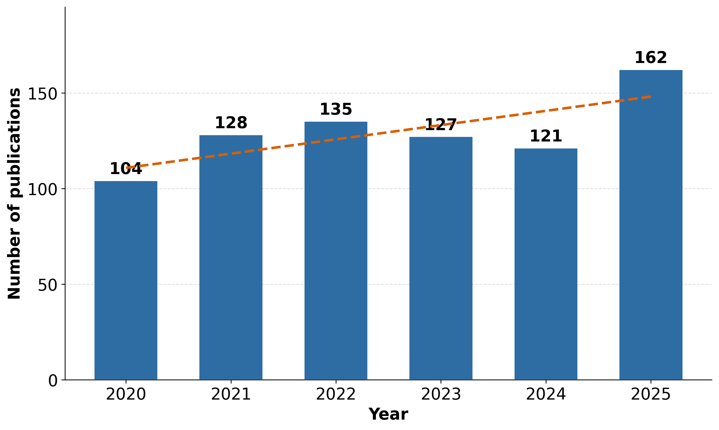
Figure 1: Annual distribution of publications on Brazilian residues for biorefineries (2020-2025).
The increase observed in 2025 is consistent with broader sectoral dynamics, including greater academic debate on the circular economy, the expansion of regulatory instruments such as RenovaBio, and the publication of the National Bioeconomy Strategy (BRASIL, 2025), as well as a collaborative research profile with 7.02 co-authors per document and 23.01 % international co-authorship, which tends to accelerate scientific production and dissemination.
    - Most frequent residues
Figure 2 presents the ten most frequent residues in the corpus. Sugarcane bagasse stands out as the leading substrate, present in 198 publications (25.5 % of the corpus), a frequency approximately three times higher than that of the second most-studied material, rice husk and bran (64 articles). This trend reflects intrinsic characteristics of the substrate: bagasse is generated at the mill during juice extraction, forming an inherently concentrated industrial stream available in high volumes, with a well-characterized lignocellulosic composition of approximately 53 % cellulose. The continental relevance of this stream is evidenced by the fact that Brazil and Colombia jointly account for 97 % of the residues derived from sugarcane processing in South America (Sampaolesi et al., 2023).
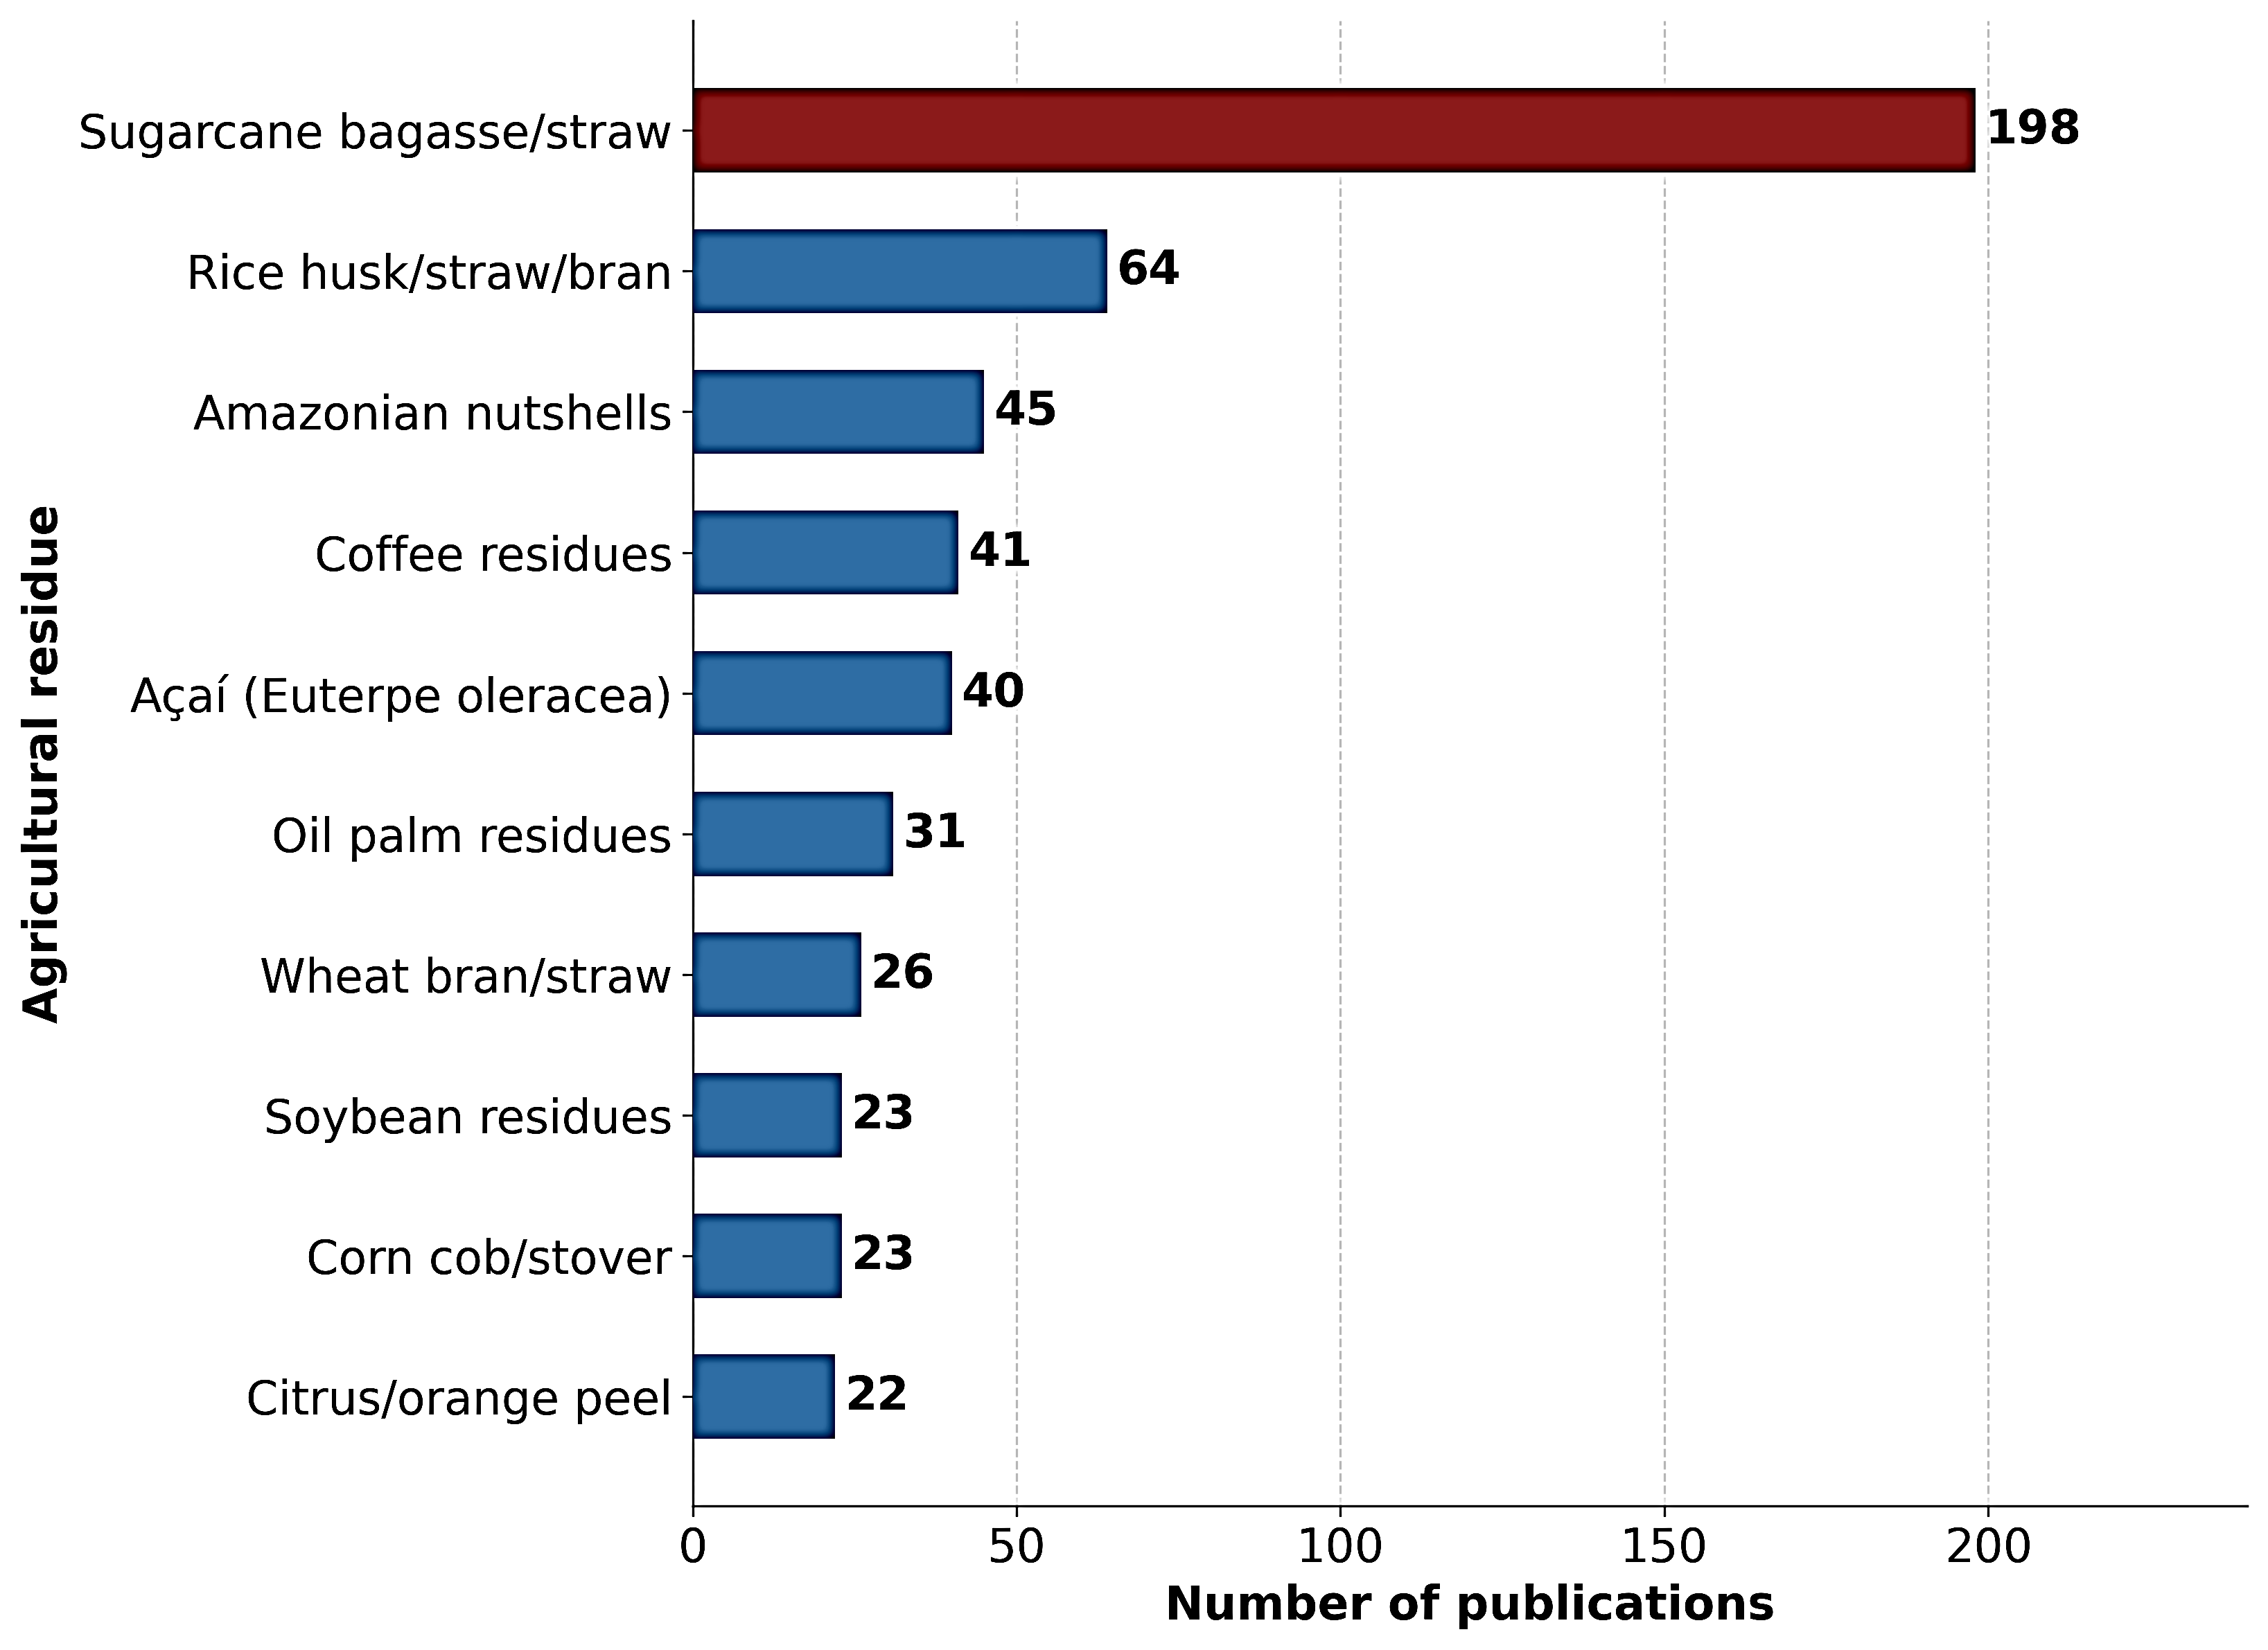
Figure 2: Most frequent residues in the corpus (2020-2025).
The same logic of industrial concentration explains the position of the other most-studied residues: coffee residues (41 articles), rice husk and bran (64 articles), wheat bran (26 articles), and orange peel and citrus residues (22 articles) are generated at processing units with supply chains amenable to integration with biorefinery processes. Amazonian nutshells (45 articles) and açaí residues (40 articles) demonstrate the growing recognition of the Amazon as a source of industrial-scale biomass. Açaí seeds (Euterpe oleracea), the main residue of pulp processing and corresponding to 85 % of the fruit mass, present a relevant lignocellulosic composition (43.81 % cellulose, 25.89 % hemicellulose, and 24.56 % lignin), characteristics that qualify them as a promising feedstock for bioenergy conversion (Ferreira et al., 2021). Residues from native fruits were characterized as precursors of high-performance carbonaceous materials, with biochars produced from Legal Amazon residues achieving surface areas of up to 298 m² g⁻¹ through thermochemical conversion (Borges et al., 2025). Palm oil residues (31 articles) complete the group of the ten most studied, forming a geographically diversified feedstock landscape that extends beyond the sugarcane-centered model.
    - Technological routes and temporal dynamics
Keyword co-occurrence network analysis organized the corpus into three technological clusters, whose annual article volumes are represented in Figure 3.
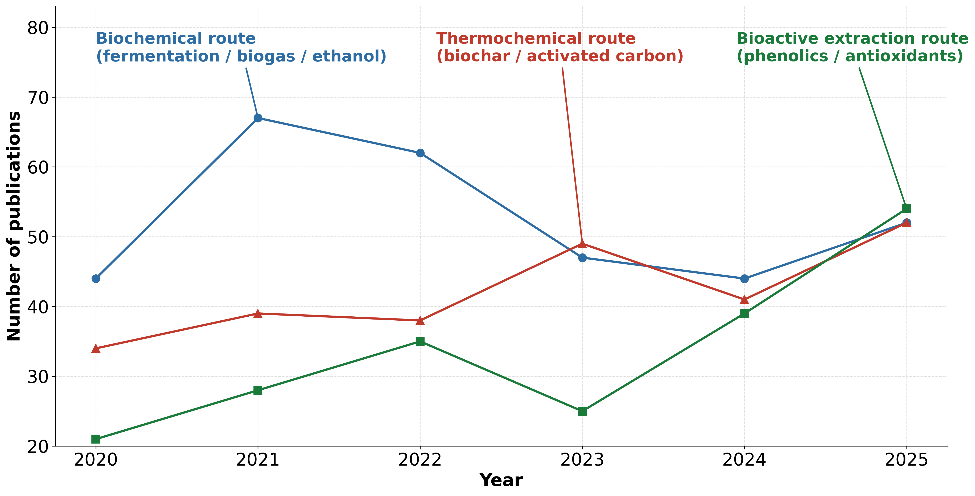
Figure 3: Author keyword co-occurrence network of residue valorization in Brazil within biorefinery research, from 2020 to 2025.
Cluster C1, associated with the Biochemical route (fermentation, biogas, and ethanol), includes 316 articles (40.7 % of the total), making it the dominant pathway historically, with a peak of 67 publications in 2021 before decreasing and stabilizing. This cluster highlights the use of lignocellulosic biorefineries based on enzymatic hydrolysis and microbial fermentation, primarily utilizing sugarcane bagasse as the main substrate. The industrial scale of this pathway is well documented: Brazil produces over 600 million tons of sugarcane annually, and ethanol from this feedstock can reduce greenhouse gas emissions by up to 80 % compared with petrol, with an energy balance roughly seven times more favorable than that of maize ethanol (Karp et al., 2021). Co-digestion strategies have also been explored within this pathway, such as anaerobic co-digestion of Brazilian lignocellulosic residues, including sugarcane bagasse and coffee husk, with poultry manure. This approach shows that optimizing the C/N ratio between nitrogen-rich and carbon-rich industrial streams can enhance methane yields, reaching 126.02 Nm³ of CH₄ per ton of residue in the best case (De Oliveira et al., 2020). Açaí residues are another example within this pathway; Brazil produced 1,7 million tons of fruit in 2018, generating revenue of USD 1,07 billion. The seeds resulting from industrial pulp processing form a significant lignocellulosic stream. From 1,214 tons of this residue, anaerobic digestion can produce up to 2.77 Nm³ of biogas with 50 % methane, enough to supply roughly 61 % of the electricity needed for the frozen pulp production process (Ferreira et al., 2021). Therefore, according to Vandenberghe et al. (2022), while RenovaBio consolidates the first-generation basis in sugar, ethanol, and bioelectricity, integrating new-generation biochemical routes paves the way for biopolymers, organic acids, enzymes, and other biomolecules within a circular bioeconomy framework.
Cluster C3, related to the Thermochemical route (biochar and activated carbon), includes 253 articles (32.6 %) and shows a distinct growth pattern. After remaining relatively stable between 2020 and 2022, it surpassed the Biochemical route in 2023 (49 versus 47 articles) and maintained a similar volume in subsequent years. This trend reflects the ongoing development of carbonaceous material production from Brazilian residues. Serafin et al. (2021) produced microporous carbons from Amazonian nutshells, with ultramicropores smaller than 0.7 nm and a CO₂ capture capacity of 5.13 mmol g⁻¹ at 0°C and 1 bar; Silva et al. (2022) found that Brazil nut shells (Bertholletia excelsa), an industrial by-product with a production of 33 thousand tons in 2020, activated with KOH at 600°C, yield carbons with a surface area of 332.2 m² g⁻¹ and a phenol adsorption capacity of 68.52 mg g⁻¹, achieving 48.2 % removal efficiency in simulated industrial effluent, expanding their applications from CO₂ capture to organic contaminant treatment. Otoni et al. (2024) characterized biochars produced at 350°C from 20 organic residues from the Brazilian Amazon: bagasse biochars showed high carbon content (around 64 %) and low H/C ratios (0.69–0.77), indicating high aromaticity and long soil residence, with potential for carbon sequestration and greenhouse gas mitigation; coffee husk biochars had high ash content (79 %) and elevated nutrient levels, making them suitable for soil fertility conditioning. Borges et al. (2025) demonstrated that slow pyrolysis at 650°C of residues from baru, cupuaçu, and pequi produces biochars with carbon contents up to 80.65 %, surface areas reaching 298 m²g⁻¹, and bio-oils containing phenolic fractions between 48.5 % and 60.4 %, positioning native fruit by-products as viable sources for advanced carbonaceous materials and chemical feedstocks. Miranda et al. (2021) provides detailed mechanistic insights into sugarcane bagasse pyrolysis, documenting that vacuum pyrolysis above 400°C maximizes liquid fractions by reducing secondary reactions, while fast pyrolysis can yield up to 75 % bio-oil.
Cluster C2, related to Bioactive Extraction (phenolics and antioxidants), comprises 202 articles (26.0 %) and presents the most pronounced growth trajectory of the period: from 21 articles in 2020, output rose continuously to 54 publications in 2025, surpassing the Thermochemical route in the final year. This growth results from the convergence of the scientific trend toward recovering high-value bioactive compounds from food-processing by-products with the diffusion of green extraction methodologies, such as supercritical fluid extraction and enzymatic extraction (Alazaiza et al., 2025). The dependence of bioactive profiles on processing conditions is a recurring finding: Albuquerque et al. (2020) identified cyanidin-3-O-glucoside at 19.45 mg g⁻¹ as the main anthocyanin in jabuticaba residues, while Inada et al. (2020) demonstrated that freeze-drying preserves anthocyanins, whereas oven drying at 75°C promotes hydrolysis and increases gallic acid content by 214 %, a result with direct implications for industrial drying decisions. On a global scale, Brazil ranks second in scientific production on bioactive extraction from agricultural residues, behind only India (Alazaiza et al., 2025), confirming the country’s strategic positioning in this emerging value chain.
    - Inter-route convergence
This convergence is underpinned by 143 articles (18.4 % of the corpus) that simultaneously address two or more clusters in a single experimental design, indicating that a growing share of the literature treats the three routes as complementary rather than alternative. The rationale is compositional: lignocellulosic fractions (cellulose and hemicellulose from bagasse, coffee husk, or rice husk) feed biochemical conversion; lignin-rich and carbonaceous fractions feed thermochemical processing for biochar and activated carbon; and phenolic-rich husks and films sustain bioactive extraction cascades. Cross-route connections, such as the transfer of lignin from enzymatic hydrolysis to pyrolysis and the recovery of phenolics from bio-oil in the extraction step, confirm that these are interdependent rather than parallel pathways. Figure 4 systematizes these interconnections as an integrated biorefinery superstructure.

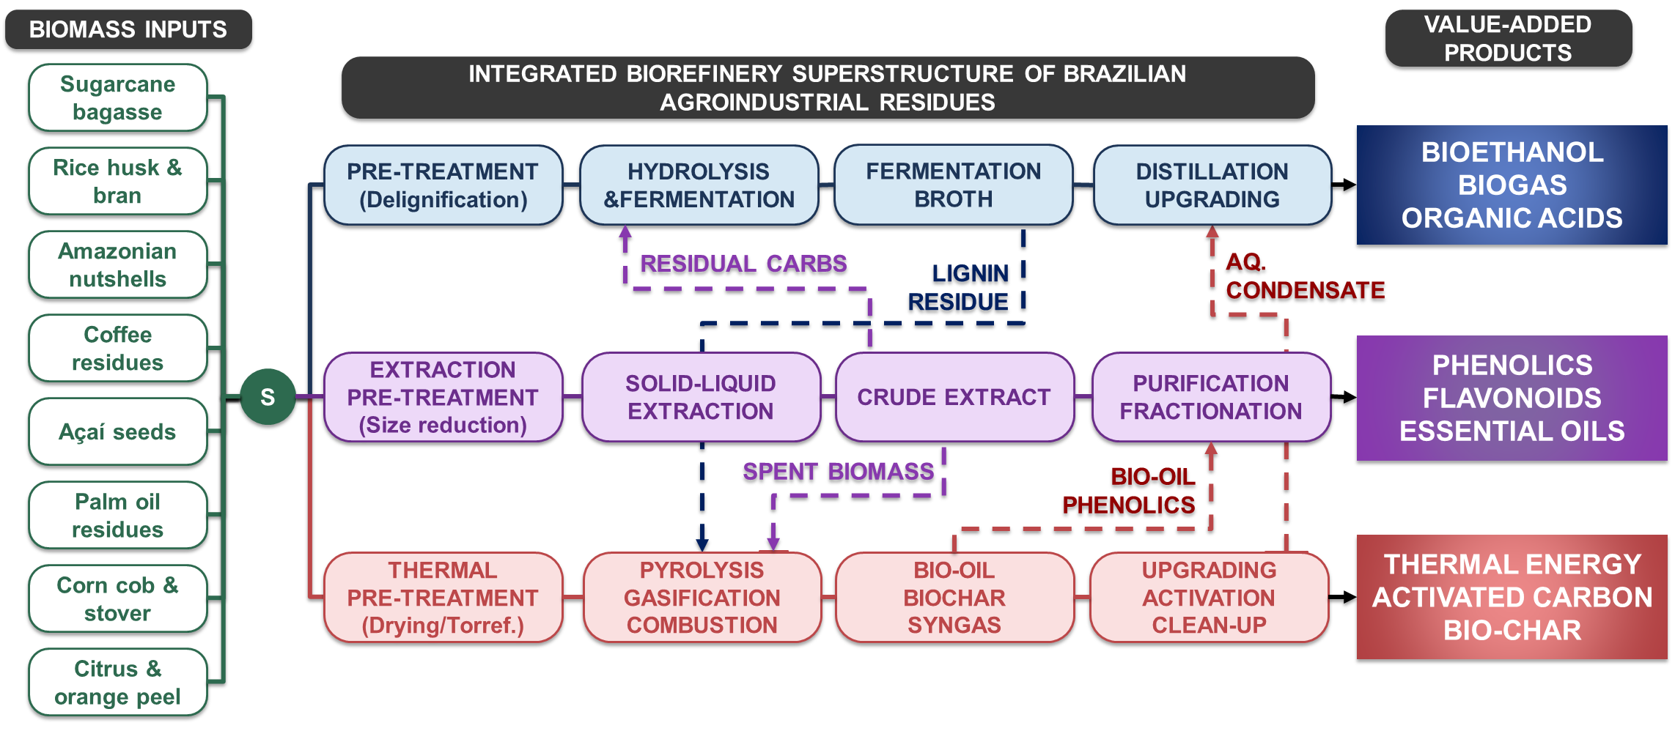
Figure 4: Integrated biorefinery superstructure for Brazilian residue streams.
“Note: S indicates the Splitter unit, and C1 (blue), C2 (purple), and C3 (red) indicate the Biochemical, Bioactive Extraction, and Thermochemical routes, respectively.”
Concrete examples already operate at an industrial scale. In the sugarcane energy sector, pentose valorization from bagasse fractionation for xylitol production (approximately 65 % yield via Candida fermentation; market estimated at USD 1.4 billion in 2025) can raise profitability by roughly 40 % relative to ethanol from the same streams, while lignin conversion to resin precursors and industrial additives adds approximately 35 % over its energy use (Karp et al., 2021). First- and second-generation integration, including ethanol production and electricity co-generation, is demonstrated by the Raízen (São Paulo) and GranBio-BioFlex1 (Alagoas) plants (Karp et al., 2021). At a regional scale, açaí processing residues are simultaneously exploited for biogas via anaerobic digestion, for bioactive compounds targeting the global nutraceutical market, and for thermochemical conversion, constituting an emblematic multi-cluster feedstock (Ferreira et al., 2021; Borges et al., 2025).
The continental inventories documented by Sampaolesi et al. (2023) and Borges et al. (2025) provide the physical basis for this integration: Brazil accounts for 26 % of South America's indirect biomass flows, and the complementary compositions of the main residue streams make multi-route exploration technically viable at the plant level.
  - Conclusions
The results indicate that research on Brazilian residues is undergoing a paradigmatic transition, moving from mono-route models towards integrated processing architectures compatible with the biorefinery superstructure concept. The convergence of the Biochemical, Thermochemical, and Bioactive Extraction routes toward similar proportions in 2025, supported by 18.4 % of multi-cluster publications, indicates that the lignocellulosic, carbonaceous, and phenolic fractions of the same residues are increasingly being treated as complementary substrates rather than alternative streams. The inter-route connections identified in the literature, such as the use of lignin from the Biochemical route as a substrate for pyrolysis and the recovery of bio-oil phenolics in the Bioactive Extraction separation step, translate these synergies into physical process streams, conferring technical coherence to the integrated biorefinery superstructure. This scientific repositioning has direct implications for process design, justifying the adoption of plant topologies with parallel routes and inter-stream integration points, and for techno-economic assessments, which must incorporate co-production synergies as a central variable rather than a secondary gain. The 56 % growth in publication volume between 2020 and 2025 signals acceleration of this scientific frontier, underpinned by the compositional diversity of Brazilian residual biomass, from sugarcane bagasse to native Amazonian fruit residues.
Acknowledgments
Acknowledgment of financial support from the Human Resources Program of the Brazilian National Agency of Petroleum, Natural Gas and Biofuels (PRH/ANP – PRH27.1/SENAI CIMATEC), funded by resources originating from investments by qualified oil companies under the R&D&I clause of ANP Resolution No. 50/2015, and from the São Paulo Research Foundation (FAPESP), grant No. 2024/10433-6.
References
Aguiar A. et al., 2021, Sugarcane straw as a potential second generation feedstock for biorefinery and white biotechnology applications, Biomass and Bioenergy, 144, 105896, DOI: 10.1016/j.biombioe.2020.105896.
Alazaiza M.Y.D. et al., 2025, From agro-waste to bioactive wealth: Analyzing nutraceutical extraction and applications, Case Studies in Chemical and Environmental Engineering, 11, 101066, DOI: 10.1016/j.cscee.2024.101066.
Albuquerque B.R. et al., 2020, Jabuticaba residues (Myrciaria jaboticaba (Vell.) Berg) are rich sources of valuable compounds with bioactive properties, Food Chemistry, 309, 125735, DOI: 10.1016/j.foodchem.2019.125735.
Borges M.S. et al., 2025, Exploring the potential of waste biomass from the Brazilian Legal Amazon in bioproducts production, Journal of the Brazilian Chemical Society, 36, 5, e-20240202, DOI: 10.21577/0103-5053.20240202.
BRASIL, Ministério do Desenvolvimento, Indústria, Comércio e Serviços (MDIC), 2025, Elements for a National Strategy for the Implementation of Biorefineries in Brazil, MDIC/PNUD, Brasília, Brasil (in Portuguese).
De Oliveira Paranhos A.G. et al., 2020, Methane production by co-digestion of poultry manure and lignocellulosic biomass: Kinetic and energy assessment, Bioresource Technology, 300, 122588, DOI: 10.1016/j.biortech.2019.122588.
EMBRAPA, 2022, Study suggests converting agri-food residues into raw materials to leverage the circular bioeconomy, Embrapa, Brasília, Brasil (in Portuguese).
Ferreira S.F. et al., 2021, Waste management and bioenergy recovery from acai processing in the Brazilian Amazonian region: a perspective for a circular economy, Biofuels, Bioproducts and Biorefining, 15, 37–46, DOI: 10.1002/bbb.2147.
Grillo A.V., Santos B.F., 2023, Simulation of Poly-lactic Acid Production from Sugarcane Bagasse Constituents Extracted with Supercritical Water, Chemical Engineering Transactions, 99, 595–600, DOI: 10.3303/CET2399100.
Inada K.O.P. et al., 2020, Effect of high hydrostatic pressure and drying methods on phenolic compounds profile of jabuticaba (Myrciaria jaboticaba) peel and seed, Food Chemistry, 309, 125794, DOI: 10.1016/j.foodchem.2019.125794.
Karp S.G. et al., 2021, Bioeconomy and biofuels: the case of sugarcane ethanol in Brazil, Biofuels, Bioproducts and Biorefining, 15, 899–912, DOI: 10.1002/bbb.2195.
Loschi M., Pirrho S., 2025, PAM 2024: Com queda nos preços e na safra de grãos, valor da produção agrícola cai pelo segundo ano seguido, Agência IBGE Notícias, Rio de Janeiro, Brasil.
Miranda N.T. et al., 2021, Sugarcane bagasse pyrolysis: A review of operating conditions and products properties, Renewable and Sustainable Energy Reviews, 149, 111394, DOI: 10.1016/j.rser.2021.111394.
Otoni J.P. et al., 2024, Potential for agronomic and environmental use of biochars derived from different organic waste, Journal of Cleaner Production, 449, 141826, DOI: 10.1016/j.jclepro.2024.141826.
Sampaolesi S. et al., 2023, Potentials of biomass waste valorization: Case of South America, Sustainability, 15, 8343, DOI: 10.3390/su15108343.
Santos L.A. et al., 2020, Methane generation potential through anaerobic digestion of fruit waste, Journal of Cleaner Production, 256, 120389, DOI: 10.1016/j.jclepro.2020.120389.
Schneider V.E., Peresan D., 2012, Diagnóstico dos resíduos orgânicos do setor agrossilvopastoril e agroindustrias associadas, Ipea, Brasília, Brasil.
Serafin J. et al., 2021, Preparation of low-cost activated carbons from amazonian nutshells for CO2 storage, Biomass and Bioenergy, 144, 105925, DOI: 10.1016/j.biombioe.2020.105925.
Silva M.C.F. et al., 2022, KOH activated carbons from Brazil nut shell: Preparation, characterization, and their application in phenol adsorption, Chemical Engineering Research and Design, 187, 387–396, DOI: 10.1016/j.cherd.2022.09.012.
Spessato L. et al., 2022, Nitrogen-doped activated carbons with high performances for CO2 adsorption, Journal of CO2 Utilization, 61, 102013, DOI: 10.1016/j.jcou.2022.102013.
Vandenberghe L.P.S. et al., 2022, Beyond sugar and ethanol: The future of sugarcane biorefineries in Brazil, Renewable and Sustainable Energy Reviews, 167, 112721, DOI: 10.1016/j.rser.2022.112721.

