 CHEMICAL ENGINEERING TRANSACTIONS  VOL. xxx, 2026 | A publication of  
The Italian Association
of Chemical Engineering
Online at www.cetjournal.it

Guest Editors: Marco Bravi, Antonio Marzocchella, Giuseppe Caputo
Copyright © 2026, AIDIC Servizi S.r.l.
ISBN 979-12-81206-xx-x; ISSN 2283-9216

Eco-Friendly Biosurfactant Gel from Starmerella bombicola for Crude Oil Removal on Coral Surfaces
Fabíola C.G. de Almeida^{1*}, Maria Eduarda P. da Silva², Káren G.O. Bezerra¹, Maria da Glória C. da Silva¹, Leonie A. Sarubbo^{1,2,3}
¹ Advanced Institute of Technology and Innovation - IATI, Rua Potira, n. 31, Prado, 50751310, Recife, Pernambuco, Brazil.
² Postgraduate Program in Chemical Engineering, Federal University of Pernambuco, Recife, Brazil.
³ Catholic University of Pernambuco, Rua do Príncipe, n. 526, Boa Vista, CEP: 50050-900, Recife, Pernambuco, Brazil.
* Corresponding author’s email address: fabiola.almeida@iati.org.br
This study evaluated the potential of a biosurfactant produced by Starmerella bombicola ATCC22214 formulated as a gel for oil removal from coral surfaces in marine environments. The biosurfactant was produced in a 50 L bioreactor and exhibited an anionic profile, achieving a surface tension reduction of 32.08 mN/m, an emulsification index of 93%, a yield of 13.5 g/L, and a Critical Micelle Concentration (CMC) of 0.65 g/L. The biosurfactant was incorporated into a sodium alginate–based gel formulation that exhibited physicochemical stability and favorable organoleptic properties. Ecotoxicological assays using Artemia salina indicated low toxicity and environmental safety. Marine organism recruitment further confirmed its non-toxic behavior. Cleaning assays demonstrated effective solubilization and removal of crude oil. More than 90% of oil adhered to coral surfaces was successfully removed. The results highlight the gel’s high cleaning efficiency and ecological compatibility. Thus, the biosurfactant-based gel represents a sustainable alternative for marine oil remediation.
  - Introduction
Hydrocarbon pollution in marine environments is a global concern driven by the increasing exploration and transportation of petroleum. Leaks and oil spills release large quantities of toxic compounds into the oceans, causing substantial damage to marine fauna and flora and severely affecting sensitive ecosystems such as coral reefs. Conventional remediation approaches, including chemical dispersants, have limited ecological applicability due to their toxicity and the persistence of adverse impacts on marine biological systems (Wei et al., 2024; Olaleye et al., 2024; Zhang et al., 2024). One potential solution to the low bioavailability of hydrophobic pollutants involves the use of surfactants. These compounds have molecular structures containing both hydrophilic and hydrophobic moieties, which tend to accumulate at interfaces between fluid phases with different degrees of polarity (e.g., oil/water and water/oil). Surfactants exhibit surface- and interfacial–tension–reducing properties, conferring detergent, emulsifying, lubricating, solubilizing, and dispersing capacities (Santos et al., 2016; Eras-Muñoz et al., 2022).
Biosurfactants are amphiphilic molecules produced by microorganisms that reduce surface and interfacial tension between immiscible phases, thereby facilitating the emulsification of oil in water. These compounds offer significant advantages over synthetic surfactants, including biodegradability, low toxicity, and high efficiency under extreme environmental conditions of salinity, temperature, and pH (Markam et al., 2024). Among biosurfactants, sophorolipids produced by the yeast Starmerella bombicola stand out for their superior surface-active properties and strong capacity to emulsify petroleum-derived hydrocarbons (Sarubbo et al., 2022; Eras-Muñoz et al., 2022).
Therefore, biosurfactants represent a promising alternative for environmental remediation, including oil spill cleanup and wastewater treatment, as they influence the hydrophobicity of microbial cell surfaces—an essential factor in biodegradation. In addition, biosurfactants can enhance hydrocarbon biodegradation by emulsifying the contaminant. The aim of this study was to produce a biosurfactant from the yeast Starmerella bombicola ATCC 22214, evaluate its properties and potential toxicity, and formulate a gel for safe application in the remediation of petroleum-contaminated coral surfaces.
  - Material and Methods
    - Production media of biosurfactant and culture conditions
The yeast Starmerella bombicola ATCC 22214 was used to produce the biosurfactant. Biosurfactant production was carried out by the yeast in a 50 L bioreactor, using the medium described by Konishi et al. (2015). The medium consisted of 50 g/L olive oil as a hydrophobic source, 25.0 g/L glucose as the soluble substrate, 1.0 g/L yeast extract, 0.5 g/L KH₂PO_{4,} and 0.5 g/L MgSO₄·7H₂O in distilled water. The medium was dissolved and sterilized by autoclaving at 121 °C for 20 minutes. The inoculum was standardized to 10% (v/v), and biosurfactant production was performed in a 50 L Bioreactor (Allbiom, Cajuru, Brazil) at 250 rpm and 0.5 vvm at 30 °C for 8 days (192 h). After this period, the fermentative broth was subjected to surface tension analysis and to emulsification activity assays.
    - Surface activity
Surface tension of the fermentative broth was measured using a Du Nouy Tensiometer model Sigma 700 (KSV Instruments Ltd., Finland) at room temperature. Measurements were performed at 25 ± 1 °C after a platinum ring was dipped in the solution to reach equilibrium. Each measurement was performed in triplicate, and the average value was reported.
    - Emulsification activity
Emulsification activity was measured using the method described by Cooper and Goldenberg (1987), in which 2 mL of an oil (motor oil, petroleum, or diesel oil) was added to 2 mL of the biosurfactant solution in a graduated screw-cap test tube and then vortexed at high speed for 2 minutes. The emulsion stability was determined after 24 h, and the emulsification index was calculated by dividing the measured height of the emulsion layer by the mixture's total height and multiplying by 100. The assays were carried out in triplicate and did not vary more than 5% (v/v).
    - Isolation and determination of the critical micelle concentration (CMC)
The fermentative broth was placed in a separatory funnel for biosurfactant extraction using ethyl acetate (1:1, v/v) (Daverey & Pakshirajan, 2010). The concentration at which micelles began to form was defined as the Critical Micelle Concentration (CMC). The CMC of the biosurfactant was determined over a concentration range of 0.001–3% (w/v) in distilled water, followed by surface tension measurements. The surface tension at each concentration was determined in triplicate. The maximum standard deviation associated with the surface activity measurements was ± 0.2 mN/m. The CMC of the biosurfactant was estimated from the constant surface tension value.
    - Characterization of the isolated biosurfactant
The isolated biosurfactant was chemically characterized by determining total protein content (Bradford, 1976), carbohydrates (Dubois et al., 1956), and lipids (Manocha et al., 1980). The ionic charge of the biosurfactant was determined using the agar double diffusion technique, adapted from Luna et al. (2016). Test tubes contained 2 mL of a 1% (v/v) solution of the fractions and 2 mL of a pure compound with a known ionic charge. The anionic reference was sodium dodecyl sulfate (SDS), and the cationic reference was barium chloride. The appearance of precipitation in the tubes (indicative of ionic character) was monitored for 48 h at room temperature. A tube containing the junction of SDS and barium chloride served as the standard.
    - Biosurfactant gel formulation
The isolated biosurfactant (5.0% w/v) was incorporated into a gel base containing sodium alginate (0.6% w/v), glycerine (1.0% w/v), and triethanolamine (0.2% w/v). The formulation was adjusted to achieve an appropriate consistency for experimental application, while preserving organoleptic characteristics (color, odor, and texture) and solution stability. After formulation, ecotoxicity tests (using Artemia salina as an indicator organism) and recruitment tests in aquatic environments were conducted to assess potential adverse effects of the biosurfactant gel.
    - Toxicity tests using Artemia salina and recruitment tests in aquatic environments
The toxicity tof the biosurfactant gel was evaluated against Artemia salina at concentrations of 1:1, 1:2 (v/v), and undiluted (pure), using the larvae of the microcrustacean as the indicator organism, in accordance with Silva et al. (2010). The recruitment tests in aquatic environments were based on the study by Fernandes et al. (2010), who analyzed larval adhesion and the establishment of the fouling community by installing metal plates at preselected locations to monitor larval recruitment. In field activities, the experimental protocol involved metal plates measuring 20 cm in height, 10 cm in width, and 0.5 cm in thickness. Samples (50 mL) of the biosurfactant gel were incorporated into a commercial water-based white paint (IQUINE Ltda., Recife, Brazil) at concentrations of 2.5, 5.0, 7.5, and 10.0% (w/w). Each side of each plate constituted the same condition (duplicate experiments). The plates were fixed to aluminum rails, with the structure positioned in the Atlantic Ocean and supported by buoys connected to the Pina Basin pier in Recife, Pernambuco, Brazil, where it remained for 15 days.
    - Oil removal tests on coral surface
The cleaning test was carried out according to the methodology described by Da Silva et al. (2024), with adaptations involving corals. A known mass of coral was uniformly contaminated with 500 µL of petroleum at the surface; subsequently, the coral was left at rest for 48 h to allow greater oil adhesion. The contaminated section of the coral was then exposed to the formulated biosurfactant gel for 2 min. Afterwards, the coral was immersed in distilled water to remove any excess biosurfactant gel. The coral was subsequently dried in an oven at 40 °C for 30 min, and its mass was recorded. Oil removal was calculated using the following equation:

Oil removal (%) = [(Mc − Mw)/(Mc − Mi)] × 100 (1)

where Mc is the mass of the coral contaminated by oil, Mw is the mass of the coral after cleaning, and Mi is the initial mass of the coral (before contamination).
  - Results & Discussion
Nowadays, the quality of a new surfactant agent is typically assessed by measuring surface tension and emulsifying capacity. Results indicated that the surfactant produced by the yeast Starmerella bombicola ATCC 22214 in a 50 L bioreactor exhibited a surface tension of 32.08 ± 0.08 mN/m and a pH of 6.2 at the end of fermentation (Figure 1). The biosurfactant extraction yielded 13.5 g/L, with a critical micelle concentration (CMC) of 0.65 g/L of isolated biosurfactant in ethyl acetate. Furthermore, the surfactant demonstrated the ability to form stable emulsions with high efficiency in motor oil (93.75 ± 0.25 %), petroleum (99.00 ± 0.1 %), and diesel (90.50 ± 0.2 %), indicating potential applications in remediation processes in which these oils are contaminants. Biosynthesis of yeast-derived biosurfactants involves the production of structures containing a variety of hydroxylated fatty acids and carbohydrates, which are characterized by unique surfactant properties. Preliminary analysis of the biosurfactant produced by S. bombicola ATCC 22214 revealed a glycolipid composed of 53% (w/w) carbohydrates and 45% (w/w) lipids, with an anionic charge.

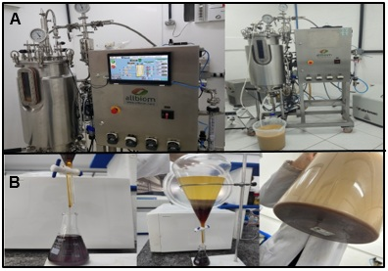

Figure 1: Illustration of the steps in the (A) biosurfactant production and (B) isolation.

The biosurfactant gel formulation exhibited highly stable behavior, with the isolated biosurfactant (5.0% w/v) incorporated into a gel base containing sodium alginate (0.6% w/v), glycerine (1.0% w/v), and triethanolamine (0.2% w/v). The formulation maintained its organoleptic properties, displaying a pearlescent, translucent appearance, a pleasant odor, and a fluid, homogeneous consistency (Figure 2). In addition, the absence of toxicity is fundamental to the application of an environmentally friendly product (Almeida et al., 2019). Accordingly, the toxicity assessment of the biosurfactant gel was carried out using the microcrustacean Artemia salina at concentrations of 1:1 (v/v), 1:2 (v/v), and undiluted (pure). The formulation showed satisfactory results, as mortality rates between 10 and 20 % (w/v) were observed across all tested concentrations (Table 1).

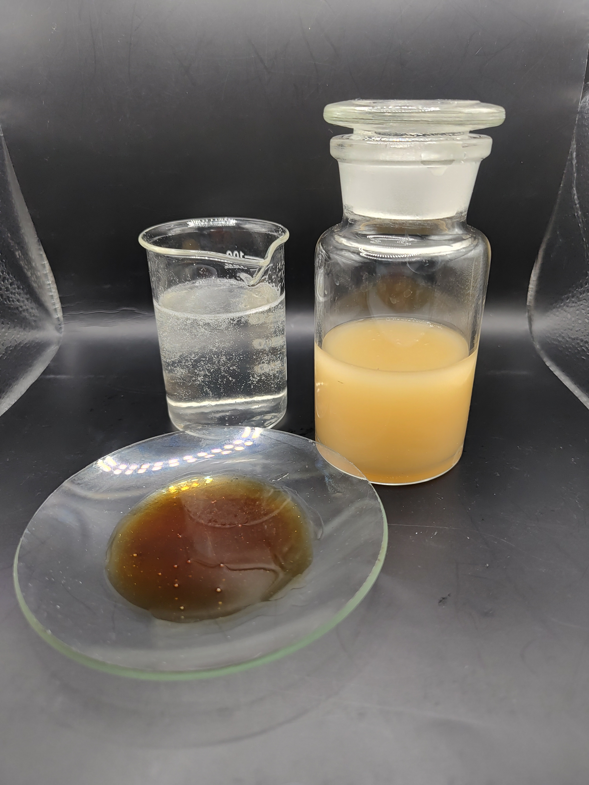
B
C
A

Figure 2: Illustration of the biosurfactant gel formulation (A); Illustration of the isolated biosurfactant 5.0% (w/v) plus glycerin 1.0% (w/v) and triethanolamine 0.2% (w/v) (B); Gel base of sodium alginate 0.6% (w/v) (C).
Table 1: Toxicity tests using Artemia salina in different concentrations of biosurfactant gel produced.
Marine Organism | Biosurfactant Gel Concentration
 | 1:1 (v/v) | 1:2 (v/v) | undiluted
Artemia salina  (amount of mortality %) | 10 ± 0.2 | 10 ± 0.3 20 ± 0.1

Biofouling involves the deposition of micro- and macro-organisms on submerged surfaces, beginning with biofilm formation that can evolve into more complex biological communities (Callow, 2011; Yebra et al., 2004). The biosurfactant gel formulation was evaluated for its effect on the fouling process of marine organisms. The absence of interference with this process indicates that the formulation is non-toxic. In the recruitment test, relative frequency and abundance data are essential for understanding the fouling process. After 15 days of immersion in an aquatic environment, the plates were analyzed separately using a laboratory magnifying glass. Figure 3 presents data from counting encrusting organisms on the plates, indicating that the biosurfactant gel is not toxic to the marine environment, as the average abundance of encrusting organisms exceeded 2,000 units on both sides of each plate compared with the control.
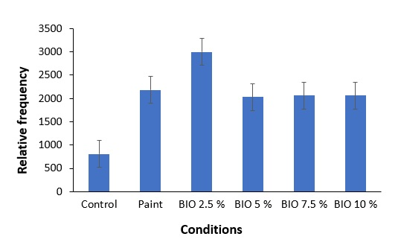
Figure 3: Relative frequency of fouling on control plate (without the addition of any compound), plate with commercial paint alone, and plates with commercial paint containing different concentrations of the biosurfactant gel produced (2.5, 5.0, 7.5, e 10% w/v)
To evaluate the biosurfactant gel's ability to emulsify hydrophobic pollutants, tests were conducted to assess its cleaning capacity on petroleum-impregnated coral. To illustrate the gel’s efficiency more clearly, only part of the contaminated surface was cleaned, allowing comparison with the untreated section, as shown in Figure 4.

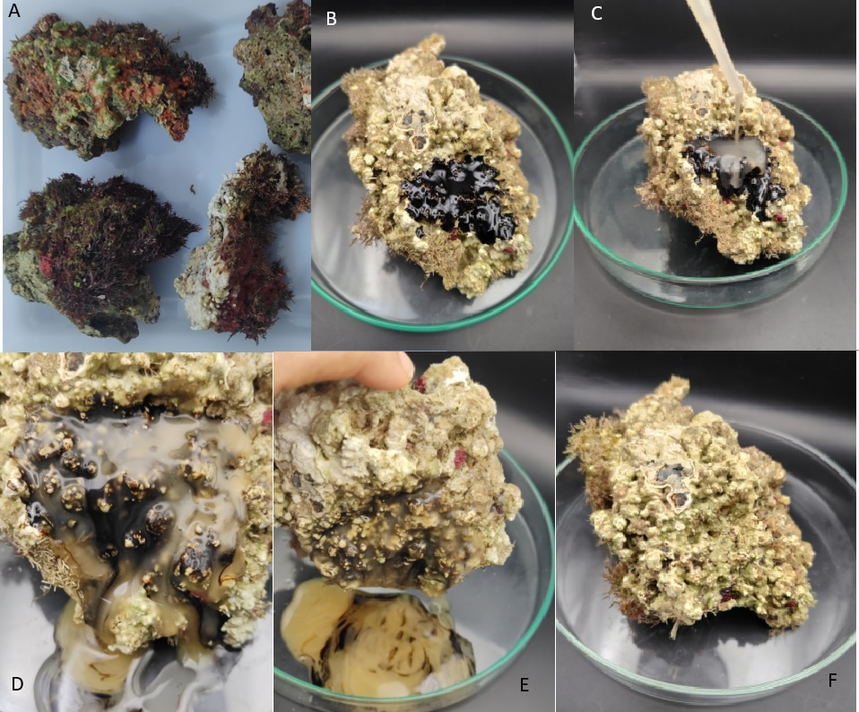

Figure 4: Illustration of the steps in the process of cleaning oil-impregnated corals using biosurfactant gel: Collected corals (A); Contamination of the coral surface (B); Addition of the gel to the contaminated surface (C); Contact of the coral with gel for one minute (D); Contact of the coral with gel for two minutes (E); Coral after washing (F).

The biosurfactant gel solubilized and removed 90.5% ± 0.02 of the petroleum adhered to the surface of the tested coral. This result demonstrates the feasibility of the biosurfactant gel as a biotechnological additive for remediation processes in environments contaminated with petroleum and its derivatives. Moreover, the results are comparable to those reported in other studies that demonstrated significant removal of petroleum and its derivatives using biosurfactants in soils and on various surfaces. The application of biosurfactants alone in marine and industrial settings for oil treatment has shown promising outcomes. Studies comparing two biosurfactants with chemical surfactants, such as polysorbate 20 and polysorbate 80, demonstrated comparable dispersion and emulsification performance (Rodríguez-López et al., 2018). In addition, surfactants derived from plant sources exhibited superior surface-active properties compared with Tween 80 and the synthetic surfactant sodium lauryl sulfate (SLS) (Tmáková et al., 2015).
  - Conclusions
The use of a biosurfactant produced by Starmerella bombicola ATCC 22214 in gel form proved a promising approach for removing crude oil from coral surfaces, exhibiting high emulsifying activity, low toxicity, and effective cleaning performance. These characteristics support the potential of biosurfactants as environmentally friendly alternatives to synthetic surfactants and chemical dispersants in marine environmental remediation strategies. Importantly, the adoption of such biosurfactant gels could contribute to the protection and resilience of coral reef ecosystems by enabling targeted oil removal with reduced ecological disruption compared with conventional dispersants. Future studies should focus on full-scale applications and tests under natural conditions, as well as on evaluating the impacts on coral communities and marine microbiota.

Acknowledgments
This work supported by the National Council for Scientific and Technological Development (CNPq), the Foundation for the Support of Science and Technology of the State of Pernambuco (FACEPE) and the Coordination for the Improvement of Higher-Level Education Personnel (CAPES). The authors are grateful to the Centre of Sciences and Technology of the Catholic University of Pernambuco (UNICAP) and to the Advanced Institute of Technology and Innovation (IATI), Brazil.
References
Almeida F.C.G., Rocha e Silva N.M.P., Souza T.C., Almeida D.G., Luna J.M., Farias C.B.B., Rufino R.D., Sarubbo L.A., 2019, Surfactant Activity of Artocarpus Heterophyllus Fruit Extract and Application in Oil Removal of Solid Surface, Chemical Engineering Transactions, 74, 1135–1140.
Bradford M.M., 1976, A rapid sensitive method for the quantification of microgram quantities of protein utilising the principle of protein-Dye Binding. Analytical Biochemistry, 72, 248–254.
Callow J.A., Callow M.E., 2011, Trends in the development of environmentally friendly fouling-resistant marine coatings, Nature Communications, 2, 244.
Cooper D.G., Goldenberg BG. 1987, Surface-active Agents from Two Bacillus Species, Applied and Environmental Microbiology, 53, 224–229.
Daverey A., Pakshirajan K., 2010, Sophorolipids from Candida bombicola using mixed hydrophilic substrates: production, purification and characterizatio, Colloids and Surfaces B: Biointerfaces, 79, 246–253.
Da Silva I.A., de Almeida F.C.G., Alves R.N., Cunha M.C., de Oliveira J.C.M., Fernandes M.L.B., Sarubbo L.A., 2024, The formulation of a natural detergent with a biosurfactant cultivated in a low-cost medium for use in coastal environmental remediation, Fermentation, 10, 7, 332.
Dubois M., 1956, Colorimetric Method for Determination of Sugars and Related Substances, Química Analítica, 28, 350–356.
Eras-Muñoz E., Farré A., Sánchez A., Font X., Gea T., 2022, Microbial biosurfactants: a review of recent environmental applications, Bioengineered, 13, 5, 12365–12391.
Fernandes M.L.B., Silva A.K.P., Ferreira G.F.A., Nery P.P.C.F., Chaves A.C., Magalhães J.S., Campos J.D.S., Oliveira P.L.S., 2010, Qualitative study of succession of the encrusting fauna on artificial reefs in an area under the influence of a thermoelectric power plant in Pernambuco, Brazil, Northeastern Journal of Zoology, 4, 82–96.
Konishi m., Yoshida Y., Horiuchi J.I., 2015, Efficient production of sophorolipids by Starmerella bombicola using a corncob hydrolysate medium, Journal of Bioscience and Bioengineering, 119, 3, 317–322.
Luna J. M., Rufino R. D., Sarubbo L.A., 2016, Biosurfactant from Candida sphaerica UCP0995 exhibiting heavy metal remediation properties, Process Safety and Environmental Protection, 102, 558–566.
Manocha M.S., San-Blas G., Centeno S., 1980, Lipid composition of Paracoccidioides brasiliensis: possible correlation with virulence of different strains, Microbiology, 117, 1, 147–154.
Markam S.S., Raj A., Kumar A., Khan, M. L., 2024, Microbial biosurfactants: Green alternatives and sustainable solution for augmenting pesticide remediation and management of organic waste, Current Research in Microbial Sciences, 7, 100266.
Olaleye S.A., Isibor P.O., Agbontaen D.O., Imoobe T.O., Kayode-Edwards I.I., 2024, Impacts of Oil and Gas Exploration. In: Arctic Marine Ecotoxicology: Climate Change, Pollutants, and Their Far-Reaching Effects. Cham: Springer Nature Switzerland, 195–209.
Rodríguez-López L., Rincón-Fontán M., Vecino X., Cruz J.M., Moldes A.B., 2018, Biological surfactants vs. Polysorbates: Comparison of their emulsifier, Tenside Surfactants Detergents, 55, 273–280.
Santos D.K.F., Luna J.M., Rufino R.D., Santos V.A., Sarubbo L.A., 2016, Biosurfactants: Multifunctional Biomolecules of the 21st Century, International Journal of Molecular Sciences, 17, 401–430.
Silva S.N.R.L., Farias C.B.B., Rufino R.D., Luna J.M., Sarubbo L.A., 2010, Glycerol as substrate for the production of biosurfactant by Pseudomonas aeruginosa UCP0992, Colloids and Surfaces. B, Biointerfaces, 79, 174–183.
Sarubbo L.A., Silva M.D.G.C, Durval I.J.B., Bezerra K.G.O., Ribeiro B.G., Silva I.A., Twigg M.S., Banat I.M., 2022, Biosurfactants: Production, properties, applications, trends, and general perspectives, Biochemical Engineering Journal, 181, 108377.
Tmáková L., Sekretár S., Schmidt S., 2015, Plant-derived surfactants as an alternative to synthetic surfactants: Surface and antioxidant activities, Chemical Papers. 70, 188–196.
Yebra D.M. Kill S., Dam-Johansen K., 2004, Antifouling technology—Past, present and future steps towards efficient and environmentally friendly antifouling coatings, Progress in Organic Coatings, 50, 75–104.
Wei Z., Wei Y., Liu Y., Niu S., Xu Y., Park J.H., Wang J.J., 2024, Biochar-based materials as remediation strategy in petroleum hydrocarbon-contaminated soil and water: Performances, mechanisms, and environmental impact, Journal of Environmental Sciences, 138, 350–372.
Zhang Z., Sun H., Guo, Y., 2024, The impact of marine oil spills on the ecosystem, International Journal of Engineering Science and Technology, 2, 1, 2958–2857.

