 CHEMICAL ENGINEERING TRANSACTIONS  VOL. xxx, 2026 | A publication of  
The Italian Association
of Chemical Engineering
Online at www.cetjournal.it

Guest Editors: Marco Bravi, Antonio Marzocchella, Giuseppe Caputo
Copyright © 2026, AIDIC Servizi S.r.l.
ISBN 979-12-81206-xx-x; ISSN 2283-9216

Evaluation of phytocannabinoid-based edible coating as a natural antimicrobial solution to improve strawberry quality -and shelf life
Laura Rabasco-Vílchez^{a*}, Francisco Jiménez-Jiménez^{b}, Arícia Possasª, Fernando Pérez-Rodríguezª
ª Department of Food Science and Technology, UIC Zoonosis y Enfermedades Emergentes (ENZOEM), CeiA3, Campus Rabanales, Universidad de Córdoba, 14014 Córdoba, Spain
^{b} Department of Engineering, Universidad Miguel Hernández de Elche, Orihuela, 03312 Alicante, Spain
t62ravil@uco.es
Extending the shelf life of fresh fruits is essential to reduce food loss and waste and to maintain their safety and quality. This study evaluated the antimicrobial activity of highly purified phytocannabinoids from Cannabis sativa L., cannabidiol (CBD) and cannabigerol (CBG), against key foodborne pathogens and spoilage molds, and assessed a CBD-based edible coating applied to strawberries under refrigerated storage. In vitro, CBD and CBG showed marked inhibitory activity against Gram-positive bacteria, with minimum inhibitory concentrations (MICs) of 2–4 µg/mL, whereas Gram-negative strains required substantially higher concentrations (200-300 µg/mL). Antifungal assays revealed selective inhibition of Fusarium oxysporum, with CBD achieving the highest growth reduction from 100 µg/mL. Based on these results, a CBD-based coating was applied to inoculated and non-inoculated strawberries stored at 5 °C for 7 days. Coated fruits showed lower surface decay, reduced weight loss, and higher firmness than uncoated samples, although no significant differences were detected in microbial counts. Overall, the CBD-based coating improved physical quality and attenuated deterioration in strawberries, supporting its potential as a plant-derived strategy to enhance shelf life of fresh berries.
  - Introduction
Extending the shelf life of food products to mitigate food loss and waste (FLW) remains a critical global challenge. To maintain food quality and safety until consumption while reducing FLW, various postharvest technologies and packaging materials have been developed. In this context, the use of plant-derived bioactive compounds, integrated into edible coatings or used in produce washing, has emerged as a sustainable and effective alternative to conventional treatments (Thi Thanh Nga et al., 2022). Recent research has highlighted the antimicrobial properties of phytocannabinoids derived from Cannabis sativa L., demonstrating their capacity to inhibit the growth of diverse bacteria and fungi (Sionov and Steinberg, 2022). Cannabis sativa L. is characterized by its unique profile of cannabinoids. The most prominent compounds include the psychoactive tetrahydrocannabinol (THC) and the non-psychoactive cannabinoids cannabidiol (CBD) and cannabigerol (CBG). Beyond their antimicrobial activity, phytocannabinoids are also biologically active compounds that interact with the human endocannabinoid system and other receptors, thereby demonstrating a wide range of biological activities, and therefore cannot be considered inert food ingredients (de Almeida & Devi, 2020). Despite their potential, the use of Cannabis sativa L. derivatives in food is strictly regulated worldwide. The European Union classifies Cannabis sativa L. derivatives as "Novel Foods" under Regulation (EU) 2015/2283, requiring comprehensive safety assessments prior to authorization. Accordingly, any incorporation of CBD into foods must consider the potential consequences of human exposure, including the need to comply with established intake limits and safety margins (AECOSAN, 2026). In this context, the purpose of the present work is not to advocate for increased systemic exposure to CBD through the diet, but to evaluate the effectiveness of Cannabis sativa L. purified cannabinoids in extending the shelf life of strawberries and enhancing the microbiological safety of fresh produce.
  - Material and methods
    - Cannabis sativa L. cannabinoids
Cannabis sativa L. cannabidiol (CBD) and cannabigerol (CBG) powder extracts (99 % purity) were obtained from the company Phytoplant Research, SLU (Córdoba, España).
    - In vitro assays
Minimum Inhibitory Concentration (MIC)
The MIC of the CBD and CBG extracts were evaluated against two strains of Listeria monocytogenes (CECT 3254 and LMP1), Staphylococcus aureus (HB33 and HB34), Salmonella enterica (CECT 704 and CECT 687), Escherichia coli (CECT 4783 and CECT 4076) and one strain of the molds Fusarium oxysporum (CECT 2715), Botrytis cinerea (CECT 20973) and Rhizopus stolonifer (CECT 2344). The MIC value of each extract against the selected bacteria was determined using the broth microdilution method, following the Clinical and Laboratory Standards Institute guidelines with minor modifications (CLSI, 2012). Firstly, microbial concentrations were adjusted according to 0.5 McFarland standard and then serially diluted to 10⁵ CFU/mL. Then, stock CBD and CBG solutions were prepared by dissolving the extracts in dimethyl sulfoxide (DMSO) to account for their hydrophobic nature. From these stocks, a range of concentrations was prepared in accordance with previously reported protocols (Blaskovich et al., 2021) using Mueller-Hinton Broth (MHB) as the diluent (Table 1). The assay was conducted in 96-well Bioscreen C plates. All experimental conditions were performed in triplicate. The plates were incubated at 37 °C for 24 h in the Bioscreen C system, with absorbance measured automatically every 15 min. To determine the MIC of CBD and CBG extracts against the molds, a range of concentrations defined in Table 1, was selected based on the study by Duanis-Assaf et al. (2024). The antimicrobial efficacy was evaluated using the agar macrodilution method as described by Carrizo et al. (2020). All treatments were performed in triplicate. The plates were incubated at 28 °C for 5 days. The MIC was determined by calculating the percentage of inhibition (IN, %) according to the following Equation 1:
$$IN \left(\%\right)=\frac{C-E}{C}×100$$
Eq(1)
where C represents the growth diameter of the mold in the control plate and E is the growth diameter in the plate containing the extract.
Table 1: CBD and CBG extracts concentrations (µg/mL) evaluated against pathogenic bacteria and spoilage molds
 | Microorganism | Concentration (µg/mL)
Bacteria | Listeria monocytogenes | 4.0, 4.3, 4.6, 5.0
Bacteria | Staphylococcus aureus | 2.0, 3.0, 4.0, 5.0
Bacteria | Salmonella enterica | 200, 250, 300, 350
Bacteria | Escherichia coli | 200, 250, 300, 350
Molds | Fusarium oxysporum | 1.0, 4.0, 20.0, 100.0
Molds | Botrytis cinerea | 1.0, 4.0, 20.0, 100.0
Molds | Rhizopus stolonifer | 1.0, 4.0, 20.0, 100.0

    - In vivo assays
Experimental design
For the in vivo experiments (Figure 1), strawberry samples were divided into four groups: No Fungus/No Coating (NFNC), No Fungus/With Coating (NFWC), With Fungus/No Coating (WFNC), and With Fungus/With Coating (WFWC). Strawberries from the WFNC and WFWC groups were first inoculated with 100 µL of a F. oxysporum spore suspension (10⁶ spores/mL) inside a biosafety cabinet. After the inoculum had dried, strawberries from the WFWC and NFWC groups were coated with a CBD-based edible coating. Once the coating was dried, all strawberries were placed into four polyethylene terephthalate (PET) trays containing 24 individual compartments. Each fruit was placed in a separate compartment to facilitate individual monitoring. The samples were stored for 7 days at 5 °C.
F. oxysporum spore suspension
For preparing the F. oxysporum spore suspension, 3 mL of a spore stock suspension stored at −80 ºC at a concentration of 10⁶ spores/mL were inoculated into a flask containing 500 mL of Potato Dextrose Broth (PDB, Oxoid, United Kingdom). The inoculum was then incubated at 26 ºC for 7 days with shaking at 120 rpm. After this period, mycelium and spores were separated using a 0.5 mm pore-size filter. The mycelium was discarded and the spore concentration was adjusted to 10⁶ spores/mL using a Neubauer counting chamber. The procedure is described in Figure 1.
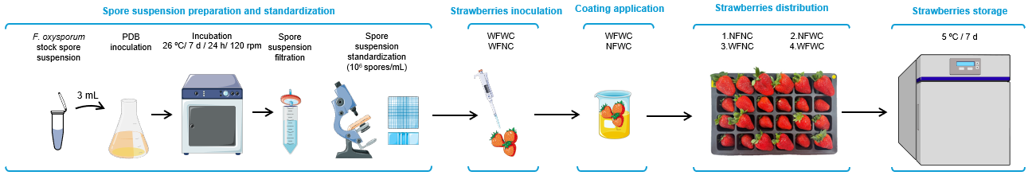
Figure 1. Experimental set-up and procedure
CBD-based edible coating preparation and application
An edible coating was formulated using commercial coconut oil-derived Medium-Chain Triglycerides (MCT) (Drasanvi) and CBD extract powder (99% purity). The CBD concentration within the coating was determined based on the MIC value obtained from previous in vitro antifungal activity assays. The coconut oil-derived MCT was selected as the carrier to ensure the proper dissolution of the lipophilic CBD extract (Duranova et al., 2024). The coating was applied by immersion.
Surface decay
The surface decay of strawberries was assessed daily by the same evaluator over a 7-day period. Damage was categorized using a 6-point scale where Grade 0 represented "no damage" and Grade 5 represented "extreme damage". The percentage of damaged surface (DS, %) for each group and analysis day was estimated according to Equation 2:
$$DS \left(\%\right)= \frac{0∙X_{0}+1∙X_{1}+2∙X_{2}+ 3∙X_{3}+4∙X_{4}+5∙X_{5}}{N}×100$$
Eq.(2)
Where X₀, X₁, X₂, X₃, X₄, and X₅ represent the number of strawberries showing no damage (0), slight damage (1), moderate damage (2), high damage (3), severe damage (4), and extreme damage (5), respectively, and N is the total number of evaluated fruits.
Microbiological analysis
Microbiological analyses for the quantification of aerobic mesophilic bacteria, Enterobacteriaceae, and coliforms in the strawberries were performed in duplicate and carried out daily throughout the study period. For this purpose, two strawberries were randomly selected from each tray and analyzed following ISO 4833-1:2013, ISO 21528-2:2017, and ISO 4832:2006 standards, respectively. Following the incubation period, colony counting and quantification were performed, with results expressed as colony-forming units per gram of sample (CFU/g).
Quality analysis
Colour was evaluated daily during the study period for the four groups of strawberries. Colorimetric values were measured using a CM-23d spectrophotometer (Minolta Company, Japan). Color was described according to the CIELab system. The total color difference (ΔE*) between coated and no coated strawberries was calculated using Equation 3:
$${ΔE}^{*}=\sqrt{{{(ΔL}^{*})}^{2}+({Δa}^{*})^{2}+{{(Δb}^{*})}^{2}}$$
Eq.(3)
In this equation, ΔL*, Δa* and Δb* represent the differences between the L*, a*, and b* values at specific storage intervals and their corresponding initial values on day 0. ΔE values were classified according to the guidelines developed by Schuessler (n.d). Weight loss (WL, %) was evaluated by weighting each strawberry individually using an AS 310.R2 PLUS precision balance (RADWAG, Poland), with mass recorded at 24-hour intervals. WL was calculated according to Equation 4, where W_{i} and W_{f} represent the initial and final weights, respectively.
$$WL \left(\%\right)= \frac{W_{i }-W_{f}}{W_{i}}$$
Eq.(4)
Regarding texture, NFWC and NFWC groups were evaluated using a TA.XTExpressC texture analyser (Stable Micro Systems, UK). Six strawberries from each group were analysed daily. Firmness was expressed as the Peak Positive Force (PPF, g), representing the fruit's initial resistance to compression and penetration.
Statistical analysis
The obtained data were exported to MS Excel v365 (Microsoft Corp.) for initial processing. Microbiological count values were log-transformed (log CFU/g) prior to analysis. Subsequently, statistical analysis was conducted using an independent samples t-test to evaluate the differences between coated and uncoated samples regarding weight loss, texture, colour, and the growth of aerobic mesophilic microorganisms. For the percentage of damaged surface (%DS), data were analysed using a two-way ANOVA with treatment (combination of coating and mold inoculation) and storage time (day) as factors. Estimated marginal means were calculated, and pairwise comparisons between treatments were performed using Tukey’s test. All statistical procedures were performed using R software (version 4.5.1).
  - Results and discussion
    - In vitro assays
The MIC values for L. monocytogenes strains were 4 μg/mL for CBD and CBG and the MIC for S. aureus strains ranged 2-3 μg/mL for CBG. For S. enterica 704 and 687, the MIC values for CBD and CBG were obtained to be between 200 and 250 μg/mL. Similarly, the MIC values for both E. coli strains ranged from 200 to 250 μg/mL for both compounds, except for the strain 4783, which exhibited a CBG extract MIC between 250 and 300 μg/mL. Other studies have shown that CBD and CBG are most active against Gram-positive bacteria such as Staphylococcus aureus, with reported MICs typically around 1–2 µg/mL in in vitro assays (Appendino et al., 2008; Blaskovich et al., 2021). Regarding the antimicrobial activity of cannabinoids against Gram-negative bacteria, most publications report very limited activity, with values higher than 64 µg/mL for CBD and higher than 100 µg/mL for CBG (Blaskovich et al., 2021; Farha et al., 2020). Regarding antifungal activity, the inhibition was exclusively observed against F. oxysporum at the concentrations studied. According to the inhibition percentages (%IN) presented in Table 2, the CBD extract exhibited higher antifungal activity, concluding that this extract reduced the fungal radial growth at the lowest tested concentration of 1 μg/mL (Figure 2). Nevertheless, the extract showed dose-dependent antifungal activity against F. oxysporum, with partial inhibition up to 100 µg/mL; thus, the MIC was >100 µg/mL after 5 days. Evidence for direct antifungal activity of CBD against Fusarium spp. is still very limited as most published CBD antifungal activity studies against Fusarium spp. focuses on other compounds such as essential oils (Park et al., 2017).
Table 2. Inhibition percentages (% IN) against F. oxysporum for different concentrations evaluated of CBD and CBG extracts.
Extract | 1 µg/mL | 4 µg/mL | 20 µg/mL | 100 µg/mL
CBD | 11.03 % | 23.41 % | 56.94 % | 71.43 %
CBG | 4.33 % | 18.87 % | 42.24 % | 62.44 %

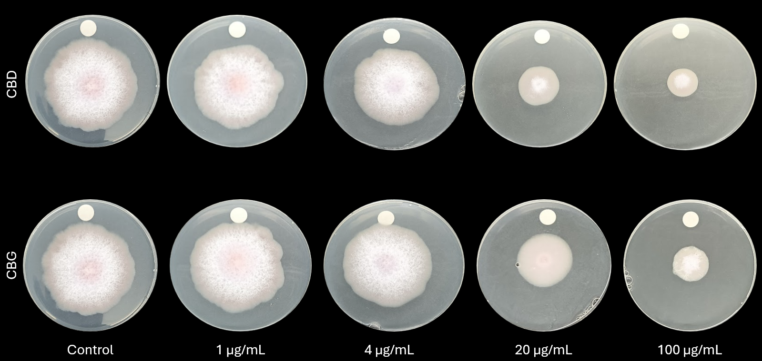
Figure 2: F. oxysporum radial growth at the different concentrations evaluated of CBD and CBG extracts.
    - In vivo assays
Surface decay
Damaged surface (DS) was highest in WFNC (2.71%), followed by NFNC (2.33%). Coated samples showed significantly lower DS values than uncoated ones (p < 0.05), while no significant differences were observed between inoculated and non-inoculated samples. Same results have been obtained by other authors, demonstrating the effectiveness of CBD-based coating for extending shelf life and maintaining the appearance (Sukhavattanakul et al., 2023).
Table 3. Percentage of damaged surface (%DS) of strawberry groups over the 7-day study period.
Day | NFNC | NFWC | WFNC | WFWC
1 | 0.00 % | 0.08 % | 0.21 % | 0.00 %
2 | 0.54 % | 0.29 % | 0.29 % | 0.25 %
3 | 0.58 % | 0.38 % | 0.58 % | 0.25 %
4 | 1.13 % | 0.67 % | 1.21 % | 0.67 %
5 | 1.33 % | 0.71 % | 1.96 % | 0.96 %
6 | 2.00 % | 0.92 % | 2.04 % | 0.96 %
7 | 2.33 % | 1.63 % | 2.71 % | 1.08 %

Microbiological analysis
According to Student’s t-test, no statistically significant differences were found in aerobic mesophilic microorganisms counts between coated and uncoated strawberries (p = 0.1468). Similarly, no significant differences were observed between coliform and Enterobacteriaceae counts (p > 0.05). These results suggest that, under the evaluated experimental conditions, the CBD coating did not exert a significant effect on the total microbial load.
Quality analysis
The results concerning color analysis demonstrated a noticeable difference between coated and uncoated strawberries from day 1, which increased progressively until day 6 and subsequently decreased on day 7. Thus, the coating induced a significant and progressive colour change during the first six days of storage. Regarding weight loss, NFWC strawberries exhibited the lowest percentage, suggesting that the coating exerts a positive effect on preserving strawberry quality during storage. This weight loss reduction may be partly attributed to the lipid component of the coating, which likely acted as a physical barrier, limiting water evaporation. Conversely, when comparing inoculated samples, weight loss was higher than in non-inoculated ones, being particularly pronounced in the WFNC group (Figure 3). Finally, texture analysis revealed that from days 2 to 6, NFWC strawberries maintained higher PPF values (300–350 g) than NFNC fruits, indicating greater firmness and delayed softening. On day 7, PPF values declined in both groups, more sharply in the coated samples, suggesting reduced coating efficacy after day 6. Although the difference in texture was marginally nonsignificant (p = 0.055), the trend indicates that the coating contributed to preserving strawberry firmness during storage.
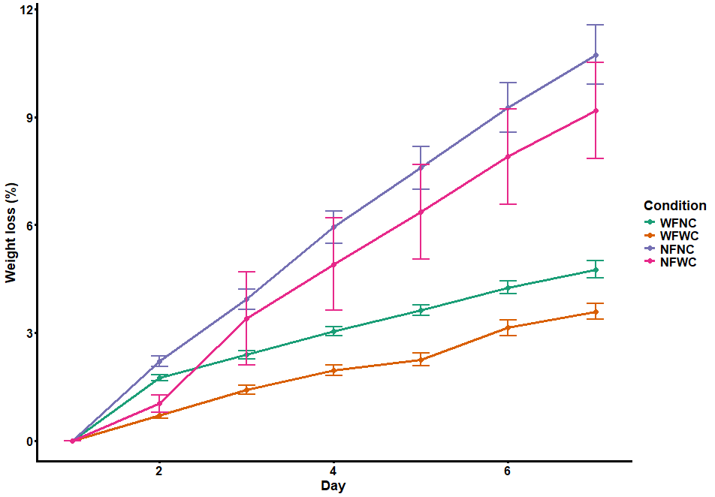

Figure 3: Evolution of weight loss (%) in strawberries during storage.
  - Conclusions
This study concludes that CBD-based edible coating serves as a promising natural solution for extending the shelf life of strawberries. In vitro assays revealed strong activity of CBD and CBG against Gram-positive bacteria, but limited efficacy against Gram-negative bacteria. Antifungal effects were partial, with CBD achieving 71.43% radial growth inhibition of F. oxysporum at 100 µg/mL (MIC >100 µg/mL), outperforming other molds tested. In vivo, CBD coatings significantly reduced surface decay and weight loss compared to uncoated strawberries. However, these results are subject to experimental variability as the experiments have been developed as preliminary proof-of-concept assays. The partial antifungal activity and in vivo effects underscore the need for further optimization and validation studies under standardized conditions to better assess the uncertainty and reproducibility of the treatment. These findings highlight the potential of Cannabis sativa L. derivatives as sustainable postharvest treatments for berries, warranting additional research.
Aknowledgements
The authors express their sincere gratitude to Phytoplant Research, SLU (Córdoba, Spain) for the provision of the high-purity Cannabis sativa L. cannabidiol (CBD) and cannabigerol (CBG) powder extracts, which were instrumental in the execution of both the in vitro and in vivo experimental experiments of this study.
References
Agencia Española de Seguridad Alimentaria y Nutrición (AECOSAN), 2026, Actualización sobre la seguridad del cannabidiol (CBD) como nuevo alimento, <https://www.aesan.gob.es/AECOSAN/web/noticias_y_actualizaciones/noticias/2026/seguridad_cannabidiol.htm> accessed 13.02.2026
Appendino G., Gibbons S., Giana A., Pagani A., Grassi G., Stavri M., Smith E., Rahman M.M., 2008, Antibacterial Cannabinoids from Cannabis sativa: A Structure−Activity Study. Journal of Natural Products, 71, 1427–1430. https://doi.org/10.1021/np8002673
Blaskovich, M.A.T., Kavanagh, A.M., Elliott, A.G., Zhang, B., Ramu, S., Amado, M., Lowe, G.J., Hinton, A.O., Pham, D.M.T., Zuegg, J., Beare, N., Quach, D., Sharp, M.D., Pogliano, J., Rogers, A.P., Lyras, D., Tan, L., West, N.P., Crawford, D.W., Peterson, M.L., Callahan, M., Thurn, M., 2021, The antimicrobial potential of cannabidiol, Communications Biology, 4. https://doi.org/10.1038/s42003-020-01530-y
Carrizo, S.L., Zampini, I.C., Sayago, J.E., Simirgiotis, M.J., Bórquez, J., Cuello, A.S., Isla, M.I., 2020. Antifungal activity of phytotherapeutic preparation of Baccharis species from argentine Puna against clinically relevant fungi, Journal of Ethnopharmacology, 251, 112553. https://doi.org/10.1016/j.jep.2020.112553
CLSI, n.d. M07-A9: Methods for Dilution Antimicrobial Susceptibility Tests for Bacteria That Grow Aerobically; Approved Standard—Ninth Edition.
Duanis-Assaf, D., Feldman, M., Maurer, D., Feygenberg, O., Steinberg, D., Alkan, N., 2024, Cannabinoids: A new natural agent to control postharvest decay development. Postharvest Biology and Technology, 211, https://doi.org/10.1016/j.postharvbio.2024.112842
Duranova, H., Kuzelova, L., Fialkova, V., Simora, V., Kovacikova, E., Joanidis, P., Borotova, P., Straka, D., Hoskin, R.T., Moncada, M., de Medeiros, F.G.M., Gabriny, L., 2024, Coconut-sourced MCT oil: its potential health benefits beyond traditional coconut oil. Phytochemistry Reviews, 24:1 24, 659–700. https://doi.org/10.1007/s11101-024-09969-1
Farha, M.A., El-Halfawy, O.M., Gale, R.T., Macnair, C.R., Carfrae, L.A., Zhang, X., Jentsch, N.G., Magolan, J., Brown, E.D., 2020, Uncovering the Hidden Antibiotic Potential of Cannabis. ACS Infectious Diseases, 6, 338–346. https://doi.org/10.1021/acsinfecdis.9b00419
Feldman, M., Sionov, R.V., Mechoulam, R., Steinberg, D., 2021, Anti-Biofilm Activity of Cannabidiol against Candida albicans. Microorganisms, 9, 9, 1–17. https://doi.org/10.3390/microorganisms9020441
Inselberg, H., do Nascimento Nunes, M.C., 2021, Using Cannabidiol as a potential postharvest treatment to maintain quality and extend the shelf life of strawberries. Postharvest Biology and Technology, 173, 111416. https://doi.org/10.1016/J.POSTHARVBIO.2020.111416
Park, J.Y., Kim, S.H., Kim, N.H., Lee, S.W., Jeun, Y.C., Hong, J.K., 2017. Differential inhibitory activities of four plant essential oils on in vitro growth of Fusarium oxysporum f. sp. fragariae causing Fusarium wilt in strawberry plants. The Plant Pathology Journal, 33, 582. https://doi.org/10.5423/PPJ.OA.06.2017.0133
Schuessler, Z. (n.d.). ΔE Color Difference Comparison, <https://zschuessler.github.io/DeltaE/learn/>, accessed 20.01.2026
Sionov, R.V., Steinberg, D., 2022. Anti-Microbial Activity of Phytocannabinoids and Endocannabinoids in the Light of Their Physiological and Pathophysiological Roles. Biomedicines. https://doi.org/10.3390/biomedicines10030631
Sukhavattanakul, P., Thanyacharoen, T., Chuysinuan, P., Techasakul, S., Ummartyotin, S., 2023, Influence of a transparent and edible coating of encapsulated cannabidiol nanoparticles on the quality and shelf life of strawberries. ACS Applied Materials and Interfaces, 15, 23834–23843. https://doi.org/10.1021/ACSAMI.3C04036/ASSET/IMAGES/LARGE/AM3C04036_0007.JPEG
Thi Thanh Nga, P., Phuong Nghi Nguyen, H., Thang Nguyen, X., Phuong Minh Pham, T., & Thi Kim Le, P. (2022). A Mini-Review on Essential oils, Chitosan, and Their Application in Preserving Fruits and Vegetables. Chemical Engineering Transactions, 97, 109–114. https://doi.org/10.3303/CET2297019

