 CHEMICAL ENGINEERING TRANSACTIONS  VOL. xxx, 2026 | A publication of  
The Italian Association
of Chemical Engineering
Online at www.cetjournal.it

Guest Editors: Marco Bravi, Antonio Marzocchella, Giuseppe Caputo
Copyright © 2026, AIDIC Servizi S.r.l.
ISBN 979-12-81206-xx-x; ISSN 2283-9216

Supercritical fluid extraction of lipids from the microalgae Schizochytrium
Patrizia Casella¹, Marco Iannaccone², Nicola Fedele¹, Anna Sabatino¹, Gian Paolo Leone³, Antonio Molino¹
¹ ENEA, Italian National Agency for New Technologies, Energy and Sustainable Economic Development, Department for Sustainability, Sustainable Agrifood System Division, Regenerative Circular Economy Laboratory, RC Portici. P. Enrico Fermi, 1, 80055 Portici (NA), Italy
² ENEA, Italian National Agency for New Technologies, Energy and Sustainable Economic Development, Department for Sustainability, Sustainable Agrifood System Division, Laboratory 4.0, RC Portici. P. Enrico Fermi, 1, 80055 Portici (NA), Italy
³ ENEA, Italian National Agency for New Technologies, Energy and Sustainable Economic Development, Department for Sustainability, Sustainable Agrifood System Division, Regenerative Circular Economy Laboratory, RC Casaccia. Via Anguillarese, 301, 00123 Santa Maria di Galeria (RM), Italy
antonio.molino@enea.it
Microalgae represent a promising source of high-value compounds, including proteins, lipids, and carotenoids. Some species can accumulate lipids up to 70% of their dry weight, consisting of a wide range of saturated, monounsaturated, and polyunsaturated fatty acids, including omega-3 and omega-6 fatty acids. Omega-3 fatty acids are essential for human health, particularly in the prevention of cardiovascular diseases. Fish-derived products and dietary supplements currently represent the main sources for human consumption.
Among microalgae, Schizochytrium sp. has attracted considerable interest due to its high lipid content, accounting for approximately 50% of dry biomass, and its ability to produce high-value long-chain polyunsaturated fatty acids such as eicosapentaenoic acid and docosahexaenoic acid.
In this study, supercritical carbon dioxide extraction was investigated as a green and sustainable technology for lipid recovery from Schizochytrium sp. biomass. Under supercritical conditions, CO₂ combines high solvent capacity with high diffusivity and low viscosity, enabling efficient and selective extraction of lipids, including thermolabile compounds, without the use of toxic organic solvents. Moreover, the moderate operating temperatures help preserve the chemical and nutritional integrity of polyunsaturated fatty acids.
Extractions were carried out using the LUWAR pilot plant at pressures above 260 bar, a temperature of approximately 50 °C, and an extraction time of 240 minutes. The extraction yields, together with the characterization of the lipid extracts and the residual biomass, demonstrated that supercritical carbon dioxide extraction is an efficient and promising technology for the recovery of high-value lipids from microalgae, while also enabling the potential valorization of the defatted biomass within an integrated biorefinery approach.

  - Introduction
In recent years, increasing attention has been directed toward alternative sources of long-chain polyunsaturated fatty acids (PUFAs), particularly docosahexaenoic acid (DHA) and eicosapentaenoic acid (EPA). These PUFAs have proven effects on in cardiovascular health prevention, neurodevelopment, and cognitive function. Nowadays, the main source of omega-3 (EPA and DHA) remains fish oil, which is the main ingredient in nutraceutical products that provide a definite supply of omega-3 for those who need to supplement the diet.
A valid alternative source of omega-3 are certain species of microalgae as Nannochloropsis, Isochrysis galbana, Phaeodactylum tricornutum that can produce till to 30% of lipids on dry basis (Ryckebosch et al., 2014).
Schizochytrium sp. is one of the natural producers of lipids, that is capable of accumulating high lipid levels (up to 50–60% of dry biomass), and DHA typically represents 30–50% of total fatty acids depending on strain and cultivation conditions (Jia et al., 2024).
Efficient recovery of DHA-rich lipids from Schizochytrium biomass is a critical step for industrial application but algal oil derived from Schizochytrium sp. with minimum contents of 22.5 % DHA and 10 % EPA is still authorized by EFSA for the use in foodstuff (EFSA, 2014).
Conventional solvent extraction methods (e.g., hexane or chloroform–methanol mixture) may present drawbacks related to solvent residues, environmental impact, and potential oxidation of sensitive PUFAs. Supercritical carbon dioxide (CO₂-SFE) extraction has gained increasing interest as a green alternative technology. Supercritical fluid extraction is particularly attractive for high-value lipid products such as DHA-rich oil due to its food-grade processing conditions, the absence of toxic solvent residues in the final product, and its regulatory acceptance for nutraceutical and functional food applications. Furthermore, the efficiency of the CO₂ under supercritical conditions is highly influenced by several parameters: pressure, temperature, particle size, solvent flow rate, and co-solvent addition (Nozari and Kander 2025).
The present study aims (i) to characterize the proximate composition and fatty acid profile of Schizochytrium sp. biomass, (ii) to evaluate the performance of pilot scale of supercritical CO₂ extraction in terms of yield and DHA enrichment, and (iii) to assess the compositional changes in the exhausted biomass within a biorefinery perspective.
  - Material and methods
    - Characterization of biomass and extracts
The microalgae Schizochytrium sp. was provided as powder (80 mesh) and was characterized before supercritical fluid extraction and after the extraction to evaluate the content of the principal compounds (humidity, ash, proteins, lipids, fibers).
Humidity and ash content were quantified gravimetrically after drying at 105 °C for at least 2 hours and after combustion at 550 °C for at least 4 hours following the UNI EN ISO 712 and UNI EN ISO 2171.
Crude proteins were quantified by Kjeldahl method following the instructions of the UNI EN ISO20483:2014. Before starting the analysis, the sample was pre-treated and sieved to reach < 0.5 mesh of particle size. The biomass was weighed (0.5 - 1 g) for the digestion by using catalyst tablets and H₂SO₄ 18.4 M, followed by distillation under vapor by adding NaOH 10.8 M, and boric acid with coloured indicators. Titration was performed by using sulfuric acid solution and protein content was calculated by multiplying the nitrogen content by the conversion factor of 6.25.
Total lipids were extracted by pressurized liquid extraction by using ASE 350 (Dionex). The biomass was mechanically pre-treated at 600 rpm for 5 minutes with the inert material (diatomaceous earth, DE) at a ratio 1:1 w/w. The pre-treated biomass was loaded in the extraction stainless steel cells (around 4 g) and the extraction was performed by hexane at 50°C and 100 bar (Iovine et al., 2019). Three extracts were obtained which were then subjected to the fatty acid methyl esters (FAMEs) identification procedure.
FAMEs were identified following the procedure of the official method UNI EN ISO 12966 by using gas chromatography (GC) and the detector flame ionization detector (FID). Tricosanoic acid (C23) was used as internal standard for fatty acids quantification. Total dietary fibers were quantified by enzymatic-gravimetric method following the official method AOAC 985.29.
    - Supercritical fluid extraction
CO₂-SFE tests were conducted on Schizochytrium powder pre-treated by ball milling and including diatomaceous earth in a quantity equal to 1:1 w/w compared to the microalgal weight. Supercritical fluid extractions were performed by LUWAR pilot plant (Figure 1) located in ENEA Casaccia research centre.
The pilot plant worked at the operative conditions reported in Table 1. Biomass was loaded (96.2 g) in the vessel after a mild drying treatment to remove the remaining humidity. The extraction was performed at 240 minutes but transition times were also considered between the different extraction phases. Pressure and temperature (P_{E}, T_{E}: average extraction pressure and temperature recorded during the test) have been set to 267 bar and 49 °C. The average scCO₂ flow recorded during the test was 0.42±0.02 kg/min.
Table 1: CO₂-SFE operative conditions
Biomass (g) | P_{E} (bar) | T_{E} (°C) | Q_{scCO2}(kg/min) | Time (min)
96.2 | 267.6±1.1 | 49.2±0.3 | 0.42±0.02 | 240
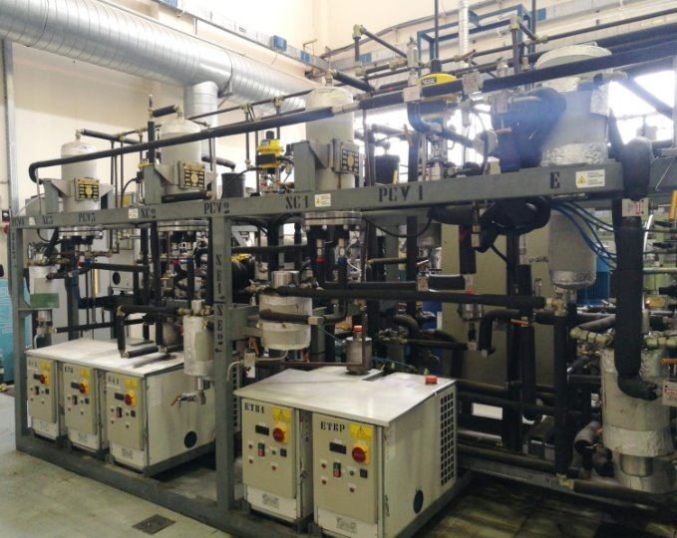
Figure 1. CO₂-SFE Pilot Plant LUWAR
The system has two separators in series (SE2 and SE3) set to the same set point (net of the pressure drop between them). During the entire session, the extract was recovered in its entirety from the first of the two separators (SE2).
The extraction yield was assessed by referring to the quantity of extract recovered (EXT) expressed in grams calculated per the weight of the dry loaded matrix (WDM) multiplied by 100:

$$Y \left(\%\right)= \frac{EXT}{W_{DM}} ·100$$

The extraction parameters and yield were calculated as the mean value and standard deviation of four replicates.
  - Results and discussion
    - Schizochytrium characterization
The characterisation of the microalgae Schizochytrium sp. highlighted that lipids are the main component (45%). Proteins accounted for 32%, followed by ashes (12%), and fibers (5%) (Figure 2).

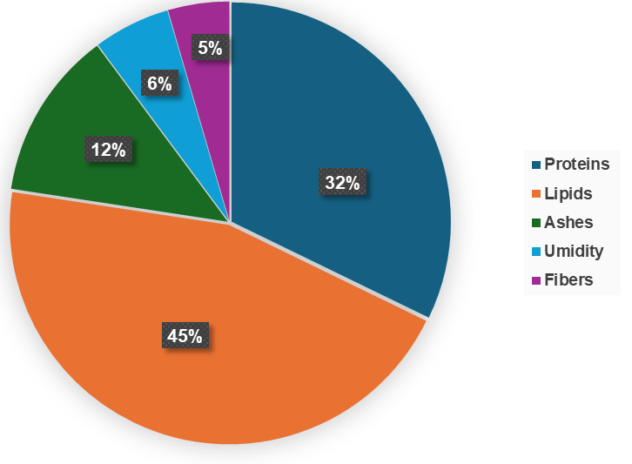
Figure 2: Characterization of the microalgae Schizochytrium sp.
The lipid content of the biomass is in line with scientific evidence that has shown that under optimal growing conditions Schizochytrium sp. can contain up to 55% lipids (Jia et al., 2024). About fatty acids, they represented 72.0% of total lipids (Table 2), and polyunsaturated fatty acids (PUFAs) represented 74.7%, which is typical of Schizochytrium species. Saturated fatty acids (SFAs) accounted for 24.3% and monounsaturated fatty acids (MUFAs) are present only in minor amounts (1.0%). The high PUFAs proportion is characteristic of DHA-producing species and reflects active long-chain PUFA biosynthesis. In fact, DHA constitutes 69.4% of total FAs and 93% of PUFAs. These percentages are in line with the recent work by Berzal et al. 2024, which compared the lipid profile of a commercial Schizochytrium oil with the extract obtained by accelerated solvent extraction with hexane.
Table 2: Fatty acids
Fatty acids (%)
SFAs | 24.3
MUFAs | 1.0
PUFAs | 74.7
Fatty acids distribution (%)
Linoleic acid | 2.8
alfa-linoleic acid | 1.9
EPA | 2.3
DHA | 93.0
DHA purity (%) | 22.6
TFAs purity (%) | 32.5
    - Supercritical fluid extraction
In Table 3, all operative conditions of CO₂-SFE were reported. Using the same quantity of biomass (96.2 g), four extraction tests were carried out under the same operating conditions. The yields varied across the four extraction tests, ranging from a minimum of 7.0% to a maximum of 12.4% (average value 9.3±2.2 %).
A high extraction yield (16.93 ± 0.01 %) was obtained by Rodríguez-España et al., 2022 from 5 grams of biomass at a temperature of 75°C and a pressure of 425 bar. The difference of the extraction yield may be due to a higher kg CO₂/g biomass ratio and higher extraction temperature and pressure. They also evaluated the effect of different pretreatments (mechanical, ultrasound, microwave and sonication). The best pretreatment was found to be grinding, which yielded up to 39% lipid yield. In this work the biomass was also pre-treated by ball-milling due to past evidence in the increase of extraction yield (Iovine et al., 2019).
Table 3: Session Data - Supercritical extraction of Schizochytrium sp.
 |  | Average value
Biomass | Humidity (%) |  | 3.8±0.1
Biomass | W_{DM} (g) |  | 96.2
 | P_{E} (bar) |  | 267.6±1.1
 | T_{E} (°C) |  | 49.2±0.3
 | ρSCCO₂ (kg/m³) |  | 849.3±1.6
Process | Transient (min) |  | 10 – 52
 | Time (min) |  | 240
 | QSCCO₂ (kg/min) |  | 0.42±0.02
 | WSCCO₂/biomass (kg/g) |  | 1.02±0.05
Extraction yield | EXT (g) |  | 9.0±2.2
 | Y(%) |  | 9.3±2.2
ρSCCO₂: density of scCO₂ at average pressure and temperature conditions; transient: process time achieved under conditions different from those considered as set points; time: duration of the test under operating conditions considered as set points (or very close to them); WSCCO₂/biomass: ratio between the amount of CO₂ that passed through the matrix during the test (duration at steady state) and the loaded matrix; EXT: extract recovered as a result of tapping from the separator; Y(% DM): process yield of the tapped extract compared to WDM
Rodríguez-España et al., 2022 experimented also the use of co-solvent (ethanol) and demonstrated an increase in overall yield from 19.05% to 20.42% with the use of ethanol, while at the same time highlighting that the impact on fatty acids (yield, composition) was not significant and was even evident in a reduction in DHA yield. During this experiment, the use of ethanol as a co-solvent was not considered, as the aim was to focus the extraction on the fatty acid components, avoiding the co-extraction of polar compounds that affect the lower final concentration of the substances of interest (e.g. DHA) in the extract.
The extraction yield obtained in this study is in line with the data obtained by Liu et al., 2018, who achieved a yield of 9% from 200 grams of Schizochytrium sp. without pre-treatment at 240 minutes and 197 kgCO₂/g biomass. It should be noted that in our study, this yield was obtained from a smaller amount of biomass (96.2 g) and solvent (1.02±0.05 kgCO₂/g biomass). This highlighted as the CO₂:biomass ratio was optimized in this work at pilot scale respect to the results of the authors Liu et al., 2018. Furthermore, Liu et al., 2018 achieved a yield of 18% after 6 hours of CO₂-SFE with stepwise methanol addition (Table 4).
In another study, Zinnai et al., 2016 achieved a yield of 15% at 250 bar and 55°C and 0.5 kgCO₂/g biomass, reaching a yield of 28% at the pressure 700 bar.
Table 4: Comparative CO₂-SFE yield
Biomass (g) | vessel  (ml) | Pre-treatment | Pressure (bar) | Temperature (°C) | Q_{scCO2} (kg/min) | Time (min) | scCO₂/ biomass  (kg/g) | Y (%) | Ref.
80 | 600 | milling | 250 | 55 | 0.2 | 240 | 0.5 | 15 | Zinnai et al., 2016
80 | 600 | milling | 700 |  |  |  |  | 28 | Zinnai et al., 2016
200 | 5000 | no | 258 | 50 | 164 | 240 | 197 | 9  11 | Liu et al., 2018
The extract obtained in this work consisted of an oil composed of 100% lipids, of which fatty acids constituted 81.4%. In the extract the distribution of fatty acids does not vary from that of the initial biomass (Table 5). Although the extraction yield achieved in this study was not as high as in other studies (Zinnai et al., 2022), the operating conditions used in the pilot plant certainly influenced positively the quality of the extract. The extract has increased purity of DHA (56.5%) and total fatty acids (81.4%). With regard to the lipid composition of the extract obtained from Schizochytrium after CO₂-SFE, some authors (Liu et al., 2018) found no differences between extraction with CO₂ under supercritical conditions and extraction with CO₂ and co-solvent (methanol). And these authors did not identify DHA in the extracts of Schizochytrium. In contrast, Zinnai et al., 2022 observed how temperature and pressure affect lipid composition. They found that DHA contributed most to PUFAs, accounting for 70.5% at 55°C and 550 bar. In this study, the percentage of DHA in PUFAs was significantly higher than in the studies cited, as is the percentage of fatty acids, which in the study by Zinnai et al., 2022, is around 30%.
Table 5: Fatty acids of extract
Fatty acids (%)
SFAs | 24.3
MUFAs | 1.0
PUFAs | 74.7
Fatty acids distribution (%)
Linoleic acid | 2.8
alfa-linoleic acid | 1.9
EPA | 2.3
DHA | 93.0
DHA purity (%) | 56.5
TFAs purity (%) | 81.4
The biomass residue of Scizochytrium left after extraction with supercritical fluids can still be considered a resource that can be used for further applications, such as in the field of feed, as discussed by He et al., 2017. He et al. (2017) examined the use of several edible vegetable oils as entrainers for the extraction of DHA from Schizochytrium limacinum by supercritical CO₂ extraction. After the extraction, the fatty acids composition of the residual biomass was studied and the authors highlighted that DHA content reduced from 61% to 28% with the increase of the concentration of others compounds (C16, C18:1, C18:2).
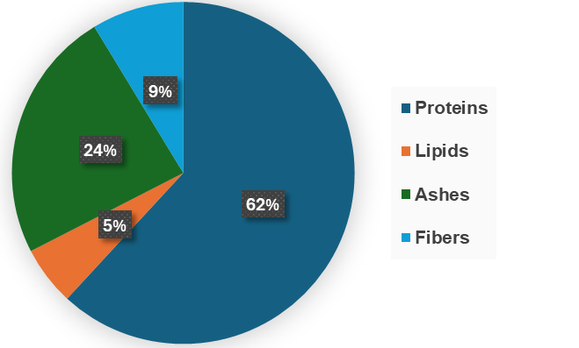
Figure 3: Characterization of the microalgae Schizochytrium sp. exhausted biomass
In this study, the biomass residue after extraction with supercritical fluids was collected and characterized. As can be seen in Figure 3, the biomass contains 62% protein and 5% lipids, followed by 9% fibers. It is interesting to note that the percentage of protein has increased further compared to the initial percentage (32%). The residual biomass is protein- and fiber-rich, so can be suitable for other valorization pathways to recovery protein rich fraction. As demonstrated by He et al., 2017, the results on the lipid composition of the exhausted oil show that DHA no longer accounts for the largest percentage of total fatty acids.
  - Conclusions
The initial biomass exhibited high lipid and DHA content, confirming its suitability for omega-3 production. Supercritical CO₂ extraction achieved selective concentration of DHA without altering fatty acid distribution. Although total extraction yield (9.3%) was moderate compared to other studies on supercritical fluid extraction, DHA purity significantly increased. The residual biomass remains a promising protein-rich co-product, supporting biorefinery valorization strategies.
Acknowledgments
This work was co-founded by the European Union's Horizon Europe program as part of the project PROTEIN4IMPACT (Grant Agreement No. 101182324). Views and opinions expressed are, however, those of the author(s) only and do not necessarily reflect those of the European Union or the European Research Executive Agency (REA). Neither the European Union nor the granting authority can be held responsible for them.
References
Berzal G., García-García P., & Señoráns F. J., 2024. Integrated process for Schizochytrium oil extraction, enzymatic modification of lipids and concentration of DHA fatty acid esters using alternative methodologies. Marine Drugs, 22(4), 146.
EFSA Panel on Dietetic Products, Nutrition and Allergies (NDA), 2014. Scientific Opinion on the extension of use for DHA and EPA‐rich algal oil from Schizochytrium sp. as a Novel Food ingredient. EFSA Journal, 12(10), 3843.
He B., Wang Y., Dou X., & Chen Y. F., 2017. Supercritical CO₂ extraction of docosahexaenoic acid from Schizochytrium limacinum using vegetable oils as entrainer. Algal research, 21, 58-63.
Iovine A., Cerbone A., Mehariya S., Musmarra D., Casella P., Molino, A., 2019, Effect of Mechanical Pretreatment on Nannochloropsis Gaditana on the Extraction of Omega-3 by Using Accelerated Solvent Extraction Technology. CET Journal - Chemical Engineering Transactions, 2019, 74, 943, 10.3303/CET1974158
Liu, S., Abu Hajar, H. A., Riefler, G., & Stuart, B. J. (2018). Lipid Extraction from Spirulina sp. and Schizochytrium sp. using supercritical CO 2 with methanol. BioMed Research International, 2018(1), 2720763. https://doi.org/10.1155/2018/2720763
Nozari, B., & Kander, R., 2025. Supercritical CO2 technology for biomass extraction. Industrial Crops and Products, 233, 121348.
Rodriguez-Espana M., Mendoza-Sanchez L. G., Magallon-Servin P., Salgado-Cervantes M. A., Acosta-Osorio A. A., & Garcia, H. S., 2022. Supercritical fluid extraction of lipids rich in DHA from Schizochytrium sp. The Journal of Supercritical Fluids, 179, 105391. https://doi.org/10.1016/j.supflu.2021.105391
Ryckebosch E., Bruneel C., Termote-Verhalle R., Muylaert K., & Foubert I., 2014. Influence of extraction solvent system on extractability of lipid components from different microalgae species. Algal Research, 3, 36-43.
Jia Y. L., Zhang Q. M., Du F., Yang W. Q., Zhang Z. X., Xu, Y. S., ... & Huang, H., 2024. Identification of lipid synthesis genes in Schizochytrium sp. and their application in improving eicosapentaenoic acid synthesis in Yarrowia lipolytica. Biotechnology for Biofuels and Bioproducts, 17(1), 32. https://doi.org/10.1186/s13068-024-02471-y
Zinnai A., Sanmartin C., Taglieri I., Andrich G., & Venturi F., 2016. Supercritical fluid extraction from microalgae with high content of LC-PUFAs. A case of study: Sc-CO2 oil extraction from Schizochytrium sp. The Journal of Supercritical Fluids, 116, 126-131. http://dx.doi.org/10.1016/j.supflu.2016.05.011

