 CHEMICAL ENGINEERING TRANSACTIONS  VOL. xxx, 2026 | A publication of  
The Italian Association
of Chemical Engineering
Online at www.cetjournal.it

Guest Editors: Marco Bravi, Antonio Marzocchella, Giuseppe Caputo
Copyright © 2026, AIDIC Servizi S.r.l.
ISBN 979-12-81206-xx-x; ISSN 2283-9216

Impact of Feature Engineering on Hybrid Model performance: case study of biofuel process.
Juan Federico Herrera-Ruiz ª, Carlos Eduardo Robles-Rodriguez ^{b}, Cesar Arturo Aceves-Lara ^{b}, Javier Fontalvo ª and Oscar Andrés Prado-Rubio ^{a*}
ª Grupo de Investigación en Aplicación de Nuevas Tecnologías (GIANT) Departamento de Ingeniería Química, Universidad Nacional de Colombia sede Manizales, Campus La Nubia, Manizales, 170003, Colombia
^{b} TBI, Université de Toulouse, CNRS, INRAE, INSA, Toulouse, France
*Corresponding author: oaprador@unal.edu.co
Advances in monitoring and computation have accelerated bioprocess digitalization, thus increasing the relevance of hybrid semi-parametric models. However, Machine learning tools struggle with collinearity in bioprocess datasets and lack of interpretability, where the selection of the biological and operational signals used for training the non-parametric component is still not straight forward. To address this, a three-step pipeline for feature engineering (i.e. SHAP values, mutual information, and domain knowledge) is proposed. Using this approach, hybrid models were built for ABE fermentation by Clostridium saccharoperbutylacetonicum, combining mechanistic mass balances and stablished kinetics with a Gaussian Process (GP) model for predicting butanol formation. Four datasets (three for training, one for validation) covering seven states were used, and 8,000 models were trained per strategy, enabling robust ensemble comparisons. SHAP ranked glucose, time, acetate, and acetone as the most influential features for the GPs. However, including time did not improve predictions, as mutual information showed its predictive content is largely redundant with metabolites. Conversely, initial glucose—ranked low by SHAP—was useful for anchoring batch variability. Hybrid models using glucose, initial glucose, and acetate outperformed both the parametric baseline and SHAP-guided choices, reducing validation RMSE by up to 12.8%. This strategy showed that integrating interpretability, redundancy analysis, and mechanistic insight yields more accurate and meaningful hybrid models than relying on importance scores alone.
Keywords: Hybrid modelling; Biobutanol; Feature Engineering; Ensemble Learning
  - Introduction
The increasing emphasis on sustainable development goals has intensified research into the optimization of bioprocesses for renewable fuels and chemicals, particularly driven by advances in process monitoring, data acquisition, and computational power (Gargalo et al., 2024). These developments, together with modern modelling and simulation tools, have catalyzed digitalization of biomanufacturing processes. In this context, hybrid modelling has emerged as a powerful framework, combining parametric (i.e. mechanistic representations) with non-parametric (i.e. data-driven) methods to alleviate their respective limitations (Herrera-Ruiz et al., 2025). In ABE (Acetone–Butanol–Ethanol) fermentation, kinetic models are often highly nonlinear and overparameterized, which leads to large uncertainty in estimated parameters, thus low interpretability (Shinto et al., 2007). Despite hybrid model’s capabilities to enhance predictive accuracy, the interpretability and explainability of the non-parametric component remains almost unexplored in literature. Hybrid models require biological and operational signals as inputs to inform the data-driven sub-components. The choice of these signals results from feature engineering which is a critical step to treat and send the relevant input data to the models. Despite its importance, the reported hybrid modeling of bioprocesses has not explored systematic approaches for selecting inputs to the non-parametric structure, which affects model understanding, prediction capabilities and prospects of industrial implementations. On the other hand, the direct application of standard machine-learning interpretability tools remains challenging in bioprocess settings, where predictors are often highly collinear and constrained by mass balances. These characteristics can lead to misleading importance scores if interpretability is treated in isolation.
In this work, we develop different hybrid model’s structures to improve state predictions of ABE fermentation by Clostridium saccharoperbutylacetonicum, with a particular focus on biobutanol production—a key molecule for sustainable biofuel applications (Malik et al., 2024). Using glucose as the main carbon source, seven fermentation states were monitored across four experimental datasets (Shinto et al., 2007), comprising three training batches and one independent validation batch. Although semi-structured kinetic models for butanol fermentation are well established, they are frequently overparameterized, which limits both structural and practical identifiability and degrades predictive robustness. Here, we explicitly investigate how feature-engineering strategies influence the performance and interpretability of hybrid models. The proposed hybrid modeling framework couples mechanistic mass-balance equations with Gaussian Processes (GP) used to represent the biobutanol formation rate.
  - Modeling details
    - Experimental Data and Signal preprocessing
Four C. saccharoperbutylacetonicum glucose fermentation datasets (Shinto et al., 2007) were used. Authors measured: biomass, glucose, butyrate, acetate, acetone, and butanol. The four experimental datasets were split into three training batches and one validation batch to evaluate inter-batch generalization. Raw data underwent noise reduction and outlier correction. Outliers were detected using a 3-point moving median window and corrected via the Savitzky-Golay polynomial approach (Sánchez-Rendón et al., 2024).
    - Hybrid Model Formulation
The hybrid model architecture was built based upon the full parametric ABE process for batch conditions, where Shinto’s model was used as a baseline (Shinto et al., 2007). The mass balance model in batch conditions consists of 19 reaction rates, 16 states and 46 parameters. Only 6 states were measured: glucose, acetone, acetate, biomass, butyrate, and butanol. For the hybrid approach, Butanol reaction rate was replaced by a GP, as seen in Eq (1):
$$\frac{dButanol}{dt}=r_{butanol}=GP\left(X\right)$$ | (1)
Where X represents a vector of possible inputs to the GP (features).
    - Feature Engineering and Input Selection Strategy
A systematic feature engineering strategy identified the best input set for the GP estimator. Numerical differentiation of the experimental data provided the butanol reaction rates, which served as the target variable. Training 8,000 GP models with multiple feature combinations enabled ranking of candidate input importance. The feature set included all measured variables except butanol concentration, along with time and initial glucose concentration. SHapley Additive exPlanations (SHAP) values quantified feature relevance by attributing each model prediction to the marginal contribution of each input in a game-theoretic framework (Wu, 2025).
Mutual Information (MI) quantifies the dependence between candidate features and the butanol reaction rates, enabling investigation of non-linear relationships and assessment of how different features reduce uncertainty in the butanol reaction rates (Vergara & Estévez, 2014). Unlike Pearson’s correlation, MI captures arbitrary non-linear relationships and accommodates mixed input types (Papaioannou et al., 2025). MI is defined as in Eq (2):
$$MI(W;Y)=I(W;Y)=H\left(W\right)+H(Y)-H(W,Y)$$ | (2)
where H(W) is defined as the entropy of variable W, which is defined in Eq (3) for continuous variables. As such I(W:Y) measures how much knowing W’s entropy reduces uncertainty on Y’s entropy. If I(W:Y)=0 both variables are independent, whereas higher values indicate high relationship between variables (Papaioannou et al., 2025)
$$H\left(W\right)=\int{-p\left(W\right)⋅log\left(W\right)}$$ | (3)
Finally, Conditional Mutual Information (CMI) was analyzed to assess the marginal information gained when adding specific variables as inputs to the GP. As such, CMI is calculated as seen in Eq (4):
$$CMI(W;Y,Z)=I(W;Y,Z)=H\left(W,Z\right)+H(Y,Z)-H(W,Y,Z)-H(Z)$$ | (4)
CMI measures new information provided by W about Y once Z is already known (Zan et al., 2022).
    - Training Strategy and Evaluation
For every candidate model structure (defined by a specific subset of inputs to the GP) the ensemble strategy was applied. Experimental data calibrated the GP models, while testing relied on model-based inputs: at each integration step, the ODE solver provided predicted concentrations as inputs to the GP. An ensemble approach produced the final predictions to improve robustness and mitigate overfitting (Herrera-Ruiz et al., 2025). The Root Mean Squared Error (RMSE) quantified model performance. For each structure, an ensemble of hybrid models enabled benchmarking of RMSE reduction, as defined in Eq. (2), against the full parametric Shinto model.
$$RMSE_{red}=\frac{RMSE_{Parametric Model} - RMSE_{Hybrid Model}}{RMSE_{Parametric Model}}$$ | (5)
    - Computational Details
All computations were performed on a commercial laptop with an Intel(R) Core (TM) i9-14900HX CPU 2.20GHz, with 24 cores, 32 GB of RAM, and a 16 GB NVIDIA GeForce RTX 4090 GPU. Calculations were performed in MATLAB 2024a® and Python 3.11.1
  - Results
SHAP values were calculated and averaged to assess how each feature contributed to the overall prediction of butanol’s reaction rate. Figure 1 presents the average absolute SHAP value for each feature. As seen, glucose is the input variable that the GPs rely more for making predictions of the butanol reaction rate, with around 30% of importance, followed by time with 20% and the rest of variables hover around 10% each. Interestingly, butyrate concentration has the lowest SHAP value, despite being the immediate metabolite precursor for butanol. Taken together, these results indicate that time and glucose are the main contributors, and they should be used mainly for making predictions. However, using time as input contradicts mechanistic knowledge and reduces interpretability and extrapolation capabilities, due to bioprocesses not having dependency on time in the right-hand side of the ordinary differential equations. Moreover, measuring metabolites such as acetone, acetate, and butyrate to make predictions about butanol hinders models’ viability and usefulness, as they will require high precision in their predictions of those variables to accurately predict the main metabolite. Moreover, including more features increases model complexity, making it less interpretable for decision-making. Therefore, models should aim to have the highest prediction capabilities, while using the least number of features possible, while retaining interpretability and not-contradicting mechanistic knowledge.

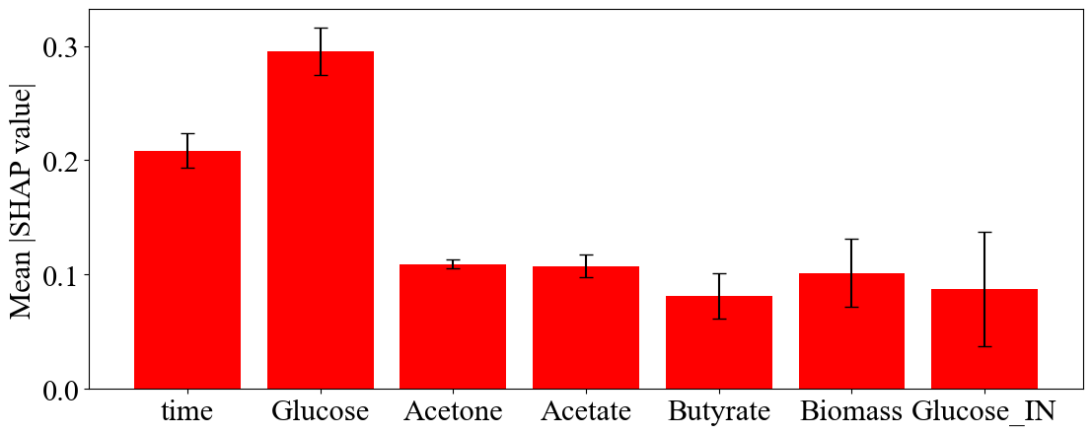

Figure 1: Average SHAP values for prediction of butanol reaction rate
MI was calculated across all experiments to overcome the mentioned limitations. Figure 2 shows the MI of butanol’s reaction rate for three cases: i) when only knowing that feature (blue bars), ii) once time is known (green bars), iii) once glucose is known (red bars). It is observed that metabolites such as acetate, acetone and butyrate have the highest MI, followed by glucose. Interestingly, time has the lowest MI for the continuous variables (58% lower than acetate’s MI), being comparable to the MI given by initial glucose concentration (63% lower than acetate’s MI), which is a static value for each experiment. On the other hand, when analyzing green bars, it is seen that adding time as an input to the other features actively decreases butanol’s reaction rate MI, except for initial glucose concentration and biomass. A similar situation is observed in the red bars, where using glucose as a fixed input only increases MI for initial glucose concentration and butyrate. On average, adding time as a feature reduces MI by 4%, while adding glucose as a feature increases MI by 6%. This indicates that time has little unique information.
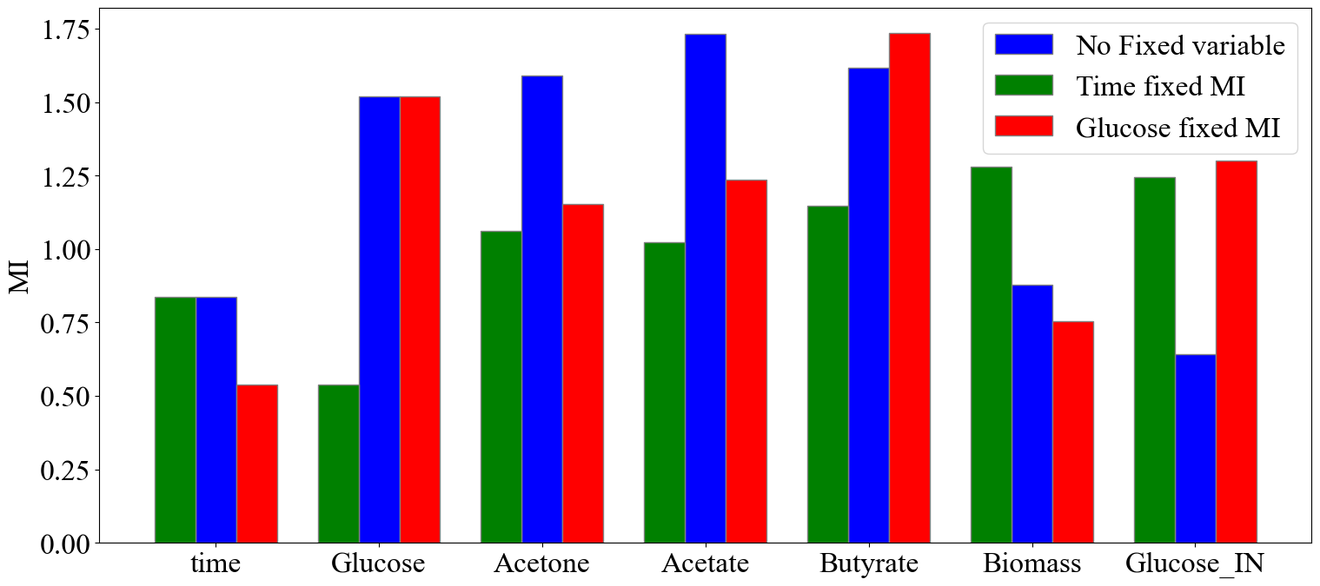
Figure 2: MI of butanol’s reaction rate for different features. Blue bars indicate no variable was fixed as input, green bars indicate time was fixed as an input, and red bars indicate glucose was fixed as input.
Conditional Mutual Information (CMI) measured how much new information each variable adds to the prediction of the butanol reaction rate when either time or glucose is already known, as displayed in Figure 3. Larger bars indicate a greater increase in information beyond the baseline variable. Metabolic variables contain more unique information than time by an average of 35%. In contrast, the same variables increase the information by only 22% when compared to glucose. Furthermore, once glucose is known, time has less than one quarter of the unique information that glucose has when time is known. These comparisons show that time contributes little unique information about the butanol reaction rate, whereas metabolic variables provide more information on butanol’s reaction rate.
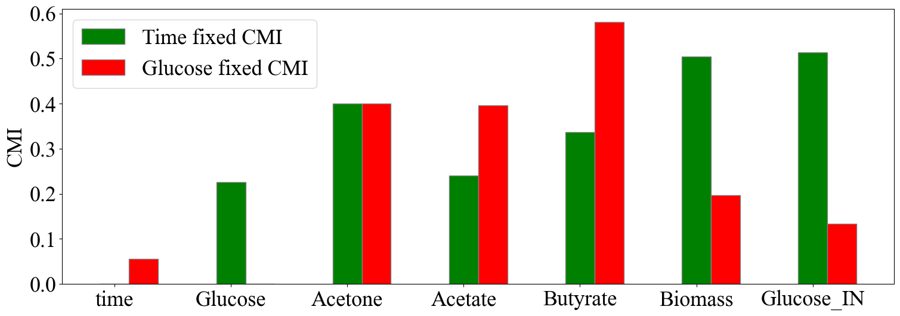
Figure 3: CMI for the different features. Red bars indicate that Glucose was fixed as an input, while green bars indicate that time was fixed as an input.
From the previous analysis, it was shown that metabolic variables have higher information on butanol’s reaction rate, as such, hybrid models using different features were built for testing predictive capabilities. Although Figure 2 showed that butyrate has the highest MI for butanol’s reaction rate, Shinto’s original Model III presents the best performance overall (Shinto et al., 2007), but has low predictive capabilities for butyrate (r² less than 0.65). Therefore, butyrate was not used as a feature. Hybrid models were trained in parallel, with training times ranging from 39 up to 49 hours. Prediction times were less than 3 minutes on average.
Table 1 presents RMSE for different subsets of features for inputs. All ensemble sizes were between 12 and 19 models. Using only glucose as feature for the GPs, the ensemble model exhibits worse performance than the parametric baseline, with RMSE increasing 2.2% in training and more than 10% in validation. On the other hand, when using time and glucose as inputs, RMSE in the training and validation data are reduced by 25.3% and 9.0% respectively. However, when replacing time with the initial substrate concentration, RMSE reduces to 10.4% in validation and 32.1% in training. Moreover, adding acetone as a feature improves performance, but using time has lower gains in validation sets than when using initial substrate concentration. When using initial glucose concentration to each batch, prediction improves RMSE up to 8.9% (using glucose and acetone) and to 12.8% when using the three state variables. These results highlight that metabolic variables have possibility of improving validation performance, enhancing generalization while avoiding overfitting. Moreover, even if a single metabolic variable has high MI on butanol’s reaction rate, using only one input yields lower performance, due to the difficulties of capturing batch to batch variability. Likewise, it is shown that adding more metabolic information results in diminishing returns, while increasing model complexity and requirements for accurate information.
Table 1: RMSE for training and validation experiments. RMSE reduction when compared to the baseline parametric model. HM stands for “Hybrid Model”.
Model: inputs | Training  RMSE | Validation  RMSE | Training RMSE  reduction % | Validation  RMSE reduction%
Parametric Model | 51.031 | 52.981 | N/A | N/A
HM: Glucose | 52.463 | 58.567 | -2.196 | -10.16
HM: Glucose + Time | 38.100 | 48.200 | 25.339 | 9.02
HM: Glucose + Acetone | 41.749 | 48.264 | 18.189 | 8.90
HM: Glucose + Glucose Initial | 34.677 | 47.480 | 32.046 | 10.39
HM: Glucose + Time+ Acetone | 36.377 | 46.589 | 28.716 | 12.06
HM: Glucose +Acetone + Glucose Initial | 40.452 | 46.167 | 20.731 | 12.86
Figure 4 presents the dynamic profiles for the baseline parametric model (Shinto et al., 2007) and the ensemble hybrid models corresponding to the three best-performing input sets, with prediction envelopes represented by the shaded area.

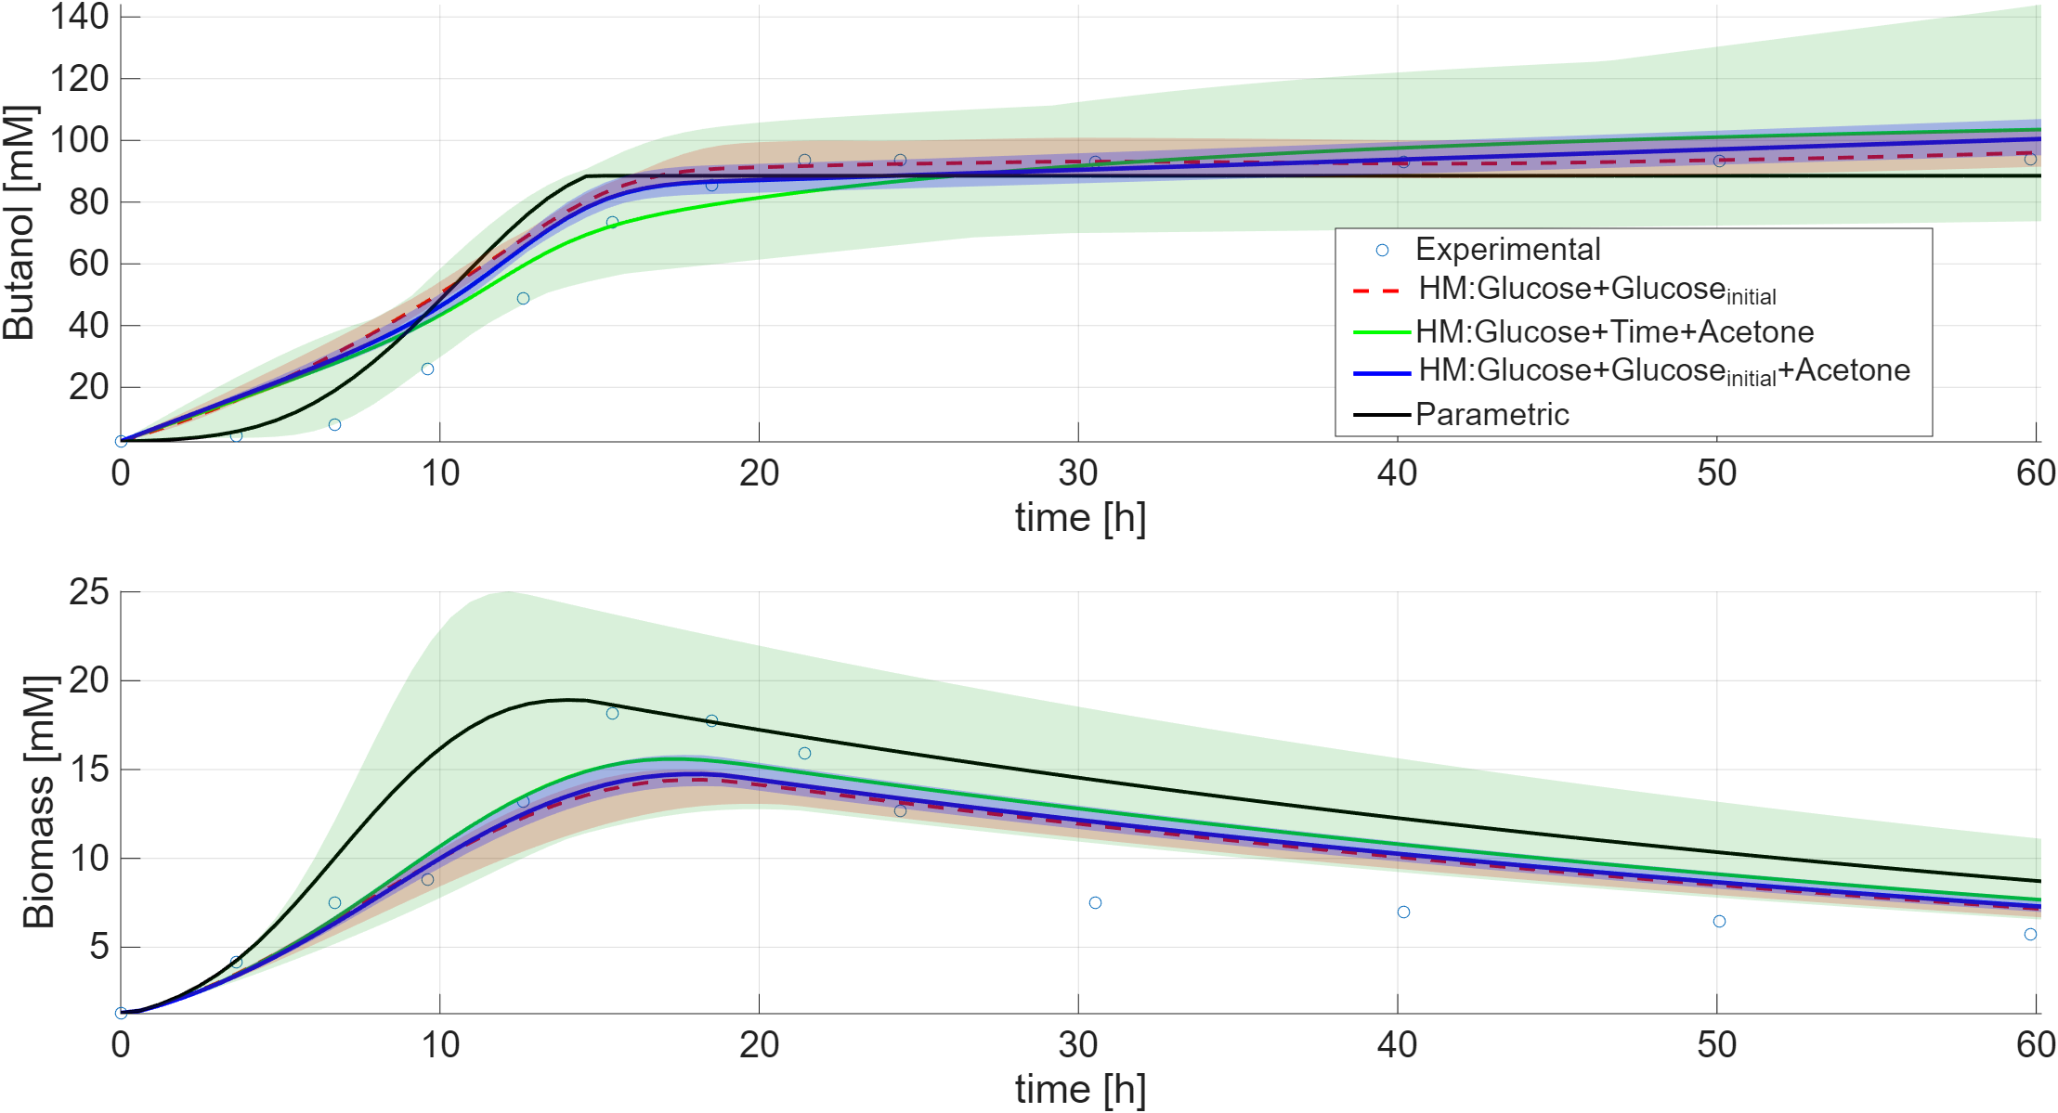
Figure 4: Dynamic profiles for Butanol (top) and Biomass (bottom) in the validation set
As seen in Figure 4, performance across the different hybrid model structures is similar; however, prediction envelopes differ in width, despite comparable ensemble sizes. These differences reflect changes in the error distribution induced by the choice of input variables. Although the three-metabolite configuration achieves the best overall performance, it also produces the highest predictive uncertainty. Moreover, performance gains are seen not only in butanol, but also in biomass, due to the original model considering product inhibition. Thus, hybridizing one substance leads to overall increased performance in several states.
  - Conclusions
This work established a systematic feature engineering framework for hybrid models’ development in bioprocesses, specifically addressing the challenges of interpretability in ABE fermentation. By integrating SHAP values, Mutual Information (MI), and Conditional Mutual Information (CMI), it was shown that relying solely on importance rankings from standard machine learning tools can be misleading in biological contexts.
RMSE reductions showed that non-metabolic variables, specifically time, should be excluded from the non-parametric component of hybrid models, despite high SHAP rankings. This is because kinetic rates are state-dependent rather than explicitly time-dependent. Conversely, anchoring the model with metabolic variables, such as initial glucose concentration, significantly improved performance, reducing validation RMSE by up to 10.38% compared to the parametric baseline, while the best performance was seen when using glucose, acetone, and initial glucose concentration, reducing validation RMSE up to 12.8%.
Furthermore, the application of CMI revealed that while different metabolic states (e.g., acetone, acetate) theoretically possess unique information regarding the butanol reaction rate, this does not translate into model predictive gain. Diminishing returns were observed when adding acetone to glucose and initial glucose concentration. These marginal improvements are due to noise amplification rather than additive uncertainty reduction. Considering the complexities of measuring metabolites, using glucose and glucose initial as inputs to the hybrid model presents a balanced tradeoff, having only 2% lower RMSE reductions than the best performing hybrid model, while requiring less inputs, relying on less measurement error and uncertainty. Ultimately, this methodology highlights that accurate hybrid models for bioprocesses require feature engineering that aligns data-driven insights with fundamental mechanistic principles. Future works should focus on enhancing butyrate’s predictions, to use it as inputs for butanol’s reaction rate.
Acknowledgments
Juan Federico Herrera-Ruiz received funding by the Colombian General Royalty System (Sistema General de Regalías de Colombia) and Ministry of Science, Technology and Innovation of Colombia (Ministerio de Ciencia, Tecnología e Innovación) with the projects BPIN: 2022000100035, and contract 112721-029-2025 for mobility in partnership with ECOS NORD.
This work was partially supported by the Ecos Nord Programme France-Amérique Latine (Colombie), reference ECOS Nord N° C25S01
Cesar-Arturo Aceves-Lara is also affiliated to: Laboratoire mixte international BIOTEC VAL, IRD, MESRS, ISSBAT 9, Avenue Docteur Zouhaier ESSAFI -1006 Tunis
References
Gargalo, C. L., Malanca, A. A., Aouichaoui, A. R. N., Huusom, J. K., & Gernaey, K. V. (2024). Navigating industry 4.0 and 5.0: the role of hybrid modelling in (bio)chemical engineering’s digital transition. Frontiers in Chemical Engineering, 6. https://doi.org/10.3389/fceng.2024.1494244
Herrera-Ruiz, J. F., Fontalvo, J., & Prado-Rubio, O. A. (2025). Hybrid model development for Succinic Acid fermentation: relevance of ensemble learning for enhancing model prediction. Proceedings of the 35th European Symposium on Computer Aided Process Engineering (ESCAPE 35), 1896–1901. https://doi.org/10.69997/sct.153338
Malik, M. A. I., Usman, M., Waqas Rafique, M., Raza, S., Saleem, M. W., Abbas, N., Sajjad, U., Hamid, K., Rezaul Karim, M., & Abul Kalam, M. (2024). Managing energy transition alongside environmental protection by making use of AI-led butanol powered SI engine optimization in compliance with SDGs. Heliyon, 10(9), e29698. https://doi.org/10.1016/j.heliyon.2024.e29698
Papaioannou, N., Myllis, G., Tsimpiris, A., & Vrana, V. (2025). The Role of Mutual Information Estimator Choice in Feature Selection: An Empirical Study on mRMR. Information, 16(9), 724. https://doi.org/10.3390/info16090724
Sánchez-Rendón, J. C., Matallana, L. G., Morales-Rodriguez, R., & Prado-Rubio, O. A. (2024). Enhanced kinetic model parameters for xylitol bioproduction from Candida mogii ATCC 18364 (pp. 2497–2502). https://doi.org/10.1016/B978-0-443-28824-1.50417-8
Shinto, H., Tashiro, Y., Yamashita, M., Kobayashi, G., Sekiguchi, T., Hanai, T., Kuriya, Y., Okamoto, M., & Sonomoto, K. (2007). Kinetic modeling and sensitivity analysis of acetone–butanol–ethanol production. Journal of Biotechnology, 131(1), 45–56. https://doi.org/10.1016/j.jbiotec.2007.05.005
Vergara, J. R., & Estévez, P. A. (2014). A review of feature selection methods based on mutual information. Neural Computing and Applications, 24(1), 175–186. https://doi.org/10.1007/s00521-013-1368-0
Wu, L. (2025). A review of the transition from Shapley values and SHAP values to RGE. Statistics, 59(5), 1161–1183. https://doi.org/10.1080/02331888.2025.2487853
Zan, L., Meynaoui, A., Assaad, C. K., Devijver, E., & Gaussier, E. (2022). A Conditional Mutual Information Estimator for Mixed Data and an Associated Conditional Independence Test. Entropy, 24(9), 1234. https://doi.org/10.3390/e24091234

