 CHEMICAL ENGINEERING TRANSACTIONS  VOL. xxx, 2026 | A publication of  
The Italian Association
of Chemical Engineering
Online at www.cetjournal.it

Guest Editors: Marco Bravi, Antonio Marzocchella, Giuseppe Caputo
Copyright © 2026, AIDIC Servizi S.r.l.
ISBN 979-12-81206-xx-x; ISSN 2283-9216

The Combined Role of Reaction Severity and Precursor Concentration in the Synthesis of Hydrothermal Carbon from D-xylose
Antonio Piconeª, Christian Chiaruzzi^{b}, Chiara Corrado^{c}, Bartolomeo Cosenza^{d}, Maurizio Volpeª, Antonio Messineo^{a*}
ªDipartimento di Ingegneria e Architettura, Università degli Studi di Enna “Kore”, Cittadella Universitaria, 94100, Enna, Italia
^{b}Horizonfirm s.r.l., Piazza Francesco Crispi 1, 90139, Palermo, Italia
^{c}Dipartimento di Biomedicina, Neuroscienze e Diagnostica Avanzata, Università di Palermo, Via Divisi 83, 90133, Palermo, Italia
^{d}Dipartimento di Ingegneria Civile e Industriale, Università di Pisa, Largo Lucio Lazzarino, 56122, Pisa, Italia
Corresponding author: antonio.messineo@unikore.it
Hydrothermal carbonization (HTC) is widely recognized as a promising thermochemical technology for the synthesis of bio-derived and tunable carbonaceous materials, which hold high potential in many emerging application fields. Despite the rapid progress made by academic exploration, significant gaps persist in the comprehension of the reaction mechanisms involved, posing ongoing challenges for the precise process control. In order to optimize the conversion, this study examines the influence of reaction severity and starting precursor concentration on the synthesis of HTC carbon from D-xylose. Results revealed that both the reaction parameters play a key role during the process, leading to the increase of char mass yield: from 10.7 to 35.4 wt%, with reaction severity, and from 17.3 to 31.0 wt%, with D-xylose starting concentration. In terms of elemental composition, the increase of process severity and feedstock concentration promote an enhanced carbonization degree, while the FTIR spectra highlighted the occurrence of a severe D-xylose dehydration and the formation of solid products by furfurals polycondensation.
  - Introduction
At present, both energy and chemical production rely on a persistent overexploitation of fossil-based resources with a significant carbon footprint, which has made the development of alternative approaches an urgent imperative. In response to the well-known climatic and sustainability challenges, the accessibility to renewable feedstock for carbon-neutral industrial processes is of critical importance. In particular, the rational valorization of lignocellulosic biomass may represent a viable strategy for the generation of bio-derived energy carriers and the synthesis of valuable platform chemicals, accelerating the transition toward a new industrial era complying with the green chemistry requirements and based on the circular economy principles (Wang et al., 2022). Hydrothermal carbonization (HTC) is a thermochemical conversion process that has shown to be well-suited for wet feedstock treatment and will likely play a pivotal role in global carbon neutrality strategies, in the near future (Volpe et al., 2020). Fundamentally, HTC is a chemical process carried out in a closed, mild and autogenous pressure reaction environment, to transform organic substrates into solid-phase carbon-dense materials, known as hydrochar (Picone et al., 2021). The German chemist Friedrich Bergius introduced the concept of hydrothermal conversion, pioneering the HTC technology, in 1913. However, only in the last two decades, the synthesis of hydrothermal carbons has received a dramatically growing academic interest, prompted by the unprecedented demand for clean energy and advanced materials, obtainable in an environmentally friendly manner (Gong et al., 2023). Indeed, the main reason behind the HTC renaissance is related to its effectiveness in preparing tailored and unique carbonaceous materials by simply adjusting the reaction conditions and functionalizing the process, with high environmental compatibility and a low energy input (Picone et al., 2021).
Owing to their outstanding and relatively easily tunable properties, hydrothermal carbons have demonstrated an enormous potential in promoting the scientific and technological progress, justifying the renewed cross-disciplinary interest in HTC by researchers. Carbon materials synthesized by HTC have been promisingly employed across a broad range of application fields, including renewable energy, energy storage, environmental remediation, soil improvement, and catalysis, among others (Gong et al., 2023). Most recently, carbon quantum dots, the third HTC solid-phase product, has shown great promise for hi-tech innovative applications, given their excellent optic properties, strong photoluminescence, crystalline domain, and biocompatibility (He et al., 2022). A tailored synthesis of carbon quantum dots through the hydrothermal method may significantly contribute to the development of materials science for the sustainable production of green and engineered nanocarbons, which are expected to revolutionize the fields of biomedicine, electronics, energy storage, and even emerging conversion processes, such as artificial photosynthesis, for the production of clean energy and storable fuels, the synthesis of chemicals, and the effective carbon capture (He et al., 2022; Matter et al., 2024).
Although the application aspect is the ultimate goal of materials engineering, the production of tailored HTC carbons and the expansion of their functional scope, toward unpredictable research directions, strictly require achieving a precise control of the synthesis process. Until now, the hydrothermal conversion of a wide range of HTC carbon precursors, including saccharides, plant polymers, and phenolic compounds, has been largely investigated, disclosing the chemistry behind the formation mechanisms (Shi et al., 2019). Still, a large number of reaction details remain unknown or controversial, such as the conversion priorities during monomers interaction, the mutual influence of competing subreactions, and the real role of intermediate phases in both homogeneous and heterogeneous solvothermal reactions (Gong et al., 2023). A mechanistic elucidation of char formation at the liquid-solid interface, by establishing the correlation between HTC parameters and properties of the final product, is recognized as a key step for a deeper understanding (Modugno and Titirici, 2021). For the purpose, this study explores the critical role of reaction severity and precursor concentration in HTC of D-xylose. Additionally, for the first time in literature, a two-stage sequential HTC is proposed to shed light on the conversion priorities and the formation of solid phases, when both temperature and substrate concentration vary during the process.
The obtained results could provide a new perspective for the comprehension of the dynamic interplay between hydrothermal conditions and char formation, which requires new efforts to unveil the true nature of the multiphase reactions involved.
  - Materials and methods
    - Synthesis of hydrothermal carbons
The hydrothermal carbons were synthesized through a stainless-steel batch reactor, with an internal volume of 50 mL, by using microcrystalline D-xylose (Chem-Lab, 99% purity) as starting feedstock. As listed in Table 1, three groups of experiments were designed to study the effect of reaction severity, precursor concentration, and a two-stage sequential HTC on char formation and properties.
Table 1: Experimental design (SF=severity factor, logR₀; c= starting concentration of D-xylose).
HTC test | Experiments  group | Reaction conditions
HTC test | Experiments  group | Temperature (°C) | Time  (min) | SF  (logR₀) | c  (%)
(1) | (I) - Effect of reaction severity | 210 | 30 | 4.72 | 10
(2) | (I) - Effect of reaction severity | 210 | 60 | 5.02 | 10
(3) | (I) - Effect of reaction severity | 210 | 120 | 5.32 | 10
(4) | (I) - Effect of reaction severity | 210 | 240 | 5.62 | 10
(5) | (I) - Effect of reaction severity | 240 | 30 | 5.60 | 10
(6) | (I) - Effect of reaction severity | 240 | 60 | 5.90 | 10
(7) | (I) - Effect of reaction severity | 240 | 120 | 6.20 | 10
(8) | (I) - Effect of reaction severity | 240 | 240 | 6.50 | 10
(9) | (II) - Effect of precursor concentration | 240 | 60 | 5.90 | 5
(10) | (II) - Effect of precursor concentration | 240 | 60 | 5.90 | 15
(11) | (II) - Effect of precursor concentration | 240 | 60 | 5.90 | 25
(12) | (III) - Two-stage sequential  HTC | 210 - 240 | 60 - 60 | 5.02 - 5.90 | 10
(13) | (III) - Two-stage sequential  HTC | 210 - 240 | 60 - 120 | 5.02 – 6.20 | 10
(14) | (III) - Two-stage sequential  HTC | 210 - 240 | 60 - 240 | 5.02 – 6.50 | 10
For each test, the reactor was loaded with D-xylose plus deionized water to reach the desired starting precursor concentration (5,10,15, 25%). Once the reactor was sealed and purged with pure nitrogen to guarantee an inert atmosphere, the mixture was heated up to the selected temperature (210 or 240 °C) and kept isothermal for 30-240 min.
All the details of the followed experimental procedure can be found in previous works (Picone et al., 2021; Volpe et al., 2022). HTC experiments were performed in duplicate to ensure reproducibility and evaluate data deviation (results valid if relative standard deviation, RSD < 2.5%).

    - Analytical methods
HTC reaction severity (SF, logR₀) was calculated as proposed by Overend and Chornet (Østergaard et al., 2009):

$$logR_{0}=t ×\exp\left(\frac{T-100}{14.75}\right)$$  with T (°C), the HTC temperature, and t (min), the duration of the isothermal reaction phase. | (1)
After the HTC reaction, the solid product was separated from the spent process solvent by vacuum filtration and dried in a ventilated oven at 55 °C, until constant weight. The solid mass yield (char formation) was then computed, on dry basis, as the ratio (wt% d.b.) between the mass of the recovered HTC carbon (m_{hc}) and that of starting D-xylose (m_{xyl}):

$$char formation \left(wt\% d.b.\right)=\frac{m_{hc}}{m_{xyl}}× 100\%$$ | (2)

The gas yield was similarly determined, by assuming CO₂ as the sole gaseous product, while the liquid yield was obtained by difference. The final products from HTC of D-xylose were generated by homogeneous (HM) liquid-to-liquid reactions and heterogeneous (HT) liquid-to-solid and liquid-to-gas conversion pathways. Therefore, the percentage contribute of HM and HT reactions to the hydrothermal conversion was estimated as the liquid mass yield and the sum of solid and gas formations, respectively.
Both D-xylose and derived HTC carbons were characterized in terms of elemental analysis and Fourier-transform infrared spectroscopy (FTIR). Elemental analysis was carried out through a CHN LECO 828 series elemental analyzer, with argon as carrier gas and EDTA as calibration standard. Given the fractions of elemental carbon (C) and oxygen (O, calculated by difference) for each sample, the carbonization and deoxygenation indexes were evaluated as follows:

$$κ \left(\%\right)=\frac{C_{hc}-C_{xyl}}{C_{xyl}}× 100\%$$ | (3)
$$δ \left(\%\right)=\frac{\left|O_{hc}-O_{xyl}\right|}{O_{xyl}}× 100\%$$ | (4)

where the subscripts hc and xyl refer to the HTC carbon and D-xylose, respectively.
To identify the surface functionalities, FTIR was performed using a Shimadzu IR Tracer in mid-IR mode, equipped with a Universal ATR sampling device containing a diamond/ZnSe crystal. The spectra were recorded in the range from 600 to 4000 cm⁻¹, with a resolution of 4 cm⁻¹, by averaging 64 scans, baseline corrected and normalized.

  - Results and discussion
    - The effect of reaction severity and precursor concentration on char formation
Both reaction severity and starting precursor concentration had a notable influence on the formation of carbon solid products, as clearly showed by the increasing linear and more than linear (parabolic) trends of solid mass yield, reported in Figure 1a and 1b, respectively. Unlike common biomass, from which hydrochar is formed simultaneously via solid-to-solid and liquid-to-solid reactions, during HTC of D-xylose (completely dissolved in water before the thermal treatment), char formation is attributed only to heterogeneous polymerization and condensation (Modugno and Titirici, 2021). The highly endothermic nature of liquid-to-solid conversion pathways implies that, as the reaction proceeds, the yield of hydrothermal carbons cumulatively increases, due to the promoted structural growth of carbonaceous nano-sized nuclei and their subsequent aggregation toward recoverable solid microparticles (Wang et al., 2022). This phenomenon was appreciably boosted by the increase of the thermal energy supplied and the residence time. Similarly, higher starting concentrations (c%) of D-xylose led to a faster production of HTC carbons, with the solid yield increasing from 17.3 wt%, at c=5%, to a maximum value of 31.0 wt%, at c=25%; the latter not far from the value (31.6 wt%) obtained after the test (sample 6) carried out at the same temperature (240 °C), with a double reaction time (60 min, 25% versus 120 min, 10%). This outcome suggests that a higher concentration of reactive carbon precursors in the liquid solvent may catalyze their interphase polycondensation, as in the case of an increasing reaction severity (Gong et al., 2023).

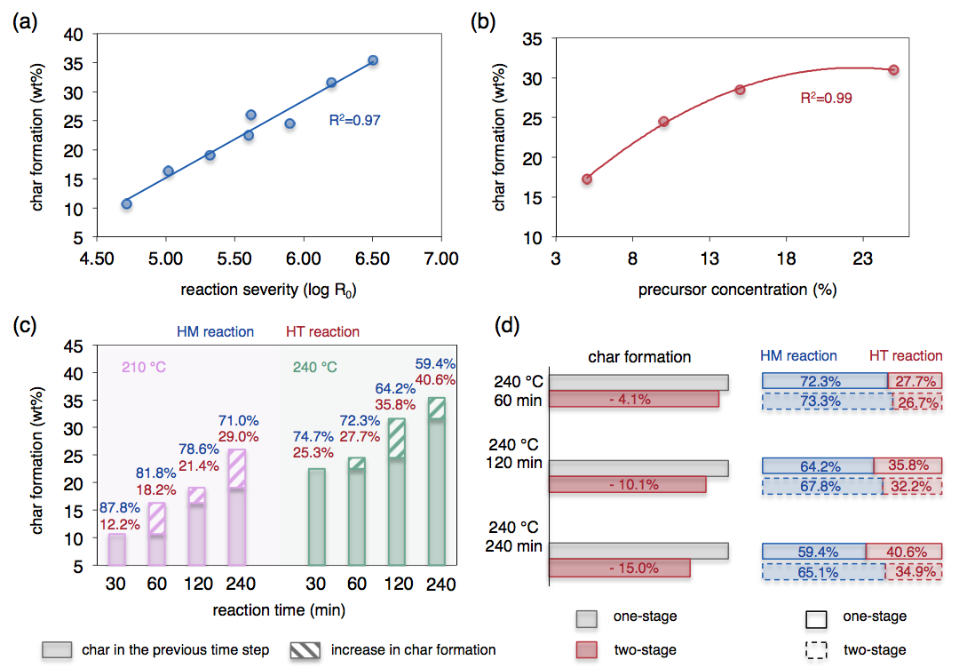

Figure 1: Trends of char formation versus reaction severity (a) and precursor concentration (b), time evolution of char formation during experiments at 210 °C and 240 °C (c), and comparison between one-stage and two-stage HTC (d). Average values are shown (experiments carried out in duplicate, RSD ≤ 1.0%).

Figure 1c shows the combined effect of reaction severity and starting solid to liquid mass ratio, during the time evolution of char formation, for HTCs performed at 210 and 240 °C. A prolonged reaction time obviously translated into a higher conversion degree, with a considerable reduction of the soluble char precursors concentration (from 10 to 5.6%, at 210 °C, from 10 to 3.5%, at 240 °C, after 240 min), as reflected by the strongly enhanced heterogeneous reactions and the specular decrease of the liquid-to-liquid pathways. Despite the progressively reduced availability of convertible mass in the liquid phase, as reaction time increased from 30 to 240 min, the greater reaction severity was responsible for a significant increment in char formation. Conversely, when D-xylose was hydrothermally treated through a two-stage sequential process (first stage at 210 °C for 60 min; second stage at 240 °C for 60, 120, and 240 min), homogeneous reactions were promoted over heterogeneous ones, and an antagonistic effect in forming solid products was observed, especially for longer reaction times, compared to one-stage HTC runs at 240 °C. The main reason for this peculiar finding is likely related to the nature and reactivity of the liquid conversion intermediates (Volpe et al., 2022). After the first HTC stage at 210 °C, the increase of temperature (up to 240 °C) may have favored the generation of difficult-to-polymerize species, such as benzenes from degradation of furan derivates, decreasing the formation of insoluble hydrothermal products and then the char yield. Indeed, benzenes may form from furfural after alkylation and dehydration reactions, remaining in the liquid phase due to the lack of active functional sites for the production of solid char (Shi et al., 2019).
However, to corroborate this hypothesis, a detailed analysis of the HTC process water would be strictly necessary.
    - Elemental composition and surface functionality of hydrothermal carbons
After the hydrothermal treatment, compared to raw feedstock, all the solid products exhibited a dramatic increase in the elemental carbon content, with an evident dropping of the oxygen fraction and a slight decrease of hydrogen. As suggested by the remarkable decline of H/C and O/C atomic ratio values, these variations in the elemental composition are consistent with the formation of polycondensation solid products and the occurrence of intense dehydration and decarboxylation reactions (Modugno and Titirici, 2021). As expected, the O/C ratio decreased with the rise of temperature, probably due to an enhanced dehydration, while longer reaction times fostered a moderate increase in the carbonization degree (κ increased from 69.9 to 74.3%, at 210 °C; from 70.9 to 76.5%, at 240 %). It is noteworthy that the increase of reaction severity and starting solid to liquid mass ratio led to comparable values of carbonization and deoxygenation indexes, which confirms the key role of carbon precursors concentration in HTC.

Table 2: Samples elemental composition (wt% d.b.), atomic ratios (H/C, O/C), and derived parameters (carbonization index, κ and deoxygenation index, δ). Elemental analysis performed in duplicate (average values are reported; RSD ≤ 0.9%). κ and δ measured in %.
Sample | C | H | O* | H/C | O/C | κ | δ
D-xylose | 37.8 | 6.8 | 55.4 | 2.14 | 1.10 | - | -
(1) | 64.2 | 4.5 | 31.3 | 0.84 | 0.37 | 69.8 | 43.5
(2) | 64.8 | 4.4 | 30.8 | 0.81 | 0.36 | 71.4 | 44.4
(3) | 65.5 | 4.4 | 30.1 | 0.80 | 0.34 | 73.3 | 45.7
(4) | 65.9 | 4.3 | 29.8 | 0.78 | 0.34 | 74.3 | 46.2
(5) | 64.6 | 4.3 | 31.1 | 0.79 | 0.36 | 70.9 | 43.9
(6) | 65.2 | 4.4 | 30.4 | 0.80 | 0.35 | 72.5 | 45.1
(7) | 66.3 | 4.4 | 29.3 | 0.79 | 0.33 | 75.4 | 47.1
(8) | 66.7 | 4.4 | 28.8 | 0.79 | 0.33 | 76.5 | 47.8
(9) | 63.7 | 4.3 | 32.0 | 0.80 | 0.38 | 68.5 | 42.2
(10) | 65.9 | 4.4 | 29.7 | 0.80 | 0.34 | 74.3 | 46.4
(11) | 66.6 | 4.3 | 29.1 | 0.77 | 0.33 | 76.2 | 47.5
(12) | 65.2 | 4.3 | 30.5 | 0.79 | 0.35 | 72.5 | 44.9
(13) | 66.1 | 4.3 | 29.6 | 0.78 | 0.34 | 74.9 | 46.6
(14) | 66.5 | 4.3 | 29.2 | 0.77 | 0.33 | 75.9 | 47.3
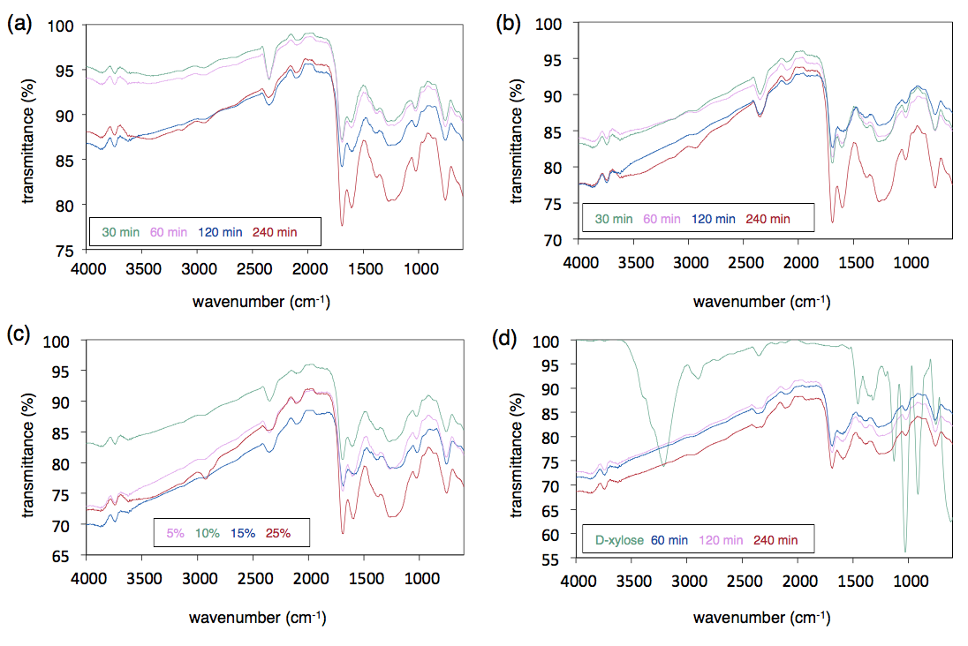
*Computed by difference: O = 100% – C% –H%. All samples are free of N, S, and ash contents.

Figure 2: FTIR spectra for the synthesized hydrothermal carbons: (a) Group I (210 °C); (b) Group I (240 °C); (c) Group II; (d) Group III (spectrum of D-xylose is included).

Looking at the FTIR spectra (Figure 2), all the synthesized HTC carbons showed an clear decrease of the peak centered at 3350 cm⁻¹ (O-H stretching vibrations in hydroxyl and/or carboxyl groups), disclosing the occurrence of a severe dehydration during the thermal treatment, while the significant weakening of the peak positioned at 1030 cm⁻¹ (C-O bonds stretching vibrations), could be due to intermolecular condensation reactions, since the C-O bonds probably served as active sites for the polymerization of the carbon precursors, concentrated in the liquid phase (Wang et al., 2022).
The bands at around 1700 cm⁻¹ and 750 cm⁻¹, respectively attributed to the stretching of C=O groups and to the C-H bending vibration, became stronger with the increase of reaction severity and starting D-xylose concentration, suggesting that the HTC carbons were mainly formed by furfurals and indicating an increased aromaticity. Another evident peak was observed at 1200 cm⁻¹, which could be associated with the C-O-C stretching vibration, for the possible presence of ether and/or pyrone stable groups in the char core (Modugno and Titirici, 2021). Overall, the evolution of surface functionalities indicates the formation of solid carbons by a more intense condensation, as the hydrothermal conversion proceeded.
  - Conclusions
The synthesis of hydrothermal carbons from D-xylose was investigated, assessing the role of reaction severity and starting precursor concentration. The hydrochar mass yield increased from 10.7 to 35.4 wt%, with reaction severity, and from 17.3 to 31.0 wt%, with D-xylose starting concentration. In HTC runs carried out at 210 and 240 °C, for 240 min, the increase of conversion severity and the simultaneous reduction of convertible mass, promoted the heterogeneous reactions, with an appreciable increment in the char mass yield. In contrast, the two-stage sequential HTC (210 °C for 60 min and 240 °C for 60,120 and 240 min) led to an evident antagonism effect in forming hydrochar (up to –15%), probably due to the greater production of difficult-to-polymerize carbon precursors by enhanced homogeneous reactions.
The hydrochars’ elemental composition highlighted an evident increasing carbonization degree and a specular deoxygenation, as HTC proceeded. Consistently, FTIR spectra showed a significant weakening of the peaks assigned to O-H and C-O bonds, indicating the occurrence of a severe D-xylose dehydration and the formation of solid products by polycondensation.
FTIR analysis also revealed the presence of carbonyl functional groups in the analyzed samples, suggesting that the HTC carbons were mainly formed by furfurals. This work provided new insights into unraveling the highly complex correlation between the HTC operating parameters and the formation of carbonaceous solid products with unique properties, contributing to expand the current knowledge on the hydrothermal evolution of carbohydrate chemistry.
Acknowledgments
Authors gratefully acknowledge support of the "SiciliAn MicronanOTecH Research And Innovation Center - SAMOTHRACE" project (MUR, PNRR-M4C2, ECS_00000022).
References
Gong Y., Xie L., Chen C., Liu J., Antonietti M., Wang Y., 2023. Bottom-up hydrothermal carbonization for the precise engineering of carbon materials. Prog. Mater. Sci., 132, 101048.
He C., Xu P., Zhang X., Long W., 2022. The synthetic strategies, photoluminescence mechanisms and promising applications of carbon dots : Current state and future perspective. Carbon N. Y. 186, 91–127.
Matter M.E., Tagnon C., Stache E.E., 2024. Recent Applications of Photothermal Conversion in Organic Synthesis. ACS Cent. Sci., 10, 1460-1472.
Modugno P., Titirici M., 2021. Influence of Reaction Conditions on Hydrothermal Carbonization of Fructose. ChemSusChem, 14, 5271–5282.
Overend R.P., Chornet E., 1987. Fractionation of lignocellulosics by steam aqueous pretreatments. Philos. Trans. R. Soc. Lond. A., 321, 523–536.
Picone A., Volpe M., Giustra M.G., Di Bella G., Messineo A., 2021. Hydrothermal Carbonization of Lemon Peel Waste : Preliminary Results on the Effects of Temperature during Process Water Recirculation. Appl. Syst. Innov., 4, 19.
Shi N., Liu Q., He X., Wang G., Chen N., Peng J., Ma L., 2019. Molecular structure and formation mechanism of hydrochar from hydrothermal carbonization of carbohydrates. Energy Fuels, 33, 9904-9915.
Volpe M., Fiori L., Merzari F., Messineo A., Andreottola G., 2020. Hydrothermal carbonization as an efficient tool for sewage sludge valorization and phosphorous recovery. Chem. Eng. Trans. 80, 199–204.
Volpe M., Picone A., Luz F.C., Mosonik M.C., Volpe R., Messineo A., 2022. Potential pitfalls on the scalability of laboratory-based research for hydrothermal carbonization. Fuel 315, 123189.
Wang R., Jia J., Jin Q., Chen H., 2022. Forming mechanism of coke microparticles from polymerization of aqueous organics during hydrothermal carbonization process of biomass. Carbon N. Y. 192, 50–60.

