 CHEMICAL ENGINEERING TRANSACTIONS  VOL. xxx, 2026 | A publication of  
The Italian Association
of Chemical Engineering
Online at www.cetjournal.it

Guest Editors: Marco Bravi, Antonio Marzocchella, Giuseppe Caputo
Copyright © 2026, AIDIC Servizi S.r.l.
ISBN 979-12-81206-xx-x; ISSN 2283-9216
VALORIZATION OF FOOD INDUSTRY BY-PRODUCTS THROUGH THE CULTIVATION OF THE MICROALGA CHROMOCHLORIS ZOFINGIENSIS
Simona Cozzolino^{1*}, Giovanni Luca Russo^{2*}, Fabio Orlandi³, Paolo Masi^{1,2}, Antonio Luca Langellotti¹, Antonino Pollio⁴,Prospero Di Pierro^{1,2}
¹Centre for Innovation and Development in Food Industry, CAISIAL, University of Naples Federico II, 80055 Portici, Italy
²Department of Agricultural Sciences, University of Naples Federico II, 80055 Portici, Italy
³Department of Civil and Environmental Engineering, University of Perugia, 06125 Perugia, Italy
⁴Department of Biological Sciences, University of Naples Federico II, 80126 Naples, Italy
Simona Cozzolino (e-mail: simona.cozzolino@unina.it)

The bioconversion of low-value food industry by-products into high-value compounds through microbial processes represents a promising route toward circular bioeconomy. This study explored the potential of the green microalga Chromochloris zofingiensis to grow mixotrophically using nutrients derived from industrial by-products. After preliminary screening on simple sugars and organic nitrogen sources, four by-products were selected: beet blackstrap molasses (MOL), cheese whey permeate (CWP), spent brewery yeast (SBY), and corn steep liquor (CSL).
C. zofingiensis showed high productivity on all substrates, achieving up to fourfold higher biomass daily yield compared to autotrophic controls (0.4 g/L/d with MOL or CSL vs. 0.1 g/L/d in BBM). Among all substrates, CSL exhibited the most pronounced effect, yielding up to 2.29 g/L dry weight biomass with 5 g/L supplementation, over 3.5 times higher than controls. Pigment productivity was maximized with corn steep liquor at 5 g L⁻¹, reaching 7.80 mg L⁻¹ d⁻¹ total carotenoids and 1.41 mg L⁻¹ d⁻¹ astaxanthin, about 5.4 fold and 4.9 fold higher than the control, respectively.
Introduction
Globally, approximately 30% of food produced for human consumption is lost or wasted each year, accounting for about 1.3 billion tons (FAO, 2013). Of this, over 700 million tons originate from the agro-food industry. A significant portion of these materials consists of nutrient-rich food by-products and wastes (FBW) that can be valorized as low-cost substrates for biotechnological processes. Typical examples include sugar molasses (rich in fermentable sugars), corn steep liquor (CSL, a nitrogen source), whey permeate (WP, rich in lactose), spent yeast extract (containing peptides and vitamins), and glycerol, a by-product of biodiesel production. Complex organic fractions such as polysaccharides, lipids, and proteins often require hydrolysis to release assimilable monomers (Ende et al., 2019). FBW pre-treatment can enhance substrate suitability by improving bioavailability, reducing color, removing inhibitory compounds, and increasing stability during storage and transport (Russo et al., 2024; Massa et al., 2017). C. zofingiensis is a green microalga with high biorefinery potential due to its ability to assimilate organic carbon sources under mixotrophic conditions and to synthesize high-value carotenoids such as astaxanthin (Tambat et al., 2023). Thus, this microalga is a promising platform for the sustainable bioconversion of agro-industrial residues into bioactive compounds with nutraceutical, pharmaceutical, and cosmetic relevance, supporting circular bioeconomy strategies and waste valorization within the food sector.
The aim of this study was to evaluate the potential of selected agro-industrial by-products as low-cost nutrient sources for the cultivation of C. zofingiensis. The experimental design comprised two main steps: (a) evaluation of mixotrophic growth on pure organic substrates (sugars, amino acids, peptides), (b) assessment of growth performance using individual and blended.
2. MATERIALS AND METHODS
2.1 Experimental Design
The experimental design focused on vegetative growth screening. First, C. zofingiensis was cultivated in four standard media (BBM, BBM-3N, BG11, KUHL) to select the basal formulation. Second, we ran short screening trials to quantify the effect of inoculum density, defined organic nitrogen sources (yeast extract, peptone, monosodium glutamate), defined organic carbon sources (glucose, fructose, lactose, sucrose, maltose, galactose, lactic acid, and a lactose–lactic acid mix), and C/N ratio on growth performance. Third, food industry by-products were chemically characterized and tested as single supplements at 2.5 and 5 g/L (dry-weight basis), including corn steep liquor, beet molasses, cheese whey permeate, and spent brewery yeast, and growth was assessed after 6 days using Cmax, productivity, and specific growth rate.
2.2 Cultivation Systems and Growth Assessment
Lab scale cultures of 50 mL were carried out in sterile polycarbonate cylindrical containers (125 × 75 × 80 mm, light path ~0.5 cm) on an orbital shaker (70 rpm). Illumination was provided by red/blue LEDs (ratio 3:1) at incident light of 150 µE m⁻² s⁻¹). Temperature in the climatic chambers were kept at 25 ± 1 °C.
The specific growth rate 𝜇 (day⁻¹) and the daily biomass productivity P (mg L⁻¹ day⁻¹) were calculated using the following equations (Minyuk et al., 2020).
$$μ=\frac{ln⁡C_{1}-ln⁡C_{0}}{t_{1}-t_{0}},P=\frac{C_{1}-C_{0}}{t_{1}-t_{0}}$$Where $C$is the dry biomass (g L⁻¹) and $t$ is cultivation time (days).
2.4 Pigment Analysis
Pigments were extracted from 50 mg lyophilized biomass with methanol following the protocol modified from Lichtenthaler & Wellburn (1983), vortexed with quartz beads, and measured (400–750 nm). Chlorophyll a, b, and total carotenoids were calculated (Wellburn, 1994; Franke et al., 2022), and astaxanthin quantified by the following equation:
$$[\text{Astaxanthin}]=({\text{Abs}}_{530}-{\text{Abs}}_{750})×6.365+0.092$$
Values were normalized to biomass and expressed as mg L⁻¹ day⁻¹.
2.5 Food By-product Characterization
Beet molasses, corn steep liquor (CSL), ultrafiltered buffalo cheese whey permeate (CWP), and spent brewery yeast (SBY) were analyzed for dry matter, ash, salt, moisture, pH, sugars, and nitrogen. Protein, reducing sugars, and polysaccharides were measured via Bradford, DNS, and Dubois assays, respectively. SBY was autolyzed (7% w/w, 50 °C, 24 h), centrifuged, and sterilized (121 °C, 20 min) following the protocol reported by Russo et al., 2022.
Molasses exhibited a very high dry matter content and the highest glucose equivalent value (666.27 g kg⁻¹), indicating a strong prevalence of organic carbon, with negligible protein value (1.83 g kg⁻¹). Whey permeates, showed appreciable reducing sugars and protein values, indicating the presence of readily available soluble organic nitrogen. Corn steep liquor was characterized by high dry matter and ash contents and a very high protein value (304.15 g kg⁻¹), Spent brewery yeast showed intermediate dry matter and high carbohydrate content and protein values.

2.6 Statistical Analysis
Experiments were conducted in triplicate, and data are reported as mean ± SD. One-way ANOVA was used to assess significant differences (p < 0.05), followed by Tukey’s post-hoc test when applicable. Analyses were performed using IBM© SPSS© Statistics 23 (SPSS, Inc., Chicago, IL, USA).
3.RESULTS AND DISCUSSION
3.1 Evaluation of Growth Performance in Standard Culture Media
Four standard media (BG11, KUHL, BBM, BBM-3N) were compared to assess C. zofingiensis vegetative growth. The results are reported in Figure 1.
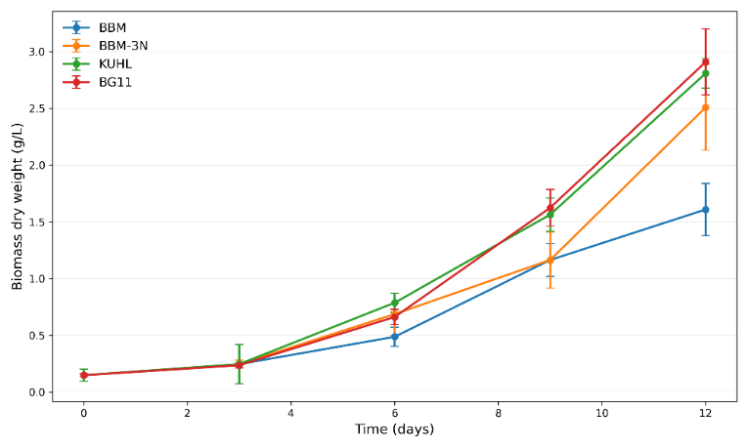
Figure 1. Growth curves of C. zofingiensis cultured in four standard media (BG11, KUHL, BBM, BBM-3N).
All cultures (0.147 g/L initial biomass DW) showed a 3-day lag phase and entered exponential growth from day 5-6. Biomass increased to day 12 in all conditions, with BG11 achieving the highest value (2.908 g/L) and BBM the lowest (1.408 g/L). BBM-3N outperformed BBM but remained below KUHL and BG11, indicating that nitrogen enrichment alone does not explain the best performing formulation.
Growth-rate profiles reflected similar trends: BG11 and BBM-3N supported faster early growth, whereas KUHL exhibited the highest rates between days 3 to 9, supporting mid-phase cultivation. These results identify BG11 and Kuhl as the most supportive media for C. zofingiensis growth and highlight the need for medium renewal or semi-continuous operation after day 12 to maintain productivity.
3.2. Combined Analysis of Growth Performance Under Varying Inoculum Levels, Nitrogen-Organic Carbon Sources, and C/N Ratios
A set of cultivation trials was carried out to assess the effects of initial inoculum concentration, nitrogen source supplementation, organic carbon addition, and C/N ratio on the growth performance of C. zofingiensis. The results are reported in Figure 2.
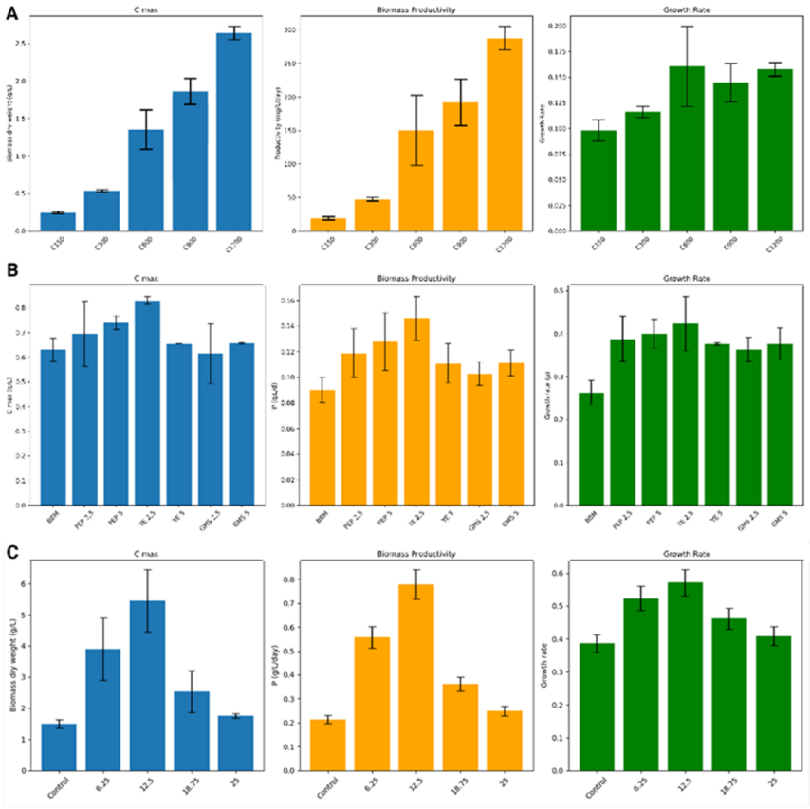

Figure 2. Effect of inoculum concentration (A), organic nitrogen sources and doses (peptone, yeast extract, monosodium glutamate) (B) and carbon/nitrogen ratio (C/N) (C) maximum biomass concentration (Cmax, g/L), biomass daily productivity (P), and specific growth rate (μ) of for C. zofingiensis.

Under high irradiance and reduced light-path conditions, increasing the inoculum from 100 to 600 mg/L resulted in a substantial increase in biomass production, with daily productivity rising from 0.029 to 0.198 g/L/d. The μ plateau at intermediate inoculum density fits typical light and mass-transfer constraints that appear as cultures become denser. Nitrogen source selection strongly affected growth. The control gave the lowest performance. Yeast extract at 2.5 g/L achieved the best overall performance, while increasing it to 5 g/L reduced C_{max} and productivity. Yeast extract likely improved growth through readily assimilable amino acids, peptides, and vitamins, while the drop at 5 g/L suggests an upper concentration range where osmotic load, metabolic imbalance, or inhibitory compounds reduce net biomass output. This pattern aligns with broader evidence that medium formulation and nutrient balance drive C. zofingiensis productivity and downstream biorefinery performance, rather than nitrogen concentration alone (Wood et al., 2024).
In mixotrophic conditions, the addition of simple sugars significantly enhanced biomass accumulation. Glucose and fructose yielded the highest C_{max} (≈1.26-1.27 g/L) and growth rates (0.361-0.363 µ), while galactose and lactic acid produced moderate improvements. Lactose resulted in the lowest biomass, indicating limited utilization efficiency. The carbon source ranking, with glucose and fructose as top performers, matches recent physiological evidence that C. zofingiensis responds strongly to these sugars and shifts metabolism toward sugar-supported growth in light, while other sugars show weaker utilization (Hu et al., 2024).
Evaluation of different C/N ratios revealed that growth increased up to a C/N ratio of 12.5, where the maximum biomass (5.45 g/L) was achieved. Higher ratios (18.75-25) led to reduced biomass and productivity, suggesting carbon excess and nitrogen limitation. The C/N response follows established mixotrophic behavior, where moderate C/N supports maximal biomass, while high C/N promotes nitrogen limitation and reduces growth stability (Oliviero et al., 2022). This outcome is useful for the next step of this paper, since FBW supply carbon and nitrogen in fixed ratios.
3.3 Growth Tests with Food By-product Substrates
The effects of different FBW on the biomass and pigment production of C. zofingiensis by supplementing CSL, CWP, beet molasses, and SBY at 2.5 and 5 g/L (dry-weight basis) was evaluated. The results are reported in Figure 3.
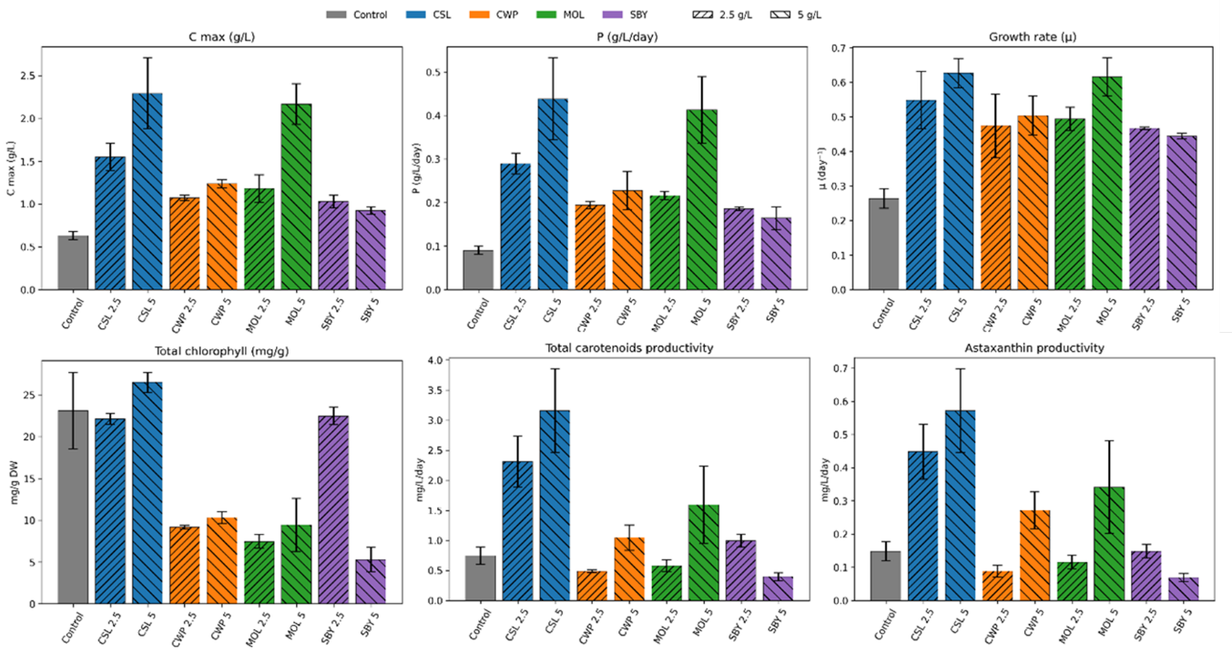
Fig. 3 Growth performances and pigment profile of Chromochloris zofingiensis in media supplemented with corn steep liquor (CSL), cheese whey permeate (CWP), beet molasses (MOL), or spent brewery yeast (SBY) at 2.5 or 5 g/L (dry weight). Panels report Cmax (g/L), biomass productivity P (g/L/day), specific growth rate μ (day⁻¹), total chlorophyll (mg/g DW), carotenoids productivity (mg/L/day DW), astaxanthin productivity (mg/L/day DW). Bar color groups substrates, hatch marks indicate dose.
The results showed that microalgal growth and pigments were significantly affected by the type and concentration of food-based waste (FBW) added to the culture medium.
The control showed the lowest biomass output (Cmax 0.64 g/L, P 0.09 g/L/day, μ 0.26 day⁻¹) but the highest pigment concentrations, with high total chlorophyll and carotenoids per biomass, which fits a more photoautotrophic allocation in the absence of external organic nutrients. CSL produced the strongest growth response and a clear dose effect, reaching the highest biomass and the highest P and μ, while maintaining high total chlorophyll and high carotenoids per biomass. This pattern matches the role of CSL as a nitrogen-rich stream with vitamins and minerals that supports rapid biomass formation, and it aligns with recent works where CSL supports microalgal growth alone or in blends with sugar-rich residues (Russo et al., 2024) and growth of Yarrowa lipolitica (Santos et al.,2018). Moreover, CSL 5 delivered the highest astaxanthin productivity, 1.41 mg L⁻¹ d⁻¹, about 4.9 fold higher than the control (0.29 mg L⁻¹ d⁻¹) Molasses also enhanced growth, especially at 5 g/L, while total chlorophyll and carotenoids per biomass remained lower than CSL and the control, which is consistent with reports that sugar-rich by-products drive mixotrophic biomass accumulation while reducing chlorophyll density per cell through metabolic rebalancing (Oliviero et al., 2022).
CWP increased growth compared with the control, with a modest dose response in C_{max} and P, and it showed the highest astaxanthin fraction at 5 g/L (about 26% of total carotenoids), suggesting that whey-derived supplementation supported growth while also promoting a more carotenogenic pigment partitioning under these conditions. Even though CWP 5 showed the highest astaxanthin share (about 26% of total carotenoids), its astaxanthin productivity was 0.42 mg L⁻¹ d⁻¹, because biomass productivity and total carotenoid content were lower than CSL conditions. SBY increased growth relative to the control but did not improve performance at 5 g/L, and pigments dropped sharply at 5 g/L, which points to saturation or inhibition linked to by-product load, such as reduced light penetration, lower nutrient bioavailability, or inhibitory soluble fractions.
CWP supported biomass accumulation compared to the control, although the increase was less pronounced than that observed with CSL, suggesting a lower nutritional efficiency or the need for nutrient balancing or co-substrate supplementation.
These results highlight the importance of selecting and optimizing both the type and concentration of food industry by-products and suggests a pairing of a nitrogen-rich stream with a carbon-rich stream (molasses or whey-derived sugars) to improve growth while tuning pigment targets.
4. CONCLUSION
This work systematically evaluated the potential of C. zofingiensis as a biotechnological platform for the valorization of food industry by-products and for the production of high value-added compounds, with particular emphasis on carotenoids and astaxanthin. The results clearly demonstrate that both growth and secondary metabolism of this microalga are strongly affected by culture medium composition and operating conditions.
The comparison among standard media showed that BG11 and KUHL support the highest growth performance, while nitrogen enrichment of BBM improves biomass production without achieving optimal levels, confirming that balanced nutrient availability is essential to maximize productivity. The analysis of cultivation parameters identified optimal growth conditions, including an initial inoculum of approximately 400 mg/L, yeast extract at 2.5 g/L as nitrogen source, glucose or fructose as carbon sources, and a C/N ratio of 12.5 as the most efficient configuration for biomass production.
Corn steep liquor was identified as the most effective substrate for enhancing growth and productivity, while spent brewery yeast and cheese whey permeate supported growth to a lesser extent. SBY was essential to achieve maximum biomass yields, highlighting the importance of balanced nutrient supply. From an industrial perspective, corn steep liquor stands out as a low cost and widely available substrate, but future scale up should account for batch to batch variability in composition, possible inhibition at high organic loads, simple pretreatments such as filtration and pH adjustment, and typical mixotrophic constraints including contamination control, oxygen transfer, foaming, and light gradients in larger reactors.

REFERENCES

Ende, S. S., & Noke, A.,2019, Heterotrophic microalgae production on food waste and by-products. Journal of Applied Phycology, 31(3), 1565-1571.
Franke, S., Steingröwer, J., Walther, T., & Krujatz, F.,2022, The oxygen paradigm.Quantitative impact of high concentrations of dissolved oxygen on kinetics and large-scale production of Arthrospira platensis. Chemengineering, 6(1), 14.
Hu, Y., Kim, N., Roth, M. S., Louie, K. B., Kosina, S. M., Upadhyaya, S., ... & Northen, T. R., 2024, Green microalga Chromochloris zofingiensis conserves substrate uptake pattern but changes their metabolic uses across trophic transition. Frontiers in Microbiology, 15, 1470054.
Lichtenthaler, H. K., & Wellburn, A. R., 1983, Determinations of total carotenoids and chlorophylls A and B of leaf extracts in different solvents. Biochemical Society Transactions, 11(5), 591-592
Massa, M., Buono, S., Langellotti, A. L., Castaldo, L., Martello, A., Paduano, A., ... & Fogliano, V., 2017, Evaluation of anaerobic digestates from different feedstocks as growth media for Tetradesmus obliquus, Botryococcus braunii, Phaeodactylum tricornutum and Arthrospira maxima. New Biotechnology, 36, 8-16.
Minyuk, G., Sidorov, R., & Solovchenko, A., 2020, Effect of nitrogen source on the growth, lipid, and valuable carotenoid production in the green microalga Chromochloris zofingiensis. Journal of Applied Phycology, 32, 923-935.
Oliviero, M., Langellotti, A. L., Russo, G. L., Baselice, M., Donadio, A., Ritieni, A., Graziani, G., & Masi, P., 2022, Use of different organic carbon sources in Cynara cardunculus Cells: Effects on biomass productivity and secondary metabolites. Plants, 11(5), 701.
Russo, G. L., Langellotti, A. L., Verardo, V., Martín-García, B., Di Pierro, P., Sorrentino, A., Baselice, M., Oliviero, M., Sacchi, R., & Masi, P., 2022, Formulation of new media from dairy and brewery wastes for a sustainable production of DHA-Rich Oil by Aurantiochytrium mangrovei. Marine Drugs, 20(1), 39.
Russo, G. L., Langellotti, A. L., Verardo, V., Garcia, B. M., Oliviero, M., & Masi, P., 2024, Sustainable cultivation of Porphyridium cruentum via agro-industrial by-products: A study on biomass and lipid enhancement. Biocatalysis and Agricultural Biotechnology, 60, 103341.
Santos, F., Freitas, K., Neto, J. C., Ana, G. F. S., Rocha-Leao, M. H., & Amaral, P., 2018, Tiger nut (Cyperus esculentus) milk byproduct and corn steep liquor for biosurfactant production by Yarrowia lipolytica. Chemical Engineering Transactions, 65, 331-336.
Tambat, V. S., Patel, A. K., Singhania, R. R., Vadrale, A. P., Tiwari, A., Chen, C. W., & Dong, C. D., 2023, Sustainable mixotrophic microalgae refinery of astaxanthin and lipid from Chlorella zofingiensis. Bioresource Technology, 387, 129635.
Wellburn, A. R., 1994, The spectral determination of chlorophylls a and b, as well as total carotenoids, using various solvents with spectrophotometers of different resolution. Journal of plant physiology, 144(3), 307-313.
Wood, E. E., Ross, M. E., Jubeau, S., Montalescot, V., & Stanley, M. S., 2024, Progress towards a targeted biorefinery of Chromochloris zofingiensis: a review. Biomass Conversion and Biorefinery, 14(7), 8127-8152.

