 CHEMICAL ENGINEERING TRANSACTIONS  VOL. xxx, 2026 | A publication of  
The Italian Association
of Chemical Engineering
Online at www.cetjournal.it

Guest Editors: Marco Bravi, Antonio Marzocchella, Giuseppe Caputo
Copyright © 2026, AIDIC Servizi S.r.l.
ISBN 979-12-81206-xx-x; ISSN 2283-9216

Preparation and Characterization of Magnetic Bacterial Nanocellulose Using Different Approaches
Kaja Gajšt, Katja Vasić, Maja Leitgeb, Željko Knez, Mateja Primožič*
University of Maribor, Faculty of Chemistry and Chemical Engineering, Smetanova ulica 17, 2000 Maribor, Slovenia
mateja.primozic@um.si

Native bacterial nanocellulose (BNC) exhibits limited functional versatility, notably the absence of intrinsic magnetic responsiveness. This property can be imparted through the incorporation of magnetic nanoparticles (MNPs), which enable the development of magnetically active BNC composites with enhanced physicochemical and application-specific characteristics. The resulting nanocomposites combine the intrinsic biocompatibility and structural integrity of BNC with the functional advantages of magnetic materials, expanding their applicability in biomedical and technological fields.
Magnetic bacterial nanocellulose beads (MBNC) were synthesized using two different approaches: an in situ method, where MNPs were generated directly within pre-formed BNC beads, and an agitated fermentation-based method, in which pre-synthesized MNPs were incorporated into the culture medium during BNC production by Komagataeibacter xylinus. The influence of cultivation and synthesis parameters, such as shaking speed, incubation time, and nanoparticle concentration, on the morphological, magnetic, and physicochemical characteristics of the resulting MBNC was systematically investigated. Magnetic property measurements revealed that in situ synthesized MBNC with a smaller bead diameter exhibited better magnetic responsiveness. The most magnetic properties of MBNC, obtained via the agitated fermentation-synthesis method, were observed in beads synthesized at a shaking speed of 140 rpm with the addition of 0.5 g of MNPs to the medium. The obtained results provide valuable insights into optimizing synthesis conditions for scalable production of magnetically functionalized bacterial nanocellulose, highlighting its potential use in biomedical engineering, environmental remediation, and smart material design.
  - Introduction
Nanotechnology is one of the fastest-developing fields in modern science, largely due to its potential for designing materials with enhanced or entirely new functional properties. Among the most promising nanomaterials is native bacterial nanocellulose (BNC) (de Souza Ferreira et al., 2025), which represents a pure, sustainable, and biocompatible alternative to traditional plant-derived cellulose (Jozala et al., 2016). Unlike plant cellulose, BNC does not require harsh purification procedures, as it contains no lignin, hemicellulose, or other impurities (Acharyya et al., 2024; Barja, 2021). Due to its high crystallinity, excellent mechanical strength, remarkable water-holding capacity, and three-dimensional porous structure, BNC is highly versatile and finds applications in biomedicine, pharmaceuticals, environmental technologies, and materials engineering (Sharma and Bhardwaj, 2019; Swingler et al., 2021).
Despite its numerous advantages, BNC lacks certain important properties such as antimicrobial activity, antioxidative capacity, electrical conductivity, and magnetic responsiveness (Sriplai and Pinitsoontorn, 2021). These limitations reduce its applicability in advanced functional systems, such as smart biomaterials, magnetically guided drug delivery, or bioseparation. Consequently, over the past decade, research has increasingly focused on developing BNC-based nanocomposite materials in which the native BNC matrix is functionalized with the addition of other substances, such as biopolymers, natural extracts, metal ions, or nanoparticles (Revin et al., 2022).
Magnetic nanoparticles (MNPs), particularly magnetite (Fe₃O₄), are highly attractive functional components due to their superparamagnetism, small size, low toxicity, and stability (Azizi, 2020; Yingkamhaeng et al., 2018). Incorporating these nanoparticles into BNC results in a nanocomposite known as magnetic bacterial nanocellulose (MBNC), which combines the mechanical and biophysical advantages of BNC with the magnetic properties of Fe₃O₄ nanoparticles. MBNC has demonstrated significant utility across a broad range of technological and environmental applications, including advanced wastewater remediation, immobilization and stabilization of biological reagents, integration into microfluidic platforms, controlled drug delivery systems, and the development of high-performance electrochemical devices (de Souza et al., 2023; Sriplai and Pinitsoontorn, 2021).
A crucial step in designing nanocomposites is the selection of BNC morphology. While static fermentation yields BNC membranes, dynamic fermentation enables the synthesis of BNC beads, which, due to their higher specific surface area, uniform porosity, and improved adsorption capacity, represent a more effective substrate for nanoparticle incorporation and for further use in bioseparation or targeted applications (Zhu et al., 2011).
Therefore, in our study, magnetic nanocomposites based on BNC beads and MNPs were synthesized by two different synthesis approaches. During in situ synthesis, BNC functions as a chemical reactor, allowing nanoparticle formation within its three-dimensional porous structure. Another approach involves introducing nanoparticles directly into the culture medium at the beginning of BNC biosynthesis. During cultivation, the BNC microfibrils form a three-dimensional network structure capable of entrapping the nanoparticles added to the medium (Sriplai and Pinitsoontorn, 2021). Previous studies (Arias et al., 2016; Echeverry-Rendon et al., 2017; Yingkamhaeng et al., 2018) prepared MBNC nanocomposites using the in situ synthesis approach, while Galateanu et al. (Galateanu et al., 2015) applied synthesis during shaking fermentation, but in these cases, the authors adopted a static cultivation method, utilizing BNC membranes as the structural matrix.
For both synthesis approaches, the influence of various parameters on the properties of the resulting MBNC with the aim of optimizing the synthesis itself was investigated. The MBNC samples were characterized using SEM, and their magnetic properties were evaluated.
  - Materials and methods
    - Materials
Citric acid (C₆H₈O₇), iron(III) chloride hexahydrate (FeCl₃· 6 H₂O), iron(II) chloride tetrahydrate (FeCl₂· 4 H₂O), and meat peptone were supplied by Merck (Darmstadt, Germany). Disodium hydrogen phosphate (Na₂HPO₄), hydrochloric acid (HCl), and sodium hydroxide (NaOH) were purchased from Sigma-Aldrich (St. Louis, USA). D-glucose monohydrate (C₆H₁₂O₆ · H₂O) and yeast extract were supplied by Duchefa Biochemie (Haarlem, The Netherlands). Aqueous ammonia solution (25% w/w NH₃) was obtained from LabExpert, KEFO (Ljubljana, Slovenia). The selected microorganism, Komagataeibacter xylinus (DSM 2325), was purchased from DSMZ-German Collection of Microorganisms and Cell Cultures GmbH from Berlin, Germany.
    - Production of BNC beads
BNC beads were produced by K. xylinus. For the growth and production medium, Hestrin and Schramm (HS) medium (Yassine et al., 2016) was selected. Before sterilization, the pH value of the medium was adjusted to 6.0 using HCl or NaOH, respectively. For the inoculum, one loopful of K. xylinus was inoculated in 50 mL HS medium and incubated at 26 °C on a rotary shaker (120 rpm) for 24 h. The production of BNC beads was carried out in 250 mL Erlenmeyer flasks, containing 125 mL of medium with 5 % of inoculum. Incubation was carried out at 26 °C under different agitation speeds and durations. After the incubation period, BNC beads were withdrawn from the culture medium, washed with distilled water, and immersed in 1 M NaOH for 24 h. BNC beads were then washed with distilled water until a neutral pH was reached.
    - MNPs synthesis
Fe²⁺ and Fe³⁺ salt solutions were prepared in distilled water, ultrasonicated, and transferred to a three-neck flask equipped with mechanical stirring. Aqueous ammonia solution was added dropwise to raise the pH, leading to the formation of an Fe(OH)ₓ precipitate. After 30 minutes of stirring, additional aqueous ammonia solution was added to increase the pH above 11, promoting the conversion of the precipitate into Fe₃O₄ MNPs, indicated by the solution turning black. The MNPs were then magnetically separated, washed repeatedly with distilled water until the supernatant was clear, dried at 50 °C, and finally ground to obtain the dry MNPs powder.
    - In situ synthesis of MBNC beads
In a three-neck flask, a solution of iron ions was prepared using a 2:1 molar ratio of Fe³⁺ and Fe²⁺ ions. The appropriate masses of FeCl₃·6H₂O and FeCl₂· 4H₂O were weighed and dissolved in distilled water. A continuous flow of nitrogen gas was supplied through one of the flask necks to prevent oxidation of the iron ions. BNC beads were then added to the solution. The mixture was heated to 80 °C under constant stirring (250 rpm) to ensure sufficient impregnation of the BNC beads with the iron solution. Once the temperature stabilized at 80 °C, the stirring speed was increased to 600 rpm, and 10 mL of aqueous ammonia solution (25% w/w) was added dropwise to raise the pH and initiate coprecipitation of the iron ions. Stirring at 80 °C was continued for an additional 15 minutes. The resulting MBNC material was separated and washed several times with distilled water. The prepared MBNC samples were stored in centrifuge tubes in distilled water at 4 °C. Figure 1 presents the assembled apparatus used for the in situ preparation of MBNC.
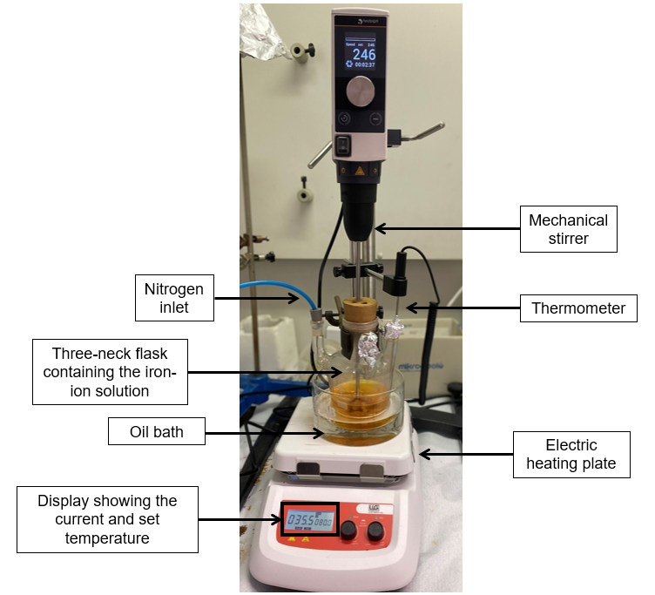
Figure 1: Setup for the in situ synthesis of MBNC.
    - Formation of MBNC beads by agitated fermentation
Different amounts (0.25 g, 0.5 g, and 0.75 g) of the prepared MNPs were weighed into Erlenmeyer flasks, followed by the addition of 125 mL of HS medium, and then sterilized. In a sterile environment, 6.25 mL of the K. xylinus inoculum was pipetted into each sterile Erlenmeyer flask. The inoculated flasks were then placed on a rotary shaker and incubated for 3 days at 26 °C under different agitation speeds (140 rpm, 180 rpm, and 220 rpm). After three days, the resulting MBNC was separated from the medium and washed with distilled water.
    - Characterization
Before characterization, the MBNC samples were freeze-dried using a Christ Epsilon 2-4 LS Cplus lyophilizer. The morphology and elemental composition of MBNC were analyzed using SEM (FEI Sirion 400 NC). Prior to imaging, lyophilized beads were coated with a thin layer of gold. Magnetic properties were determined inductively under an alternating magnetic field using a high-frequency magnetic characterization system.
  - Results and Discussion
    - BNC beads production
Dynamic fermentation conditions had a significant effect on the production of BNC beads. The influence of cultivation time (3, 5, and 7 days) and agitation speed (120, 140, and 160 rpm) was evaluated. It was observed that during dynamic fermentation of K. xylinus at 26 °C, spherical BNC beads formed after three days, with their number and size dependent on the shaking speed, as shown in Figure 2. Higher shaking speed resulted in a smaller average diameter of BNC beads and an increased average number of beads. Prolonged fermentation time led to an increase in the diameter of BNC beads, while the number of beads remained constant. By varying cultivation time (Figure 2a) and shaking speed (Figure 2b), BNC samples of different sizes were obtained and subsequently used for in situ synthesis of MBNC.
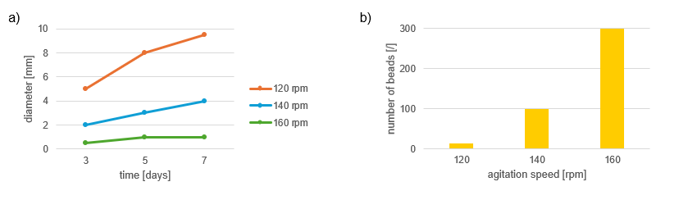
Figure 2: a) Effect of cultivation time on the diameter of produced BNC beads, and b) effect of agitation speed on the number of formed BNC beads.
    - Preparation of MBNC via agitated fermentation
For the synthesis of MBNC by the agitated fermentation method, the effects of shaking speed (140 rpm, 180 rpm, and 220 rpm) and mass of added MNPs (0.25 g, 0.5 g, and 0.75 g) were investigated. At a shaking speed of 140 rpm, a single large MBNC bead (Figure 3a) was formed after three days of incubation at 26 °C, whereas at 180 rpm and 220 rpm, approximately 300 smaller MBNC beads with an average diameter of 0.5 mm were obtained (Figure 3b). The largest bead diameter was achieved at 140 rpm with the addition of 0.5 g of MNPs.
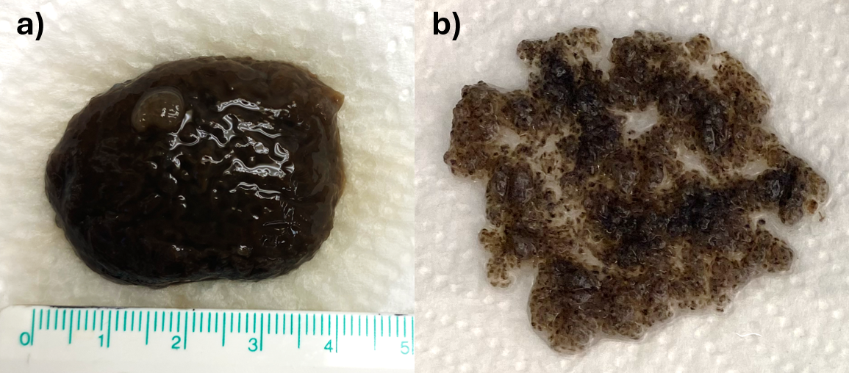
Figure 3: MBNC produced via agitated fermentation at a) 140 rpm and b) 220 rpm, with the addition of 0.5 g of MNPs to the medium.
    - Morphological characterization
SEM images of the samples obtained by both synthesis approaches are shown in Figure 4. SEM analysis of the MBNC samples confirmed successful synthesis of the nanocomposite material. Both in situ synthesized MBNC (Figure 4a) and those obtained via agitated fermentation (Figure 4b) exhibited characteristic nanocellulose fibrils with embedded MNPs.
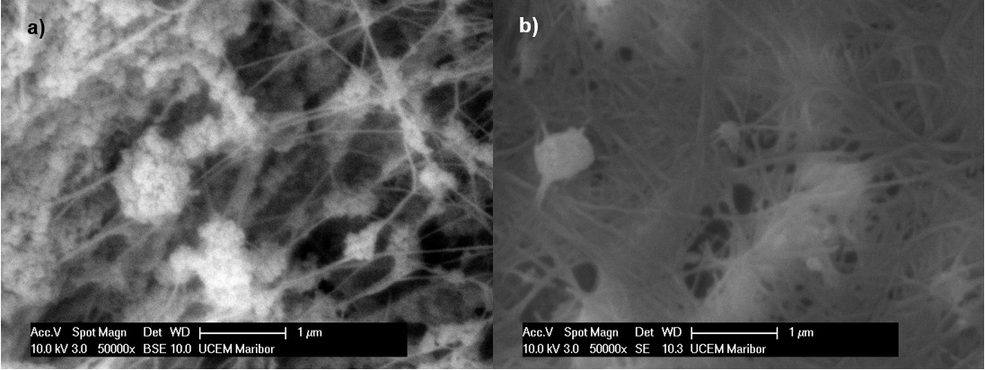
Figure 4: SEM images of MBNC produced a) via in situ synthesis and b) during agitated fermentation at 50.000X magnification.
    - Magnetic Properties
Magnetic polarization of the lyophilized MBNC samples was measured under an alternating magnetic field, resulting in typical hysteresis loops. The magnetic polarization achieved at the maximum applied magnetic field (Hₚ) was denoted as Jₚ (J peak), representing the highest point on the hysteresis loop. The value of Jₚ indicates the extent to which the material can be polarized under a given magnetic field and serves as a reference parameter for assessing its magnetic performance. A higher Jₚ value, therefore, reflects a greater magnetization capability.
Table 1 presents the measured J_{p} values for MBNC samples of varying diameters synthesized using the in situ method. MBNC with a smaller diameter exhibit higher J_{p} values, which can be attributed to their larger surface-to-volume ratio. This provides a greater number of accessible hydroxyl groups on the BNC for binding iron ions and subsequently forming Fe₃O₄ nanoparticles.
Table 1: Magnetic response of MBNC samples of different diameters synthesized via the in situ method
Diameter [mm] | J_{p} [T]
0.5 | 0.0158
2 | 0.0087
5 | 0.0057
Among the samples synthesized via the agitated fermentation, the highest J_{p} value (0.017 T) was obtained for the sample prepared at 140 rpm with the addition of 0.5 g of MNPs. When comparing the MBNC samples that exhibited the strongest magnetic response for each synthesis method (Figure 5), a slightly higher Jₚ value was observed for the sample synthesized during fermentation under shaking conditions. The hysteresis loops also differed in their widths, indicating distinct values of magnetic coercivity, H_{c}. H_{c} represents the intensity of the magnetic field required to reduce the magnetic polarization of the material to zero after prior saturation, i.e., after exposure to a magnetic field. The H_{c} of the MBNC synthesized via the in situ method was approximately 5000 A/m, whereas the H_{c} of the MBNC synthesized during agitated fermentation was about 600 A/m. This indicates that the in situ synthesized MBNC exhibits an enhanced ability to retain remanent magnetization even after the external magnetic field is withdrawn. Such magnetic stability represents a critical parameter in the evaluation and selection of magnetic materials for targeted technological applications.
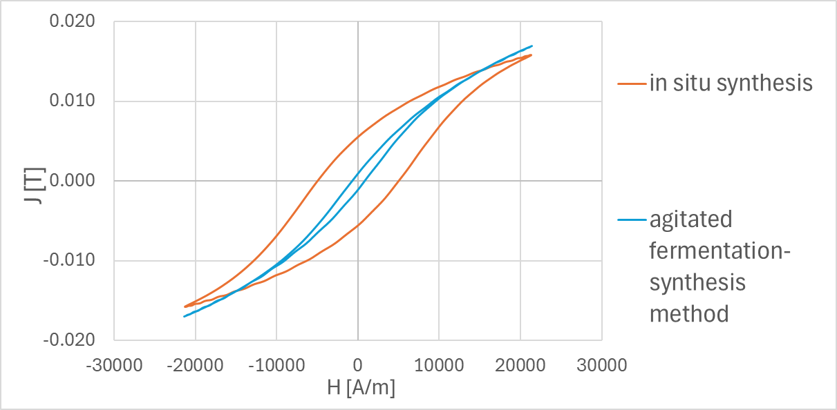
Figure 5: Comparison of hysteresis loops for the MBNC samples with the highest magnetic response obtained via the two synthesis methods (in situ and agitated fermentation synthesis).
  - Conclusions
BNC nanocomposites with MNPs using two different methods, which were confirmed by SEM analysis and magnetic property measurements, were successfully synthesized. The highest magnetic response was observed for the MBNC sample synthesized via the in situ method, exhibiting the smallest diameter of 0.5 mm, as well as for the MBNC sample prepared at 140 rpm with the addition of 0.5 g of MNPs to the medium during agitated fermentation (see Table 2). This study offers detailed insights into the synthesis and functionalization of BNC beads with MNPs, highlighting their effectiveness as robust carrier matrices. The resulting MBNC exhibits considerable potential for deployment across diverse biomedical and environmental applications, as well as in the development of next-generation electronic and sensing devices. Future work will focus on systematically evaluating the performance and applicability of the synthesized MBNC beads within these targeted technological domains.
Table 2: Experimental summary for synthesis of MBNC beads with the highest magnetic response
Method | Cultivation conditions | Yield | Diameter [mm] | Number of beads
In situ | 160 rpm, 3 days, 26 °C | 5.7 g | 0.5 | 300
Agitated fermentation | 140 rpm, 3 days, 26 °C, 0.5 g MNPs | 7.4 g | 40 | 1

Acknowledgments
This research was supported by the Slovenian Research and Innovation Agency (ARIS) within the framework of program P2-0046 (Separation Processes and Production Design), program P2-0114 (Applied Electromagnetics), and a young researcher ARIS fellowship contract, number 2894/FKKT-2025. Prof. Dr. Maja Leitgeb and Prof. Dr. Željko Knez are partly employed at the University of Maribor, Faculty of Medicine, Taborska ulica 8, 2000 Maribor, Slovenia. Assist. Prof. Dr. Katja Vasić is partly employed at the University of Maribor, Faculty of Electrical Engineering and Computer Science, Laboratory for Applied Electromagnetics, Koroška cesta 46, 2000 Maribor, Slovenia.
References
Acharyya P.P., Sarma M., Kashyap A., 2024, Recent advances in synthesis and bioengineering of bacterial nanocellulose composite films for green, active and intelligent food packaging, Cellulose, 31(12), 7163–87.
Arias S.L., Shetty A.R., Senpan A., Echeverry-Rendón M., Reece L.M., Allain J.P., 2016, Fabrication of a Functionalized Magnetic Bacterial Nanocellulose with Iron Oxide Nanoparticles, Journal of Visualized Experiments, (111), e52951.
Azizi A., 2020, Green Synthesis of Fe₃O₄ Nanoparticles and Its Application in Preparation of Fe₃O₄/Cellulose Magnetic Nanocomposite: A Suitable Proposal for Drug Delivery Systems, Journal of Inorganic and Organometallic Polymers and Materials, 30, 3552-3561.
Barja F., 2021, Bacterial nanocellulose production and biomedical applications, The Journal of Biomedical Research, 35(4), 310-317.
De Souza Ferreira A., Rodrigues H.C., Montanher P.F., de Souza S.S., de Castilhos Ghisi N., 2025, The current state of bacterial nanocellulose research: a scientometric analysis. Cellulose 32, 1469–1483.
De Souza T.C., de Amorim J.D.P., da Silva Junior C.J.G., de Medeiros A.D.M., de Santana Costa A.F., Vinhas G.M., Sarubbo L.A., 2023, Magnetic Bacterial Cellulose Biopolymers: Production and Potential Applications in the Electronics Sector, Polymers,15(4), 853.
Echeverry-Rendon M., Reece L.M., Pastrana F., Arias S.L., Shetty A.R., Pavón J.J., Allain J.P., 2017, Bacterial Nanocellulose Magnetically Functionalized for Neuro-Endovascular Treatment, Macromolecular Bioscience, 17(6).
Galateanu B., Bunea M.C., Stanescu P., Vasile E., Casarica A., Iovu H., Hermenean A., Zaharia C., Costache M., 2015, In Vitro Studies of Bacterial Cellulose and Magnetic Nanoparticles Smart Nanocomposites for Efficient Chronic Wounds Healing, Stem Cells International, 2015, 195096.
Jozala A.F., de Lencastre-Novaes L.C., Lopes A.M., de Carvalho Santos-Ebinuma V., Mazzola P.G., Pessoa A. Jr, Grotto D., Gerenutti M., Chaud M.V., 2016, Bacterial nanocellulose production and application: a 10-year overview, Applied Microbiology and Biotechnology,100(5), 2063-2072.
Revin V.V., Liyaskina E.V., Parchaykina M.V., Kuzmenko T.P., Kurgaeva I.V., Revin V.D., Ullah M.W., 2022, Bacterial Cellulose-Based Polymer Nanocomposites: A Review, Polymers, 14(21), 4670.
Sharma C., Bhardwaj N.K., 2019, Bacterial nanocellulose: Present status, biomedical applications and future perspectives, Materials Science and Engineering C, 104, 109963.
Sriplai N., Pinitsoontorn S., 2021, Bacterial cellulose-based magnetic nanocomposites: A review, Carbohydr Polym, 254, 117228.
Swingler S., Gupta A., Gibson H., Kowalczuk M., Heaselgrave W., Radecka I., 2021, Recent Advances and Applications of Bacterial Cellulose in Biomedicine, Polymers, 13(3), 412.
Yassine F., Bassil N., Flouty R., Chokr A., Samrani A.E., Boiteux G., Tahchi M.E., 2016, Culture medium pH influence on Gluconacetobacter physiology: Cellulose production rate and yield enhancement in presence of multiple carbon sources, Carbohydrate Polymers, 146, 282-291.
Yingkamhaeng N., Intapan I., Sukyai P., 2018, Fabrication and Characterisation of Functionalised Superparamagnetic Bacterial Nanocellulose Using Ultrasonic-Assisted In Situ Synthesis. Fibers and Polymers, 19, 489–497.
Zhu H., Jia S., Wan T., Jia Y., Yang H., Li J., Yan L., Zhong C., 2011, Biosynthesis of spherical Fe₃O₄/bacterial cellulose nanocomposites as adsorbents for heavy metal ions, Carbohydrate Polymers, 86(4), 1558–1564.

