 CHEMICAL ENGINEERING TRANSACTIONS  VOL. xxx, 2026 | A publication of  
The Italian Association
of Chemical Engineering
Online at www.cetjournal.it

Guest Editors: Marco Bravi, Antonio Marzocchella, Giuseppe Caputo
Copyright © 2026, AIDIC Servizi S.r.l.
ISBN 979-12-81206-xx-x; ISSN 2283-9216

Set up of lab-scale packed bed of lignocellulosic biomass for cellulase adsorption characterization
M. Tanga^{a,b}, M.E. Russo^{a*}, L. Marraª, A. Marzocchellaª, P. Salatinoª
ªDipartimento di Ingegneria Chimica, dei Materiali e della Produzione Industriale - Università degli Studi di Napoli Federico II, P.le V. Tecchio 80, 80125 Napoli, Italy
^{b}Istituto di Scienze e Tecnologie per l’Energia e la Mobilità Sostenibili – Consiglio Nazionale delle Ricerche, P.le V. Tecchio 80, 80125 Napoli, Italy
merusso@unina.it
Enzymatic hydrolysis (EH) of lignocellulosic biomass (LB) is a central step in biorefinery saccharification, yet its large-scale implementation remains limited by unproductive enzyme adsorption on lignin and mass transfer constraints within biomass particles, both of which reduce sugar yields. The dosage of cellulases is crucial to achieve high conversion of polysaccharides and the amount of enzymes to the biomass is strongly affected by adsorption of enzymes on the biomass particles. In this study, a lab-scale packed-bed reactor was developed to investigate cellulases adsorption under continuous-flow conditions, to support the selection of enzyme dosage and in EH processes. The system enables the evaluation of enzyme partitioning between solid and liquid phases avoiding the limitations posed by mixing in stirred reactors at high-solids content. First, bovine serum albumin (BSA) was employed as an inert protein to set-up the apparatus and calibrate the on-line UV absorbance measurements. Then, the commercial cellulase cocktail Cellic® CTec2 was used as an industrially relevant biocatalyst to perform continuous adsorption tests with Cynara cardunculus and Arundo donax as reference biomass substrates. Breakthrough profiles and final protein partitioning showed an increase in adsorption capacity compared to data from batch adsorption tests in high-solids mixed systems. The study provides quantitative data for the design of heterogeneous biocatalytic processes relevant in the field of sugar-based biorefinery and opens opportunities to the study of multicomponent enzyme solutions on complex solid substrates.
  - Introduction
Second-generation biofuels produced from lignocellulosic residues are increasingly recognized as sustainable alternatives to first-generation biorefinery products derived from food crops, still accounting for approximately 96% of global production (Robak and Balcerek, 2020). Enzymatic hydrolysis of lignocellulosic biomass is the core process of feedstock saccharification and remains limited by high costs associated with the biocatalyst consumption required to maximize sugar yield. Indeed, unproductive enzyme binding to the lignin fraction and mass transfer limitations within biomass particles significantly reduce final sugar yields (Chakraborty and Paul, 2020).
The heterogeneous structure of LB promotes non-productive interactions between cellulolytic enzymes and lignin through hydrophobic, electrostatic, and hydrogen-bonding interactions, resulting in partial enzyme deactivation and reduced catalytic efficiency (Brondi et al., 2019), leading to higher enzyme loading requirements (Reis et al., 2023).
In industrial EH processes, effective enzyme-substrate contact is crucial and is maximized in high biomass slurries by large enzyme excess (up to 5 g/L) in discontinuous stirred reactors (Roy Choudhury, 2024). The complex multiscale structure of LB poses diffusion limitations to enzyme access to substrate surfaces, making EH strongly dependent on particle size, pore structure, and enzyme loading. Theoretical modeling approaches, such as the pore-hindered diffusion-reaction model (Luterbacher et al., 2013), demonstrated that pore size distribution controls enzyme accessibility and hydrolysis yields. The enzymatic depolymerization of cellulose in biomass particles is a surface phenomenon; the adsorption of biocatalyst on the substrate's internal and external surfaces is the first step of a complex mechanism that is relevant for the effective dosage of the biocatalyst. In addition, the deconstruction of biomass particles can be described effectively through theoretical models informed by proper data about adsorption of cellulases (Petrášek and Nidetzky, 2025).
Several studies investigated the adsorption of cellulases as the first step that leads to the binding of each cellulase to the specific substrate (cellulose and hemicellulose) embedded in the multi-component solid structure. Data about the overall adsorption capacity of different biomass feedstock and cellulase cocktails can support dosage and recycling strategies to design saccharification processes and have been retrieved from batch tests with differently stirred slurries. This technique is largely adopted with a variety of slurry concentrations, biomass particle sizes, sample scales, and types of stirring (Posilipo et al., 2025; Hu et al., 2018).
In addition to cellulases, PETase and keratinase have been studied for the degradation of polymers in plastic and keratinaceous wastes (Pirillo et al., 2021; Pei et al., 2025) for the recovery of the monomeric components of the solid substrates (cellulose, hemicellulose, PET, keratin). Other processes, such as those based on laccase and phenol-oxydases can be applied to the pretreatment of lignocellulose (Thangavelu et al., 2018) and to the biochemical modification of lignin for further biorefinery purposes (Posilipo et al., 2024).
It is evident the urgent need to establish reference methods to assess the type and extent of interaction between the biocatalysts and the solid substrates (often available in the form of multicomponent solids such as lignocellulose and plastic materials). Indeed, data about the adsorption capacity and the degree of reversibility of the protein adsorption phenomenon are crucial for the design of bioreactors for industrial deployment of these processes.
To overcome the limits of mixing high-solid slurries at lab scale, this study explores the implementation of a packed bed device through the continuous monitoring of the adsorption and desorption process under continuous-flow conditions. The setup of the system with Cynara cardunculus and Arundo donax biomass has been accomplished with inert protein. The adsorption of commercial cellulase cocktails on the pretreated biomass provided a first set of data that were compared with those previously obtained from batch adsorption tests with the same biomass slurry.
  - Materials and Methods
2.1 Enzymes and lignocellulosic biomass
Biomass of both Cynara cardunculus and Arundo donax were kindly provided by Prof Marco Barbanera from University of Tuscia and Prof Massimo Fagnani from the University of Naples Federico II. Both biomasses were milled to a particle size of 0.5 mm and pretreated according to well-established procedure through an alkaline hydrolysis process previously developed for enzymatic hydrolysis studies (Russo et al., 2022; Posilipo et al., 2025). Pretreated biomass was extensively washed and dried at mild temperature (50°C o.n.), then stored until used at room temperature. Cellic® CTec2 was provided by Novozymes Latin America, Araucária, PR, Brazil) and stored at -20°C. Other buffers and reagents were purchased from Merck KGaA (Darmstadt, Germany). The biomass was characterized to assess the morphology of the particles through optical microscopy (DM2700M, Leica Microsystems).
2.2 Packed bed device
The apparatus - sketched in Figure 1a – set up for the characterization of the adsorption of proteins included:
- the column (Figure 1b) (Bio-Scale MT2 column, BioRad Laboratories, Hercules, California) 52 mm height and having internal diameter d_{c} = 7mm;
- the buffer tank kept under constant stirring;
- a peristaltic pump (MiniPuls 3, Gilson);
- an online flow cell (Starna Scientific, Hainault, United Kingdom) placed in the spectrophotometer chamber (Cary 60, Varian Inc.).
The column was packed with biomass (≈ 240 mg) soaked overnight-in the reference buffer. To ensure the formation of a stable bed, the biomass slurry was loaded in the column, which was then closed and flushed with buffer solution at half of the flow rate (0.5 mL/min) used during adsorption tests until a constant bed volume was achieved. If necessary, biomass was added and the packing step repeated to compensate any packed bed shrinking. Then, the flow rate was gradually increased to the operating value (1 mL/min) and a 30-minute equilibration was run. During all experiments, the outlet volumetric flow rate was monitored to check the peristaltic pump was providing a constant flow, despite the moderate changes in bed volume that might cause variation in bed resistance. The bed porosity (ε) was estimated according to Eq. 1 (Dixon, 1988) assuming (equilateral) cylindrical shape for dry biomass particles having an equivalent spheric volume d_{pe.}

$ε=0.36+0.10\left(\frac{d_{pe}}{d_{c}}\right)+0.7{\left(\frac{d_{pe}}{d_{c}}\right)}^{2}$ (1)

A) 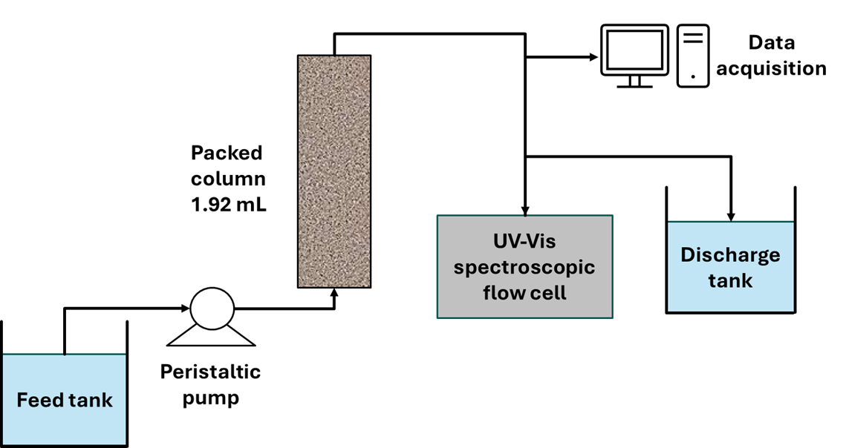B) 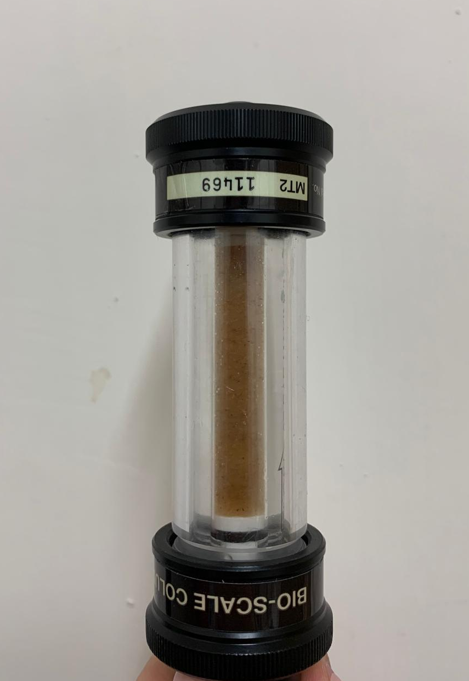
Figure 1: Schematic diagram of the packed-bed system (A) and picture of the packed bed column loaded with Cynara cardunculus biomass (B).
The adsorption and desorption dynamics were assessed by measuring the total protein concentration in the liquid effluent. The procedure is based on the following steps: (i) the biomass was loaded in the adsorption unit and a set volume of protein solution was loaded in a well-mixed buffer tank; (ii) the buffer (0.05M sodium citrate, pH 4.8) started to circulate in the system at the pre-set flow rate (F) and any protein release from biomass was verified by on-line UV absorbance measure on the effluent buffer; (iii) the protein solution was fed to the column; (iv) the UV absorbance of the solution at the exit of the column was measured on-line until a constant value was approached. (v) The desorption started with the feeding of fresh buffer to the column. The time course of the protein concentration in the liquid effluent from the adsorption (iii- iv) and desorption (v) steps was calculated with the reference UV-protein concentration calibration curve.
2.3 Protein concentration analysis
Protein concentration was measured as UV absorbance of the solutions by means of a spectrophotometer (Cary 60, Varian Inc.). The wavelength was set to 280 nm and the absorbance was continuously monitored with a 1 s sampling interval. The calibration was carried out both in a 1 mm and a 10 mm path length quartz flow cell with BSA and Cellic® CTec2 solutions.
2.4 Data analysis
Online measures of UV absorbance were converted into concentration-time courses according to the calibration for both BSA and Cellic® CTec2 tests. Thus, breakthrough curves were obtained for each continuous adsorption test. The overall mass balance on the proteins provided Eq. 2. Data of breakthrough curves were numerically integrated according to Eq. 2 over the time interval of each adsorption test, in order to calculate the concentration of adsorbed proteins E_{b} in the biomass bed equilibrated to the continuously flowing enzyme solution at the concentration C_{EL}. Similarly, the mass of desorbed enzymes was calculated from the concentration time course obtained from step (v) by numerical integration.

$E_{b}=\int_{0}^{t_{final}}{Q\left(C_{E0}-C_{EL}\right)}dt$ (2)
  - Results and discussion
3.1 Preliminary protein adsorption tests in packed bed
Calibrations of UV-absorbance measurements were carried out using both bovine serum albumin (BSA) and Cellic® CTec2 in quartz flow cells with optical path lengths of 1 mm (0.054 Abs_{280 nm}* L/g BSA, 0.346 Abs_{280 nm} * L/g Cellic® CTec2) and 10 mm (0.518 Abs_{280 nm} * L/g BSA). The 1 mm path-length quartz flow cell was selected for the characterization of adsorption and desorption as it allows the use of higher inlet enzyme concentrations (> 1 g/L) and minimizes the mixing volume of the liquid stream out of the column.
Adsorption and desorption tests were performed by packing the column with 230 ± 0.4 mg of biomass, corresponding to a liquid volume of 0.77 ± 0.03 mL for C. cardunculus and 0.81 ± 0.005 mL for A. donax. Considering the liquid volume recovered from the tests, the void fraction results in 0.39 for C. cardunculus and 0.41 for A. donax. These values can be compared with that calculated through the theoretical bed porosity (Eq. 1). To this aim the particle shape and average size was assessed from analysis of optical microscopy images (Figure 2) with ImageJ software. Assuming a cylindrical geometry of biomass particles (Figure 2), the equivalent particle diameter (dₚ_{ₑ}) was determined as the diameter of a sphere having the same volume and resulted 0.21 mm and 0.32 mm for C. cardunculus and A. donax, respectively.
Preliminary adsorption tests were carried out with BSA solutions at initial concentrations of 1.0 g/L and 2.6 g/L, and 1 mL/min flow rate (Figure 3). For C. cardunculus, the amounts of adsorbed BSA were 6.2 mg/g and 13.4 mg/g at initial protein concentrations of 1.0 g/L and 2.6 g/L, respectively. Similar adsorption capacities were observed for A. donax (5.3 mg/g and 13.9 mg/g) under the same operating conditions. The fair reproducibility of the breakthrough curves obtained at the same flow rate for the two tests carried out with each biomass suggests neglecting any effect of the variation of biomass bed porosity. In addition, no relevant variation in the flow rate were detected in the outlet liquid stream along the duration of the tests (1.00±0.01 mL/min). Also, the back pressure consistent with the peristaltic pump (Miniplus Gilson) is higher (500 Pa) than the calculated theoretical pressure drop (4.45 Pa for C. cardunculus and 1.93 Pa for A. donax).
The fraction of desorbed BSA decreased with increasing inlet concentration, from 38% to 23.7% for Cynara cardunculus and from 40.8% to 15.6% for Arundo donax when increasing the initial concentration from 1.0 to 2.6 g/L. This behaviour revealed as expected a non-reversible adsorption of proteins on biomass particle surface. In addition, the desorption extent depended on the adsorbed enzyme loading and thus may suggest an increase in hydrophobic binding (with lignin) as the biomass saturation increases.

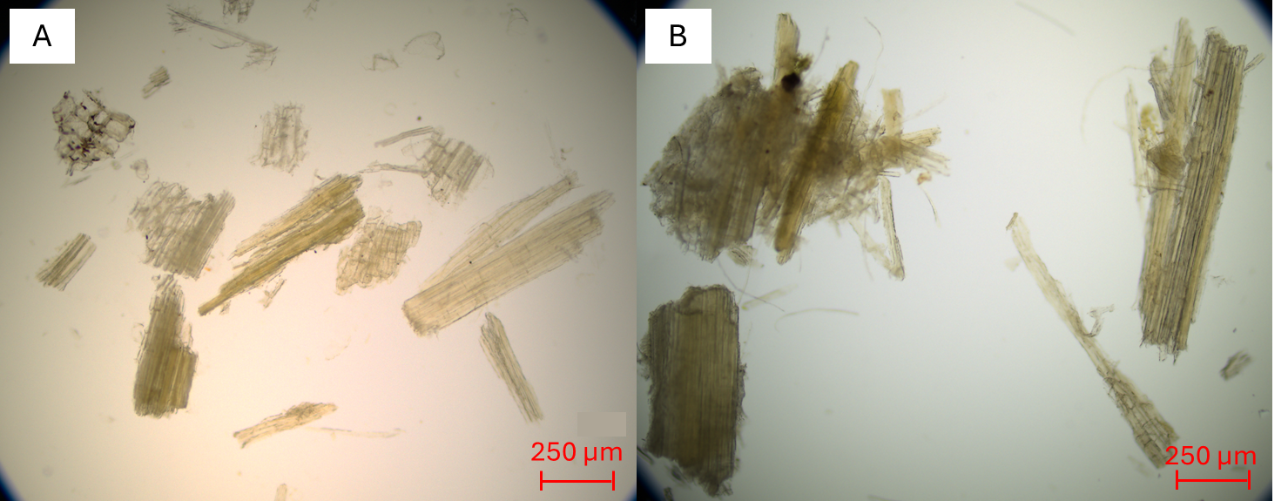
Figure 2: Optical microscopy images (transmitted light, bright field) of alkali-pretreated Cynara cardunculus (A) and Arundo donax (B).
A)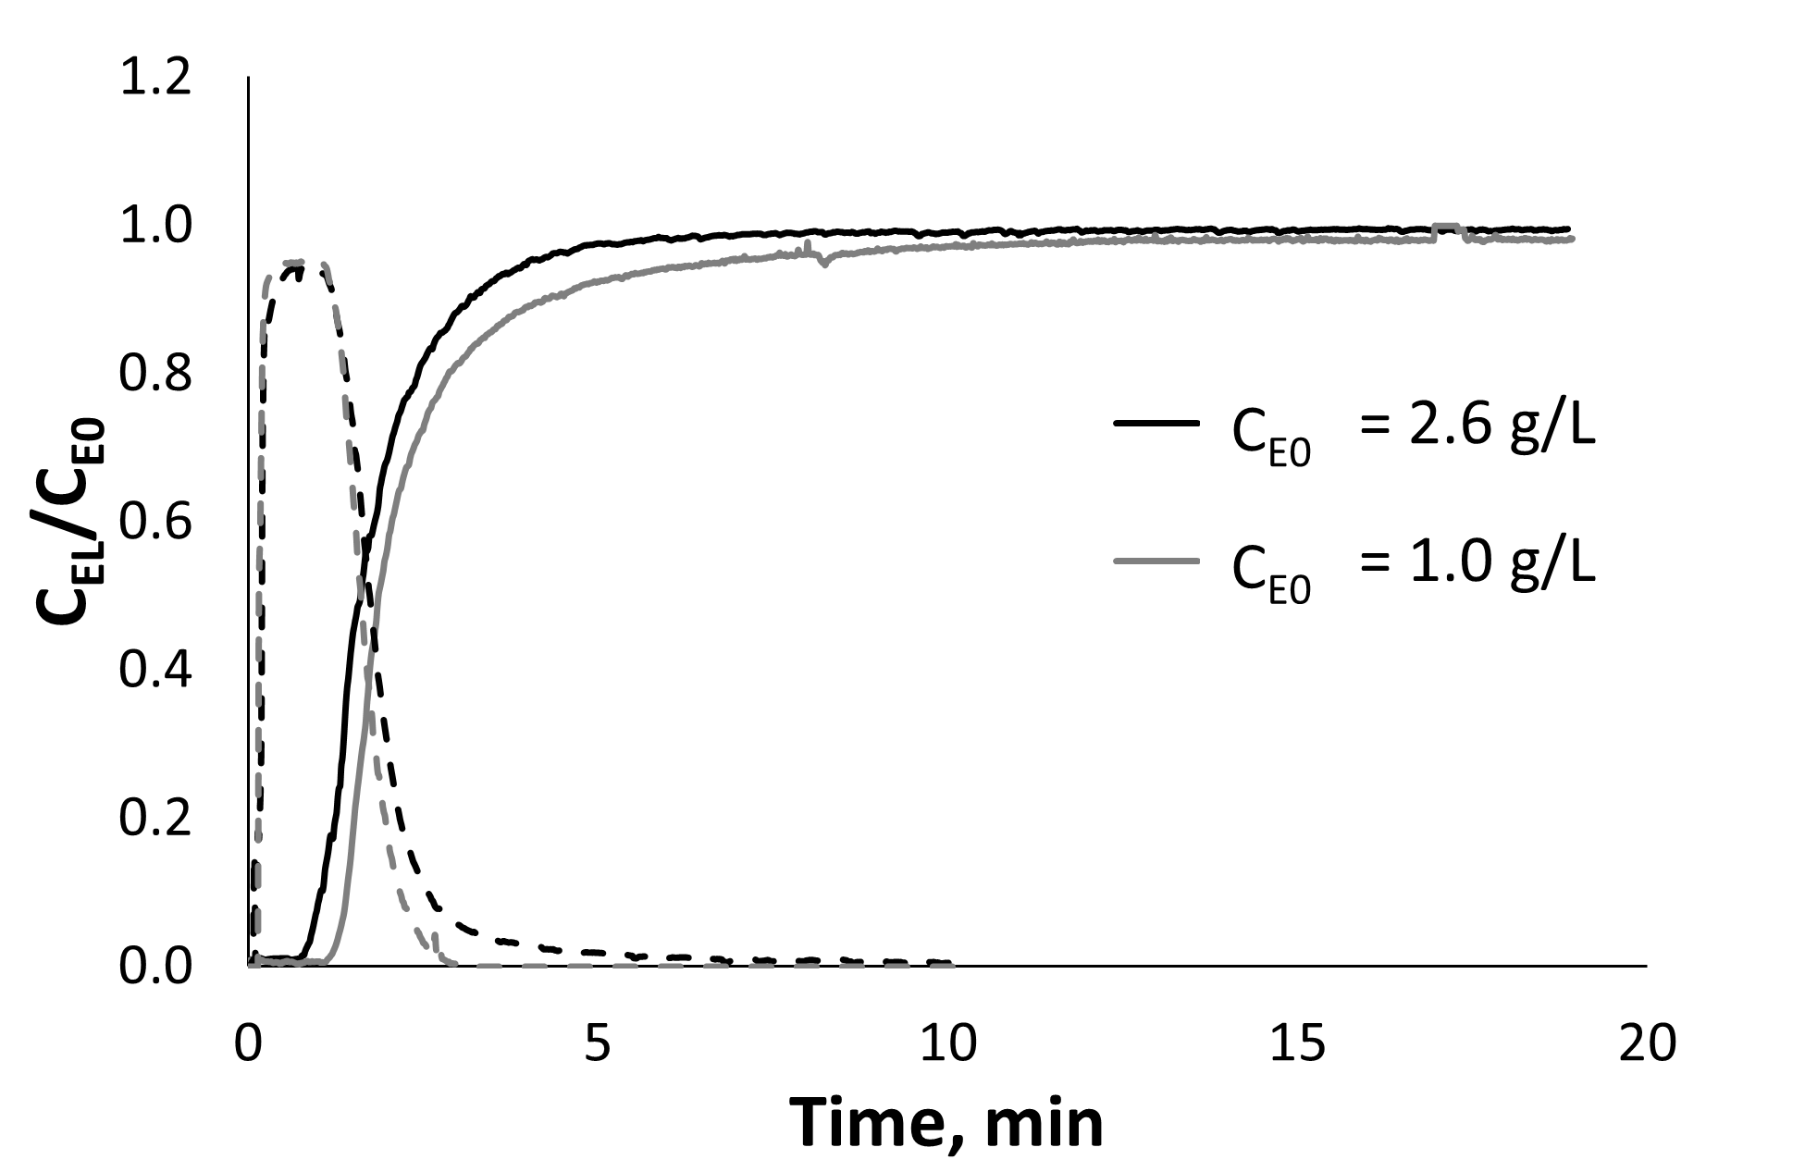B)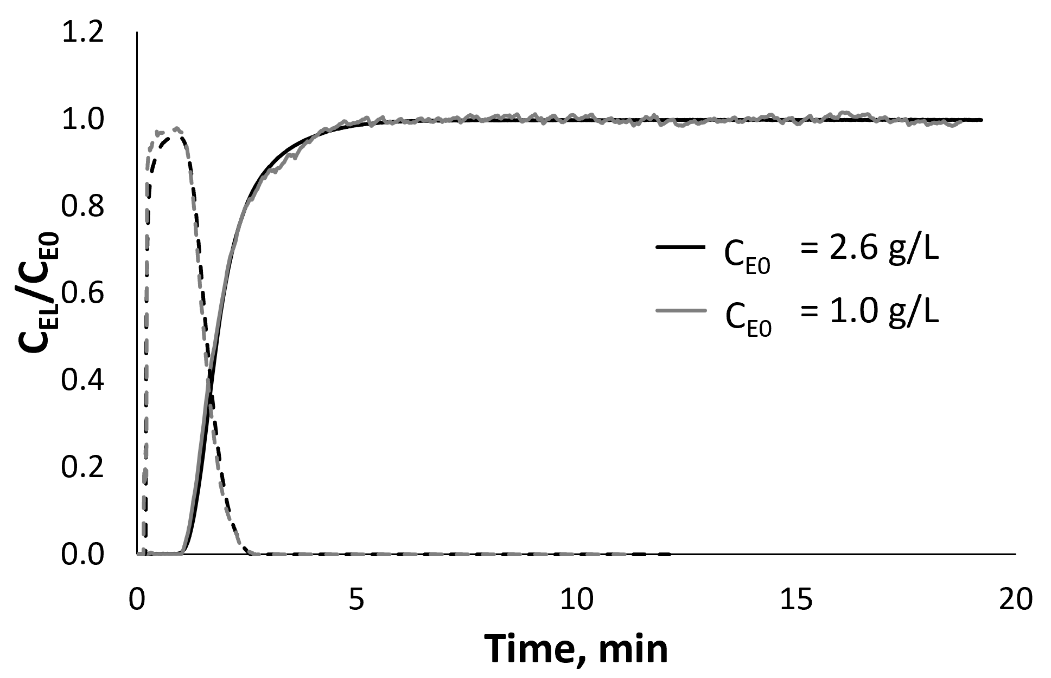
Figure 3: Adsorption (continuous lines) and desorption (dashed lines) of BSA in packed bed of alkali-pretreated Cynara cardunculus (A) and Arundo donax (B).
3.2 Adsorption tests with commercial cellulase cocktails
For the adsorption tests with Cellic® CTec2, the column was packed with 239 ± 6 mg of C. cardunculus biomass and 0.73 ± 0.04 mL of liquid were measured by emptying the biomass bed (0.37 void fraction). Again, this value was consistent with the theoretical estimation of bed porosity (Eq. 2). Some techniques can be applied to improve the reproducibility of biomass bed settling and thus of bed porosity (e.g. biomass pre-conditioning in fluidized bed to remove fines). Despite this opportunity, it is worth to apply the present methodology to biomass samples having a size distribution as close as possible to those used at large scale to retrieve enough robust data (including variability) on the biomass adsorption capacity.
The results of Cellic® CTec2 adsorption (breakthrough curves and desorption curves) are reported in Figure 4. The dynamics of breakthrough curves shows a less conserved behaviour with respect to data in Figure 3. It is worth to note that, even if the conditions (room temperature) are far from the optimal conditions of Cellic® CTec2 (50°C), a partial hydrolysis of biomass may occur along the test (30 min). This may be the reason for variations observed in breakthrough curves that will deserve further adjustment of the method in the future. At 0.5, 1.0, and 2.6 g/L inlet enzyme concentrations 13.1, 18.3, and 27.8 mg/g adsorbed enzyme were assessed, respectively. The desorption was complete for the lowest initial enzyme concentration, while 43% and 23% of adsorbed enzymes were desorbed at 1.0 and 2.6 g/L initial enzyme concentration. Results of Cellic® CTec2 adsorption were compared with previous data obtained with the same commercial cocktail in a batch mixed system at 5% w/v of C. cardunculus (Posilipo et al., 2025) (Table 1). The maximum adsorption capacity reached in the packed bed device was higher than the maximum adsorption capacity obtained in 5% w/v batch tests. The differences observed between packed-bed and batch experiments suggested a strong influence of hydrodynamic conditions and mass transfer rate on adsorption capacity.
In batch tests with mixed (e.g. by orbital shaking) biomass slurry (5-10%w/v), the transport of enzymes from the bulk liquid to the external surface of the biomass particles depends on the slip velocity between particles and the liquid. Particles aggregation can negatively affect the distribution of the enzymes to the biomass surface. In the biomass packed bed, the convective mass transport is improved by the liquid velocity across the bed voids thus a deeper access to biomass surface may occur. This is a relevant aspect that should be considered to set lab scale procedures as little dependent as possible on the type of mixing applied to the slurry.
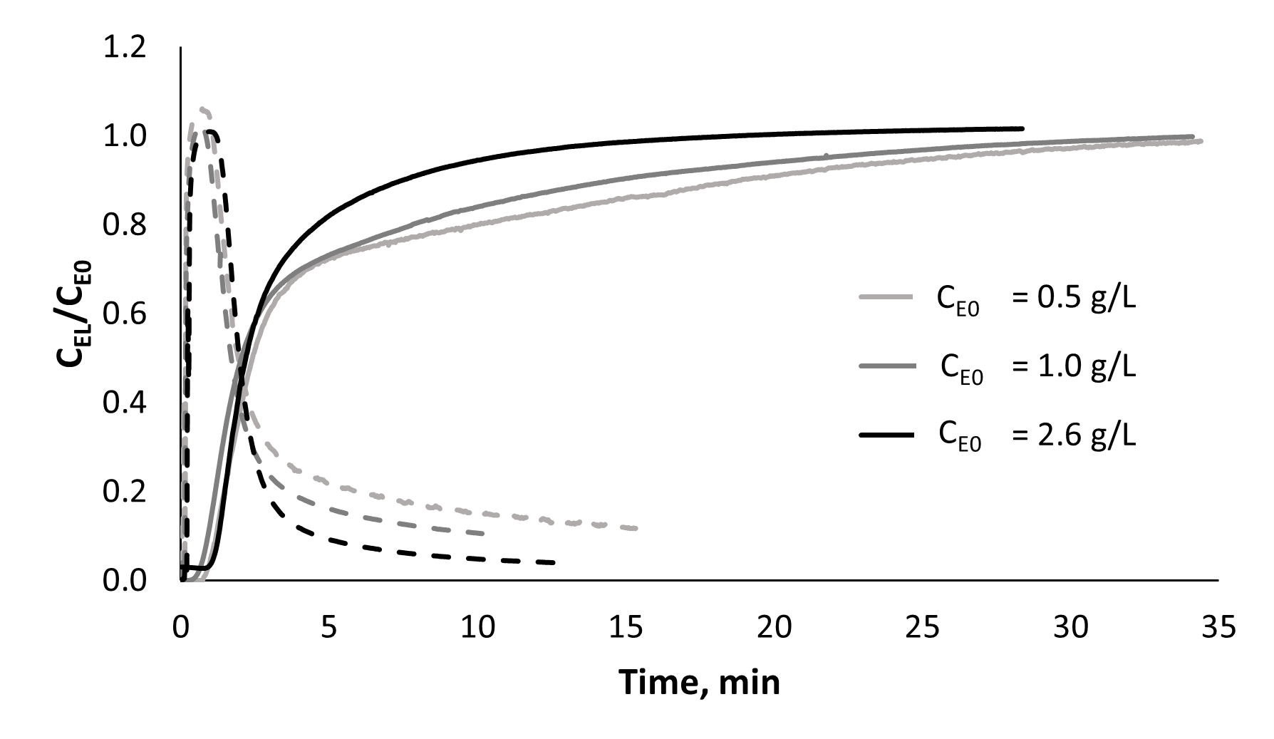
Figure 4: Adsorption (continuous lines) and desorption (dashed lines) of Cellic® CTec2 at different inlet concentrations of total cellulases in packed bed of pretreated Cynara cardunculus.
Table 1: Total cellulase adsorption on pretreated Cynara cardunculus biomass. *Single runs from data in Figure 4, standard error can be assessed for the initial enzyme concentration C_{E0} only (dilution of Cellic® CTec2 stock and total protein assay gave standard error below 5%).
This work* |  | Posilipo et al., 2025
C_{EL}, g/L | E_{b}, mg/g | C_{EL}, g/L | E_{b}, mg/g
0.50 | 12.1 | 0.50 ± 0.02 | 7.60 ± 0.40
1.02 | 18.1 | 0.78 ± 0.11 | 8.25 ± 0.25
2.58 | 27.2 | 1.50 ± 0.11 | 17.00 ± 1.00
  - Conclusions
The developed method for the characterization of adsorption and desorption of cellulases that occur in biomass hydrolysis is based on a continuously operated packed-bed device. The system allows the on-line monitoring of protein concentration at the column outlet, and can be operated using reference proteins (e.g., commercial cocktails) as well as single enzymes to investigate their adsorption on lignocellulosic biomass.
The results demonstrate that the maximum adsorption capacities of pretreated Cynara cardunculus biomass are larger than the adsorption capacity assessed with mixed batch systems. So, the improved liquid velocity in the packed-bed configuration can overcome limitations associated with batch tests in mixed high-solids slurries where convective mass transfer is limited by biomass-liquid slip velocity and biomass aggregates may reduce the access of enzymes to the biomass surface. Overall, the proposed method deserves to be extended and adapted to several biomass and enzymes mixtures to investigate the interaction of multicomponent enzyme solutions with complex solid substrates and to retrieve quantitative data for the design and optimization of biocatalytic hydrolysis units. Morphological analysis of biomass can support the detailed modelling of the packed bed behavior under continuous flow. These findings are relevant to applications in biorefinery processes, textile waste degradation, and fiber modification, as well as the biocatalytic depolymerization of plastic waste.

Acknowledgments
Part of the study is funded in the framework of the Italian National Recovery and Resilience Plan (NRRP), Mission 4 Component 2 Investment 1.3 - Call for tender No. 1561 of 11.10.2022 of Ministero dell’Università e della Ricerca (MUR) funded by the European Union – NextGeneration EU; Project code PE0000021, Concession Decree No. 1561 of 11.10.2022 adopted by Ministero dell’Università e della Ricerca (MUR), Project title “Network 4 Energy Sustainable Transition – NEST”.
References
Brondi M.G., Vasconcellos V.M., Giordano R.C., Farinas C.S., 2019, Alternative Low-Cost Additives to Improve the Saccharification of Lignocellulosic Biomass, Applied Biochemistry and Biotechnology, 187, 461–473.
Chakraborty S., Paul S.K., 2020, Interaction of reactions and transport in lignocellulosic biofuel production, Current Opinion in Chemical Engineering, 29, 104-121.
Dixon A.G., 1988, Correlations for wall and particle shape effects on fixed bed bulk voidage, The Canadian Journal of Chemical Engineering, 66, 705-708.
Hu J., Mok Y.K., Saddler J.N., 2018, Can We Reduce the Cellulase Enzyme Loading Required to Achieve Efficient Lignocellulose Deconstruction by only Using the Initially Absorbed Enzymes? ACS Sustainable Chemistry & Engineering, 6, 6233–6239.
Luterbacher J.S., Parlange J.-Y., Walker L.P., 2013, A Pore-Hindered Diffusion and Reaction Model Can Help Explain the Importance of Pore Size Distribution in Enzymatic Hydrolysis of Biomass, Biotechnology and Bioengineering, 110, 127–136.
Pei X-D, Jiao D-Q, Li F, Fang Y-H, Zhou Z-Q, Liu X-L, Wang C-H, 2025, Targeted Adherence and Enhanced Degradation of Feather Keratins by a Novel Prepeptidase C‑Terminal Domain-Fused Keratinase, Journal of Agricultural and Food Chemistry, 73, 1182−1192
Petrášek Z., Nidetzky B., 2025, The effect of accessibility of insoluble substrate on the overall kinetics of enzymatic degradation, Biotechnology and Bioengineering, 122, 4, 895-907.
Pirillo V., Pollegioni L., Molla G., Analytical methods for the investigation of enzyme-catalyzed degradation of polyethylene terephthalate, 2021, The FEBS Journal 288, 4730–4745
Posilipo A., Russo M.E., Marzocchella A., 2024, Characterization of Laccase Adsorption on Lignocellulosic Biomasses, Chemical Engineering Transactions, 210, 271-276.
Posilipo A., Russo M.E., Salatino P., Marzocchella A., 2025, Optimal dosage and recycle of cellulases for efficient biomass saccharification of cardoon and giant reed, Biochemical Engineering Journal, 219, 109735.
Reis C.E.R., Libardi Junior N., Bento H.B.S., de Carvalho A.K.F. de, Vandenberghe L.P. de S., Soccol C.R., Aminabhavi T.M., Chandel A.K., 2023, Process strategies to reduce cellulase enzyme loading for renewable sugar production in biorefineries, Chemical Engineering Journal, 451, 138690.
Robak K., Balcerek M., 2020, Current state-of-the-art in ethanol production from lignocellulosic feedstocks, Microbiological research, 240, 126534.
Roy Choudhury S., Das A., Chakraborty R., 2024, Review on progress in cellulase catalyzed saccharification of agricultural lignocellulosic biomass towards fermentable sugar and bioethanol: Kinetics & reactor configurations, Biocatalysis and Agricultural Biotechnology, 58, 103142.
Russo M.E., Procentese A., Montagnaro F., Marzocchella A., 2022, Effect of enzymes adsorption on enzymatic hydrolysis of coffee silverskin: Kinetic characterization and validation, Biochemical Engineering Journal, 180, 108364.
Thangavelu K., Desikan R., Taran O.P., Uthandi S., 2018, Delignification of corncob via combined hydrodynamic cavitation and enzymatic pretreatment: process optimization by response surface methodology, Biotechnology for Biofuels, 11, 203.

