 CHEMICAL ENGINEERING TRANSACTIONS  VOL. xxx, 2026 | A publication of  
The Italian Association
of Chemical Engineering
Online at www.cetjournal.it

Guest Editors: Marco Bravi, Antonio Marzocchella, Giuseppe Caputo
Copyright © 2026, AIDIC Servizi S.r.l.
ISBN 979-12-81206-xx-x; ISSN 2283-9216

Biological Sulphate Removal from Tannery Wastewater using Mixed Microbial Culture in a Sequencing Batch Reactor
Sara Danieli^{a,}*, Marco Gottardoª, Matteo Macilotti^{b}, Davide Beltrame^{c}, Umberto Rizzato^{c}, Marco Nogarole^{d}, Francesco Valentinoª
ªDepartment of Environmental Science, Informatics and Statistics, Ca’ Foscari University of Venice, Via Torino 155, 30172 Mestre-Venice, IT
^{b}Distretto Veneto della Pelle, Via del Lavoro 22, 36071 Arzignano (Vicenza), IT
^{c}Acque del Chiampo S.p.A., Via Ferretta 20, 36071 Arzignano (Vicenza), IT
^{d}Stazione Sperimentale per l’Industria delle Pelli e Materiali Concianti (SSIP) – Italian Leather Research Institute (SSIP), Via del Lavoro 22, 36071 Arzignano (Vicenza), IT
sara.danieli@unive.it
Industrial wastewater, particularly form tanneries, often contains high sulphate and metal concentrations that represents environmental and health risks and are costly to treat with conventional methods. In this context, biological processes employing sulphate-reducing bacteria (SRB) offer a promising and sustainable alternative, as SRB reduce sulphate (SO₄²⁻) to sulphide (S²⁻) under anaerobic conditions. In this study, unsterile mixed microbial consortium was employed to treat sulphate-rich tannery wastewater in a 4.5 L anaerobic Sequencing Batch Reactor (SBR), fed with ethanol or molasses as electron donors. Up to 71% sulphate removal was achieved when ethanol combined with molasses were used at neutral pH, a temperature of 30° C, a COD/SO₄²⁻ ratio (g/g) of 0.52 and an F/M ratio (g COD/g VSS) of 0.47. Both substrates sustained SRB activity with different sulphate-reduction behaviors. Overall, the results demonstrate the feasibility of SBR with mixed biomass as a cost-effective strategy for sulphate removal, particularly when combined with low-cost electron donors such as molasses, promoting process intensification and supporting the scalability for industrial wastewater treatment.
  - Introduction
The escalation of global economic and population growth has significantly augmented industrial activities, leading to the generation of substantial volumes of industrial wastewater. Industries such as pulp and paper manufacturing, leather processing, mineral production and petrochemical production, discharge wastewater rich in sulphate (SO₄²⁻) (Zhang et al., 2022). Among these industrial sectors, the tannery industry is a prominent contributor to environmental pollution, producing large volumes of highly variable and recalcitrant wastewater. Leather processing necessitates the extensive use of sulphate salts, chromium, chlorides, and various organic tanning agents, leading to wastewater characterized by high chemical oxygen demand (COD), high salinity, and the presence of sulphates and metals, especially from the beamhouse, tanning and post-tanning operations (Andriamanohiarisoamanana et al., 2024; Mahesh et al., 2018).
The complex and recalcitrant nature of tannery effluents presents significant challenges for conventional physicochemical treatment methods, which are often costly, generate secondary sludge and struggle to comply with increasingly strict discharge limits (Virpiranta et al., 2021). Sulphate concentrations in tannery wastewater can exceed 10,000 mg/L, far above regulatory thresholds (250-1000 mg/L) (Costa et al., 2020), creating a need for sustainable and cost-effective removal technologies that also support water reuse. In this context, biological treatment approaches have been proposed as promising options for contaminant removal, providing a long-term solution to the negative environmental consequences of industrial activity (Chandran et al., 2023).
Sulphate-reducing bacteria (SRB) represent an eco-efficient treatment solution for sulphur recovery and wastewater treatment, enabling sulphate reduction and simultaneous heavy metal precipitation as insoluble sulphides, with lower operating costs and good scalability compared to conventional methods (Wang et al., 2023; Virpiranta et al., 2021). Although primarily strict anaerobes, some SRB genera like Desulfobulbus, Desulfotomaculum, and Desulfovibrio can operate under microaerobic conditions (Novair et al., 2024), and utilize various organic and inorganic electron donors, including lactate, acetate, ethanol, or hydrogen. Their performance depends on operational parameters, such as pH, temperature, the chemical oxygen demand to sulphate ratio (COD/SO₄²⁻), electron donor type, hydraulic retention time (HRT), and microbial interactions (Zhang et al., 2022). While conventional carbon sources like lactate are effective for biological sulphate reduction, their cost-effectiveness is a limiting factor. Among the potential organic electron donors, ethanol and molasses represents attractive alternatives due to their availability, biodegradability, and cost-effectiveness (Costa et al., 2020; Novair et al., 2024).
To address these challenges, preliminary batch experiments were conducted to assess sulphate reduction using different electron donors, followed by a Sequencing Batch Reactor (SBR) inoculated with enriched mixed SRB biomass. This study evaluates sulphate removal from tannery wastewater and identifies optimal operating conditions using ethanol or molasses, demonstrating the feasibility of SBR systems as a sustainable and scalable solution for high-sulphate industrial effluents.
  - Materials and Methods
2.1 Inoculum Source and Enrichment of Sulphate-Reducing Bacteria

The inoculum was collected from the anoxic stage of the tannery wastewater treatment plant (WWTP) located in Arzignano (Northern Italy). The WWTP treats approximately 30,000 m³/d of tannery industrial effluents generated by leather-processing activities. Sulphate-reducing bacteria were enriched using a synthetic culture medium composed of sulphate salts (e.g., MgSO₄, FeSO₄, Na2SO4), ammonium and phosphorus salts, NaCl, yeast extract, and ethanol as the carbon source and electron donor. This medium was used for the enrichment batch tests.
    - Sequencing batch reactor (SBR) configuration and operation
The wastewater used for the SBR tests was collected from the tannery WWTP located in Arzignano. This stream, specifically selected as the feed for the continuous SBR experiments, corresponds to the effluent obtained after primary treatment and conventional biological treatment aimed at the removal of COD, nitrogen, suspended solids, and chromium. For the purposes of the SBR operation, the sulphate concentration of the feed was further increased through the addition of sulphate salts, and ammonium was supplemented to ensure adequate nitrogen availability.
The SBR consisted of a jacketed reactor with a working volume of 4 L. The reactor was operated with anaerobic conditions and maintained at a constant temperature of 30 ± 1 °C. The pH (7.0) was continuously monitored and controlled by software developed by Idea Bioprocess Technology Srls.
Each operational cycle lasted 24 h and consisted of the following phase: feeding, reaction under continuous stirring, and effluent withdrawal. All phases were manually controlled. At the beginning of each cycle, a predefined feed volume of 3.0 L was pumped into the reactor, at the end of the reaction phase, the treated wastewater was withdrawn from the system, maintaining a hydraulic retention time (HRT) of 1.5 days. The SBR was operated for 90 days and divided into three experimental periods characterized by a different electron-donor use, Table 1 summaries the conditions applied for each period.
Table 1: Summary of the average parameters in the influent and operating conditions applied in the SBR.
Variables | Ethanol | Ethanol & Molasses | Molasses
Cycle numbers | 30 | 30 | 30
SO₄²⁻ (mg/L) | 1791 | 3014 | 2611
F/M (g COD/g VSS) | 0.30±0.01 | 0.47±0.02 | 0.45±0.02
COD/SO₄²⁻ (g/g) | 0.51±0.02 | 0.52±0.02 | 0.61±0.03
HRT (d) | 1.5 | 1.5 | 1.5
SRT (d) | 80 | 80 | 80
%COD of Ethanol | 100 | 58 | 0
%COD of Molasses | 0 | 42 | 100

    - Analytical methods and calculation
The monitoring of the cycles was carried out through chemical analysis of the influent and effluent samples. Alcohols (ethanol) and volatile fatty acids (VFAs), including acetic acid, were quantified by gas chromatography using Agilent 8890 GC system equipped with a flame ionization detector (FID). Hydrogen was used as the carrier gas (HyGen 200, Claind, hydrogen generator), and an Agilent J&W DB-WAX Ultra Inert column (30 m length, 0.53 mm ID, 1.0 μm film thickness) served as the stationary phase. The samples were prepared with 1 mL of the filtered solution, 100 μL of phosphoric acid and 100 μL of internal standard (2 -etilbutyrric acid). Sulphate concentrations were determined using a sulphate test kit (HI38000 Hanna Instrument) after the filtration of the samples (0.22 μm), in combination with a UV/Vis spectrophotometer (Jasco V-730). The method is based on the formation of barium sulphate turbidity, which was measured photometrically at 466 nm.
The sulphate removal efficiency was calculated as the percentage ratio between the decrease in sulphate concentration and its initial value, according to the equation:

$$Removal \left(\%\right)=\frac{{\left[{SO}_{4}^{2-}\right]}_{0}-{\left[{SO}_{4}^{2-}\right]}_{t}}{{\left[{SO}_{4}^{2-}\right]}_{0}}∙100$$

where [SO₄²⁻] ₀ and [SO₄²⁻]ₜ denote the sulphate concentrations at the start of the test and at time t, respectively.
  - Results
    - Test-batch results with Synthetic Substrate
A preliminary set of batch tests was carried out using mixed biomass enriched in sulphate-reducing bacteria (SRB) and a growth medium comparable to that used during the enrichment phase, differing solely in the type of carbon substrate supplied (acetic acid, ethanol, or methanol). Figure 1 presents the results of these assays, which were conducted to identify the most effective electron donor for the selected inoculum.
Over the 8-day operational period, the three experimental conditions exhibited different behaviors in both sulphate consumption and electron-donor dynamics. The ethanol-fed test showed the fastest and most substantial decline in sulphate concentration, achieving a 52.2% reduction, in agreement with previous studies identifying ethanol as a highly efficient and readily metabolizable electron donor for sulphate-reducing communities (Bomberg et al., 2017). During the first three days, ethanol consumption was accompanied by a progressive increase in acetic acid, a trend consistent with mixed-culture pathways and with incomplete oxidation observed during sulphate reduction.
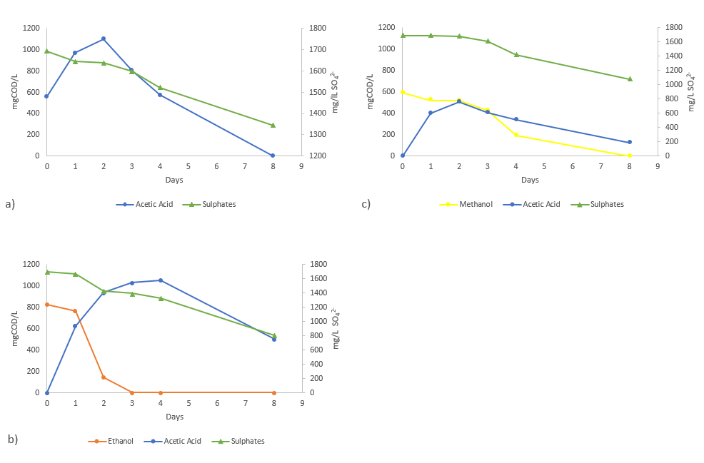
Figure 1: Trends of sulphates reduction using acetic acid (a), ethanol (b) and methanol (c) as electron-donors.

This interpretation aligns with the modelling study of Nagpal and colleagues, who demonstrated that mixed sulphate-reducing consortia containing Desulfovibrio desulfuricans can oxidize ethanol while producing acetate in stoichiometric proportions (Nagpal et al., 2000). However, the superior performance observed using ethanol as electron donor should not be ascribed exclusively to its biochemical stability (Bomberg et al., 2017); factors such as community structure or biomass adaptation may also have shaped the outcomes. In the methanol test, substrate oxidation was coupled with acetic acid formation (503 mg COD/L), while sulphate reduction remained limited (36.4%). This suggests that methanol oxidizing pathways may have been more competitive than sulfidogenic ones, rather than methanol being intrinsically inefficient as an electron donor. The acetic-acid assay exhibited the lowest performance (20.7% removal), possibly associated with the substantial increase in organic load caused by the initial accumulation of acetic acid, which reached a peak of 1101 mg COD/L. The resulting rise in the COD/SO₄²⁻ ratio may have reduced the thermodynamic advantage for sulphate reduction, favoring alternative metabolic routes, as previously reported for similar systems (Ozuolmez et al., 2015).
3.2 Test on different ethanol concentrations
Given the superior performance of ethanol as an electron donor in the preliminary tests, additional batch assays were conducted to assess the influence of ethanol concentration on sulfidogenic kinetics in view of subsequent SBR study. Among the tested concentrations (Fig. 2), the test with the highest dosage (1.5 ml/L) yielded the most pronounced sulphate removal (73.7%), with ethanol consumption mirroring the decline in sulphate, suggesting coupling between electron donor oxidation and sulfidogenesis (Bomberg et al., 2017). However, sulphate reduction at this concentration only became evident after the third day, whereas at the lower ethanol addictions (0.5 and 1.0 ml/L) the reduction was detectable from day 2, reaching 57.3% and 63.7% of removal respectively. This delayed response with the higher ethanol concentration may reflect a physiological adaptation or a metabolic stress within the microbial consortium. Although no direct microbiological analyses were performed to verify these mechanisms, literature evidence indicates that ethanol concentrations can influence oxidation kinetics and electron donor distribution among competing pathways (Kaksonen et al., 2003). Overall, ethanol concentration appeared to affect both the extent and kinetics of sulphate reduction under the tested conditions, which is a key parameter for the subsequent design and operation of the SBR process.
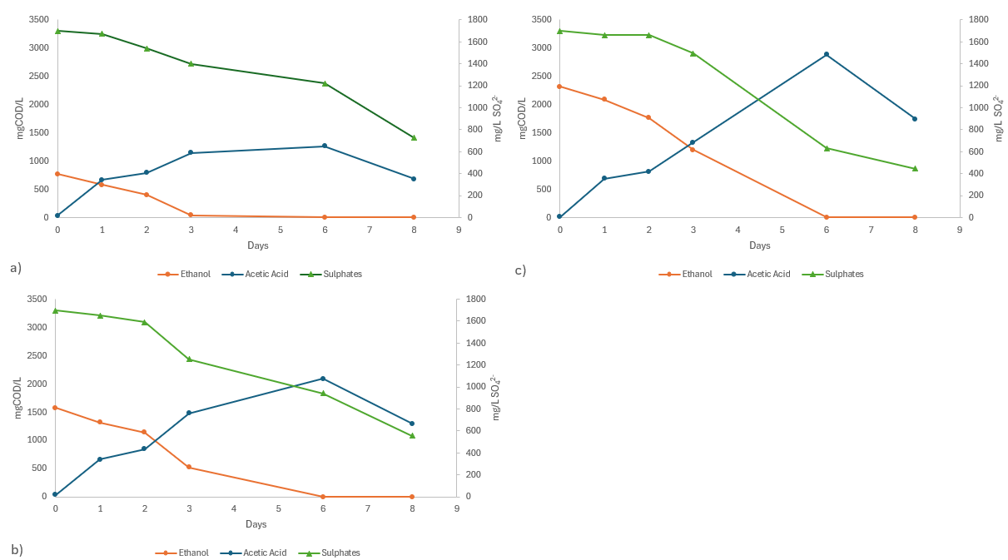Figure 2: Trends of sulphates reduction adding different ethanol concentration: 0.5 ml/L (a), 1.0 ml/L (b), and 1.5 ml/L (c).
    - SBR test with biologically treated Tannery Wastewater
After inoculation with SRB-enriched biomass, the SBR was operated for 90 days under sulphate-reducing conditions structured into three distinct operational phases (Table 1). Each period was conducted under a different electron-donor regime: (i) ethanol (Run I), (ii) a combination of ethanol and molasses (Run II), and (iii) molasses (Run III). The corresponding organic loading, expressed as F/M ratio, ranged between 0.30 and 0.47 g COD/g VSS across the three runs and the biomass detected in each period was 3.02±0.1, 3.39±0.2, 3.56±0.2 g VSS/L respectively. Sulphate-reduction efficiency was assessed over daily operational cycles by comparing sulphate concentrations at feeding (t₀) and after 24 h of reaction (t₁), as summarized in Figure 3.
The Run I exhibited the lowest performance, with an average sulphate-removal efficiency of 34%. Influent sulphate concentrations averaged around 1790 mgSO₄²⁻/L, decreasing to approximately 1180 mgSO₄²⁻/L after 24 h. Although ethanol was fully consumed in each cycle, the limited reduction (611 mgSO₄²⁻/L) and the accumulation of acetate suggested that part of the electron flow was diverted toward non-sulfidogenic pathways, likely due to the rapid depletion of the readily biodegradable substrate and competition with other anaerobic microorganisms (Bomberg et al., 2017).
In contrast, the use of molasses as the sole electron donor (Run III) resulted in a moderately improved average sulphate removal of 42%. Initial sulphate concentrations (2611 mgSO₄²⁻/L) dropped to nearly 1515 mgSO₄²⁻/L in 24 h, corresponding to 1096.2 mgSO₄²⁻/L of reduction. The improved performance compared to ethanol alone may be attributed to the complex composition of the substrate, which likely ensured a more sustained release of biodegradable carbon through the cycle.
Notably, the highest performance was observed in Run II (ethanol and molasses combined), with 71% removal (3014 mgSO₄²⁻/L to 875 mgSO₄²⁻/L). This superior behavior may be associated with complementary substrate utilization, where ethanol provided a readily available substrate while molasses acted as a slower and more sustained carbon source, potentially supporting SRB activity throughout the cycle.
It should be noted that the COD/SO₄²⁻ ratio, which determines electron donor availability for sulphate-reducing bacteria, was intentionally maintained within a narrow range throughout the three operational runs. Considering that the theoretical COD/SO₄²⁻ ratio required for complete sulphate reduction is approximately 0.67 g/g (when expressed as SO₄²⁻), the applied values (0.51–0.61 g/g) indicate operation under near-stoichiometric and slightly donor-limited conditions. The slight variations observed were not the result of deliberate changes in organic loading conditions, but rather reflected differences in the intrinsic COD contribution of the selected feedstocks (ethanol and molasses). Therefore, the reactors were operated under comparable stoichiometric regimes, allowing performance differences to be primarily attributed to the nature, complexity and biodegradation kinetics of the electron donors, rather than to significant shifts in COD/SO₄²⁻ balance.

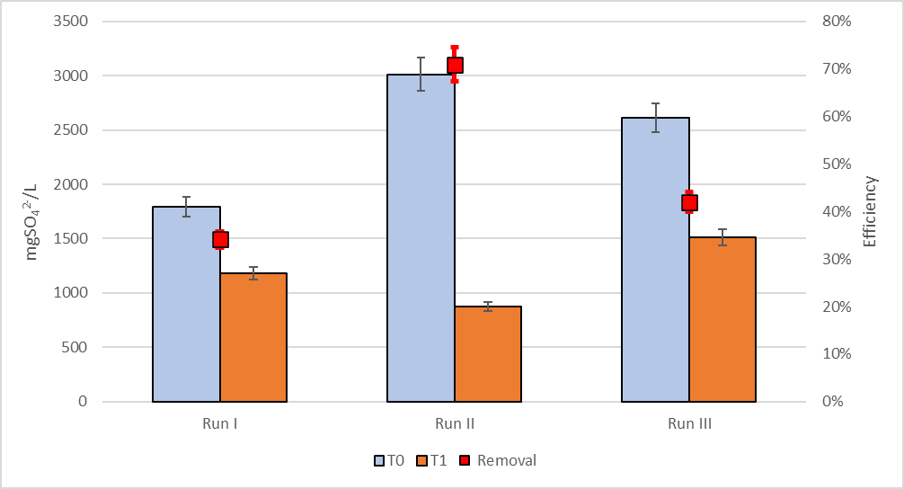
Figure 3: Overview of the SBR process performance during Run I (ethanol), Run II (ethanol and molasses) and Run III (molasses).
  - Conclusions
This study investigated sulphate removal from tannery wastewater using a mixed microbial culture enriched in SRB and operated in an SBR. The combined addiction of molasses and ethanol as electron donors proved to be the most effective solution, achieving a sulphate removal of 2139.8 mg SO₄²⁻/L within 24 hours, corresponding, with the operational conditions used, to a removal efficiency of 71%.
These findings demonstrate the feasibility of biological sulphate removal in SBR systems treating tannery wastewater using low-cost substrates such as molasses. Although the experiments were performed under controlled laboratory conditions, the results provide valuable insights into the influence of electron-donor composition and substrate availability on sulfidogenic performance. Future research should investigate microbial community structure and evaluate shorter HRT and continuous systems to further assess long-term process stability and industrial scalability.
Acknowledgments
The authors gratefully acknowledge the “REWASTER - Trattamenti circolari innovativi degli scarti del processo conciario” project for financial support of this research, in the frame of the Call PR Veneto FESR 2021-2027. Azione 1.1.1 Sub A DGR n. 729/2024. This work was supported by the DoE 2023-2027 (MUR, AIS.DIP.ECCELLENZA2023_27.FF project). This study was also carried out within the "Interconnected Nord-Est Innovation Ecosystem (iNEST)" project and received funding from the European Union Next- GenerationEU - National Recovery and Resilience Plan (NRRP) – MISSION 4 COMPONENT 2, INVESTIMENT N. ECS00000043 – CUP N. H43C22000540006. This manuscript reflects only the authors’ views and opinions, neither the European Union nor the European Commission can be considered responsible for them.
References
Andriamanohiarisoamanana, F. J., Farghali, M., Mohamed, I. M. A., Yoshida, G., Shiota, K., & Ihara, I. (2024). Impact of tannery wastes on anaerobic co-digestion: enhancing biogas production and process efficiency. Collagen and Leather, 6(1).
Bomberg, M., Mäkinen, J., Salo, M., & Arnold, M. (2017). Microbial community structure and functions in Ethanol-Fed sulfate removal bioreactors for treatment of mine water. Microorganisms, 5(3), 61.
Chandran, P., Suresh, S., Balasubramain, B., Gangwar, J., Raj, A. S., Aarathy, U. L., Meyyazhagan, A., Pappuswamy, M., & Sebastian, J. K. (2023). Biological treatment solutions using bioreactors for environmental contaminants from industrial waste water. Journal of Umm Al-Qura University for Applied Sciences, 11(2), 185–207.
Costa, J. M., De Castro, K. C., Rodriguez, R. P., & Sancinetti, G. P. (2020). Anaerobic reactors for the treatment of sulphate and metal-rich wastewater: a review. International Journal of Environmental & Analytical Chemistry, 102(4), 923–934.
Kaksonen, A. H., Franzmann, P. D., & Puhakka, J. A. (2003). Performance and ethanol oxidation kinetics of a Sulfate-Reducing Fluidized-Bed reactor treating acidic Metal-Containing wastewater. Biodegradation, 14(3), 207–217.
Mahesh, M., Arivizhivendhan, K. V., Nivetha, K., Swarnalatha, S., & Sekaran, G. (2018). Anaerobic digestion of sulphate-rich post-tanning wastewater at different COD/sulphate and F/M ratios. 3 Biotech, 8(2), 130.
Nagpal, S., Chuichulcherm, S., Livingston, A., & Peeva, L. (2000). Ethanol utilization by sulfate-reducing bacteria: An experimental and modeling study. Biotechnology and Bioengineering, 70(5), 533–543.
Novair, S. B., Atigh, Z. B. Q., Lajayer, B. A., Shu, W., & Price, G. (2024). The role of sulphate-reducing bacteria (SRB) in bioremediation of sulphate-rich wastewater: Focus on the source of electron donors. Process Safety and Environmental Protection, 184, 190–207.
Ozuolmez, D., Na, H., Lever, M. A., Kjeldsen, K. U., JÃ¸Rgensen, B. B., & Plugge, C. M. (2015). Methanogenic archaea and sulfate reducing bacteria co-cultured on acetate: teamwork or coexistence? Frontiers in Microbiology, 6, 492.
Virpiranta, H., Sotaniemi, V., Leiviskä, T., Taskila, S., Rämö, J., Johnson, D. B., & Tanskanen, J. (2021). Continuous removal of sulfate and metals from acidic mining-impacted waters at low temperature using a sulfate-reducing bacterial consortium. Chemical Engineering Journal, 427, 132050.
Wang, H., Zhang, M., Dong, P., Xue, J., & Liu, L. (2023). Bioremediation of acid mine drainage using sulfate-reducing wetland bioreactor: Filling substrates influence, sulfide oxidation and microbial community. Chemosphere, 349, 140789.
Zhang, Z., Zhang, C., Yang, Y., Zhang, Z., Tang, Y., Su, P., & Lin, Z. (2022). A review of sulfate-reducing bacteria: Metabolism, influencing factors and application in wastewater treatment. Journal of Cleaner Production, 376, 134109.

