 CHEMICAL ENGINEERING TRANSACTIONS  VOL. xxx, 2026 | A publication of  
The Italian Association
of Chemical Engineering
Online at www.cetjournal.it

Guest Editors: Marco Bravi, Antonio Marzocchella, Giuseppe Caputo
Copyright © 2026, AIDIC Servizi S.r.l.
ISBN 979-12-81206-xx-x; ISSN 2283-9216

Development of a rapid UV spectroscopic method for determining the enzyme activity in catechol carboxylation
M. Di Giacomoª, R. Fernández Lafuente^{b}, P. Abellanas-Perez^{b}, C. K. Winkler^{c}, P. Salatinoª, M.E. Russo^{a*}, A. Marzocchellaª
ªDipartimento di Ingegneria Chimica, dei Materiali e della Produzione Industriale - Università degli Studi di Napoli Federico II, P.le V. Tecchio 80, 80125 Napoli, Italy
^{b} Instituto de Catálisis y Petrolquímica, Consejo Superior de Investigaciones Cientíﬁcas, Cantoblanco, 28049 Madrid, Spain
^{c} Department of Chemistry, University of Graz, Heinrichstrasse 28, 8010 Graz, Austria
merusso@unina.it
Biocatalytic fixation of CO₂ into carboxylic acids offers a sustainable route to carbon capture and utilization. Microbial cofactor-free non-oxidative decarboxylases catalyze the reversible ortho-carboxylation of phenolic substrates under mild conditions in the presence of adequate concentrations of bicarbonate ions. The development of industrial biocatalysts based on immobilized DHDBs asks for a rapid method for the screening of immobilization techniques and optimization of carboxylation operating conditions. UV spectroscopy methods applied to DHDBs activity assay are scarce and not standardized, differing in solvent composition, wavelengths, and data analysis, while HPLC methods are more popular, as they are useful for substrate screening over a variety of phenols. The present contribution reports the development of a UV spectroscopic method for the analysis of both the carboxylation and decarboxylation reactions catalyzed by decarboxylases with 2,3-dihydroxybenzoic acid (2,3-DHBA) and catechol as substrates/products. Absorption spectra show which wavelengths provided the most significant differences among catechol and 2,3-DHBA, and the optimal ones were set to follow catechol and 2,3-DHBA concentration dynamics in the reaction mixture. The activity assay of 2,3-DHBD from Aspergillus oryzae was defined to the developed method with 0.05 g/L enzyme and 10 mM 2,3-DHBA. Further carboxylation tests of catechol proved the effectiveness of the method at relevant conditions for future optimization of 2,3-DHBD immobilization and continuous flow monitoring of phenols conversion by enzymatic carboxylation.
  - Introduction
Enzymatic processes for carbon capture and utilization (CCU) include both carbon fixation pathways and synthetic transformations that incorporate CO₂ as a C₁ (Marra et al., 2022; Russo et al., 2022). In this framework, non-oxidative decarboxylases catalyze the reversible ortho-carboxylation of phenolic substrates as a biocatalytic analogue of the Kolbe–Schmitt reaction under mild conditions and high selectivity (Tommasi 2010, Ren et al., 2016; Wuensch et al., 2014). Within this enzyme class, metal-dependent ortho-benzoic acid decarboxylases, including 2,3-dihydroxybenzoate decarboxylase from Aspergillus oryzae (2,3-DHBD_Ao), have been applied to the selective carboxylation of phenols in the presence of bicarbonate, near-ambient conditions (Hofer et al., 2021; Pesci et al., 2015). Equation 1 shows the carboxylation reaction for catechol.

$Catechol+HCO_{3}^{-} \underset{↔}{2,3DHBD}2,3-DHBA+H_{2}O$ Eq. 1

The scale-up of the phenol carboxylation by DHBDs relies on the development of stable and active immobilized biocatalysts to enable continuous operations (Marra et al., 2024). The optimization of immobilization strategies and reaction conditions requires rapid and valid analytical methods for the simultaneous quantification of both phenolic substrates and their corresponding carboxylic acids in multicomponent reaction mixtures. This requirement is critical due to the strong structural similarity between the substrate and the product.
Current analytical methods for decarboxylase activity assay are mainly based on chromatographic techniques, largely applied for substrate screening and carboxylation tests. Spectroscopic methods based on UV absorbance measurements have been used for decarboxylation activity assay of DHDBs with a poor unification of assay conditions (Santha et al., 1996; Kamath et al., 1987). The exploration of wide operating windows, optimal conditions for enzyme immobilization, and the characterization of the heterogeneous process in continuous bioreactors require a quick and effective methodology. Thus, UV-Visible spectroscopic assays represent an attractive alternative to HPLC. UV-based methods reported for DHBD activity determination lack standardization, differing in solvent composition and wavelength selection (Santha et al., 1996; Kamath et al., 1987), while colorimetric assays based on phenols-iron complex formation suffer from high pH sensitivity and are not suitable for online measurements (Yoshida, 2004), thereby limiting their broader applicability and comparability across studies.
In this work, these limitations are addressed by developing a UV-spectroscopic assay for 2,3-DHBD_Ao that enables the quantitative analysis of both the direct decarboxylation and reverse carboxylation reactions of 2,3-DHBA and catechol. This approach offers a rapid and cost-effective analytical tool for determining initial rates and screening enzyme activity of both free and immobilized enzyme preparations, thereby supporting the future optimization of DHBD immobilization strategies and continuous phenol carboxylation processes.
  - Materials and Methods
2,3-DHDB from Aspergillus Oryzae was purchased by Enzyan Biocatalysis GmbH (Graz, Austria) in the form of concentrated (96 g L⁻¹) aqueous samples stored at -20°C until use. All reagents and buffer salts were purchased by Merck KGaA (Darmstadt, Germany) including HPLC grade trifluoracetic acid (TFA) and acetonitrile.
    - Calibration of UV spectroscopic analysis
UV absorption spectra of catechol and 2,3-DHBA solutions were measured in a quartz cell (1 cm optical length, 1 mL) with Cary 60 (Varian Inc.) spectrophotometer at room temperature. Solvents were prepared with 0.1 M sodium phosphate at pH 8.0 (solvent D) and 3 M KHCO₃ solution (pH 8.5) (solvent C). The samples were diluted with a ‘quenching solution’ (QS) (3%v/v TFA, 50%v/v acetonitrile in water) to apply the same conditions of the HPLC analysis (see section 2.2) and to stop the reaction by enzyme deactivation. The optimal dilution was selected to achieve the maximum difference in absorbance spectra between catechol and 2,3-DHBA. Under this condition, the maximum wavelengths in single-component solutions were selected. The absorbance at the maximum wavelengths of bi-component solutions was assessed by setting relative concentrations of catechol and 2,3-DHBA to mimic the reaction solutions (according to overall stoichiometry of Eq. 1). Single-component calibrations provided extinction coefficients for catechol and 2,3-DHBA in both solvent D and C. Then single-component and bi-component calibrations were compared to define the relation between the catechol concentration and the absorbance of bi-component solutions at the corresponding maximum wavelength.
    - HPLC analysis
Catechol and 2,3-DHBA concentrations were assessed through HPLC according to Pesci et al. (2015) with an Infinity 1260 (Agilent Technologies) equipped with diode array. Each sample was diluted 1:10 in QS and injected in a Luna® C18(2) (Phenomenex) column (250 × 4.6 mm, 5 µm, 100 Å) was operated at 30 °C. The mobile phase was H₂O–0.1%TFA and a gradient of acetonitrile–0.1%TFA was applied as follows: 0–2 min, 2%; 2–20 min, 2–80%; 20–25 min, 95%, eventually a 3 min 0% was fed to restore the initial conditions. Catechol and 2,3-DHBA were detected at 280 nm and 254 nm, respectively (Pesci et al., 2015; Wuensch et al., 2014). Calibration with standard 0 – 50 mM solutions gave elution times of 15.4 min and 16.5 min for catechol and 2,3-DHBA, respectively.
    - 2,3-DHDB activity assay: Decarboxylation tests
Decarboxylation of 2,3-DHBA was applied to define the activity assay for 2,3-DHBD_Ao at 30°C under stirring in solvent D. Minimization of headspace and addition of ascorbic acid at an equimolar concentration with respect to 2,3-DHBA was necessary to avoid catechol oxidation. The reaction conditions were defined to assess the concentrations of substrate and product after optimal dilution in QS. The absorbance was measured at both selected wavelengths. Duration of the assay and enzyme concentration were tuned to verify the linear time-decay of the substrate concentration.
    - Enzymatic carboxylation of catechol
Carboxylation of catechol was assessed with 2,3-DHDB_Ao in solvent C according to Pesci et al. (2015) at 30°C in 5.0 mL vials with addition of ascorbic acid. The catechol concentration decay and acid product concentration increase were monitored by UV absorbance measurements according to the method described in section 2.1.
  - Results and discussion
    - Spectra and calibration from UV spectroscopic analysis
Preliminary analyses were carried out to analyze UV absorbance spectra between (200 - 400 nm) for 10 mM single-component catechol and 2,3-DHBA solutions in solvent D. The optimal dilution in QS was selected by assessing the absorbance of 10 mM single-component solutions at different sample-QS ratios including 1:10 ratio that is applied for HPLC method (Pesci et al. 2015; Wuensch et al. 2014). The 1:20 dilution ratio provided the maximum absorbance difference between catechol and 2,3-DHBA.

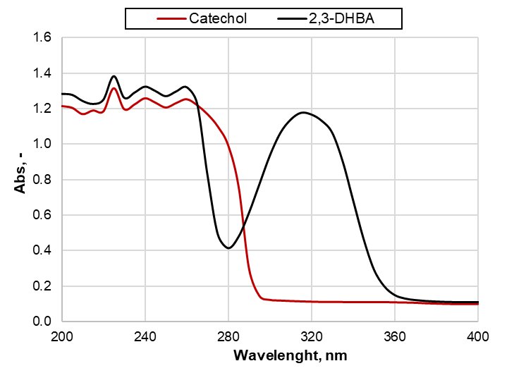
Figure 1. UV absorbance spectra of 10 mM catechol and 10 mM 2,3-DHBA solutions in solvent D upon 1:20 dilution in QS.
As reported in Figure 1, both solutions exhibited nearly similar absorbance below 260 nm. In the spectrum of catechol solution, the absorbance was almost negligible in the range 290-400 nm. The spectrum of 2,3-DHBA solution showed a minimum between 260-280 nm and a prominent peak at 320 nm. A similar behaviour was observed for 10 mM single-component solutions in solvent C under the same dilution conditions (data not shown). These preliminary results guided the calibration of UV absorbance measurements at 280 and 320 nm for the quantification of catechol and 2,3-DHBA, respectively, with scarce interference of the other compound, in both single- and bi-component solutions. Calibration of 2,3-DHBA was performed at 320 nm using solutions ranging from 0 to 10 mM in both solvents C and D, diluted 1:20 in QS (0–0.5 mM final concentrations) (Figure 2A). The molar extinction coefficients ɛ_{2,3-DHBA}(320 nm)= 2.09 mM⁻¹ cm⁻¹ (solvent C) and 1.89 mM⁻¹ cm⁻¹ (solvent D) for 2,3-DHBA were determined from the linear regression of data sets in Figure 2A and were applied for the calculation of acid concentration in the bi-component solutions due to the poor contribution of catechol at wavelength larger than 290 nm (Figure 1). Due to the evident overlap of catechol and 2,3-DHBA spectra at 280 nm, catechol concentration assessment was performed using bi-component solutions mimicking the decarboxylation reaction mixture (from 0-10 mM to 10-0 mM catechol-2,3-DHBA) (Figure 2B). Parity plot (Figure 2C) showed the absorbance values of the bi-component solution close (deviation <10%) to the sum of absorbances from the single-component solutions for each considered concentration of acid and catechol (Eq. 2). Thus, the concentration of catechol can be calculated from the linear combination (Eq. 2-4) of the absorbance at 280 nm of the single-component solutions and according to the stoichiometry of Eq. 1.

${Abs}_{mix}\left(280 nm\right)=C_{Cat}∙ε_{Cat}\left(280 nm\right)+C_{DHBA}∙ε_{2,3-DHBA}\left(280 nm\right)$ Eq. 2
$C_{DHBA}=C_{DHBA_0}-C_{Cat}$ Eq. 3
$C_{Cat}=\frac{{Abs}_{mix}\left(280 nm\right)-{Abs}_{2,3-DHBA_0}\left(280 nm\right)}{ε_{Cat}\left(280 nm\right)-ε_{2,3-DHBA}\left(280 nm\right)}$ Eq. 4

The analysis of absorbance data was successfully verified in solvent C (data not shown). The catechol and 2,3-DHBA concentrations were thus assessed through the measurement of mixture absorbances at 280 and 320 nm in both decarboxylation and carboxylation reactive mixtures.

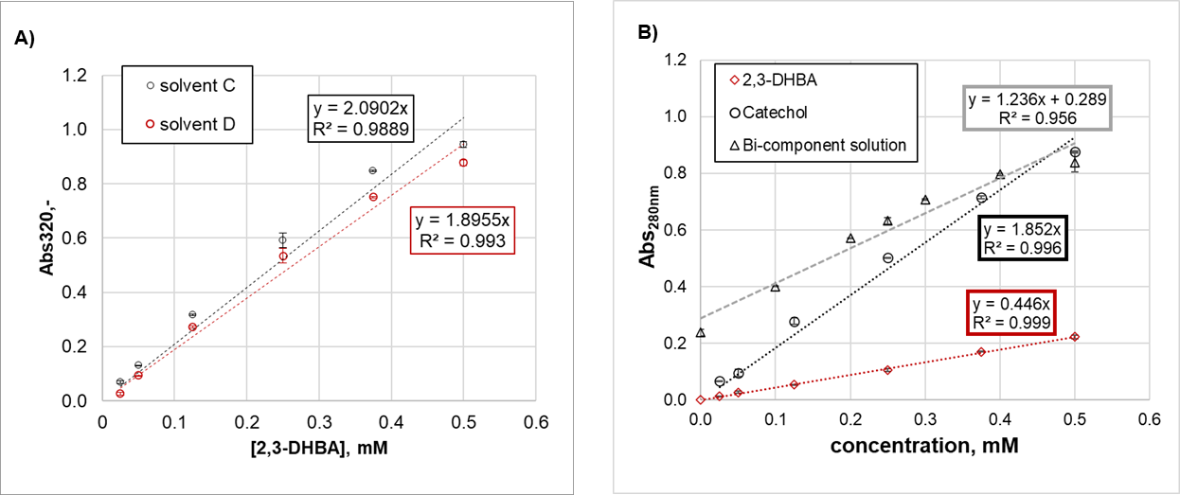
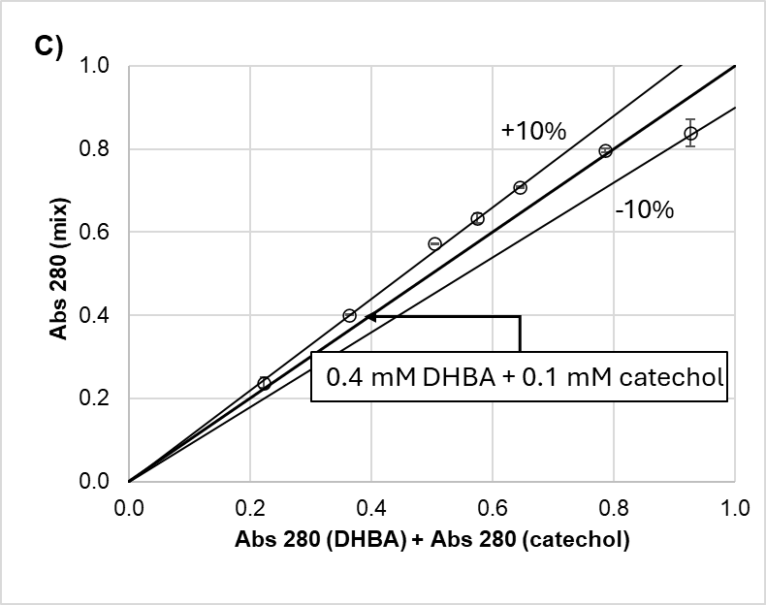
Figure 2. A) Absorbance at 320 nm of 2,3-DHBA solutions in solvent C and D (1:20 diluted in QS). B) Absorbance at 280 nm of single-component catechol (open black circle) and 2,3-DHBA (red diamonds) solutions, and bi-component mixtures (open black triangles). Catechol concentration is reported for bi-component solutions miking catechol conversion into 2,3 DHBA. All samples were diluted 1:20 in QS. C) Parity plot: absorbance of bi-component solution vs sum of absorbance of equimolar single-component solutions at 280 nm.
    - 2,3-DHBD_Ao activity assay and carboxylation tests
The conditions of the decarboxylation activity assay were selected from the analysis of the literature (see section 1). The decarboxylation reaction was fast enough to assays the activity at 0.05 g L⁻¹ enzyme concentration and 10 mM 2,3-DHBA in solvent D. Reaction progress was followed by collecting samples from 0 to 30 min; samples were then analyzed using UV spectroscopy according to the developed methods. Validation of the UV assay was performed by comparison with the substrate and product concentrations assessed through HPLC.
The relative product concentration increased linearly over 30 min and data from UV measures were fairly confirmed by HPLC analysis (Figure 3). The assessed activity of 0.05 g L⁻¹ 2,3-DHBD_Ao was 0.16 and 0.12 mM DHBA/min for initial concentration of substrates 9.8 and 12.9 mM, respectively.
The enzymatic carboxylation of catechol catalyzed by 2,3-DHBD_Ao was also evaluated using the developed UV–spectroscopic method with 10 mM catechol in 3 M KHCO₃ solution.
The produced 2,3-DHBA approached 3.3 mM in 24 h (Figure 4) and reflected the corresponding rounded theoretical concentration calculated according to the equilibrium constant 1.6 10⁻⁴ mM⁻¹ (Pesci et al., 2015) assuming negligible bicarbonate consumption. The catechol theoretical concentration was 6.8 mM. The measured catechol concentration decreased below the expected minimum value. The time course of catechol concentration was non monotonic and increased between 6 and 24h up to 5.6 mM. The data recorded at 24h had a 10% deviation from the stoichiometric equilibrium conversion consistent with the balance closure observed for data in Figure 3 (100 to 91% for UV and 100 to 95% for HPLC measures). The dynamics of catechol consumption assessed in carboxylation tests may be affected by undesired oxidation, speciation of catechol deprotonated forms depending on pH, and kinetics of enzyme-substrate complex formation that asks for further investigation at variable enzyme concentrations.

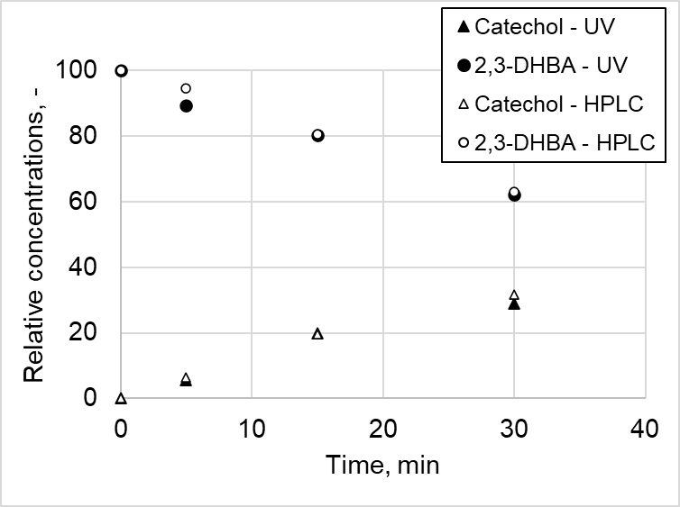
Figure 3. Time-course of the relative concentrations (with respect to initial 2,3 DHBA concentration) during decarboxylation assay catalyzed by 2,3-DHBD_Ao (solvent D, 30°C).
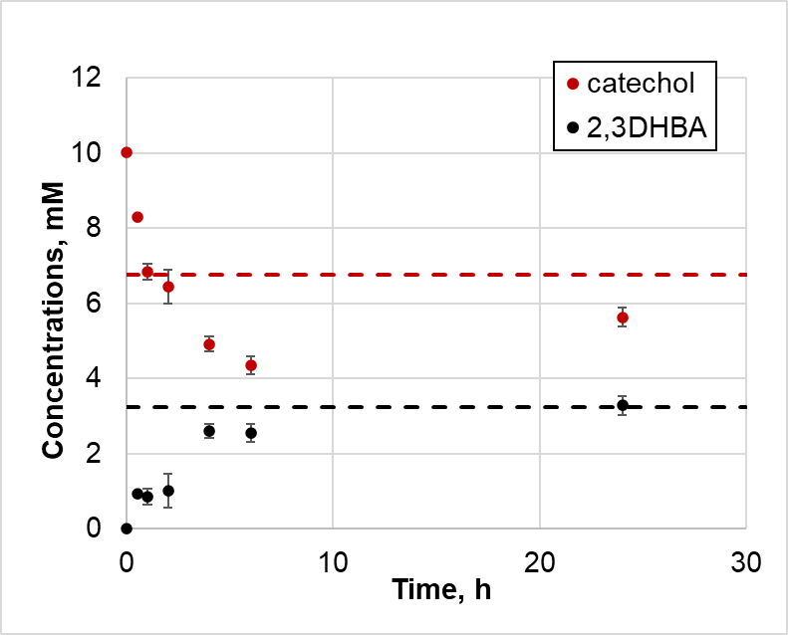
Figure 4. Catechol consumption and 2,3DHBA production in carboxylation test with 2,3-DHBD_Ao (batch tests in Solvent C, at 30°C). Samples were analyzed through UV method upon 1:20 dilution in QS. Dashed lines equilibrium concentrations.
The rapid and simultaneous assessment of catechol and carboxylic acid concentrations was proved and allows further screening of immobilized DHBDs activity by decarboxylation tests as well as adjustments for on-line measurements of the adsorption of substrates and products on solid surface in case of heterogenous biocatalysts.
  - Conclusions
A UV-spectroscopic assay was developed for the simultaneous quantification of catechol and 2,3-DHBA in reactions catalyzed by 2,3-DHBD_Ao. The assessment of catechol and 2,3-DHBA concentration in bi-component solutions was possible upon proper dilution of reactive samples in QS and analysis of absorbance at 280 and 320 nm. The enzyme activity can be rapidly assessed by decarboxylation tests. Linear decrease of substrate concentration was observed for 30 min at the defined conditions and was validated against HPLC data. Application to catechol carboxylation confirmed the good performance of this method and highlighted its suitability for monitoring both carboxylation and decarboxylation reactions. This approach provides a rapid, low-cost, and robust tool for screening free and immobilized decarboxylases, optimizing reaction conditions, and supporting potential online monitoring of phenols carboxylation processes. Overall, the method facilitates systematic evaluation and development of 2,3-DHBD_Ao as a biocatalyst for CO₂ fixation into carboxylic acids.
Nomenclature
2,3-DHBA – 2,3-dihydroxybenzoic acid
2,3-DHBD_Ao – 2,3-DHDB from Aspergillus oryzae
ɛ – Molar extinction coefficients (mM⁻¹ cm⁻¹)
HPLC – High Performance Liquid Chromatography
Acknowledgments
Sveva Buonocore is gratefully acknowledged for support in spectroscopic measurements. M.D.G. is recipient of a fellowship PhD in Biotechnology of the Università degli Studi di Napoli Federico II, funded by the Piano Nazionale di Ripresa e Resilienza 2022–25, PNRR DM351 – Investimento 4.1 Ministry of University and Research of Italy. The study is partially funded in the framework of the project PRIN 2022 – 202249PTSY - Enzyme cascade for combined use of CO₂ and Lignocellulose derived phenols for Carboxylic Acids production - ELiCA funded by European Union - Next Generation EU, Missione 4 Componente 1 CUP B53C24006760006.
References
Hofer G., Sheng X., Braeuer S., Payer S. E., Plasch K., Goessler W., Faber K., Keller W., Himo F., Glueck S. M., 2021. Metal Ion Promiscuity and Structure of 2,3-Dihydroxybenzoic Acid Decarboxylase of Aspergillus oryzae. ChemBioChem, 22, 652–656.
Kamath A. V., Dasgupta D., Vaidyanathan C.S., 1987. Enzyme-catalysed non-oxidative decarboxylation of aromatic acids: I. Purification and spectroscopic properties of 2,3 dihydroxybenzoic acid decarboxylase from Aspergillus niger. Biochemical and Biophysical Research Communication, 145, 586–595.
Marra L., Knuutila H., Russo M.E., 2022. A novel CO₂ capture and utilization strategy by enzyme catalysis: preliminary assessment of process layout. Chemical Engineering Transactions, 93, 31–36.
Marra L., Russo M.E., Knuutila H.K., Marzocchella A., Salatino P., 2024. CO₂ capture and utilization by biocatalytic synthesis of carboxylic acids: a process design study. Chemical Engineering Science, 285, 119618.
Pesci L., Glueck S. M., Gurikov P., Smirnova I., Faber K., Liese A., 2015. Biocatalytic carboxylation of phenol derivatives: kinetics and thermodynamics of the biological Kolbe-Schmitt synthesis. The FEBS Journal, 282(7), 1334–1345.
Ren J., Yao, P. Yu S., Dong W., Chen Q., Feng J., Wu Q., Zhu D., 2016. An Unprecedented Effective Enzymatic Carboxylation of Phenols. ACS Catalysis, 6(2), 564–567.
Russo M.E., Capasso C., Marzocchella A., Salatino P., 2022. Immobilization of carbonic anhydrase for CO₂ capture and utilization. Applied Microbiology and Biotechnology, 106, 3419–3430.
Santha R., Rao N.A., Vaidyanathan C.S., 1996). Identification of the active-site peptide of 2,3-dihydroxybenzoic acid decarboxylase from Aspergillus oryzae. Biochimica et Biophysica Acta, 1293, 191–200.
Tommasi I.C., 2019. Carboxylation of hydroxyaromatic compounds with HCO₃⁻ by enzyme catalysis: recent advances open the perspective for valorization of lignin-derived aromatics. Catalysts, 9(1), 37.
Yoshida M, Fukuhara N, Oikawa T., 2004. Thermophilic, Reversible -Resorcylate Decarboxylase from Rhizobium sp. Strain MTP-10005: Purification, Molecular Characterization, and Expression. Journal of Bacteriology, 2004, 6855–6863.
Wuensch C., Gross J., Steinkellner G., Lyskowski A., Gruber K., Glueck S. M., Faber, K., 2014. Regioselective ortho-carboxylation of phenols catalyzed by benzoic acid decarboxylases: a biocatalytic equivalent to the Kolbe–Schmitt reaction. RSC Advances, 4(19), 9673.

