 CHEMICAL ENGINEERING TRANSACTIONS  VOL. xxx, 2026 | A publication of  
The Italian Association
of Chemical Engineering
Online at www.cetjournal.it

Guest Editors: Marco Bravi, Antonio Marzocchella, Giuseppe Caputo
Copyright © 2026, AIDIC Servizi S.r.l.
ISBN 979-12-81206-xx-x; ISSN 2283-9216

Multi-objective optimization model for the integration of biodigester with solar- LPG hybrid systems in a heating district: Case study in Silos, Colombia
Nicolas Cabreraª, Viatcheslav Kafarov^{a,}*, A.M. Rosso-Cerón^{d}, Andrés F. León Esteban^{c}
ª Department of Chemical Engineering, Carrera 27 Calle 9, Universidad Industrial de Santander, Bucaramanga, Colombia
^{b} Department of Chemical Engineering, Cl. 5 No. 3-93, Kilometro 1 Vía Bucaramanga, Universidad de Pamplona, Pamplona, Norte de Santander, Colombia
^{c} Department of Electrical, Electronic and Telecommunications Engineering, Carrera 27 Calle 9, Universidad Industrial de Santander, Bucaramanga, Colombia
kafarov@uis.edu.co
This study evaluates the integration of biotechnologies, such as biodigesters, into the design of energy systems composed of solar collectors, liquefied petroleum gas (LPG) and natural gas pipeline networks, with the aim of meeting the thermal demand of the municipality of Silos, Colombia, and promoting the circular economy through the use of organic waste from agricultural activity. The energy planning project was designed using a multi-objective mixed integer linear programming (MOMILP) model, which aims to minimise the net present value (NPV) and total CO₂ emissions generated. The results of the model show that the integration of biodigesters is a key factor in fully meeting the thermal demand of the area, considering the availability of local resources. The greatest energy contribution from biodigesters was in alternative A10, with a 2.10% share of the total energy generated by the energy matrix. The proposed methodology and considerations provide essential information for policymakers and stakeholders in energy planning projects and can be applied to a wide variety of projects aimed at integrating thermal districts.
  - Introduction
Electricity and heat production is one of the main sectors contributing to greenhouse gas emissions, accounting for approximately 32% (Ritchie et al. 2020). Furthermore, due to high population density, cities are responsible for 70% of CO₂ emissions associated with energy production (IEA, 2016). Due to the socio-economic growth of cities, it is estimated that by 2050, 66% of the world's population will reside in urban areas (Dominkovic, 2018). Likewise, an increase in energy demand and greenhouse gas emissions is expected. Therefore, in order to reduce the rate of climate change, various international agreements and sustainable development goals have been established to promote the energy transition.
To move towards an efficient energy transition, it is necessary to design energy planning projects, which consist of determining when and how much capacity of unconventional technologies should be installed throughout the planning horizon (Koltsaklis and Dagoumas, 2018). Globally, energy planning projects have mainly focused on the power sector, leaving heat production in the background. However, thermal energy accounts for nearly 50% of final energy consumption, highlighting the importance of including its analysis in order to move towards a sustainable energy transition (IEA, 2023).
Thermal demand is mainly used for water and space heating. The most commonly used systems are thermal districts, which consist of centralised infrastructures responsible for supplying thermal energy to communities through pipe networks. These thermal districts are a key element in the decarbonisation of communities, as they allow for the integration of various unconventional technologies, which in turn promotes greater energy efficiency and diversification of the energy system (Köfinger et al., 2016).
Tian et al. (2019) conducted a review of solar thermal districts in Denmark since 2006, demonstrating their high potential for application. Among the main advantages are low solar thermal energy prices, thermal district companies managed mainly by end users, availability of low-cost land, reduced construction costs for new thermal plants thanks to the existing pipe network, high efficiency and durability.
Novosel et al. (2022) used the H2RES tool to analyse the integration of a heating and cooling district in the Republic of Croatia, with the aim of promoting decarbonisation at the national level. The results showed that the incorporation of power-to-heat technologies, such as solar photovoltaic and wind energy, increases the efficiency of heat supply in heating districts.
Pakere et al. (2023) conducted a detailed analysis of the installation of a thermal district from technical, economic and environmental perspectives. They identified that it is advisable to incorporate thermal storage tanks, as they allow for a more continuous and efficient heat supply, as well as promoting an increase in the rate of generation from biomass. They also concluded that low-temperature thermal districts significantly reduce production costs and environmental impact, while high-temperature thermal districts do not show a notable decrease in this impact.
Colombia has been one of the pioneering Latin American countries in promoting the installation of thermal districts as an innovative technological solution to climate change. However, due to the country's socio-economic conditions, the infrastructure for large-scale implementation is not yet in place. As a result, the few projects aimed at promoting thermal districts have been developed mainly in large cities and have been based on the replacement of existing equipment rather than on an optimal and comprehensive design of the technologies (Ministry of Environment, 2020). Therefore, in Colombia, there is no applied methodology that allows for the optimal design of thermal districts in rural areas or in geographical contexts with decentralised energy technologies.
In addition, the proposed thermal districts are commonly composed mainly of solar thermal systems and power plants based on power-to-heat technologies. In this context, an innovative solution consists of incorporating environmental biotechnologies, such as biodigesters, in order to supply thermal energy and, at the same time, take advantage of local agricultural resources to promote the circular economy.
Therefore, this study proposes a methodology based on a mixed integer linear multi-objective optimisation model (MOMILP) to evaluate the most sustainable alternatives for meeting thermal demand in high mountain areas. The MOMILP model aims to minimise the net present value (NPV) and total CO₂ emissions caused by the installation of thermal technologies, while considering operational, design and budgetary constraints. The technologies considered are biodigesters, LPG, solar collectors and the extension of natural gas networks, which can supply thermal demand through either centralised or decentralised configurations. Additionally, thermal demand and heat supply are standardized in kWh to facilitate their comparison and integration with electrical demand and generation. The proposed methodology provides valuable insights for stakeholders involved in the assessment of thermal systems in high-mountain and isolated regions of Colombia, supporting the integration of biotechnologies for organic waste utilisation and contributing to a more efficient and sustainable energy transition.
  - Mathematical formulation
This section presents the mathematical structure of the MOMILP model, including the objective functions and the design, operational, and budgetary constraints.
    - Objective functions
The objective functions aim to minimize the NPV (Eq(1)) and CO₂ emissions (Eq(2)). The NPV includes investment costs, fixed and variable operating and maintenance (O&M) costs, fuel acquisition costs, natural gas network extension costs, and profits derived from trading surplus thermal energy with other communities. CO₂ emissions include those produced by fuel-based plants, such as biodigester, and natural gas network.
$NPV=\sum_{t}{\frac{1}{{(1+RD)}^{t}}}\left[\left(\sum_{p}{{Capx}_{p,t}\sum_{z}{{ACa}_{z,p,t}}}\right)+\left(\sum_{p}{{OpxVa}_{t,p}\sum_{z}{{EnG}_{z,p,t}}}\right)+\left(\sum_{p}{{OpxFi}_{p,t}\sum_{z}{TA{Ca}_{z,p,t}}}\right)+\left(\sum_{\left(re | re∈rec\right)}{{CF}_{re.t}\sum_{z}{{FF}_{z,re,t}}}\right)+\left(\sum_{\left(z | z∈c\right)}{HT_{t,z}*{NGCo}_{t,z}} +\sum_{\left(z | z∈c\right)}{{ANG}_{t,z}}*{LNG}_{z} *{ING}_{z,t} \right)-\sum_{p}{{Rev}_{p,t}∙{EnS}_{p,t}}\right]$ | (1)
${CO}_{2} emissions=\sum_{t}{\left[ \sum_{z}{\left({{EFNG}_{z}*HT}_{t,z}+\sum_{p}{{EF}_{z,p}*{EnG}_{z,p,t}}\right)}\right]}$ | (2)
    - Constraints
The restrictions of the MOMILP model can be classified into operational, design, and budgetary restrictions.

2.2.1 Operational restrictions
These restrictions guarantee the thermal supply to the community of interest.
Energy balance: thermal plants p, during period t, must meet thermal demand, which is divided into domestic applications (Eq(3)) and hot water supply (Eq(4)).
$\sum_{p|p∈pc}{{(EnG}_{z,p,t})+HT_{z,t}=}{HD}_{z,t}*\left(1-{HWD}_{z,t}\right)+EnS; ∀ z,t$ | (3)
$\sum_{\left(p | p∈pa\right)}{{EnG}_{z,p,t}={HWD}_{z,t}}{HD}_{z,t}; ∀ z,t$ | (4)
Operation of thermal power plants: the energy generated by each plant, during period t, must not exceed the amount of heat that can be generated during the plants' operating hours.
${EnG}_{z,p,t}≤ {OTH}_{z,p}*{OC}_{z,p,t}; ∀ z,p,t$ | (5)
Efficiency of installed plants: heat flow must not exceed the efficiency of the total installed capacity of each technology p.
${OC}_{z,p,t}{≤ HGE}_{z,p }*{TACa}_{z,p,t};∀ z,p,t$ | (6)
Extension of natural gas networks: the heat transported through gas lines cannot exceed that permitted by the gas line (Eq(7)). Furthermore, new natural gas lines must comply with the construction period prior to their entry into operation (Eq(8)).
${HT}_{z,t}≤{ONG}_{z,t}*{AF}_{z}*{LNG}_{z}*{HPL}_{z,t };∀ z|z∈zc,t$ | (7)
${ONG}_{z,t}≤\sum_{v≤t-Tt}{{ING}_{z,v}}; ∀ z|z∈zc,t$ | (8)
2.2.2 Design constraints
These restrictions ensure that installed capacities are consistent with those permitted by the resources available in the area of interest.
Total installed capacity: total installed capacity is defined as the sum of previously installed capacity and newly installed capacity, considering the building time v, of each thermal plant.
${TACa}_{z,p,t}={ {OCA}_{z,p}*ICA}_{z,p}+\sum_{v≤t-BT}{A{Ca}_{z,p,t };∀ z,p,t}$ | (9)
Installed capacity limits: Ensure that the added capacities do not exceed the established permissible limits (Eq(10)), and that the cumulative sum of these capacities throughout the planning horizon does not exceed the maximum allowed (Eq(11)).
${MinCa}_{z,p}*{In}_{z,p,t}{≤ACa}_{z,p,t}≤{MaxCa}_{z,p}*{In}_{z,p,t };∀ z,p,t$ | (10)
$\sum_{t}{\sum_{z}{{ACa}_{z,p,t }}}{≤ MaxCa}_{z,p} ;∀ z,p$ | (11)
Thermal energy generation: The thermal energy generated must not exceed the maximum thermal generation potential of the resources available in the area z.
${EnG}_{z,p,t}≤{{HCE}_{re,p}*TFC}_{z,re,p,t}*{Cp}_{re,p};∀ z,re,p,t$ | (12)
Energy resource consumption: The amount of available primary thermal sources, can be expressed as the sum of the sources available re, for each technology (Eq(13)). Furthermore, the total amount of sources must not exceed the energy potential of the study area (Eq(14)).
${TFA}_{z,re,t}=\sum_{p}{{TFC}_{z,re,p,t };∀ z,re,t }$ | (13)
${FA}_{z,re,t}≤{PRA}_{z,re,t} ; ∀ z,re,t$ | (14)
2.2.3 Budgetary constraints
The total cost of the system is limited by the capital available to the stakeholders or the financial support established for the new capacities and expansion of natural gas networks.
$\sum_{t}{\frac{1}{1+{RD}^{t}}}\left[\left(\sum_{p}{{Capx}_{p,t}*{ACa}_{z,p,t}}\right)+{ANG}_{z,t}*{LNG}_{z}*{ING}_{z,t}\right]≤{BG}_{z};∀ z$ | (15)
    - Case study
The MOMILP model was implemented in the municipality of Silos, 64.6% of which is made up of the Santurbán Páramo, an ecosystem that supplies potable water to approximately 2.5 million people. The municipality includes both urban and rural areas, and its energy system combines natural gas networks with decentralised thermal systems. In the base year considered (2018), Silos had 7,046 inhabitants with a thermal demand of 1,095,400 kW, which was projected to reach 1,319,200 kW by 2040. The model input data was obtained from various sources, including the NASA POWER tool for solar radiation, the AGRONET database for biomass in Colombia, IRENA, the Single Information System, UPME, and the Ministry of Mines and Energy for financial and technical data. Among the agricultural residues available in the area, potatoes were selected as the main resource due to their moisture content of less than 40%, which makes them a suitable option for use in biodigesters.
  - Results and analysis
The MOMILP model was implemented in Python using the Pyomo library and solved with the epsilon-constraint method and the Gurobi solver (academic licence). One of the main results shows that the inclusion of biotechnologies, particularly biodigesters, enables the design of an energy matrix capable of meeting the thermal demand of the municipality of Silos using locally available resources, while also supporting the circular use of organic waste. This configuration further allows the generation of energy surpluses that can be commercialised. By contrast, when biodigesters are excluded, the MOMILP model fails to converge.
Beyond their role in system feasibility, biodigesters also address environmental challenges in agriculture-based municipalities, such as the accumulation of organic waste across the region. They enable the production of biogas, a cleaner fuel suitable for both thermal and electrical generation, thereby facilitating the future integration of cogeneration units and promoting a more diversified energy matrix.
The Pareto diagram obtained from the MOMILP model identifies ten alternatives with a clear trade-off between total system cost and CO₂ emissions (Figure 1). Although energy surpluses can be sold, the resulting revenues are insufficient to offset total system costs. Consequently, the net present value (NPV) remains positive and is interpreted as the total system cost, in line with the adopted sign convention and the minimisation objective. System costs range from 5,416,460.19 USD to 5,977,361.93 USD, while total CO₂ emissions decrease from 22,909,240 kg to 17,667,410 kg. A marked contrast is observed between alternatives A1 and A10, which prioritise economic and environmental objectives, respectively. These differences are mainly driven by investment costs, operation and maintenance (O&M) expenses, and fuel consumption, with cleaner technologies requiring higher initial investments.
The Pareto front exhibits a convex shape. Initial emission reductions are achieved at relatively low cost, but marginal costs increase as more ambitious sustainability targets are pursued. Early improvements rely on lower-cost options, such as technologies with higher emission levels, including LPG. In later stages, stricter CO₂ mitigation requires the adoption of cleaner technologies, such as natural gas networks, solar collectors, and biodigesters, which significantly increase marginal costs. This pattern reflects the exhaustion of low-cost options and the effect of diminishing returns, consistent with the findings of Li et al. (2023) and Ren et al. (2022).
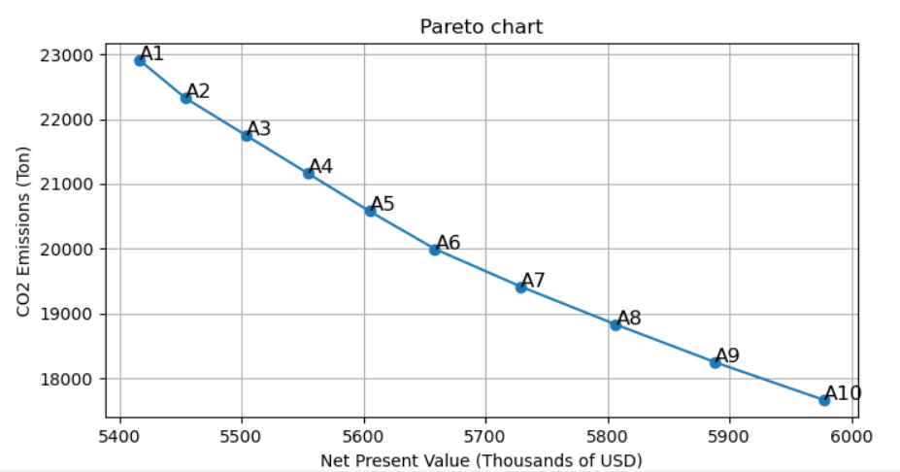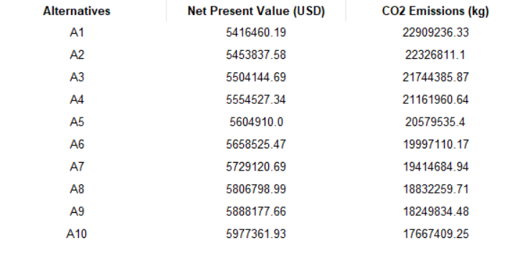
Figure 1. Pareto chart and values of each alternative.
Figure 2 shows the contribution of each technology to thermal energy generation. Solar collectors maintain a constant share of 0.7%, as domestic hot water demand is primarily met by this technology. The use of LPG and natural gas networks exhibits opposite trends. LPG, as the lowest-cost option, is prioritised initially, with its contribution decreasing from 90.18% to 51.12%. In contrast, the share of natural gas networks increases from 7.59% to 46.07%, reflecting their lower CO₂ emissions. Biodigesters provide a constant contribution across alternatives A1 to A9, while in A10 their share increases, supporting a cleaner and more cost-effective system configuration. Although the biodigester contributes a relatively small share of thermal energy, it plays a critical role in the system. It acts as a support technology that supplies the remaining thermal demand and ensures compliance with the energy balance constraint, thereby enabling successful model convergence.
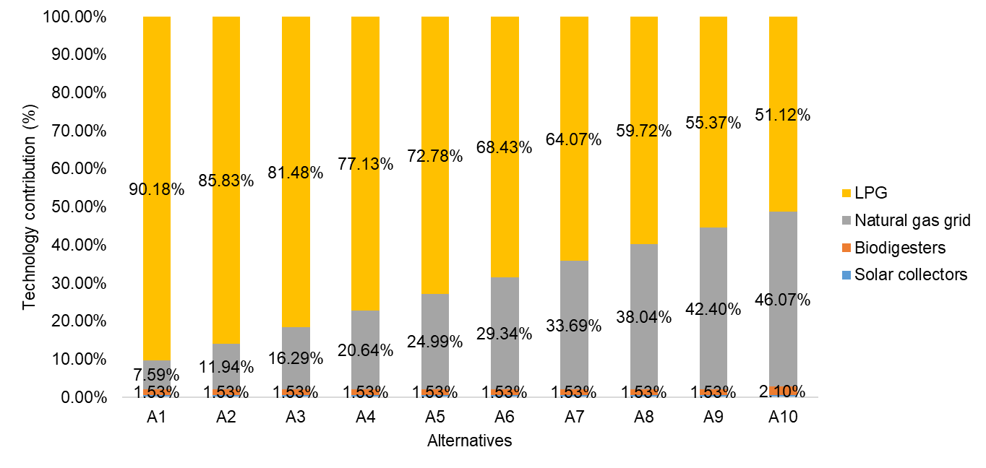
Figure 2. Percentage contribution of thermal energy generated by technologies.
Additionally, given that the model is deterministic, a sensitivity analysis was performed to identify the most critical parameters. The results indicate that investment costs have the greatest influence, due to the similarity between the technologies evaluated. These parameters are particularly relevant, as the investment costs of unconventional technologies can vary significantly due to factors such as inflation and the rate of technological learning.
Finally, since the energy matrix remains largely dependent on fossil fuels, future research should explore the integration of additional thermal technologies, such as geothermal energy, cogeneration units, and thermal storage systems. Moreover, given the diverse configurations of the alternatives, selecting the most sustainable option requires the application of multi-attribute decision-making methods that reflect stakeholder priorities.
  - Conclusions
The implementation of the MOMILP optimisation model made it possible to evaluate the integration of biotechnologies, such as biodigesters, into an energy system composed of LPG and natural gas networks in the municipality of Silos, with the aim of meeting thermal demand and promoting the circular economy through the use of organic waste. The resulting Pareto diagram highlights the inherent trade-off between economic and environmental objectives, showing how system configurations evolve from solutions prioritising lower-cost fuels, such as LPG, towards cleaner technologies as environmental criteria gain importance. In this context, biodigesters increase their relevance in the most environmentally oriented alternatives.
The optimisation model implemented in the municipality of Silos demonstrated that the integration of biotechnologies in the design of energy planning projects is a key element, as it enables thermal demand to be fully satisfied through hybrid system configurations. In particular, biodigesters play a critical supporting role by contributing to system feasibility, ensuring compliance with the energy balance constraint, and enabling model convergence, despite their relatively small share in total thermal generation. Moreover, the Pareto-based multi-objective formulation facilitates the identification of compromise solutions and supports decision-makers and stakeholders in selecting the most suitable alternative according to their priorities, especially when combined with multi-attribute decision-making methods.
Finally, this robust optimisation framework enabled a comprehensive assessment of local energy potential and the strategic role of biotechnologies within a circular economy approach, supporting the energy transition in high-mountain areas. Furthermore, the proposed methodology can be adapted to other regions to evaluate the integration of biotechnologies into their energy systems, contributing to the sustainable planning and expansion of regional energy infrastructures.
Nomenclature
Sets | Model parameter (Units)
re - Resources | RD - Discount rate
p - Plants | Capx - Unit investment cost, USD/kW
t - Period | OpxVa - Unit variable cost, USD/kWh
z - Zones | OpxFi - Unit fuel cost, USD/kW
Subsets: | CF - Unit fuel cost, USD/kg
D $⊆ z-$ Decentralized zones | NGCo - Unit operation cost of natura gas lines, USD/kWh
C ⊆ z - Centralized zones | ANG - Unit investment cost of new lines of natural gas, USD/km
pa ⊆ p - Hot water plants | Rev - cost of energy sales, USD/kWh
pb ⊆ p – Fuel thermal plants | LNG - Length of natural gas of pipelines, km
Continuos Variables | EFNG - Emissions factor of natural gas, kg CO₂/kWh
TACa - Total installed capacity, kW | EF - Emission factor of local resources, kg CO₂/kWh
OC - Operational capacity, kW | HD - Heat demand, kWh
ACa - Additional capacity to install, kW | HWD - Fraction of demand for hot water
EnG - Generated heat, kWh | OTH - Annual operating time of heat plants, h
EnS - Surplus energy sold, kWh | HGE - Heat generation capacity efficiency
TFC - Total fuel flow consumes, kg/y | HPL - Heat generated per pipeline length, kW/km
TFA - Total fuel flow available, kg/y | TFC - Time factor, h
HT - Heat Transfer, kWh | MaxCa - Maximum capacity to be added, kW
Binary Variables | MinCa - Minimum capacity to be added, kW
In - If a new capacity is installed, otherwise | Cp - Heating value of primary source, kJ/kg
ONG - If new natural gas pipelines operate | HCE - Primary thermal resource to heat conversion efficiency
ING - If new natural gas pipelines are installed | PRA - Primary resource available, Unit of source
 | BG - Total budget for new heating plants and networks over the entire period, USD
Acknowledgments
The authors would like to acknowledge the financial support from the Ministry of Science, Technology, and Innovation of Colombia for the project "Development of a computational tool and renewable energy technologies for energy transition in high mountain areas post-pandemic," CD 82605 CT ICETEX 2022-0644.
References
Bynum, Michael L., Gabriel A. Hackebeil, William E. Hart, Carl D. Laird, Bethany L. Nicholson, John D. Siirola, Jean-Paul Watson, David L. Woodruff. Pyomo - Optimization Modeling in Python. Third Edition Vol. 67. Springer, 2021.
Dominkovic D. F., 2018, Modelling Energy Supply of Future Smart Cities. Technical University of Denmark.
Gurobi Optimization, LLC, Gurobi Optimizer Reference Manual, 2024, <www.gurobi.com>
Hannah Ritchie, Pablo Rosado and Max Roser, 2020, Breakdown of carbon dioxide, methane, and nitrous oxide emissions by sector, Published online at OurWorldinData.org <archive.ourworldindata.org/20251204-144539/emissions-by-sector.html> accessed 10.10.2025
IEA, 2016, Energy Technology Perspectives 2016, IEA, Paris <www.iea.org/reports/energy-technology-perspectives-2016> accessed 10.10.2025
IEA, 2023, Heat – Renewables 2023 - Analysis, <www.iea.org/reports/renewables-2023/heat> accessed 10.10.2025
International Renewable Energy Agency – IRENA, 2023, Renewable Power Generation Costos in 2023, Abu Dhabi.
Köfinger M., Basciotti D., Schmidt R., Meissner E., Doczekal C., Giovannini A., 2016, Low temperature district heating in Austria: Energetic, ecologic and economic comparison of four case studies. Energy, 110, 95-104.
Koltsaklis N. E., & Dagoumas A. S., 2018, State-of-the-art generation expansion planning: A review. Applied Energy, 230, 563-589.
Li C., Wang L., Zhang Y., Yu H., Wang Z., Li L., Wang N., Yang Z., Maréchal F., Yang Y., 2023, A multi-objective planning method for multi-energy complementary distributed energy system: Tackling thermal integration and process synergy. Journal Of Cleaner Production, 390, 135905.
Ministry of Environment and Sustainable Development from Colombia, 2020, Thermal Districts Methodological Guide (in Spanish)
NASA POWER, 2024, "Energy Resources Data," NASA POWER Data Viewer. <power.larc.nasa.gov/data-access-viewer/> accessed 25.08.2025.
Novosel T., Feijoo F., Duić N., Domac J., 2022, Impact of district heating and cooling on the potential for the integration of variable renewable energy sources in mild and Mediterranean climates. Energy Conversion And Management, 272, 116374.
Pakere I., Feofilovs M., Lepiksaar K., Vītoliņš V., Blumberga D., 2023, Multi-source district heating system full decarbonization strategies: Technical, economic, and environmental assessment. Energy, 285, 129296.
Ren F., Lin X., Wei Z., Zhai X., Yang J., 2022, A novel planning method for design and dispatch of hybrid energy systems. Applied Energy, 321, 119335.
SUI, 2022, Energy Consumption Trends in High Altitude Regions, Journal of Sustainable Energy Systems.
Tian Z., Zhang S., Deng J., Fan J., Huang J., Kong W., Perers B., Furbo S., 2019, Large-scale solar district heating plants in Danish smart thermal grid: Developments and recent trends. Energy Conversion And Management, 189, 67-80.

