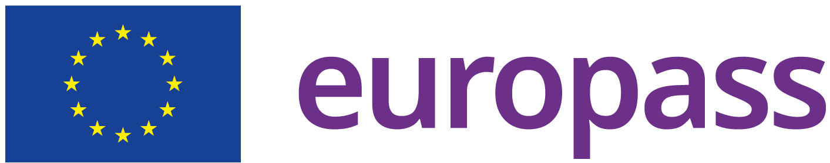
Valeria Ghirardi
Date of birth: 04/09/1985
Nationality: Italian
Phone number: (+39) 3420980598 (work)
e-mail: v.ghirardi@barzano-zanardo.com
Address: Via Borgonuovo 10, 20121, Milano, Italia (Work)

WORK EXPERIENCE
01/07/2024 – Current Milano, Italia

PATENT ATTORNEY BARZANÒ & ZANARDO SPA
  - Filing and obtaining national, European, and foreign patents;
  - Preparation of opinions on patent validity and freedom to operate;
  - Assistance in European opposition and appeal proceedings;
  - Technical advice for parties in national cases;
  - Presentations on industrial property to public and private clients.

01/04/2021 – 30/06/2024 Roma, Italia

PATENT ATTORNEY DE SIMONE & PARTNERS

01/05/2011 – 31/03/2021 Roma, Milano, Italia

PATENT ATTORNEY CANTALUPPI & PARTNERS

EDUCATION AND TRAINING
2022

QUALIFIED REPRESENTATIVE AT UNIFIED PATENT COURT (UPC)
2016

QUALIFIED REPRESENTATIVE AT EUROPEAN PATENT OFFICE
2016

QUALIFIED REPRESENTATIVE AT ITALIAN PATENT OFFICE
2007 – 2010 Roma, Italia; Texas, USA

MASTER DEGREE IN PHARMACEUTICAL BIOTECHNOLOGY, Università “La Sapienza”,

2009-2010 Research Fellow at University of Texas Medical Branch (UTMB, Texas, USA)
2004 – 2007 Roma, Italia

BACHELOR DEGREE IN BIOTECHNOLOGY, Università di Tor Vergata

1999 – 2004 Roma, Italia

SCIENTIFIC HIGH SCHOOL Liceo Scientiﬁco "E. Majorana"
LANGUAGE SKILLS

Native language: ITALIAN
Other languages: ENGLISH

Autorizzo il trattamento dei miei dati personali presenti nel CV ai sensi dell’art. 13 d. lgs. 30 giugno 2003 n. 196 - “Codice in materia di protezione dei dati personali” e dell’art. 13 GDPR 679/16 - “Regolamento europeo sulla protezione dei dati personali”.

