 CHEMICAL ENGINEERING TRANSACTIONS  VOL. , 2024 | A publication of  
The Italian Association
of Chemical Engineering
Online at www.cetjournal.it

Guest Editors: Marco Bravi, Antonio Marzocchella, Giuseppe Caputo
Copyright © 2024, AIDIC Servizi S.r.l.
ISBN 979-12-81206-10-6; ISSN 2283-9216
Economic evaluation of a large-scale PHBV production facility: impact of polymer content on the final selling price
Claudia Amabile^{a,*}, Teresa Abateª, Simeone Chianeseª, Raul Munoz^{b}, Dino Musmarraª
ª Department of Engineering, University of Campania “Luigi Vanvitelli”, Via Roma 29, 81031, Aversa, Italy
^{b} Institute of Sustainable Processes, University of Valladolid, Dr. Mergelina, s/n, 47011, Valladolid, Spain
claudia.amabile@unicampania.it

Abstract
Poly(3-hydroxybutyrate-co-3-hydroxyvalerate) (PHBV) is a biodegradable polymer with excellent thermal and mechanical properties comparable to fossil-based plastics. Scaling up the production of this polymer could provide a viable solution for reducing the use of fossil-based materials. However, its current production capacities are limited, with only a few facilities implementing the process at pilot or semi-industrial scales. The primary challenge lies in the high production costs, with 40% of the expenses attributed to the feedstock used for fermentation. Additionally, the energy required for sterilization in processes using pure methanotrophic cultures further reduces its economic viability. In this study, the economic aspects of the PHBV production process were assessed at an industrial level (100,000 t/y PHBV), using cheap and renewable substrates such as valeric acid and methane. A mixed methanotrophic consortium was used to reduce the need for sterility. The techno-economic analysis was based on estimating both fixed investment and operating costs. Then, a sensitivity analysis was performed to analyse the effect that the polymer content has on the final selling price: the initial biomass concentration was set to 30 g L^{-1,} and the PHBV content was considered to be 20, 30, 40, 50 and 70% wt on a dry weight basis. The results revealed that increasing the polymer content beyond 40% wt led to a more competitive PHBV selling price, thus opening significant market opportunities.
  - Introduction
During the last decades, the world has been intensely suffering from plastic pollution since significant amounts of waste are continuously discharged into the environment, posing a threat to both the environment and human health (Horton, 2022). Because of the above, researching an alternative solution to these materials has become a pressing issue in the scientific community. Making the widespread deployment of biobased and biodegradable materials possible could effectively help to simultaneously reduce the use of petrochemical resources and the diffusion of recalcitrant materials for single-use applications (Acharjee et al., 2023; Dietrich et al., 2017). Poly(3-hydroxybutyrate-co-3-hydroxyvalerate) (PHBV) is a very promising biopolymer belonging to the family of polyhydroxyalkanoates (PHAs) (Policastro et al., 2021). Many microorganisms produce these polyesters biologically under nutrient starvation and in the presence of a carbon source. Indeed, under unfavourable growth conditions, the metabolism of these bacteria is addressed to the storage of an alternative carbon and energy reserve, which occurs through the conversion of the carbonaceous substrate into PHA granules (Koller et al., 2010). The granules obtained can then be extracted, processed, and used for several applications. In this context, packaging, biomedical, and agriculture have emerged as the most explored (Poltronieri and Kumar, 2018). Anyway, the market uptake of PHAs is still hindered by their high production cost, which is significantly higher than that of other polymers such as polypropylene, PET and others (van den Oever et al., 2017). Consequently, PHAs only represented 3.9% of the total bioplastics produced in 2022 (European bioplastics, 2023).
Many factors contribute to the final cost of PHAs. Still, the substrates used during fermentation, the extraction process, and the sterility requirements for avoiding contamination related issues account for almost 100% of the total PHAs price. In general, the carbon source used represents between 40 and 50% of the total final price, and this is particularly evident in the case of PHBV since its generation relies on the presence of a secondary carbon source as well (Policastro et al., 2021). For this reason, in recent years, it was investigated the possibility of using renewable or waste-derived feedstocks, such as methane and volatile fatty acids (VFAs), produced from anaerobic digestion, to be fed as primary and secondary carbon sources, respectively (Amabile et al., 2023b; López et al., 2018). Several studies analyzed the possibility of producing PHAs from methane and VFAs using methanotrophic pure or mixed cultures, and most of them revealed that high percentages of PHBV (up to ≈50%) were produced in both cases (Myung et al., 2016, 2015). In this context, the cultivation conditions appear to be relevant since optimizing the process leads to higher fractions of polymer accumulated, thus enabling higher production and reducing costs. In addition, extracting PHA granules from the cells accounts for a very high percentage of the total PHA costs. Previous studies have reported that PHA downstream can account for up to 40% of the final process cost (Pagliano et al., 2021). Adopting a recycling approach for recovering the solvents and antisolvents used downstream of PHAs was a successful strategy. This helps cut down material costs and mitigates the environmental impact (Levett et al., 2016). In this study, the techno-economic analysis of a large-scale PHBV production process in which methane and valeric acid are used as feedstocks was conducted. The plant capacity considered is 100,000 t/y, and the polymer content was adjusted from 40% to 70%. This variation was implemented to emphasize the impact of the strain accumulation capacity on the computed price of PHBV.
  - Materials and Methods
The process proposed and analyzed in this work for producing PHBV at an industrial scale consists of (i) a fermentation line for growing a mixed methanotrophic culture and promoting the accumulation of PHBV under nutrient starvation, (ii) a downstream line for harvesting the pellet from the culture medium and extracting the polymer granules from the cells, (iii) a chemicals recovery line, to recirculate the solvent and the antisolvent used during the extraction (Figure 1). The plant was assumed to operate continuously for 365 days per year.
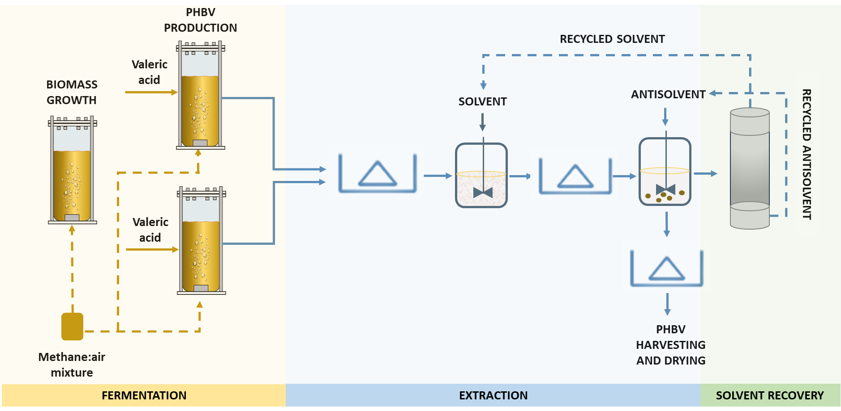
Figure 1. Scheme of the process analysed.
The fermentation process involved a sequence of three bubble column bioreactors, each with a volume of 7,000 cubic meters, designed for cultivating a mixed methanotrophic consortium. The selection of the inoculum was based on its ability to survive under nonsterile conditions and produce PHBV from methane and valeric acid. The polymer storing capacity was previously assessed at a laboratory scale, with a maximum content of 40% wt of PHBV reached after 48 hours (Amabile et al., 2023a).
The growth reactor was assumed to operate under steady-state conditions, maintaining a cell concentration of 30 g/L, and the working volume was set at 80% of the reactor volume. To enhance the efficiency of the cultivation process, the growth reactor was integrated with two accumulation columns working in parallel. The PHBV production phase was planned to occur on alternating days, lasting for 48 hours each time to facilitate the achievement of the maximum PHBV content in each accumulation reactor. Methane was used as gaseous carbon feedstock by mixing it with air and bubbling it through microporous gas diffusion systems.
Following the fermentation process, the PHBV downstream line was designed. A daily operation process in which the PHBV granules are extracted and processed was considered. Solvent extraction was chosen as the extraction technique since it guarantees high recovery and purity yields (Yang et al., 2015). To minimize the environmental impact, the non-toxic and eco-friendly solvent 1,3-dioxolane was used, while water was employed as an antisolvent during the precipitation phase. Note that, as for the cultivation step, the kinetic of the extraction, the recovery (96%) and purity (85%) yields were taken from a previous experimental work in which the same pair of solvent/antisolvent was used (Abate et al., 2024.). The duration of the extraction and precipitation considered was 1 hour each; the biomass/solvent ratio was set to 6 (w/v), and the solvent/antisolvent ratio considered was 1:3 v/v.
Finally, a solvent recovery system was also considered to reduce the costs of the materials used for extraction and limit the disposal of chemical substances.

    - Economic analysis
The techno-economic analysis of the 100,000 t/y PHBV production plant was conducted by estimating fixed capital and operating costs. The first category included major equipment costs (MEC), instrumentation and control, construction, and installation. The last three items were assumed to represent 35%, 15% and 47% of the MEC, respectively. (Rueda et al., 2023). The major equipment costs included the purchase cost of the bioreactors, pumps, centrifuges, compressors, mixing tanks, and distillation columns. More specifically, the cost of the bubble columns was assumed to be the sum of material costs, installation and construction; that of the centrifuges was taken from the charts provided by Ulrich (1984), and that of mixing tanks was calculated by scaling the price of a tank (C_{a}) with a known volume (V_{b}) according to Eq.1(Gael D. Ulrich, 1984).
$C_{a}=C_{b}{\left(\frac{V_{a}}{V_{b}}\right)}^{n}$ (Eq.1)
The costs of pumps, compressors and driers were given by local suppliers, while the solvent recovery line was assumed to cost almost the same as the extraction line (98%) (Rueda et al., 2023).
The operating costs were calculated by considering the materials (reagents for cultivation and extraction), energy (mainly linked to centrifugation and mixing), labour (four categories of operators), and maintenance (4% of MEC). Regarding the materials, starting from the price of the reagents to be used, a mass balance has been conducted to calculate the price for cultivation and extraction during 365 days of operation. Regarding the energy expenses, the average price of 0.135 €/kWh from 2008 to 2023 was considered (Eurostat, 2023). The energy consumption was calculated as reported in Eq.2.
$C_{u}=C_{e}×Pw×t$ (Eq.2)
where C_{u} is the energy cost of a unit u, C_{e} is the electricity price for kWh, P is the power of the unit considered (kW), and t is the working time of the unit (h).
The breakeven point (BEP) of PHBV was computed as zero 20 years net present value (NPV) by applying a discount rate of 8% during the cash flow analysis.
Finally, the assessment of the influence of the PHBV content on the final selling price was performed by varying the accumulation capacity of the strain between 20 and 70% wt.
  - Results and discussion
    - Economic evaluation of a 100,000 t/y production plant
The PHBV selling price baseline was assessed by considering a 100,000 t/y PHBV production plant and an initial biomass concentration of 30 g/L with a strain accumulation capacity of 40% wt. The outline and the purchase costs of the process units are reported in Table 1. The main categories contributing to the economic estimation were the major equipment costs, energy expenses and materials (Table 2). MEC was the most significant part, accounting for 41% of the total plant cost. Equipment for extracting the polymer and recovering the solvent represented the most onerous aliquot, accounting for more than 50% of the MEC (Table 1). Construction, installation, instrumentation, and control accounted for 6.6%, 20.7%, and 15.4%, respectively.
The energy expenses were mainly linked to extraction and solvent recovery, with only 1.2% being related to fermentation. This finding was justified by the high amount of culture medium that undergoes centrifugation and mixing daily. Similar results were obtained in another techno-economic assessment of PHB production, in which the major energy consumption was related to centrifugation and distillation (Price et al., 2022).
Almost 90% of the materials were attributed to the fermentation phase due to the high amounts of chemicals needed for culture medium preparation. In this context, note that the recycling strategy adopted during the downstream allowed significant resource savings and cost reduction. Indeed, the chemicals required for extraction are generally provided in quantities on the order of cubic meters. In contrast, most salts were supplied as trace elements during cultivation.
Table 1. Outline and purchase costs of the main process units
Unit | Price [€/u] | Number of units per single line
Pump | 4,657 | 43
Reactor | 266,649 | 3
Centrifuge | 340,000 | 69
Extraction tank | 4,734,766 | 1
Precipitation tank | 9,994,038 | 1
Table 2. Results of the techno-economic assessment baseline for a 100,000 t/y plant
Category | Line | Cost [€] | Percentage [%]
MEC | Fermentation | 36,007,213 | 2.6
MEC | Extraction | 389,353,178 | 27.7
MEC | Solvent recovery | 381,566,115 | 27.1
Energy | Fermentation | 7,734,204 | 1.2
Energy | Extraction | 321,593,878 | 49.9
Energy | Solvent recovery | 315,162,001 | 48.9
Materials | Biomass growth* | 605,378,953 | 59.7
Materials | PHBV accumulation* | 277,425,424 | 27.4
Materials | Downstream** | 131,185,152 | 12.9
*Biomass growth and PHBV accumulation = Fermentation
**Downstream = Extraction + Solvent recovery

    - Sensitivity analysis: influence of the PHBV content on the final selling price
The results of the sensitivity analysis are shown in Figure 2. More specifically, the cost was reduced from 17.4 to 11.6, 8.6, 6.9 and 5 €/kg when increasing the polymer content from 20% to 30%, 40%, 50% and 70% wt, respectively. Note that the effect of this parameter is more evident for lower polymer contents, with a maximum reduction of 33% by increasing the polymer content from 20% to 30% wt.
The influence of the polymer content on the PHBV cost mainly affected the number of lines required to obtain the desired productivity by keeping the plant unchanged. Specifically, the number of process lines decreased from 12 to 8, 6, 5 and 4 by increasing the polymer content from the minimum to the maximum considered.
The lower price obtained in this work was comparable to that reported in a previous assessment by Levett et al. (2016), which used the same biomass concentration and 50% wt accumulation capacity. They found that the price of PHB at 4.15 € per kg of PHB, on average, could be achieved. Even though this value is comparable to the lowest one obtained in this study, it is essential to highlight that, in general, the production of PHBV tends to incur higher costs than PHB. This aspect can be further elucidated by considering that while PHB can be produced from methane as the sole carbon source, the generation of PHBV requires a secondary carbon source, leading to additional expenses (Policastro et al., 2021).
Compared to other techno-economic evaluations of PHB production, the price is among the lowest reported. For instance, Wang et al. (2022) evaluated the feasibility of producing PHB from Haloferax mediterranei in a 9,700,000 t/y plant using lactose as feedstock and obtained a price varying between 4.7 and 16.4 € per kg of PHB. The assessment by Rueda et al. (2023), in which cyanobacteria were cultivated in 100 reactors of 1m³ to produce PHB from CO₂ and wastewaters, showed higher PHB prices of 130-433 €/kg. The accumulation capacities considered by the authors varied between 15% and 50% wt. Similarly, Price et al. (2022) evaluated the possibility of producing PHB using cyanobacteria in a 10,000 t/y plant and obtained prices in the 9.3-18.3 €/kg range, depending on the accumulation capacity considered. Finally, it appears from other studies that the size of the plant is a factor that strongly influences the PHA selling price. More specifically, the higher the plant capacity, the lower the final cost of the material produced.

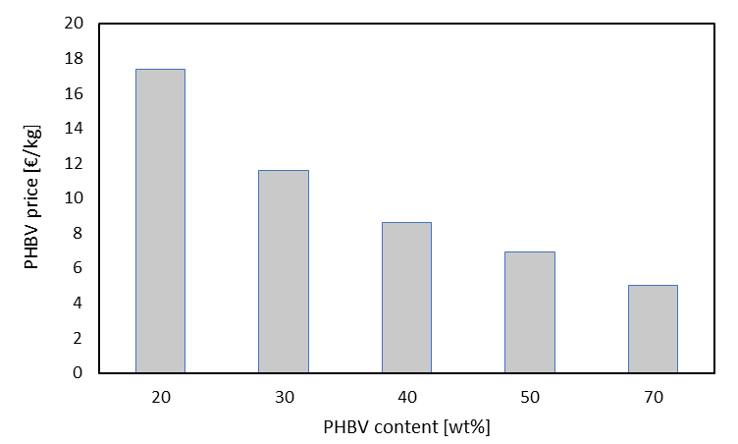
Figure 2. Results of the sensitivity analysis: PHBV accumulation capacity between 20 and 70% wt
Conclusions
This work proposed the techno-economic analysis of a PHBV production plant using renewable and waste-derived feedstocks, e.g., methane and valeric acid. An industrial production scale of 100,000 t/y of PHBV, assuming working for 365 days per year, was considered. All the categories governing the PHBV selling price, such as MEC, energy, materials, labour and maintenance, were considered. The baseline analysis was based on the experimental data previously obtained at a lab scale with a biopolymer content of 40% wt. Then, the accumulation capacity of the consortium considered was varied and increased up to 70% wt. The lowest price of 4 €/kg was obtained in this last condition. However, the PHBV price reported here is still higher than that of commercial polymers. Therefore, further optimization of the production process is required.
Nomenclature
C_{a} = cost of equipment a
C_{b} = cost of equipment b
C_{e} = electricity price
C_{u} = energy consumption of unit u
MEC =major equipment cost
PHA = polyhydroxyalkanoate
PHBV = poly(3-hydroxybutyrate-co-3-hydroxyvalerate)
Pw = unit power
t = time
V_{a} = volume of equipment a
V_{b} = volume of equipment b
Acknowledgements
The authors would like to thank the University of Campania Luigi Vanvitelli. The Regional Government of Castilla y León and the EU-FEDER (CL-EI-2021-07, and UIC 315) are also gratefully acknowledged.
References
Abate, T., Amabile, C., Chianese, S., Musmarra, D., Muñoz, R., 2024, Exploring 1,3-dioxolane extraction of poly(3-hydroxybutyrate) and poly(3-hydroxybutyrate-co-3-hydroxyvalerate) from Methylocystis hirsuta and mixed methanotrophic strain: effect of biomass-to-solvent ratio and extraction time. under Rev.
Acharjee, S.A., Bharali, P., Gogoi, B., Sorhie, V., Walling, B., Alemtoshi, 2023. PHA-Based Bioplastic: a Potential Alternative to Address Microplastic Pollution, Water, Air, and Soil Pollution. Springer International Publishing. https://doi.org/10.1007/s11270-022-06029-2
Amabile, C., Abate, T., Chianese, S., Musmarra, D., Muñoz, R., 2023a. The co-conversion of methane and mixtures of volatile fatty acids into poly(3-hydroxybutyrate-co-3-hydroxyvalerate) expands the potential of an integrated biorefinery. Bioresour. Technol. 387. https://doi.org/10.1016/j.biortech.2023.129699
Amabile, C., Abate, T., De Crescenzo, C., Muñoz, R., Chianese, S., Musmarra, D., 2023b. An innovative and sustainable process for producing poly ( 3-hydroxybutyrate-co-3-hydroxyvalerate ): simulating volatile fatty acid role and biodegradability. Chem. Eng. J. 473. https://doi.org/10.1016/j.cej.2023.145193
Dietrich, K., Dumont, M.J., Del Rio, L.F., Orsat, V., 2017. Producing PHAs in the bioeconomy — Towards a sustainable bioplastic. Sustain. Prod. Consum. 9, 58–70. https://doi.org/10.1016/j.spc.2016.09.001
Gael D. Ulrich, 1984. A guide to chemical engineering process design and economics.
Horton, A.A., 2022. Plastic pollution: When do we know enough? J. Hazard. Mater. 422, 126885. https://doi.org/10.1016/j.jhazmat.2021.126885
Koller, M., Salerno, A., Dias, M., Reiterer, A., Braunegg, G., 2010. Modern biotechnological polymer synthesis: A review. Food Technol. Biotechnol. 48, 255–269.
Levett, I., Birkett, G., Davies, N., Bell, A., Langford, A., Laycock, B., Lant, P., Pratt, S., 2016. Techno-economic assessment of poly-3-hydroxybutyrate (PHB) production from methane - The case for thermophilic bioprocessing. J. Environ. Chem. Eng. 4, 3724–3733. https://doi.org/10.1016/j.jece.2016.07.033
López, J.C., Arnáiz, E., Merchán, L., Lebrero, R., Muñoz, R., 2018. Biogas-based polyhydroxyalkanoates production by Methylocystis hirsuta: A step further in anaerobic digestion biorefineries. Chem. Eng. J. 333, 529–536. https://doi.org/10.1016/j.cej.2017.09.185
Martien van den Oever, Karin Molenveld, Maarten van der Zee, H.B., 2017. Biobased and biodegradable plastics - Facts and Figures, Wageningen Food & Biobased Research. https://doi.org/10.18174/408350
Myung, J., Flanagan, J.C.A., Waymouth, R.M., Criddle, C.S., 2016. Methane or methanol-oxidation dependent synthesis of poly(3-hydroxybutyrate-co-3-hydroxyvalerate) by obligate type II methanotrophs. Process Biochem. 51, 561–567. https://doi.org/10.1016/j.procbio.2016.02.005
Myung, J., Galega, W.M., Van Nostrand, J.D., Yuan, T., Zhou, J., Criddle, C.S., 2015. Long-term cultivation of a stable Methylocystis-dominated methanotrophic enrichment enabling tailored production of poly(3-hydroxybutyrate-co-3-hydroxyvalerate). Bioresour. Technol. 198, 811–818. https://doi.org/10.1016/j.biortech.2015.09.094
Pagliano, G., Galletti, P., Samorì, C., Zaghini, A., Torri, C., 2021. Recovery of Polyhydroxyalkanoates From Single and Mixed Microbial Cultures: A Review. Front. Bioeng. Biotechnol. 9, 1–28. https://doi.org/10.3389/fbioe.2021.624021
Policastro, G., Panico, A., Fabbricino, M., 2021. Improving biological production of poly(3-hydroxybutyrate-co-3-hydroxyvalerate) (PHBV) co-polymer: a critical review. Rev. Environ. Sci. Biotechnol. 20, 479–513. https://doi.org/10.1007/s11157-021-09575-z
Poltronieri, P., Kumar, P., 2018. Polyhydroxyalkanoates (PHAs) in Industrial Applications. Handb. Ecomater. 1–30. https://doi.org/10.1007/978-3-319-48281-1_70-2
Price, S., Kuzhiumparambil, U., Pernice, M., Ralph, P., 2022. Techno-economic analysis of cyanobacterial PHB bioplastic production. J. Environ. Chem. Eng. 10, 107502. https://doi.org/10.1016/j.jece.2022.107502
Rueda, E., Senatore, V., Zarra, T., Naddeo, V., García, J., Garfí, M., 2023. Life cycle assessment and economic analysis of bioplastics production from cyanobacteria. Sustain. Mater. Technol. 35, e00579. https://doi.org/10.1016/j.susmat.2023.e00579
Wang, K., Hobby, A.M., Chen, Y., Chio, A., Jenkins, B.M., Zhang, R., 2022. Techno-Economic Analysis on an Industrial-Scale Production. Processes 10–17.
Yang, Y.H., Jeon, J.M., Yi, D.H., Kim, J.H., Seo, H.M., Rha, C.K., Sinskey, A.J., Brigham, C.J., 2015. Application of a non-halogenated solvent, methyl ethyl ketone (MEK) for recovery of poly(3-hydroxybutyrate-co-3-hydroxyvalerate) [P(HB-co-HV)] from bacterial cells. Biotechnol. Bioprocess Eng. 20, 291–297. https://doi.org/10.1007/s12257-014-0546-y

