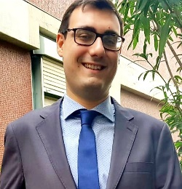
Dr. Massimiliano Gaeta was awarded the PhD degree in Chemical Sciences in December 2019 (University of Catania, Italy, supervisor: Prof. R.Purrello), defending the thesis entitled “Porphyrin-based nanostructures via self-assembly: non-covalent and covalent approach”. He spent part of his formation at Universidad Autònoma de Madrid (Madrid, Spain), to realize adsorbent materials based on covalent organic frameworks, and at CNR-ISMN (Messina, Italy) to investigate functionalised polymeric membranes for fuel cells. His main scientific interests are focused on hybrid supramolecular materials and engineered biocomposites. Currently, he is a Postdoctoral Researcher (University of Catania, Italy) working on novel bio-inspired composite adhesives from melanin-like polymers.

