Injectable polymer-nanoparticle hydrogel with pH and thermo-responsive drug release

Elisa Lacroce¹*, Filippo Rossi¹
¹ Department of Chemistry, Materials and Chemical Engineering “Giulio Natta”, Politecnico di Milano, via Mancinelli 7, 20131, Milan, Italy
*Elisa Lacroce E-Mail: elisa.lacroce@polimi.it

1.Introduction
Injectable polymer-nanoparticle hydrogels are promising tools in the field of cell and drug delivery. One of the principal advantages of the use of hydrogel for drug release is the possibility of being injected in a specific site of the body allowing a localized drug release, limiting the adverse effects related to its circulation in healthy tissues. In addition, the presence of polymeric nanoparticles inside the hydrogel improves the mechanical properties of the gel and guarantees the presence of hydrophobic and hydrophilic regions able to release drugs with different hydrophilicity and dimensions.
2. Methods
In this work we synthetized an injectable pH and thermo-responsive polymer-nanoparticle hydrogel following the procedure reported in literature by Eric A. Appel et al. [1] for the synthesis of HPMC-C₁₂ hydrogel and Chun-Liang Lo et al. [2] for the synthesis of poly(D,L-lactide)-g-poly(N-isopropylacrylamide-co-methacrylic acid) nanoparticles. In particular, a radical co-polymerization of monomers and a subsequent dialysis of the product were performed in order to obtain the polymeric nanoparticles. The release of a mimetic drug from nanoparticles was studied in acidic environment (pH=5) at different temperatures. Finally, the polymer-nanoparticle hydrogel was developed by mixing the functionalized HPMC-C₁₂ solution with the nanoparticle solution.
3. Results and discussion
The nanoparticles have pH and thermo-responsive behaviour due to the presence of PNIPAM, a thermo-responsive polymer, and methacrylic acid, sensible to pH changes. The presence of a temperature over 37°C and a pH 5 environment causes the collapse of the outer shell leading to structural changes of the core with the subsequent release of therapeutic drug encapsulated inside the nanoparticles. Results of the drug release at pH=5 from the PLA-g-P(NIPAm-co-MAA) nanoparticles showed a cumulative drug release of 60% at 42°C instead of 14% at 37°C after 96 hours. The formation of polymer-nanoparticle hydrogel was performed by mixing the two solutions with a luer lock mechanism and mechanical tests confirmed its injectability.
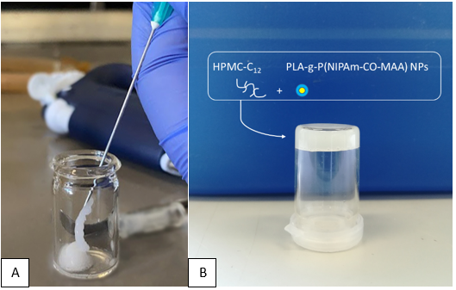
Figure 1. Representations of injectability (A) and schematic structure (B) of the polymer-nanoparticle hydrogel.

4. Conclusions
In this work we combined the injectability of the HPMC hydrogel with the pH and thermo-responsive properties of polymeric nanoparticles to develop a hybrid system for localized, controlled and temperature-dependent drug release.
References
[1] E. A. Appel, M. W. Tibbitt, M. J. Webber, B. A. Mattix, O. Veiseh, and R. Langer, “ARTICLE Self-assembled hydrogels utilizing polymer-nanoparticle interactions,” Nat. Commun., 2015, doi: 10.1038/ncomms7295.
[2] C. L. Lo, K. M. Lin, and G. H. Hsiue, “Preparation and characterization of intelligent core-shell nanoparticles based on poly(D,l-lactide)-g-poly(N-isopropyl acrylamide-co-methacrylic acid),” J. Control. Release, vol. 104, no. 3, pp. 477–488, Jun. 2005, doi: 10.1016/j.jconrel.2005.03.004.

