**Reaping Chemical Engineering heritage by leveraging green solvents:**   
**opportunities and issues**

Vittoria Sapone1, Alessio Mazzelli 2, Marco Valentini1, Agnese Cicci 2, Marco Bravi1*

*1 Dip. Ingegneria Chimica Materiali Ambiente, Sapienza Università di Roma, via Eudossiana, 18, 00184 Roma;*   
*2 NextChem Spa, Via Di Vannina, 88, 00156, Roma, Italy*

*\*Corresponding author E-Mail: marco.bravi@uniroma1.it*

**1.Introduction**

Renewably using biomasses in place of depleting fossil resources is seen as one major means for providing long-term viability to our civilization. However, the ubiquitous presence of oil refining products on today's market can be replicated by bio refined products only if biorefining technology achieves a degree of flexibility and optimisation resembling that attained by oil refining technology at a fraction of its current cost.

Learning the lesson from oil refining history begins with identifying a single (and ideally “universal”) unit operation, which should be flexible enough to be up to the hard challenge of addressing the fractionation of a diverse pool of biomass types, by providing an efficient separation of components with quite different physical characteristics [1]. Inasmuch as the diversity and complexity of biomasses is much higher than the diversity among crude oils, biomasses are solids, so the question arises as to whether, and in which way, extraction mediated by a solvent can be carried out to serve as a significant analogue of distillation in the “biomass age”.

As a route toward such an ambitious objective, the adopted unit operations might deploy reusable concepts and “pluggable” operating conditions and materials acting as solvents or modifiers thereof.

From a commercial point of view, compounds, or fractions, which can be obtained from biomasses (higher plants, macroalgae and microalgae) may have multiple markets which may require different specifications, impose different regulations, and consequently attach a different value to the very same semi-finished product. Hence, a process should aim at “market-neutrality” to avoid putting restrictions on the market placement of a product due to regulatory issues. In this scenario, beside the not yet solved issue of the primary biomass production costs, the evaluation and optimization of the biorefining costs is just as important and the level of optimization in this area is nothing but primitive.

The present article discusses two possible approaches to bio-refining whole biomass of the *Chlorella vulgaris* microalga, with different aims and readiness to market: obtaining raw primary fractions by a novel use of the so-called “switchable solvents” and fractionating tryglycerides and individual carotenoids by staged supercritical CO2 (sCO2)-assisted extraction.

**2. Approaches and methods**

2.1 Circular Extraction by using Switchable Solvents

One step in learning the lesson of oil refining may be taken by recalling analogies among unit operations from classical undergraduate unit operations courses in distillation, separation requires heat (the cost item), and is brought about by virtue of relative volatility (the driving force), under physical (diffusional) hindrances.

In solvent-mediated extraction separation requires a suitable solvent (the cost item) and is brought about by virtue of solubility in that solvent (the driving force), under physical (entanglement) and chemical bonding hindrances. Along oil refineries history, optimising distillation has implied optimising heat integration, in turn obtained by reusing the “same heat” at “different temperature levels” by designing the whole required heat exchange network by using the thermal pinch technology. The question arises, hence, as to whether useful hints toward optimised biomass fractionation can be found by taking the analogy route and looking for “reusable solvents” across “different solubility features” (i.e., solvents that may be modified, and thus be adapted) for very different tasks in the extraction process.

Switchable hydrophilicity solvents have only been used in their hydrophobic form to extract hydrophobic solutes. However, the treated biomass might also contain hydrophilic solutes, as well as debris that might not be soluble in either hydrophobic or hydrophilic solvents; hydrophilic solutes may be expected to be easily removed by treating with a hydrophilic solvent the residue which remained after the extraction with the hydrophobic solvent. It should be noted that, after completing the hydrophilicity switch, the formerly hydrophobic switchable hydrophilicity solvent has the very needed hydrophilicity character. The hydrophilic form of the SHS, obtained after switching, may thus be suitable for extraction of hydrophilic material from the raw biomass or separation of the hydrophilic material from the solid residue, obtained after that biomass has undergone an extraction by the SHS in hydrophobic form. By noting that both hydrophilicity states of the original switchable solvent can be used in two specific and complementary extraction tasks, it can be concluded that the biomass extraction can begin with either the hydrophobic or the hydrophilic form of the solvent and may continue with the other form and can be started from either form of the solvent itself. This dual use of SHSs, denoted as “Circular Extraction”, has been touted to increase the utility of the extraction process and of the solvent itself because of the second (complementary) biomass extraction task, and to be potentially conducive to a reduction of the environmental impacts associated with the solvent because these latter are now amortized over two extractions per cycle [2].

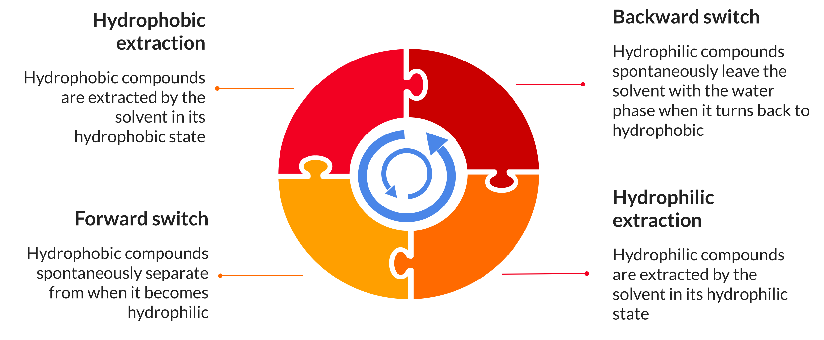

**Figure 1.** Sequential two-stage extraction by switchable solvents in Circular Extraction. in counterclockwise (“forward”) or counterclockwise (“backward”) arrangement..

Some chemicals exhibiting switchable behaviour provide a specific additional performance as a cell-breaking means or tolerate the presence of water in the biomass thus bringing a substantial process simplification and energy requirement. Here, we will demonstrate the bio-fractionating approach by dimethylcyclohexylamine (DMCHA), which can be switched by using CO2 and a Natural Eutectic System (NaDES) based on the mixture of food-grade caprylic and lauric acid, which can be switched by a very low toxicity amine (Jeffamine) [3]. The microalgal biomass, produced in house by autotrophic growth in pure culture, was processed in the wet state in an orbitally agitated flask. Extraction rates were calculated: for lipids, by weighing the recovered material; for carbohydrates and proteins, by assaying the undissolved residue by the appropropriate test (Lowry and Dubois).

2.2 Staged s CO2-assisted extraction and fractionation

The extraction and fractionation of *C. vulgaris* to obtainhigh value-added components, including carotenoids and Omega-3, by employing sCO2 and, when necessary, ethanol as co-solvent, was carried out as a two-stage process. During the first stage, triglycerides are extracted but carotenoids remain in the matrix and are removed in a second extraction phase. The operation was evaluated by an overall model implemented as a combination of two different sub models: a model describing the extraction of triglycerides, and a model for describing the extraction of carotenoids. Both models were adopted from the open literature. The extraction of triglycerides was modelled according to Sovova [4][5] “Broken and the Intact Cell” model” by assuming an appropriate size of dried microalga beads. Equations (1) and (2) relevant to the “fast” and “slow” period, respectively, make up the extraction model:

while external mass transfer resistance, θf , was expressed as the ratio to the residence time tr, of the fluid phase mass transfer characteristic time, tf. This latter was estimated by calculating the Sherwood number of the microalgal beads and the diffusivity of lipids as described in detail in [6]. The carotenoids extraction process using sCO2 and ethanol as a co-solvent was calculated by the Reverchon [7] kinetic model. In lack of a full set of experimental data that could allow adopting motivation either model structure (Sovová or Reverchon) for both molecule classes, the detailed motivation for using two separate models is discussed [6]. The characteristics of the microalgal biomass during the second extraction phase were assumed to be equal to those of unextracted biomass. The diffusivity of carotenoids in the microalgal matrix was assumed after Macías-Sánchez [8] who determined it in *Nannochloropsis gaditana* cells. The co-solvent-to-solvent ratio employed for the modelling was adopted after a literature survey and fixed to 5% w/w.

CO2 density was calculated by the Huang equation [9], compounds solubility by the Chrastil model [10], whose thermodynamic parameters were estimated by a group contribution method. SCO2 viscosity was estimated as done by Heidaryan [11] while the diffusivity of each component in the solvent was calculated as done by He [12].

The simulation of the entire process was carried out employ- ing the Aspen Plus software (V10, AspenTech). The daily biomass feed was set to 360 kg. The optimal operating conditions were optimised by MATLAB, to estimate the saturation times and the equipment volume. The extraction process was carried out in batch. Therefore, as the spreadsheet software can only be employed for continuous processes, the simulation was integrated with the system analysis carried out by using MATLAB. An optimization of the operating conditions for each microalgal component was carried out, by using the previously described models and by assuming that carbohydrates are in starchy form and that proteins share the composition of the most represented aminoacid of the microalga, i.e. leucin. The design of the equipment was carried out according to classical engineering criteria, calculated residence times were confirmed by qualified industry professionals and the cost of equipment with the volumes processed was provided by vendors. When the amount of extract and the density of the currents were known, the sizing of vessels was done. Regarding the CAPEX, each equipment was designed according to manuals [13]. The compressors and pumps power and their minimum energy consumption was calculated by Aspen Plus. The use of Aspen plus software for energy and sCO2 consumed allowed the calculation of OPEX.

**3. Results and discussion**

3.1 Biofractionation of *C. vulgaris* by Circular Extraction use of switchable solvents

Extraction results (Figure 2) showed that lipids extraction was nearly quantitative and confined to the hydrophobic phase, while the extraction of both proteins and carbohydrates occurs partly in the hydrophobic phase and partly in the hydrophilic phase, arguably according to the affinity with the solvent. For proteins, DMCHA still had some edge over NaDES-based extraction, while the reverse is true for carbohydrates. Carbohydrates are extracted for the most part during the hydrophobic stage, while the reverse is true for proteins. In “Backward mode”, observed yield is similar, but protein extraction was essentially carried out during the hydrophilic stage for the NaDES-based extraction, while with DMCHA some additional gain was observed also during the hydrophobic stage. Carbohydrates extraction, however, received a significant boost during the hydrophobic stage, and this was observed with both solvents.

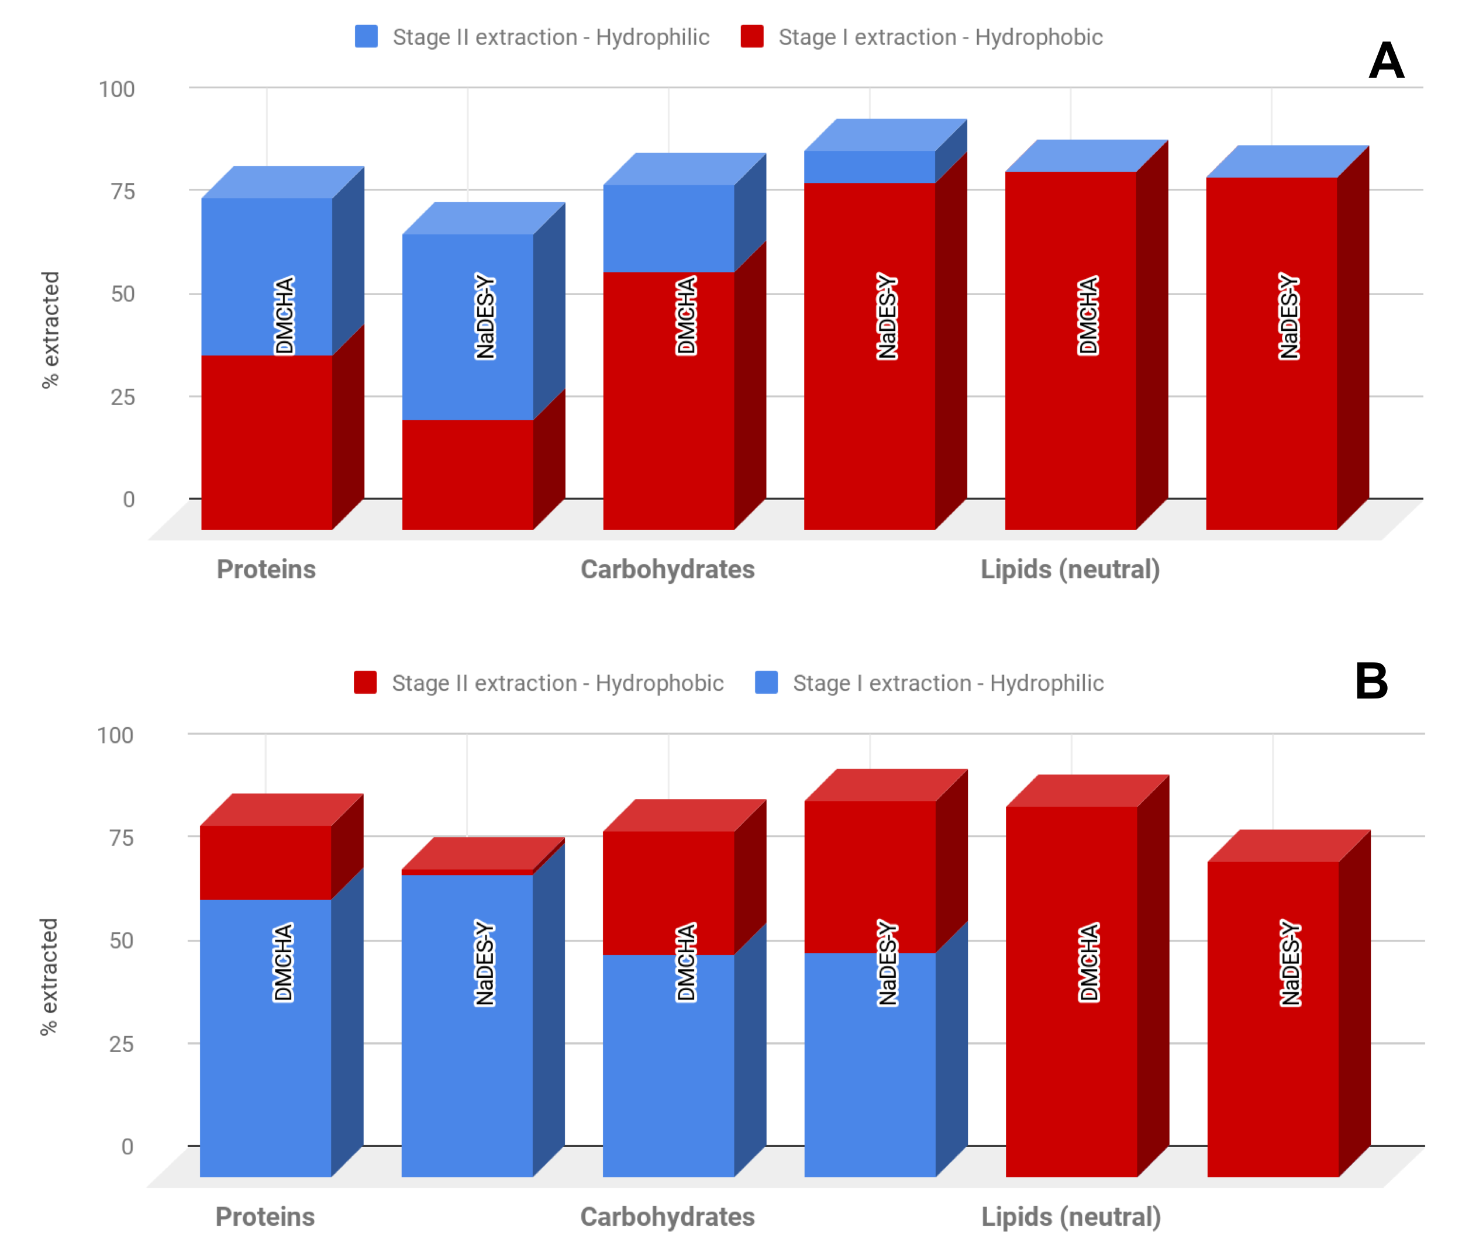

**Figure 2.** Results of *C. vulgaris*  biofractionation into primary fractions by Circular Extraction use of switchable solvents with "forward” (subfigure A) and “backward” (s. B) ordering of extractions

3.2 Biofractionation of *C. vulgaris* into triglycerides and carotenoids by sCO2

Given the different grounds and level of development of this application, the relevant part of results deals with the time-averaged results that are obtained in optimised conditions. These latter were found at 50 °C, 200 bar, and 5 kg/kg solvent to solid ratio for both extraction phases, thus allowing a total of 3 full biomass extractions per day. By recovering the extract from the two extraction phases in different vessels, the overall daily yield of the first phase is 38.3% of the feed, while that of the second is 2.3%. No carbohydrates or proteins were anticipated in the extracts. During the depressurization phase, the solvent contained in the extractor is not recovered; therefore, a daily CO2 make up of 485 kg for all the extractions was calculated. A loss of ethanol with the extracts was also quantified. A process scheme was designed (Figure 3) and, by using the approximate costing procedure described previously, a Total Treatment Cost of the microalgal feed of 44 Euro/kg was anticipated, that lies within the range of values for pigment production from 12.50 D /kg to 107.95 D/kg cited by Slegers et al. (2020). In addition, the present work satisfies the conditions required by Slegers et al. [14] to develop a profitable microalgae production chain because there are technological innovations enabling cost reductions, especially in micro-algae production and is present a developing multiproduct biorefinery concepts aimed at valorizing the full biomass through the cascading principle deriving a range of new specialty products with applications in food, aquaculture and non-food.

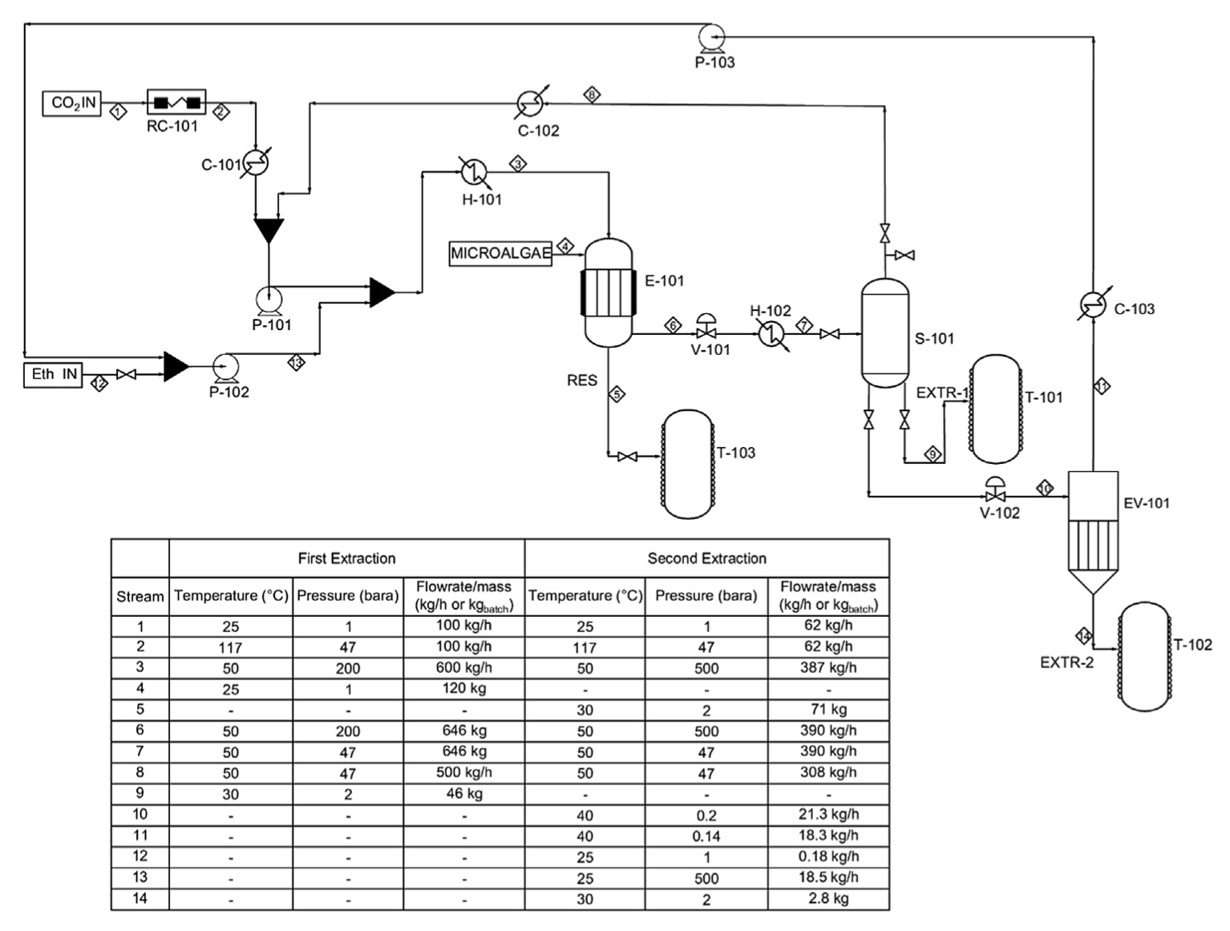

**Figure 3.** Process scheme for the batch biorefining of *C. vulgaris* to triglycerides and carotenoids by sCO2.

**4. Conclusions**

Biorefining is a key “macro” operation of the biomass age and a fundamental one to obtain the full biologic and economic value of the processed biomasses. This article has shown that existing industry-standard bio-safe processes such as sCO2-assisted extraction can provide an array of high value lipidic compounds. However, carbohydrates and proteins are left in the residue, and should be therefore extracted from the biomass residue by further, cascaded processes. Furthermore, sCO2 turnover is highly energy intensive even more than most classical evaporative processes. Doing without phase change can prospectively save energy and keep the product safe and can be done in a neat way by using switchable solvents in a Circular Extraction approach, enabling one-pot processing, in some cases also dispensing biomass drying and fragilization needs with. However, a lot of work needs to be done from the thermodynamic, kinetic, and process development point of view to make bare “maximum yields” into reliable process development at the expected TRLs for industrial application.

**References**

1. González-Delgado, A.D. and Kafarov, V., 2012. Microalgae based biorefinery: evaluation of several routes for joint production of biodiesel, chlorophylls, phycobiliproteins, crude oil and reducing sugars. Chem Eng Trans, 29(1), pp.607-612.
2. Cicci, A., Sed, G., Jessop, P. G., Bravi, M. (2018). Circular extraction: an innovative use of switchable solvents for the biomass biorefinery. Green Chemistry, 20(17), 3908-3911.
3. Sed, G., Cicci, A., Jessop, P. G., Bravi, M. (2018). A novel switchable-hydrophilicity, natural deep eutectic solvent (NaDES)-based system for bio-safe biorefinery. RSC Advances, 8(65), 37092-37097.
4. H. Sovová, Mathematical model for supercritical fluid extraction of natural products and extraction curve evaluation, J. Supercrit. Fluids. 33 (2005) 35–52. <https://doi.org/10.1016/j.supflu.2004.03.005>.
5. H. Sovová, Modeling the supercritical fluid extraction of essential oils from plant materials, J. Chromatogr. A. 1250 (2012) 27–33. <https://doi.org/10.1016/j.chroma.2012.05.014>
6. Mazzelli, A., Valentini, M., Cicci, A., Iaquaniello, G., Bravi, M. (2022). Industrial bio-fractionation process of microalgae valuable products using supercritical CO2. A techno-economical evaluation. Chemical Engineering Research and Design, 178, 50-60.
7. E. Reverchon, G. Donsi, L.S. Osseo, Modeling of Supercritical Fluid Extraction from Herbaceous Matrices, Ind. Eng. Chem. Res. 32 (1993) 2721–2726. https://doi.org/https://doi.org/10.1021/ie00023a039.
8. M.D. Macías-Sánchez, C.M. Serrano, M.R. Rodríguez, E. Martínez de la Ossa, Kinetics of the supercritical fluid extraction of carotenoids from microalgae with CO2 and ethanol as cosolvent, Chem. Eng. J. 150 (2009) 104–113. https://doi.org/10.1016/j.cej.2008.12.006.
9. Huang, Z., Shi, X.-H., Jiang, W.-J., 2012. Theoretical models for supercritical fluid extraction. J. Chromatogr. A 1250, 2–26, http://dx.doi.org/10.1016/j.chroma.2012.04.032.
10. J. Chrastil, Solubility of Solids and Liquids in Supercritical Fluids, J. Phys. Chem. 86 (1982) 3016– 3021. https://doi.org/https://doi.org/10.1021/j100212a041.
11. E. Heidaryan, T. Hatami, M. Rahimi, J. Moghadasi, Viscosity of pure carbon dioxide at supercritical region: Measurement and correlation approach, J. Supercrit. Fluids. 56 (2011) 144– 151. https://doi.org/10.1016/j.supflu.2010.12.006.
12. C.-H. He, Prediction of Binary Diffusion Coefficients of Solutes in Supercritical Solvents, AlChE J. 43 (1997) 2944–2947. https://doi.org/https://doi.org/10.1002/aic.690431107.
13. R. Peters, M., Timmerhaus, K., West, Plant Design and Economics for Chemical Engineers, McGraw-Hill Education., 2002.
14. P.M. Slegers, G. Olivieri, E. Breitmayer, L. Sijtsma, M.H.M. Eppink, R.H. Wijffels, J.H. Reith, Design of Value Chains for Microalgal Biorefinery at Industrial Scale : Process Integration and Techno-Economic Analysis, 8 (2020) 1–17. https://doi.org/10.3389/fbioe.2020.550758.