**Methane cracking in molten tin to produce pure hydrogen and carbon.**

Benedetta de Caprariis1*, Paolo De Filippis1, Francesco Anania1, Gaetano Iaquaniello2*

*1 Department of Chemical Engineering, Sapienza University of Rome; 2 NextChem S.p.A.*

*\*Benedetta de Caprariis E-Mail: benedetta.decaprariis@uniroma1.it*

**1.Introduction**

Methane cracking is considered a bridge technology linking the production of grey and green hydrogen. Processes with the aim of producing hydrogen from renewable and green sources are still not ready for an industrial scale-up. The price of the green hydrogen is too high compared to the grey hydrogen produced by fossil fuels [1]. Scientific and industrial research activities in this sector are continuously improving the state of the art and a possible industrialization of these processes at a competitive price is expected in no less than 10 years. Electrolysis of water is the only green process which was scaled up at industrial level and which contributes for a quote of 4 % to the total hydrogen production. The rest of the hydrogen comes from fossil fuels contributing thus to the CO2 emissions. To respect the limits imposed by European Union in 2050, waiting for the industrialization of green hydrogen production processes, a viable alternative is the methane cracking.

Methane cracking involves the reaction (1).

CH4 = C+2H2 (1)

Methane at high temperature is cracked into carbon and hydrogen. The produced hydrogen is pure and the carbon is a solid and, thus, easy to be separated. The carbon is a key product of the process, depending on its physical and chemical properties, it can be valorized or sequestrated making the process zero CO2 emission. As already demonstrated the carbon can be produced in different forms such as carbon coke, carbon nanotubes and others, some of which can have a very high commercial value. However, this process presents several issues which should be addressed before it can be scaled up. The reaction takes place at very high temperatures (about 1000 °C) and a catalyst is needed to obtain reasonable conversion of methane. The process produce carbon and thus the traditional catalysts (such as supported Ni) are immediately deactivated, furthermore the production of carbon creates serious problems of reactor clogging [2]. To overcome these problems traditional reactors should be completely revolutionized.

Aim of this work is to develop an innovative methane cracking reactor using molten tin as medium for the methane cracking reaction. The use of molten tin leads to several advantages; tin has an excellent thermal conductivity and thus the heat transfer between the medium and the methane is enhanced, its melting temperature is low, its vapor pressure is very low at the used temperatures assuring a low vaporization of the tin and thus low tin loss in the outlet gas flow. Furthermore, its density is higher than that of the produced carbon which implies the floating of the carbon on the tin and thus and easy separation between them. The use of tin has already been explored in literature for methane cracking [3,4], however a systematic study where the influence of temperature, residence time, and presence of filler is investigated is not present.

**2. Methods**

The tests are conducted in a quartz fixed bed tubular reactor (1.7 cm in diameter and 35 cm height) filled with liquid tin and heated by an external electric furnace. The methane is injected into the reactor by a capillary with internal diameter of 0.25 mm. The tested temperatures range between 950 and 1070 °C and the methane inlet flow rate between 30 ml/min to 60 ml/min. The effect of the bed height on the methane conversion was also investigated, the tests were performed in three different bed heights, 15, 18, 20 cm. The filler used has spheric shape with a diameter of 3 mm made of aluminosilicate. At the reactor exit the produced carbon is separated in a flask and characterized by SEM, XRD and Elemental analyzer and the gas is sent to a Mass Spectrometer for the analysis. The experimental set-up is reported in Figure 1.

**Figure 1.** Experimental set-up.

**3. Results and discussion**

In Figure 2 the results of the tests made for different bed heights and different flow rates are reported. The maximum conversion, about 20 %, is reached for 15 ml/min of methane flow rate and 150 mm of bed height. The conversion at 1070 °C is quite low but it was expected in absence of a catalyst and a filler. The conversion decreases when the flow rate is increased since the residence time decreases, however a strange behavior is noted increasing the bed height. It seems that the increase of the bed height and, therefore, of the residence time led to a worse conversion for a constant flow rate.

However, the increase of the bed height favors the formation of carbon, in fact when the tests are made using a bed height of 150 mm the carbon is produced in form of a very sticky liquid which by the GC-MS analysis resulted to be made of PAH. The carbon formation in fact involves several reactions; the carbon can be formed directly from the methane decomposition or can be formed passing through the production of PAH which needs higher residence time to dehydrogenate to form pure carbon. Pure carbon is produced only when the bed height is increased to 210 °C. The carbon is in form of fine sheet having a depth of 200 nm.

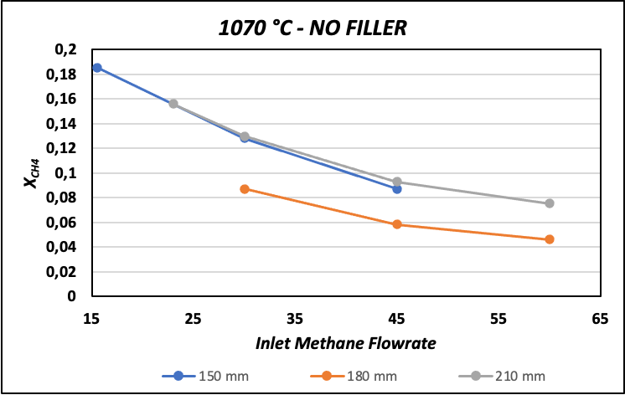

**Figure 2.** Tests made at different methane flow rate and bed height at a constant temperature of 1070 °C

One of the critical points of the process is the separation between the carbon and hydrogen. The carbon is collected on the top of the tin bed. To avoid the presence of tin entrained by the carbon it is important to create a calm zone in the reactor where the carbon and the tin can have the time to be divided into two distinct layers.

The tests at different temperatures were made at a constant bed height of 15 cm and at a flow rate of 30 ml/min. The tests (Figure 3) show that the reaction in absence of catalyst is activated at temperature higher that 1020 °C. The conversion for lower temperature is almost zero.

The tests made with the spherical filler into the tin bed



**Figure 3.** Tests made at different temperature (Bed height 15 cm and CH4 flow rate 30 ml/min)

The tests with the filler show that the conversion can be increased consistently. In Figure 4 the results of a long duration test are reported, it can be noted that the filler has a very goof stability since the conversion remains constant all the 24 hours.

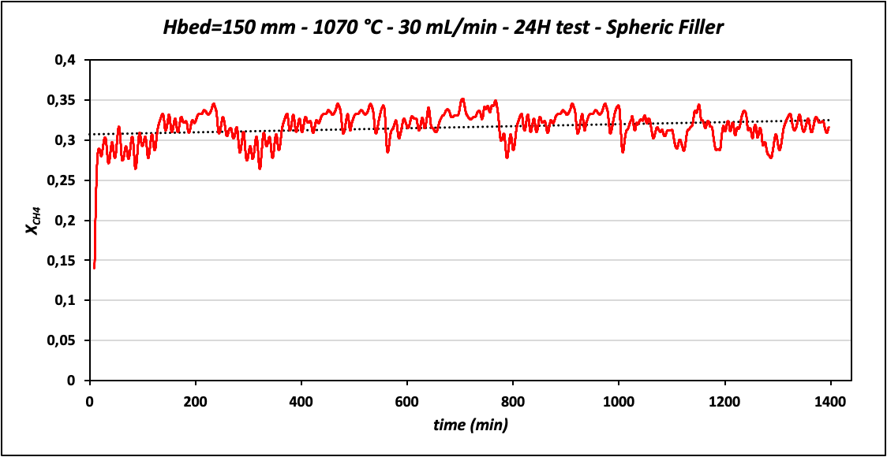

**Figure 4.** Long duration test with spherical filler.

**4. Conclusions**

The results show that residence time and bubble dimension play a fundamental role on the process. The average methane conversion is about 15 % which is enhanced in presence of the filler up to 30 %. However, the presence of the filler makes the separation between carbon, filler and tin not trivial. The bed heigh is also a fundamental parameter, higher is the bed, higher is the quality of the obtained carbon but the increase of the bed height seems not favor the methane conversion. This study demonstrates the feasibility of the methane cracking in molten tin reactor for the production of pure hydrogen without CO2 emissions. The value of methane conversion obtained in the tested conditions are satisfactory to envisage a scale up in the reactor which was designed for this application.

**References**

1. L. Weger, A. Abanades, T. Butler, Int. J. Hydrogen Energ. 42 (2017) 720-731.
2. A. Amin, E. Croiset, W. Epling, Int. J. Hydrogen Energ. 36 (2011) 2904-2935.
3. I.V. Kudinov, A.A.PimenovY.A.KryukovG.V.Mikheeva, Int. J. Hydrogen Energ. 46 (2021) 10183-10190.
4. M.Msheik, S.Rodat, S.Abanades, Energies, 14 (2021)3107-3112.