**Facile and Scalable Synthesis of Cu2O-SnO2 Catalyst For The Photoelectrochemical CO2 Conversion**

Zoli Maddalena1*, Roldán Daniela1, Guzmán Hilmar1, Castellino Micaela1, Chiodoni Angelica2, Bejtka Katarzyna2, Russo Nunzio1, Hernández Simelys1*

*1 CREST group, Department of applied science and technology (DISAT), Politecnico di Torino, Turin, Italy;  
2 Center for Sustainable Future Technologies, IIT@Polito, Istituto Italiano di Tecnologia, Turin, Italy*

*\*Corresponding author E-Mail: maddalena.zoli@polito.it; simelys.hernandez@polito.it*

**1.Introduction**

CO2 concentration in the atmosphere is increasing every year from the 50s, at the beginning of industrial acceleration, up to now, when it exceeds 410 ppm. Since natural CO2 sink cannot keep up with the constant anthropogenic emissions, a renewable and green approach to CO2 recovery is increasingly necessary to minimize its worrying impact on the environment. Within the depicted scenario, electrochemical and photoelectrochemical CO2 reduction processes have been widely investigated as promising methods to transform CO2, under mild reaction conditions, into useful chemicals or fuels [1,2]. The first challenge of such processes is to find suitable catalysts with a high activity, good charges separation and improved solar conversion efficiency. Whitin this work, we focused on the CO2 reduction reaction (CO2RR) path directed towards products like CO (the syngas production is also taken into consideration) and formic acid, for which the transfer of 2 electrons is required. Cu2O is a cheap, abundant, and intrinsically p-type semiconductor. Due to its narrow band gap (~ 2.1 eV) and the suitable positioning of conduction and valence bands, Cu2O is an ideal photocatalyst for CO2RR. Despite these promising features, Cu2O is limited by its instability and continuous decrease of photoactivity under operative conditions [3]. The coupling cuprous oxide with a with a n-type wide bandgap semiconductor is here investigated as an effective way to prevent its self-photoreduction or oxidation. A noticeable electron mobility together with a good intrinsic stability have driven the choice towards tin oxide (SnO2), which is also able to form a p-n junction with the Cu2O photocatalyst.  
In this work we target the development of a facile and scalable synthesis method for the Cu2O-SnO2 catalyst. A particular focus is given to the preparation of photoelectrodes for the photo-electrocatalytic CO2 reduction process and, finally, the evaluation of the catalyst performances in terms of stability and faradaic efficiencies of the target products.

**2. Methods**

The synthesis of photoactive copper-tin-oxide-based catalyst was optimized by an ultrasound assisted co-precipitation method. The significant advantages of the sonochemical synthesis approach [4] guided the choice of coupling these two methods. In addition, the reproducibility of the synthesis is boosted by using a completely automatised set-up made of peristaltic pumps. The characterization steps included several techniques: Transmission Electron Microscopy (TEM), Field Emission Scanning Electron Microscopy (FESEM), X-ray photoelectron spectroscopy (XPS) X-rays Diffraction Analysis (XRD), among others, and allowed the morphological assessment and the crystalline phase evaluation.

**3. Results and discussion**

From XRD on catalyst powder, it was found a correspondence to the cubic crystalline phase (cuprite) of Cu2O which points out the suitability of the synthesis method. The elemental composition of the material was evaluated by comparing XPS and EDX (Energy Dispersive X-Ray) results both in the bulk and on the surface. It appears that the stannous compound presence is mainly present onto the surface of the catalyst, constituting a protection layer to Cu2O. The study on specific surface area and porosimetry of the material, measured from N2 adsorption/desorption isotherms, revealed a mesoporous structure with a BET surface area value of 142 m2/g, a pore volume of 0.12 cm3/g and an average pore width of 5.9 nm, which were detected via BJH method. From UV-Visible Spectroscopy analysis, the band gap energy value of 2.5 eV was calculated via Tauc plot method. The composition of a catalyst-based ink was optimized to avoid the Cu(I) oxidation during the electrodes preparation and preserve the catalyst photoactivity, which was assessed for the photo-electrocatalytic CO2 reduction in an H-cell system. The PEC behaviour of Cu2O-SnO2 catalyst was evaluated using these photocathodes, for the photo-electroreduction of CO2 in bicarbonate-based electrolyte. Cyclic Voltammetry tests carried out in both N2 and CO2 saturated environment showed more than double current density values with CO2 (-1.25 vs. -2.75 mA cm-2), confirming an higher activity towards CO2 reduction. Moreover, Linear Sweep Voltammetry and Chronoamperometry tests were leaded under the alternance of dark and light conditions, in order to show up the photoactivity of the catalyst. As reported in Figure 1, the photocurrent density was maintained stable for one hour (red dots), as evidence of the system stability.  
Chronopotentiometry tests at different current density values were performed, and the Faradaic efficiencies (FE) of both gaseous and liquid products were evaluated. CO was detected from the test at -1 mA cm-2 with a FE = 8%, and it reached a maximum (FE = 18.5%) by applying -3 mA cm-2. Also, we investigated how the simulated sunlight illumination can affect the products composition. Test carried out under light conditions were found to hinder the H2 evolution (by a factor 1.5) and to produce around a double amount of CO (4.02% vs. 8.43%) and Formate (2.48% vs. 4.75%) with respect to dark conditions. Finally, ex-situ characterizations (XRD) of the electrodes after the photo-electrocatalytic tests pointed out a partial change of the Cu oxidation state, from Cu(I) to metallic Cu.

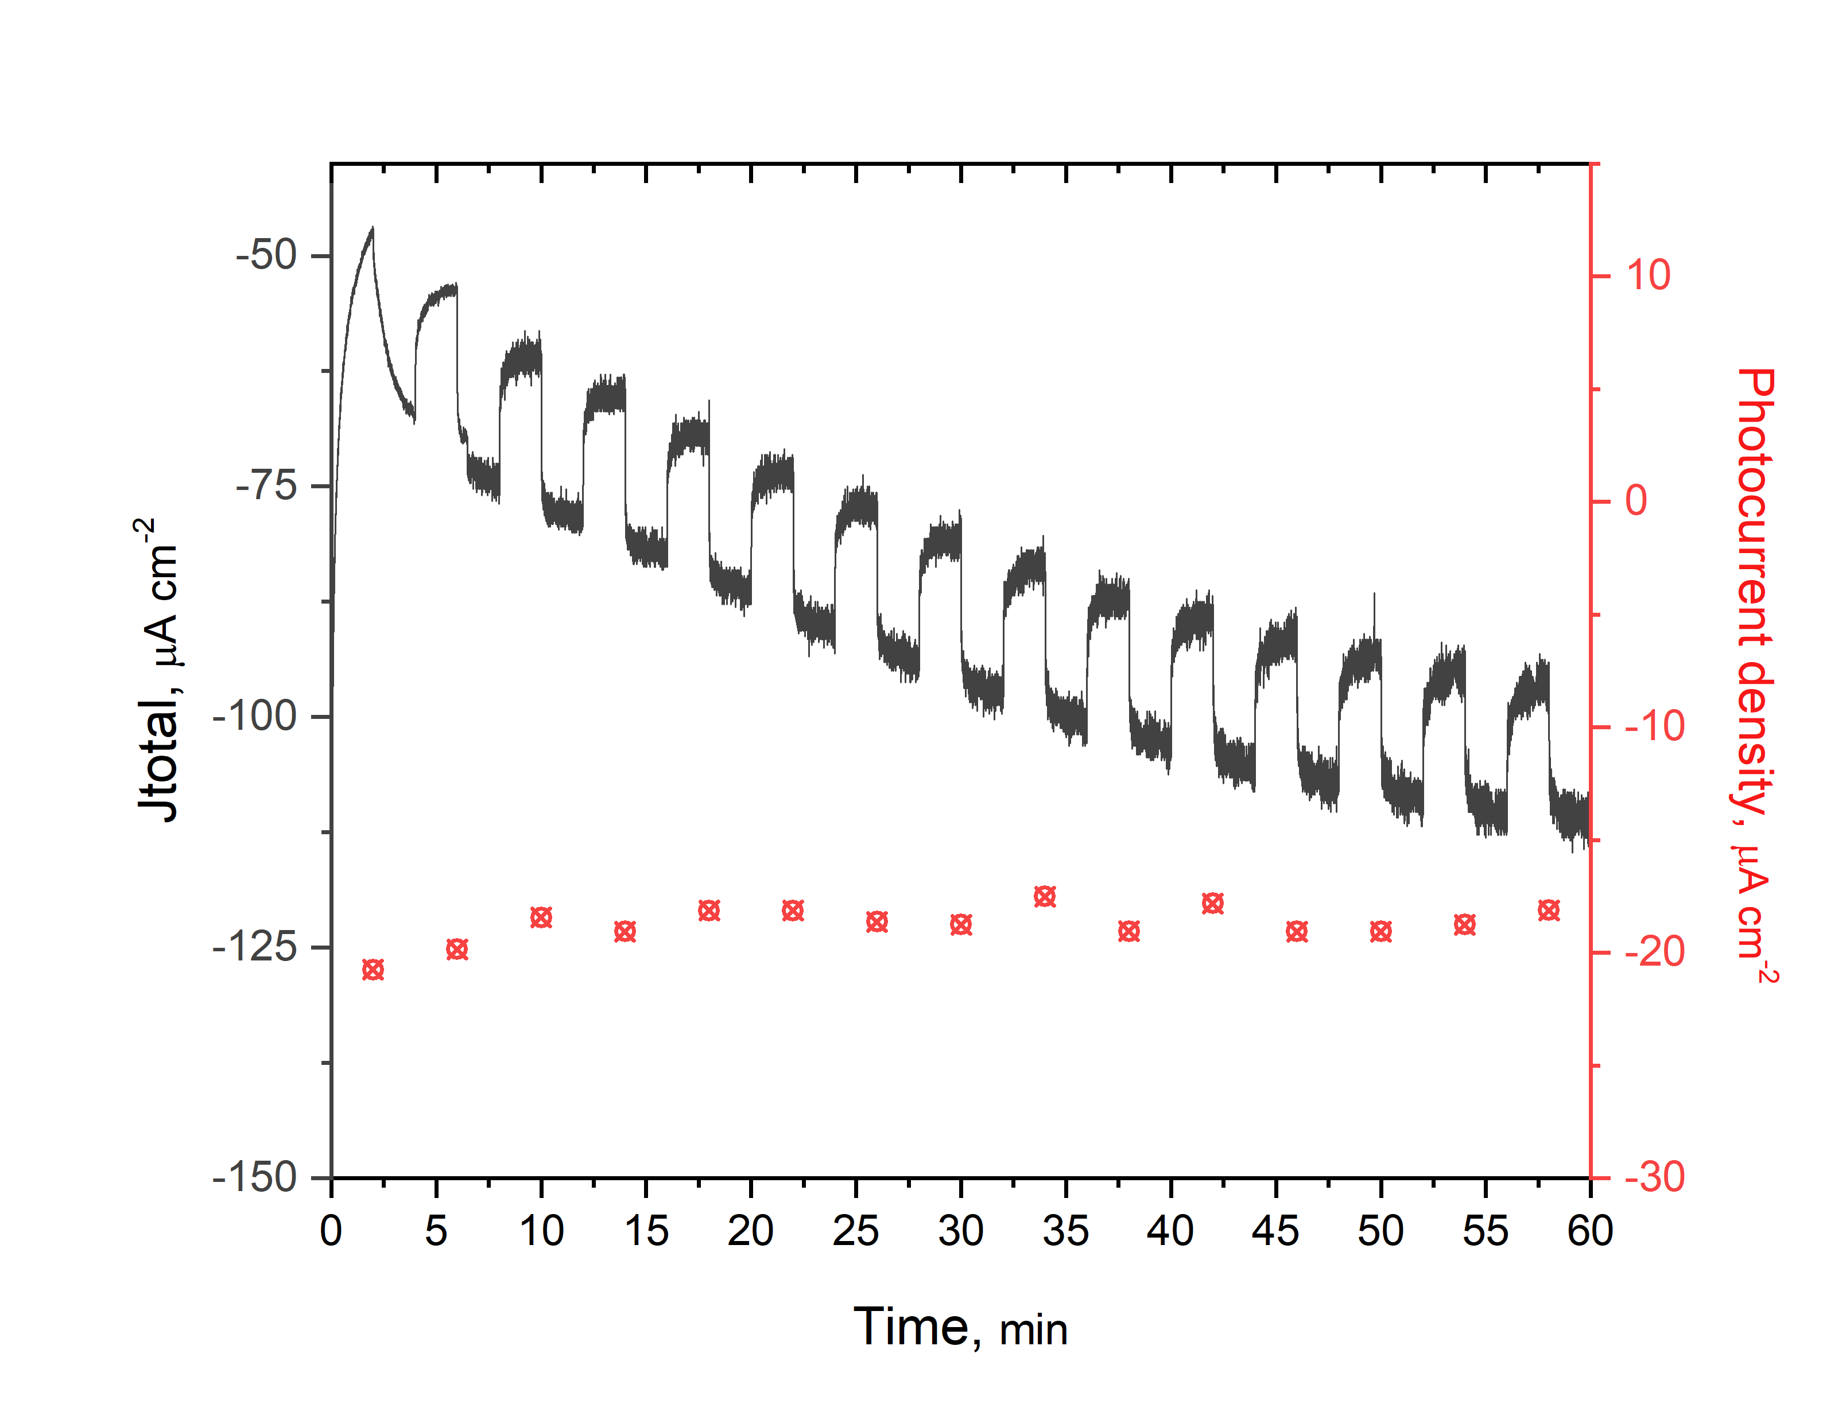

**Figure 1.** Chronoamperometry test plot, -250mV vs. RHE, under an alternated enlightenment (each 2 mins).

**4. Conclusions**

In conclusion, a simple, scalable, and reproducible method was developed for the Cu2O-SnO2 synthesis. A complete characterization allowed to investigate the catalyst morphology and the Cu(I) phase was found onto the photocathodes. Photo-electrocatalytic CO2 reduction tests were carried out to finally assess the stability of the catalyst during time and the syngas and Formate production was evaluated in terms of their Faradaic efficiencies, showing a noticeable increase of C-based compounds under light conditions. It confirmed that the use of visible light seems to be highly appealing for the photoexcitation of CO2·- richly mentioned in literature as the activated species of CO2. Further developments will be devoted to optimize the SnO2 loading into the Cu2O photocatalyst and the sunlight utilization of this photo-electrocatalytic system.

Acknowledgements: The research leading to these results has received funding from the EU’s Horizon 2020 Research and Innovation Action under the SunCoChem project (Grant Agreement No 862192).

**References**

1. S. Hernández et al., Green Chem. 19 (2017) 2326-2346
2. H. Guzmán, S. Hernández, N. Russo, Green Chem. 23 (2021) 1896-1920
3. Paracchino, A., Laporte, V., Sivula, K. et al., Nature Mater 10(2011)456–461
4. S. Yadav et al., Ultrasonics Sonochemistry 61 (2020) 104839