**Analyzing the production of pure K2SO4 via rigorous process simulation to overcome lack of literature and experimental data**

Marco Vaccari1*, Livia Di Palma1, Leonardo Tognotti1, Giovanni Papa2, Elisabetta Brunazzi1

*1 University of Pisa, Department of Civil and Industrial Engineering, Largo Lucio Lazzarino 2, 56126 Pisa (Italy)*

*2 Altair Chimica SPA, Saline di Volterra (PI), Italy*

*\*Corresponding author E-Mail: marco.vaccari@ing.unipi.it*

**1.Introduction**

Potassium sulfate (K2SO4), a chlorine-free potash fertilizer, is commonly used to supply essential potassium for plant growth, and the traditional and most widespread production process is the Mannheim one [1]. Another production process composed of a larger number of phases but characterized by decidedly more moderate operating conditions include the co-production of K2SO4 and ammonium chlorine (NH4Cl) [2]. The maximum temperatures of the process considered reach 60°C against 600°C of the Mannheim case, and pressure is also moderate as 101,325 KPa are maintained up to the evaporative crystallization which instead occurs at 10 KPa. In addition, the chemicals involved are less dangerous than sulfuric and hydrochloric acids which necessarily follow the most stringent regulations that influence the production process, storage, and disposal of effluents.

A recent pilot plant of this process was designed in an Italian chemical company (later named Altair), in which facility the presence of several production lines covering part of the necessary reagents (KCl, FeSO4) implied a strong saving on raw material costs and a more favorable integration with the existing plants rather than the Mannheim process. Few aspects concerning the complex chemistry behind the unit operations at stake together with its missing description in international reference documents [3], make the definition of the operating conditions for obtaining the maximum production of potassium sulfate not an easy task. In fact, the process yield strictly depends on the possibility of accurately predict the co-precipitation of salts in solution and therefore limiting the production of by-product as much as possible. For the aforementioned reasons, literature or experimental data on solubility of the salts in the particular solution of interest for this process are very difficult to find, whether not present at all at the operating conditions required.

In this context, the purpose of this work is to study the production process of K2SO4 with the help of rigorous process simulation to better analyze how the production of by-products (NH4Cl) can be minimized by understanding how the solubility of these two main salts are affected by their interaction.

**2. Methods**

One of the main issues related to the original design and subsequent construction of Altair K2SO4 pilot plant is represented by the study of the fractional crystallization of the mother liquors after the first precipitation of K2SO4. The lack of solubility data for the fractional crystallization step and in general the influence of NH4Cl on K2SO4 is crucial information to define the plant parameters to maximize the precipitation of the product.

The quantities of species present in the treated solutions in the processes examined give rise to complex electrolytic solutions. Consequently, it is necessary a simulator capable, through complex mathematical models, of creating a robust and reliable model able to predict the behavior of the various components.

For these reasons, the tool chosen in this work is the software UniSim Design R470 with OLI Engine as the thermodynamic package.

In the production process of K2SO4, it is important to have a reliable simulator for predicting solubilities as various competitive precipitations are at stake that can influence the crystallization of the main product. Consequently, the choice of the thermodynamic model falls on MSE for the following reasons: possibility to simulate solutions from infinite dilution down to pure solute, and high accuracy in the prediction of the properties of multicomponent systems with several concurrent solid phases. In addition, it is possible to reproduce properties of systems with two ionic liquid phases and calculation of solid-gas (or sublimation) as well as vapor-liquid, solid-liquid and liquid-liquid equilibria are available.

The tools chosen for the analysis and the simulation of the process, possess different potentialities useful to better characterize this study and they can offset the lack of literature data in this area. Therefore, to study the reciprocal solubility of the main salts in solution, a first validation of the simulator has been performed by testing the solubility of the single salts in water with literature data [4]. As expected, the validation tests carried out demonstrated the reliability of the software, this allowed us to continue with the study of mixed salts in solution. Since the maximum temperature reached in the process is about 56 °C, solubilities of K2SO4 in function of percentage by weight of the NH4Cl in solution and vice versa are studied in the range 10-60 °C as shown in Figure 1. This study is necessary as before the last crystallizer both salts coexist in an unsaturated ammonium chloride solution. In general, the greater the amount of NH4Cl, the more K2SO4 remains in solution even if the trend in the left panel of Figure 1 is showing a non-monotone behavior of the solubility curve. The maximum solubility of K2SO4 occurs around 17%wt NH4Cl at 55°C, while at lower temperatures the maximum shifts on greater amounts. Instead, the trend shown in the right panel of Figure 1 is monotone decreasing, indicating that as the %wt of K2SO4 increases in the solution, the greater is the amount of NH4Cl that precipitates.

Hence, the two salts in solution actually influence each other, both counterproductively for the purposes of the objectives of the studied process. This explains the difficulty of the evaporative fractional crystallization since, compared to the design expectations based on salt-water solubility, less pure K2SO4 and a higher quantity of mixed salts are obtained.

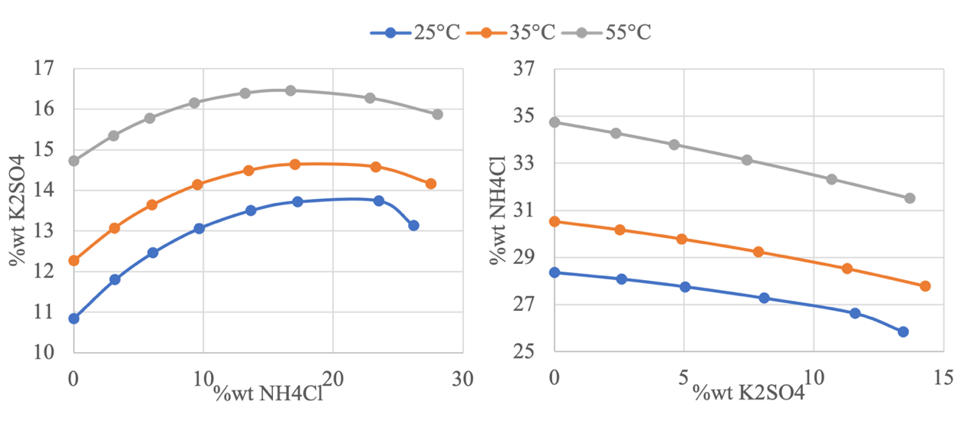

**Figure 1.** Trend of the solubility of the two salts with respect to the second one at different temperatures. On the left K2SO4 as a function of the % wt of NH4Cl, and on the right NH4Cl as a function of the % wt of K2SO4.

Once verified the combined solubility of the two salts, the entire pilot plant has been simulated to verify how the yield results are distant from the original design. The stationary batch pilot plant is simulated as a continuous process with the additional fictitious streams leaving each crystallizer. The purpose of these streams is to simulate the increase in flow rate accumulated in the various operating cycles of the equipment. The PFD of the simulated process production of K2SO4 as by design of the Altair pilot plant is reported in Figure 2.

The process starts with the carbonation of ammonia; the process feed constituted by a stream of 30% ammonia solution [33] (Stream 1 in Figure 2) diluted with fresh water (Stream 2) and a gaseous supply of CO2, is sent to the reactive absorption column to obtain the production of a solution of (NH4)2CO3 2.2 M (Stream 4).

In the atmospheric batch column, the aqueous streams are recycled until a pH value of 9.4 is obtained. This value was fixed through experimental tests and selected as ammonium carbonate is formed complete, without precipitation. This unitary operation is simulated with a single state of equilibrium and the calculated pH is 8.8. In particular, the stage of equilibrium is simulated through a Flash evaporator (V-100) with an energy stream (E1) that controls the outlet temperature around the value of 50°C, counteracting the effects of the strongly exothermic absorption reaction.

The column outlet (Stream 4 in Figure 2) is sent to a first stirred reactor V-101 in which the ammonium sulfate ((NH4)2SO4) is obtained through the reaction between FeSO4 hydrate and (NH4)2CO3. Also here, an energy stream is needed (E2) to obtain the output at 25 C so that the reaction is completed correctly with a pH of 8.5. The reaction forms a by-product, solid iron carbonate, separated from the solution via a three-phase separator (SSS-100) as it represents an impurity for the final product (Stream 9).



**Figure 2**. PFD of the K2SO4 pilot plant of Altair simulated with UniSim Design R470.

The suspension of (NH4)2SO4 is sent to a second stirred reactor where the endothermic reaction with the potassium chloride (KCl) for the formation of K2SO4 takes place. Through the associated energy stream (E3) the resulting suspension (Stream 15) is maintained at 50°C for a complete formation of K2SO4, and then fed into a crystallizer (simulated as solid separator SSS-101) to obtain the first production of pure K2SO4 crystals.

In real-life operation of the pilot plant, the mother liquors are stored for 3 cycles and then sent to the first evaporative crystallizer, hence two fictitious streams with the same conditions and compositions of the one leaving the stirred reactor are created in the simulator. Finally, the three streams are combined in a mixer (Mix-2) to obtain the same feed rate indicated in the reference process (Stream 17b).

The resulting stream is heated and laminated up to 10 KPa to be sent to the evaporative FC crystallizer in order to obtain more pure K2SO4. This phase is simulated via solid separator as the precipitation of the crystals is calculated through thermodynamic models and not as a function of the simulated equipment, while the separator allows the separation of the crystals from the solution.

The heat power of the exchanger (E-101) is varied through the logical unitary operation Adjust to avoid precipitation of the by-product NH4Cl imposing zero its output flow. Again, the solution exiting the crystallizer (Stream 19) is stored up to the second cycle, then the same mechanism is used for its simulation. The resulting solution (Stream 21) is sent to a second exchanger (E-102) for the preheating necessary to obtain evaporation of the second evaporative crystallizer. Also in this case, the unitary Adjust operation is used to have the solid flow rate consistent with the description of the process at the output, by varying the power heat exchanger.

**3. Results and discussion**

The results obtained in the simulation compared with the reference values from the original design are shown in Table 1. As can be seen in Table 1., the phase of ammonia carbonation is satisfactorily simulated as the only relevant difference is in the pH value of the resulting stream slightly deviating from the reference one. On the other hand, the suspension (Stream 8) obtained for the iron carbonation coincides with the reference one also in terms of pH value. As expected, the difference between reference data and simulation results is encountered in the crystallization phases. The quantities of the products from crystallization with KCl (Streams 14/15 in Figure 2) are very similar even if the precipitation of K2SO4 differs by 10 kg with respect to the reference one. This is due to the possible approximations used in the design in the absence of electrochemical equilibria data that the simulator instead considers.

The thermal power used in the first evaporative crystallization is the maximum possible to avoid the precipitation of NH4Cl, therefore the amount of pure K2SO4 obtained (Stream 20) is similar to the reference one, at expense of a greater amount of steam (Stream 18). Finally, having set up via the logical operation Adjust the quantity of mixed salts to be obtained, the difference stands on the composition of the mother liquor and the amount of water evaporated. For both K2SO4 and NH4Cl, the quantities are similar to the design data while the amount of water evaporated needed is almost half compared to the reference value.

To conclude, the simulated process is consistent with the design of the Altair pilot plant mostly in the early stages. The data regarding fractional crystallization, as expected, deviate from those provided. This is in fact the original design problem and approximation of the complex systems in solution. In fact, the solubility of the main product is influenced by the presence of NH4Cl and its conditioning is difficult to predict without a complex mathematical model, such as that of the simulator.

Clearly this is not an arrival point, since *ad hoc* experiments are to be conducted on the real-life plant, but the simulation tool gives the opportunity to formulate and explore different alternative configurations possibly more efficient, or even the continuous scale-up of the system.

**Table 1** Comparison between design data and simulation results for all the process phases. Quantities are expressed in kg and (aq) indicate compounds in solution.

|  |  |  |  |  |  |  |  |  |  |  |  |
| --- | --- | --- | --- | --- | --- | --- | --- | --- | --- | --- | --- |
|  | *Ammonia Carbonation* | | *Iron Carbonation* | | | | *Crystallization with KCl* | | | | |
|  | *(NH4)2CO3(aq)* | | *FeCO3* | | *(NH4)2SO4(aq)* | | *K2SO4(aq)* | | *NH4Cl(aq)* | | *K2SO4* |
| Design | 108.1 | | 97.8 | | 111.5 | | 79.4 | | 86.4 | | 61.4 |
| Simulation | 106.7 | | 97.71 | | 11.52 | | 89.11 | | 91.3 | | 52.48 |
|  | *First Evaporative Crystallizer* | | | | | *Second Evaporative Crystallizer* | | | | | |
|  | *K2SO4* | *NH4Cl* | | *H2Oev* | | *K2SO4* | | *NH4Cl* | | *H2Oev* | |
| Design | 139.5 | 0 | | 1071.4 | | 124.5 | | 242.7 | | 848.9 | |
| Simulation | 133 | 0 | | 1202 | | 120.2 | | 242.26 | | 430.9 | |

**4. Conclusions**

This work focused on study the problematics encountered by a real pilot plant for an unconventional production process of pure K2SO4. The presence of numerous electrolytical components in solution makes it difficult to predict how to best manage the minimization of the precipitation of by-products in the crystallization stages. The lack of literature data on the solubility of ternary solutions and the recent economical infeasibility to perform experiments, has led to analyze the fractional crystallization via rigorous process simulation. Unisim Design with OLI thermodynamic package gave the possibility to study the process by exploiting the mathematical models of the OLI package that consider complex electrochemical equilibria. Simulation results showed agreement with the original design of the plant based on solubility of binary solutions (salt-water), except for the crystallization phases. According to the simulator, less water is needed to be evaporated in the last phase to obtain the amount of mixed salts in the reference. This simulation can be the starting point for the formulation of alternative configurations. Indeed, even if the main purpose is the continuous scale-up of the system, such tool can be easily exploited to explore process variations for eventually a greater production of pure K2SO4.

**Acknowledgment**

This work has been supported by Sviluppo Regione Toscana through the POR CREO FESR 2014 - 2020 funding program (GREEN FIELD PEAS, sub-project K2SO4).

**References**

1. O.G. Sheveleva, V.A. Rupcheva, V. Z. Poilov, Russ. J. Appl. Chem. 89 (1) (2016) 29–33
2. Y. Mubarak, Int. J. Eng.&Tech., 7:185,2018
3. EUROPEAN COMMISSION. Reference document on best available techniques for the manufacture of large volume inorganic chemicals - ammonia, acids and fertilisers. 2007
4. G. D. Perry R. Perry’s chemical engineer’s handbook. McGraw-Hill Education, 2007