**Technical and economic analysis of the decarbonization of steelmaking using green hydrogen**

Antonio Trinca1*, Giorgio Vilardi1

*Sapienza University of Rome, Dept. of Chemical Engineering Materials Environment, via Eudossiana 18, 00184 Rome, Italy;*

*\*antonio.trinca@uniroma1.it*

**1.Introduction**

The environmental changes encountered nowadays are more and more worrying. In the recent years, several conferences and deals were programmed with the aim to reduce global greenhouse emissions. Steel is one of the most important raw materials for global industry. The main iron and steel making processes use energy and reduction agents derived from carbon sources, as carbon coke and natural gas. They are characterized by high energy consumption and high greenhouse gases emissions. The 4% of total European emissions and the 22% of total European industry emissions derives from steel sector [1]. Blast Furnace (BF) technology produces the 71% of global steel: the entire process has an energy demand around of 19.2 GJ/t of steel produced and emits 1.694 tCO2/t of steel [8, 9]; the 24% of steel derives from the recycle of scrap in an Electric Arc Furnace (EAF) with an energy demand of 3.3 GJ/t and an emission of 0.190 tCO2/t [3]. The remaining 5% is produced in Direct Reduced Iron (DRI) process where iron is reduced by gaseous reducing agents, under melting conditions [3]. The process can be coupled with EAF furnace. DRI/EAF process consumes 13 GJ/t [4], and 0,5-0,9 tCO2/t of steel [3, 6]. DRI/EAF process is already a viable solution to reduce CO2 emissions, moreover conventional direct reduction reactors can also use hydrogen as reductant [6].

This work will analyse the possibility to decarbonize iron and steel making process and its economic results compared with the fossil route, using green hydrogen and renewable energy in DRI/EAF process.

**2. Process layout**

The DRI/EAF with hydrogen process is a modified plant of DRI/EAF process. The plant uses hydrogen instead of syngas as reducing gas. Hydrogen is produced by a Proton exchange membrane (PEM) electrolyser from water and renewable energy.

DRI/EAF (Midrex layout) and DRI/EAF with hydrogen plants have been simulated using AspenPlus software. Following figures describe the process scheme of the two plants.

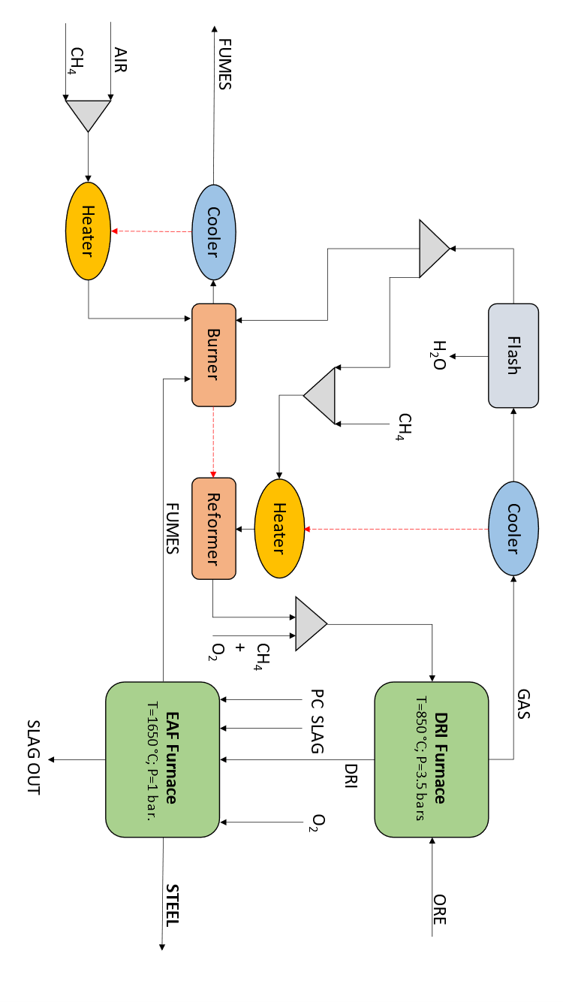

**Figure 1**. DRI/EAF scheme. Dotted lines represent heat streams, continued lines represent material streams.

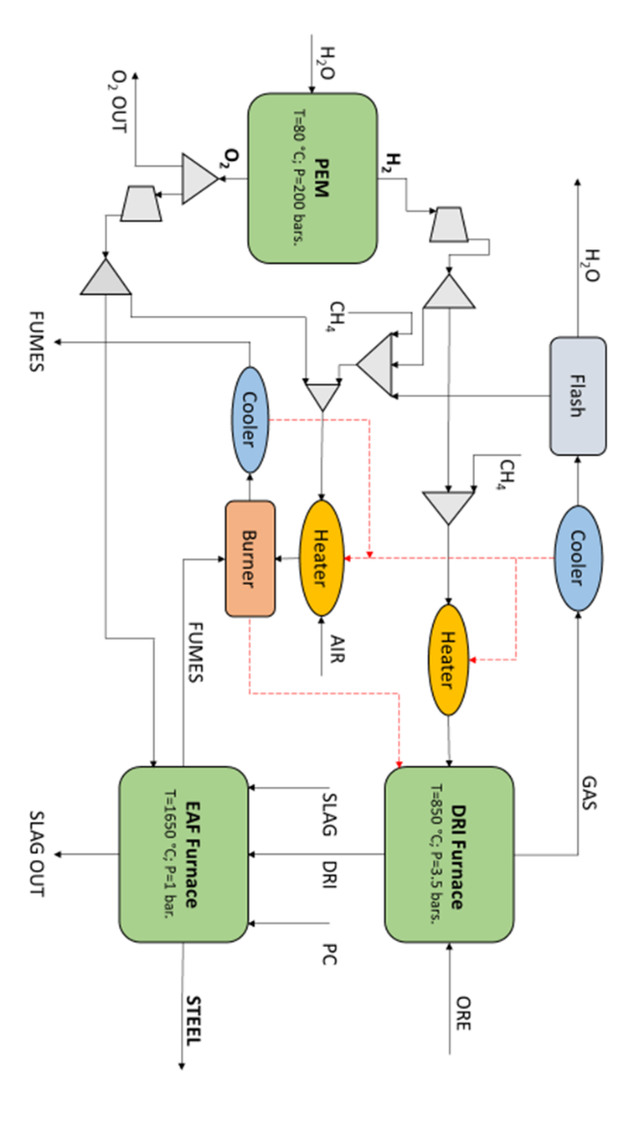

**Figure 2**. DRI/EAF with hydrogen scheme process. Dotted lines represent heat streams, continued lines represent material streams.

An energy, exergy, environmental and economic analysis of the two flowsheets have been made.

**3. Results and discussion**

Energy and exergy yield values are similar. Waste exergy of the DRI/EAF plant is 81,84 MW against 47,14 MW of the hydrogen plant. Certainly, there is room for improvement.

|  |  |
| --- | --- |
| $$η_{g}$$ | |
| DRI-EAF | **0,63** |
| DRI-EAF-H2 | **0,62** |
|  | |
| DRI-EAF | **0,52** |
| DRI-EAF-H2 | **0,51** |

**Table 1.** Energy ($η_{g}$) and exergy ($η_{ex}$) yield.

Hydrogen plant has an energy demand 15,9% and a power energy consumption 468% more than traditional DRI/EAF, because of the great demand of PEM electrolyser.

|  |  |  |  |  |  |
| --- | --- | --- | --- | --- | --- |
|  | *Methane* | *Carbon* | *Electricity* | *Total* | *Unit* |
| DRI-EAF | 9,42 | 1,00 | 1,80 | **12,22** | GJ/t |
| DRI-EAF-H2 | 2,94 | 1,00 | 10,23 | **14,73** | GJ/t |

**Table 2.** Energy demand.

CO2 emissions, using hydrogen and renewable energy, decrease by the 71,7% with respect to DRI/EAF process; NOx emissions decrease by the 49,3% with respect to DRI/EAF process.

|  |  |  |
| --- | --- | --- |
|  | *CO2* | *NOx* |
| DRI-EAF | 0.73 | 0.19 |
| DRI-EAF-H2 | 0.21 | 0.01 |
| Unit | t/t | kg/t |

**Table 3.** Specific CO2 emissions.

Operative cost, using hydrogen and renewable energy, increases by the 161%.

|  |  |
| --- | --- |
| *Opex* | |
| DRI-EAF | 389.21 |
| DRI-EAF-H2 | 1017.84 |
| Unit | $/t |

**Table 4.** Opex results.

**4. Conclusions**

This work is focused on the reduction of greenhouse gas emissions from iron and steel making process, in line with the global and European targets. The potential use of green hydrogen and renewable energy in a conventional DRI/EAF plant is investigated. The simulations of the conventional DRI/EAF plant and the DRI/EAF with hydrogen plant are carried out with the software AspenPlus. Energy and exergy analysis show the possible improvements in terms of efficiency. Economic and environmental results are compared. Despite a higher operative cost, green hydrogen allows a great reduction in CO2 and NOx emissions. About the economic feasibility, nowadays, this production way is not practicable in terms of economic results. However, author is confident that DRI/EAF with hydrogen process will become economical attractive in the next years, because of the great investment established by governments in new production routes and in renewable energy. Author is also confident that in the next years more efficient electrolysers will be designed and that the renewable energy availability will increase.

**References**

[1] R. Berger, *The future of steelmaking – How the European steel industry can achieve carbon neutrality*. 2020.

[2] M. Hammerschmid, *Evaluation of biomass-based production of below zero emission reducing gas for the iron and steel industry*. Biomass Conversion and Biorefinery, 2021, pp. 169–187.

[3] Laplace Conseil, “Impacts of energy market developments on the steel industry,” *74th Session of the OECD Steel Committee*, no. July, pp. 1–2, 2013, [Online]. Available: https://www.oecd.org/sti/ind/Item 9. Laplace - Steel Energy.pdf

[4] Olga Chiappinelli, *A green COVID-19 recovery of the EU basic materials sector: identifying potentials, barriers and policy solutions*. 2020.

[5] F. Muscolino, A. Martinis, M. Ghiglione, P. Duarte, M. Ghiglione, and P. Duarte, *Introduction to direct reduction technology and outlook for its use*, pp. 25–31, 2016.

[6] P. Cavaliere, *Direct Reduced Iron: Most Efficient Technologies for Greenhouse Emissions Abatement*. 2019.