**Hydrogen sulfide mix gas permeation in Aquivion® perfluorosulfonic acid (PFSA) ionomer membranes for natural gas sweetening**

Virginia Signorini1, Marco Giacinti Baschetti1*, Diego Pizzi2, Luca Merlo3

*1 Department of Civil, Chemical, Environmental and Material Engineering (DICAM), Alma Mater Studiorum, University of Bologna, Via Terracini, 28, 40131 Bologna, Italy;*

*2 Renco S.p.A., Strada del Montefeltro, 51, Pesaro (PU), Italy*

*3 Solvay Specialty Polymers Italy S.p.A., V.le Lombardia 20, Bollate (MI), Italy*

*\*Corresponding author E-Mail: marco.giacinti@unibo.it*

**1.Introduction**

Hydrogen sulfide is one of the most toxic and acid contaminants presents in pre and post combustion processes of fossil fuel, such as coal or natural gas. Its attendance, together with that of CO2 and higher hydrocarbons, must absolutely be removed from the natural gas streams prior to its commercialization [1].

Among the several process available for the Natural Gas Sweetening, gas separation with polymeric membranes become, in the latest years, one of the most suitable technologies because of its good performance, high efficiency in gas transport, mechanical and operational simplicity and relatively low cost of production and manufacturing [2–4].

Perfluorosulfonated acid ionomers (PFSA) have recently found wide use in various industrial applications, including membrane technology for Methane recovery due to their interesting affinity with polar compounds and good separation performances in humid conditions. In fact, PFSA membranes have a hydrophobic polytetrafluoroethylene-based fluorinated chain and a hydrophilic side chain ending in a SO3H group. These sulfonic end-groups cause high water absorption and the formation, in humid environment, of interconnected water domains which become the preferential path for permeating gases (Fig.1) [5,6]. Thanks to this heterogenous structure, indeed, the gas can permeate in the water channels by solution-diffusion mechanisms where the most water-soluble compounds permeate faster respect to the other (so that H2S > CO2 > CH4)[7].

In the present work, the membrane characterized is Aquivion® E87-12S, a short side chain perfluorosulfonic acid ionomer (PFSA) which exhibits high durability, good thermal and mechanical properties, high chemical stability to acidic compounds [8], and resulted to have extremely good resistance to plasticization and aging induced by CO2 and H2S [9].

Permeability of Aquivion® E87-12S films are tested with CO2/H2S/CH4 ternary mixture at 35°C, and at relative humidity ranging from 20 to 95%.

**Figure 1.** Humid gas permeation scheme in PFSA matrix

**2. Methods**

The material used for mixture permeation’s studies is Aquivion E87-12S, a commercial perfluorosulfonic acid (PFSA) ionomer membrane characterized by an equivalent weight of 870 gpol/molSO3H. It is produced by Solvay Specialty Polymers Italy S.p.A. (Bollate (MI) Italy) by melt-extrusion process [10]. The experiments were carried out in a purposely developed manometric system with closed volume and variable pressure, which is immersed in a thermostatic bath to ensure temperature control. The system is designed to conduct both dry and humid test, so that before any test, the two side of the membrane are equilibrated to the desired water activity in order to conduct humid test. Moreover, the sample cell is put in direct contact with a 2L upstream reservoir, where the mixture stream is loaded, while the downstream side is maintained under vacuum. Any possible concentration polarization phenomena related to the lack of flow in the upstream side were avoided by a magnetic driven mixer which ensured proper homogenization of gas composition during experiments. The composition of the feed and permeate flows was then characterized by a Micro Gas Chromatograph analyzer (Agilent Technology).

**3. Results and discussion**

In Figure 2 are displayed the permeability data for the three gases tested in the mixtures: H2S, CO2 and CH4 as a function of relative humidity. The feed stream composition has been calibrated and checked by using the Micro-gas Chromatograph, and it has been taken more or less constant to a mol fraction of 0.1, 0.09 and 0.8 for CO2, H2S and CH4 respectively.

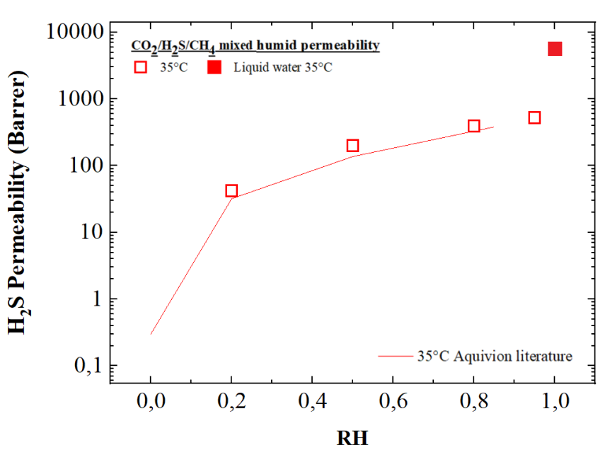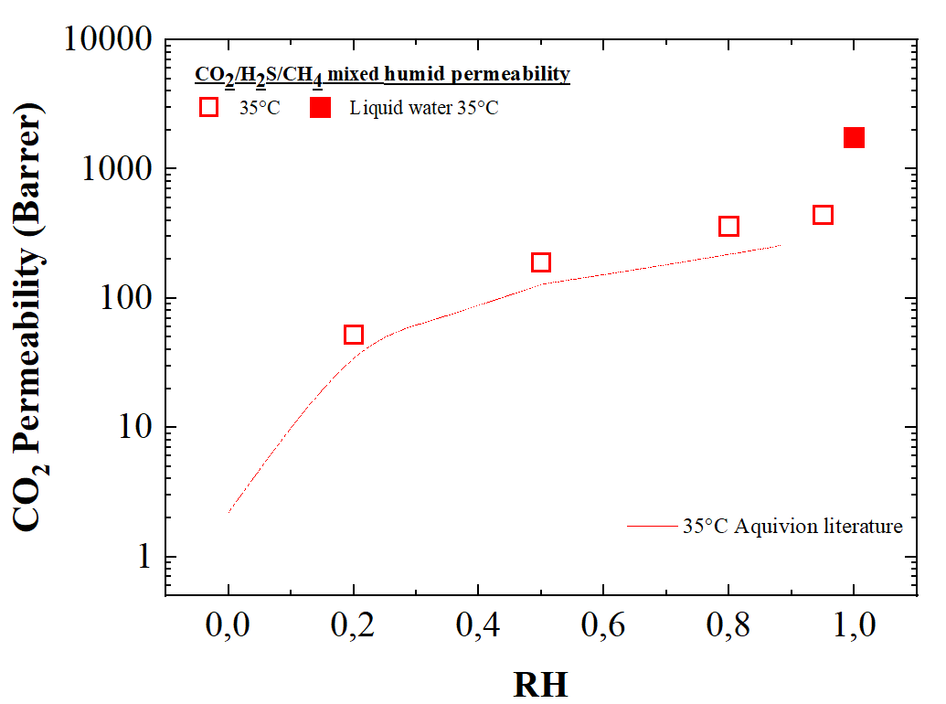

(b)

(a)

(c)

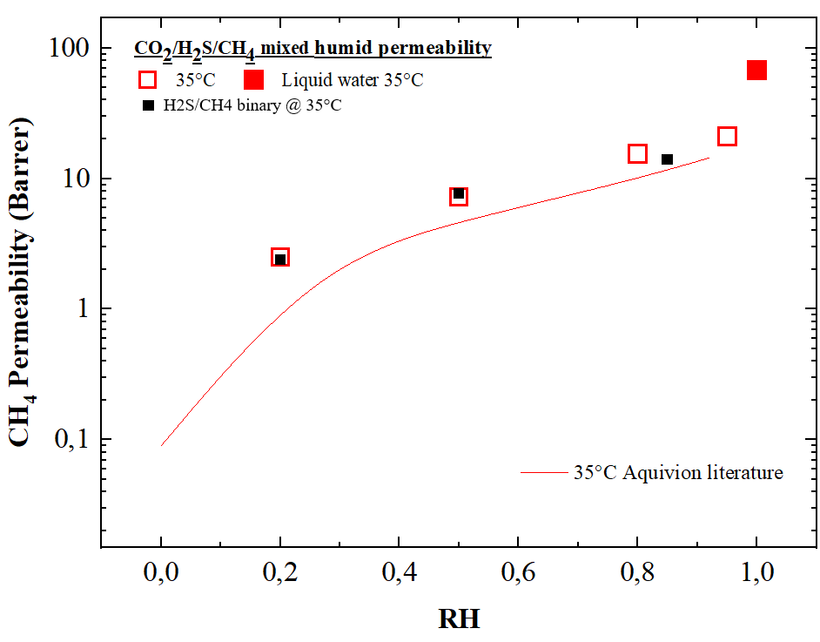

(c)

**Figure 2**. H2S (a), CO2 (b) and CH4 (c) permeability as a function of relative humidity at 35°C and compare with literature data [7,11]

The results confirmed the major influence of water content on the gas permeation behaviour in PFSA as permeability strongly increased with RH, thanks to the hydrophilic characteristic of the material which tends to swell in humid condition, creating highly permeable water “channels” in the polymeric matrix.

The higher variation can be tracked down between 0 and 20% of humidity, where the permeability for all three gases increases sharply, since water vapor saturates the membrane and interconnected water channels start to be formed into the polymeric chain. At the higher humidity values investigate din the present work (from 20% to 95%), the permeability behaviour tends to rise more gently according to the water domains getting bigger and to the reduction of their tortuosity. At 95%RH, the permeability values obtained for all CO2, CH4 and H2S are similar to those in pure water, suggesting that the gas transport across the membrane is governed by solution-diffusion mechanism in the water swollen domains of the hydrated PSFA.

In particular, CO2 and CH4 results confirmed experimental data already available in the open literature, for pure components while H2S reflects the behaviour already observed for binary data, (which are the only one, to the best of our knowledge, currently present in literature), showing a permeability increase by more than two orders of magnitude in the humidity range investigated.

In terms of separation behaviour hydrogen sulphide selectivity with respect to methane increased with water activity moving from 17 at RH 20% to 25obtained at 95% RH. Regarding CO2, the selectivity trend in Aquivion with respect to CH4 is similar to the one observed for H2S since they share the same acidic behaviour.

Even though this kind of polymer is not one of the best among studied in literature for natural gas sweetening, its selectivity to acid gases tends to achieve the upper bound limit, due to the great swelling of the membrane, especially for CO2/CH4 separation, as can be observed from the Robeson’s Plot in Fig.3.

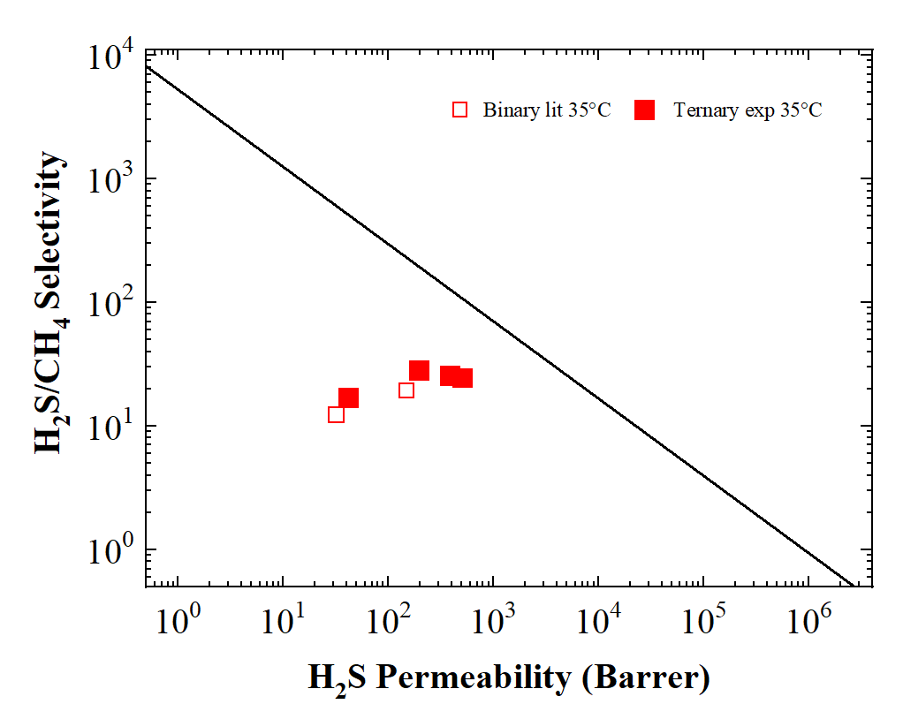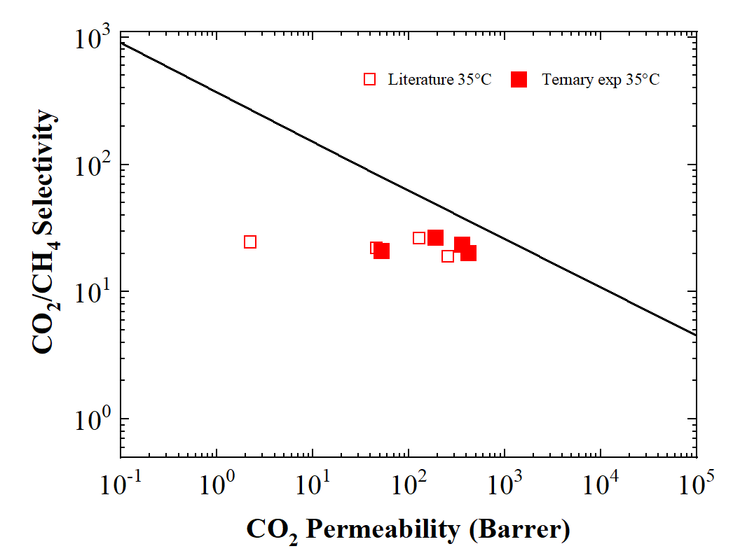

1. **(b)**

**Figure 3.** Robeson’s plot for a) H2S/CH4 and b) CO2/CH4 system in Aquivion ®as a function of relative humidity. Literature data from [7,11]

**4. Conclusions**

Aquivion E87-12S® membrane has been tested for CO2 and H2S removal for natural gas sweetening through permeation test with ternary mixtures 35°C and relative humidity ranging from 20 to 95%.

The tests performed confirm that the membrane permeation behaviour is higly affected by the polymer hydrophilicity, which confer the ability of Aquivion® material to separate acidic compounds from natural gas. The presence of water indeed swells the materials positively affecting the permeability of acidic gases in the membrane, which tends to the values which could be calculated for a theoretical water membrane.

Current data therefore confirm that an interconnected network of hydrophilic domains exists in the hydrated polymer which speed up and control the gas permeation in the membrane.

Overall, the humid permeation tests carried on in the present work demonstrate good separation properties of Aquivion® E87-12S membrane with respect to the CO2/CH4 and H2S/CH4 system, even though permeability and selectivity are not the best observed in open literature; however, the separation performances obtained together with the high chemical and mechanical resistance, showed by this polymers makes it a potential candidate for industrial applications, also considering the excellent resistance of the membrane to plasticization and aging in H2S.

**References**

[1] T.D. Burchell, R.R. Judkins, M.R. Rogers, A.M. Williams, A novel process and material for the separation of carbon dioxide and hydrogen sulfide gas mixtures, Carbon N. Y. 35 (1997) 1279–1294. https://doi.org/10.1016/S0008-6223(97)00077-8.

[2] C.A. Scholes, G.W. Stevens, S.E. Kentish, Membrane gas separation applications in natural gas processing, Fuel. 96 (2012) 15–28. https://doi.org/10.1016/J.FUEL.2011.12.074.

[3] R.W. Baker, K. Lokhandwala, Natural gas processing with membranes: An overview, Ind. Eng. Chem. Res. 47 (2008) 2109–2121. https://doi.org/10.1021/IE071083W.

[4] P. Bernardo, E. Drioli, G. Golemme, Membrane gas separation: A review/state of the art, Ind. Eng. Chem. Res. (2009). https://doi.org/10.1021/ie8019032.

[5] J. Catalano, T. Myezwa, M.G. De Angelis, M.G. Baschetti, G.C. Sarti, The effect of relative humidity on the gas permeability and swelling in PFSI membranes, in: Int. J. Hydrogen Energy, 2012. https://doi.org/10.1016/j.ijhydene.2011.07.047.

[6] A.L. Rollet, O. Diat, G. Gebel, A new insight into nafion structure, J. Phys. Chem. B. (2002). https://doi.org/10.1021/jp020245t.

[7] L. Olivieri, H. Aboukeila, M. Giacinti Baschetti, D. Pizzi, L. Merlo, G.C. Sarti, Humid permeation of CO2 and hydrocarbons in Aquivion® perfluorosulfonic acid ionomer membranes, experimental and modeling, J. Memb. Sci. (2017). https://doi.org/10.1016/j.memsci.2017.08.030.

[8] E.Y. Safronova, A.K. Osipov, A.B. Yaroslavtsev, Short Side Chain Aquivion Perfluorinated Sulfonated Proton-Conductive Membranes: Transport and Mechanical Properties, Pet. Chem. (2018). https://doi.org/10.1134/S0965544118020044.

[9] M. Mukaddam, E. Litwiller, I. Pinnau, Gas Sorption, Diffusion, and Permeation in Nafion, Macromolecules. (2016). https://doi.org/10.1021/acs.macromol.5b02578.

[10] T.D. Sheet, Aquivion ® E87-12S, (2017).

[11] V. Signorini, M. Giacinti Baschetti, D. Pizzi, L. Merlo, Hydrogen sulfide mix gas permeation in Aquivion® perfluorosulfonic acid (PFSA) ionomer membranes for natural gas sweetening, J. Memb. Sci. 640 (2021) 119809. https://doi.org/10.1016/J.MEMSCI.2021.119809.