**Effect of flow induced crystallization on the flow length of injection molded polypropylene**

Rita Salomone*, Vito Speranza, Sara Liparoti, and Roberto Pantani

*Department of Industrial Engineering, University of Salerno, via Giovanni Paolo II, 132 – Fisciano (SA) - Italy*

*\*Corresponding author E-Mail: rsalomone@unisa.it*

**1.Introduction**

Micro injection molding (µIM) represents one of the widespread processes for a large-scale production of micro components since it matches high automation, short processing time, and high flexibility. µIM can be applied to several fields, from the electronic to the biomedical ones, where high dimensional and geometrical accuracy is mandatory. On its turn, geometrical and dimensional accuracy depends on the complete filling of the cavity during processing [1,2], which is a complex task in µIM, due to the reduced cavity thickness (in the micrometrical range). The strong flow intensity coupled with the fast cooling occurring during µIM induces the material solidification before the complete cavity filling. Many studies focused on the investigation of the effect of processing conditions on the filling length [3–6]. The main process parameter influencing the final filling length is the cavity temperature: a high cavity temperature delays the cooling, allowing for the complete filling of the cavity. The final morphology of the parts, which in turn determines the mechanical performances, is also influenced by the operating conditions, particularly, the cavity temperature [7,8]. In this work µIM tests were conducted in an end-less cavity under several conditions of mold temperature and injection velocity, to assess the influence of those parameters on the final filling length.

**2. Methods**

The µIM samples were obtained adopting a commercial isotactic polypropylene, T30G, supplied by Basell (Ferrara, Italy), and characterized in previous works [9,10].

The injection molding machine MegaTech H10/18-2 (Tecnica Duebi, ITA) was adopted for µIM tests. Figure 1 shows the sketch of the cavity adopted for the experiments.

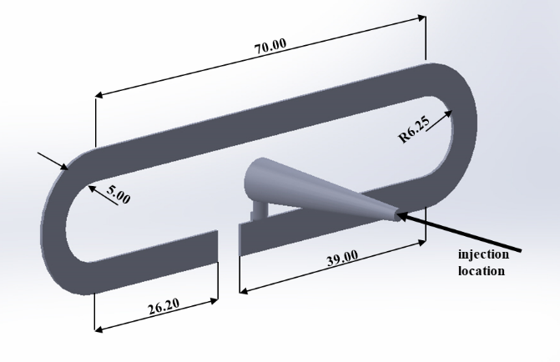

**Figure 1.** Sketch of the cavity adopted for the µIM tests. Dimensions are expressed in millimeters. The cavity thickness is 0.50 mm.

Experimental conditions of µIM tests are shown in table 1.

**Table 1**. Experimental conditions adopted for µIM tests

|  |  |
| --- | --- |
| Injection pressure [bar] | 100 |
| Injection temperature [°C] | 230 |
| Mold temperature [°C] | 60 – 80 –100 |
| Injection velocity [mm/s] | 13.2 – 26.4 – 39.6 – 52.8 – 59.4 |

**3. Results and discussion**

The final filling length depends on both the adopted mold temperature and the injection velocity. It must be noticed that in none of the considered cases the cavity is completely filled. In particular, the lower is the mold temperature, the shorter is the filling length. Figure 2 shows the results, in terms of final filling length achieved during µIM on changing mold temperature and injection velocity.

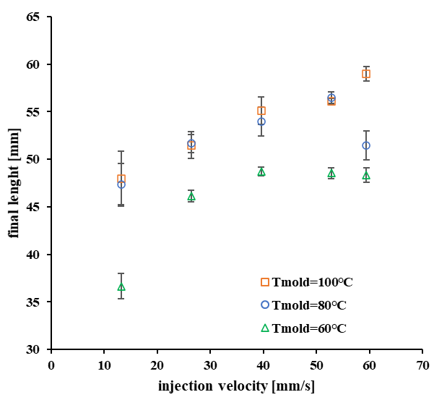

**Figure 2.** Final sample length obtained at different injection velocities for the three mold temperatures

The increase of mold temperature generally induces an increase of the final filling length. This finding is clearly detectable on increasing mold temperature from 60°C to 80°C. The samples obtained with 60°C mold temperature show the shortest filling length, because of the faster cooling and solidification. As a general effect, the increase of the injection velocity also induces an increase of the final filling length. This increase is due to the delay of cooling during the filling. A maximum value of the final filling length was achieved for an injection velocity of 59.4 mm/s, the longest one, with 100°C mold temperature. With 60°C and 80°C, a maximum value of the final filling length was detected at an intermediate velocity: 39.6 mm/s, and 52.8 mm/s, respectively. The injection velocity has indeed two effects: as the velocity increases, for the same solidification time a longer sample is obtained; furthermore, the crystallization rate increases and thus solidification time reduces. The effect of velocity on the crystallization rate depends on temperature: the crystallization growth rate shows a maximum at a given temperature [11], for higher/lower temperatures, the crystallization rate becomes smaller. Obviously, for temperature above the melt temperature, or for temperature below the glass transition, the crystallization is hindered. On its turn, the temperature which corresponds to the maximum value of the crystallization rate increases with the flow intensity, the injection velocity in these cases. The presence of a maximum in the final filling length at different injection velocities would depend on the complex interplay between the flow intensity and the temperature field.

**4. Conclusions**

The dimensional and geometrical accuracy of µIM strongly depends on the operative conditions.

In this work the evolution of the final cavity filling lengths at different mold temperatures and injection velocities during µIM tests was assessed. The final filling length strongly depends on the complex interplay between the flow and temperature fields since they both affect the crystallization rate. If crystallization occurs before the polymer has completely filled the cavity, any further filling is hindered. On its turn, crystallization rate increases with the flow intensity: the temperature at which maximum crystallization rate occurs shifts toward higher values on increasing flow intensity. This is the reason on the bases of the non-monotonous trend of the final filling length with velocity and temperature, especially when 60°C and 80°C were adopted for the mold. With 100°C mold temperature, the maximum of the final filling length was not detected, probably, it would be detected at higher injection velocities.

**References**

[1] M.R. Mani, R. Surace, P. Ferreira, J. Segal, I. Fassi, S. Ratchev, Journal of Micro and Nano-Manufacturing. 1 (2013).

[2] A. Eladl, R. Mostafa, A. Islam, D. Loaldi, H. Soltan, H. Hansen, G. Tosello, Micromachines. 9 (2018).

[3] W.-W. Kim, M.G. Gang, B.-K. Min, W.-B. Kim, The International Journal of Advanced Manufacturing Technology. 75 (2014) 293-304

[4] G. Fu, S.B. Tor, D.E. Hardt, N.H. Loh, Microsystem Technologies. 17 (2011) 1791-1798

[5] D. Yang, C. Liu, Z. Xu, J.Z. Wang, L.D. Wang, Key Engineering Materials, 483 (2011) 53-57

[6] S. Liparoti, V. Speranza, A. de Meo, F. de Santis, R. Pantani, Journal of Polymer Engineering. 40 (2020) 783-795

[7] J. Zhang, C. Guo, X. Wu, F. Liu, X. Qian, Part B, 50 (2011) 2227-2241

[8] J. Jiang, S. Wang, B. Sun, S. Ma, J. Zhang, Q. Li, G.-H. Hu, Materials & Design, 88 (2015) 245-251

[9] F. de Santis, R. Pantani, G. Titomanlio, Polymer, 90 (2016) 102-110

[10] R. Pantani, V. Speranza, G. Titomanlio, Journal of Rheology. 59 (2015).

[11] R. Pantani, F. de Santis, V. Speranza, Polypropylene Handbook, Springer International Publishing, Cham 2019 pp. 243-294