**Ammonia fuel cells onboard zero-emission ships: a comparison of different solutions**

Roberta Russo1*, Tommaso Coppola1, Luca Micoli1

*1 Department of Industrial Engineering (DII), School of Polytechnic and Basic Sciences, University of Naples “Federico II”, 80125 Naples, Italy*

*\*Corresponding author E-Mail: roberta.russo5@unina.it*

**1.Introduction**

The reduction of the carbon footprint of maritime shipping is currently a debated topic and a primary goal [1]. In the last decades, the International Maritime Organization (IMO) has targeted greenhouse gas (GHGs) emissions on ships introducing several regulations aiming a 50% reduction in GHGs by 2050 up to a complete elimination in this century [1 - 2].

Several climate-friendly alternatives are being considered to reach that goal, these include both power energy technologies, such as fuel cells and batteries, and innovative fuels, like hydrogen and methanol [3 - 5]. Ammonia has recently attracted wide interest as fuel for shipping [6 - 7].

Nowadays, ammonia is primarily used to produce fertilizers and other chemicals rather than for energetic purposes. Nevertheless, in the future, there is potential for climate-friendlier production processes. Green ammonia can be synthesized by using green hydrogen coming from renewable or non-carbon sources, like wind or solar energy, and the so-called blue ammonia can be produced reducing the emission footprint of the production using carbon capture technologies [8 - 10].

Ammonia certainly has the energy potential for an alternative marine fuel: it's abundant and common, it has an energy density of around 3 kWh/l, it does not have to be stored in high-pressure tanks or cryogenic dewars (unlike hydrogen and GNL) [11].

The most relevant advantage of using ammonia in the marine sectors is that it does not release CO2 and other harmful compounds, such as Sulphur oxides (SOX) and particulate matter (PM), allowing to comply with the stringent environmental regulations [6 - 7, 12].

Ship-owners and industry analysts state that ammonia will play a pivotal role in decarbonizing ships, according to a DNV’s report (2019), ammonia could make up 25 % of the maritime fuel mix by 2050, with nearly all newly built ships running on ammonia from 2044 onward [13]. However, the application of ammonia in the marine transportation sector is still at early stages: no vessels of any size today are equipped to use this fuel. Even if they were, the supply chain of green ammonia is almost virtually non-existent [8]. As green ammonia slowly scales up, the shipping industry will have to solve some other issues related to toxicity, corrosiveness, slow ignition and NOX emissions [11 - 14]. Moreover, since ammonia's energy density is about half that of diesel, if it is used as a direct fuel in ICE, ships will need to accommodate larger storage tanks or to reduce the operating range of vessels.

Nevertheless, burning ammonia in ICE produces nitrogen dioxide (NOx) which contributes to smog, acid rains and can harm people[14]. Combustion also yields small amounts of nitrous oxide (N2O) is a GHG significantly more dangerous than CO2. Therefore, shipbuilders have to consider special equipment to install onboard to avoid such outcome, e.g. a selective catalytic reduction system (SCR) [15].

An option to prevent air pollution with ammonia is to use the Fuel Cell (FC) technology instead of ICEs [16 - 19]. An FC is an electrochemical device that converts the chemical energy of a fuel directly into electrical energy with an efficiency higher than ICEs. Since no combustion process occurs in an FC, the release of harmful gases or particles in the air is avoided [20 - 21].

The mega-yacht is an interesting application for these technologies because it could favour a market in which passengers are allowed to enjoy a virtually silent and clean yachting experience.

The construction of yachts had an impressive growth in the last decades reaching an industrial production scale, therefore they cannot be considered “private ships” anymore and have to be developed accordingly to commercial passenger ships rules (e.g. MARPOL). This means that yachts have to abide by the environmental rules as well [15].

The present work investigates the possibility of installing ammonia FCs onboard ships aiming to supply the hotel loads and to support the propulsion in different operating conditions. The main purpose is to reach the zero-emission condition and to allow the navigation in Emission Control Areas (ECA). A comparison has been made between three different FC technologies: Proton Exchange Membrane Fuel Cell (PEMFC), Solid Oxide Fuel Cell (SOFC) and Alkaline Fuel Cell (AFC).

**2. Methods**

* 1. **Fuel Cell Systems**

FC technologies considered in the present work are PEMFC, SOFC, AFC.

Ammonia can be fed to the SOFC and AFC directly, while to PEMFC is used as a hydrogen carrier [17, 18]. In the latter case, ammonia is dissociated easily into nitrogen (N2) and hydrogen (H2) through an endothermic reaction, then the produced hydrogen is concentrated before feeding an FC.

For all cases under consideration, the flow rate of fuel to be treated has been estimated using relation (1), assuming that the electrical efficiency (η) is constant:

𝑚 = 𝑃/η 𝐿𝐻𝑉 (1)

Where *P* is the power generated, *LHV* is the lower heating value of hydrogen (120 MJ/kg) or ammonia (18.48 MJ/kg).

* + 1. **Proton Exchange Membrane Fuel Cell**

PEMFCs use a polymer membrane with high proton conductivity as an electrolyte and operate at temperatures between 70 and 100 °C; they are mainly developed for automotive and small-scale power generation (1-250 kW) applications. The product FCgen®-HPS provided by Ballard (Canada) has been assumed as a reference [22], which operates at low temperature (70-80 °C). This PEM module provides 140 kW power with an electrical efficiency of 55%. The electrodes must be made of porous materials to allow diffusion of the reactant gases into the active zones, where the noble metal catalyst is in contact with the ionic and electronic conductor. The membrane is semi-permeable, allowing positive ions to pass through, but providing electrical isolation by not allowing electrons to pass, which are forced to travel through the external circuit set up to transfer electrical energy from the fuel cell to the user. The membrane must be impregnated with a precise amount of water, which is controlled during operation by humidifying the hydrogen and air introduced. A basic working scheme is shown in Figure 1 and other main characteristics are reported in Table 1.

The characteristic reactions at the anode, cathode and overall reaction are:

Anode reaction: $H_{2}→2H^{+}+2e^{-}$ (2)

Cathode reaction: $\frac{1}{2} O_{2}+2H^{+}+2e^{-}→ H_{2}O$ (3)

Overall reaction: $H_{2}+ \frac{1}{2} O_{2}→ H_{2}O$ (4)

The pure hydrogen required for fuelling the PEM is supposed to be produced by the ammonia decomposition and purification systems, which constitute the ammonia processing system (AP). The ammonia is taken from the tanks, preheated in a heat exchanger (for better energy efficiency), vaporised and then separated in the main reactor. In this study, we referred to the specifics and performance of the reactor supplied by the SinceGas company (China), which can process an NH3 flow rate up to 250 Nm3/h. Within the reactor, ammonia can be dissociated into hydrogen and nitrogen (N2) via the endothermic reaction:

$NH_{3}→ \frac{1}{2} N_{2}+\frac{3}{2} H_{2}$ ΔH = 46.22 kJ/mol (5)

This reaction requires both a catalyst and a heat source, which is supposed to be produced electrically on board. Then, a Pressure Swing Adsorption (PSA) system, which generally uses special molecular sieves, is required for the separation of H2 from N2. Specifically, the PSA returns a quantity of pure hydrogen of about 15 kg/h.

* + 1. **Solid Oxide Fuel Cell**

SOFCs operate at high temperatures (in the range 700-1000 °C) to ensure high conductivity to the electrolyte, which consists of ceramic material (zirconium oxide doped with yttrium oxide) [23]. SOFCs can be divided into two categories depending on the chemical specific of electrolyte. In the present study, it is considered a basic electrolyte, which conducts O2- ions. They are particularly promising for stationary power generation and cogeneration in power ratings from a few kW to several tens of MW. For instance, the product “SOFC BOL module” provided by Bloom Energy company (United States of America) has been selected as reference. This module has an output power of 350 kW and an electrical efficiency of 55%; other specifics are reported in Table 1 and a basic working scheme is shown in Figure 1.

The overall and the electrodes’ reactions are [24]:

Anode reactions: $NH_{3}→ \frac{1}{2} N_{2}+\frac{3}{2}H_{2}$ (6)

$H_{2}+ O^{2-}$ $→ H_{2}O+$ $2e^{-}$ (7)

Cathode reaction: $\frac{1}{2} O_{2}+2e^{-}→ O^{2-}$ (8)

Overall reaction: (9)

* + 1. **Alkaline Fuel Cell**

AFCs use an electrolyte consisting of a water solution of potassium hydroxide (≈30 %) and operate at temperatures of around 120 °C [21, 24]. They have reached a good degree of technological maturity, especially for special uses (military and space applications); their characteristics (requiring extremely pure feed gases) have severely limited their diffusion. A model from the AFC energy (United Kingdom) 350 kW HydroX-Cell(L) catalogue is chosen, with an electrical efficiency of 60%. The specifics are reported in Table 1; the working scheme is shown in Figure 1.

The overall reaction, the characteristic reactions at the anode and cathode are as follows [21, 24]:

Anode reaction: ${NH}_{3}+ {3OH}^{-} →\frac{1}{2} N_{2}+{3H}_{2}O+ {3e}^{-}$ (10)

Cathode reaction: $\frac{3}{2}O_{2}+{\frac{3}{2}H}_{2}O+{3e}^{-} → {3OH}^{-}$ (11)

Overall reaction: ${2NH}_{3}+\frac{3}{2}O_{2}$ $→N_{2}+3H_{2}O$ (12)

**Table 1.** Main specifics of the selected FC and AP power system

|  |  |  |  |  |
| --- | --- | --- | --- | --- |
| Specific | AP | PEM | SOFC | AFC |
| Inlet | NH3 | H2 | NH3 | NH3 |
| Operating temperature [°C] | 100-300 | 70-80 | 700 | 120 |
| Power [kW] | 600 | 140 | 350 | 350 |
| Efficiency [%] | 88 | 55 | 55 | 60 |
| Weight [kg] | 47 | 55 | 18433 | 17500 |
| Volume [m3] | 14 | 0.1 | 33 | 67 |

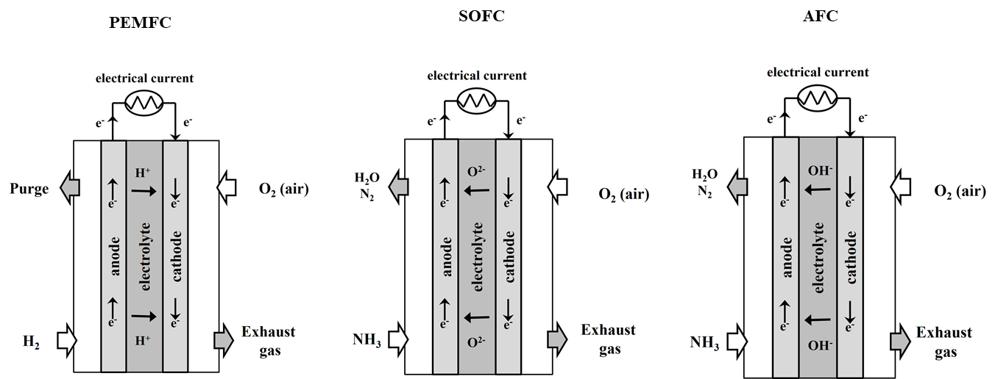

**Figure 1.** PEMFC, SOFC and AFC working schemes

* 1. **Case study**

The target ship is a mega-yacht with a length of about 64 m, which has an Atlantic autonomy of 4000 nm at 14 kn and reach a maximum speed of 18 kn. Shipowners generally establish the main requirements of the ship, i.e. the number of passengers and crew, size of cabins, public spaces, speed. These and other general characteristics of the mega-yacht are reported in Table 2.

|  |  |
| --- | --- |
| Main dimension LxBxH [m] | 64.4x11.3x6.2 |
| Displacement [t] | 921 |
| Full load immersion [m] | 3.6 |
| Decks [num] | 4 |
| Passengers [num] | 12 |
| Crew members [num] | 10 |
| Cruise speed [kn] | 14 |
| Maximum speed [kn] | 18 |
| Autonomy [day] | 14 |
| Propulsion Diesel engine (×2) [kW] | 1320 |
| Shaft Generator engine (×2) [kW] | 260 |
| Gen-set [kW] | 575 |

**Table 2.** General specifications of the mega-yacht



**Figure 2.** The layout of the mega-yacht: A: Sun Deck (12.9 m above BL); B: Upper Deck (9.2 m above BL); C: Main Deck (6.2 m above BL); D: Lower Deck (3.3 m above BL)

The ship's structure is laid out over four decks, as shown Figure 2. The engine room is placed between the Base Line (BL) and the Main Deck, while the fuel is stored between bulkhead 4th and the collision bulkhead. The initial configuration of the mega yacht includes two main Diesel engines (1320 kW Rolls Royce, model 4-stroke MTU 12V 4000 M33F) capable of supplying a maximum power of about 3021 kW to reach 18 kn. Additionally, it is considered the installation of two liquid-cooled permanent magnet synchronous motor shaft generators directly connected to the gearboxes (Type C SISHIP EcoProp from Siemens) to recover the engines' waste energy and to provide additional power to the propeller when the main engine is underperforming. This configuration allows both the “Power Take In” (PTI) and “Power Take-Off” (PTO) modes for the energy transmission [25]. A Diesel Gen-set (MTU 12V 2000 M41A by Rolls Royce) provides the non-propulsion power demand, with a power output of 575 kW at 1500 rpm.

1. **Results and discussion**

**General Arrangements**

The onboard installation of FCs has a different arrangement for the three technologies under consideration, depending on volume and weight of the FC system.

PEMFC are installed in a different area than the AP, though the footprint is limited, it can be arranged in a separate enclosed space within the engine room. The AP is arranged between the 3rd and 4th bulkheads. These rooms are classified as Hazardous Area Zone 1; therefore, a dedicated ventilation system and airlocks are provided.

SOFC and AFC have a very similar onboard layout: the FC space is larger than the case of PEMFC, which is due to the higher footprint. These are arranged between the 3rd and 4th bulkheads and enclosed by airlocks. The described arrangements are shown in Figure 3.

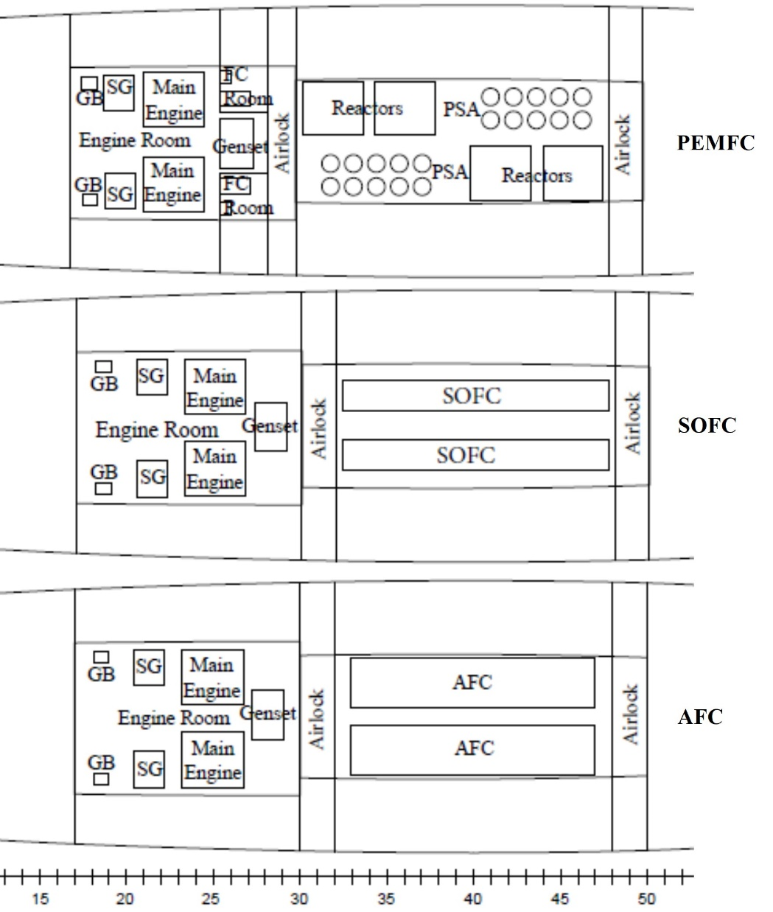

**Figure 3.** PEMFC, SOFC and AFC systems arrangement

Ammonia is supposed to be stored onboard in the liquid state at 98 kPa and 240 K. According to the international rules [26], ammonia cannot be contained in structural tanks but in type C double-walled tanks. Cemin Eurotank (Italy) tanks are chosen as reference for the study, these have an external diameter of 980 mm, an internal diameter of 950 mm and are specifically sized accordingly to the available space. It results that 48 m3 of ammonia can be stored in nine tanks with the main specifics reported in Table 3, and arranged on board as shown in Figure 4.

**Table 3.** Main specifics of NH3 storage tanks

|  |  |  |  |
| --- | --- | --- | --- |
| Tanks | Volume | Length | Weight (empty) |
| [num] | [m3] | [m] | [t] |
| 6 | 5.0 | 6.8 | 1.2 |
| 3 | 6.0 | 8.5 | 1.5 |

**Figure 4**. Ammonia storage tanks arrangement

* 1. **Autonomy**

The available volume for the storage tanks limited the amount of ammonia stored onboard, this affects considerably the autonomy of the ship depending on the FC and operating mode.

In the case that the FC system supplies only the hotel loads (kitchen, lightnings, air conditioning, rooms and deck), the autonomy is 6 days for PEMFC, 13 days for SOFC and 14 days for AFC. It must be noted that the lowest value for the PEMFC is due to the additional power required by AP.

The zero-emission condition can be achieved by FCs powering both the propulsion and the hotel loads during the navigation and mooring in ports. In this case, the autonomy is approximatively the same for SOFC and AFC, while for the PEMFC is only 3 days.

If it is assumed that the zero-emission condition is limited to 250 nm at 8 kn, allowing entry and exit in ECA areas and anchoring in ports, the autonomy is 4 days for PEMFC, 11 days for SOFC and 12 days for AFC.

The autonomies are summarized in Table 4.

**Table 4.** Autonomy for different conditions and FCs

|  |  |  |  |
| --- | --- | --- | --- |
| Condition | Autonomy [days] | | |
| PEMFC | SOFC | AFC |
| Hotel loads | 6 | 13 | 14 |
| Zero Emission | 3 | 6 | 6 |
| Zero Emission @ 8 kn, 250 nm | 4 | 11 | 12 |

**4. Conclusions**

This work investigated the application of different ammonia-fuelled FC technologies (PEMFC, SOFC and AFC) for the electric power generation and to reach the zero-emission condition. A 64 m length mega-yacht was assumed as case study.

To identify the optimal solution, a comparison was carried out in terms of both the effect on the general arrangement and autonomy of the ship.

It resulted that, PEMFC was the most commercialized FC technology with the highest power density, but the presence of a bulky and heavy AP system was necessary to produce pure H2. Although SOFC and AFC could be directly fuelled by ammonia, they required a significant space onboard for the installation.

The zero-emission condition was reached with all the FC configurations, but the limited ammonia volume stored affected the ship’s autonomy. The autonomy was in the range 3-4 days in the case of PEMFC and 6-12 days in the case of SOFC and AFC. Allocating more spaces onboard to the ammonia storage tanks can increase the autonomy, but it requires fundamental modification of the original arrangement of the ship.

**References**

[1] “Cutting GHG emissions from shipping - 10 years of mandatory rules.” [Online]. Available: https://www.imo.org/en/MediaCentre/PressBriefings/pages/DecadeOfGHGAction.aspx. [Accessed: 01-Feb-2022].

[2] J. E. McCarthy, “Air pollution and greenhouse gas emissions from ships,” in Air Pollution and Ship Emissions, 2010.

[3] J. Anders, “Comparison of Alternative Marine Fuels SEA\LNG Ltd,” 2019.

[4] L. Ming Main Author, L. Ming, L. Chen, and L. Siu Lee Jasmine Sze Jia Yin Koh Eng Kiong Yang Mengyao Gou Xueni, “Methanol as a Marine Fuel-Availability and Sea Trial Considerations Alternative Fuels for International Shipping A Study on the Future Energy Options of Singapore Harbour Craft Electrification of Singapore Harbour Craft-Shore and Vessel Power System Considerations Executive Summary,” 2020.

[5] E. A. Bouman, E. Lindstad, A. I. Rialland, and A. H. Strømman, “State-of-the-art technologies, measures, and potential for reducing GHG emissions from shipping – A review,” Transp. Res. Part D Transp. Environ., 2017, doi: 10.1016/j.trd.2017.03.022.

[6] J. Hansson, S. Brynolf, E. Fridell, and M. Lehtveer, “The potential role of ammonia as marine fuel-based on energy systems modeling and multi-criteria decision analysis,” Sustain., vol. 12, no. 8, Apr. 2020, doi: 10.3390/SU12083265.

[7] K. Kim, G. Roh, W. Kim, and K. Chun, “A Preliminary Study on an Alternative Ship Propulsion System Fueled by Ammonia: Environmental and Economic Assessments,” J. Mar. Sci. Eng. 2020, Vol. 8, Page 183, vol. 8, no. 3, p. 183, Mar. 2020, doi: 10.3390/JMSE8030183.

[8] D. R. MacFarlane et al., “A Roadmap to the Ammonia Economy,” Joule, vol. 4, no. 6, pp. 1186–1205, Jun. 2020, doi: 10.1016/j.joule.2020.04.004.

[9] Z. Cesaro, J. Thatcher, and R. Bañares-Alcántara, “Techno-Economic Aspects of the Use of Ammonia as Energy Vector,” Techno-Economic Challenges Green Ammon. as an Energy Vector, pp. 209–219, Jan. 2021, doi: 10.1016/B978-0-12-820560-0.00009-6.

[10] S. Ghavam, M. Vahdati, I. A. G. Wilson, and P. Styring, “Sustainable Ammonia Production Processes,” Front. Energy Res., vol. 9, Mar. 2021, doi: 10.3389/FENRG.2021.580808/FULL.

[11] O. Elishav, B. Mosevitzky Lis, A. Valera-Medina, and G. S. Grader, “Storage and Distribution of Ammonia,” Techno-Economic Challenges Green Ammon. as an Energy Vector, pp. 85–103, Jan. 2021, doi: 10.1016/B978-0-12-820560-0.00005-9.

[12] M. Gallucci, “The ammonia solution: Ammonia engines and fuel cells in cargo ships could slash their carbon emissions,” IEEE Spectr., vol. 58, no. 3, pp. 44–50, Mar. 2021, doi: 10.1109/MSPEC.2021.9370109.

[13] “Ammonia as a marine fuel DNV.” [Online]. Available: https://www.dnv.com/Publications/ammonia-as-a-marine-fuel-191385. [Accessed: 01-Feb-2022].

[14] H. Kobayashi, A. Hayakawa, K. D. K. A. Somarathne, and E. C. Okafor, “Science and technology of ammonia combustion,” Proc. Combust. Inst., vol. 37, no. 1, pp. 109–133, Jan. 2019, doi: 10.1016/J.PROCI.2018.09.029.

[15] V. Ruggiero, “ScienceDirect Peer-review under responsibility of the scientific committee of the International Conference on Industry 4.0 and Smart Manufacturing.-NC-ND license (http://creativecommons.org/licenses/by-nc-nd/4.0/) Peer-review under responsibility of the s,” 2020, doi: 10.1016/j.promfg.2020.02.020.

[16] A. Afif, N. Radenahmad, Q. Cheok, S. Shams, J. H. Kim, and A. K. Azad, “Ammonia-fed fuel cells: a comprehensive review,” Renew. Sustain. Energy Rev., vol. 60, pp. 822–835, Jul. 2016, doi: 10.1016/J.RSER.2016.01.120.

[17] D. Cheddie, “Ammonia as a Hydrogen Source for Fuel Cells: A Review,” Hydrog. Energy - Challenges Perspect., Oct. 2012, doi: 10.5772/47759.

[18] O. Siddiqui and I. Dincer, “A review and comparative assessment of direct ammonia fuel cells,” Therm. Sci. Eng. Prog., vol. 5, pp. 568–578, Mar. 2018, doi: 10.1016/J.TSEP.2018.02.011.

[19] L. Micoli, T. Coppola, and M. Turco, “A Case Study of a Solid Oxide Fuel Cell Plant on Board a Cruise Ship,” J. Mar. Sci. Appl., vol. 20, no. 3, pp. 524–533, Sep. 2021, doi: 10.1007/S11804-021-00217-Y.

[20] P. T. Moseley, “Fuel Cell Systems Explained,” J. Power Sources, 2001, doi: 10.1016/s0378-7753(00)00571-1.

[21] A. Coralli, B. J. M. Sarruf, P. E. V. De Miranda, L. Osmieri, S. Specchia, and N. Q. Minh, “Fuel cells,” in Science and Engineering of Hydrogen-Based Energy Technologies: Hydrogen Production and Practical Applications in Energy Generation, 2018.

[22] “FCgen HPS Spec Sheet.” [Online]. Available: https://www.ballard.com/about-ballard/publication_library/product-specification-sheets/fcgen-hps-spec-sheet. [Accessed: 24-Feb-2022].

[23] S. J. McPhail, B. Conti, and J. Kiviaho, The Yellow Pages of SOFC Technology - International Status of SOFC deployment 2017. 2017.

[24] P. Breeze and P. Breeze, “Chapter 7 – Fuel Cells,” Power Gener. Technol., 2019, doi: 10.1016/B978-0-08-102631-1.00007-9.

[25] “The Superyacht Directory | Superyacht Database.” [Online]. Available: https://www.boatinternational.com/yachts/the-superyacht-directory. [Accessed: 24-Feb-2022].

[26] IMO, “the International Code of Safety for Ships Using Gases or Other Low-Flashpoint Fuels (Igf Code),” Imo, 2016.