**Functionalized magnetite nanoparticles for the recovery of VFAs from a water solution**

Elisa Lacroce1*, Giovanna Massobrio1, Filippo Rossi1, Maurizio Masi1

*1 Department of Chemistry, Materials and Chemical Engineering “Giulio Natta”, Politecnico di Milano, via Mancinelli 7, 20131, Milan, Italy*

*\*Elisa Lacroce E-Mail: elisa.lacroce@polimi.it*

**1.Introduction**

Volatile fatty acids (VFAs) are widely used in chemical, pharmaceutical and food industry [1] due to their large application for producing paint, plastics, synthetic fibers, emulsions, coating formulations, pesticides, flavours, supplements and antibiotics [2]. About 90% of VFAs production is derived from petrochemical routes with negative effects on environment [2][3]. The recovery of chemical products from waste streams represents nowadays a promising strategy in the context of circular economy [4][5]. This work is focused on the recovery of VFAs from an aqueous solution by using functionalized magnetite nanoparticles as adsorbent agents with the aim of reusing them for other absorption/desorption cycles as schematized in figure 1.

**2. Methods**

Magnetite nanoparticles (MNPs) were synthetized by the co-precipitation method from hydrated FeCl2 and FeCl3. Then, they were functionalized with adipic acid, oleic acid or APTES molecules (F-MNPs) and absorption tests were performed in order to extract the VFAs from a water solution. Gas chromatography analyses were conducted to estimate the percentage of absorption from the starting water solution.

**3. Results and discussion**

Magnetite nanoparticles with 8 nm of diameter were synthetized in order to have a high surface area to volume ratio. The functionalization with different molecules was performed to study the different effect on absorption capacity. Indeed, the absorption of VFAs on the nanoparticles was dependent on the interaction with the molecules used for the functionalization. In the case of functionalization with oleic acid and adipic acid the absorption was the results of hydrophobic interactions between the -CH2 groups of the two chains. In the other case, in a pH environment of 7 the protonated amine groups of APTES molecules attracted electrochemically the unprotonated carboxylic groups of VFAs. Absorption tests were performed using different concentrations of nanoparticles and the best results showed around 30% of absorption using APTES and adipic acid functionalization and 21% using oleic acids.

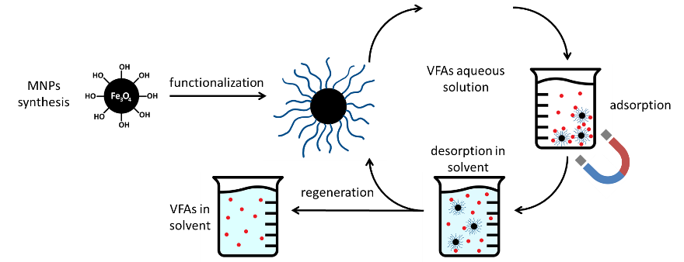

**Figure 1.** Schematic representation of the use of MNPs for VFAs recovery.

**4. Conclusions**

In this work we synthetized different functionalized magnetite nanoparticles for the recovery of VFAs from a water solution. The functionalization with different molecules was performed to allow different interactions between VFAs and MNPs and to find the best functionalization for having the maximum absorption percentage. The maximum absorption percentage was near 30% of the starting VFAs solution by using APTES and adipic acid-functionalized MNPs. Next steps of the project will be related to the desorption of VFAs and the use of recovered nanoparticles for other extraction cycles.

**References**

[1] C. S. López-Garzón and A. J. J. Straathof, “Recovery of carboxylic acids produced by fermentation,” *Biotechnol. Adv.*, vol. 32, no. 5, pp. 873–904, Sep. 2014, doi: 10.1016/J.BIOTECHADV.2014.04.002.

[2] M. Atasoy, I. Owusu-Agyeman, E. Plaza, and Z. Cetecioglu, “Bio-based volatile fatty acid production and recovery from waste streams: Current status and future challenges,” *Bioresour. Technol.*, vol. 268, pp. 773–786, Nov. 2018, doi: 10.1016/J.BIORTECH.2018.07.042.

[3] E. V. Fufachev, B. M. Weckhuysen, and P. C. A. Bruijnincx, “Toward Catalytic Ketonization of Volatile Fatty Acids Extracted from Fermented Wastewater by Adsorption,” *ACS Sustain. Chem. Eng.*, vol. 8, no. 30, pp. 11292–11298, Aug. 2020, doi: 10.1021/ACSSUSCHEMENG.0C03220.

[4] H. PA *et al.*, “Selective Extraction of Medium-Chain Carboxylic Acids by Electrodialysis and Phase Separation,” *ACS omega*, vol. 6, no. 11, pp. 7841–7850, Mar. 2021, doi: 10.1021/ACSOMEGA.1C00397.

[5] W. S. Lee, A. S. M. Chua, H. K. Yeoh, and G. C. Ngoh, “A review of the production and applications of waste-derived volatile fatty acids,” *Chem. Eng. J.*, vol. 235, pp. 83–99, Jan. 2014, doi: 10.1016/J.CEJ.2013.09.002.