**ELECTRONIC NOSE FOR REAL-TIME MONITORING OF ODOUR EMISSIONS AT A WASTEWATER TREATEMENT PLANT**

Stefano Prudenza, Carmen Bax*, Laura Capelli

*Politecnico di Milano, Department of Chemistry, Materials and Chemical Engineering, piazza Leonardo da Vinci 32, 20133 Milano, Italy*

*\*Corresponding author E-Mail: carmen.bax@polimi.it*

**1.Introduction**

Atmospheric emissions from industrial activities are subjected to control and regulation worldwide. Their monitoring and mitigation represent a common concern for chemical engineers who deal with the development and design of abatement systems [1], the study of new measurement techniques [2], the modelling of emissions impact [3, 4].

Odour emissions are nowadays recognized as atmospheric pollutants and consequently need to be monitored and kept under control such as any other emissions. Due to the particularity of these emissions, many efforts have been done by the scientific community to develop suitable methods for modelling and quantifying odour impacts, as well as for keeping odour emissions under control [5].

A development perspective for monitoring of odorous emissions from industrial activities in the Industry 4.0 era concerns the realization of networks of monitoring systems to be installed at emission sources or plant fencelines for a real-time analysis. Those systems can provide useful information for identifying potential malfunctioning and anomalies. In this scenario, electronic noses (e-noses), i.e. instruments combining a gas sensor array with machine learning algorithms, can serve as useful monitoring tool. If adequately trained, they are capable to provide a real-time qualitative and quantitative characterization of the odorous mixtures they are exposed to.

If installed at plant fenceline or directly at emission sources, e-noses can detect odours originating from anomalies during normal operating conditions: In other words, the e-nose can be trained to detect deviations from reference conditions. This in turn allows the setting of “warning” thresholds, enabling sudden intervention in case of malfunctions. Thanks to its peculiarity to classify odours, the e-nose can also provide indications about the cause of the malfunctioning, thereby guiding maintenance operations.

In this context, this paper describes a feasibility study proposing the use of an e-nose to on-line monitor odorous emissions from a wastewater treatment plant (WWTP). The WWTP under exam receives both civil and industrial wastewaters from ca. 40 industries of different types (e.g., chemical, tanneries, paper mill, printing, food, car washes etc.). Civil wastewaters account for about 60-70% of the total incoming flowrate (i.e., about 22’000 m3/day), while industrial wastewaters account for the remaining 30-40%.

Due to the frequent reports of odour nuisance by citizens living in the proximity of the plant, in agreement with the regional guidelines on odour emission management, several olfactometric campaigns were carried out at the emissions sources with the purpose of determining odour concentrations and odour emission rates. This preliminary work allowed identifying the emission sources that are most responsible for the odour nuisance and evaluating the odour impact associated to the plant in the surrounding territories. As expected, based on experimental evidences collected so far, the arrival tank turned out to be the most problematic source of the plant. One peculiarity of this plant concerns the considerable variability of the concentration of odour emissions from the arrival tank: odour concentrations ranging from 2’000 to 120’000 ouE/m3 were recorded. These results pointed out that there are some moments in which a particularly odorous wastewater arrives at the plant, causing the malodorous events. However, the origin of these odours, which could be related to the simultaneous presence of discharges from several different industries causing the release of compounds with a low odour threshold, has not yet been uniquely determined. Since these particular odorous conditions occur occasionally, the use of an instrument capable to provide a real-time monitoring of the odours emitted from the arrival tank and activate specific alarms may allow the execution of targeted chemical and olfactometric analyses, when the “incriminated” wastewater is present in the plant. The chemical speciation of the substances contained in the liquid and in its headspace, compared with the respective olfactory threshold values, may enable the identification of the chemicals most responsible for the odour that is generated in the stages of wastewater conferment and pre-treatment.

In this context, this paper describes the experimental procedure involved for the e-nose training and evaluate its performance. The training is a crucial phase for the use of e-nose as monitoring tools, since in this phase the instrument develops its classification and quantification capability based on a reference dataset (i.e., the Training Set – TS), including samples showing the characteristic “patterns” of the odours that the instrument is expected to detect and recognize during the monitoring phase. To do this, the training involves the collection of odour samples at plant emission sources, according to specific sampling protocols. It is worthy to highlight that sampling is one of the main issues pertaining to odour characterization and measurement, on which the quality of results is heavily dependent [6]. Odour samples are characterized by dynamic olfactometry (EN 13725:2022) to assess their odour concentration and then analysed by the e-nose to build the TS. For the specific monitoring, the e-nose, equipped with an automatic gas sampling system, has been installed at the arrival tank of the WWTP. The training lasted about 1 month and involved the analysis of samples collected at the arrival tank under different meteorological and operating conditions of the plant. E-nose signals relevant to the training period were combined with the odour concentration, obtained by dynamic olfactometry, and with reports of presence/absence of odour by the citizens living nearby the plant to implement data processing models aimed at identifying a Normal Operating Region (NOR) [7], representative of moderate presence of odour on the arrival tank not causing odour events in surrounding territories. This paper reports also the results of the model validation. In this phase, gas samples have been randomly collected at the plant in order to verify the correct functioning of the model developed.

**2. Methods**

**2.1 Monitoring system**

2.1.1 Electronic nose

An electronic nose is an instrument capable to recognise and quantify odours by means of a gas sensor array and a multivariate machine learning algorithm. The architecture of an e-nose strictly depends on the specific application for which it is designed. In general, an e-nose comprises [8, 9]:

* A sampling system: it generally consists of a vacuum pump, which sucks the odorous mixture to be analysed and delivers it to the detection system. In some e-noses, specifically designed for the environmental monitoring, the sampling system is equipped with drying units or filters to generate odourless reference air, or compensate the moisture content of the sample.
* A detection system: it comprises an array of gas sensors, whose nature and number depends on the specific application, enclosed into an inert chamber, where gas to be analysed is sucked by means of a vacuum pump.
* A pattern recognition unit: it involves machine learning techniques for processing sensor signals, determining odour fingerprint and producing an estimate of the odour class or concentration for an unknown sample along with an estimate of the confidence placed on the assignment.

The instrument used in this project is an outdoor e-nose commercialized by Ellona, i.e., WT1 monitoring system. It is equipped with 4 metal oxide sensors (MOS), characterized by a high sensitivity to volatile compounds, 3 electrochemical sensors sensible to hydrogen sulphide, formaldehyde and ammonia, and a photoionization detector (PID) calibrated in isobutylene for detection of volatile organic compound (VOC). The instrument comprises also sensors for evaluating the temperature and relative humidity of external environment.

The WT1 software enables the real-time visualization and preliminary pre-processing of signals (i.e., resistance values for MOS sensor, concentrations in ppm of H2S, NH3, formaldehyde and VOC for electrochemical sensors). The data processing pathway developed within the project, which is described in Section 2.2, was implemented in Rstudio.

2.1.2 Sampling system

The automatic gas sampler used in this study is an airtight suitcase of 25 liters produced by Scentroid (VC20) equipped with a membrane vacuum pump and Nalophan bags for sample collection. This system can be activated both manually and by the e-nose to which it is connected, when the alarm threshold is exceeded.

**2.2 Training of the e-nose**

The training phase represents a crucial phase for the use of e-nose for the environmental monitoring. It consists in the creation of a dataset from which identify, define and discriminate a “reference” condition on the arrival tank, representative of low odour concertation that do not create nuisance nearby the plant. It is worth to underline that an inappropriate training might compromise the performance of the e-nose and result in misclassifications or under/overestimations of the concentrations of odours detected.

In this research, the training phase lasted about 30 days. In this phase, the e-nose was installed at the arrival tank of the WWTP plant (***Figure 1***) to acquire data representative of the odorous emissions from the tank. In order to avoid problems associated to the extreme environmental conditions of the arrival tank shed (high relative humidity and high levels of hydrogen sulphide), a dilution system was applied at the inlet of the e-nose. This system mixes the air from the arrival tank shed with outdoor ambient air in a ratio 1:1.

The gas sampler was placed nearby the e-nose (***Figure 2***) to allow the communication between the instruments and sucks the ambient air from the arrival tank shed by means of a Teflon tube.

|  |
| --- |
| **Figure 1.** The WT1 installed outside the arrival tank (on the left), the inlet section of arrival tank (in the middle) and the second section of the arrival tank (on the right) with sludge recirculation active. |
|  |

|  |
| --- |
| **Figure 2.** The airtight suitcase placed nearby the WT1 outside of the arrival tank. |

At the end of the training the data obtained from the e-nose sensors’ generated a dataset consisting of 246570 observation and 6 features (i.e., the signals of 2 MOS, 3 electrochemical sensors and 1 PID sensor).

In order to correlate those e-nose signals relevant to the analysis of emissions from the arrival tank with their odour concentration, the training phase involved the collection of gas samples inside the arrival tank shed under different meteorological and operating conditions of the plant and their characterization by dynamic olfactometry. During this period, 18 gas samples were randomly collected on 10 different days, and characterized by dynamic olfactometry, with the purpose of combining sensors’ signals with odour concentrations detected at the arrival tank. The samplings were carried out on different days under diverse conditions of the plant (e.g., different incoming wastewater flowrate, active or inactive recirculation of sludges) in order to include in the training dataset the variability of the source.

Once the data have been collected a specific procedure, illustrated in Figure 3, has been developed for their elaboration.

First of all, the sensors response is averaged on 5 minutes, to reduce the dataset dimensionality, and ease their elaboration and interpretation, preserving information useful for further processing. Then, a principal component analysis (PCA) [10] was applied in order to reduce even more the data dimensions, allowing for a better visualization and investigation of their structure. Finally, PCA scores were used as inputs of Support Vector Machine [11] (SVM) algorithm to define a rigorous NOR region representative of normal conditions at the plant.

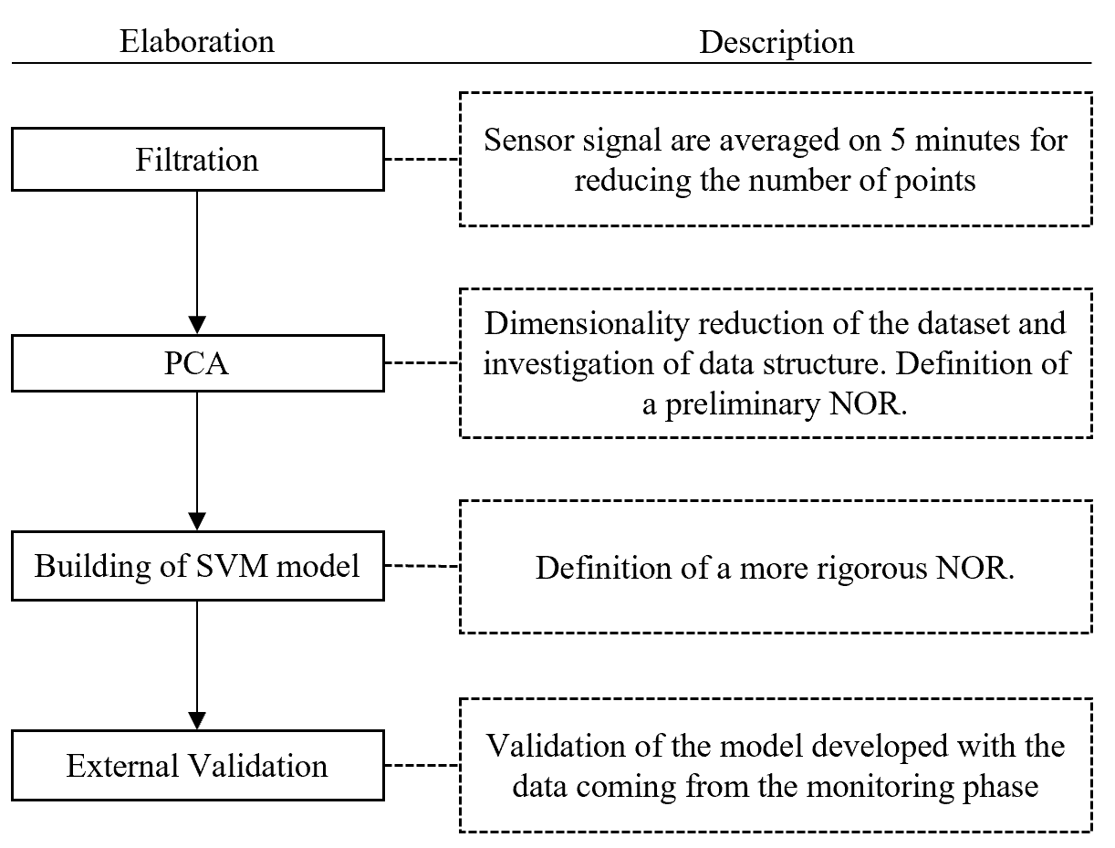

**Figure 3.** Block diagram of the data elaboration for the developing and validating the model.

**2.3 Monitoring and validation**

After the implementation of the model on the e-nose the monitoring phase started. The data collected by the nose in this phase follow the data processing pathway implemented on the training. The sensors response is averaged over 5 minutes, and then the data are projected onto the PCA model based on training data.

Then, the new PCA coordinates obtained from the monitoring points were used as inputs for the Support Vector Machine (SVM) algorithm to determine if they fall inside or outside the NOR. In case of projection outside the NOR boundaries, the e-nose report an alarm and activate the automatic sampler.

In order to validate the model, at the beginning of the monitoring phase, samples collected by the automatic sampler in case of alarm threshold exceedance and under normal conditions were analysed by dynamic olfactometry to determine their odour concentration and compare them with the predictions made by the monitoring system.

**3. Results and discussion**

**3.1 Training**

3.1.1 Preliminary considerations

The data collected during the training phase were processed by PCA, whose results are reported in Figure 4. The model built on 2 principal components describes 72.7% of the variance of the data.

Figure 4-A reports the PCA score plot, illustrating the projection of observations into the new reference system defined by principal components, which provides information about the existence of clusters in the data. In this graph, the odour concentration of the gas samples taken from the arrival tank are highlighted. Figure 2-A points out that on the PC1 there is a clear correlation between the odour concentration and the signal registered by the sensors, since moving on the left part of the graph the ouE/m3 increases.

Conversely, Figure 4-B reports the PCA loading plot, which provide information about the correlation among variables and their importance for the purpose of differentiating different conditions. In order to identify the variables contributing to the dispersion of points in the PCA score plot, the visual investigation of the loading plot in Figure 2-B shows that that the region where peaks of odour are present is the left one, since all the features related to the electrochemical sensors point in this direction. Conversely, the MOS sensors’ loadings point in the exactly opposite verse. Therefore, in the left portion of the plot, low resistance values are expected, in line with the MOS n-type behaviour when exposed to gas.

Moreover, this plot also enables determining correlations between the sensor signals. In this case, the MOS sensors are mainly correlated with the hydrogen sulphide, formaldehyde and PID sensors (i.e., the angle between the arrows is narrower than 90°, the one indicative of no correlation), while there is a negligible correlation with the ammonia sensor (i.e., the angle is close to 90°). This is probably due to the lower levels of ammonia registered on the arrival tank, varying among 0.3 and 1.5 ppm.

Finally, combining the point distribution of the score plot and the information coming from the loading plot, looking at the PC2 distribution of scores, 3 main regions of odours can be identified: one in the top-left part, one in the middle-left and one in the bottom-left part of the score plot. These 3 regions are relevant to different odour conditions at the arrival tank, associated to high levels of VOC, hydrogen sulphide/formaldehyde and ammonia respectively. Obviously, the odour presence will not be caused only by those compounds, but this information gives an estimation of the class of molecules most responsible for the specific odour peak.

|  |
| --- |
| A  Increasing odour concentration |
| B  **Figure 4.** Loading (A) and scores (B) plot of the PCA on the training data. The numbers displayed in the score plot indicates the odour concentration of the gas samples taken from the arrival tank. |

It is worthy to highlight that a multivariate approach, considering all the simultaneous sensors’ responses, is needed to obtain reliable e-nose outputs. Figure 5 compares the responses of PID and H2S sensors with the odour concentration of the gas samples collected at the arrival tank of the WWTP. It highlights a very poor correlation among single sensors response and odour properties of samples: R2 of 0.28 and 0.48 were obtained for PID and H2S sensors, respectively. Thus, single gas sensors cannot provide outputs directly correlated to the odour concentration of samples, which can be used to implement smart monitoring systems.

|  |
| --- |
| **Figure 5.** The PID values [ppm] versus the odour concentration [ouE/m3] of the samples taken from the arrival tank during the training phase. |

3.1.2 E-Nose model for WWTP monitoring

Based on the information obtained from the loading and score plots, the results of the olfactometric analysis and the citizen reports, a NOR region of the arrival tank has been defined on the score plot (Figure 6) by selecting only the points of the score plot that satisfied the following conditions: PC1>0 ˄ ∀ PC2, -2.5<PC1<0 ˄ -3<PC2<2.

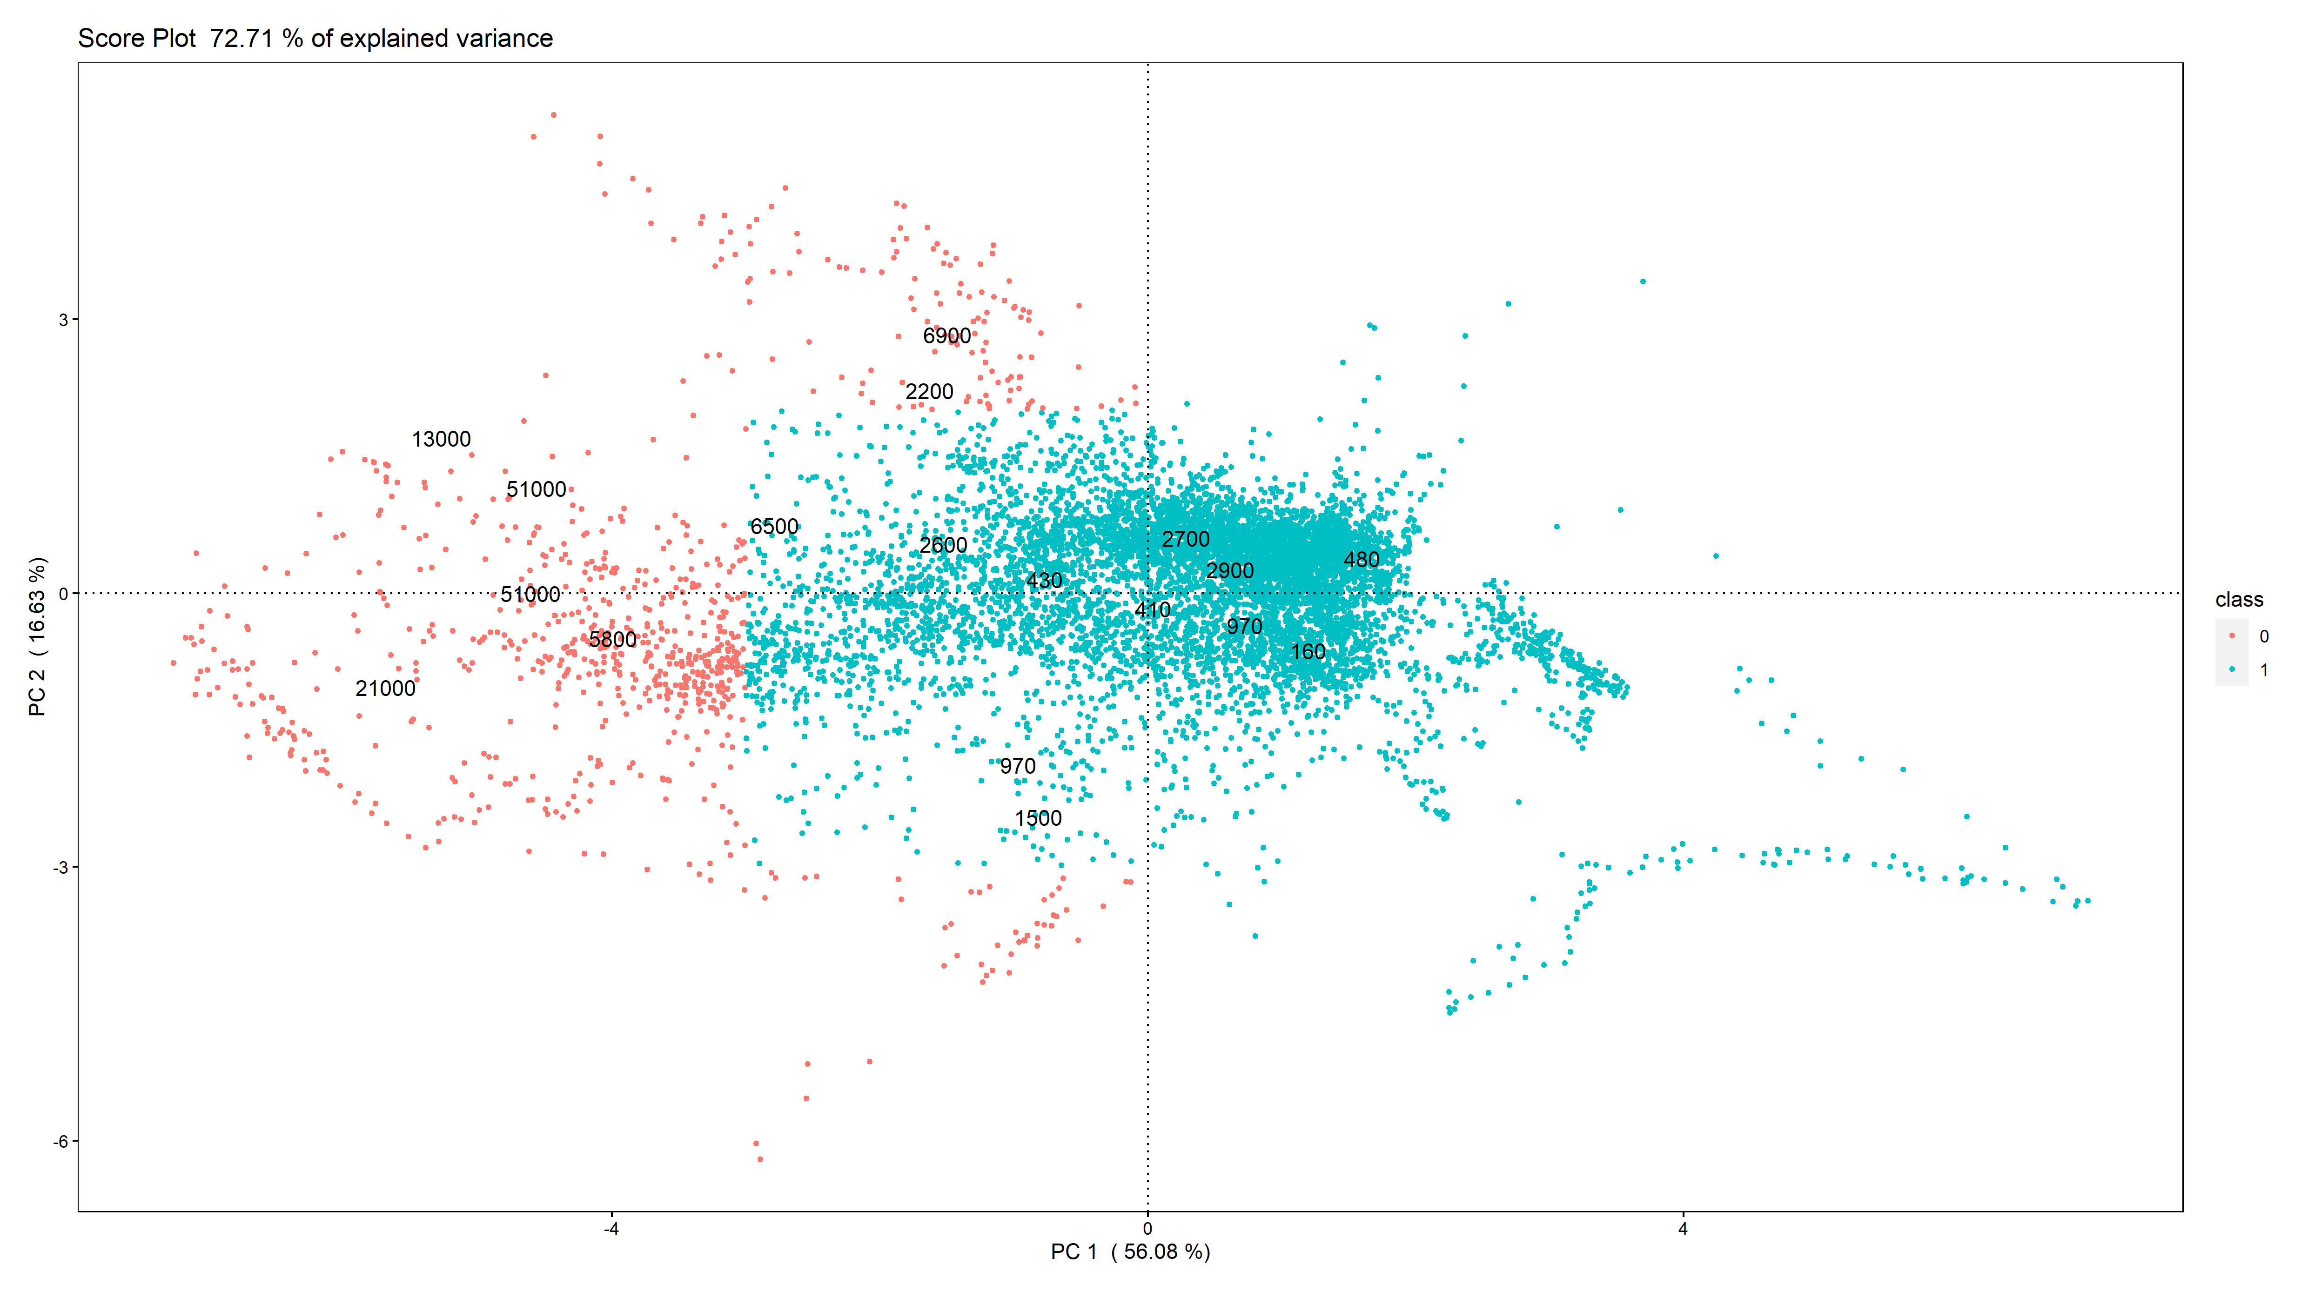Once defined this region, the point satisfying the imposed condition has been used to develop a one-classification SVM model, able to define a more accurate confidence region though a radial kernel. In this type of models two parameter are needed for the definition of the shape of the confidence region representative of the class. The “nu” parameter expressing the information of the percentage of possible outlier in the dataset, and the “gamma” parameter that define the shape of the boundaries of the NOR are defined based on training data distribution. In this case study, nu and gamma parameters have been set as 0.0001 and 0.03, respectively. The confidence region obtained as results is reported in Figure 7. With the purpose of introducing also an intermediate alarm region, representative of anomalous conditions that cannot be assimilated to the NOR region, but not so troubling in terms of odour concentration, a second area has been identified. This region is defined by PCA points satisfying the following requirements: PC1>0 ˄ ∀ PC2, -4<PC1<0 ˄ -4<PC2<3. Also in this case, the SVM, using as parameters nu=0.0001 and gamma=0.03, has been used to define the boundaries of the intermediate region.

**Figure 6.** Score plot where the point satisfying the NOR condition are coloured in blue.

NOR

Thus, the final model illustrated in Figure 8 comprises two distinct regions: the NOR, representative of the typical odour concentration of the arrival tank for normal incoming wastewater, and an intermediate region indicating that the incoming wastewaters are creating anomalous odour on the arrival tank, but still characterized by acceptable odour concentrations not causing nuisance nearby the plant.

|  |
| --- |
| **Figure 7.** PCA score plot with the NOR defined thought the use of one-classification SVM.    **Figure 8.** The PCA score plot with the NOR and the intermediate alarm region obtained with one-classification SVM. |

**3.2 Monitoring and Validation**

During the monitoring phase, the data are continuously acquired by the e-nose and processed by the models implemented on the training data. With the purpose of evaluating the capability of the e-nose to recognize and reveal the presence of anomalous odours, verification tests is carried out. This phase involved the automatic withdrawal of samples representative of both reference and anomalous odour conditions, i.e. representative of different odour concentration levels, at the arrival tank. Specifically, 9 independent samples, collected in 5 different days, have been considered: 4 representatives of the NOR and 5 representatives of the anomalous conditions.

Figure 9 illustrates the results of this validation phase. Samples characterized by odour concentrations lower than 4’600 ouE/m3 fall within the NOR. Conversely, samples collected under anomalous conditions (i.e., odour concentrations ranging from 9’200 ouE/m3 to 26’000 ouE/m3) fall outside the NOR.

The NOR defined by the model proved to be suitable for the discrimination between conditions representative of normal functioning of the plant characterized by odorous emissions not causing odour events in the surroundings and anomalous odour peaks. Moreover, the alarm defined turned out to be effective in signalling the exceedance of the critical odour concentration, and activating automatic sampling systems with the purpose of identifying the causes of the odour event detected.

|  |
| --- |
| **Figure 9.** Score plot of the PCA on the first weeks of monitoring. The numbers displayed in the score plot indicates the odour concentration of the gas samples taken from the arrival tank. |

**4. Conclusions**

This paper presented, as a case study, the e-nose monitoring of odorous emissions from the arrival tank of a WWTP. The e-nose was trained to signal the detection of malodours by implementing specific multivariate model, based on PCA and SVM algorithms, combining e-nose signals with odour concentration of gas collected on the arrival tank and the citizen reports about the presence or absence of odours nearby the plant.

The results achieved prove that the developed system is capable to real-time detect deviations from reference conditions (i.e. conditions with low-to-moderate odour emissions), and provide information about the potential causes of the malfunction. This system can serve the plant operator for different purposes. It could be useful for the identification of the substances responsible of odours peaks and consequently develop a specific tailored abatement system, thus optimizing the costs and benefits compared to more generic solutions. Moreover, if the wastewater source that cause the problems is identified it could be separated and pre-treated appositely before entering the WWTP for example with ozone treatments [12], ultraviolet light [13], nanoparticles [14] and other innovative treatments [15].

Future goals to be achieved within these applications concern the implementation of a more precise quantification model to estimate the odour concentration based on regression. Moreover, future work should focus on the validation over time of the model to spot the sensors drifting and intervene to compensate it with an appropriate drift correction model in order to extend the alarm model validity.

**References**

[1] A. Setiabudi, M. Makkee, and J. A. Moulijn, "An optimal NOx assisted abatement of diesel soot in an advanced catalytic filter design," *Applied Catalysis B: Environmental,* vol. 42, no. 1, pp. 35-45, 2003/04/15/ 2003.

[2] Q. W. Wang, P. Zhou, N. Shen, and S. S. Wang, "Measuring carbon dioxide emission performance in Chinese provinces: A parametric approach," *Renewable and Sustainable Energy Reviews,* vol. 21, pp. 324-330, 2013/05/01/ 2013.

[3] K. Li, S. Thompson, and J. Peng, "Modelling and prediction of NOx emission in a coal-fired power generation plant," *Control Engineering Practice,* vol. 12, no. 6, pp. 707-723, 2004/06/01/ 2004.

[4] J. A. Jahnke, "Continuous emission monitoring," 2000.

[5] C. Bax, S. Sironi, and L. Capelli, "How Can Odors Be Measured? An Overview of Methods and Their Applications," *Atmosphere,* vol. 11, no. 1, 2020.

[6] L. Capelli, S. Sironi, and R. Del Rosso, "Odor sampling: techniques and strategies for the estimation of odor emission rates from different source types," (in eng), *Sensors (Basel, Switzerland),* vol. 13, no. 1, pp. 938-955, 2013.

[7] D. Leung and J. A. Romagnoli, "Chapter 6.4 - Fault Diagnosis Methodologies for Process Operation," in *Computer Aided Chemical Engineering*, vol. 11, B. Braunschweig and R. Gani, Eds.: Elsevier, 2002, pp. 535-556.

[8] J. A. Covington, S. Marco, K. C. Persaud, S. S. Schiffman, and H. T. Nagle, "Artificial Olfaction in the 21<sup>st</sup> Century," *IEEE Sensors Journal,* vol. 21, no. 11, pp. 12969-12990, 2021.

[9] P. Boeker, "On ‘Electronic Nose’ methodology," *Sensors and Actuators B: Chemical,* vol. 204, pp. 2-17, 2014/12/01/ 2014.

[10] H. Abdi and L. J. Williams, "Principal component analysis," *WIREs Computational Statistics,* vol. 2, no. 4, pp. 433-459, 2010.

[11] M. Sun, "Support Vector Machine Models for Classification," in *Encyclopedia of Business Analytics and Optimization*, J. Wang, Ed. Hershey, PA, USA: IGI Global, 2014, pp. 2395-2409.

[12] C. V. Rekhate and J. K. Srivastava, "Recent advances in ozone-based advanced oxidation processes for treatment of wastewater- A review," *Chemical Engineering Journal Advances,* vol. 3, p. 100031, 2020/11/15/ 2020.

[13] W. Yang, H. Zhou, and N. Cicek, "Treatment of Organic Micropollutants in Water and Wastewater by UV-Based Processes: A Literature Review," *Critical Reviews in Environmental Science and Technology,* vol. 44, no. 13, pp. 1443-1476, 2014/07/03 2014.

[14] S. Manikandan *et al.*, "Emerging nano-structured innovative materials as adsorbents in wastewater treatment," *Bioresource Technology,* vol. 320, p. 124394, 2021/01/01/ 2021.

[15] J. M. Lema and S. S. Martinez, *Innovative wastewater treatment & resource recovery technologies: impacts on energy, economy and environment*. IWA publishing, 2017.