**The VIRTCHEM project: the virtual immersive education for chemistry and chemical engineering**

Carlo Pirola1,*,Alessandro Pedretti2, Claude Jolivalt3, Farzaneh Arefi3, Ludek Mika4, Petr Smejkal4

*1 Dipartimento di Chimica, Università degli Studi di Milano, via Golgi, 19 20133 Milano; 2 Dipartimento di Scienze Farmaceutiche, Università degli Studi di Milano, via Mangiagalli, 25 20133 Milano, 3* *Sorbonne Universite,* *CNRS, Laboratoire de Réactivité de Surface, LRS, 4 Place Jussieu, Paris F-75005, France,4* *Department of Chemistry Education,Charles University, , Hlavova 2030/8, 128 00 Praha, Czech Republic*

*\*Corresponding author E-Mail: carlo.pirola@unimi.it*

**1.Introduction**

Virtual immersive laboratories should be considered as an appealing and synergistic possibility for education in science, technology and engineering, strongly complementary to experimental activities performed in laboratory or exercises delivered in traditional rooms. Traditionally, degree courses in chemical sciences have been delivered using traditional teaching approaches, classroom exercises and real experiments in laboratories. Recently, innovative teaching methodologies have been proposed on the basis of the use of simulation science [1]. In this context, a new didactic project called VIRTCHEM was proposed by the three universities of Milan (Università degli Studi), Paris (Sorbonne Universite) and Prague (Charles University) proposing virtual laboratories in the various fields of chemistry and chemical engineering. The project was based on to the use of different types of virtual reality (VR) software for an immersive experience within the reproduction of chemistry laboratories, an industrial chemistry plant and investigation of structure of molecules. Students used these immersive programs in rooms equipped with VR workstations in the virtual rooms located in the departments of the three universities. During virtual exercises, specifically prepared according to educational goals, students collected information and data that required their interpretation, analysis and discussion in working teams to promote not only their learning but also their soft skills and critical thinking. Ten students from each university were selected to participate to the project. Preliminary lessons, about the theoretical background of the virtual exercises, were delivered as distance lessons and then three working weeks in Milan, Paris and Prague were conducted in presence during the spring of 2022 year. The project was funded by the 4eu+ European University Alliance (https://4euplus.eu/4EU-183.html).

**2. Methods**

VIRTCHEM project proposed immersive experiences in virtual laboratories by organizing preparatory lessons, virtual exercises, analysis of the data collected and a final meeting to share the teaching experiences. Expected educational outcomes were to promote innovative approaches such as student-centered and project-based learning by providing learning tools with improved flexibility and to provide an alternative to laboratory sessions when students are unable to attend the lab because of disabilities or attendance challenges (pregnancy, safety, pandemic issues). Another important goal of the project was to enable exploration of industrial platform or laboratory instrument set-up at a level inaccessible in “real life” such as inside process components and to take students on a realistic tour of an industrial plant since most of them never experience an in-person visit of an industrial site before their graduation. Particular attention was devoted to promote soft skills as to improve creativity, risk taking, social responsibility, teamwork ability, self-confidence and communication skills and to promote educational collaboration among universities.

**3. Results and discussion**

The project was based on the use of the following three simulation software Labsim, Eyesim and Nanome (Fig.1). LabSim is a laboratory simulator of inorganic analytical chemistry that allows to do solubility test, pH measurement and phase separation, and to perform a qualitative analysis of inorganic substances. The database allows to reproduce more than 3500 reactions. (<https://nova.disfarm.unimi.it/labsim>). Eyesim reproduces a Crude Distillation Unit plant from a physical and chemical point of view. The users can visit the plant and perform different exercises [2]. Nanome (Cuni, by Nanome Inc.) is a software for visualization and manipulation with molecules allowing immersion into a centre of almost any molecule to study its structure and properties. It is suitable for the educational purposes due to its wide platform support and illustrative way of molecule presentation. Webpage and short presentation is at https://nanome.ai/ .

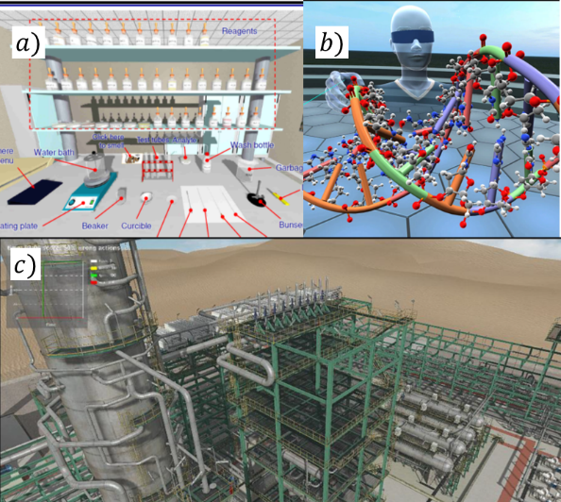

**Figure 1.** Example of screenshots of the software a) Labsim; b) Nanome; c) Eyesim.

The participation and evaluation of the students in the project was very positive. The planned activities, still in progress, are allowing students with heterogeneous basic preparation to be able to acquire basic notions on all the topics of the project. Quantitative results will be given during the GRICU conference, after the end of all the activities, including the final evaluation of the student groups' work scheduled for May 2022.

**4. Conclusions**

A new and innovative education project, VIRTCHEM, was proposed and delivered to students from different European Universities and degree courses. The project covered different areas of chemical sciences (chemical engineering, analytical and inorganic chemistry, molecular chemistry). The proposed activities resulted strongly complementary and synergic respect the traditional lessons and exercises.

**References**

1. V. Potkonjak, M. Gardner, V. Callaghan, P. Mattila, C. Guetl, V.M. Petrović, K. Jovanović, Comput. Educ. 95 (2016) 309–327
2. C. Pirola, C. Peretti, F. Galli, Computer Chem. Eng. 140 (2020) 106973