A comprehensive chemical kinetic framework for the thermo-catalytic pyrolysis of light hydrocarbons for value added carbon solids and turquoise hydrogen production.
Matteo Pelucchi^{1*}, Francesco Serse¹, Clarissa Giudici¹, Zhaobin Ding², Andrea Nobili¹, Davide Cafaro², Daniele Micale², Matteo Ferri², Mauro Bracconi², Matteo Maestri²
¹CRECK Modeling Lab. Department of Chemistry Materials and Chemical Engineering, Politecnico di Milano, Piazza Leonardo da Vinci 32, 20133, Milano
²Department of Energy, Politecnico di Milano, Via La Masa, 34, 20156, Milano
*Corresponding author E-Mail: matteo.pelucchi@polimi.it
1. Introduction
The large majority of fossil sources (gas, oil, coal, ~10 gigatonnes/yr) are exploited to generate energy through combustion, the main responsible of CO₂ emissions (>30 GT/yr) and of climate change. More than 12% of this energy is used by the metal industry to process materials that currently cannot be fully replaced by plastic polymers (e.g. low thermal/electrical conductivity, insufficient strength). In this context, value added carbon solids (VACS) pave the way for sustainable energy and large-scale advanced materials production as well as climate change mitigation¹. Specifically, the contextual production of hydrogen and carbon materials from methane and hydrocarbons cracking allows to overcome challenges in storage or disposal of carbon in the form of gas or liquid (e.g. CO₂) or solid side products, currently limiting the large scale implementation of carbon capture and storage technologies, by creating valuable products that can be used at large scale (above 1 million tons/yr) by displacing metals, ceramics, fertilizers and other materials with high carbon dioxide footprint. Beyond the widely known and implemented technology of carbon black (i.e. amorphous carbon) production, direct conversion of hydrogen rich feedstock such as methane or light hydrocarbons to VACS and H₂ is becoming of increasing scientific and industrial interest. This work proposes a first semi-detailed chemical kinetic framework, hierarchical and modular in nature, able to describe qualitatively and quantitatively the relationships between catalyst, reaction conditions and VACS (carbon black, carbon nanotubes-CNT) properties in the thermo-catalytic pyrolysis of methane.
2. Methods
An amorphous carbon model and a VACS growth model are coupled to a homogeneous gas-phase pyrolysis model to follow the transition from gas-phase to particulate matter particles in the gas phase and to carbon nanotubes (CNT) at the catalyst surface. The amorphous carbon model has been described and extensively validated in a previous work² and implements recent experimental and theoretical findings on the persistent radical behavior of particles and aggregates³. It discretizes heavy PAHs and soot particles into 25 sections of lumped pseudo species, called BINs, from 20 to over 10⁸ C-atoms, with a spacing factor of two. Each section consists of three subsections covering different H/C ratio, with thermochemical and diffusion properties computed through group additivity method and aerosol dynamics theory². Different reaction classes are implemented to rigorously describe the main chemical and physical pathways involving amorphous carbon such as particle inception, growth, coagulation, and dehydrogenation. Reference kinetic parameters for particles are derived by analogy from model PAHs molecules accounting for the transition from gas to solid as resulting from extensive density functional theory calculations on large PAHs molecules and graphene layers⁴. The flexibility of the amorphous gas-phase carbon model (soot) is here extended to include surface adsorption of gas phase species and successive growth of solid carbon deposits according to a similar systematic approach. Further extension to catalytic surface deposition mechanisms paves the way for a semi-detailed approach to turquoise hydrogen and carbon materials production modelling.
3. Results and discussion
Figure 1 summarizes the capability of the model to reproduce both (a) gas species formation and evolution (including hydrogen) and deposition rates as a function of temperature (b) and residence time (c) for propane pyrolysis at p=2.7 kPa in a perfectly stirred reactor, as reported in [5]. Panel (d) shows the competition between amorphous carbon formation (black lines) in the gas stream and carbon deposition (red lines).

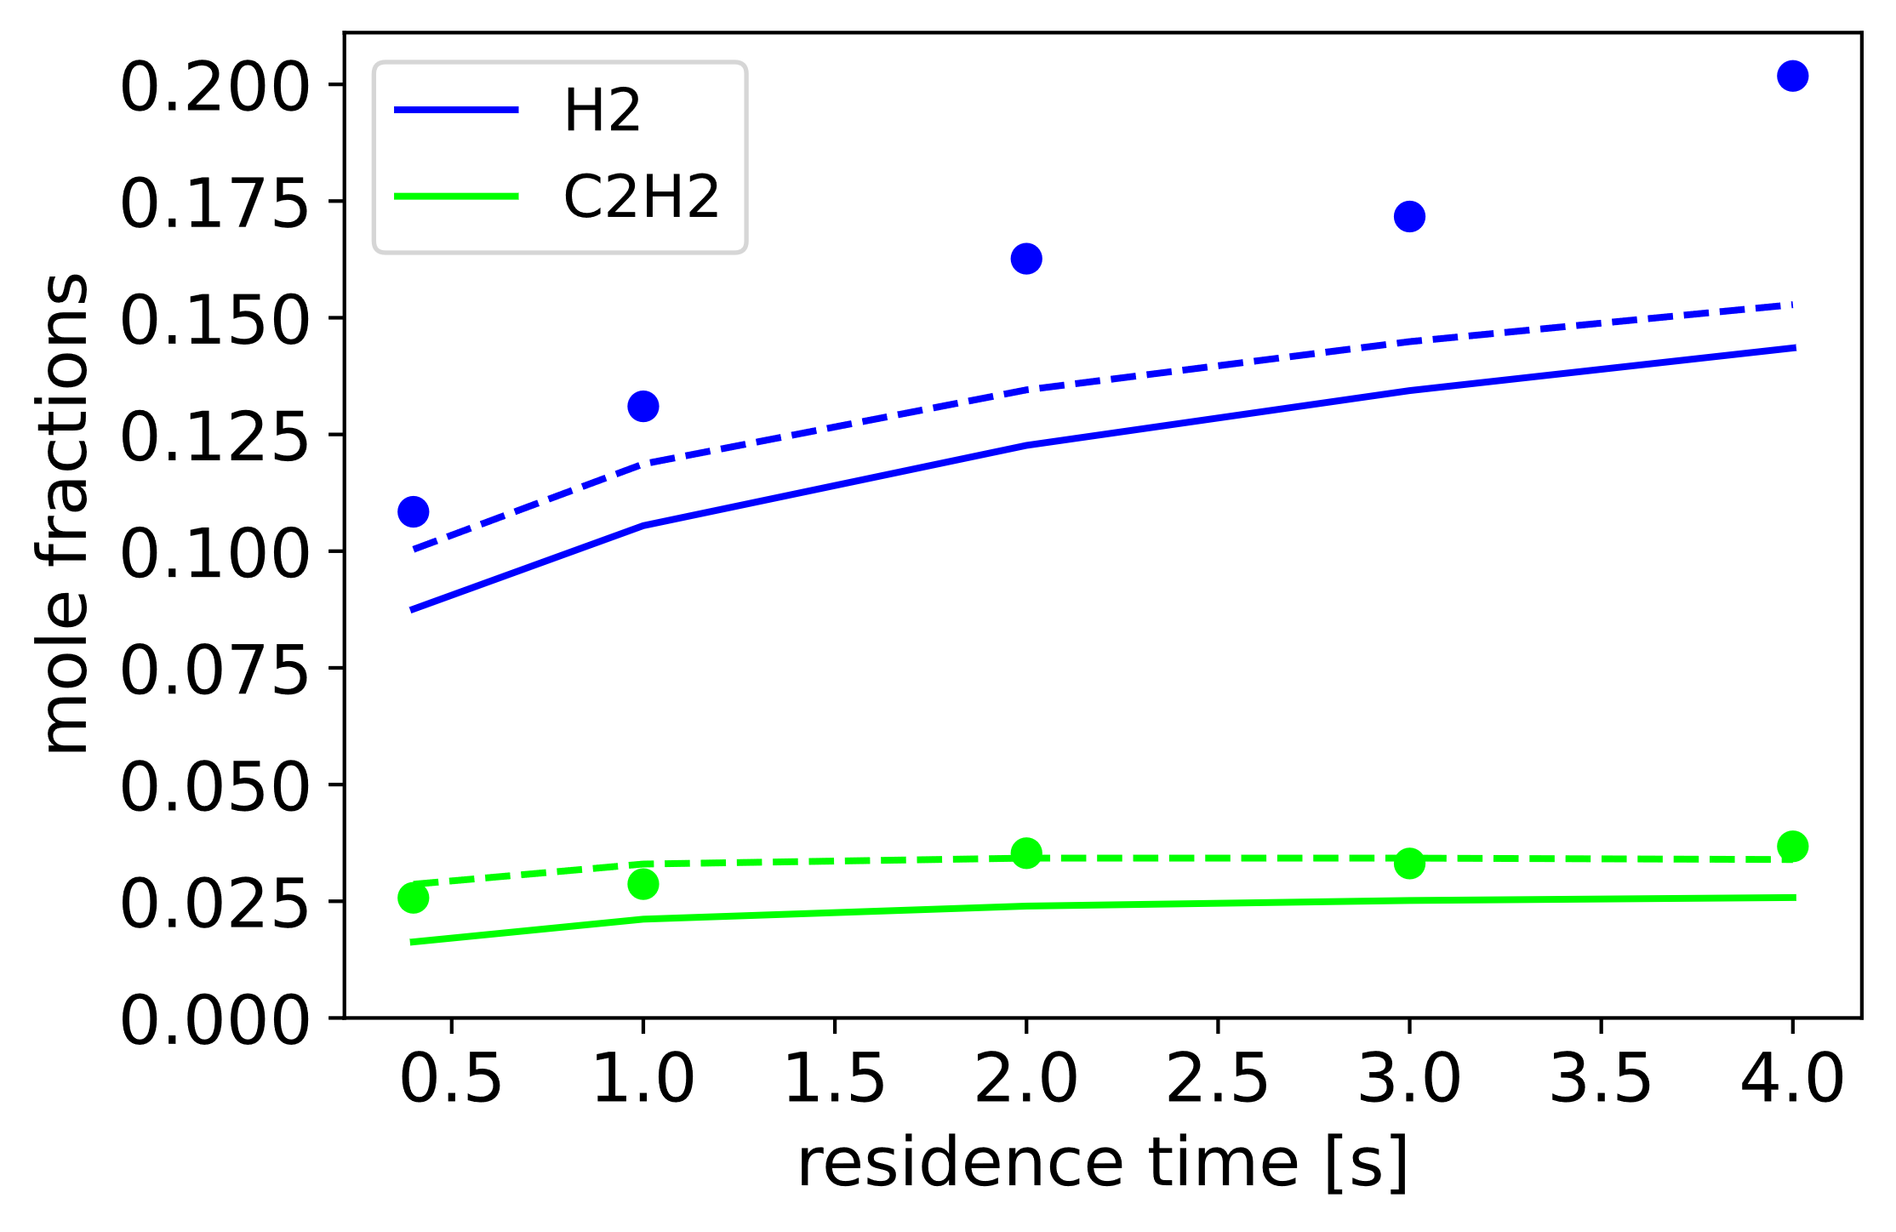 | 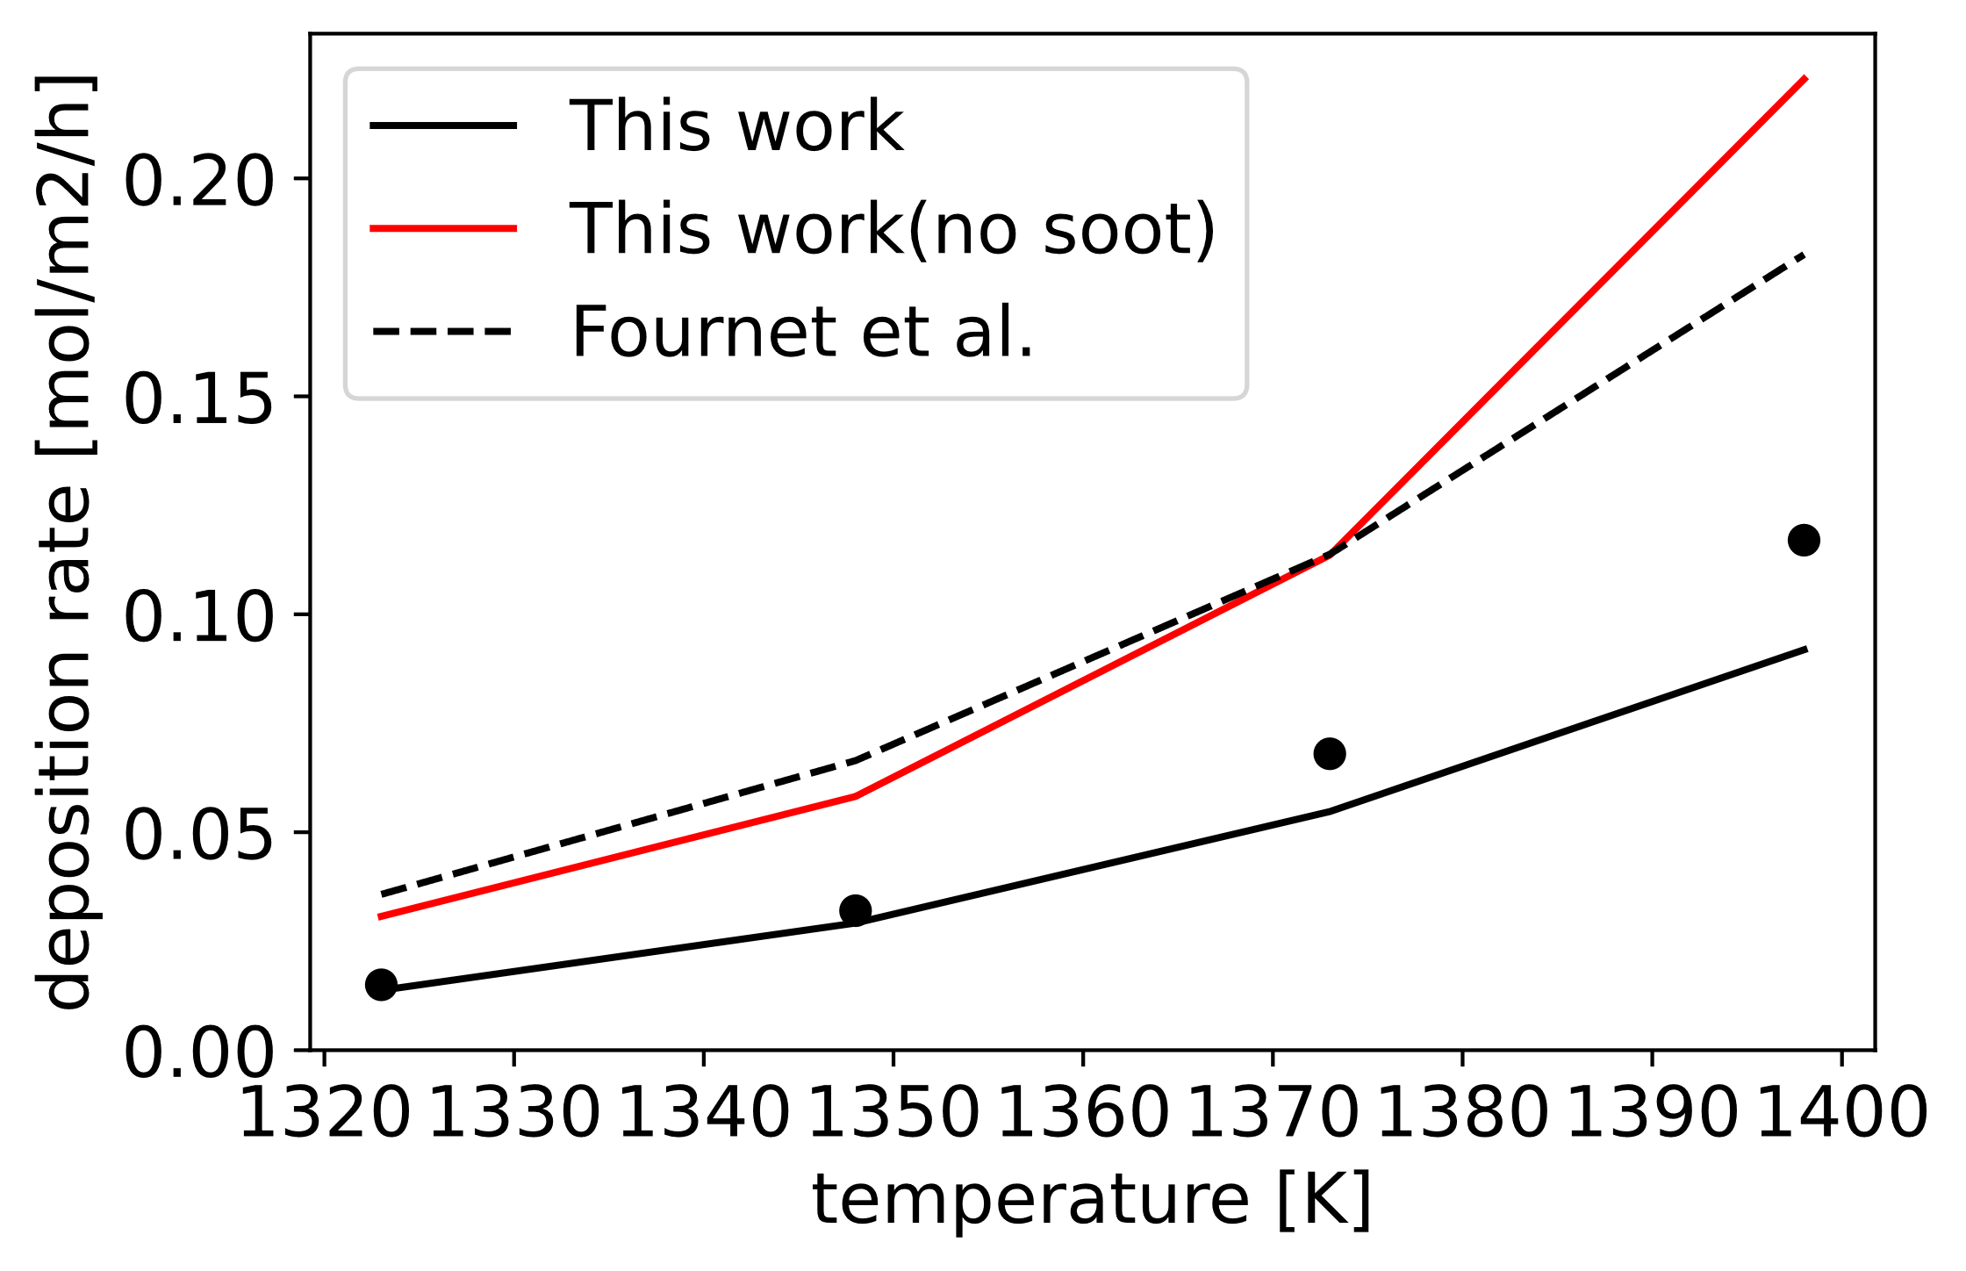
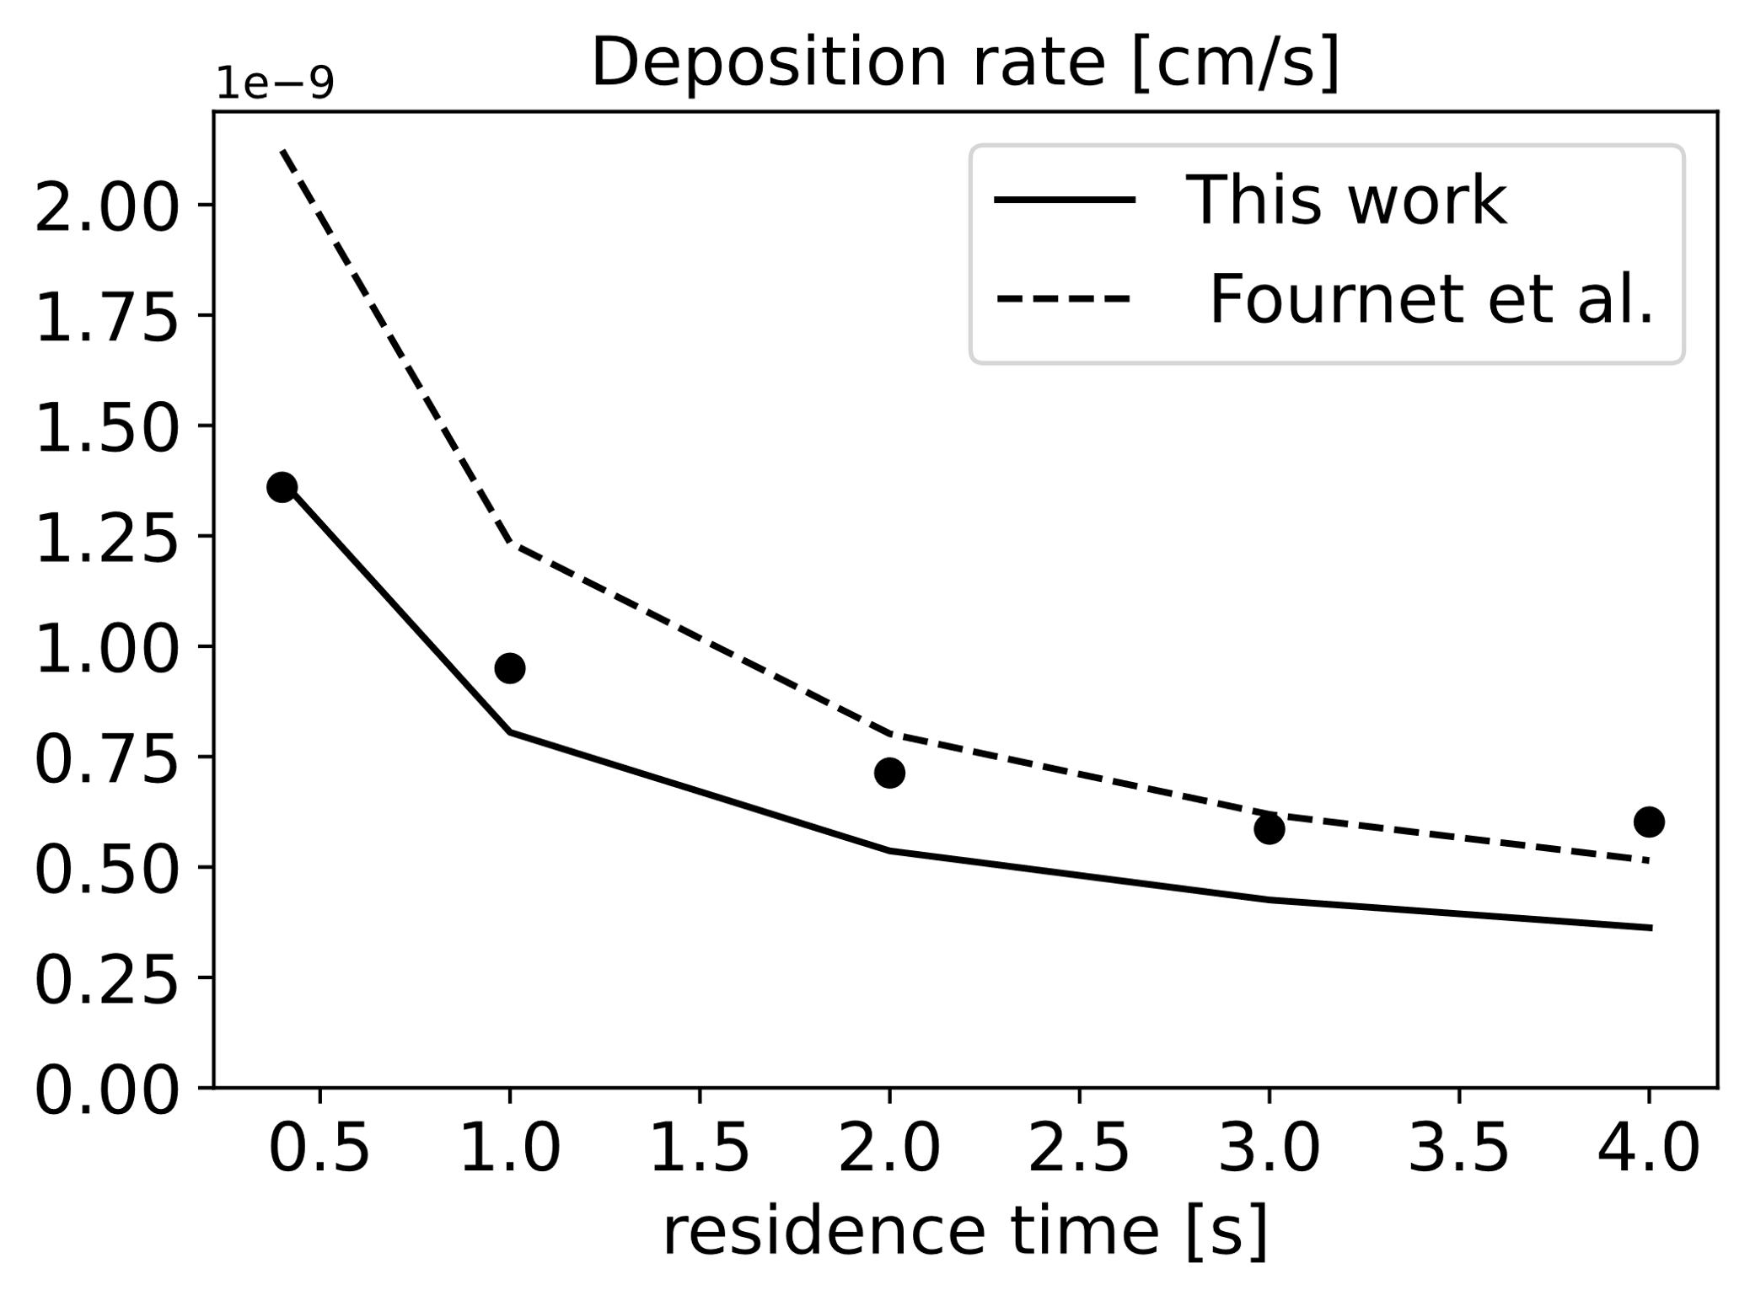 | 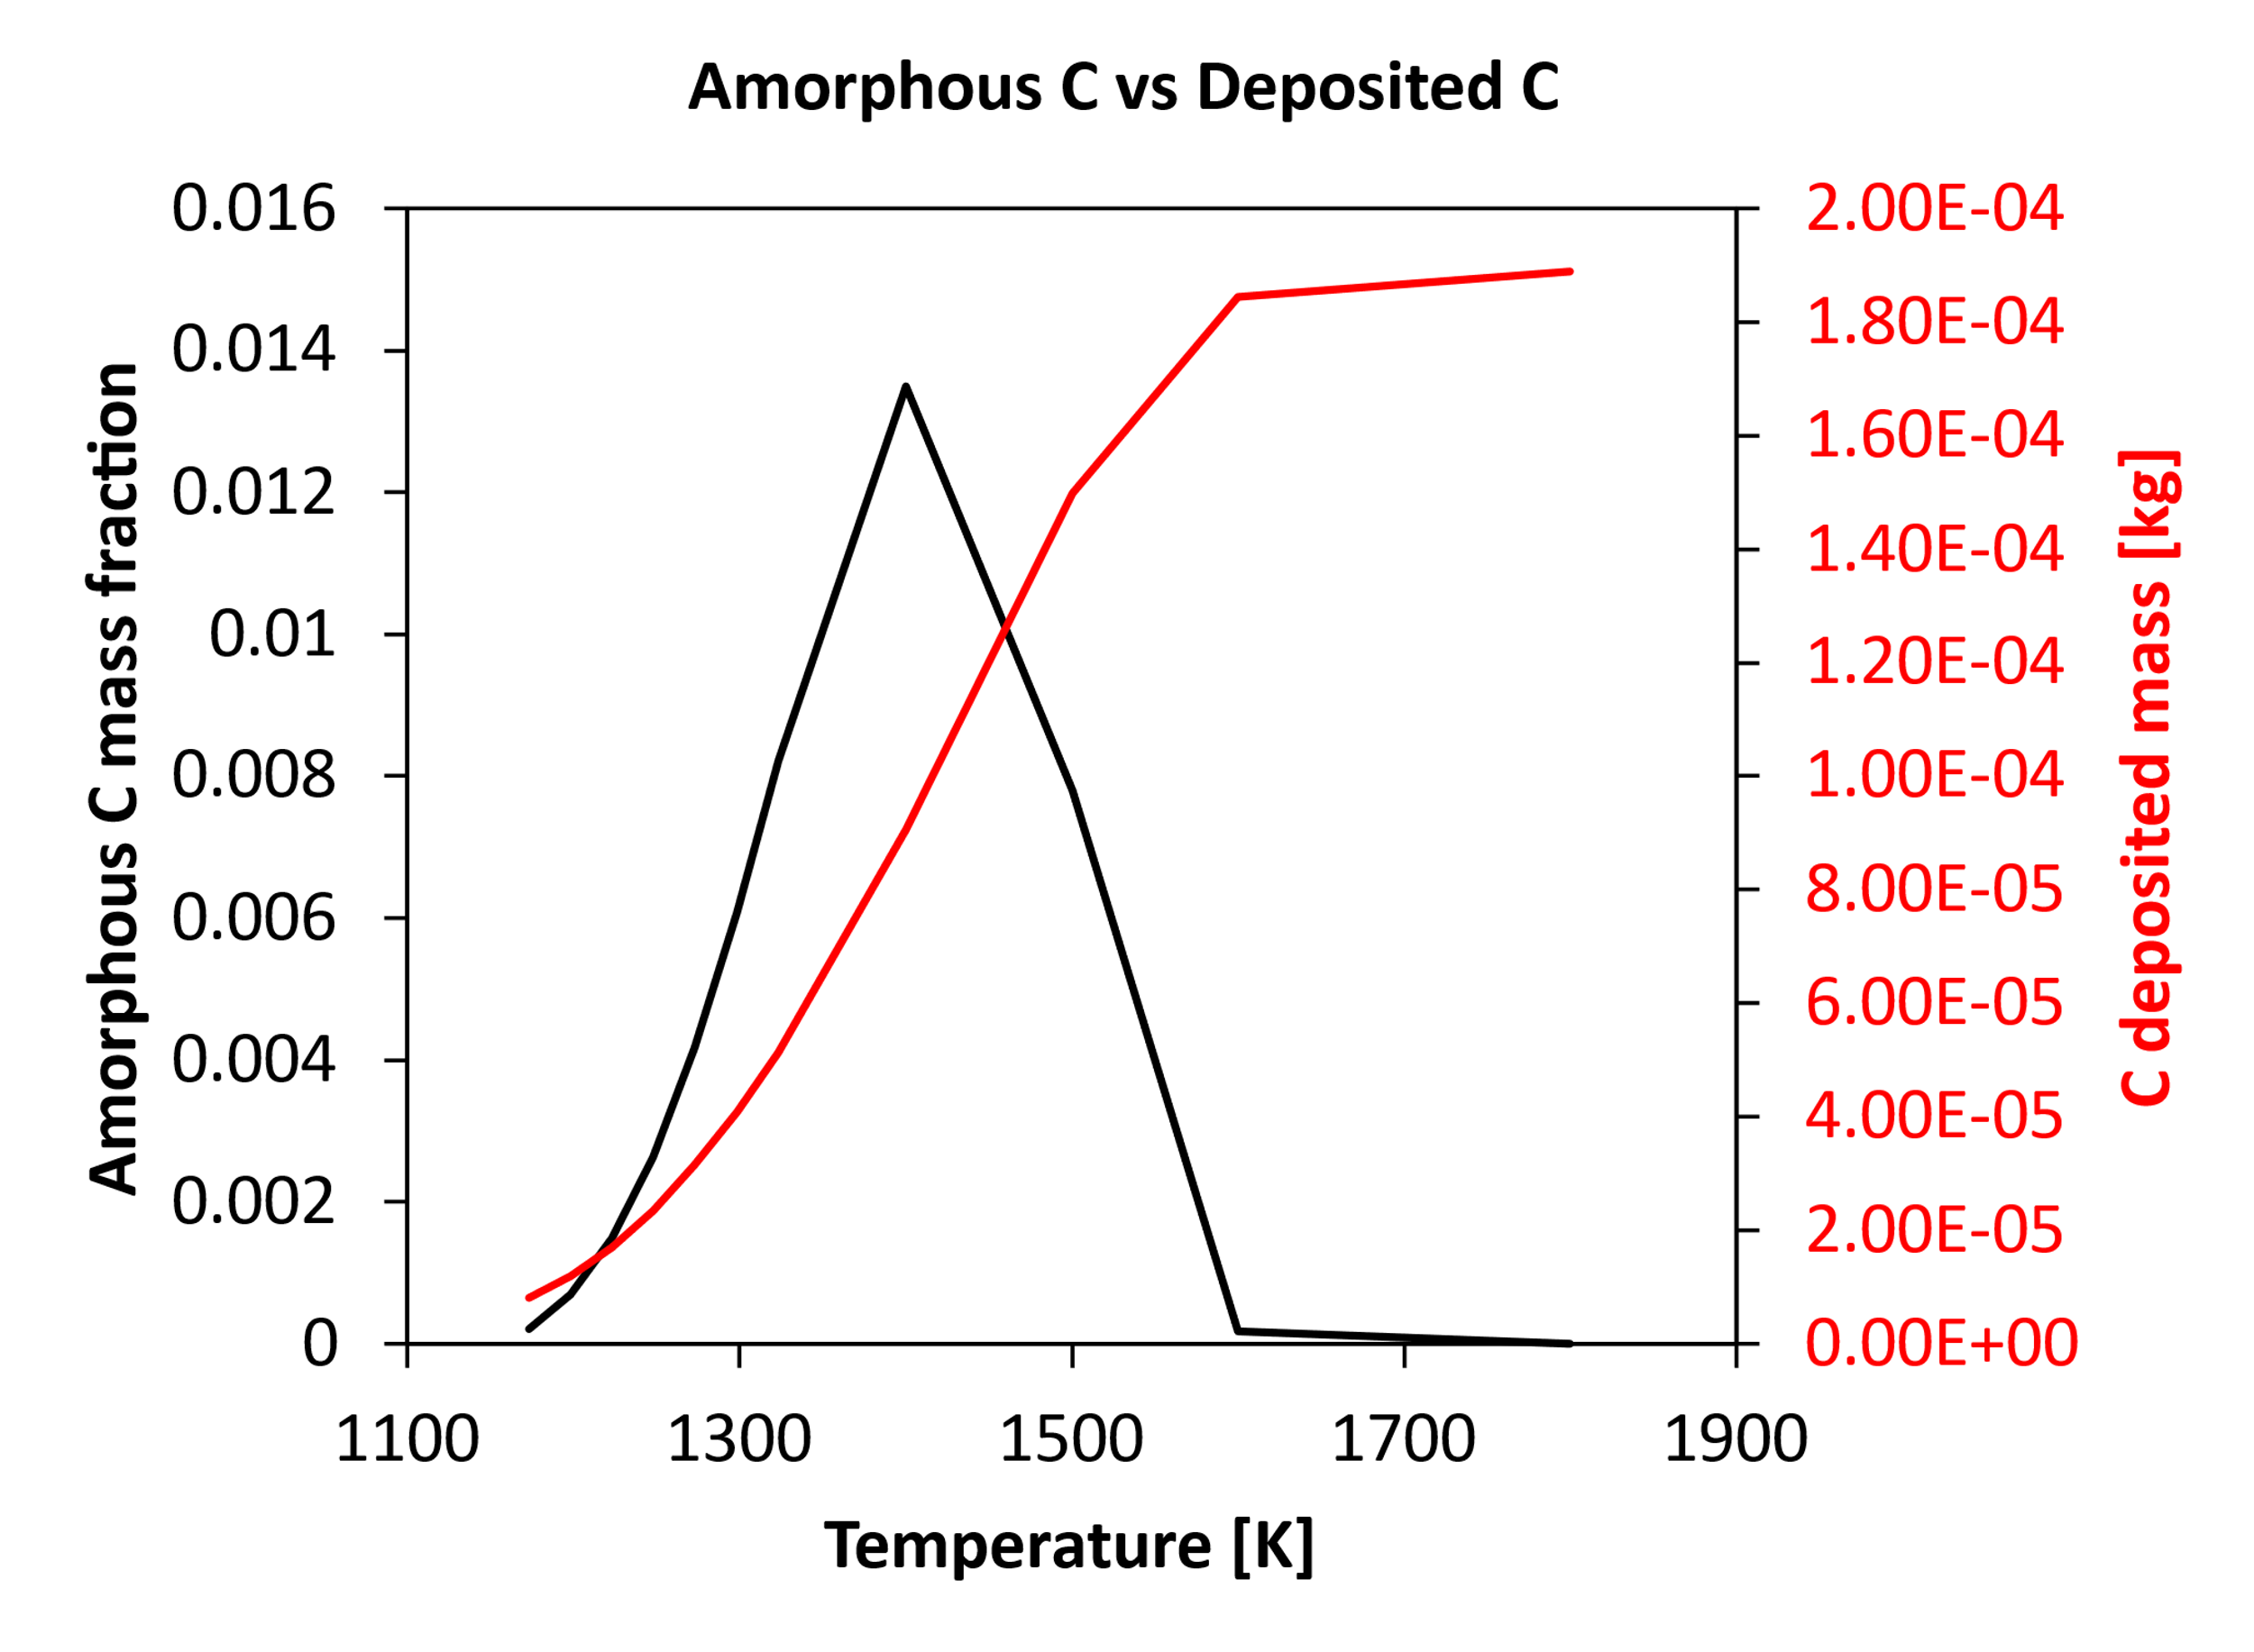
Figure 1. Model performances for methane pyrolysis: from gas-phase (a) to amorphous and pyrolytic carbon (b,c) and their competing formation (d). Experiments and dashed lines from [5], solid lines: this work.
4. Conclusions
The novel approach here presented overcomes the state-of-the-art modelling efforts for carbon materials growth. Indeed, available models are largely based on purely phenomenological approaches (i.e. power-law single step kinetics) of limited validity. This work provides a fundamentally based semi-detailed kinetic model describing both homogeneous gas-phase species evolution and amorphous carbon formation andsurface carbon deposition. The approach has been extended also to catalytic CNT growth, providing promising results. Further model reduction makes our framework applicable to reactor scale simulations. However, a scarcity of kinetic relevant data suitable for model validation is highlighted in the literature. On one hand, this limits model reliability assessments, and on the other hand forces a systematic approach for modeling activities of such complex multiphase and multiscale phenomena. In addition, the systematic theoretical investigation of chemical pathways, potential energy surfaces and kinetic rate constants for H-abstraction reactions provides an effective methodological workflow for investigating heterogeneous gas/solid chemistry.
5. References
[1] Pasquali, M., & Mesters, C. (2021). Opinion: We can use carbon to decarbonize—and get hydrogen for free. Proceedings of the National Academy of Sciences, 118(31).
[2] Nobili, A., Cuoci, A., Pejpichestakul, W., Pelucchi, M., Cavallotti, C., & Faravelli, T. (2022). Modeling soot particles as stable radicals: a chemical kinetic study on formation and oxidation. Part I. Soot formation in ethylene laminar premixed and counterflow diffusion flames. Combustion and Flame, 112073.
[3] Nobili, A., Maffei, L. P., Baggioli, A., Pelucchi, M., Cuoci, A., Cavallotti, C., & Faravelli, T. (2022). On the radical behavior of large polycyclic aromatic hydrocarbons in soot formation and oxidation. Combustion and Flame, 235, 111692.
[4] Ding, Z.B., Di Marco, E., Pelucchi, M., Faravelli. T., Maestri, M., “First-principles assessment of the analogy between gas-phase and gas-solid H-abstraction reactions at graphene edges”, Chem. Eng. J. 377, 119691 (2019).
[5] Lacroix, R., Fournet, R., Ziegler-Devin, I., & Marquaire, P. M. (2010). Kinetic modeling of surface reactions involved in CVI of pyrocarbon obtained by propane pyrolysis. Carbon, 48(1), 132-144.
Acknowledgements
The authors acknowledge the financial support from the industry members of the Carbon-Hub consortium.

