**An experimental investigation on ionic shortcut currents reduction**

**in Acid-Base Flow Battery systems**

Alessandra Pellegrino, Andrea Culcasi, Alessandro Cosenza, Alessandro Tamburini*, Andrea Cipollina, Giorgio Micale

*Dipartimento di Ingegneria, Università degli Studi di Palermo, Viale delle Scienze ed.6, 90128 Palermo, Italy*

*\*Corresponding author E-Mail: alessandro.tamburini@unipa.it*

**1.Introduction**

In recent years, the global scenario has been shifting toward energy transition and widespread of renewables. However, the discontinuity nature of the most commonly used renewable resources, such as solar and wind, intrinsically requires the use of suitable Energy Storage Systems (ESS). In this regard, the Acid-Base Flow Battery (ABFB) is a novel and sustainable storage system based on two membrane technologies: Electrodialysis with Bipolar Membrane (EDBM) for the charging phase and Reverse Electrodialysis with Bipolar Membrane (REDBM) for the discharging phase [1]. The EDBM process, in particular, can store electrical energy in the form of pH and salinity gradients, whereas the REDBM process can supply electricity by consuming these gradients when needed [2]. The ABFB technological feasibility is strongly related to the reduction of the main detrimental phenomena affecting the process. Among these, the passage of ionic shortcut (or parasitic) currents through manifolds is the ABFB most important issue. Indeed, when parallel channels of the same solution are exposed to a voltage difference, a portion of the ionic current can pass through alternative pathways constituted by the manifolds [3]. As a result, during the charging phase, the cell current decreases, reducing acid and base production. On the contrary, during the discharging phase, the dissipated current increases, causing the battery to discharge faster. The present work aims to reduce the impact of this critical issue, thereby improving the ABFB Round Trip Efficiency (RTE).

**2. Methods**

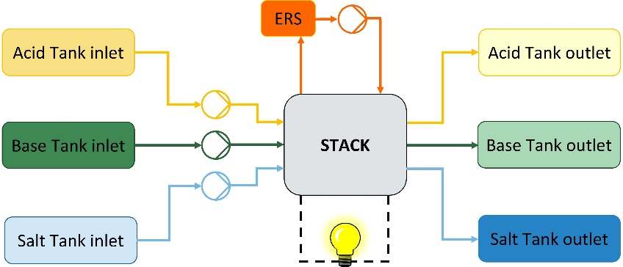A lab-scale setup was provided by Fumatech®. The stack was equipped with FAB®, FKB®, and FBM® membranes, as well as PVC/ECTFE spacers. The system was assembled with 30 triplets and the inlet operating conditions were: 0.5 cm s-1 average velocity of the solutions in the channels, 1 M inlet acid (HCl) and base (NaOH) concentrations, and 0.25M salt (NaCl) concentration.

**Figure 1.** Configuration of REDBM Open Loop tests.

In order to study the effect of the ionic shortcut currents, plastic non-conductive sticks were used to reduce the manifold section. In detail, the sticks were made of plexiglass and occlude the section by approximately 90%: this reduction increases the electrical resistance of the manifolds and is therefore expected to reduce the relevant ionic shortcut currents. On the other hand, pressure drops are expected to increase. In this work REDBM tests (i.e. the discharge phase of the battery) in open loop (i.e. without recirculation, Figure 1) with a unit assembled without the sticks (classic configuration, referred to as “test 1”) and with the sticks (referred to as “test 2”) are shown. Moreover, the battery gross and net power densities, voltage, and Round Trip Efficiency were all evaluated.

**3. Results and discussion**

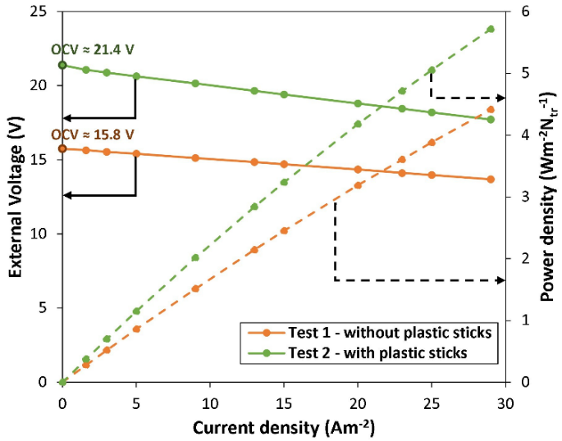Figure 2 shows the external voltage and power density as a function of the current density. The external voltage values in test 2 were higher than in test 1: Open Circuit Voltage (OCV) was 36% higher and the voltage at the highest investigated current density for REDBM (i.e., 29 Am-2) was 30% higher. Moreover, as the current density increases, the difference between the two curves of external voltage wasn’t constant. The introduction of plastic sticks into the manifolds has increased the internal global resistance of the stack, as evidenced by the slope of the curves. Furthermore, tests were performed to determine the pressure drops in the two different configurations. Finally, the achievable power density was computed, after subtracting the pumping power consumption. The maximum net power density of test 1 (at 29 Am-2) was 4.3 Wm-2Ntr-1, while for test 2 was 5.4 Wm-2Ntr-1. Therefore, the effect of the plastic sticks may potentially result in a RTE increase of 25%.

**Figure 2.**Comparison between test 1 and test 2: trend of external voltage and power density as the current density changes.

**4. Conclusions**

This work demonstrates how the inclusion of isolating material inside the manifolds can reduce the effect of parasitic currents in the system. The best design of plastic sticks cross-sectional area can be chosen to achieve a balance between reducing parasitic currents and increasing stack pressure drops. As demonstrated, the technology has significant potential for future growth, although additional experimental and modelling tests are required to improve the battery performance.

**Acknowledges**

This work was performed in the framework of the BAoBaB project (*Blue Acid/Base Battery: Storage and recovery of renewable electrical energy by reversible salt water dissociation*). The BAoBaB project has received funding from the European Union’s Horizon 2020 Research and Innovation program under Grant Agreement no. 731187 ([www.baobabproject.eu](http://www.baobabproject.eu)).

**References**

1. R. Pärnamäe, L. Gurreri, J. Post, W. J. van Egmond, A. Culcasi, M. Saakes, J. Cen, E. Goosen, A. Tamburini, D. A. Vermaas, M. Tedesco, The Acid–Base Flow Battery: Sustainable Energy Storage via Reversible Water Dissociation with Bipolar Membranes, Membranes 2020, 10, 409; https://doi.org/10.3390/membranes10120409
2. A. Culcasi, L. Gurreri, A. Zaffora, A. Cosenza, A. Tamburini,, G. Micale, On the modelling of an Acid/Base Flow Battery: An innovative electrical energy storage device based on pH and salinity gradients, Applied Energy 277 (2020) 115576, <https://doi.org/10.1016/j.apenergy.2020.115576>
3. A. Culcasi, L. Gurreri, A. Zaffora, A. Cosenza, A. Tamburini, A. Cipollina, G. Micale, Ionic shortcut currents via manifolds in reverse electrodialysis stacks, Desalination 485 (2020) 114450, <https://doi.org/10.1016/j.desal.2020.114450>