Influence of the morphology of the precursors on the electrochemical capacity of cathodes of Li-ion batteries

M. L. Para^{1*}, A. Querio¹, M. Shiea¹, S. Bodoardo¹, D. Marchisio^{1*}.
¹ Dep. of Applied Science and Technology, Institute of Chemical Engineering, Politecnico di Torino, Torino, Italy.
*maria.para@polito.it, daniele.marchisio@polito.it

1.Introduction
Lithium-ion batteries are widely spread from small portable devices to stationary battery storage systems. Particularly, for portable application and electric vehicles (EV) the favorite batteries are those made from layered nickel-manganese-cobalt oxides (NMC) [1]. The precursor for this kind of materials are nickel-manganese-cobalt hydroxide, Ni_{1-x-y}Mn_{x}Co_{y}(OH)₂, which is produced via a co-precipitation typically conducted in continuous stirred tank reactors (CSTR). This process consists of mixing the metal sulphate solutions with an ammonia solution and a basic solution, represented by the following equations:[2]
M²⁺ + n NH₃ → [M(NH₃)n]²⁺
[M(NH₃)_{n}]²⁺ + 2OH⁻ → M(OH)₂ + nNH₃
Complexes are formed between NH₃ and metal cations (M = Ni, Co, Mn), the basic media promotes a quantitative precipitation. Then, the active material NMC, can then, been obtained by a calcination with a lithium source as LiOH.
The coprecipitation process consists in nucleation, molecular growth and aggregation, particles are formed by large aggregates of smaller particles. These large aggregates are referred as secondary particles, whereas their building blocks as primary particles.
Previous studies were carried out in our research group to determine the effect of the synthesis conditions on the characteristics of the Ni_{0.8}Mn_{0.1}Co_{0.1}(OH)₂. Those studies focused on the first stage of coprecipitation, in the order of a few seconds, and it was analyzed the influence of inlet solution concentration, flow rate, and ratio between metal and complexing agent, on the characteristics of the particles obtained (particle size distribution, morphology, crystallinity and tap density).
Based on these studies, the objective of this work is to further study the effect of the mean size particles and subsequent aging of the precursor suspension, on the electrochemical properties of the active material.
2. Methods
The Ni_{0.8}Mn_{0.1}Co_{0.1}(OH)₂ synthesis is carried out within a four-inlet vortex mixer. Two opposite inlets are fed with NaOH solution, the other two opposite inlets are fed with the NH₃ and the metal sulfate solution. The metal sulfate solution had 80 % of NiSO₄, 10 % of MnSO₄ and 10 % of CoSO₄. All solutions are prepared with boiled milliQ water and then injected with the same flow rate. The suspension obtained in the outlet of the micromixer is aged in a round flask with a top stirrer and under N₂ atmosphere. Different precursors were synthesized using inlet concentrations of 1 or 2 M at different flow rates, due to experimental constrain that does not allow us to work with lower concentrations.
The active material, LiNi_{0.8}Mn_{0.1}Co_{0.1}O₂ (NMC811), is synthesized by calcining the precursor with a lithium source, under air flux. The precursor is mixed with a 7% mol excess LiOH, grinded and then a three-step calcination protocol is applied. First calcination step consists in 3 hours at 460 °C, flow by 3 hours at 560 °C and finally 15 hours at 800 °C.
The active material obtained is used to prepare a slurry that is casted in a carbon coated aluminum foil. The slurry composition is 80 % active material, 10 % of conductive carbon C65 and 10% of binder polyvinylidene difluoride (PVDF) in N-methyl-2-pyrrolidone (NMP) solvent. All components are mixed in a ball miller and then casted, with a blade height of 200 μm, then is dried at room temperature at open air. Finally, 15 mm disc are cut to used them as cathodes in coin cells 2032. They are dried under vacuum and transferred into an Ar glove box.
The coin cell are assembled with the commercial separator Celgard 2500, using metallic Li discs as counter electrodes, and 1M LiPF₆ in Ethylene Carbonate:Diethyl Carbonate 1:1 (EC:DEC (1:1)) as electrolyte.
The precursor and active material are characterized by different techniques to determine its particle size distribution (PSD) by light scattering, morphology, and crystallinity. Finally, it is determined its electrochemical performances by charge discharge cycling.
3. Results and discussion
First is analyzed the effect of the mean size of Ni_{0.8}Mn_{0.1}Co_{0.1}(OH)₂ on the specific capacity of the NMC obtained. Based on previous studies, that shows that an increase in flow rate leads to smaller and more monodisperse particles, the precursor is synthesized at three flow rates, 35, 70 and 280 mL/min, to obtain sufficiently different Ni_{0.8}Mn_{0.1}Co_{0.1}(OH)₂ particles. The suspension was immediately filtrated and washed as it goes out from the mixer.
It is seen that the specific capacity increases with the inlet flow rate of the precursor synthesis (see Figure 1). This can be correlated with a decrease in the mean size, that is 56, 32 and 16 μm, to the synthesis made at 35, 70 or 280 mL/min, respectively.
Figure 1. Specific capacity vs. cycling for NMC811 obtained from the precursors synthesized at three flow rates (see inlet). The precursor synthesis conditions were: reagents solution 1M, mixed at room temperature. Filled symbols correspond to discharge capacity and empty symbols to charge capacity.
To further study the effect of aging the suspension of the precursor, it was selected a flow rate of 70 mL/min aged at 60 °C under N₂ atmosphere, for 3 hours and overnight (t_{ON}). In Figure 2 are shown the specific capacities of the NMC811 obtained from these syntheses. For comparison it is also shown the capacity of a material obtained without aging (sample collected at the outlet of the mixer: t_{mix}).
Is observed that both materials obtained from aged precursors have higher capacity. Additionally, there is not a significantly difference between the suspension aged 3 hours or overnight. This behavior can be attributed to the different morphologies of the primary and secondary particles of the materials (see Figure 3). When analyzing the Ni_{0.8}Mn_{0.1}Co_{0.1}(OH)₂ precursors particles (first row Figure 3) it is seen that secondary particles become more compact when they are aged, also primary particles (see zoomed images inserted) change their shape from spherical to lamellar. Meanwhile, when the secondary particles of LiNi_{0.8}Mn_{0.1}Co_{0.1}O₂ are analyzed, it seems that there are not big changes, however the primary particles show a correlation with the aging time of the precursor, they become more compact and smoother.
Figure 2. Capacity versus cycling (a) for NMC811 obtained from the precursor at different aging times. The precursor synthesis conditions were: reagents solution 2M, fed at 70 ml/min flow rate, and aged at 60 °C, with top stirrer. Without aging (black), aged 3 hours (red) and aged overnight (blue).
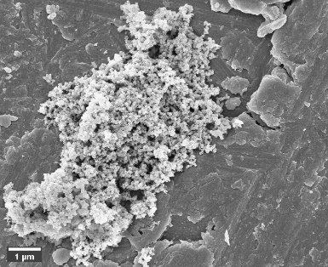  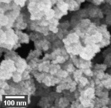 | 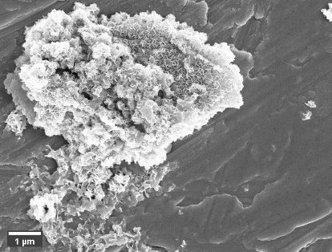  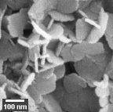 | 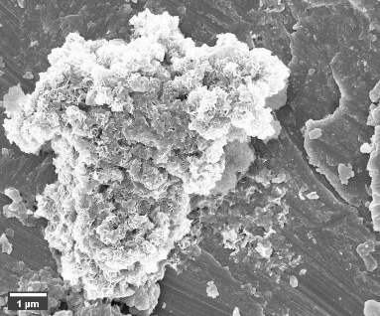  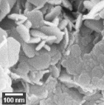
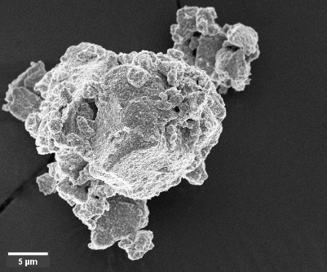  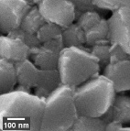 | 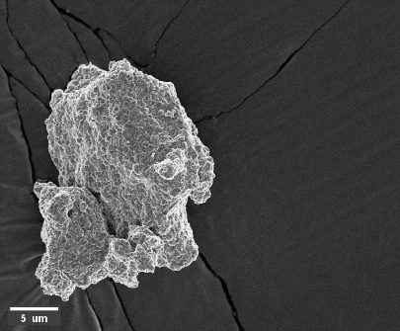  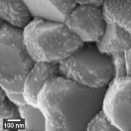 | 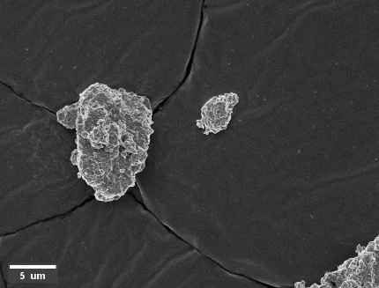  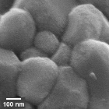
Figure 2. SEM images of Ni_{0.8}Mn_{0.1}Co_{0.1}(OH)₂ (a, b, c) and of LiNi_{0.8}Mn_{0.1}Co_{0.1}O₂ (A, B, C) for different aging times, t_{mix} (a, A), 3 hs (b, B) and t_{ON} (c, C).

4. Conclusions
Throughout this study it is analyzed the electrochemical capacity of the NMC synthesized from precursors obtained under different synthesis conditions. The higher specific capacities are obtained when the precursor particles are smaller and more compact. This meaning that the best synthesis condition to synthesize the precursor is at high flow rates to obtained smaller particles and more monodisperse, and age the suspensions to promote a lamellar shape of the primary particles and more compact secondary particles.

Acknowledgment
The research reported in this paper was funded by European Union, Horizon 2020 Programme, SimDOME Project, Grant Agreement No 814492. The views and opinions expressed in this publication are the sole responsibility of the author(s) and do not necessarily reflect the views of the European Commission/Research Executive Agency
References
- M. Armand, P. Axmann, D. Bresser, M. Copley, K. Edström, C. Ekberg, D. Guyomard, B. Lestriez, P. Novák, M. Petranikova, W. Porcher, S. Trabesinger, M. Wohlfahrt-Mehrens, H. Zhang, J. Power Sources. 479 (2020) 228708.
- A. van Bommel, J.R. Dahn, Chem. Mater. 21 (2009) 1500–1503.

