**Empowered Parameter Identification Procedure for Anaerobic Digestion Models Stability and Reliability**

Federico Moretta, Federico Rocca, Flavio Manenti, Giulia Bozzano*

*Politecnico di Milano, piazza Leonardo da Vinci, 32, 20133, Milan (MI), Italy*

*\*Corresponding author E-Mail: giulia.bozzano@polimi.it*

1. **Introduction**

Mathematical modeling of anaerobic digestion systems is crucial as it allows for the prediction and optimization of quantities such as methane and carbon dioxide. Because of its simplicity and processing speed, the AM2HN model $\left[1\right]$, an improved version of the AMOCO model $\left[2\right]$, is the ideal tool for control purposes. However, the identification procedure in the latter is ineffective, resulting in useless outcomes and meaningless parameters values. Consequently, this work provides a new approach based on resilient linear programming and advanced statistical analysis to address the inefficiency and obtain more trustworthy results.

1. **Methods**

AMOCO has a linear regression-based procedure which use experimental data and evaluate the yield coefficients in a dual-step pathway; AM2HN identification is non-linear regression based, which involves a single step evaluation for all the yield coefficients, starting from steady-state values coming both from experimental data and evaluated through ADM1 simulation $\left[3\right]$. Because of its inherent instability to data fluctuations, these procedures result in deceptive results when the analysis is performed on the absolute values of the simulated quantity. In our model, at first, the kinetic parameters of the biomasses are calculated by means of two non-linear regressions, starting from their steady-state values obtained from ADM1 simulations. The hydrolysis constant ($k_{hyd}$) and the liquid-gas transfer coefficient are then obtained by two stable and robust linear regressions, accordingly to what has already been proposed by other authors. The innovativeness of our procedure relies on the yield coefficients identification since the results obtained from the latter are misleading. Consequently, it aims to simplify and improve its reliability, employing an adaptation of the approach originally proposed in AMOCO. Firstly, it identifies two yield coefficients $\left(k_{1}, k_{6}\right)$ with two linear regressions from the methane flowrate and the steady-state values (Eq. 1, 2). Finally, two other multi-variable regressions are performed to get the four ratios which allow the computation of the remaining ones $\left(k_{2}, k_{3}, k_{4}, k_{5}\right)$, starting from both carbon and methane flowrate values at steady state (Eq. 3,4).

$$\begin{aligned}D\left(S_{1}^{in}-S_{1}\right)+k_{hyd}X_{T}=k_{1}X_{1}\left(αD+k_{d,1}\right)\#\left(1\right)\end{aligned}$$

$$\begin{aligned}q_{M}/X_{2} =k_{6}μ_{2} \#\left(2\right)\end{aligned}$$

$$\begin{aligned}q_{M}=k_{6}/k_{3} D\left(S_{2}^{in}-S_{2}\right)+ k_{6}k_{2}/k_{3}k_{1} \left[D\left(S_{1}^{in}-S_{1}\right)+k_{hyd}X_{T} \right]\#\left(3\right)\end{aligned}$$

$$\begin{aligned}q_{C}-D\left(C_{in}-C\right)=k_{4}/k_{1} \left[D\left(S_{1}^{in}-S_{1}\right)+k_{hyd}X_{T}\right]+k_{5}/k_{6} q_{M} \#\left(4\right)\end{aligned}$$

Matlab R2021a is used to perform all the regressions. The improved robustness is achieved by using the *Iterative Reweighted Least Squares (IRLS)* regression algorithm, which guarantees more reliable results where heterodasticity affects data.

1. **Results and discussion**

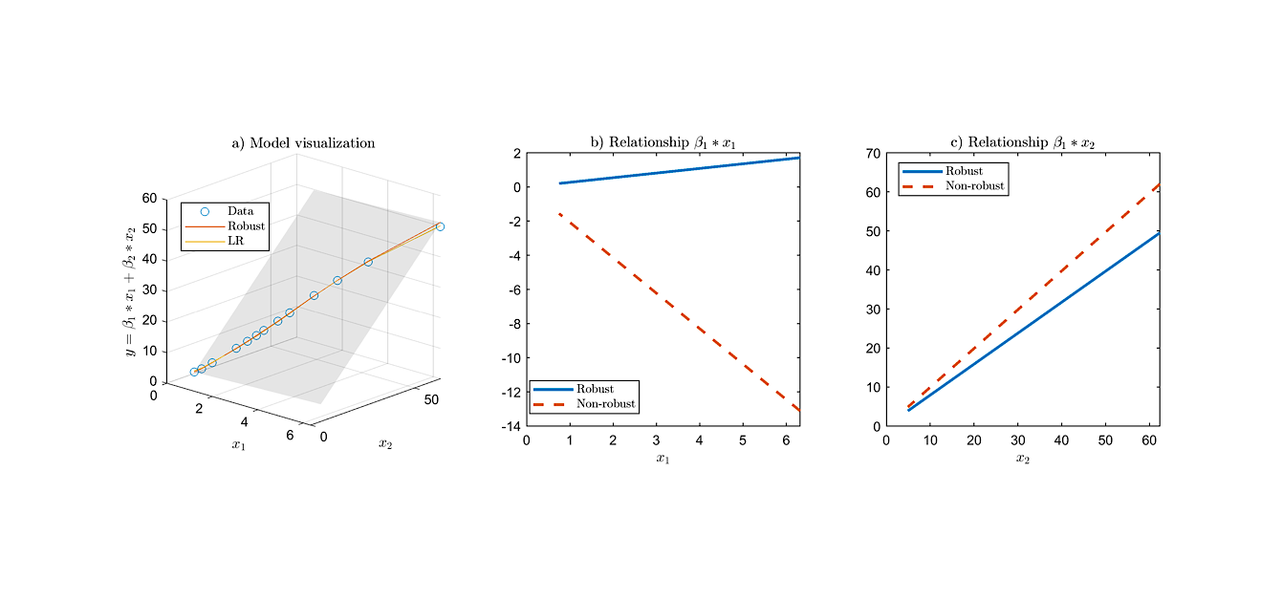A results comparison between the two procedure (new one and AM2HN) demonstrates the efficacy of this new proposed methodology. Figure 1 shows the multi-variable regression of yield ratios in Eq. 3-4, where both non-robust (NR) and robust (R) algorithm are applied. As shown, both the models perfectly fit the data (Fig. 1a). While the second relation shows a similar slope for both the NR and R (Fig. 1c, $β_{2}=k_{5}/k_{6}$), the slope of the first relation (Fig. 1b, $β_{1}=k_{4}/k_{1}$) from NR give a negative value, bringing a further simulation to misleading trends (Fig. 2). The other regressions, which allow the effective evaluation of the ratios $k_{6}/k_{5}$ and $k_{6}/k_{5}$, are not included due to space restriction, but the procedure is analogous.

**Figure 1.** Model and data visualization (a); parameter validation (b, c) ($β_{1}$: $\frac{k_{4}}{k_{1}}$, $β_{2}$: $\frac{k_{5}}{k_{6}}$, $x_{1}$: $D\left(S_{1}^{in}-S_{1}\right)+k_{hyd}X_{T}$, $x_{2}$: $q_{M}$, $y$: $q_{C}-D\left(C_{in}-C\right)$).

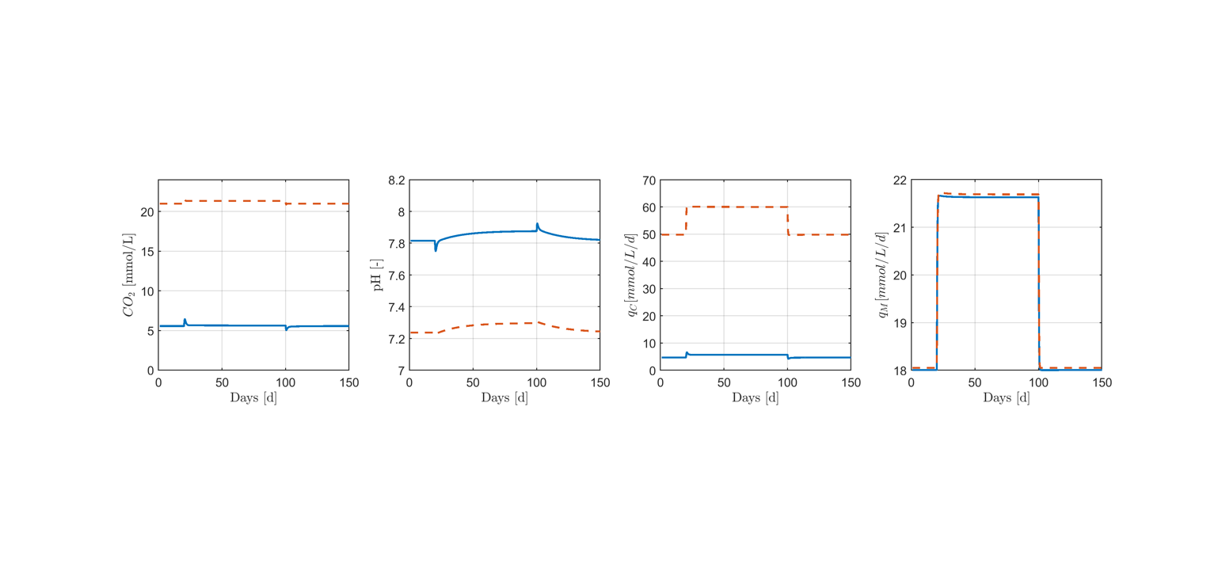The results of the simulation with the new identified parameters shows a more realistic trend of the principal variables, while preserving the model's simplicity and flexibility. In the Figure 2, the outlet molar gas fluxes of CH4 () and CO2 () are reported, being the most important. The new proposed identification leads to a difference in the result of variables related to inorganic carbon (i.e., pH) whereas the methane is almost equal with both models. The yield evaluated from the new procedure predicts a CO2 percentage in the biogas around 20%, more realistic than the higher 70% resulted from the AM2HN simulation, without compromising any other result and eventually improving them.

**Figure 2.** Results of model simulation. New identification procedure (solid line), AM2HN simulation (dashed line).

1. **Conclusions**

The new proposed identification method can be successfully applied to the AM2HN model and thus used to develop a model-oriented control strategy of an anaerobic digestion unit. The variables most affected are the ones related to the inorganic carbon, because of the improved accuracy of the estimation of the yield coefficients related to it $(k_{4},k_{5})$. The reliability of the procedure had been further tested with another set of data available within the ADM1 model, obtaining excellent results.

**References**

1. S. Hassam, E. Ficara, A. Leva, J. Harmand, Biochem. Eng. J. 99 (2015) 193–203
2. O. Bernard, Z. Hadj-Sadok, D. Dochain, A. Genovesi, J. P. Steyer, Biotechnol. Bioeng. 75 (2001) 424-438
3. D. J. Batsone *et al.*, Water Sci. Technol. 45 (2002) 65-73.