**Investigation of the bottom corrosion of atmospheric storage tanks for the management of safety**

Maria Francesca Milazzo1*, Elpida Piperopoulos1, Amani Khaskhoussi1, Giuseppe Scionti1, Paolo Bragattto2, Edoardo Proverbio1

*1 Department of Engineering, University of Messina, Contrada di Dio, 98166 Messina, Italy;*

*2 Department of Technological Innovation, INAIL Workers’ Compensation Authority, via Fontana Candida, 00040 Monteporzio Catone, Italy.*

*\*Corresponding author E-Mail: mfmilazzo@unime.it*

**1.Introduction**

Given the types of handled substances in chemical and process industry and the operating conditions, all equipment is exposed to several corrosion phenomena causing losses of containment [1, 2]. Damage mechanisms are variegated and depend on the interaction between the construction material and the process fluid as well as the surrounding environment. These could also lead to economic losses due to unplanned stops and repairments or replacements of corroded items. Corrosion is a relevant issue in atmospheric storage tanks of hydrocarbons. The monitoring of the integrity of these tanks is particularly critical as regards the measures of the thickness loss in the bottom due to pitting or other phenomena. Available techniques require that tank is taken out of service, emptied and reclaimed. The thickness measurements are repeated after a certain time interval and allow scheduling next inspection usually according to popular standards. In addition, these measures are useful for the estimation of the probability of release, essential for the assessment of the risk associated with the release of dangerous substances as well as the environmental risk in accordance with current legislations [3, 4].

This research focuses on the investigation of the evolution of the corrosion phenomenon of the bottom of the storage tanks, with respect to a case-study that is a large atmospheric tank with a floating roof, used for the storage of various light aromatic naphtha-based solvents. The scope is to contribute to the understanding of the damage mechanism and provide some basic elements useful for the application of statistical analysis formulating the probability of bottom perforation.

**2. Methods**

To investigate the evolution of the deterioration mechanism of the storage tanks bottoms, two corrosive environments were simulated in the laboratory. By mixing the naphtha solvent and the solutions, two hydrocarbon mixtures were realized at different pH. The solvent is a commercial hydrocarbon, Shellsol A100 (Kremer Pigmente GmbH & Co., Aichstetten, Germany). The first solution (A) at pH 4 contained the hydrocarbon and an aqueous solution of NaCl, NaSO4 and acetic acid according to [5, 6]. The second solution (B) at pH 2.5 contained the hydrocarbon and Sour Water as indicated in the NACE TM0177 Test Solution B (5.0 wt.% NaCl, 2.5 wt.% glacial acetic acid and sodium thiosulphate (Na2S2O3) 10-1 to 10-3 M in replacement of H2S [7]. The ratio between the hydrocarbon and the A or B solution was in both cases 4/1.

The carbon steel specimens, 20 x 30 x 3 mm (width x length x thickness) were immersed in the two hydrocarbon solutions. Before the immersion, the specimens were treated in ultrasound (frequency 30 kHz), with acetone (CH₃-CO-CH₃), to remove the possible grease residues present on the surface. Subsequently, they were pickled in a Clarke solution (250 ml of hydrochloric acid (HCl), 5 g of antimony oxide (Sb2O3), 12.5 g of stannous chloride (SnCl2), in continuous stirring, at room temperature, for 35 minutes. Then, they were washed sequentially with soda, distilled water and ethanol.

Periodically 2 specimens (one from the solution A and one from the B one) were extracted, pickled, always through Clarke solution, and structurally and morphologically characterized, respectively by X-Ray Diffraction (XRD) and Scanning Electron Microscope (SEM). The XRD instrument used for the structural analysis of the material was a Bruker D8 Advance (Bruker, Billerica, MA, USA), in Bragg-Brentano θ–2θ configuration, with CuKα radiation (40 V, 40 mA). XRD patterns were collected in the range 10°–80° with a step of 0.1°/s. The morphological investigation was conducted through an instrument FEI Quanta FEG 450 (FEI, Hillsboro, OR, USA), operating at high vacuum with an accelerating voltage of 20 kV.

**3. Results and discussion**

Before the immersion, specimens are structurally characterized by XRD analysis (Figure 1a). The presence of the Fe peak (JCPDS # 04-007-9753) is evidenced, constituting more than 98 wt.% of a carbon steel. The results of morphological characterization, after the extraction of the specimens, are compared with carbon steel specimens before the immersion procedure (Figure 1b). A homogenous morphology of the sample is observed by SEM analysis, free of particular relevant cracks.

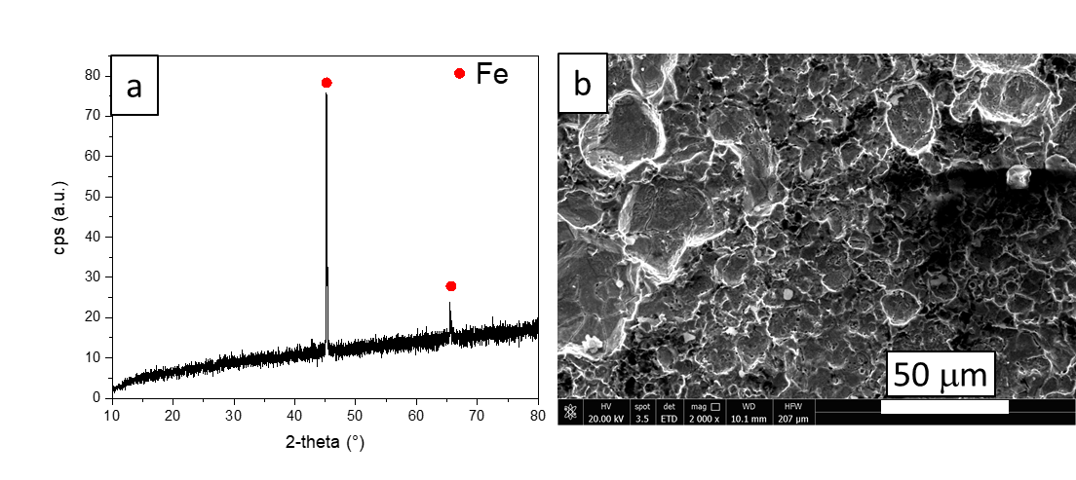

**Figure 1.** XRD diffractogram (a) and SEM image (b) of carbon steel specimen before the immersion procedure.

The results of the surface characterization of the specimens show two different ways of evolving the corrosive phenomenon. At 238 days all the specimens appear corroded (Figure 2). A selective attack can be noted for the sample extracted from solution A (Figure 2a). While corrosion is manifested itself in the form of pits for samples extracted from solution B (Figure 2b), where the sodium thiosulfate is probably the cause of this behavior.

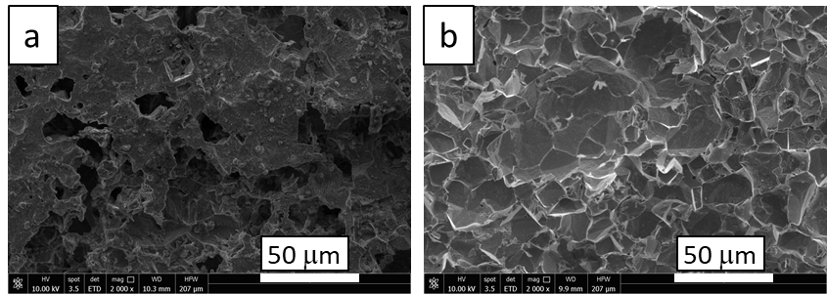

**Figure 2.** SEM images of samples extracted from solution A (a) and B (b), after 238 days of immersion

Pit depth measurements are useful for the estimation of the probability of the occurrence of the critical pit at the bottom of an atmospheric tank based on the application of the extreme value theory (EVT). The EVT is well known in the field of corrosion and in this study could represent a useful method to extrapolate the trend of the phenomenon from the specimens to the bottom of a tank for which the simulation system is representative. The limiting corrosion depth for safety purpose can be determined by means of popular standards [8].

The results of the study allow the establishment operator to integrate more appropriate investigations about the release scenarios due to the corrosion mechanisms within the risk assessment. These integrations consist in the quantification of the release probability accounting for the actual evolution of the phenomenon obtained through the simulation in the laboratory; moreover, through the use of more sophisticated models, the prediction of the probability of perforation and the remaining useful lifetime (RUL). These models combine the EVT and the Bayesian inference [9].

**4. Conclusions**

The study highlights the importance of underestimating the evolution of the corrosion in major hazard establishments, as it could be the cause of industrial accidents with the release of dangerous substances. To control and manage this problem, the operator usually carries out inspections and applies statistical modelling to calculate the probability of release, therefore, the investigation of the corrosive phenomenon certainly allows improving the understanding of its evolution.

**Acknowledgments**

This work has been funded by INAIL within the BRIC/2018 ID = 11 project MAC4PRO and the BRIC/2021 ID = 3 project DRIVERS.

**References**

1. M.H.Wood, A.V.Arellano, L.Van Wijk, Corrosion Related Accidents in Petroleum Refineries, European Commission Joint Research Centre Report no. EUR 26331, 2013.
2. OECD, Organisation for Economic Cooperation and Development, Ageing of hazardous installations, OECD Environment, Health and Safety Publications - Series on Chemical Accidents, no. 29, 2017.
3. EU Council, Directive 2010/75/EC on industrial emissions (integrated pollution prevention and control) (Recast), Official Journal of the European Union L334(2010), 17–119, 2010.
4. EU Council, Directive 2012/18/EU on the control of major-accident hazards involving dangerous substances, Official Journal of the European Union L197(2012), 1-37, 2012.
5. A.Rajasekar, S.Maruthamuthu, N.Muthukumar, S.Mohanan, P.Subramanian, N.Palaniswamy, Bacterial degradation of naphtha and its influence on corrosion, Corros. Sci., 47(1), 257-271, 2005.
6. A.Groysman, N.Erdman, A Study of Corrosion of Mild Steel in Mixtures of Petroleum Distillates and Electrolytes, Corrosion, 56(12), 1266-1271, 2000.
7. L.Calabrese, M.Galeano, E.Proverbio, D.Di Pietro, F.Cappuccini, A.Donato, Monitoring of 13% Cr martensitic stainless steel corrosion in chloride solution in presence of thiosulphate by acoustic emission technique, Corrosion Science, 111, 151-161, 2016.
8. EEMUA, Users’ Guide to the Inspection, Maintenance and Repair of above Ground Vertical Cylindrical Steel Storage Tanks, EEMUA 159, 2014.
9. M.F.Milazzo, G.Ancione, P.Bragatto, E.Proverbio, 2022, A probabilistic approach for the estimation of the Residual Useful Lifetime of atmospheric storage tanks in oil industry, Journal of Loss Prevention in the Process Industries (forthcoming).