**NiFe alloy based electrochemical sensor for sugars detection in food**

Francesca Mazzara*1, Bernardo Patella1, Michele Russo2, Alan O’Riordan3, Giuseppe Aiello1, Claudia Torino4, Antonio Vilasi4, Rosalinda Inguanta1

*1Laboratorio Chimica Fisica Applicata, Dipartimento di Ingegneria, Università degli Studi di Palermo, Viale delle Scienze, 90128 Palermo;*

*2 Dipietro Group, Siracusa, Italy*

*3Nanotechnology group, Tyndall National Institute, University College Cork, Dyke Prade, Cork, Ireland*

*4Istituto di Fisiologia Clinica (IFC)-Consiglio Nazionale delle Ricerche-Reggio Calabria-Italy*

*\*francesca.mazzara04@unipa.it*

**1.Introduction**

Sugars are essential organic compounds for humans, that play several fundamental roles in their life and development. They are naturally present in a wide range of food and produced in the human body. In fact, carbohydrates, consumed through a correct diet, are broken down into glucose, that is the most important source of energy for the body [1]. Sugars can be found in a range of foods including fruit, vegetables and honey and its quantification is very important to evaluate the quality of many foodstuffs. However, sugars may be added as additive during food processing, beverages and other preparations. While natural sugars are required by the body to satisfy the energy needs, added sugars are harmful to human health. Sugar consumption, especially added sugar, has been indicated as a major cause of several chronic diseases such as obesity, heart disease, diabetes and dental caries [2]. The World Health Organization (WHO) suggests that free sugars should make up no more than 10% of our daily energy intake [3]. Based on data relating to disease and mortality due to sugar intake, the European Commission has implemented a series of policies aimed to regulating sugar intake such as taxes on high-sugar foods [4]. To evaluate the concentration of sugars different techniques are available such as high-performance liquid chromatography and nuclear magnetic resonance. Among the quantification methods, electrochemical sensors have met with great success due to the simplicity of use, speed in response and high sensitivity and selectivity. In this work, non-enzymatic sensors were developed. In particular, a nanostructured electrode based on NiFe alloy was employed that exhibit very good catalytic properties [5].

**2. Methods**

Nanostructured electrodes based on nickel-iron (NiFe) alloys, obtained by template electrosynthesis method, were used as active materials for the electrochemical detection of glucose. This simple sugar was selected as a model to optimize the sensor. The nanostructured electrodes were fabricated through a two-step electrodeposition method. First of all, a thin layer of gold was sputtered onto a surface of a polycarbonate membrane to make it electrically conductive. On this surface, a Ni layer was electrodeposited by a potentiostatic deposition using a typical Watt’s bath. This layer acts as a mechanical support and current collector for the nanostructures. The deposition solution of the NWs consists of the Watt’s bath containing also FeSO4•7H2O. NWs electrodeposition was carried out by pulsed potential. After NWs deposition, the polycarbonate membrane was etched in chloroform at room temperature. All samples were characterized by Xray diffraction (XRD), scanning electron microscopy (SEM) and energy dispersive spectroscopy (EDS) in order to study morphology and evaluate composition and crystalline phases of the alloy. The fabrication procedure and characterization methods are detailed in [6].

Sensor performances were evaluated by Cyclic Voltammetry (CV) technique at room temperature in a three-electrode cell with a Pt wire as a counter-electrode and a SCE as a reference. Sensors were also validated in real samples in order to compare our results with those obtained with conventional techniques. All tests reported in this work were repeated three times using a new electrode and fresh solution for each test and the main value was plotted to calculate the main properties of the sensor.

**3. Results and discussion**

The electrochemical deposition leads a nanostructured electrode consists of regular array of NWs. This morphology ensures a very high surface area and thus a very high electrocatalytic activity. As it possible to observe from Fig. 1, NWs have a cylindrical shape with a smooth and regular surface. They also present the typical interconnections due to template morphology. From EDS analyses, reported in Fig. 2, the composition of NWs was evaluated, founding a Fe content of about 79%. XRD pattern reveals the deposition of FCC Fe-Ni alloy (card no. 47-1405), with a preferentially oriented along the (200) plane.

Figure 1 SEM image of NiFe NWs

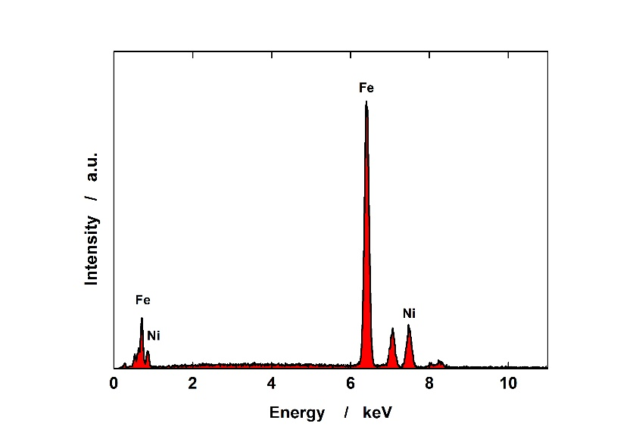

Figure 2 EDS spectrum of NiFe NWs

In order to perform the detection of glucose, CV was employed as electrochemical technique using NiFe NWs electrode as working electrode. In CV graph clearly appears the peak of glucose oxidation at about 0.1 V vs SCE that increases with the increase of glucose concentration. The NiFe electrodes show good behavior in terms of sensitivity and stability. Sensors were also validated with real samples of food. The achieved results were in good agreement with conventional techniques.

**4. Conclusions**

NiFe NWs based electrodes were fabricated by electrochemical deposition on a polycarbonate membrane that acts as template. Electrodes were tested for the detection of glucose. Sensors were fully characterized by means of several techniques, which revealed the deposition of both NiFe alloy with nanowire morphology that ensures a high surface area. Electrodes were tested in a basic solution in which good performance were obtained. The NiFe electrodes show good behavior in terms of sensitivity and stability. Sensors were also validated in real food and drink samples and the results appear good and comparable to values obtained by using standard technique.

**References**

[1] V. Misra, A.K. Shrivastava, S.P. Shukla, M.I. Ansari, Effect of sugar intake towards human health, 1 (2016) 9.

[2] L. Bonsembiante, G. Targher, C. Maffeis, Type 2 Diabetes and Dietary Carbohydrate Intake of Adolescents and Young Adults: What Is the Impact of Different Choices?, Nutrients. 13 (2021) 3344.

[3] World Health Organization, Food and Agriculture Organization of the United Nations, Strengthening nutrition action: a resource guide for countries based on the policy recommendations of the Second International Conference on Nutrition (ICN2), World Health Organization, Geneva, 2018.

[4] N. Fidler Mis, C. Braegger, J. Bronsky, C. Campoy, M. Domellöf, N.D. Embleton, I. Hojsak, J. Hulst, F. Indrio, A. Lapillonne, W. Mihatsch, C. Molgaard, R. Vora, M. Fewtrell, Sugar in Infants, Children and Adolescents: A Position Paper of the European Society for Paediatric Gastroenterology, Hepatology and Nutrition Committee on Nutrition, Journal of Pediatric Gastroenterology & Nutrition. 65 (2017) 681–696.

[5] T.-H. Yeh, C.-W. Liu, H.-S. Chen, K.-W. Wang, Preparation of carbon-supported PtM (M=Au, Pd, or Cu) nanorods and their application in oxygen reduction reaction, Electrochemistry Communications. 31 (2013) 125–128.

[6] B. Buccheri, F. Ganci, B. Patella, G. Aiello, P. Mandin, R. Inguanta, Ni-Fe alloy nanostructured electrodes for water splitting in alkaline electrolyser, Electrochimica Acta 388 (2021) art. no. 138588.