Coupling of experimental and computational approaches in the study of complex (nano)systems for industrial and biomedical applications

Domenico Marson1*, Maria Russi1, Erik Laurini1, Sabrina Pricl1,2

*1 Molecular Biology and Nanotechnology Laboratory (MolBNL@UniTS), DEA, University of Trieste, Piazzale Europa 1, 34127 Trieste, Italy*

*2 Department of General Biophysics, Faculty of Biology and Environmental Protection, University of Lodz, ul. Pomorska 141/143, 90-236 Łódź, Poland*

*\* Corresponding author e-mail: domenico.marson@dia.units.it*

# 1.Introduction

In the contemporary material and drug development process, computer-assisted material design (CAMD) has proven to be a great asset in the prediction and characterization of different properties of complex molecular systems. Advancements in the last two decades, in high-performance computing (HPC) allowed researchers to share lights on increasingly multifaceted aspects of (nano)material development for industrial and biomedical applications. Nonetheless, to get detailed structure/property insights on the performance of a variety of materials – from (bio)proteins to micelles and synthetic polymers, a combination of HPC-based methods and experimental techniques are necessary. Accordingly, in this presentation we will give an overview of such hybrid approach with examples that, although referring to specific case-studies, hold a general validity and can be adapted to the study of any sophisticated (nano)systems.

# 2. Methods

Nowadays, HPC-based calculations allow researchers to design and predict the properties of highly complex materials with a great degree of accuracy, using computational techniques spanning different time and size scales [1]. In particular, focusing on molecular dynamic (MD) simulations is possible to follow the time evolution of a system of interest with atomistic resolutions, and describe a plethora of phenomena that pertain to the MD time/scale domain, including, *e.g.*, thermodynamics and kinetic events [2-7] (Figure 1). Yet, with the addition of tailored experimental investigations, other important information including – among many others – structural and mechanical properties of polymer (nano)composites and/or critical micellar concentrations (CMC) and aggregation numbers for (bio)surfactants (Nagg) can be precisely derived [8-17].

Among all physico-chemical experimental techniques available to the purpose, fluorescence spectroscopy (FS) and isothermal titration calorimetry (ITC) are the most versatile and powerful methods. For example, fluorescence quenching of aromatic amino acids induced by a ligand binding can unveil the underlying mechanism, and yield information of the overall ligand-receptor binding affinity [7, 18]. Contextually, ITC is becoming a gold standard approach for studying intermolecular and/or intramolecular interactions both in aqueous buffers and in different organic solvents [11-13]. Specifically, by measuring the heat exchanged during any interaction event it allows the direct derivation of the enthalpy variation, the stoichiometry of the species involved as well as the binding affinity constant. From the knowledge of these quantities the remaining thermodynamics parameters (entropy and free energy variations) can be directly estimated. $K_{a}$. With an eye on surfactants, the relevant CMC and Nagg can be retrieved with this technique; moreover, by re-elaborating the ITC thermograms kinetics information (*e.g*., the association ($k_{on}$) and dissociation rate constants ($k_{off}$)) can be reliably calculated. Interestingly, all these data can find their counterpart *in silico*, for which more sophisticated techniques, which include metadynamics, free energy perturbation (FEP) and steered MD simulations, exist to investigate in detail the molecular rationales for these phenomena [5, 18-19].

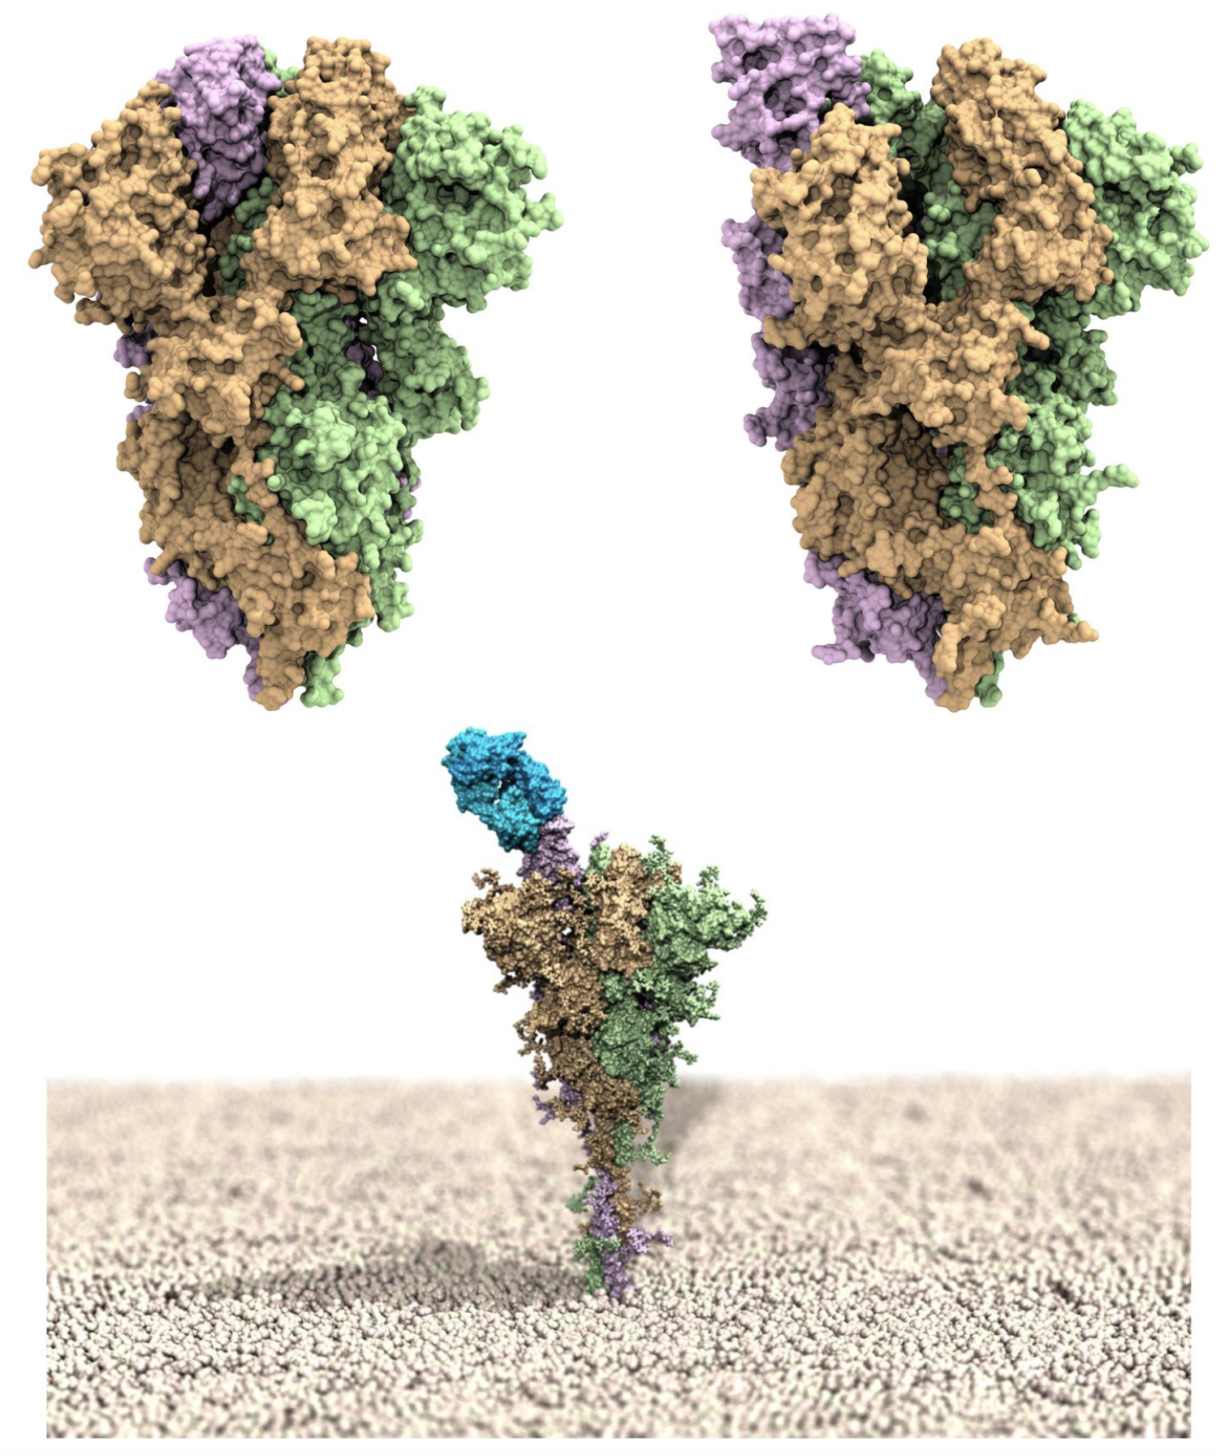

**Figure 1**.  Upper panel: models of the SARS-CoV-2 spike homotrimeric protein in the down (left) and up (right) conformations. The three spike protomers are highlighted by their light green, tan and light purple van der Waals surfaces, respectively. Bottom panel: computer rendering of the full-length SARS-CoV-2 homotrimer embedded in a membrane model (polar heads in light tan spheres), showing one protomer in the up position and in complex with the LY-CoV555 (bamlanivimab) monoclonal antibody (light blue van der Waals surface) [3].

# 3. Results and discussion

To highlight the combined use of FS/ITC and HPC-based simulations, we will report a couple of examples dealing with protein/ligand binding [7, 18]. Purposely, the results obtained from the application of this hybrid approach to the thermodynamic and kinetic characterization of the interaction of human serum albumin (HSA) – the major protein component of human blood – with different ligands (two FDA anticancer drugs and a complex dendrimeric molecule) will be presented and discussed.

Next, we will report on the accurate determination of the binding stoichiometry among the radionuclide 111In(III) (an element used in clinical single photon emission computed tomography (SPECT) bioimaging) with biocompatible nanocarriers bearing different terminal macrocyclic rings, *i.e*. DOTA (1,4,7,10-tetraazacyclododecane-1,4,7,10-tetraacetic acid) and NOTA (1,4,7-triazacyclononane-1,4,7triacetic acid. For other self-assembling amphiphilic nanosystems we will also show some results stemming from the coupling of HPC- and experimental-based techniques, which allowed us to characterize their main micellar features, including their CMC and Nagg values [9, 12].

# Finally, we will introduce a correlative analysis between the mechanical and structural properties exploited in the determination of the intrinsic changes of double strand DNA when interacting with different intercalant molecules (Figure 2). The procedures and results obtained in this study can be extended to a wide category of molecules and polymer of different nature, therefore finding further applications in different field, *e.g.*, from the optimal titration of chemotherapeutic drugs to environmental studies for the detection of heavy metals in human serum [17].

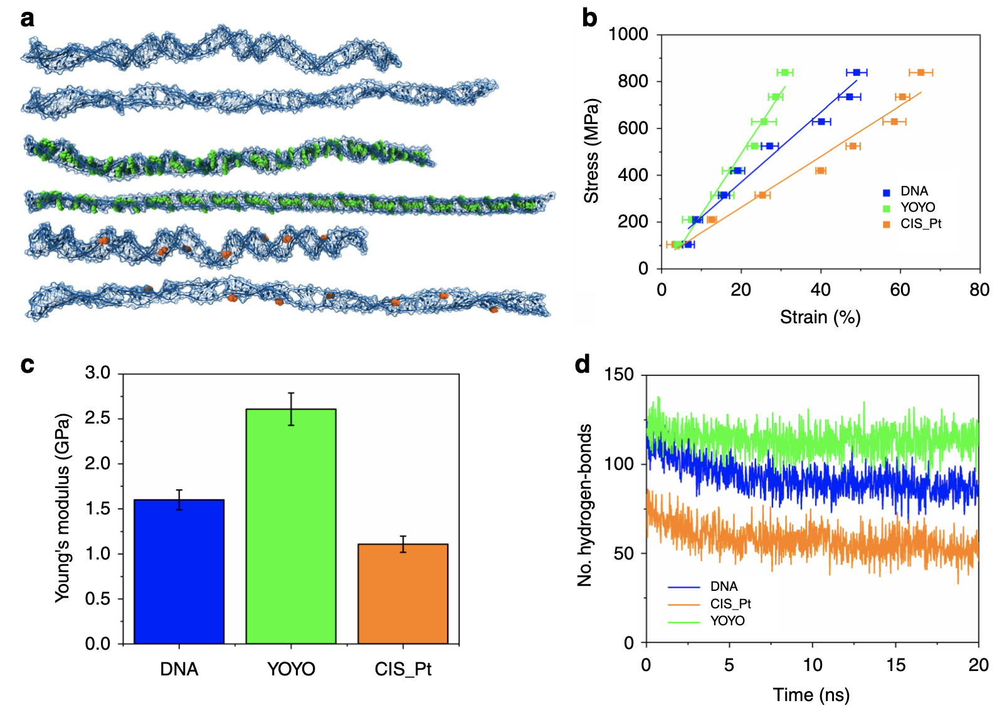

**Figure 2.** SMD simulations of pristine DNA and DNA intercalated with YOYO-1 and CisPt. a) Simulated conformational structures of the bare DNA (top), DNA intercalated with YOYO-1 (center), and CisPt (bottom) under uniaxial stretching deformation. In each ﬁgure, the ﬁrst corresponds to the initial structure, while the second represents the ﬁnal conformation reached at the maximum simulated strain. b) Stress–strain curve of the unidirectional traction applied to the DNA (blue), DNA/YOYO-1 (green), and DNA/CisPt (orange) systems. The Young’s moduli for each complex are calculated from the slope of the linear ﬁtting. The strain at each force has been averaged over three simulations and the corresponding standard errors are reported. c) Calculated Young’s modulus values for DNA (blue), DNA/YOYO-1 (green), and DNA–CisPt (orange) complexes. d) Change in the number of hydrogen bonds of DNA (blue), DNA/YOYO-1 (green), and DNA/CisPt (orange) systems during the simulation time applying the maximum stress value [17].

# 4. Conclusions

With the advent of supercomputers, *in silico* methods are gaining a true momentum in the design, study and characterization of complex (nano)systems with high performance in different application sectors. Nonetheless, experimental routines based on chemico-physical techniques are still of age to corroborate computer-based predictions and/or to achieve a higher order of accuracy. In this presentation, we offered a necessarily confined yet significant number of examples in which the efficient combination of both methodologies led to effective material structure/property determinations for very complex systems of industrial and biomedical interest. As such, this approach holds a general validity and can be further expanded to the design and characterization of new, high-performance materials.

# References

[1] M. Fermeglia, A. Mio, S. Aulic, D. Marson, E. Laurini, S. Pricl, Molecular Systems Design & Engineering2020, *5*, 1447-1476.

[2] E. Laurini, D. Marson, S. Aulic, A. Fermeglia, S. Pricl, Acs Nano2021, *15*, 6929-6948.

[3] E. Laurini, D. Marson, S. Aulic, A. Fermeglia, S. Pricl, Sci Rep2021, *11*, 20274.

[4] E. Laurini, D. Marson, S. Aulic, M. Fermeglia, S. Pricl, Acs Nano2020, *14*, 11821-11830.

[5] D. Marson, E. Laurini, M. Fermeglia, D. K. Smith, S. Pricl, Fluid Phase Equilibria2018, *470*, 259-267.

[6] D. Marson, E. Laurini, P. Posocco, M. Fermeglia, S. Pricl, Nanoscale2015, *7*, 3876-3887.

[7] E. Laurini, D. Marson, P. Posocco, M. Fermeglia, S. Pricl, Fluid Phase Equilibria2016, *422*, 18-31.

[8] D. Marson, S. Aulic, M. Fermeglia, E. Laurini, S. Pricl, in Design and Delivery of SiRNA Therapeutics (Eds.: H. J. Ditzel, M. Tuttolomondo, S. Kauppinen), Springer US, New York, NY, 2021, pp. 267-296.

[9] E. Laurini, S. Aulic, N. Skoko, D. Marson, M. Fermeglia, S. Pricl, in Design and Delivery of SiRNA Therapeutics (Eds.: H. J. Ditzel, M. Tuttolomondo, S. Kauppinen), Springer US, New York, NY, 2021, pp. 245-266.

[10] E. Laurini, S. Aulic, D. Marson, M. Fermeglia, S. Pricl, in Design and Delivery of SiRNA Therapeutics (Eds.: H. J. Ditzel, M. Tuttolomondo, S. Kauppinen), Springer US, New York, NY, 2021, pp. 209-244.

[11] L. Ding, Z. Lyu, B. Louis, A. Tintaru, E. Laurini, D. Marson, M. Zhang, W. Shao, Y. Jiang, A. Bouhlel, L. Balasse, P. Garrigue, E. Mas, S. Giorgio, J. Iovanna, Y. Huang, S. Pricl, B. Guillet, L. Peng, Small2020, *16*, e2003290.

[12] D. Dhumal, W. Lan, L. Ding, Y. Jiang, Z. Lyu, E. Laurini, D. Marson, A. Tintaru, N. Dusetti, S. Giorgio, J. L. Iovanna, S. Pricl, L. Peng, Nano Res2020, *14*, 2247-2254.

[13] L. Ding, Z. Lyu, A. Tintaru, E. Laurini, D. Marson, B. Louis, A. Bouhlel, L. Balasse, S. Fernandez, P. Garrigue, E. Mas, S. Giorgio, S. Pricl, B. Guillet, L. Peng, Chem Commun2019, *56*, 301-304.

[14] Y. Dong, T. Yu, L. Ding, E. Laurini, Y. Huang, M. Zhang, Y. Weng, S. Lin, P. Chen, D. Marson, Y. Jiang, S. Giorgio, S. Pricl, X. Liu, P. Rocchi, L. Peng, J Am Chem Soc2018, *140*, 16264-16274.

[15] E. Laurini, D. Marson, S. Aulic, A. Mio, M. Fermeglia, S. Pricl, Chemical Engineering Transactions2018, *74*, 619- 624.

[16] E. Laurini, D. Marson, M. Fermeglia, S. Pricl, J Comput Sci-neth2018, *26*, 28-38.

[17] S. Stassi, M. Marini, M. Allione, S. Lopatin, D. Marson, E. Laurini, S. Pricl, C. F. Pirri, C. Ricciardi, E. Di Fabrizio, Nat Commun2019, *10*, 1690.

[18] M. Russi, G. Cavalieri, D. Marson, E. Laurini, S. Pricl, Mol Pharmaceut2022, *in press.*

[19] C. Holtschulte, F. Börgel, S. Westphälinger, D. Schepmann, G. Civenni, E. Laurini, D. Marson, C. V. Catapano, S. Pricl, B. Wünsch, Chemmedchem2022, e202100735.