Oil-in-water nanoemulsions for encapsulation of lycopene from tomato waste

Junyang Li¹*, Giulia De Negri Atanasio¹, Roberta Campardelli¹, Patrizia Perego¹
1 Department of Civil, Chemical and Environmental Engineering, University of Genoa, Via Opera Pia, 15, 16145 Genoa, Italy;
*Corresponding author E-Mail: junyang.li@edu.unige.it

1.Introduction
Lycopene is a carotenoid of industrial/commercial value, it can be found in ripe tomatoes, pink grapefruit, watermelon, guava and papaya, giving them their distinctive red color due to accumulation in the plant through photosynthetic pigment-pigment complexes [1]. Lycopene has anticancer action, is capable of preventing cardiovascular diseases and modulate the immune system. Therefore, it is widely used in functional foods, nutraceuticals, pharmaceuticals and/or other applications [2,3]. However, due to the presence of double bonds in the structure, lycopene is very unstable to factors such as oxygen, light, heat and humidity, which greatly affects its stability during processing and storage, as oxidation may promote its color and loss of functional activity. In this sense, encapsulation is considered an efficient method to improve the stability, bioavailability and effective delivery of lycopene [4]. In recent years, a wide range of colloidal delivery systems have been developed to encapsulate bioactive components, such as molecular complexes [5-7], micro/nano-encapsulation [8-10], micro/nano-emulsions [3], liposomes [11-13], microgels [14,15], and biopolymer particles [16,17]. Due to their easy application in the food industry, emulsion-based delivery systems are particularly suitable for protecting nutraceuticals. In this study, natural extract rich in lycopene obtained by tomato waste was stabilized in oil in water emulsions (O/W). The effect of different extract concentrations in the O/W emulsion on emulsion droplets size distribution emulsion, stability over time and lycopene entrapment efficiency was evaluated.

2. Methods
Preparation of lycopene O/W emulsion
To prepare the emulsion, isopropyl myristate was selected as oil phase, whereas the water phase was prepared dissolving pluronic at concentration of 1.5% (w/w). The ratio between the water and the oil phase was kept constant: 90/10 (w/w). Briefly, 9g of isopropyl myristate and 1g extracts was mixed with ultrasound at 40% amplitude, on/off = 30/30 s/s. Then 90g of pluronic solution was emulsified at 7000 rpm for 1 min using a high speed rotor stator. Then oil phase was slowly added and emulsified for 9 min. The emulsions were then analyzed with Mastersizer-3000 for drop size distribution (DSD). The emulsions were ultrasonicated at 70% amplitude with probe for 5 min (on/off = 30/30 s/s). At the end of the process emulsions were analyzed for DSD again. All the process was in ice bath.
Total lycopene amount and free lycopene content was determined according to. The encapsulation efficiency was obtained by the following equation:

$Encapsulation efficiency (\%)=\frac{m_{total}-m_{free}}{m_{initial}}*100$ (Eq. 1)

Where $m_{total}$ is the total amount of lycopene loaded in the nanoemulsions, $m_{free}$ is the free lycopene in the nanoemulsions, and $m_{initial}$ is the initial amount of lycopene added to the nanoemulsions. The $m_{total}$ and $m_{free}$ were measured following the protocol reported by [18].
To evaluate the storage stability of the nanoemulsions at different temperatures, samples (40 mL) were transferred into glass tubes and stored in the dark at 4, 25, 37 °C. The concentration of lycopene and the particle size of nanoemulsions were measured at regular intervals of three month. Samples were equilibrated at room temperature for 10 min before analysis.

3. Results and discussion
Emulsions were prepared using different amount of tomato waste extract. The extract was obtained by ultrasound assisted extraction at operative conditions of: T = 65 °C, t = 20 min, Liquid to solid ration = 72 mL/g, Amplitude = 65%, on = 33 s, Volume = 90 mL. Lycopene content in extract was 1536 ± 53 µg/g. Different emulsions were changing the O/W ratio and the extracts concentration.
Droplet size is the main parameter to describe the nanoemulsions; the viscosity of the oil phase can determine the final droplet size of nanoemulsions to a certain extent. The optical microscope images of Figure 3 show that the lycopene O/W nanoemulsions were characterized by droplet size of about 350 nm. In addition, the droplets are uniformly dispersed, without aggregations and fusion. Emulsions produced at different conditions were characterized by DSD between 200 nm and 800 nm.

(a) 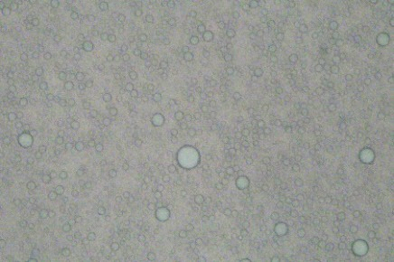 (b) 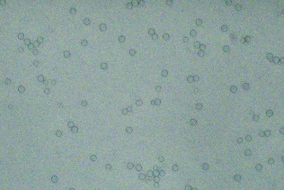
100µm
100µm
Figure 1. Optical microscope image of empty (a) and loaded (b) nanoemulsions.

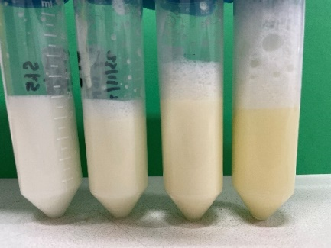
Figure 2. Emulsions loaded with different amounts of extract.

Increasing extract amount loaded in the O/W emulsion, a progressive increase of orange color was observed in the final product (Figure 2).

Storage stability of lycopene nanoemulsions
The stability of the lycopene nanoemulsion was determined at 4°C, 25°C and 37°C. Figure 3a shows that the appearance of the nanoemulsion at different storage temperatures showed significant changes after three months of storage at 37°C. The prepared nanoemulsions did not flocculate or precipitate at 4°C and 25°C. 37°C was a condition of accelerate aging. The stability of the nanoemulsion during storage was evaluated by measuring the change in particle size. Figures 3b shows that particle size did not change much at 4 °C and 25 °C during the first 4 weeks. In addition, the nanoemulsion becomes unstable at 37 °C, a phenomenon that may be due to the decrease in the repulsive force between droplets at relatively high temperature, and consequently, the increase of the average particle size from 300 nm to 800 nm, with the appearance of larger particles.
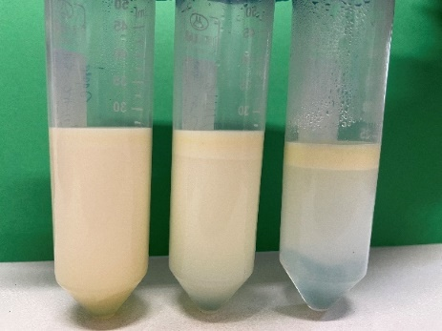
Figure 3a. Emulsion at 4°C, 25°C and 37°C after 3 months. Figure 3b. Lycopene extracts (1g).

The encapsulation efficiency (EE) of lycopene in O/W nanoemulsion was calculated according to Eq. 1. Results demonstrated that after 3 months and at different temperature of the lycopene retention rate was in the range between 10.7-55.1 %.
4. Conclusions
In conclusion, O/W nanoemulsions can stabilize tomato waste extract, and different parameters can have a significant impact on the stability of lycopene nanoemulsions. The choice of extract ratio is crucial to improve the properties of nanoemulsions. Future work will regard the study of naturally stabilized emulsions.

References
[1] S. Rahimi; M. Mikani. Microchem. J. 146 (2019) 1033-1042.
[2] G. Vasapollo; L. Longo; L. Rescio; L. Ciurlia. J Supercrit Fluids 29 (2004) 87-96.
[3] D. Sotomayor-Gerding; B.D. Oomah; F. Acevedo; E. Morales; M. Bustamante; C. Shene; M. Rubilar. Food Chem 199 (2016) 463-470.
[4] G.L.A. Sampaio; S. Pacheco; A.P.O. Ribeiro; M.C. Galdeano; F.S. Gomes; R.V. Tonon. Lwt 116 (2019) 108589.
[5] Y. Deswal; S. Asija; D. Kumar; D.K. Jindal; G. Chandan; V. Panwar; S. Saroya; N. Kumar. Res. Chem. Intermed. 48 (2021) 703-729.
[6] A. Arora; S. Singh; P. Oswal; D. Nautiyal; G.K. Rao; S. Kumar; A. Kumar. Coord Chem Rev . 438 (2021).
[7] H. Wang; S. Wang; H. Zhu; S. Wang; J. Xing. Antioxidants (Basel) 8 (2019).
[8] R. Delshadi; A. Bahrami; A.G. Tafti; F.J. Barba; L.L. Williams. Trends Food Sci Technol . 104 (2020) 72-83.
[9] Z. Akbarbaglu; S.H. Peighambardoust; K. Sarabandi; S.M. Jafari. Food Chem 359 (2021) 129965.
[10] A.L.R. Souza; D.W. Hidalgo-Chávez; S.M. Pontes; F.S. Gomes; L.M.C. Cabral; R.V. Tonon. Lwt 91 (2018) 286-292.
[11] M. Pettinato; P. Trucillo; R. Campardelli; P. Perego; E. Reverchon. Chem Eng Process . 151 (2020).
[12] B.S. Esposto; P. Jauregi; D.R. Tapia-Blácido; M. Martelli-Tosi. Trends Food Sci Technol . 108 (2021) 40-48.
[13] A. Najafi; R.A. Taheri; M. Mehdipour; G. Farnoosh; F. Martinez-Pastor. Anim Reprod Sci 195 (2018) 168-175.
[14] F. Scheffold. Nat Commun 11 (2020) 4315.
[15] S. Stock; R. von Klitzing. Curr Opinion Colloid Interface Sci. 58 (2022).
[16] Y. Xiong; R. Georgieva; A. Steffen; K. Smuda; H. Baumler. Journal of J. Colloid Interface Sci. 514 (2018) 156-164.
[17] Y. Li; S. Gong; X. Guan; H. Jiang; S. Tao; C. Yang; T. Ngai. Adv. Mater. Interf. 8 (2021).
[18] C. Zhao; L. Wei; B. Yin; F. Liu; J. Li; X. Liu; J. Wang; Y. Wang. Int J Biol Macromol 153 (2020) 912-920.

