Organic coatings from vegetable oils for corrosion protection

Leonardo Iannucci^{1*}, Camilla Noè¹, Valeria Gozzano¹, Marco Sangermano¹,
Emma Angelini¹, Sabrina Grassini¹
¹ Department of Applied Science and Technology, Politecnico di Torino, Corso Duca degli Abruzzi 24, Torino, Italy
*Corresponding author E-Mail: leonardo.iannucci@polito.it

1. Introduction
The need to reduce oil consumption has stimulated an increasing interest in novel polymeric materials derived from vegetable oils, which can have wide applications, from composites production to coatings application [1][2]. Dealing with the anti-corrosion coatings field, major importance is attributed to the coating barrier properties, which determine the diffusion kinetics of aggressive species through the material [3]. Consequently, a widely recognized approach is to add fillers inside the polymeric matrix to slow down this process and improve corrosion protection effectiveness [4].
In order to evaluate the possible use of novel eco-friendly materials in the anti-corrosion field, this study characterizes UV-cured epoxy coatings from vegetable resources. Moreover, the effect of filler addition is investigated, assessing the effect of nanoclay content on the coating barrier properties.
2. Methods
Diglycidylether of vanillyl alcohol (DGEVA) was used as biobased epoxy monomer; it was synthesized and provided by Specific Polymers (Castrier, France). The photocurable formulations were prepared by mixing the epoxy resin with a 2 phr (per hundred resin) of photoinitiator (PhI) and with different concentrations of nanoclay (0 wt%, 3 wt%, 5 wt%). Subsequently, they were applied on mild steel substrates using a spiral bar coater (final coating thickness of 50 μm) and then cured under a DYMAX UV-lamp for 60 s with a light intensity of 125 mW/cm². The photopolymerization reaction was conducted in air at room temperature.
Electrochemical measurements were performed in 3.5 wt% sodium chloride (NaCl) solution in a three-electrode cell, using an Ag/AgCl electrode as reference and a titanium sheet as counter electrode. Electrochemical Impedance Spectroscopy (EIS) measurements were carried out using an alternating voltage signal of 20 mV, in the frequency range from 10⁴ Hz to 10⁻² Hz, acquiring 10 points per frequency decade.
3. Results and discussion
The UV-curing process allows to obtain thermoset materials which, thanks to the low filler content, keep their transparency. In order to assess their corrosion protection effectiveness, EIS measurements were performed. Impedance spectra acquired after two hours of immersion in the electrolyte solution are presented in Figure 1 as Bode diagrams. All samples exhibit a resistive behaviour at high frequencies and then a capacitive-like behaviour at lower frequencies. Actually, phase values reach a maximum value of about -35° and then reach again values close to 0° in the low-frequency range. The relatively low maximum value in the measured phase can be attributed to the high aggressivity of the electrolyte solution.
Nanoclay addition has a clear effect on protective effectiveness, as can be seen from the impedance modulus. Actually, its value at low frequencies reaches about 10⁵ Ω·cm² for the sample without filler addition, while it increases up to about 6·10⁵ Ω·cm² for the coatings containing the nanoclay. The positive effect is enhanced by the filler shape factor. Actually, clay has a lamellar shape which allows to increase the path tortuosity during diffusion of aggressive species from the environment towards the metal substrate. Thus, a lower filler content is needed, if compared to non-lamellar alternatives [6].
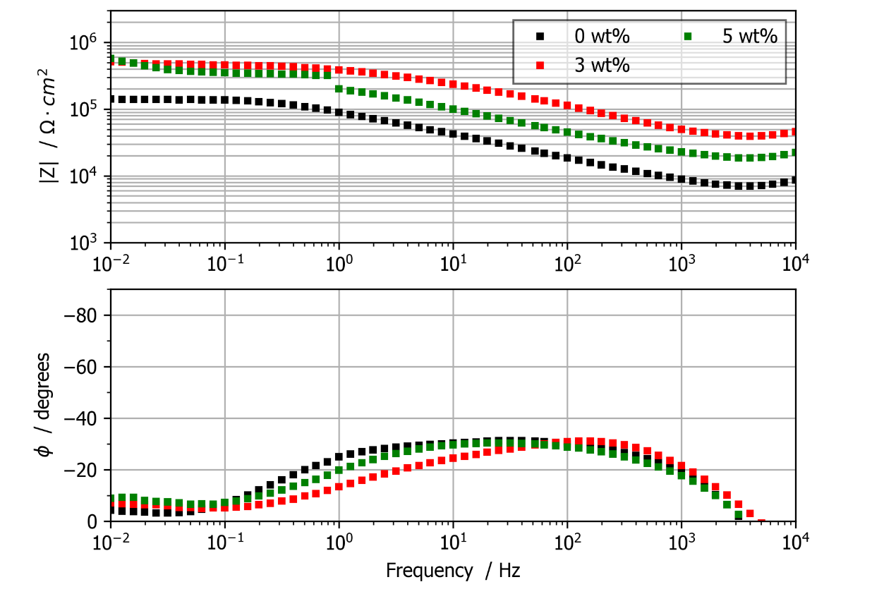
Figure 1. Impedance spectra recorded after 2 hours of immersion in 3.5 wt% NaCl electrolyte solution. Characterized samples are the three coatings, containing an increasing amount of filler (nanoclay).
It is interesting to highlight also that the beneficial effect is similar for samples containing 3 wt% and 5wt% of nanoclay, i.e. an additional increase in filler content above 3 wt% seems to have a limited effect. This can be attributed to aggregation phenomena, which often occur in nanomaterials when filler content is too high; thus, the optimal filler content is below 5 wt%.
4. Conclusions
The preliminary electrochemical measurements allowed us to assess the good protective effectiveness of the photocured coatings when immersed in an environment containing chlorides. Nanoclay addition had a positive effect on barrier properties, increasing the coating impedance modulus. Future work will be devoted to the characterization of the protective effectiveness after longer times of exposure to the electrolyte solution.
References
- R. Auvergne, S. Caillol, G. David, B. Boutevin, J.-P. Pascault, Biobased thermosetting epoxy: Present and future, Chemical Reviews, 114-2 (2014), pp. 1082-1115.
- C. Noè, M. Hakkarainen, M. Sangermano, Cationic uv-curing of epoxidized biobased resins, Polymers, 13-1,(2021), pp. 1-16.
- C. Noè, L. Iannucci, S. Malburet, A. Graillot, M. Sangermano, S. Grassini, New UV-Curable Anticorrosion Coatings from Vegetable Oils, Macromolecular Materials and Engineering, 306-6 (2021), art. no. 2100029
- R. K. Bharadwaj, Modeling the Barrier Properties of Polymer-Layered Silicate Nanocomposites, Macromolecules, 34, (2004), pp. 9189-9192
- J. L. Varela Caselis, E. Rubio Rosas, J. D. Santamaría Juárez,
- J. A. Galicia Aguilar, M. Sánchez Cantú, O. Olivares Xometl, M. Morales Sánchez, The use of montmorillonite organoclay in preparation of UV-cured DGBA epoxy anticorrosive coatings, Corrosion Engineering, Science and Technology, 53-5 (2018), pp. 362-369

