**Calibration of a lyophilization model in the presence of limited industrial data**

**for product transfer applications**

Margherita Geremia1, Gabriele Bano2, Emanuele Tomba3,

Massimiliano Barolo1, Fabrizio Bezzo1*

1. *CAPE-Lab – Computer-Aided Process Engineering Laboratory*

*Department of Industrial Engineering*

*University of Padova*

*Via Marzolo 9, 35131 Padova PD (Italy)*

1. *GlaxoSmithKline, 1250 S Collegeville Rd, Collegeville (PA), United States*
2. *GlaxoSmithKline, Via Fiorentina 1, 53100 Siena SI, Italy*

*\*Corresponding author E-Mail: fabrizio.bezzo@unipd.it*

**1.Introduction**

In the pharmaceutical industry, lyophilization is used to extend long-time stability of valuable thermolabile medicines and vaccines. Primary drying is the most time-consuming and energy-demanding step of the entire process; therefore, minimizing its duration is a key process development goal. In the last years, the use of mathematical models as part of standard lyophilization development workflow has gained momentum in the industrial practice to accelerate and optimize the primary drying recipe. However, models typically require invasive sensors (i.e., product temperature) for parameter estimation, which are rarely available in good manufacturing practice (GMP) environment. In our study, we propose a new protocol for model parameter estimation exploiting limited industrial data, namely pressure measurements and gravimetric tests and we successfully verified results on the recently proposed model by Bano et al. (2020) [1].

**2. Methods**

We exploit the mathematical model by [1] to assist product transfer and cycle optimization on a specific equipment. Specifically, we estimate only six relevant equipment-dependent parameters [2] which describe the dependency of the heat transfer mechanisms on the operating conditions, and the mass transfer resistance on the length of the dried product. The proposed protocol for the estimation of those parameters consists of two sequential steps:

* Step S1: fitting of central zone gravimetric measurements for the estimation of conduction heat transfer parameters.
* Step S2: estimation of all other relevant equipment-dependent parameters via pressure measurements only.

**3. Results and discussion**

The effectiveness of the proposed protocol is evaluated for two different pieces of equipment (EQUIP #1 and EQUIP #2). The parameter estimation task is successfully assessed in terms of parameter precision and model accuracy with respect to experimental data (see Figure 1 representing the calibration run of EQUIP #1). The model performance is then validated through validation experiments, which confirm closeness to experimental data. Model efficiency at forecasting the sublimation endpoint is verified by comparing the prediction of the total sublimation flowrate with the one obtained using the reference model (i.e., the model calibrated using the current procedure based on the availability of pressure and product temperature measurements). Finally, model performance at minimizing the primary drying duration is found to be very similar to that obtained using the reference model.

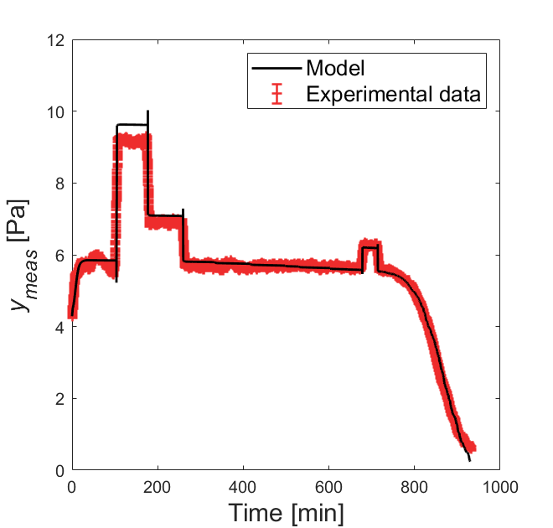

**Figure 1.** Model calibration for EQUIP #1: comparison of model profiles of pressure signal and the experimental observation.

**4. Conclusions**

The proposed workflow only relied on pressure measurements and gravimetric tests, which can be available on a large-scale equipment; no product temperature data is required. The effectiveness of our new protocol was successfully verified, thus confirming the possibility to use the model for aims of industrial interest. All tests were successfully passed for two different facilities, emphasizing the potential of the new protocol for the product transfer exercise and/or scale-up, thus making our approach particularly attractive in manufacturing environments.

**References**

[1] G. Bano, R. De-Luca, E. Tomba, A. Marcelli, F. Bezzo, M. Barolo. Primary drying optimization in pharmaceutical freeze-drying: a multi-vial stochastic modeling framework. Ind. Eng. Chem. Res. 59 (2020) 5056−5071.

[2] R. De-Luca, G. Bano, E. Tomba, F. Bezzo, M. Barolo. Accelerating the development and transfer of freeze-drying operations for the manufacturing of biopharmaceuticals by model-based design of experiments*.* Ind. Eng. Chem. Res. 59 (2020) 20071–20085.