**Rheological and Viscoelastic characterization of HDPE/LLDPE blends**

Francesca Gentile*, Sara Liparoti, Valentina Volpe and Roberto Pantani

*Department of Industrial Engineering, University of Salerno, via Giovanni Paolo II, 132 – Fisciano (SA) - Italy*

*\*Corresponding author E-Mail: fgentile@unisa.it*

**1.Introduction**

Polyolefins, including polyethylene (PE) and polypropylene (PP), are widely used in food and beverage packaging industry [1]. Linear polyethylene, such as high-density polyethylene (HDPE) and linear low-density polyethylene (LLDPE), is one of the most common materials for film applications due to its excellent performance in toughness, clarity, and thermal sealability [2]. Nevertheless, blown films from high density homo-polymers tend to be very brittle because they lack tie molecules [3], in fact, HDPE has a linear structure, without or with a few short branches, and a high degree of crystallinity [4].

It was suggested that bubble stability in film blowing is related to rheological properties [5], which are influenced by the molecular weight and molecular weight distribution. It is well known, in fact, that molecular weight parameters of a polymer impact also on its processability [6] and strongly affect the miscibility of PE blends [7]. For instance, blowability was found to be enhanced by the absence of long side chain branching in LLDPE [5].

Blending of polymers can lead to a balance of materials proprieties and processability [7], and this can also represent a viable way to achieve improved material proprieties avoiding the synthesis of new polymers [4]. A deep understanding of the rheological behavior is needed to ensure a good mixing during production of polymer blends.

In this work, rheological and dynamic mechanical behavior of blends of a HDPE and a LLDPE is investigated, to study their miscibility and processability.

**2. Methods**

Two different polyethylene were considered in this work, a high-density polyethylene (HDPE) and a linear low-density polyethylene (LLDPE). Proprieties of materials are listed in Table 1 below.

**Table 1** Proprieties of materials used in this study

|  |  |  |  |  |  |
| --- | --- | --- | --- | --- | --- |
| PE Grade | Density | Mn (g/mol) | Mw (g/mol) | Mw/Mn | Comonomer |
| HDPE | 0.956 g/cm3  (Multimodal MMD) | 8400 | 127000 | 15.12 | Butene |
| LLDPE | 0.941 g/cm3  (Bimodal MMD) | 7000 | 160000 | 22.86 | Butene, Hexene |

HDPE/LLDPE blends (Table 2) were produced by using a mini-extruder Thermo Scientific, Haake MiniLab II. The equipment is provided by a twin counter-rotating screws and a backflow channel which ensure an adequate mixing. Moreover, a slit capillary channel integrated in the close loop of the micro-compounder allows the possibility of performing rheological evaluations by measuring the pressure gradient in the recirculation channel (Figure 1).

**Table 2** Blends composition

|  |  |  |
| --- | --- | --- |
| Blend No. | LLDPE content [%] | HDPE content [%] |
| 1 | 100 | - |
| 2 | 60 | 40 |
| 3 | 70 | 30 |
| 4 | 80 | 20 |
| 5 | - | 100 |



**Figure 1** Schematic drawing describing the micro-compounder

The mini-extruder allows the possibility of performing rheological evaluations by measuring the pressure gradient in the recirculation channel; moreover the volumetric flow rate can be fixed by setting the screw rotation speed through a calibration curve. In this way, apparent shear rate in the recirculation channel can be evaluated with Hagen-Poiseuille equation, and consequently true shear rate is estimated by Rabinowitsch relationship [8]. Equations are reported below.

|  |  |
| --- | --- |
| Hagen-Poiseuille equation: ${\dot{γ}}_{a}=\frac{6 Q_{v}}{w h^{2}}$ Rabinowitsch relationship: ${\dot{γ}}_{true}=\left(\frac{2+n}{3}\right){\dot{γ}}_{a}$ | * Qv is the volumetric flow rat * w is the width of the capillary (10 mm) * h is the height of flow channel (1.5 mm) * n power law index |

The volumetric flow-rate depends on the material and on the rotation speed of the screws.

Apart from the recirculating channel, a distribution of polymer melt velocity within the mini-extruder should be taken into account. In fact, the presence of a distribution of velocity and different geometry in the recirculation channel and between the twin screws is evident. We estimate of having a velocity of polymer melts within the screws of about 1 order of magnitude greater than the velocity in the recirculation channel.

Materials were inserted between two steel plates covered with two Teflon tapes and positioned in a compression molded press (Carver press), that was previously heated to 130°C. A pre-heating time of 10 minutes ensures that pellets reached the temperature, after this waiting time, the press was closed, and materials compression occurred.

Rheological proprieties of pure materials and blends were measured using a Thermo Scientific HAAKE Mars II with parallel plate geometry. Frequency sweep experiments carried out at stress controlled with a frequency ranged between 0.1 and 100 rad/sec. The parameters used for the rheological characterization are listed in Table 3 below.

**Table 3** parameters used for rheological characterization

|  |  |  |
| --- | --- | --- |
|  | Temperatures [°C] | Frequencies [rad/sec] |
| LLDPE | 140/ 160/ 180 | 0,1-100 |
| HDPE | 140/ 160/ 180/ 200 | 0,1-100 |

Dynamic mechanical analysis (PerkinElmer DMA 8000) was performed on films prepared through compression molding as already described. Dynamic mechanical analysis (DMA) was performed in multifrequency mode (frequencies: 0.1Hz, 0.3 Hz, 1 Hz 3 Hz and 10 Hz) and temperature scan, with a temperature ranged between 20°C-130°C and a heating ramp of 1°C/min. The ramp was select to allow a measurement at each frequency at each temperature.

**3. Results and discussion**

In the following we report the properties of the pure materials. Figure 2 shows the plots of the complex viscosity (η*) as a function of the angular frequency (ω) of HDPE and LLDPE at each temperature. Rheological results of HDPE and LLDPE follow a pronounced shear thinning behavior. Furthermore, it is worth noting that at low shear rate, materials do not exhibit a Newtonian behavior, and this can be attributed to their wide molecular weight distribution.

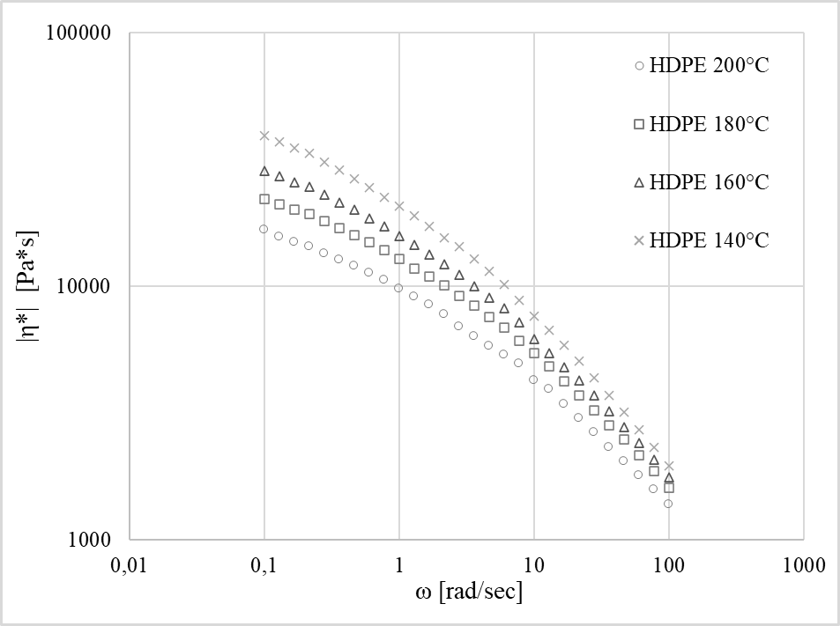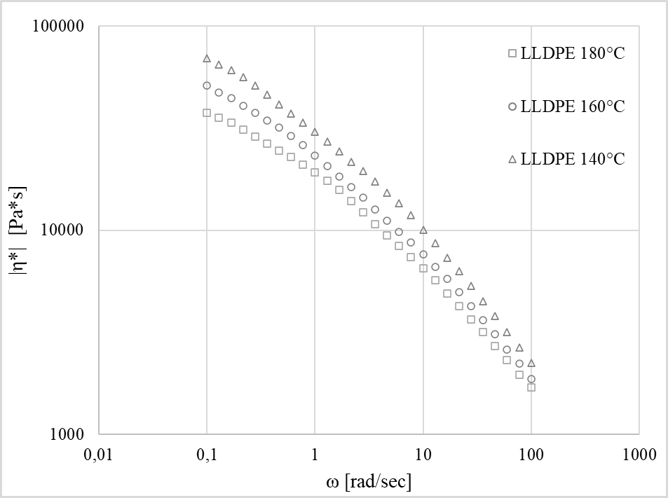

**Figure 2** Complex viscosity of HDPE (left) and LLDPE (right) as a function of frequency for different temperatures

Viscosity measurements were found to be well described by Cross equation, shown below:

Where the zero-shear viscosity η0 is given by Williams-Landel-Ferry (WLF) equation:

$$α_{T}=exp⁡\left(\frac{-C_{1}(T-T_{0})}{C_{2}+T-T_{0}}\right)$$

$$η\left(\dot{γ},T\right)=\frac{η_{0}α_{T}}{1+{\left(η_{0}α_{T}*\frac{\dot{γ}}{τ}\right)}^{1-n}}$$

Experimental data (solid line) and Cross (empty dot) equation results are plotted in Figure 3 and Figure 4. Experimental values of time-temperature shift factors αT and the results of WFL equation are shown in the same figure.

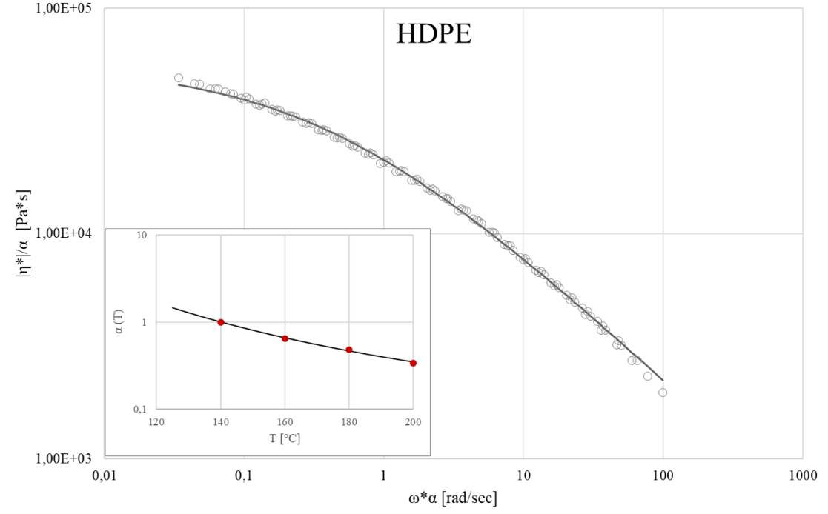

**Figure 3** Master curve at 140°C: experimental data (solid line) and Cross (empty dot) equation results and time-temperature shift factor αT for HDPE sample

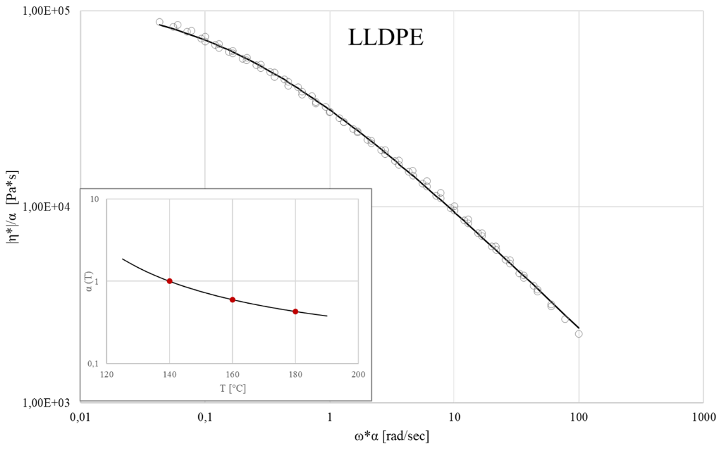

**Figure 4** Master curve at 140°C: experimental data (solid line) and Cross-WLF (empty dot) equation results and time-temperature shift factor αT for LLDPE sample

Rheological data provide an indication for identify process parameters in blends production. In fact, it can be noticed that for angular frequency greater than 50 rad/sec at temperature of 160°C (Figure 5), polymer melts exhibit comparable viscosities.

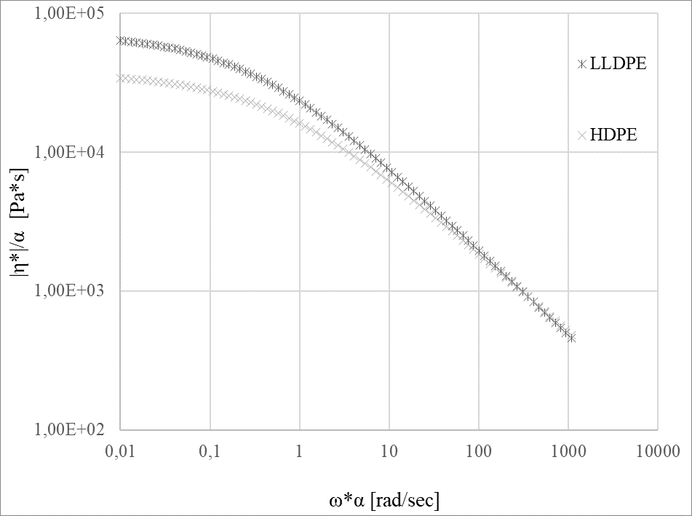

50 rad/sec

**Figure 5** Complex viscosity evaluated by Cross equation of HDPE and LLDPE samples at 160°C

The generalized Maxwell model was used to describe the viscoelastic behavior of polymer melts. Results of modelling and the experimental data of the storage modulus (G’), loss modulus (G’’) and complex viscosity are reported in Figure 5, while all the relaxation times and moduli of each Maxwell elements of the models are listed below (Table 4).

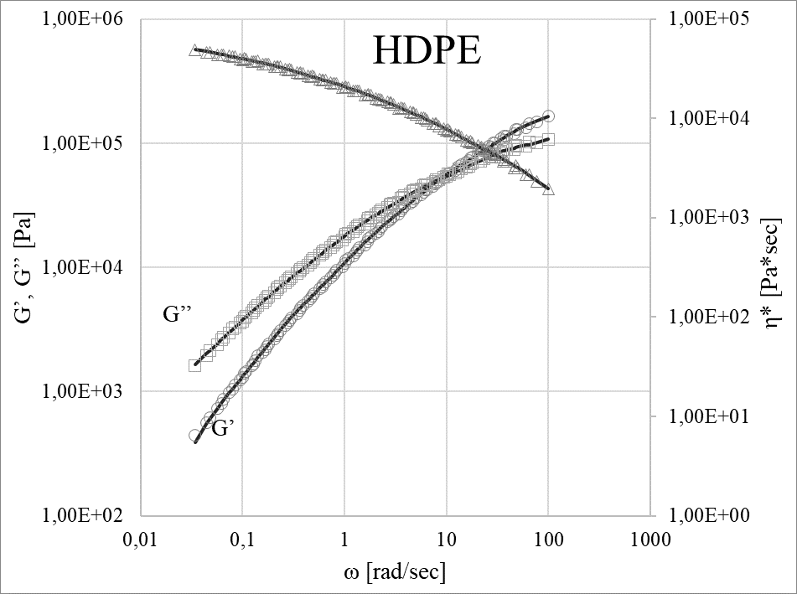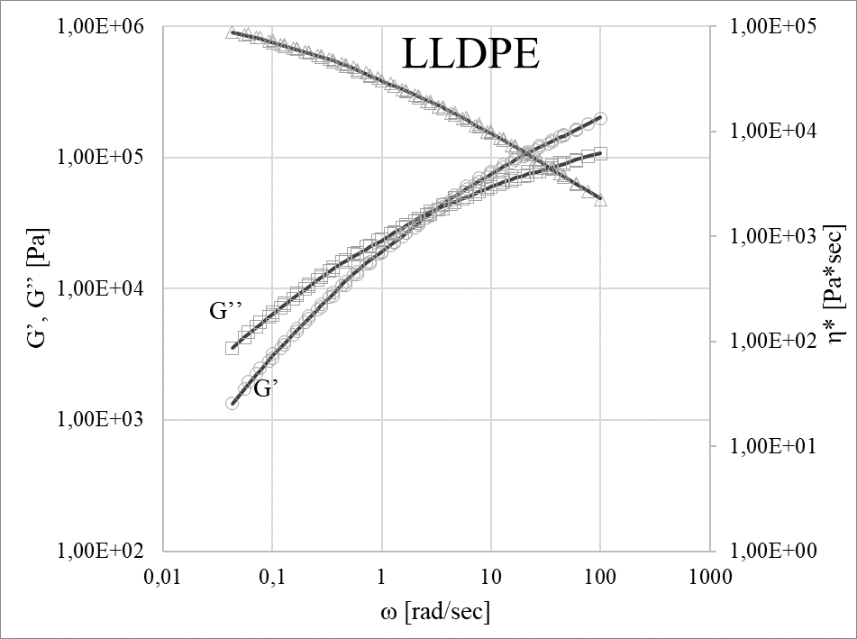

**Figure 6** Experimental data of the storage modulus (G’), loss modulus (G’’) and complex viscosity (η*) plotted with the results of generalized Maxwell model.

**Table 4** relaxation times and moduli of Maxwell's elements

|  |  |  |  |  |
| --- | --- | --- | --- | --- |
|  | LLDPE | | HDPE | |
| τ i | G i | τ i | G i |
| 1 | 4,19E+01 | 9,75E+02 | -2,80E+00 | 5,69E+00 |
| 2 | 5,75E-02 | 7,54E+04 | -1,56E+00 | 5,01E+00 |
| 3 | 7,86E-03 | 1,92E+05 | -7,79E-01 | 4,61E+00 |
| 4 | 1,96E+00 | 1,40E+04 | -1,10E-01 | 4,14E+00 |
| 5 | 3,19E-01 | 4,00E+04 | 5,75E-01 | 3,60E+00 |
| 6 | 9,52E+00 | 3,31E+03 | 1,35E+00 | 2,95E+00 |

Results of dynamic mechanical analysis are shown below in Figure 6. A remarkable change in slope is exhibited by both the HDPE and LLDPE samples soon below their melting point. This can be attributed to a softening of polymer during the test and can provide a measure of their processability at solid state. Furthermore, DMA was carried out in multifrequency mode, that allows the possibility of evaluating a time-temperature shift factor for materials at solid state. In this way, storage modulus and loss modulus data can be also used to perform a viscoelastic characterization of materials at solid state, by using the generalized Maxwell model, as already done for molten state.

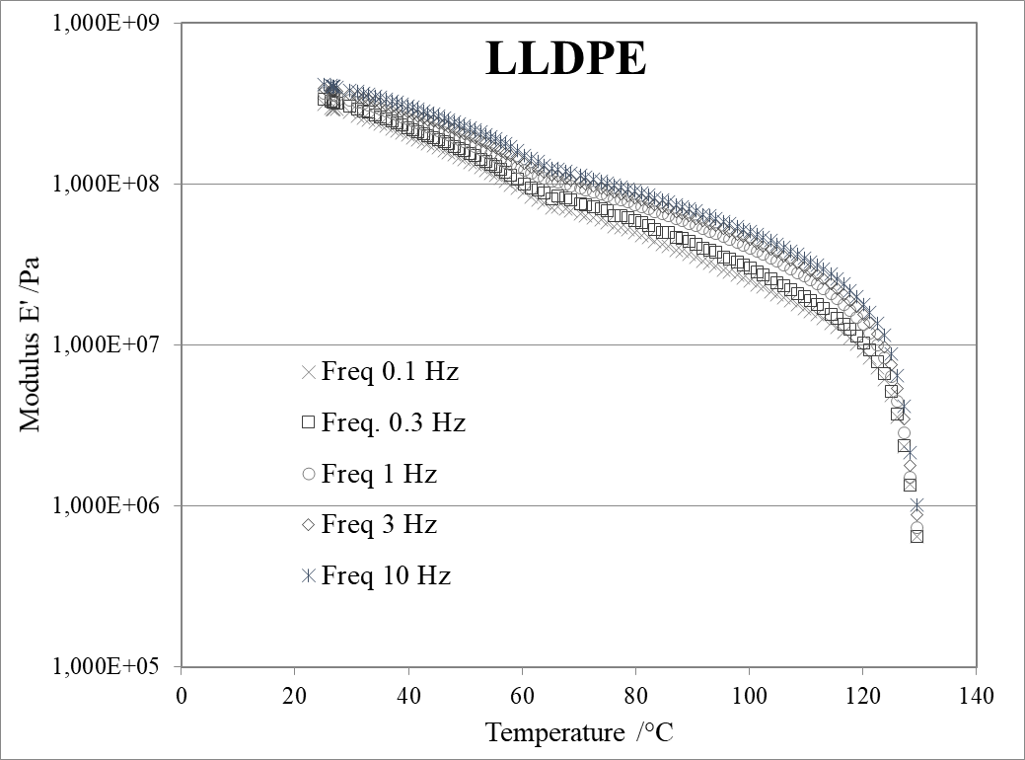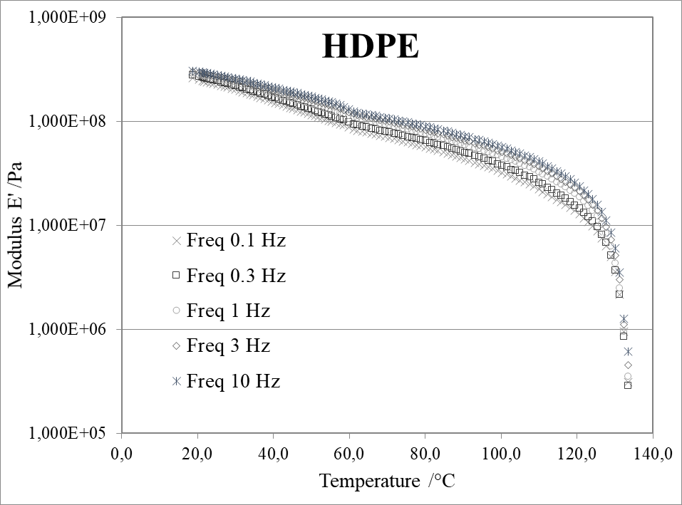

**Figure 7** Dynamical mechanical analysis results for LLDPE (left) and HDPE (right) samples

**4. Conclusions**

Two different polyethylene, namely HDPE and LLDPE, were characterized and used for production of blends with various composition. Rheological characterization was performed on all the blends and pure materials, and the viscoelastic behavior of polymer melts was also investigated. Processing parameters for blends production was previously determined by the knowledge of rheological behavior of HDPE and LLDPE used in this work. Compression molded samples were product to evaluate dynamical-mechanical behavior of all the materials considered in this study. DMA data were also interpreted by considering a viscoelastic approach.

**References**

[1] F. Roberto Passador, A. Collà Ruvolo-Filho, and L. A. Pessan, Polymer Engineering & Science, vol. 56, no. 7 (2016), 765–775

[2] W. Rungswang et al., Macromolecular Materials and Engineering, vol. 304, no. 9, (2019) 1900325

[3] O. OGAH, International Journal of Engineering and Management Sciences, vol. 3, (2012) 85–90

[4] P. Agrawal et al., Polymer Bulletin, vol. 79, no. 4, (2022) 2321–2343

[5] A. Ajji, P. Sammut, and M. A. Huneault, Journal of Applied Polymer Science, vol. 88, no. 14, (2003) 3070–3077

[6] C. L. P. Shan, J. B. P. Soares, and A. Penlidis, Polymer, vol. 44, no. 1, (2003) 177–185

[7] Y. Chen, H. Zou, M. Liang, and P. Liu, Journal of Macromolecular Science, Part B, vol. 52, no. 7, (2013) 924–936

[8] M. Yousfi, S. Alix, M. Lebeau, J. Soulestin, M.-F. Lacrampe, and P. Krawczak, Polymer Testing, vol. 40, (2014) 207–217